NEAT, HyperNeat and ES-HyperNEAT as Reinforcement Learning
Venetsia Krasteva
School of Computing, Edinburgh Napier University, Edinburgh EH10 5DT, UK
40313507@live.napier.ac.uk
Abstract—This paper compares the Neat, HyperNeat and ES-HyperNEAT as reinforcement learning methods. Neuroevolution takes inspiration from how biological brains evolved, where artificial neural networks are trained through evolutionary algorithms. The algorithms are analysed using the Open AI Gym environment in Classic Control games. The paper shows the performance of these algorithms tested with similar configurations and using different activation functions.
- Introduction

Artificial and computational intelligence in games is an active research field and rapidly growing. Researchers study the automation of play, design, and test algorithms in a controlled environment before moving to the real world. Neuroevolution (NE) applies to a wide range of problems within the field. NE is a technique that adjusts neural network weights or topologies. The technique is successfully applied to robot control [1], music generation [2], modelling biological phenomena [3], chip resource allocation [4] and character behaviour [5]. Games are excellent testbeds [6] for studying intelligent behaviour [7] and simulating live scenarios from autonomous driving [8] and strategy planning [9] [10] to open-ended phenomena [11] because they offer a series of tasks that vary widely in their graphical representation, game dynamics, and objectives introduced to an agent.

This paper compares NEAT versus HyperNEAT versus ES-HyperNEAT regarding the difficulty of setup and performance on multiple games with similar configurations and results. The primary motivation for writing this paper is that these algorithms are widely used in different scenarios but rarely compared in aspects of easily understandable experiments on different problems, where some suggest that HyperNeat improves upon NEAT [12]. Others suggest that regarding noise representation – NEAT outperforms HyperNeat due to direct encoding as the best work on compact state representations [13]. ES-HyperNEAT aims to improve upon HyperNEAT.
  - NEAT
NeuroEvolution of Augmenting Topologies (NEAT) is a method for evolving Artificial Neural Networks with a Genetic algorithm. The NEAT software was created initially in C++ code meant for the Linux operating system by Kenneth O. Stanley and Risto Miikkulainen [14]. They created it to answer the Neuroevolution question of how to gain an advantage from co-evolving neural network topologies with weights. By design, NEAT minimises the dimensionality of the search space of connection weights, so there is a significant performance gain (Fig. 1). In traditional NE approaches, a topology is chosen for the networks before the beginning of the experiment, whereas NEAT addresses this problem. Additionally, the efficiency in results is improved throughout the generations rather than only at the end.
Fig. 1. Initial solution vs Final Solution [14, Fig. 5]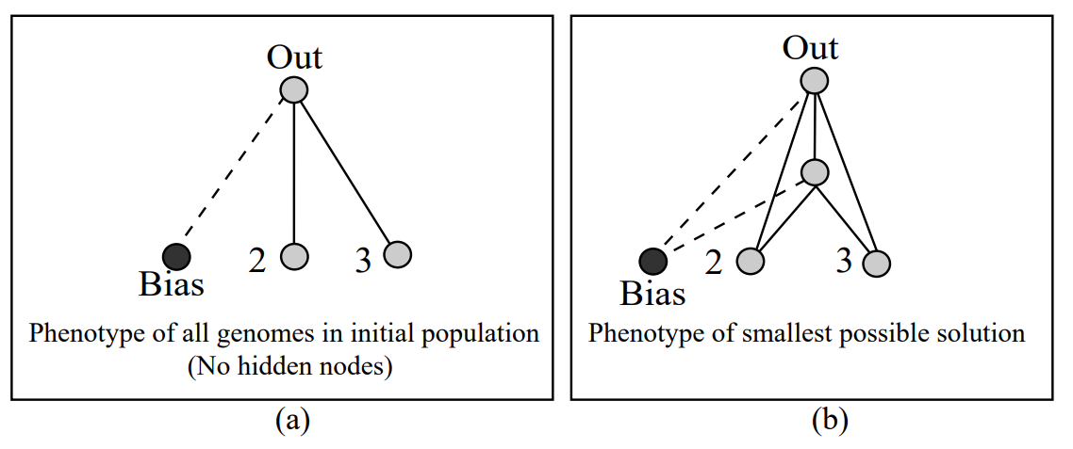
The intuition behind the algorithm comes from differently represented structures as, in nature, gene alignment is a similar problem. Nature's solution is to utilise homology (the resemblance of a composition based on descent from a common evolutionary predecessor). NEAT also introduces speciation (Fig. 1) into Neuroevolution by explicit fitness sharing, which forces individuals with similar genomes to share their fitness payoff and therefore divides the population (pop) into several species in order to solve the competing conventions (Fig. 2 having more than one way to solve a weight optimisation problem) [14] [15].
Fig. 1. Speciation [16]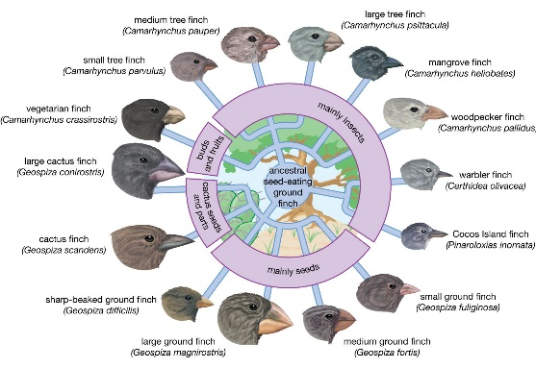
Fig. 2. Competing Conventions Problem [14, Fig. 1]
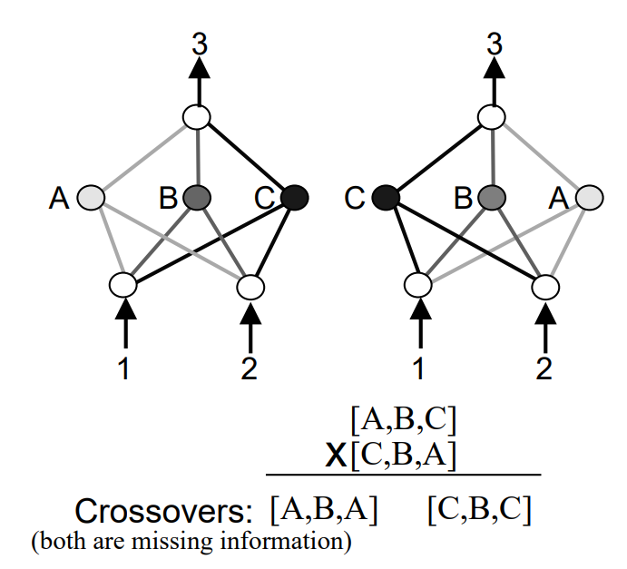
NEAT has been used in experiments such as robot control, where the experiment shows that the genomes' complexity leads to the continual coevolution of enhanced complex approaches[17]; the successful evolution of a vehicle warning system in a driving car that predicts an estimated time to crash [18]; predicting the price of stock accurately and faster than other methods [19] and Peer to Peer lending problems [20].
NEAT contributes significantly to Genetic Algorithms (GA) because it demonstrates the possibility of concurrently evolving both optimal and complicated solutions. Additionally, NEAT will not get trapped even if weights represent a local best in a fitness space since it can include different structures and add new dimensions, which implies it unlocks new approaches to escape. The vital insight is that it is not the definitive structure for the solution that matters but instead the structure of all the intermediate solutions along the way of discovering the solution [14].
  - HyperNEAT
Hypercube-based NeuroEvolution of Augmenting Topologies (HyperNEAT) is an extension of NEAT that uses a type of indirect encoding (Fig. 4) called Compositional Pattern-Producing Networks (CPPNs) (Fig. 5). CPPNs are like Artificial neural networks (ANNS) but rely on more than one activation function and are an abstraction of biological development rather than of brains. Because CPPNS encoding is itself a network, it is evolved in HyperNEAT by the NEAT algorithm [21].
Fig. 4. Direct vs Indirect encoding
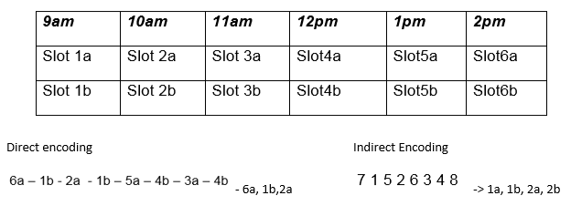
Fig. 5. Neural Network vs CPPN [22, Fig. 1]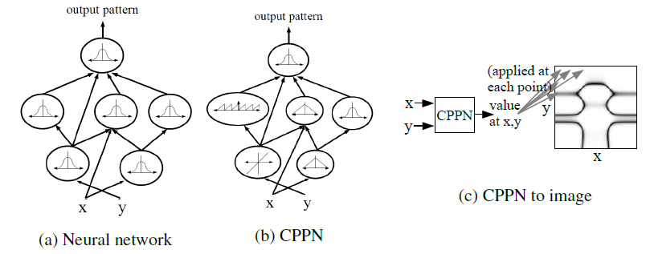
HyperNEAT was designed to thin the difference between the results produced by neuroevolution algorithms and the scale of biological brains [23]. The algorithm focuses on two research areas – Neuroevolution and generative and developmental systems (GDS). GDS addresses the compact encodings of large complex structures for evolution using indirect encodings, where each gene in the encoding does not map to a single corresponding unit of structure in the phenotype (Fig. 5). The advantage of this encoding is that it allows spatial patterns such as symmetry or repetition to be represented as networks. In order to achieve this, CPPNS takes the substrate, which contains input and output coordinates [24].
Fig. 6. Connectivity patterns made by CPPNS [23, Fig. 5] 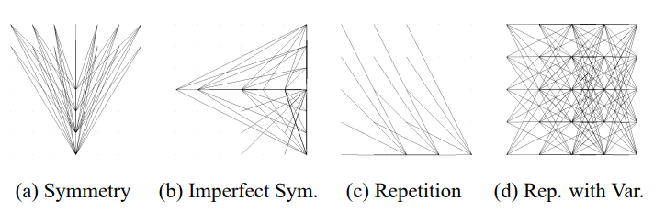
HyperNEAT shows much promise in learning from less processed data [25]. Furthermore, Hausknecht et al. [13] showed that HyperNEAT's ability to encode large-scale ANNs enables it to directly learn Atari 2600 games from raw game screen data, outperforming high human scores in three games. On the other hand, Gillespie et al. [26] conclude that even though HyperNEAT is superior to NEAT when using raw features, NEAT produced more high-scoring champions using hand-designed features. Furthermore, HyperNEAT appears to be more successful initially, but NEAT overtakes its performance in later generations.
  - Es-HyperNEAT
ES-HyperNEAT is created as a method that automatically deduces node geometry and density from CPPNs instead of needing a priori placement because HyperNEAT exposed the fact that neuroevolution gains from neurons that occur at locations within the space of the brain. ES-HyperNEAT evolves not just the location of each neuron but also can embody regions of differing density which means a resolution can increase historically over evolution [27].
ES-HyperNEAT improves on HyperNEAT by removing the need for the designer to specify hidden nodes in the substrate [28] and thus is a step forward to reaching the goal of Neuroevolution by showing promising results enabling the development of complex regular plastic ANNs [29] [27].
The algorithm solved the problem of robotic platforms whereas HyperNEAT performed efficiently as the complexity increased [30]. Furthermore, Verbancsics et al. [31] suggest that to improve the image classification architecture, ES-HyperNEAT should be used instead of HyperNEAT.
- Materials and Methods
  - Integrated Development Environment (IDE)
The IDE used for setting up the libraries and experiment is PyCharm Professional 2022.2, using a Pure Python project.
  - Data Visualizations
Data was produced by algorithms and saved onto excel spreadsheets, where data was analysed and then used in RStudio to make visualisations using the Viridis colour palette.
  - Set up of the environment

Set up Gym and Atari-Py
Final versions that the experiments use: Python (3.7.0), Atari-Py (0.2.6) and Gym (0.18.0). For Atari games to work, the machine must have Visual Studio C++ dependencies (Visual Studio C++ Build Tools). These versions were explicitly chosen due to implementation issues. The GYM and Atari-Py libraries had to be implemented into the project locally because of the issues listed below.

Issues
Python version is not compatible with OpenAI versions.
OpenAI Gym - installing ROM files locally (0.19.0); not loading games (0.20.0); runtime errors occurred (0.21.0)
Atari-py and Python - ale_c.dll could not be found; ROM file cannot be found/loaded; The specified module could not be found; gym.error.DependencyNotInstalled: No module named 'atari_py'
Open AI Gym v0.18.0 – a significant portion of the games do not run properly and do not allow for appropriate testing (Breakout, BipedalWalker-v2, AirRaid-v0, BankHeist-v0, BeamRider-v0, Bowling-v0, ChopperCommand-v0, CrazyClimber-v0, DoubleDunk-v0, ElevatorAction-v0, Enduro-v0, FishingDerby-v0, Gopher-v0, IceHockey-v0, Jamesbond-v0, Krull-v0, MontezumaRevenge-v0, NameThisGame-v0, Pitfall-v0, PrivateEye-v0, Qbert-v0, Riverraid-v0, RoadRunner-v0, Robotank-v0, Seaquest-v0, Skiing-v0, Solaris-v0, Tennis-v0, Tutankham-v0, Venture-v0, VideoPinball-v0, WizardOfWor-v0, YarsRevenge-v0, Zaxxon-v0)

Set up NEAT
The Neat-python library is used in the experiments as the documentation is extensive and easy to understand.
Due to specific configuration file headers used in earlier versions of NEAT, where they differ greatly, the experiment uses the latest version of NEAT (v0.92). There are no header differences between v0.9, v0.91 and v0.92.
The shelf activation functions were tested to see if they work, and it has been found that elu, lelu, and selu activation functions do not work, so algorithms performance was not tested with them.

Set up HyperNEAT and ES-HyperNEAT
Choosing a library that implements HyperNEAT and ES-HyperNEAT includes much consideration of the differences from the NEAT-Python library, which is why PUREPLES has been chosen, as it depends upon the NEAT-Python library [32] [33].
The functions of running the algorithms with the Open AI Gym environment are included in the library. Although the substrate that must be included in these algorithms for the Atari games is unknown, testing various substrates was unsuccessful in even launching the algorithms.
  - Set up of experiments
All experiments performed used as similar as possible configuration files to determine their effectiveness using NEAT default values set in the configuration file. Additional values were only added to the activation options (due to benefiting HyperNEAT and ES-HyperNEAT relying on working with multiple) and changing input and output values due to how the algorithms work.
The experiment's idea is to see how the algorithms perform on the Classic Control games (Cartpole, Mountain car and Acrobot), where the observation space is very limited to the agent's position and outcome of an action performed.
Each algorithm was tested for a hundred generations, and their best individual is tested on how well it performs in the game twenty times and the average is presented. This was performed twenty times per algorithm per game, and an average was concluded from the data gathered.
Functionality on how to run the algorithms efficiently was inspired by the PUREPLES library itself and NEAT-Python, while testing the individual was inspired by example code from neat-python where specific tweaks were necessary for HyperNEAT and ES-HyperNEAT as the network used is different, so the implementation of testing the individual for these algorithms was implemented in respect to how the algorithms are run.
  - Open AI Gym games

CartPole game
Fig. 1. Cart pole game
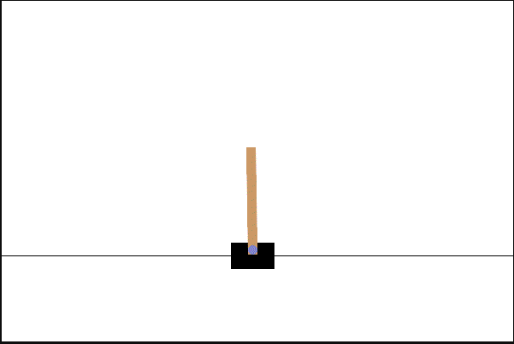
An un-actuated joint connects a pole to a cart, which moves along a frictionless track. The pendulum is positioned upright on the cart, and the objective is to steady the pole by applying forces in the left and right direction on the cart (Fig. 1).

Mountain Car game
Fig. 2. Mountain Car
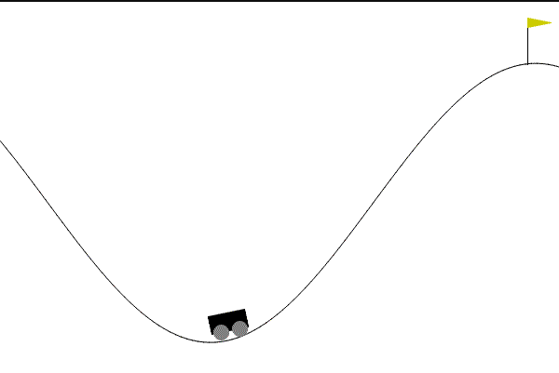
The mountain car game aims to strategically accelerate the car to reach the goal state on top of the right hill (Fig. 2).

Acrobot game
Fig. 3 Acrobot game

The system consists of two linear links to form a chain, with one end of the chain fixed. The joint between the two links is actuated. The goal is to apply torques on the actuated joint to swing the free end of the linear chain above a given height while starting from the initial state of hanging downwards (Fig. 3).
- Results
  - CartPole experiment

Experiment 1 – performance
NEAT, HyperNEAT and ES-HyperNEAT were tested to determine if the population could reach a mean fitness score of 275 for 100 generations.
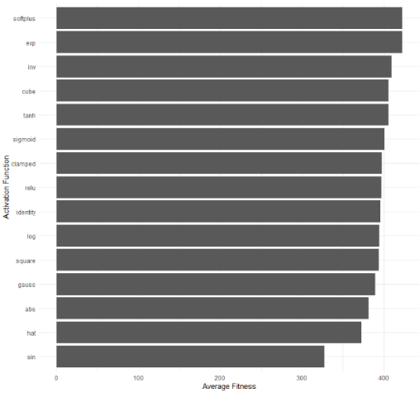
HyperNEAT and ESHyperNEAT include additional activation functions in the configuration file and a substrate. The additional two activation functions were chosen at random.
The algorithms were run twenty times, and mean Fitness for the generation was gathered to understand how quickly and efficiently the algorithm was trying to find a solution. Fig. 4 shows that NEAT can increase its fitness score quite quickly and, at some points, even reach the threshold (where termination would occur) and maintain high fitness levels, whereas HyperNEAT and ES-HyperNEAT struggle to reach a high fitness score early on in the population, but it can be viewed that the Fitness does increase over time just not as rapidly as NEAT.
This experiment shows the performance of the whole population throughout the generations without examining single individuals.
Fig. 5. Mean Fitness per generation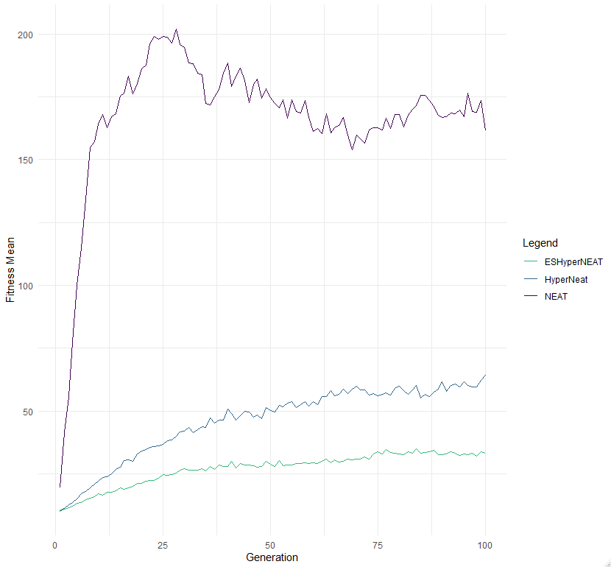

Experiment 2 – individual performance
NEAT was tested on all available and working activation functions and the average time for the algorithm to evolve an individual to a 500 score is less than two generations for all activation functions. However, when the individual was tested on the game again multiple times, the average score can be viewed in Fig. 6. Even though a solution was found early in the evolution, individuals tend to perform badly occasionally, hence the decrease in the score.
Fig.6. Average Fitness per Activation Function (NEAT)
NEAT, HyperNEAT and ES-HyperNEAT were tested on individuals reaching the fitness threshold of 500 (max score) throughout 100 generations (fitness criterion == max).
HyperNEAT was run using the three highest scores achieving activation functions, and the solutions found early in the evolution at around generation 5 on average, the best individuals over twenty runs score 147.585 on average when tested. So HyperNEAT was left to run twenty times for a hundred generations and the individuals with the highest score, tested twenty times, achieved a fitness of 394.965 on average.
The same method was applied to ES-HyperNEAT. The genome that reaches the threshold is, on average, at generation 15, scoring a fitness score of 60.3. If left to run for a hundred generations and the best individual tested twenty times achieves a fitness score of 163.9 on average.

Follow up on Experiment 1 with the highest score achieving activation functions
Fig. 7. Fitness mean per generation
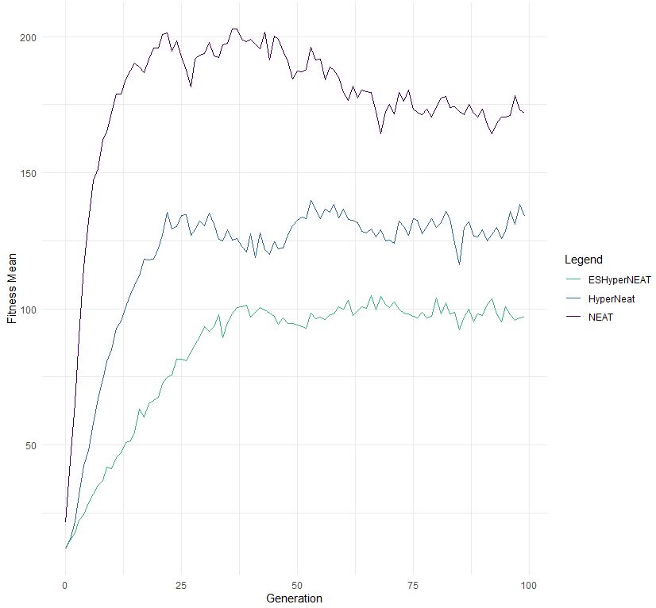
In Fig. 7, it can be observed that when running NEAT, HyperNEAT and ES-HyperNEAT using the highest score achieving three activation functions found in experiment 2 (Fig. 5), increased the mean Fitness per generation for all algorithms, but HyperNEAT and ES-HyperNEAT do not outperform NEAT.
NEAT does seem to increase its performance more rapidly as well, and additionally, the decrease in its Fitness starts much later than in Experiment 2 (Fig. 5).
  - Mountain Car Experiment (Discrete actions)

Fig. 8. Mean Fitness per Generation
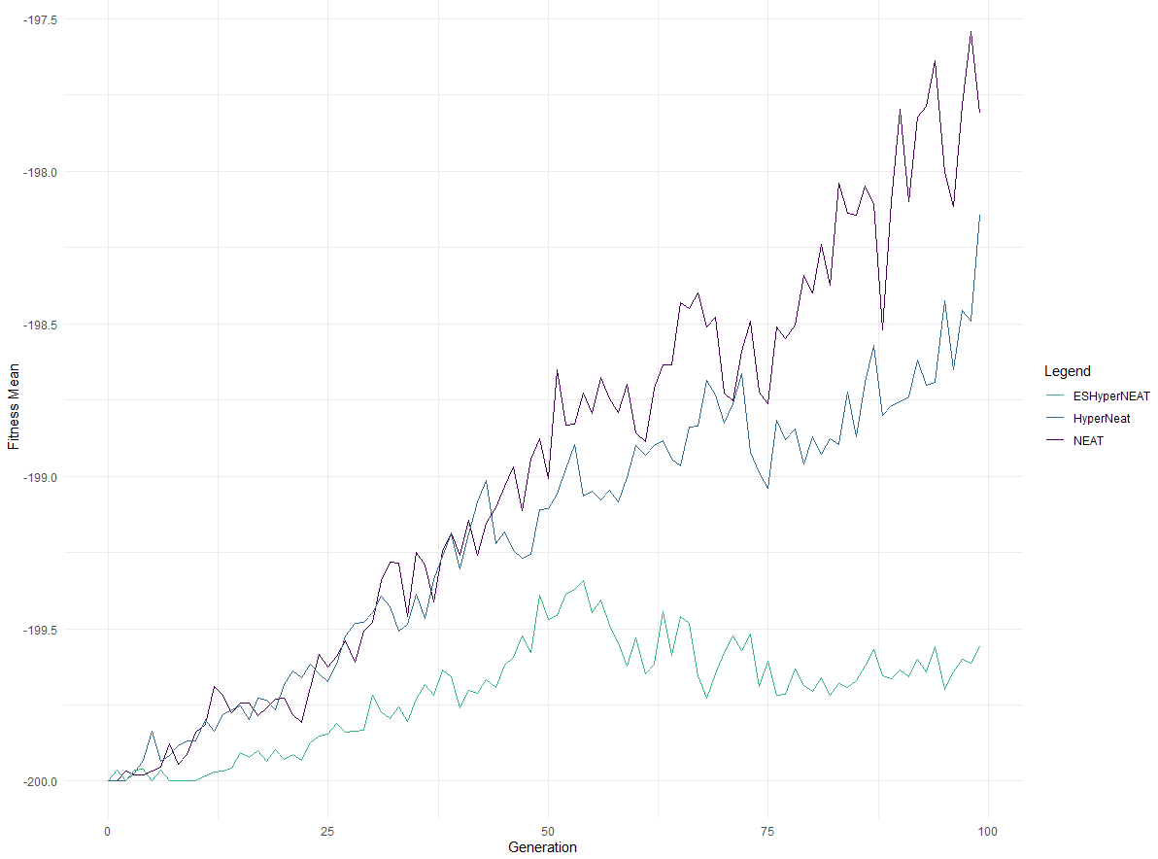
In Fig. 8, it can be observed that NEAT and HyperNEAT seem to perform equally at first, but NEAT overperforms HyperNEAT in later generations, while ES-HyperNEAT does increase in performance until around fifty generations but then does not manage to increase its Fitness. Nevertheless, NEAT and HyperNEAT still seem to have their individuals increase in Fitness, but it would take many generations to reach the optimal fitness score in the game as only a slight increase can be seen for a hundred generations while the optimal solution is a fitness score of zero which all algorithms are far from.
  - Acrobot Experiment
In Fig. 9, it can be observed that NEAT undeniably outperforms the other algorithms whilst they still increase in Fitness over time. It is relatively slower and seems to start maintaining the same Fitness around seventy-five generations. Even though NEAT does not seem to beat the game, it achieves higher scores than others, starts to decrease after sixty-four generations, and later maintains fitness scores at around seventy-five generations.
Furthermore, HyperNEAT and ES-HyperNEAT do seem to increase in Fitness until generation seventy-five and then maintain a stable fitness score until the end of the training.
Although all algorithms, even NEAT with its rapid increase in Fitness, do not reach a fitness score of minus a hundred at any point but come close to solving the game.
Fig.9. Mean Fitness per Generation
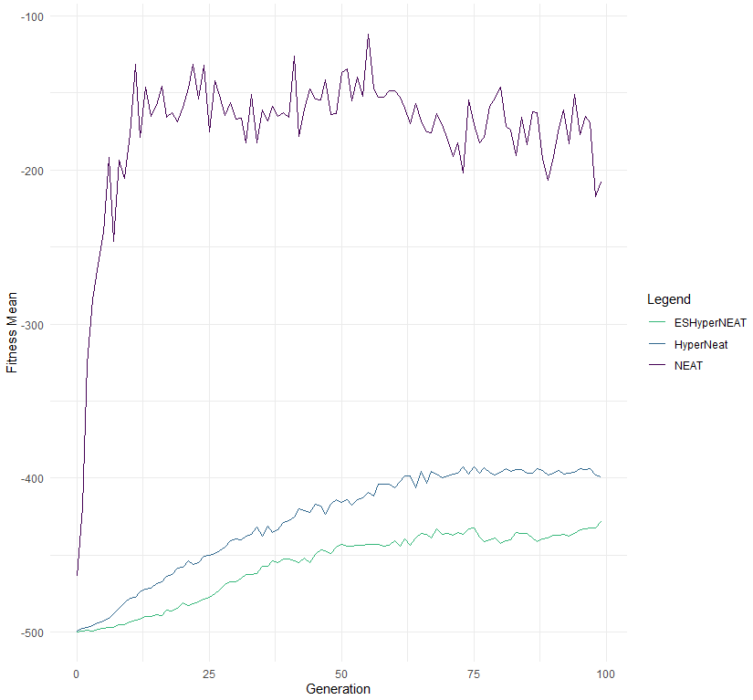
- Discussion
  - CartPole
Experiment 1 (Fig. 5), Experiment 2 (Fig. 6), and the follow-up on Experiment 1 (Fig. 7) for the CartPole game show that choosing an activation function does significantly affect the performance of HyperNEAT and ES-HyperNEAT, whilst it does speed the training for NEAT, it does not affect its performance as much as the others.
When NEAT was tested with all activation functions, it can be observed that the choice of activation function affects NEAT even if it is not as significant as HyperNEAT and ES-HyperNEAT. However, since HyperNEAT and ES-HyperNEAT use NEAT to evolve CPPN networks and their advantage is that different activation functions can be used in order to evolve (Fig. 10).
  - Mountain Car
Even though the game is simple, with only three actions and two elements in the observation space, all algorithms seem to perform poorly in this game. For example, the episode end might be a factor in the algorithms' underperforming because the agent is penalised one point each timestep, and the game terminates when a fitness score of two hundred is reached, not giving enough time for the algorithms to explore possible actions and come up with a strategy on beating the game.
Another factor might be that the algorithms work well with an observation space, such as raw game screen data [13], which compromises an RGB image, but the classic control games have a more limited observation space. Mountain Car observation space includes two elements that correspond to the position of the car along the x-axis and the velocity of the game. [34]
  - Acrobot
Acrobot has an observation space of the two rational joint angles and their angular velocities, which comprise mathematically and physically computed outcomes [35], similar to the Mountain Car game [34], which might be the cause of the decreased performance for HyperNEAT and ES-HyperNEAT.
NEAT does appear to come close to beating the game, whereas the others do not even come close. The speculation was that HyperNEAT and ES-HyperNEAT would outperform NEAT because they are supposed to exploit geometry in the game.
A factor affecting the underperforming algorithms is the different set of coordinates that the researcher initialises rather than the algorithm taking care of it. For example, a different set of coordinates might increase the performance.
  - Overall
The performance of the algorithms might also be affected by the fitness evaluation function where rewards are given to the agent (increase the Fitness) or the agent is penalised (decrease the Fitness). The CartPole game works on rewards of +1; each step is taken, making the algorithms easy to understand what needs to be done to increase the fitness score to reach the threshold. The game ends when the agent leaves the screen and the pole falls or time out. [36] In comparison, Acrobot penalises (-1) the agent for each step that does not reach the goal [35], and in Mountain Car, the agent is penalised (-1) each timestep [34].
Another critical factor in the performance is the setup of the algorithms. More noticeable are the coordinates needed for the substrate in order to run HyperNEAT and ES-HyperNEAT. However, there is no way to test if the chosen substrate is the optimal one that should be used, and the algorithms will run as long as the substrate is in the correct length and format.
As mentioned in section 4.2, a significant factor might be that HyperNEAT and ES-HyperNEAT work well with raw game screen data, and the Classic Control games do not have such an observation space and, as such, underperform NEAT itself. Hausknecht et al. [13] conclude that HyperNEAT works better than NEAT in the Atari games using an RBG image itself with no image processing needed [25], as Verbose and Stanley concluded.
- Conclusion
Whist NEAT outperforms HyperNEAT and ES-HyperNEAT in these simple classic control games, its performance and rapid increase in fitness score decrease the more extensive the search space gets, such as the Atari games. While it can still learn how to play the game, the progress is much slower without including image modification, such as image recognition or decreasing the search space, such as changing the RBG image to grayscale.
HyperNEAT and ES-HyperNEAT were developed for complicated tasks requiring the algorithm to evolve complex networks, while NEAT minimises the search space.
The experiments performed confirm that NEAT improves the efficiency of results throughout the generations rather than only at the end. They also show the importance of choosing an activation function for all algorithms.
Furthermore, this also shows the need to test the algorithms multiple times rather than once, as different results are generated each time. Additionally, the need to experiment with different configurations is vital to the performance and dependent on each problem.
While NEAT has been around for a while and many experiments have been performed, it solves more simple problems and has been stepping stones to algorithms that can solve more complex problems. Even though the setup for HyperNEAT and ES-HyperNEAT is complex, they are gaining popularity, and further experimentation with them needs to be done, as improvements are always possible and done in order for algorithm to solve real world problems as they are far more effective using CPPN-generatated networks because of the indirect representation [37].
- Acknowledgements
This endeavour would not have been possible without John Owens providing the opportunity to write this report and allowing sufficient dedication to focus on researching and testing these algorithms and for the provided support.
I am also grateful to my parents, who allowed me to study abroad and supported me throughout the years.
Lastly, I would like to mention my partner, who has kept my motivation high.
- Appendix
Fig. 2. Configuration file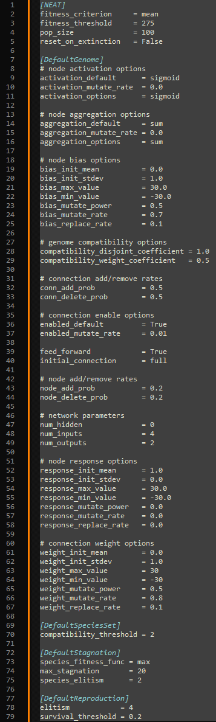
- References
[1] V. K. Valsalam, J. Hiller, R. MacCurdy, H. Lipson, and R. Miikkulainen, “Constructing controllers for physical multilegged robots using the ENSO neuroevolution approach,” Evol. Intell., vol. 5, no. 1, pp. 45–56, Mar. 2012, doi: 10.1007/s12065-011-0067-y.
[2] A. Baydin, R. Mántaras, and S. Ontanon, “Automated Generation of Cross-Domain Analogies via Evolutionary Computation,” Apr. 2012.
[3] J. Clune, J.-B. Mouret, and L. Hod, “The evolutionary origins of modularity | Proceedings of the Royal Society B: Biological Sciences.” https://royalsocietypublishing.org/doi/full/10.1098/rspb.2012.2863 (accessed Nov. 14, 2022).
[4] F. J. Gomez, D. Burger, and R. Miikkulainen, “A neuro-evolution method for dynamic resource allocation on a chip multiprocessor,” in IJCNN’01. International Joint Conference on Neural Networks. Proceedings (Cat. No.01CH37222), Jul. 2001, vol. 4, pp. 2355–2360 vol.4. doi: 10.1109/IJCNN.2001.938732.
[5] K. O. Stanley, B. D. Bryant, and R. Miikkulainen, “Real-time neuroevolution in the NERO video game,” IEEE Trans. Evol. Comput., vol. 9, no. 6, pp. 653–668, Dec. 2005, doi: 10.1109/TEVC.2005.856210.
[6] I. Althöfer, “Automatic Generation and Evaluation of Recombination Games,” ICGA J., vol. 33, no. 4, pp. 215–216, Dec. 2010, doi: 10.3233/ICG-2010-33405.
[7] P. A. Tsividis, T. Pouncy, J. L. Xu, J. B. Tenenbaum, and S. J. Gershman, “Human Learning in Atari,” p. 4.
[8] D. Choi, “A Testbed for Evaluation of Architectures for Physical Agents,” p. 4, 2007.
[9] S. Ontañón, G. Synnaeve, A. Uriarte, F. Richoux, D. Churchill, and M. Preuss, “A Survey of Real-Time Strategy Game AI Research and Competition in StarCraft,” IEEE Trans. Comput. Intell. AI Games, vol. 5, no. 4, pp. 293–311, Dec. 2013, doi: 10.1109/TCIAIG.2013.2286295.
[10] C. Hong, I. Jeong, L. F. Vecchietti, D. Har, and J.-H. Kim, “AI World Cup: Robot-Soccer-Based Competitions,” IEEE Trans. Games, vol. 13, no. 4, pp. 330–341, Dec. 2021, doi: 10.1109/TG.2021.3065410.
[11] S. Earle, J. Togelius, and L. B. Soros, “Video Games as a Testbed for Open-Ended Phenomena,” in 2021 IEEE Conference on Games (CoG), Aug. 2021, pp. 1–9. doi: 10.1109/CoG52621.2021.9619042.
[12] J. Lowell, K. Birger, and S. Grabkovsky, “Comparison of NEAT and HyperNEAT on a Strategic Decision-Making Problem,” p. 11.
[13] M. Hausknecht, J. Lehman, R. Miikkulainen, and P. Stone, “A Neuroevolution Approach to General Atari Game Playing,” IEEE Trans. Comput. Intell. AI Games, vol. 6, no. 4, pp. 355–366, Dec. 2014, doi: 10.1109/TCIAIG.2013.2294713.
[14] K. O. Stanley and R. Miikkulainen, “Evolving Neural Networks through Augmenting Topologies,” Evol. Comput., vol. 10, no. 2, pp. 99–127, Jun. 2002, doi: 10.1162/106365602320169811.
[15] K. O. Stanley and R. Miikkulainen, “Efﬁcient Reinforcement Learning through Evolving Neural Network Topologies,” p. 9.
[16] Encyclopædia Britannica, “Speciation | Causes, Process, & Types | Britannica.” https://www.britannica.com/science/speciation (accessed Dec. 04, 2022).
[17] K. O. Stanley and R. Miikkulainen, “Competitive Coevolution through Evolutionary Complexification,” J. Artif. Intell. Res., vol. 21, pp. 63–100, Feb. 2004, doi: 10.1613/jair.1338.
[18] K. Stanley, N. Kohl, R. Sherony, and R. Miikkulainen, “Neuroevolution of an automobile crash warning system,” in Proceedings of the 2005 conference on Genetic and evolutionary computation - GECCO ’05, Washington DC, USA, 2005, p. 1977. doi: 10.1145/1068009.1068340.
[19] G. Iuhasz, M. Tirea, and V. Negru, “Neural Network Predictions of Stock Price Fluctuations,” in 2012 14th International Symposium on Symbolic and Numeric Algorithms for Scientific Computing, Sep. 2012, pp. 505–512. doi: 10.1109/SYNASC.2012.7.
[20] Y. Liu, A. Ghandar, and G. Theodoropoulos, “Online NEAT for Credit Evaluation -- a Dynamic Problem with Sequential Data.” arXiv, Jul. 06, 2020. doi: 10.48550/arXiv.2007.02821.
[21] J. K. Pugh and K. O. Stanley, “Evolving multimodal controllers with HyperNEAT,” in Proceedings of the 15th annual conference on Genetic and evolutionary computation, New York, NY, USA, Jul. 2013, pp. 735–742. doi: 10.1145/2463372.2463459.
[22] T. Rasmussen, “CPPN mini-project,” Medium, Dec. 02, 2020. https://medium.com/@troelsarasmussen/cppn-mini-project-617ac24018e1 (accessed Dec. 04, 2022).
[23] K. O. Stanley, D. D’Ambrosio, and J. Gauci, “A Hypercube-Based Indirect Encoding for Evolving Large-Scale Neural Networks,” p. 39.
[24] S. Risi, J. Lehman, and K. O. Stanley, “Evolving the placement and density of neurons in the hyperneat substrate,” in Proceedings of the 12th annual conference on Genetic and evolutionary computation - GECCO ’10, Portland, Oregon, USA, 2010, p. 563. doi: 10.1145/1830483.1830589.
[25] P. Verbancsics and K. O. Stanley, “Evolving Static Representations for Task Transfer,” p. 33.
[26] L. E. Gillespie, G. R. Gonzalez, and J. Schrum, “Comparing direct and indirect encodings using both raw and hand-designed features in tetris,” in Proceedings of the Genetic and Evolutionary Computation Conference, Berlin Germany, Jul. 2017, pp. 179–186. doi: 10.1145/3071178.3071195.
[27] S. Risi and K. O. Stanley, “A unified approach to evolving plasticity and neural geometry,” in The 2012 International Joint Conference on Neural Networks (IJCNN), Jun. 2012, pp. 1–8. doi: 10.1109/IJCNN.2012.6252826.
[28] L. M. L. de Campos and R. C. L. de Oliveira, “A Comparative Analysis of Methodologies for Automatic Design of Artificial Neural Networks from the Beginnings until Today,” in 2013 BRICS Congress on Computational Intelligence and 11th Brazilian Congress on Computational Intelligence, Sep. 2013, pp. 453–458. doi: 10.1109/BRICS-CCI-CBIC.2013.81.
[29] S. Risi and K. O. Stanley, “Enhancing es-hyperneat to evolve more complex regular neural networks,” in Proceedings of the 13th annual conference on Genetic and evolutionary computation - GECCO ’11, Dublin, Ireland, 2011, p. 1539. doi: 10.1145/2001576.2001783.
[30] P. Reyes and M.-J. Escobar, “Neuroevolutive Algorithms for Learning Gaits in Legged Robots,” IEEE Access, vol. 7, pp. 142406–142420, 2019, doi: 10.1109/ACCESS.2019.2944545.
[31] P. Verbancsics and J. Harguess, “Image Classification Using Generative Neuro Evolution for Deep Learning,” in 2015 IEEE Winter Conference on Applications of Computer Vision, Jan. 2015, pp. 488–493. doi: 10.1109/WACV.2015.71.
[32] K. Stanley, “NEAT Software Catalog.” http://eplex.cs.ucf.edu/neat_software/ (accessed Nov. 15, 2022).
[33] B. Wonhol, “Bruker:Wonhol - Robin.” https://robin.wiki.ifi.uio.no/Bruker:Wonhol (accessed Nov. 15, 2022).
[34] “Mountain Car - Gym Documentation.” https://www.gymlibrary.dev/environments/classic_control/mountain_car/ (accessed Nov. 18, 2022).
[35] “Acrobot - Gym Documentation.” https://www.gymlibrary.dev/environments/classic_control/acrobot/ (accessed Nov. 18, 2022).
[36] “Cart Pole - Gym Documentation.” https://www.gymlibrary.dev/environments/classic_control/cart_pole/ (accessed Nov. 16, 2022).
[37] Ken Stanley, Joel Lehman, and Jeff Clune, “Tutorials,” Quality-Diversity optimisation algorithms. https://quality-diversity.github.io/tutorials.html (accessed Dec. 05, 2022).

