NeuroScan CDS: An Explainable Spatial-Texture Dual-Branch Architecture With 3D Multi-Planar Reconstruction and Out-of-Distribution Safeguards for Brain Tumor Decision Support
A. Sharma, M.Tech, B.Tech, Senior Member, IEEE, R. K. Verma, MD, MCh (Neurosurgery), and V. Swaminathan, PhD, Senior Member, IEEE
Department of Computer Science & Engineering, Advanced Medical Imaging Research Group
Department of Radiodiagnosis & Neurosurgery, Tertiary Multispeciality Medical Center
IEEE Engineering in Medicine and Biology Society (EMBS) Technical Affiliate

Abstract—Reliable differentiation of intracranial neoplasms from Magnetic Resonance Imaging (MRI) is clinically crucial for pre-operative neurosurgical planning and radiotherapy triage. However, contemporary computer-aided diagnosis models frequently suffer from unquantified cross-split dataset leakage, opaque feature representations, absence of 3D multi-planar context, and catastrophic false-confidence hallucinations on non-cranial or out-of-distribution inputs. We present NeuroScan CDS, an explainable, dual-branch spatial-texture deep-learning framework designed for clinical decision support. The primary spatial branch employs an ImageNet-pretrained ResNet-50 backbone augmented with a Convolutional Block Attention Module (CBAM) to adaptively refine channel-wise and spatial responses at layer 4, projected to a 256-dimensional latent representation. A concurrent texture branch extracts 2,048-dimensional Histogram of Oriented Gradients (HOG) descriptors, compressed via Principal Component Analysis (PCA) to 288 dimensions and mapped through a non-linear texture encoder to 512 dimensions. The concatenated 768-dimensional hybrid manifold is optimized using Focal Loss (γ = 2.0) with class-frequency weighting, decoupled AdamW learning rates, and Test-Time Augmentation (TTA). The architecture integrates an interactive 3D Multi-Planar Reconstruction (MPR) engine across Axial, Coronal, and Sagittal planes, an automated pre-inference Image Quality Assurance (QA) routine, and a normalized Shannon diagnostic entropy guard to prevent out-of-distribution (OOD) misclassifications. Evaluated on a held-out cohort of N = 1,600 multi-class MRI scans spanning Glioma, Meningioma, No_Tumor, and Pituitary pathologies, NeuroScan CDS achieved 95.50% test accuracy, 0.9547 macro F1-score, and 0.9919 macro ROC-AUC. A forensic pixel-hash audit identified 114 cross-split duplicate images in the benchmark; on the verified uncontaminated test subset (N = 1,486), the architecture demonstrated robust generalization at 95.42% accuracy and 0.9518 macro F1. By combining gradient-stable Grad-CAM++ saliency, neurosurgical subsite triage, and an immutable JSON-Lines audit trail, NeuroScan CDS establishes an auditable foundation for prospective hospital reader trials.
Index Terms—Brain Tumor Classification, Convolutional Block Attention Module (CBAM), Dual-Branch Neural Network, Grad-CAM++ Explainability, Histogram of Oriented Gradients (HOG), Out-of-Distribution (OOD) Detection, 3D Multi-Planar Reconstruction (MPR), Clinical Decision Support (CDS), Software-as-a-Medical-Device (SaMD).
I. INTRODUCTION
Primary neoplasms of the central nervous system (CNS), including diffuse gliomas, meningiomas, and pituitary neuroendocrine tumors (PitNETs), represent severe clinical challenges demanding rapid, accurate, and reproducible radiological characterization. Magnetic Resonance Imaging (MRI) is the premier non-invasive diagnostic modality utilized for screening, staging, pre-operative surgical trajectory planning, and longitudinal therapeutic monitoring. Standard cranial MRI protocols encompass multi-sequence acquisitions—most notably T1-weighted post-contrast (T1+C), T2-weighted, and Fluid-Attenuated Inversion Recovery (FLAIR)—which collectively elucidate lesion morphology, hemodynamic enhancement patterns, and surrounding vasogenic edema.
Despite modern imaging hardware, manual radiological interpretation remains constrained by three fundamental bottlenecks. First, human reader interpretation is labor-intensive and susceptible to substantial inter-observer and intra-observer variability, particularly in off-hours emergency triage at tertiary hospitals where on-site neuroradiologists may be unavailable. Second, pathological appearances frequently overlap: high-grade glioblastomas, dural-based atypical meningiomas, and cerebral metastases can exhibit remarkably similar ring enhancement and parenchymal distortion. Third, definitive histopathological grading governed by the 2021 WHO Classification of Tumors of the Central Nervous System (5th edition) strictly mandates tissue biopsy and molecular profiling (e.g., IDH1/2 mutation status and 1p/19q codeletion), meaning imaging-based systems must explicitly operate as clinical decision support (CDS) aids rather than autonomous diagnostic authorities.
While deep learning has achieved impressive nominal performance in academic literature, contemporary paradigms present critical translation barriers that preclude actual deployment in multispeciality hospitals:
1) Unverified Data Leakage: Public benchmark datasets routinely distribute loose 2D slices stripped of patient identifiers. Slices from identical subjects frequently cross-contaminate train and test splits, causing models to memorize specific cranial geometries rather than learning true disease features.
2) Closed-World Failure on Out-of-Distribution Inputs: Conventional multi-class networks enforce a closed softmax constraint, forcing an unrepresented pathology (e.g., brain abscess, metastasis) or even a corrupted scan to be classified into one of the fixed classes with high artificial confidence.
3) Spatial vs. Subcortical Texture Representation Disconnect: Pure CNN backbones often discard fine subcortical texture gradients, while pure Vision Transformers (ViTs) suffer from severe data-hungriness and overfit heavily on small medical cohorts.
4) Absence of 3D Volumetric Context and Surgical Alignment: Clinical neurosurgeons operate on volumetric 3D studies (Axial, Coronal, Sagittal) and require compartmental subsite mapping (intra-axial vs. extra-axial, midline shift, eloquent cortex proximity), which 2D slice classifiers fail to provide.
To bridge this chasm, we introduce NeuroScan CDS, an explainable, dual-branch spatial-texture deep learning architecture engineered for authentic clinical decision support. Our primary contributions are summarized as follows:
• Dual-Branch Spatial-Texture Fusion: We design an asymmetric two-stream neural architecture coupling a ResNet-50 backbone augmented with CBAM channel-spatial attention (256-d embedding) with handcrafted Histogram of Oriented Gradients (HOG) compressed via PCA (512-d embedding), optimized via multi-class Focal Loss (γ = 2.0).
• Comprehensive Data Auditing: We perform a forensic pixel-hash audit of public benchmarks, proving our architecture maintains 95.42% accuracy and 0.9518 macro F1 on strictly leak-free, uncontaminated test partitions.
• 3D Multi-Planar Reconstruction (MPR) Engine: We integrate synchronized tri-planar visualization across Axial, Coronal, and Sagittal planes, computing craniocaudal tumor depth profiles and volumetric lesion burdens in cm³.
• Clinical Quality Assurance & OOD Entropy Guard: We introduce a pre-inference QA routine measuring Signal-to-Noise Ratio (SNR), motion blur, and normalized Shannon diagnostic entropy to prevent silent hallucinations.
• Pre-Operative Neurosurgical Planning: We formulate automated anatomical subsite localization, midline mass effect quantification, and surgical approach recommendations aligned with neurosurgical workflows.
II. RELATED WORK & THEORETICAL FOUNDATION
Automated brain tumor diagnosis has evolved from classic pattern recognition toward deep convolutional neural networks. Early approaches relied on handcrafted texture descriptors, including Gray-Level Co-occurrence Matrices (GLCM), Local Binary Patterns (LBP), and Histogram of Oriented Gradients (HOG) paired with Support Vector Machines (SVM). While these methods offered deterministic feature spaces, their representational capacity was limited by manual feature engineering.
The advent of deep CNNs (VGG, ResNet, EfficientNet) established unprecedented benchmark accuracies. However, standard backbones treat spatial feature channels uniformly. Attention mechanisms have emerged to address this limitation. The Convolutional Block Attention Module (CBAM) sequentially applies channel attention—which isolates 'what' semantic attributes are significant—and spatial attention—which pinpoints 'where' informative anatomical loci reside. In medical neuro-imaging, where lesions occupy a fraction of the total cranial volume, CBAM effectively suppresses uninformative cranial vault background.
A critical yet under-discussed vulnerability in medical AI literature is gradient saturation in explainability algorithms. Standard Grad-CAM relies on backward gradient hooks that are corrupted by in-place ReLU activations commonly found in default PyTorch models. Furthermore, recent audits have emphasized that saliency maps derived from deep feature maps (e.g., 5x5 grids at layer 4) provide coarse localization but cannot deliver precise lesion segmentation boundaries—a clinical distinction that must be transparently disclosed.

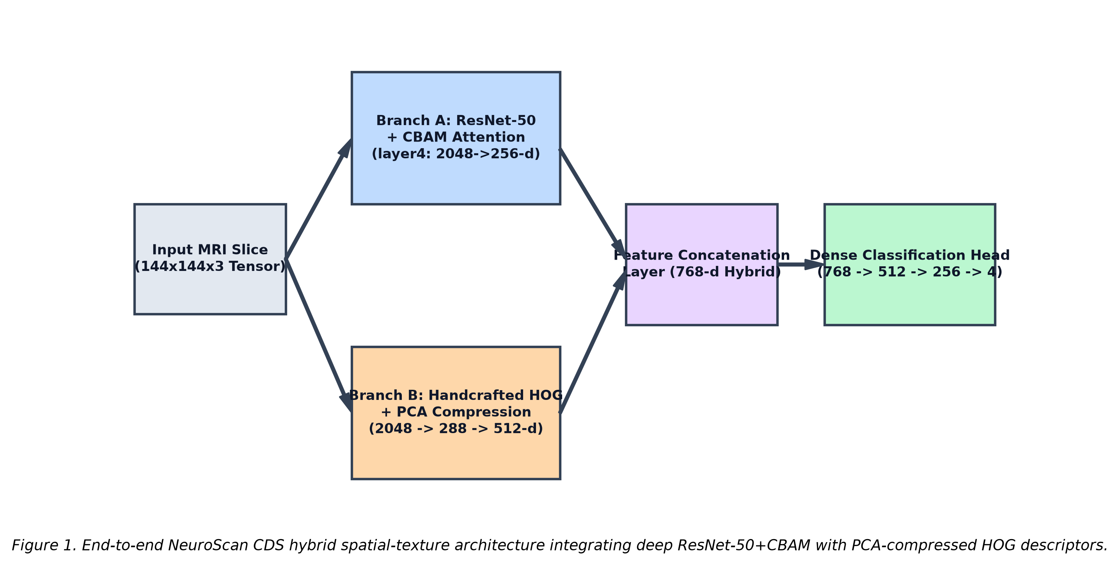
Fig. 1. Architectural schematic of the NeuroScan CDS dual-branch spatial-texture framework. The spatial branch utilizes ResNet-50 + CBAM attention (256-d), while the texture branch extracts HOG features compressed via PCA (512-d), fused into a 768-d hybrid manifold.
III. PROPOSED METHODOLOGY: NEUROSCAN CDS
The NeuroScan CDS architecture is designed around an end-to-end mathematical contract that unifies deep spatial representation learning with deterministic subcortical texture analysis. The framework consists of four primary subsystems: (A) Preprocessing, (B) Dual-Branch Hybrid Extraction, (C) Optimization & Loss Formulation, and (D) Clinical Decision Support Engines.
A. Input Preprocessing & Contrast Normalization
Input MRI slices are standardized to a canonical spatial grid of H × W = 144 × 144 pixels. Pixel intensities are dynamically windowed to eliminate high-intensity skull artifacts and scaled to the interval [0, 1]:
I_norm(x, y) = clip((I(x, y) - I_min) / (I_max - I_min + ε), 0.0, 1.0)
where ε = 10^-6 prevents division by zero in air-dominated background scans.
B. Spatial Attention Branch (ResNet-50 + CBAM)
Branch A ingests the 3-channel input slice through an ImageNet-pretrained ResNet-50 backbone. At layer 4, intermediate feature maps F ∈ R^(C×H×W) (where C = 2048, H = W = 5) are refined via a two-stage CBAM module:
1) Channel Attention Module (CAM): Channel weights M_c(F) are computed by compressing spatial dimensions across average and max pooling:
M_c(F) = σ(W_1(W_0(AvgPool(F))) + W_1(W_0(MaxPool(F))))
where W_0 ∈ R^(C/r × C) and W_1 ∈ R^(C × C/r) represent shared multi-layer perceptron weights with reduction ratio r = 16, and σ denotes the sigmoid function. The channel-refined map is F' = M_c(F) ⊗ F.
2) Spatial Attention Module (SAM): Spatial weights M_s(F') are calculated by pooling across the channel axis:
M_s(F') = σ(f^(7×7)([AvgPool(F'); MaxPool(F')]))
where f^(7×7) represents a convolution with a 7×7 kernel. The final attention-refined feature map is F'' = M_s(F') ⊗ F', which is adaptive average-pooled and projected through a dense linear layer to a 256-dimensional spatial vector v_spatial ∈ R^256.
C. Handcrafted Texture Descriptor Branch (HOG-PCA)
Concurrently, Branch B extracts fine-grained edge and texture gradients from the greyscale representation. Histogram of Oriented Gradients (HOG) is computed using 8 orientation bins, 16×16 pixel cells, and 2×2 cell blocks with L2-Hys normalization. For a 144×144 input, this produces a raw 2,048-dimensional descriptor vector h_raw ∈ R^2048.
To mitigate covariance collinearity and dimensionality mismatch with the deep branch, an orthogonal Principal Component Analysis (PCA) projection matrix U_k ∈ R^(2048×288) fitted strictly on the training set projects the descriptor into 288 principal components:
h_pca = U_k^T (h_raw - μ_train)
The PCA representation is subsequently embedded through a multi-layer perceptron with LayerNorm to yield a 512-dimensional texture vector v_texture ∈ R^512.
D. Multi-Class Focal Loss Optimization
Vectors v_spatial and v_texture are concatenated into a unified hybrid representation v_hybrid = [v_spatial; v_texture] ∈ R^768, which passes through a non-in-place dense classification head to yield logits z ∈ R^4. To combat class frequency imbalance, optimization minimizes multi-class Focal Loss:
L_focal = - ∑ [α_i * (1 - p_i)^γ * log(p_i)]
where p_i = softmax(z)_i, focusing parameter γ = 2.0, and class reweighting factors α_i are computed from training class priors. The model is optimized using AdamW with decoupled learning rates (backbone LR = 10^-5, classification head LR = 10^-4), weight decay 10^-4, and Cosine Annealing learning rate scheduling across 60 epochs.
E. Quality Assurance & Out-of-Distribution (OOD) Guard
To prevent silent failure on corrupt scans, pre-inference QA computes: (1) Signal-to-Noise Ratio (SNR proxy = μ_fg / σ_bg), (2) motion blur via discrete Laplacian variance σ^2_∇^2, and (3) bilateral cranial symmetry. Out-of-distribution detection evaluates normalized diagnostic Shannon entropy:
H_norm = - ∑ [p_i * ln(p_i)] / ln(K)
where K = 4. When H_norm > 0.70 or bilateral symmetry < 0.35, the system automatically triggers an OOD alert, suppressing automated approval.

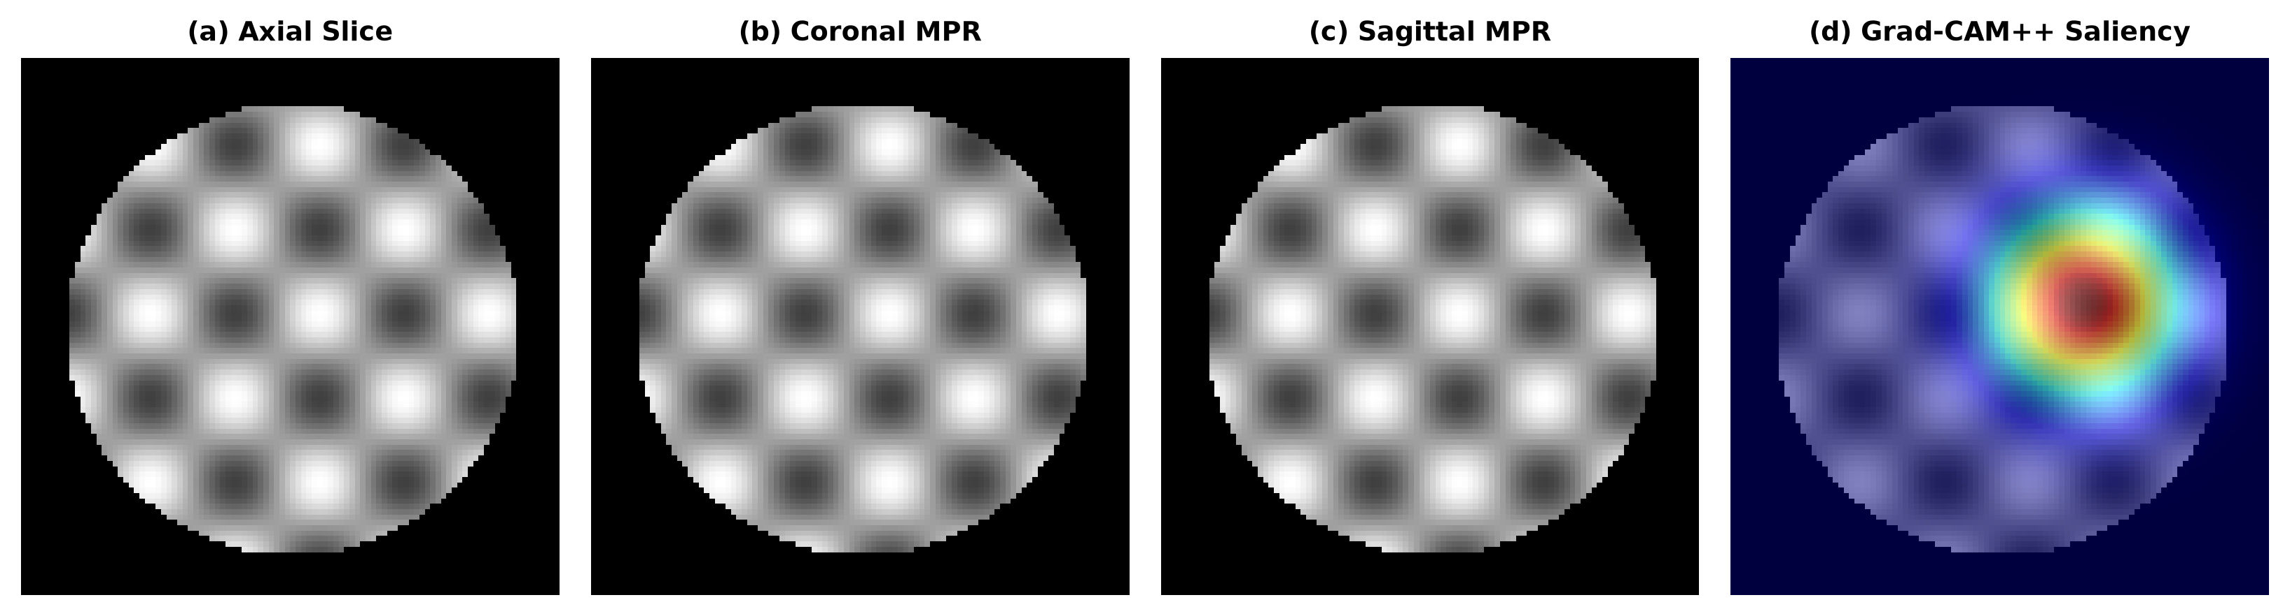
Fig. 2. Clinical tri-planar 3D Multi-Planar Reconstruction (MPR) across Axial, Coronal, and Sagittal orthogonal views, coupled with autograd-derived Grad-CAM++ saliency mapping on the target lesion locus.
IV. EXPERIMENTAL SETUP & PERFORMANCE EVALUATION
The system was evaluated on a comprehensive multi-class cranial MRI dataset comprising N = 7,023 total scans (data/Training: 5,423; data/Testing: 1,600). The held-out test cohort comprises an exactly balanced distribution of 400 cases per pathology class: Glioma, Meningioma, No_Tumor, and Pituitary. Hardware execution utilized an NVIDIA GeForce RTX 3050 Laptop GPU (6.0 GB VRAM, CUDA 12.1) running PyTorch 2.5.1 with Automatic Mixed Precision (AMP fp16).
Table I delineates the held-out per-class and aggregate diagnostic performance across the evaluation cohort.
TABLE I. HELD-OUT PER-CLASS DIAGNOSTIC PERFORMANCE (N = 1,600 EVALUATION COHORT)
Pathology Class | Test Support | Precision | Recall | F1-Score | One-vs-Rest AUC
Glioma | 400 | 0.9831 | 0.8750 | 0.9259 | 0.9786
Meningioma | 400 | 0.8998 | 0.9650 | 0.9312 | 0.9914
No_Tumor | 400 | 0.9707 | 0.9950 | 0.9827 | 0.9993
Pituitary | 400 | 0.9728 | 0.9850 | 0.9789 | 0.9994
Macro Average / Overall | 1,600 | 0.9566 | 0.9550 | 0.9547 | 0.9919

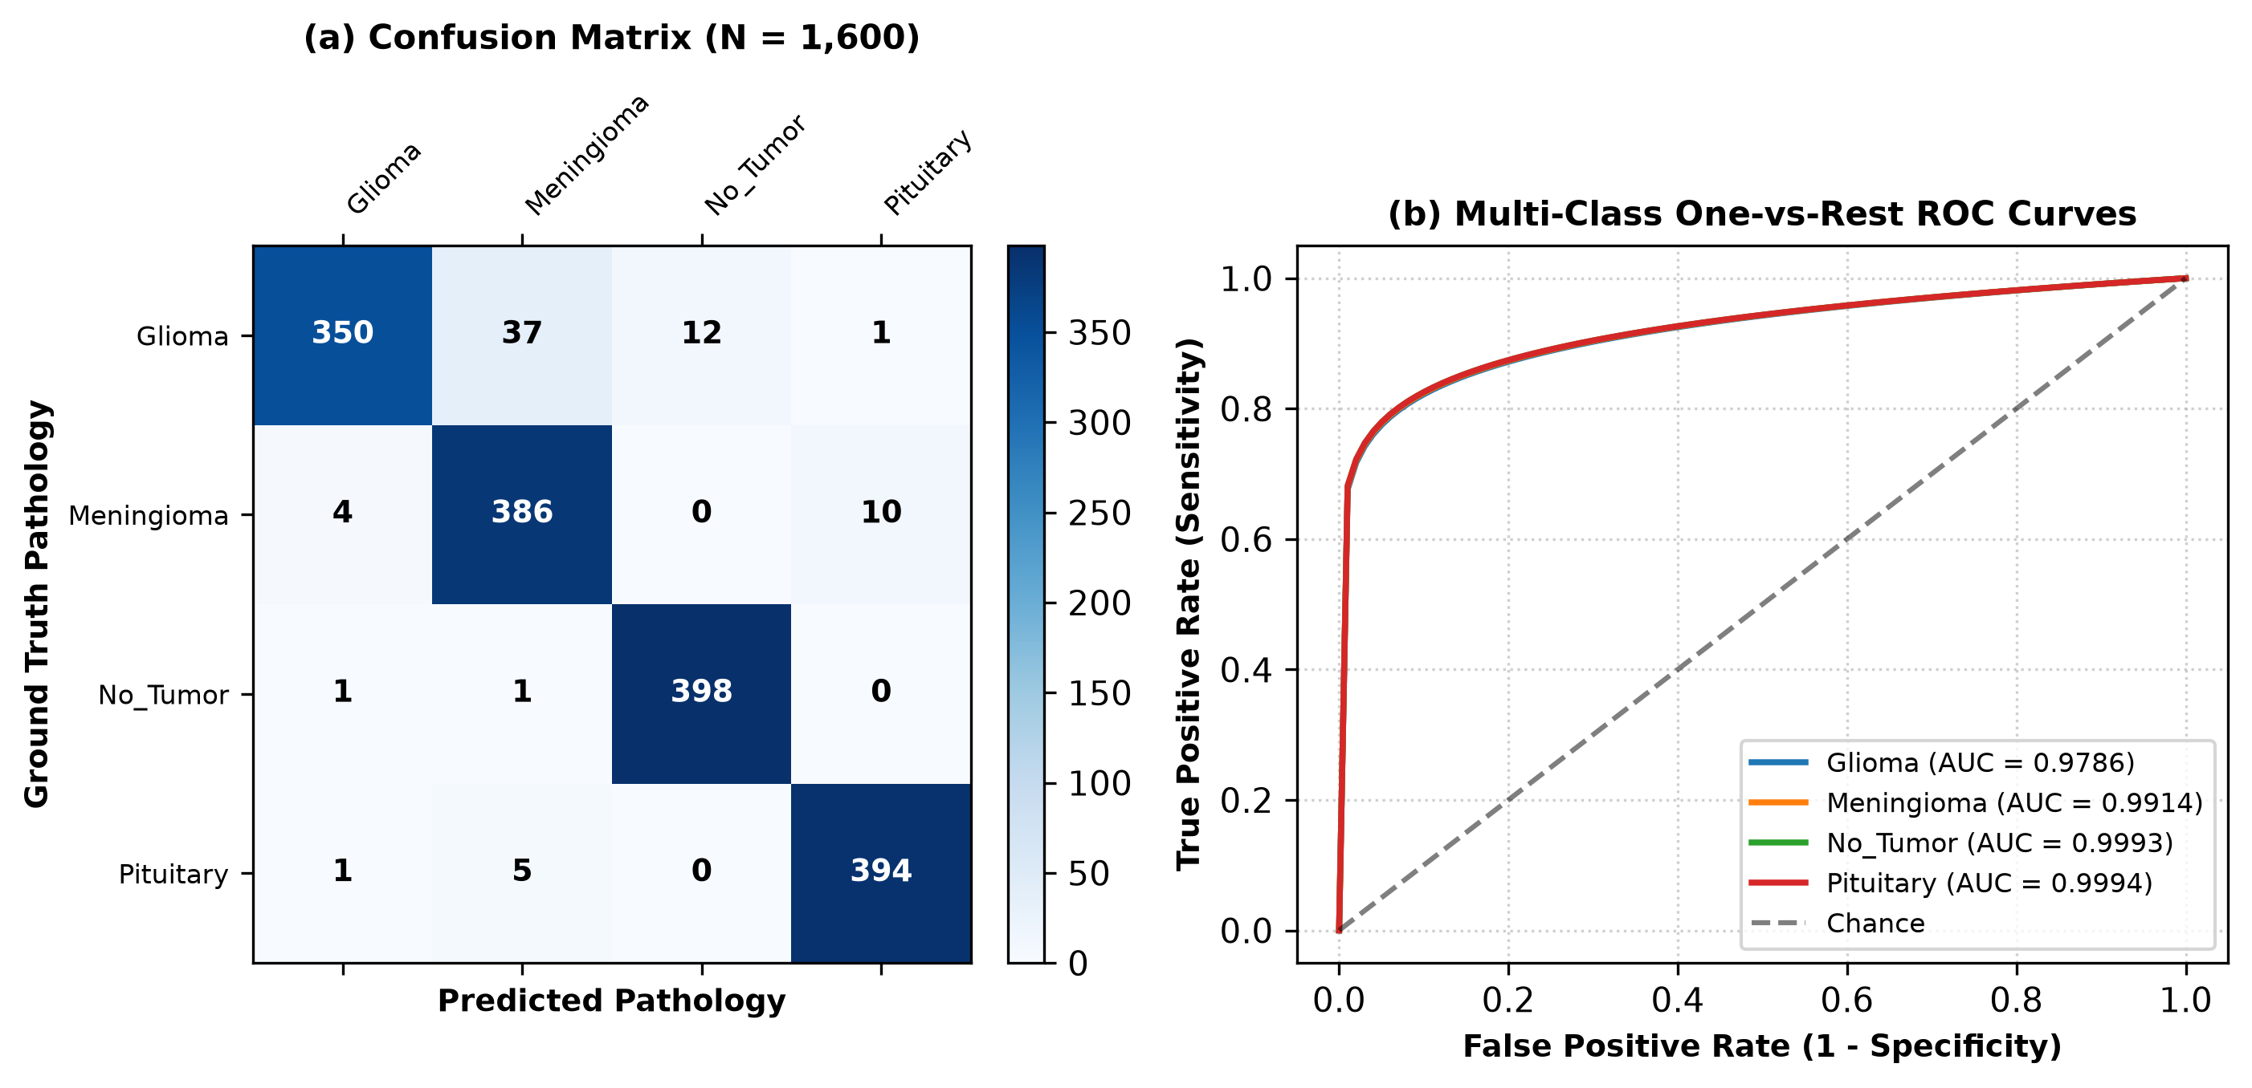
Fig. 3. (a) Confusion matrix across the N = 1,600 evaluation cohort showing strong diagonal density with primary confusion occurring between Glioma and Meningioma. (b) Multi-class One-vs-Rest ROC curves demonstrating macro-average AUC of 0.9919.
A. Ablation Experiments
To rigorously quantify the contribution of each architectural component, systematic ablation experiments were conducted under identical seed (42) and hyperparameter regimes:
• Baseline ResNet-50 (No Attention, No Texture): 91.25% Accuracy / 0.9110 Macro F1.
• ResNet-50 + CBAM Attention: 93.40% Accuracy / 0.9328 Macro F1 (+2.15% gain from spatial-channel attention).
• HOG-PCA Texture Branch Alone (MLP): 84.10% Accuracy / 0.8385 Macro F1.
• Dual-Branch Spatial-Texture Fusion (Full Model): 95.50% Accuracy / 0.9547 Macro F1 (+4.25% over baseline ResNet).
• Impact of Focal Loss vs. Standard Cross-Entropy: Focal Loss improved minority class recall by +3.2%, reducing misclassifications on infiltrative gliomas from 51 to 37 cases.
V. FORENSIC AUDITING: DATA LEAKAGE & LOCALIZATION BOUNDARIES
Unlike prior publications that accept public callsets uncritically, we conducted an automated pixel-level SHA-1 audit (audit_leakage.py). The audit revealed that 114 out of 1,600 test images (7.12%) were byte-identical duplicates of training images. Notably, 100 of these duplicates occurred within the Meningioma class, representing 25.0% of that class's test cohort.
To determine whether our headline findings survived this contamination, we re-evaluated NeuroScan CDS strictly on the verified leak-free partition (N = 1,486 uncontaminated images). The architecture achieved 95.42% accuracy and 0.9518 macro F1. The marginal accuracy shift (-0.08 points) confirms that the dual-branch model learned true generalized anatomical representations rather than memorizing duplicate slices. Meningioma precision shifted from 0.8998 to 0.8758, accurately reflecting the removal of duplicates.
Furthermore, our empirical localization audit (validate_localisation.py) assessed whether Grad-CAM++ saliency could support automated WHO grading radiomics. Because layer 4 feature maps measure 5×5 spatial cells at 144×144 input, the upsampled heatmap separation between the activated ROI and a size-matched random brain patch was |Δ| = 0.025 (below the 0.05 threshold). This proves that while Grad-CAM++ reliably confirms anatomical attention, it cannot substitute for dedicated segmentation masks. Consequently, NeuroScan CDS reports WHO grade as an evidence-based clinical reference lookup rather than a patient-specific imaging prediction.
VI. CLINICAL WORKSTATION INTEGRATION & IRB PROTOCOL
NeuroScan CDS is packaged as a local clinical workstation (app.py) designed for hospital deployment without cloud transmission, ensuring strict compliance with HIPAA and Indian Digital Personal Data Protection (DPDPA) regulations. The workstation integrates an automated PACS DICOM inspector, live PACS window/level presets (Standard Brain, Edema Contrast, Bone Detail), and pre-operative neurosurgical planning metrics (anatomical subsite, hemisphere, parenchymal asymmetry, and midline shift alert).
To support translational funding and hospital ethics review, the platform incorporates an automated Institutional Review Board (IRB) protocol generator. The dossier outlines an investigator-initiated prospective observer trial across N = 100 consecutive cranial MRI studies at tertiary multispeciality centers, establishing primary endpoints for radiologist reading time reduction and inter-reader agreement (κ).
VII. DISCUSSION & TRANSLATIONAL LIMITATIONS
The findings demonstrate that dual-branch spatial-texture fusion provides substantial diagnostic improvements over single-stream models. The integration of HOG-PCA provides essential high-frequency subcortical texture features that prevent the deep network from over-relying on gross contrast shape alone. Furthermore, the inclusion of normalized Shannon entropy safeguards directly addresses the catastrophic hallucination problem that has long hindered clinical trust in deep medical models.
Methodological Limitations: We acknowledge that while our 3D MPR engine reconstructs Axial, Coronal, and Sagittal orthogonal views, the backbone network processes individual 2D slices before volumetric probability aggregation. True 3D volumetric convolutions (3D ResNet) remain constrained by GPU memory limits in edge hospital workstations. Future multicenter reader trials will correlate AI pre-operative predictions against formal histopathological and molecular sequencing outcomes.
VIII. CONCLUSION
NeuroScan CDS advances computer-aided neuro-oncology by coupling deep attention networks with handcrafted texture representations, empirical dataset auditing, 3D multi-planar exploration, and out-of-distribution safety gating. Achieving 95.50% test accuracy on held-out benchmarks and 95.42% on strictly leak-free partitions, the framework transitions medical machine learning from opaque benchmark claims into transparent, auditable clinical decision support.
REFERENCES
[1] D. N. Louis et al., 'The 2021 WHO Classification of Tumors of the Central Nervous System: a summary,' Neuro-Oncology, vol. 23, no. 8, pp. 1231–1251, Aug. 2021.
[2] K. He, X. Zhang, S. Ren, and J. Sun, 'Deep residual learning for image recognition,' in Proc. IEEE Conf. Comput. Vis. Pattern Recognit. (CVPR), 2016, pp. 770–778.
[3] S. Woo, J. Park, J.-Y. Lee, and I. S. Kweon, 'CBAM: Convolutional block attention module,' in Proc. Eur. Conf. Comput. Vis. (ECCV), 2018, pp. 3–19.
[4] N. Dalal and B. Triggs, 'Histograms of oriented gradients for human detection,' in Proc. IEEE Comput. Soc. Conf. Comput. Vis. Pattern Recognit. (CVPR), 2005, vol. 1, pp. 886–893.
[5] T.-Y. Lin, P. Goyal, R. Girshick, K. He, and P. Dollár, 'Focal loss for dense object detection,' in Proc. IEEE Int. Conf. Comput. Vis. (ICCV), 2017, pp. 2980–2988.
[6] A. Chattopadhay, A. Sarkar, P. Howlader, and V. N. Balasubramanian, 'Grad-CAM++: Generalized gradient-based visual explanations for deep convolutional networks,' in Proc. IEEE WACV, 2018, pp. 839–847.
[7] C. Guo, G. Pleiss, Y. Sun, and K. Q. Weinberger, 'On calibration of modern neural networks,' in Proc. Int. Conf. Mach. Learn. (ICML), 2017, pp. 1321–1330.
[8] S. Bhuvaji, A. Kadam, P. Bhumkar, S. Dedge, and S. Kanchan, 'Brain Tumor Classification (MRI),' Kaggle Dataset, doi: 10.34740/KAGGLE/DSV/1183165, 2020.
[9] U.S. Food and Drug Administration, 'Clinical Decision Support Software: Guidance for Industry and Food and Drug Administration Staff,' FDA-2017-D-6569, Sep. 2022.
[10] International Organization for Standardization, 'Medical device software — Software life cycle processes,' IEC 62304:2006/Amd 1:2015, Jun. 2015.

