SMART TAPPER
Portable rubber tapping machine with bark-thickness sensing and automatic cut-depth control
FINAL MASTER FILE: complete project, every issue found and solved, patent filing in India, and product launch
Final-year team project | Final version | September 2026
Team members: ______________________ Guide: ______________________
CONFIDENTIAL. Do not publish, present publicly or upload until the provisional patent application is filed.

Contents
1. How to Use This File 4
1.1 The final set (everything you need) 4
1.2 Order of work 4
2. Complete Issue Register (All Problems Found and Solved) 5
2.1 Design and engineering 5
2.2 Electronics and software 6
2.3 Documents, cost and business 6
2.4 Patent (India) 7
3. The Idea in One Page 8
4. Background: Tapping Practice the Machine Must Follow 9
5. Existing Solutions, Novelty and Patent Search 10
5.1 What exists 10
5.2 Features we claim 10
5.3 How to do the search (do this before filing) 10
6. Machine Design 11
6.1 Reference numerals (same in drawings, text and patent) 11
6.2 Mounting: straps, pads and rail (12 to 26) 12
6.3 Cutter carriage (30 to 56) 12
6.4 How bark gauging works 13
6.5 Motor sizing (calculation) 13
6.6 Energy per tree (battery sizing) 14
6.7 Latex spout and cup (72, 74) 14
6.8 Floating cutting head (58, 59) 14
6.9 Home switches and safe start 14
6.10 Small details that matter 14
7. Bill of Materials (Final Prototype) 15
8. Electronics and Wiring 17
9. Control Software 18
9.1 Phone commands (Bluetooth serial app, device "SmartTapper") 18
10. Step-by-Step Build Procedure 20
Phase A: Mechanical (weeks 2 to 6) 20
Phase B: Electronics (weeks 4 to 7) 20
Phase C: Integration (weeks 7 to 9) 20
11. Testing and Validation Plan 21
12. Operation, Maintenance and Troubleshooting 22
12.1 Daily tapping procedure 22
12.2 Maintenance 22
12.3 Troubleshooting 22
13. Working Method and Economics 23
14. Safety 24
15. Timeline and Team Roles 25
16. All Problems at a Glance 26
17. Patentability Problems (What Can Be Patented) 28
17.1 Section 3(h): method of agriculture 28
17.2 Section 3(k): computer program per se / algorithm 28
17.3 Section 3(f): mere arrangement of known devices 28
17.4 Inventive step (non-obviousness) 28
17.5 Loss of novelty by your own disclosure 28
18. Drafting and Format Problems (All Fixed) 30
19. Ready-Made Replies to Likely Examiner Objections 31
19.1 Objection: lack of novelty or inventive step (D1 = motorised knife, D2 = bark gauge) 31
19.2 Objection: Section 3(k) (computer program per se) 31
19.3 Objection: Section 3(f) (mere arrangement) 31
19.4 Objection: claims unclear or not supported (Section 10(4)/(5)) 31
19.5 Objection: Section 3(h) (method of agriculture) 31
19.6 Other routine requirements in an FER 31
20. Ownership and Inventorship (Avoiding Disputes) 33
20.1 Template: Inventorship and IP Agreement (sign before filing) 33
21. Confidentiality Letter for Fabricators and Vendors 34
22. Procedure Problems and the Correct Filing Plan 35
22.1 Where and how to file 35
22.2 Documents to upload with the provisional application 35
22.3 Timeline with deadlines (Day 0 = provisional filing date) 35
22.4 Speeding up (Form 18A) 35
22.5 Cost plan (approximate official fees, e-filing, natural person / startup / small entity / educational institution) 36
23. Problems After Filing and After Grant 37
24. Launching the Product in India 38
24.1 Freedom to operate (FTO) 38
24.2 Business setup 38
24.3 Product compliance 38
24.4 Funding options (check current calls) 38
24.5 Manufacturing and sales 38
25. Master Checklist 40
25.1 Before filing 40
25.2 After filing the provisional 40
25.3 Going to market 40

1. How to Use This File
This one master file replaces all earlier versions (v1, v2, v3 and the separate patent guide). Older files are kept in the archive folder for reference only. Do not use them.

1.1 The final set (everything you need)
File | What it is | When you use it
SmartTapper_MASTER.docx / .pdf | This file: design, build, tests, operation, all issues solved, patent guide, launch plan | Always; show it to your guide first
Form2_Provisional_Specification.docx | Filing-ready provisional specification (Indian format) | File now, after the patent search
Patent_Drawing_Sheets.pdf | 5 drawing sheets in patent format | File with the provisional
Form2_Complete_Specification_DRAFT.docx | Complete specification with 10 claims and abstract; blanks for test results | File within 12 months of the provisional
SmartTapper.ino | Final ESP32 control program | Upload to the controller after bench tests
figures/ | The same 5 drawings as PNG images | For reports and presentations
README.txt | Short list of the files and the order of work | Quick reference

1.2 Order of work
- Read Sections 2 and 3 with your guide. Sign the inventorship agreement (Section 20).
- Do the patent search (Section 5.3). Adjust claim 1 if something close exists.
- File the provisional application (Section 22) using the Form 2 file and drawing sheets.
- Build (Sections 6 to 10), calibrate and test (Sections 11 and 12).
- Fill the test results into the complete specification and file it with Form 18 before month 12.
- If going commercial, follow Section 24.

2. Complete Issue Register (All Problems Found and Solved)
Every issue found in all reviews, from very small to very large. Severity: H = high (would stop the project or the patent), M = medium (wrong results or extra cost), L = low (quality, convenience, clarity). Status: FIXED = solved in the final files; YOU = only your team can do it, and the solution is given.

2.1 Design and engineering
# | Issue | Sev. | Solution | Status
D1 | New cut placed above the previous cut (wrong direction for downward tapping) | H | Pins in previous cut; blade s mm below | FIXED
D2 | "No extra wound" claim was false (needle passes the cambium) | H | Honest wording; tree-tag memory → probing about once a month | FIXED
D3 | Rigid clamp ring could not fit all trunk sizes | H | Padded ratchet straps | FIXED
D4 | Skid fixed on carriage could not follow uneven bark → depth error | H | Spring-urged floating cutting head (58, 59) carrying skid, blade and probe | FIXED
D5 | No home switches on blade and probe → position lost after E-stop or power loss | H | Home switches; axes re-home at every start-up | FIXED
D6 | Rail 500 mm too short for big trees | M | Two rail sizes (600 / 900 mm), adjustable end stops | FIXED
D7 | Carriage position from time | M | Hall encoder | FIXED
D8 | Motor torque not calculated | M | Calculation added; ≥ 15 kg·cm motor | FIXED
D9 | Weak DVD steppers, 1 kg load cell | M | Pancake NEMA 17 + Tr8×2 screw, 5 kg load cell | FIXED
D10 | Battery too small for claimed trees | M | 7.8 Ah pack, energy estimate; target 150 to 200 trees | FIXED
D11 | No low-battery protection (blade could stop inside the bark) | M | Battery monitor: no start below 10.8 V; safe stop below 10.0 V | FIXED
D12 | Head spring force unspecified | M | Preload ≥ 50 N, larger than the radial cutting reaction; check in test 2 | FIXED / YOU
D13 | Minimum girth stated as 40 cm; trees are tapped from 50 cm girth | L | Range 50 to 150 cm | FIXED
D14 | Coagulated latex (tree lace) in the old groove misplaces the pins | L | Remove tree lace first (normal tapping practice); added to procedure | FIXED
D15 | Blade orientation not stated | L | Cutting edge faces the direction of travel (downhill) | FIXED
D16 | Bark shavings could jam the carriage | L | Chip deflector and brush on the head | FIXED
D17 | Tapping is done before dawn; only a status LED | L | LED work lamp switched by the controller | FIXED
D18 | Strap pressure on renewing bark | L | Wide padded straps, only hand-tight, removed after each tree | FIXED
D19 | Blade tip position changes after sharpening | M | ZERO calibration against a flat plate, stored in memory | FIXED
D20 | Tree-to-tree disease spread by the blade | L | Wipe blade with disinfectant when moving between blocks or diseased trees | FIXED
D21 | Rain and water | L | No tapping in rain (normal practice); IP54 box; weatherproof tags | FIXED
D22 | Weight estimate too low after adding the floating head | L | Target under 4 kg | FIXED
D23 | Needle force values, cutting force and depth accuracy not yet measured | H | Test plan in Section 11; settings changeable without reprogramming | YOU

2.2 Electronics and software
# | Issue | Sev. | Solution | Status
E1 | Start and stop on the same button caused instant faults | H | Separate E-stop; start acts on release | FIXED
E2 | E-stop only in software | H | E-stop contact cuts actuator power; second contact to controller | FIXED
E3 | Tag date refreshed at every tapping → bark never re-gauged | H | Gauging date kept; only re-gauging updates it | FIXED
E4 | Arduino Nano had too few pins | M | ESP32 | FIXED
E5 | ESP32 boot-strapping pins risked boot failure; still short of pins | M | I/O expander for start button, LED and buzzer; safe pins only | FIXED
E6 | HX711 at 10 samples/s made probing slow | M | RATE pin HIGH (80 samples/s) | FIXED
E7 | Gauge point at 5 % could fall before the probe offset | M | Points at 10 / 50 / 90 %; offset checked | FIXED
E8 | Rail or end-stop change not detected | M | Rail length re-measured each cut; > 10 % change → re-gauge | FIXED
E9 | Settings needed reprogramming | M | Settings over Bluetooth, saved in flash | FIXED
E10 | Probe not retracted on fault | M | Retract on every fault; re-home at start-up | FIXED
E11 | Clock time lost if RTC battery fails | L | Set from compile time; warning; bark gauged every time if no clock | FIXED
E12 | NFC range only a few cm | L | Hold box to tag; beeps for 6 s until read | FIXED
E13 | Load-cell calibration needed code changes | L | TARE and CALW commands | FIXED
E14 | Program never compiled or run | H | Compile in Arduino IDE (ESP32 core 3.x), then bench-test each function | YOU

2.3 Documents, cost and business
# | Issue | Sev. | Solution | Status
B1 | Prototype cost underestimated (₹11,000) | M | Realistic BOM ≈ ₹23,500 | FIXED
B2 | Machine slower than a skilled tapper; not stated | M | Honest comparison; two-unit working method; value = skill-free, fewer wounds | FIXED
B3 | Flowchart showed a part that did not exist | L | Redrawn | FIXED
B4 | Many overlapping files and versions | L | One master file; old files archived | FIXED
B5 | Small inconsistencies (battery trees, weight, girth) | L | Unified values in all files | FIXED
B6 | No operating, maintenance or troubleshooting guide | L | Section 12 | FIXED
B7 | No launch plan (company, compliance, subsidy, sales) | M | Section 24 | FIXED
B8 | No freedom-to-operate check | M | FTO before selling | YOU

2.4 Patent (India)
All 28 patent issues are listed in Section 16 with the law, solution and status. The largest were a method claim excluded under Section 3(h), the software (3(k)) and arrangement (3(f)) objections, a title over 15 words, drawings with descriptive text, a wrong examination deadline (now 31 months), and the provisional missing features added later (floating head, homing, battery protection). All are fixed in the Form 2 files and drawing sheets.
What cannot be solved on paper: the measurements (D23), compiling and testing the code (E14), the patent search, signing the agreement, keeping the idea confidential, and the examiner's decision. For each of these the file gives the exact steps. Nobody can guarantee a patent grant, but with these fixes the application has no known avoidable defect.

3. The Idea in One Page
Problem. Tapping means shaving a thin strip of bark (about 1.5 mm high) along a 30° half-spiral cut, deep enough to open the latex vessels but stopping about 1 mm short of the cambium. Too deep wounds the tree permanently. Too shallow loses latex. Skilled tappers are scarce, and bark thickness differs from tree to tree, so a fixed-depth tool cannot be right for every tree.
Solution. A battery-powered machine that is strapped to the trunk. A motor drives a blade along a curved rail at the tapping angle. It works like this:
- Reads an NFC tag fixed on the tree. The tag stores that tree's bark thickness and the date it was measured.
- If the record is older than 30 days (or missing), it measures the bark: a thin needle with a force sensor finds the bark surface and the sudden force rise at the wood, at 3 points on the cut line. It writes the new values to the tag.
- Sets blade depth = bark thickness − 1 mm and changes it smoothly along the cut, using the motor encoder to know where the blade is.
- Alignment pins sit in yesterday's cut, so today's cut is always exactly s mm (for example 1.5 mm) below it. Bark consumption stays uniform.
Why it is new: existing hand knives rely on skill. Motorised tapping knives use a fixed depth guide. Tapping robots are fixed on one tree and costly. Our combination is measure bark → store on the tree → cut to a computed depth, with one portable unit. As far as general knowledge of the field goes, this is not on the market in India. It must be confirmed by the patent search (Section 5.3).
Parameter | Target
Tree girth | 50 to 150 cm (trees are tapped from 50 cm girth; two rail sizes)
Tapping angle | 20° to 35° adjustable (30° default)
Cut | Half spiral (S/2), downward, high left to low right
Residual bark over cambium (c) | 1.0 mm, settable 0.5 to 1.5 mm
Depth accuracy | ±0.3 mm (to be proved by tests)
Bark consumption per tapping (s) | 1.0 to 2.0 mm, set by alignment pins
Time per tree (normal day, no gauging) | about 40 to 50 s including strapping
Time per tree (gauging day, once a month) | about 70 to 80 s
Weight | under 4 kg
Battery | 12 V, 7.8 Ah Li-ion: about 150 to 200 trees per charge (estimate)
Prototype cost | about ₹23,500

4. Background: Tapping Practice the Machine Must Follow
Practice | Typical value | Design consequence
Minimum girth for tapping | 50 cm at 125 cm height | Machine range starts at 50 cm girth
Height of tapping panel opening | About 125 cm (budded trees) | Straps fit anywhere from 50 to 150 cm height
Slope of cut | About 30° (budded), 25° (seedlings) | Rail angle adjustable 20° to 35°
Length of cut | Half spiral (S/2) | Rail covers half the circumference; end stops adjustable
Direction | High left to low right | Carriage cuts downhill; latex flows to spout at low end
Order of cuts | Downward: each new cut is just below the last | Pins in previous cut, blade s mm below
Depth | Stop about 1 mm before cambium | Depth = measured T − c
Bark consumption | About 1.5 to 2 mm per tapping | s set by alignment pins
Tapping time | Early morning | LED light; works in low light
Confirm these values with the Rubber Board or RRII (Kottayam) and ask for permission to test on trees that are due for replanting. A support or test letter from them is also very useful for the patent, funding and sales.

5. Existing Solutions, Novelty and Patent Search

5.1 What exists
Existing type | Depth control | Weakness
Jebong / gouge hand knife | Tapper's skill | Long training; wounds common
Motorised / battery tapping knife | Fixed mechanical guide or hand feel | Same depth for every tree
Tree-mounted tapping robot (research) | Sensors on a fixed per-tree rail | Expensive; one unit per tree
Manual bark gauge (pricking needle) | Used by supervisors to check depth | Not linked to any cutting tool

5.2 Features we claim
- Measure-then-cut (main claim): a force-sensing needle on the carriage measures bark thickness along the tapping line, and the controller sets the blade depth from it.
- Tree-tag memory: the measured thickness and date are written to a tag fixed on the tree and reused until they expire, so the needle is needed only occasionally.
- Depth profile along the cut from several measured points, applied using encoder position.
- Alignment pins in the previous cut that fix bark consumption per tapping.
- Strap mounting with a flexible rail held off the bark by pads, fitting many girths with one unit.

5.3 How to do the search (do this before filing)
- Databases: Google Patents, Espacenet, InPASS (iprsearch.ipindia.gov.in), WIPO Patentscope, Google Scholar, Rubber Board / RRII publications.
- Classification: IPC A01G 23/10 (tapping of tree juices). Also B26B, G01B, G06K 19 (tags).
English keywords | Chinese keywords (Google Patents)
rubber tapping machine / latex tapping device | 割胶机 / 割胶装置
electric tapping knife | 电动割胶刀
tapping robot / automatic tapping | 割胶机器人 / 自动割胶
tapping depth / bark thickness detection | 割胶深度 / 树皮厚度检测
RFID tree tag rubber | 橡胶树 电子标签
Record each close result: number, title, what it has, what it lacks compared with ours. If one document already shows claim 1, the other features (tag memory, pins, strap mounting) or their combination become the main claim.
Patent / paper | Title | Has | Lacks (vs ours)

6. Machine Design
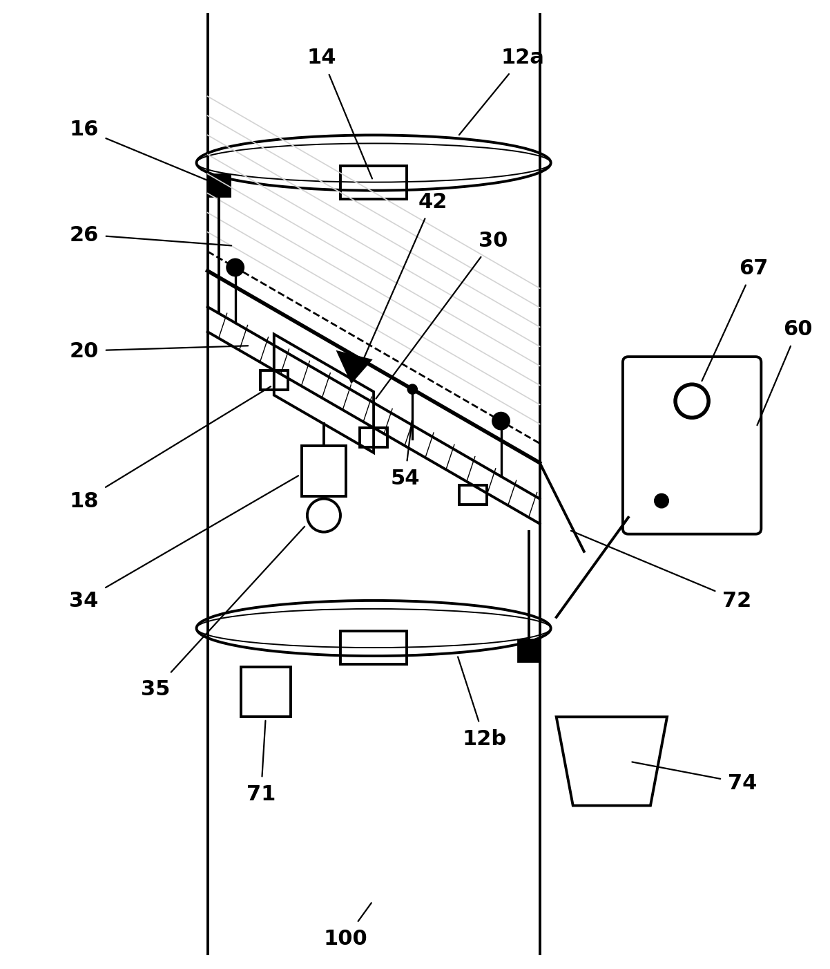
Figure 1: Front view on the tree. The new cut is made s mm below yesterday's cut.

6.1 Reference numerals (same in drawings, text and patent)
No. | Part | No. | Part
10 | Tapping device | 42 | V-gouge blade
12a / 12b | Upper / lower ratchet straps | 44 | Blade slide (MGN9 guide)
14 | Ratchet buckle | 46 / 48 | Depth stepper / Tr8×2 lead screw
16 | Sliding end clips (rail to strap) | 50 | Probe stepper
18 | Rubber-footed support pads | 52 | Load cell 5 kg
20 | Flexible helical rail (spring steel) | 54 | Needle probe
24 | Toothed belt rack on rail | 56 | Skid roller (depth reference)
26 | Alignment pins (in previous cut) | 60 / 62 | Controller (ESP32) / battery
30 | Cutter carriage | 64 | Adjustable end stops (limit switches)
34 / 35 | Gear motor / hall encoder | 66 / 67 | Start button / E-stop
36 | GT2 pulley | 68 | LED / buzzer
70 / 71 | NFC reader / tree tag | 72 / 74 | Latex spout / cup
58 / 59 | Floating cutting head / head springs
100 | Rubber tree | 102-108 | Outer bark / soft bark / cambium / wood

6.2 Mounting: straps, pads and rail (12 to 26)
- Two 50 mm padded polyester ratchet straps (12a, 12b) with rubber backing go around the trunk, one above and one below the tapping line. They fit any girth and do not damage bark when padded.
- The flexible rail (20) is a 25 × 1.5 mm spring-steel strip with a GT2 belt riveted on it (24). It is held about 25 mm off the bark by 3 to 4 rubber-footed pads (18) and fixed at each end to a strap by a sliding clip (16).
- Rail sizes: S/M = 600 mm (trees up to about 100 cm girth; half-spiral length 50 / cos 30° ≈ 580 mm); L = 900 mm (up to 150 cm girth, ≈ 870 mm). Extra length beyond the lower clip simply sticks out straight.
- Adjustable end stops (64): limit switches that clamp on the rail at the two ends of the marked half spiral.
- Slope: set with a 30° bubble level on the carriage (or a phone inclinometer app) when fixing the clips.
- Alignment pins (26): two pins at the rail ends point up into yesterday's cut. A thumb-screw sets the distance from pin to blade top edge = s (1.0 to 2.0 mm). For a new panel, use the marking template.
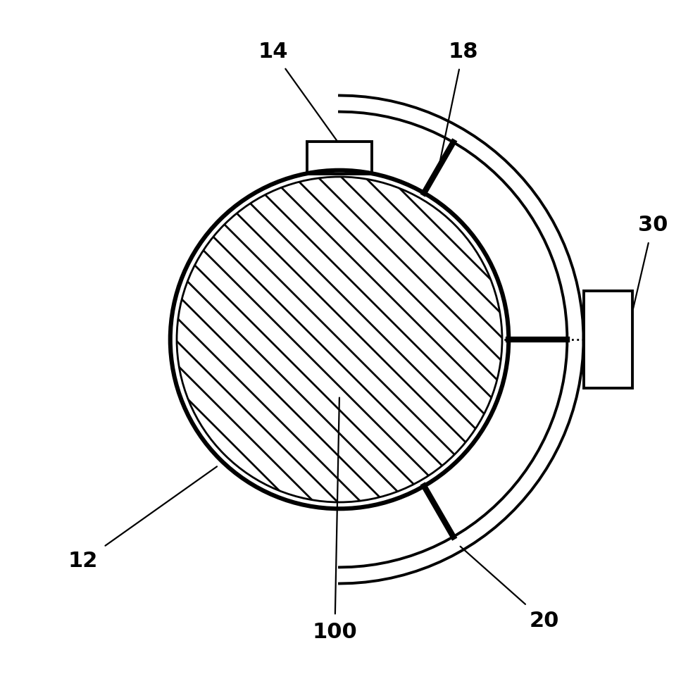
Figure 3: Top view, strap and rail held off the bark by pads

6.3 Cutter carriage (30 to 56)
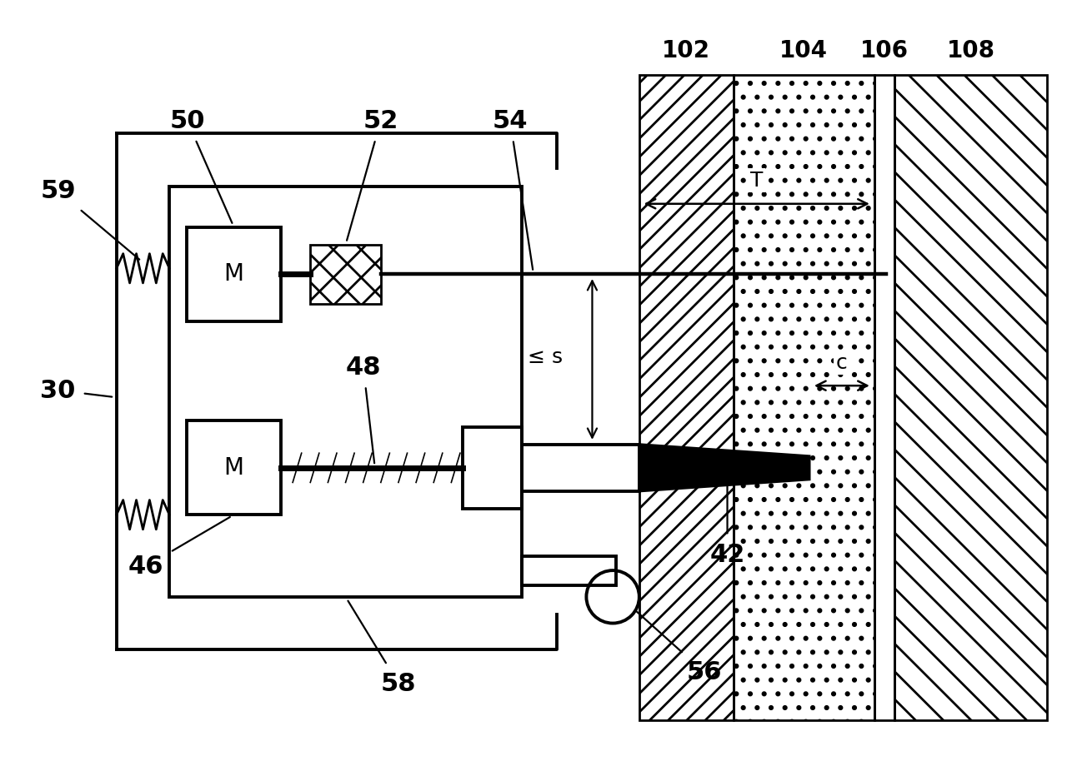
Figure 2: Section of the carriage. The probe works inside the strip removed by the same cut.
- Drive: 12 V planetary gear motor, about 60 rpm, 15+ kg·cm, with hall encoder (34, 35), driving a 20-tooth GT2 pulley (36) on the belt rack. Four V-groove rollers clamp the carriage to the strip.
- Blade (42): a standard V-gouge tapping blade (easy to buy and re-sharpen) on a slide (44) running on an MGN9 miniature linear guide.
- Depth actuator (46, 48): pancake NEMA 17 stepper + Tr8×2 lead screw. With 1/8 microstepping: 800 steps per mm (0.00125 mm per step). The lead screw is self-locking, so cutting force cannot push the blade back.
- Skid roller (56): mounted on the floating cutting head (Section 6.8); it runs on the outer bark and is the zero reference for depth.
- Needle probe (54): 0.8 mm hardened steel needle, same drive type as the blade, pushing through a 5 kg load cell (52). It is mounted a short distance ahead of the blade along the cut line, so the outer part of each prick is shaved off by the blade.

6.4 How bark gauging works
- The needle advances in 0.1 mm steps; the load cell is read after each step (HX711 at 80 samples/s).
- First force above about 50 g → bark surface (position P0).
- The needle passes the bark at moderate force. When it meets the wood, the force rises sharply. A rise of more than about 600 g within 0.3 mm → wood (position P1). (Both numbers must be calibrated.)
- Bark thickness T = P1 − P0. The needle retracts.
- Measured at 5 %, 50 % and 95 % of the rail length. T values and the date are written to the tree tag.
- While cutting, blade depth d(x) = T(x) − c, interpolated between the 3 points using the encoder position x.
Wound note: the needle does pass through the cambium at 3 small points. This is the same as the standard manual bark gauge that inspectors use, and the 0.8 mm hole is small. Because of tag memory it happens about once a month per tree instead of every tapping. Section 11 includes a check of how these pricks heal.

6.5 Motor sizing (calculation)
Quantity | Value | Note
Estimated cutting force F | 60 to 100 N | ASSUMPTION: measure it (Section 11, test 2)
GT2 20-tooth pulley pitch radius r | 6.37 mm | Pitch diameter 12.73 mm
Torque needed = F × r | 100 × 0.00637 = 0.64 N·m ≈ 6.5 kg·cm | Worst case
Motor chosen | ≥ 15 kg·cm at output | Safety factor about 2.3
Carriage speed | 60 rpm × 40 mm per rev = 40 mm/s | S/M rail cut ≈ 15 s, L rail ≈ 22 s

6.6 Energy per tree (battery sizing)
Load | Estimate
Carriage motor: 12 V × 3 A × 25 s (cut + return) | 0.25 Wh
Steppers and electronics: 12 V × 0.8 A × 20 s | 0.05 Wh
Total, normal tree | ≈ 0.30 Wh
Battery 3S3P 18650: 11.1 V × 7.8 Ah × 80 % usable | ≈ 69 Wh → about 150 to 200 trees (fewer on gauging days)

6.7 Latex spout and cup (72, 74)
A normal spout and cup stay on the tree as in manual tapping. The machine is removed after the cut.

6.8 Floating cutting head (58, 59)
- The blade slide, the needle probe and the skid roller are all mounted on one cutting head (58). The head slides radially on its own linear guide in the carriage and is pressed toward the bark by two springs (59), preload about 50 to 80 N.
- The skid therefore follows bumps and hollows of the bark, and the blade depth is always measured from the real bark surface next to the cut. The probe is on the same head, so the probe and blade use the same reference.
- Spring preload must be larger than the radial push of the blade during cutting; check this in test 2 (Section 11) and use stronger springs if the skid lifts.

6.9 Home switches and safe start
- Micro-switches mark the fully retracted position of the blade and of the probe. At every switch-on the controller retracts both to their switches ("homing"), so the positions are always known, even after an E-stop or a flat battery.
- If the E-stop was pressed with the blade in the bark: release the E-stop and switch off and on. Homing pulls the blade out, and then you can remove the machine.

6.10 Small details that matter
- Blade direction: the cutting edge faces downhill (the direction of travel).
- Chip deflector and brush on the head push shavings away from rollers and belt.
- Work lamp: a small LED lamp on the head lights the cut during pre-dawn tapping.
- Tree lace: pull off the coagulated latex strip from the previous cut before placing the pins (normal tapping practice).
- Straps: 50 mm wide padded straps, only hand-tight, never left on the tree.
- Tags: weatherproof NFC tags fixed with a stainless pin at the same place on every tree (for example 20 cm below the lower end of the panel), so the operator knows where to hold the box.

7. Bill of Materials (Final Prototype)
Approximate Indian prices (2026) from online electronics stores and local fabricators. Buy BIS-registered Li-ion cells or packs.
Item | Qty | Cost (₹)
ESP32 DevKit (WROOM-32) | 1 | 450
TMC2209 stepper driver | 2 | 700
BTS7960 motor driver | 1 | 350
Pancake NEMA 17 stepper | 2 | 1,800
Tr8×2 lead screw 100 mm + nut + coupler | 2 | 800
MGN9 linear guide (blade, probe, head) | 3 | 2,100
Head springs (pair) + stops | set | 100
12 V 60 rpm planetary gear motor with hall encoder, ≥ 15 kg·cm | 1 | 1,800
Load cell 5 kg + HX711 | 1 | 250
ACS712-20A current sensor | 1 | 150
INA219 battery monitor | 1 | 150
PCF8574 I/O expander | 1 | 100
PN532 NFC reader | 1 | 450
NTAG213 weatherproof tags (pack of 50) | 1 | 750
DS3231 RTC module | 1 | 200
Li-ion pack 3S3P 7.8 Ah with BMS | 1 | 2,500
12.6 V 2 A charger | 1 | 500
LM2596 buck converter | 1 | 100
E-stop mushroom switch (NC + NO) | 1 | 250
Limit switches (2 end stops + 2 home), start button, buzzer, LED | set | 260
LED work lamp + MOSFET module | 1 | 200
10 A fuse, holder, main switch | set | 150
Padded ratchet straps 50 mm | 2 | 900
Spring-steel strip 25×1.5 mm | 1.5 m | 400
GT2 belt 2 m + 20T pulley | 1 | 350
Support pads, end clips (aluminium + rubber) | set | 600
Carriage plate, V-groove rollers, chip deflector, brush | set | 700
V-gouge tapping blade | 2 | 500
0.8 mm steel needles | 5 | 100
IP54 enclosure + cable glands | 1 | 400
Wires, connectors, PCB, fasteners | set | 800
Flat steel zero-setting plate | 1 | 100
Machining / welding / cutting | - | 2,000
Subtotal |  | ≈ 20,300
Contingency (≈ 15 %) |  | 3,100
Budget to request |  | ≈ ₹23,500
At production volume (500 to 1,000 units, custom PCB, moulded parts) the parts cost could fall to roughly ₹10,000 to ₹13,000 per unit. This is an estimate to verify with suppliers. Save money on the prototype by applying for college / KSUM / NIDHI-PRAYAS grants (Section 24).

8. Electronics and Wiring
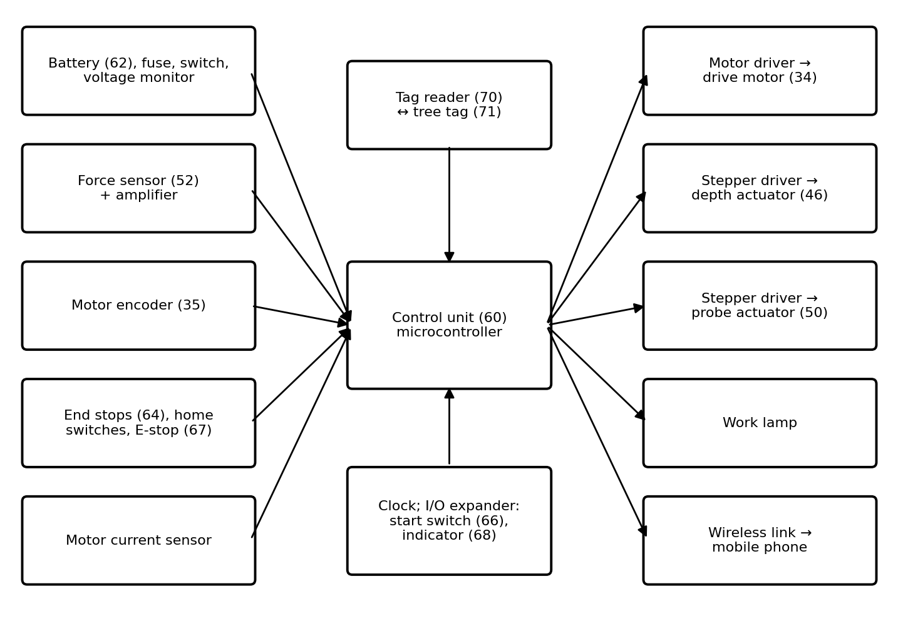
Figure 4: Electrical block diagram
ESP32 pin | Connected to | Purpose
25 / 26 | BTS7960 RPWM / LPWM | Carriage motor (RPWM = downhill)
32 / 33 | Encoder A / B | Carriage position
14 / 27 | TMC2209 #1 STEP / DIR | Blade depth (DIR HIGH = toward bark)
13 / 4 | TMC2209 #2 STEP / DIR | Needle probe
23 | Both TMC2209 EN | LOW = enabled
16 / 17 | Blade / probe home switch (to GND) | Retracted positions
18 / 19 | Top / bottom end stop (to GND) | Rail ends
35 | E-stop auxiliary contact + 10 kΩ pull-up to 3.3 V | E-stop signal
2 | MOSFET module | Work lamp
36 | ACS712 OUT via 10 kΩ / 20 kΩ divider | Motor current
39 / 5 | HX711 DOUT / SCK (RATE pin HIGH) | Probe force
34 / 15 | PN532 IRQ / RSTPDN | NFC reader control
21 / 22 | I2C SDA / SCL | PN532 (I2C mode), DS3231, PCF8574 (0x20), INA219 (0x40)
PCF8574 P0 / P1 / P2 | Start button (to GND) / LED / buzzer (active LOW) | User interface
- E-stop: its normally-closed contact is in series with the 12 V supply to all motor and stepper drivers, so pressing it removes actuator power even if the program hangs. Its normally-open contact goes to pin 35.
- Power: battery → 10 A fuse → main switch → INA219 shunt → E-stop → drivers. A separate branch via the LM2596 gives 5 V to the ESP32 (VIN), HX711, ACS712, PN532 and PCF8574. Put 100 µF across each stepper driver's supply.
- Before first power-up: set the TMC2209 current (Vref) to about 70 % of the stepper rating; check the HX711 RATE pad is set to 80 Hz; check the PN532 DIP switches are set to I2C.

9. Control Software
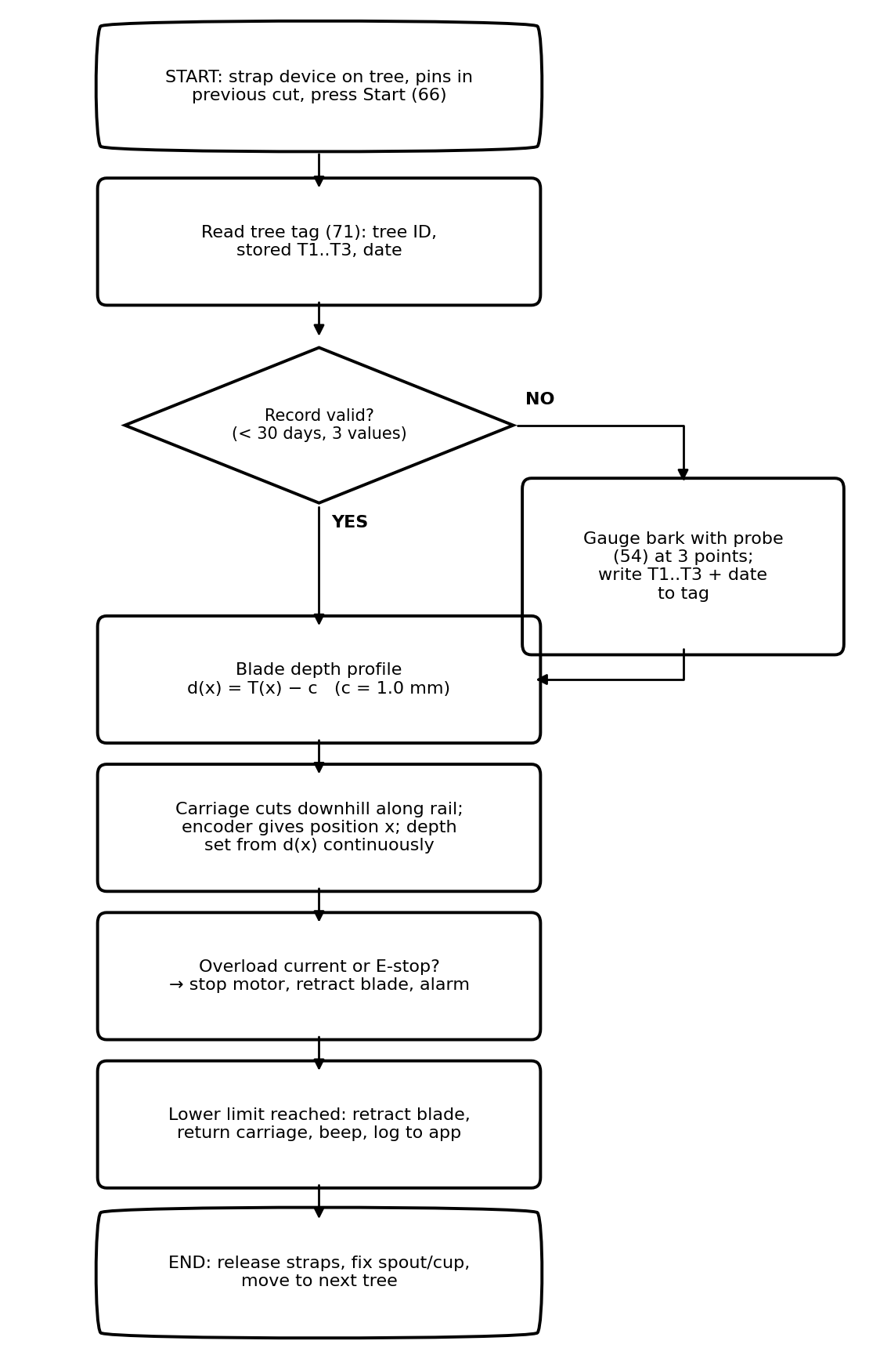
Figure 5: Operating method
Program: SmartTapper.ino (ESP32 Arduino core 3.x; libraries: HX711 by Bogdan Necula, Adafruit PN532, RTClib; Preferences and BluetoothSerial come with the core).
- Start-up: loads settings, checks clock and NFC, waits for the E-stop to be released, homes probe and blade.
- Each tree: battery check → read tag (hold box to tag) → use stored bark values if valid and not older than 30 days, else measure rail and gauge at 10 / 50 / 90 % → plunge and cut with encoder-based depth profile → retract, return, log.
- Protections: E-stop, battery low, motor overload, time-outs, reading-range checks, rail-length change detection.
- Every tree is logged over Bluetooth: tag ID, bark values, residual c, cut time, peak current, battery voltage.

9.1 Phone commands (Bluetooth serial app, device "SmartTapper")
Command | What it does
HELP | Lists commands
SHOW | Shows all settings
SET C 1.0 | Residual bark over cambium, 0.5 to 1.5 mm
SET CONTACT 50 | Probe contact force threshold (g)
SET WOOD 600 | Force rise meaning wood (g per 0.3 mm)
SET AMPS 10 | Carriage overload limit (A)
SET POFF 300 | Probe-ahead-of-blade distance (encoder counts)
TARE | Zero the load cell (nothing touching the needle)
CALW 500 | Calibrate load cell with a known 500 g weight
ZERO | Blade zero: hold flat plate on skid, press START when the tip touches
FORCE | Shows live needle force for 4 s (for calibration)
BATT | Battery voltage
The program has not been compiled on this computer. Compile it in the Arduino IDE (board "ESP32 Dev Module"), fix any library-version messages, then test each function on the bench before fitting the blade.

10. Step-by-Step Build Procedure

Phase A: Mechanical (weeks 2 to 6)
- Make a mock-up on a 15 cm and a 40 cm PVC pipe (or real trunks) to confirm strap, pad and rail dimensions.
- Rivet the GT2 belt to the spring-steel strip; make pads and end clips; fit the adjustable end stops.
- Build the carriage plate with 4 V-groove rollers and the motor + pulley. Check smooth travel on both pipe sizes.
- Mount the MGN9 guides, the lead screws and the pancake steppers for the blade and the probe; add the skid roller.
- Mount the blade, the load cell and the needle holder. Add the alignment pins with thumb-screw adjustment.
- Add the blade guard, chip deflector, brush and work lamp; fit the home switches for blade and probe.

Phase B: Electronics (weeks 4 to 7)
- Breadboard-test each part: motor + encoder counts, both steppers, load cell, current sensor, NFC read/write, RTC.
- Wire the E-stop in the motor power line. Test that pressing it stops the motors even if the program hangs.
- Solder onto perf-board or a simple PCB; fit in the IP54 box with glands.
- Compile and upload SmartTapper.ino; run ZERO, TARE and CALW (Section 9.1); then run the full cycle on a pipe covered with a 6 mm cork layer.

Phase C: Integration (weeks 7 to 9)
- Mount the electronics box on the lower strap; route cables so that they cannot reach the blade.
- Photograph and video every stage (for the report, the complete patent specification and marketing).

11. Testing and Validation Plan
Test | Where |  | Purpose
1. Bench | PVC pipe + cork layer |  | Mechanics, software, E-stop, depth repeatability
2. Cutting force | Fresh rubber log sections; pull a tapping blade with a spring balance / luggage scale |  | Real value of F for motor sizing
3. Probe calibration | Fresh log sections from a replanting site |  | Force-depth curves; set CONTACT_G and WOOD_RISE_G; compare T with vernier on sawn section
4. Field comparison | Trees due for replanting (with owner / Rubber Board permission) |  | Machine vs skilled tapper on alternate trees for 4 to 6 weeks
5. Prick healing | Same trees |  | Inspect probe points after 2 and 4 weeks
6. Endurance | One full field session |  | Trees per charge, heating, blade wear, tag reliability in rain
Metric |  | Method |  | Target
Bark thickness accuracy |  | Probe vs vernier on the sawn section |  | ±0.3 mm
Residual bark over cambium |  | Small inspection window cut after tapping |  | 1.0 ± 0.3 mm
Bark consumption |  | Distance between successive cuts |  | s ± 0.2 mm
Wounds |  | Count per 10 trees, machine vs manual |  | Fewer than manual
Latex yield |  | ml per tree or g dry rubber, alternate trees |  | Equal to or better than manual
Time per tree |  | Stopwatch |  | ≤ 50 s normal day
Trees per charge |  | Count |  | ≥ 150
Probe calibration sheet: for each sample record force at touch, force jump at wood, probe T, vernier T and error. Plot force against depth. This curve is key evidence for the complete specification.

12. Operation, Maintenance and Troubleshooting

12.1 Daily tapping procedure
- Charge the battery the day before. Carry a spare blade and needles.
- Switch on: two beeps = homing done and ready.
- At the tree: pull off the tree lace from the previous cut.
- Fit the straps (hand-tight). Clip the rail so the pins sit in the previous cut and the end stops are at the ends of the half spiral. Check the 30° bubble.
- Hold the control box to the tree tag until it beeps; press START.
- Stand clear while it cuts. Press the E-stop if anything goes wrong.
- After the beep: remove the machine, check the spout and cup, move to the next tree.

12.2 Maintenance
When | Task
Every day | Brush off shavings; wipe latex off blade and rollers with a damp cloth; recharge battery
Between blocks / diseased trees | Wipe the blade with disinfectant
Every 150 to 300 trees (or when overload faults appear) | Sharpen or change the blade, then run ZERO
Weekly | Check belt tension, rollers, strap condition, needle tip (replace if bent or blunt)
Monthly | TARE and check CALW with a known weight; check the E-stop works
Storage | Dry place; battery at about 50 % charge if stored for more than 2 weeks

12.3 Troubleshooting
Message / symptom | Likely cause | Action
"probe home switch not found" / "blade home switch not found" | Switch wire loose, axis jammed | Check switch and wiring; free the slide
"no tree tag" | Box not near tag, tag damaged | Hold closer; replace tag (record will be re-created)
"bark reading out of range" | Bent needle, wrong thresholds, knot in bark | Replace needle; FORCE to check; move gauge point
"motor overload" | Blunt blade, too deep, jam | Sharpen blade + ZERO; clear shavings; check c
"battery low" | Discharged pack | Charge; blade is retracted automatically
Cut too shallow or deep everywhere | Blade zero wrong | Run ZERO; check SET C
Cut position not 1.5 mm below previous | Pins on tree lace, pin screw moved | Clean groove; reset pin distance
"rail length changed" | End stops or clips moved | Normal; bark is re-gauged next time

13. Working Method and Economics
A skilled tapper spends about 15 to 20 seconds per tree. The machine needs about 40 to 50 seconds (strap on, cut, strap off). So the machine is not faster for a single worker. Its value is:
- Unskilled workers can tap correctly. This addresses the tapper shortage, and family members can tap their own smallholding.
- Fewer cambium wounds and uniform bark use, so the panel lasts longer and tree life and yield are protected.
- Records: each tree's bark and tapping log, useful for estates.
Two-unit method: one worker uses two machines. While unit A cuts tree 1, the worker straps unit B on tree 2. The effective time falls to about 25 to 30 s per tree. Test this in the field.
Do a simple cost-benefit table with real data from your field test: tapping wage per tree in your area, yield difference, bark saving, machine price. It is the most important slide for any investor or funding body.

14. Safety
- Blade guard; blade always retracted when not cutting; hardware E-stop cutting motor power.
- Over-current stop, time-outs and bark-reading range checks in software.
- BIS-registered Li-ion cells with BMS and fuse; charge with the correct charger only.
- Gloves and eye protection; test only with permission, first on trees due for replanting.
- Home switches and the battery monitor make sure the blade is pulled out of the bark after any fault: release the E-stop and switch off and on.

15. Timeline and Team Roles
Week | Work | Output
1 | Patent search; rubber estate / Rubber Board visit | Search table, confirmed dimensions
2 | File provisional patent | Application number, priority date
2-6 | Mechanical build | Frame, rail, carriage
4-7 | Electronics and code | Working bench system
7-9 | Integration, force and probe calibration | Calibration data
10-15 | Field comparison (4 to 6 weeks) | Results
16-17 | Report, video, presentation | Project report
Before month 12 | Complete specification + Form 18/18A | Complete application
Roles: (1) mechanical, (2) electronics, (3) software and calibration, (4) patent search, documents, testing records. Keep a dated, signed logbook; it proves inventorship.

16. All Problems at a Glance
Status key: FIXED = already solved in the new files. YOU = an action only your team can do.
# | Problem | Law | Solution | Status
1 | "Method of tapping a tree" claim is a method of agriculture | Sec. 3(h) | Method claim removed; only device claims | FIXED
2 | Software logic (tag memory, interpolation) may be called a computer program per se | Sec. 3(k) | Every claim tied to hardware with a physical technical effect; reply prepared | FIXED
3 | Straps, rail, load cell, tag reader are known parts: "mere arrangement" | Sec. 3(f) | Claim 1 recites functional link: probe force → blade position; reply prepared | FIXED
4 | Examiner may say obvious: motorised knife + manual bark gauge | Sec. 2(1)(ja) | Arguments + fallback claims + test evidence | FIXED / YOU (tests)
5 | Idea shown publicly before filing destroys novelty | Sec. 29-31 | File provisional first; confidentiality rules; NDA | YOU
6 | Vague words ("about", "preferably", "for example") in claims | Sec. 10(4)(c) | Removed from claims | FIXED
7 | Claim 1 broader than description ("gauging means") | Sec. 10(4), 10(5) | Claim 1 now recites the fully described needle + force sensor | FIXED
8 | Threshold values unknown: insufficient "best method" | Sec. 10(4)(b) | Calibration paragraphs with blanks to fill from tests | YOU (tests)
9 | Trade names (ESP32, Arduino, NTAG213, GT2, NEMA) in specification | Practice / clarity | Generic terms used in Form 2 | FIXED
10 | Title 19 words and contained "method" | Rule 13(7)(a): max 15 words | New title, 13 words | FIXED
11 | Drawings had titles and descriptive text; no sheet details | Rule 15 / drawing format | New A4 drawing sheets with margins, sheet numbers, signature line | FIXED / YOU (name, sign)
12 | Specification page format | Second Schedule format | A4, 4 cm top/left, 3 cm bottom/right, 1.5 spacing, numbered paragraphs, claims and abstract on new pages | FIXED
13 | 12 claims → extra claim fees | First Schedule | Reduced to 10 claims | FIXED
14 | Wrong deadline in v2: examination request is now 31 months, not 48 | Rule 24B (2024) | Corrected; file Form 18 with the complete specification | FIXED
15 | Missing the 12-month complete-specification deadline = application abandoned | Sec. 9(1) | Calendar plan; file complete by month 10 | YOU
16 | Improvements made after the provisional are not covered | Sec. 9(2) | File a second (cognate) provisional before disclosing improvements | YOU (if needed)
17 | No digital signature (DSC) for e-filing | e-filing rules | Get a Class 3 DSC, file through the IPR cell or agent, or file on paper at the Chennai office | YOU
18 | Disputes over ownership: students / guide / college | Sec. 6, 7(2) | Sign the inventorship and IP agreement now (Section 20) | YOU
19 | Wrong or missing inventors | Sec. 6; Form 5 | Only real human contributors; keep a logbook; AI tools cannot be inventors | YOU
20 | Applicant is not the inventor → "proof of right" needed | Sec. 7(2) | Inventors endorse Form 1 or sign an assignment within 6 months | YOU
21 | Cost of filing and agent | First Schedule | Low-fee categories, IPR cell / PIC help, SIPP for startups, 10 claims only | FIXED / YOU
22 | Slow examination (years) | Rule 24C | Form 18A if eligible (startup, small entity, female applicant, government institution) | YOU (check eligibility)
23 | First Examination Report (FER) objections | Sec. 12-15 | Reply templates in Section 19; 6 + 3 months to reply | FIXED (templates)
24 | Pre-grant or post-grant opposition by a competitor | Sec. 25 | Solid claims, test evidence, search record | YOU
25 | Filing abroad without permission | Sec. 39 | File in India first; wait 6 weeks or get permission; PCT within 12 months | YOU (if exporting)
26 | After grant: renewal fees and working statement forgotten | Sec. 53, 146; Form 27 | Renewal every year from year 3; Form 27 once every 3 financial years | YOU
27 | Selling may infringe someone else's patent | Sec. 48 | Freedom-to-operate check before launch | YOU
28 | Provisional lacked features added later (floating head, homing, battery protection) | Sec. 9, 10 | Added to the provisional before filing; later additions would not get the same priority date | FIXED

17. Patentability Problems (What Can Be Patented)

17.1 Section 3(h): method of agriculture
Problem: Section 3(h) says a method of agriculture or horticulture is not an invention. Version 2 had claim 12, "A method of tapping a tree...". Tapping rubber is a plantation practice, so an examiner would very likely reject that claim.
Solution (done): the method claim is removed. All 10 claims are for the device (a machine), which is patentable. The operating steps are still described in the description, so nobody can copy the machine and use it.

17.2 Section 3(k): computer program per se / algorithm
Problem: reading a tag, comparing dates and interpolating depth are software steps. Software alone, or a mathematical method, is not patentable in India.
Solution (done): every claim is a physical device. The control unit is claimed only together with the probe, force sensor, actuators and blade, and the result is physical: the blade stops short of the cambium, and the bark is probed less often. Under the Indian guidelines for computer-related inventions, a claim is not excluded when software gives a technical effect through hardware. A reply is ready in Section 19.2.

17.3 Section 3(f): mere arrangement of known devices
Problem: straps, rails, load cells, stepper motors and tag readers are all known. Section 3(f) excludes a mere arrangement of known devices each working independently in a known way.
Solution (done): in claim 1 the parts are not independent. The probe's force signal is processed to find the bark thickness, and that value directly sets the blade position. In claim 3 the tag value replaces probing. This interdependence gives a new result: an automatic cut depth that differs for each tree. See the reply in Section 19.3.

17.4 Inventive step (non-obviousness)
Problem: an examiner may cite a motorised tapping knife (D1) and a manual bark gauge (D2) and say it is obvious to combine them.
Solution:
- Arguments (Section 19.4): neither document teaches using a probe's force profile to position a blade automatically. The combination creates a new problem (cambium puncture from probing), which the invention solves by placing the probe inside the band of bark removed by the cut and by storing values on the tree so probing is infrequent. That is not obvious.
- Fallback claims: if claim 1 is rejected, combine claim 1 with claim 3 (tag memory) or claim 2 (probe in the removed band) or claim 5 (alignment pins). These narrower combinations are much harder to call obvious.
- Evidence (YOU): test data showing better depth accuracy, fewer wounds and equal or better yield proves a technical advance. Fill in the calibration and field-result paragraphs in the complete specification. Evidence often decides inventive-step disputes.
- Search (YOU): do the prior-art search in the project file before filing. If you find something close, adjust claim 1 first rather than let the examiner find it.

17.5 Loss of novelty by your own disclosure
Problem: anything made public before your filing date, including by you, counts against novelty. Examples: a project expo, a paper or conference, a YouTube or Instagram post, a GitHub upload, a published project report, a demonstration in a public field, a competition entry, or sharing full drawings with vendors without confidentiality.
Solution (YOU):
- File the provisional application before any public showing.
- Mark all documents "CONFIDENTIAL"; keep the project report out of the library or repository until filing.
- Give vendors or fabricators only individual part drawings, and ask them to sign a simple confidentiality letter (Section 21).
- Field tests: test on private land with the owner's written agreement to keep it confidential.
- Section 31 allows only limited exceptions (for example certain government-notified exhibitions or papers read before a learned society, then filing within 12 months). Do not rely on it. File first.

18. Drafting and Format Problems (All Fixed)
Item | Rule / requirement | What the new files do
Title | Short, specific, no more than 15 words, no trade marks or fancy words | "A portable rubber tree tapping device with bark-thickness sensing and automatic cut-depth control" (13 words)
Preamble | Provisional: "The following specification describes the invention." Complete: "...particularly describes the invention and the manner in which it is to be performed." | Correct wording in each file
Page layout | A4; margins 4 cm top and left, 3 cm bottom and right; 1.5 line spacing; pages numbered | Applied in both Form 2 files
Paragraphs | Numbered for easy reference in FER replies | [001], [002] ...
Clarity of claims | No "about", "preferably", "for example", "such as", "substantially" in claims | Removed from claims; kept only in the description
Support | Claims must be fairly based on the description | Claim 1 recites the needle probe and force sensor fully described in [025]-[026]
Sufficiency / best method | Complete specification must enable a skilled person and disclose the best method | Calibration and field-result paragraphs ready for your data
Trade names | Avoid brand/product names in the specification | Generic terms ("microcontroller", "near-field communication tag", "toothed belt")
Unity | One inventive concept | Claims 2 to 10 all depend on claim 1
Claims count | Fee payable for each claim above 10 | Exactly 10 claims
Claims page | Start on a new page with "We claim:"; signature and date after claims | Done
Abstract | No more than 150 words, on a separate page, indicate the figure | 137 words, ends with "Figure 2"
Drawings | A4, same margins, black lines, reference numerals, no descriptive matter except where needed (flow chart, block diagram); applicant name, total sheets, sheet number, signature on each sheet | Patent_Drawing_Sheets.pdf (5 sheets). You write the name and sign.
Reference numerals | Same numbers in drawings and text | Checked: 10 to 108 consistent

19. Ready-Made Replies to Likely Examiner Objections
Adapt these when you receive the First Examination Report (FER). The reply is due within 6 months of the FER, extendable by 3 months with Form 4. Always attach amended claims (clean and marked-up copies) and request a hearing "in case the objections are not waived".

19.1 Objection: lack of novelty or inventive step (D1 = motorised knife, D2 = bark gauge)
The Applicant respectfully submits that none of the cited documents,
alone or in combination, discloses or suggests a control unit that advances a
needle probe through a force sensor, determines the bark thickness from the
probe travel between first contact and the rise in force at the wood, and
drives a depth actuator to position a blade at that thickness less a residual
thickness (claim 1).

D1 discloses a fixed mechanical depth guide; the depth does not depend on the
bark of the individual tree. D2 is a hand-held gauge used for inspection and is
not connected to any cutting means. A person skilled in the art combining D1
and D2 would at most obtain a knife and a separate gauge used manually; there
is no teaching to process the probe force signal to position the blade
automatically.

Further, automatic probing would itself cause repeated punctures of the
cambium. The invention overcomes this by locating the probe within the band of
bark removed by the cut (claim 2) and by storing the sensed thickness on a data
carrier on the tree so that probing is needed only at intervals (claim 3).
Neither problem nor solution is suggested by D1 or D2.

The technical advance is shown by the test results in paragraphs [0xx]-[0xx]:
residual bark ___ ± ___ mm against ___ ± ___ mm manually, and ___ fewer
cambium wounds per 100 trees. The claimed invention therefore involves an
inventive step under Section 2(1)(ja).

19.2 Objection: Section 3(k) (computer program per se)
The claims are directed to a tapping device comprising a guide rail, a
motor-driven carriage, a blade, a depth actuator, a needle probe and a force
sensor. The control unit is claimed only in combination with these physical
elements. It acts on the force signal from the physical probe and controls the
physical position of the blade, producing the technical effect that the blade
stops short of the cambium of the particular tree, and (claim 3) that the bark
is punctured less often. The invention is not a computer program per se, and
Section 3(k) does not apply.

19.3 Objection: Section 3(f) (mere arrangement)
In the claimed device the elements do not function independently. The output
of the needle probe and force sensor is processed to determine the bark
thickness, and that value determines the position of the blade through the
depth actuator. Neither the probe nor the blade alone, nor both working
separately, would achieve an automatically varying depth of cut adapted to
each tree. The combination produces a working interrelationship and a new
result, and is not a mere arrangement of known devices under Section 3(f).

19.4 Objection: claims unclear or not supported (Section 10(4)/(5))
The Applicant has amended claim __ to recite ___, which is supported by
paragraph [0__] and Figure __. The expressions objected to have been deleted.
The amended claims are clear, succinct and fairly based on the matter
disclosed in the specification.

19.5 Objection: Section 3(h) (method of agriculture)
The claims on record are directed exclusively to a tapping device (an
apparatus). No method of agriculture or horticulture is claimed. Section 3(h)
is therefore not attracted.

19.6 Other routine requirements in an FER
- Form 3 update (details of any foreign filings) within the time the FER specifies.
- Proof of right, if the applicant is not the inventor.
- Correcting drawings or the abstract: easy to do. Submit replacement sheets.

20. Ownership and Inventorship (Avoiding Disputes)
Problems: (a) the idea came from your teacher, the design work from students, and the college may have an IP policy; (b) later someone leaves or disagrees; (c) the applicant (for example the college or your company) is not the inventor, so proof of right is needed.
Rules:
- Inventors are only the natural persons who contributed to the inventive features in the claims. AI tools cannot be inventors, and help from any tool, book or website does not make it an inventor. Every person you list must understand and be able to explain the invention. Your team should do the real development, testing and calibration and record it in a dated logbook.
- Applicant can be the inventors, the college, a company, or a mix.
- If the applicant is not the inventor, proof of right is needed: the inventors sign the endorsement in Form 1 or an assignment deed, filed within 6 months (Section 7(2)).
- Changing the applicant later (for example to your startup): before grant with Form 6; after grant, register the assignment with Form 16.

20.1 Template: Inventorship and IP Agreement (sign before filing)
INVENTORSHIP AND INTELLECTUAL PROPERTY AGREEMENT

Date: ________ Place: ________

Parties: (1) ____________ (2) ____________ (3) ____________
(4) ____________ (students) and (5) ____________ (guide), of ____________ College.

1. Invention: "A portable rubber tree tapping device with bark-thickness
sensing and automatic cut-depth control" as described in the draft dated ____.
2. Inventors: The parties agree that the inventors are: ____________________.
3. Applicant: The patent application shall be filed in the name(s) of
____________________ [the inventors / the College / both].
4. Costs: Fees shall be paid by ____________ in the ratio ____________.
5. Benefits: Income from licensing or sale of the patent shall be shared
____________ [as per the College IPR policy / equally / in the ratio ___].
6. Confidentiality: No party shall disclose the invention publicly before
the provisional application is filed, and thereafter only as agreed.
7. Future assignment: The parties agree to assign their rights to a company
formed to commercialise the invention on terms to be agreed in writing,
with the College's consent where its IPR policy requires it.
8. Leaving: A party who leaves the project remains an inventor for the
contribution made, and shall sign any document needed for the application.

Signatures: ____________ ____________ ____________ ____________ ____________
Witness: ____________

21. Confidentiality Letter for Fabricators and Vendors
CONFIDENTIALITY UNDERTAKING

I/We, ____________ (fabricator/vendor), have received drawings and information
from ____________ for fabrication of parts. I/We shall keep them confidential,
use them only to make the ordered parts, not copy or disclose them to anyone,
and return or destroy them on completion. All rights in the design remain with
____________.

Signature: ____________ Name / Firm: ____________ Date: ____________

22. Procedure Problems and the Correct Filing Plan

22.1 Where and how to file
- Appropriate office: determined by the applicant's residence or place of business (or the first-named applicant). For Kerala, Tamil Nadu, Karnataka, Andhra Pradesh, Telangana, Puducherry and Lakshadweep it is the Patent Office, Chennai.
- E-filing (cheaper, faster) needs a Class 3 digital signature certificate (DSC) for the person signing. Options: buy one (about ₹1,000 to ₹2,000), or file through your college IPR cell or an agent, or file on paper at the Chennai office (paper fees are about 10 % higher).
- You may file without an agent as an applicant in person. An agent is optional (and needs Form 26).

22.2 Documents to upload with the provisional application
Document | Notes
Form 1: application | Names of all applicants and inventors; signed by all applicants; inventors' endorsement if applicant ≠ inventor
Form 2: provisional specification | Form2_Provisional_Specification (fill names, sign, save as PDF)
Drawings | Patent_Drawing_Sheets.pdf (fill name, sign each sheet)
Form 3: foreign filing statement | State "no foreign application"; update if you file abroad later
Form 5: declaration of inventorship | Can be filed with the complete specification (or within 1 month after)
Form 28 | Only if claiming startup or small-entity status (with proof)
Proof of eligibility for lower fees | For example educational institution documents, if the college is the applicant
Fee | Paid online at filing

22.3 Timeline with deadlines (Day 0 = provisional filing date)
When | Action | Form
Before Day 0 | Search, agreement signed, documents finalised, DSC ready | -
Day 0 | File provisional + drawings | Forms 1, 2, 3 (+28)
Day 0 to month 9 | Build, test, calibrate; keep improvements confidential | -
Any time before disclosing a major improvement | Second (cognate) provisional if needed | Forms 1, 2
Month 10 (latest month 12, strict) | File complete specification with results + request examination | Forms 2, 5, 18 or 18A
Month 18 | Automatic publication (or earlier with Form 9) | (Form 9)
Examination request deadline | 31 months from priority date (2024 rules). Filing it at month 10 avoids risk | Form 18
After FER | Reply within 6 months (+3 months with Form 4) | Reply, Form 4
Grant, then from year 3 | Renewal fees every year (can be paid in advance) | Renewal
After grant | Statement of working once every 3 financial years | Form 27

22.4 Speeding up (Form 18A)
Expedited examination (Rule 24C) is available to certain applicants. Examples: a DPIIT-recognised startup, a small entity, a female applicant who is a natural person (for joint applicants, check that the rule's conditions are met for all), a government department, or an institution established by a Central or State Act or funded or controlled by the government (a government engineering college or state university may qualify). Check the current Rule 24C text before choosing Form 18A.

22.5 Cost plan (approximate official fees, e-filing, natural person / startup / small entity / educational institution)
Stage | Fee (₹)
Form 1 (provisional) | 1,600
Complete specification (≤ 30 pages, ≤ 10 claims) | No extra
Form 18 (or Form 18A) | 4,000 (or 8,000)
Form 9 early publication (optional) | 2,500
Class 3 DSC | about 1,000 to 2,000
Total to grant without agent | about 6,000 to 12,000
Renewal (years 3 to 6) | about 800 per year, rising later
Lower your cost: use the college IPR cell or a state Patent Information Centre (for Kerala, the KSCSTE Patent Information Centre) for free or low-cost help; DPIIT-recognised startups can get agent fees supported under the SIPP scheme; keep to 10 claims and 30 pages.

23. Problems After Filing and After Grant
- Opposition: after publication anyone can file a pre-grant representation (Section 25(1)); after grant, a post-grant opposition within 1 year (Section 25(2)). Defence: accurate claims, a documented search, test evidence.
- Foreign filing: Indian residents must not file abroad first. File in India, then wait 6 weeks with no secrecy direction, or get permission under Section 39. File a PCT application within 12 months of Day 0 to keep priority in rubber-producing countries.
- Renewal: missing a renewal fee makes the patent lapse (a 6-month grace with extra fee applies; restoration is possible but difficult).
- Working (Form 27): file once every 3 financial years. If the invention is not worked in India for 3 years after grant, others may seek a compulsory licence (Section 84). Plan to manufacture or license.
- Enforcement: a patent is enforced by a civil suit, which is costly. Keep the evidence file (dated logbook, filings, test data). Licensing to an established manufacturer is often the practical route for students.
- Freedom to operate: your patent does not stop others' patents applying to your product. Get an FTO check before selling.

24. Launching the Product in India
A patent protects your idea, but it does not by itself give permission to sell. Launching needs the steps below. Check every regulation with a CA or advisor, because rules change.

24.1 Freedom to operate (FTO)
Even with your own patent, your product might use something covered by someone else's patent (for example a particular motorised tapping knife design). Before selling, get a freedom-to-operate check from a patent attorney, focusing on Indian patents in force in A01G 23/10.

24.2 Business setup
- Form a Private Limited company or LLP (Private Limited is better for investment).
- Get DPIIT Startup India recognition (free, online): lower patent fees, expedited examination, SIPP support, tax benefits.
- Udyam (MSME) registration and GST registration. Ask your CA for the correct HSN code (agricultural / horticultural tools and machinery) and current GST rate.
- Assign the patent application from the inventors or college to the company by a written agreement (with the college's permission if required).
- Trademark your brand name (classes 7 and 8; about ₹4,500 per class for individuals, startups and small entities). Consider design registration for the product's appearance.

24.3 Product compliance
- Batteries: Li-ion cells or packs sold in India must be BIS-registered (Compulsory Registration Scheme, IS 16046). Buy registered cells or packs; chargers may also need BIS registration.
- Battery Waste Management Rules, 2022: a company placing batteries on the market (including inside equipment) may need Extended Producer Responsibility registration with CPCB. Confirm the applicability.
- Safety: user manual in English and Malayalam (and other languages for other states), warning labels, blade guard, warranty terms.
- Subsidy eligibility: to be sold with a government farm-machinery subsidy (for example under the Sub-Mission on Agricultural Mechanization), a machine usually needs a test report from a Farm Machinery Training & Testing Institute or an authorised centre. Plan this test once the design is final.
- Field validation: a trial report from the Rubber Board / RRII or an agricultural university (for example KAU) greatly increases farmers' trust.

24.4 Funding options (check current calls)
- College incubator / Technology Business Incubator (TBI).
- Kerala Startup Mission (KSUM) innovation grants (if in Kerala).
- NIDHI-PRAYAS (DST) prototype grant through host incubators.
- Startup India Seed Fund Scheme through approved incubators.
- Agri-startup programmes (for example NABARD-supported, RKVY-RAFTAAR agribusiness incubators).

24.5 Manufacturing and sales
- Start with a pilot batch of 20 to 50 units by a local fabricator plus a custom PCB, then move to injection-moulded or die-cast carriage parts.
- Customers: rubber estates facing tapper shortage, Rubber Producers' Societies, smallholders through dealers of tapping supplies, Rubber Board demonstration programmes. Kerala has most of the area; Tripura and the North-East are growing regions.
- Business models: outright sale; rental or "tapping-as-a-service" per tree through societies; lease with subsidy.
- After-sales: spare blades, needles, tags, batteries; a service network in rubber districts.
- Price target: set it only after the cost-benefit data from field trials (Section 13). As a rough guide, if production cost is ₹10,000 to ₹12,000, a selling price around ₹20,000 to ₹25,000 would need to be justified by labour saving and bark / yield benefits.

25. Master Checklist

25.1 Before filing
- Guide has reviewed this master file.
- Inventorship and IP agreement signed (Section 20); college IPR policy checked.
- Patent search done and recorded (Section 5.3); claim 1 checked.
- Nothing disclosed publicly; vendor confidentiality letters signed (Section 21).
- Form2_Provisional_Specification: names, addresses, date, signature; saved as PDF.
- Patent_Drawing_Sheets.pdf: applicant name and signature on every sheet.
- Form 1, Form 3 (and Form 28 if needed) filled; DSC or filing route ready (Section 22).

25.2 After filing the provisional
- Diary: Day 0 + 10 months = complete specification + Form 18 / 18A. Hard deadline: 12 months.
- Buy parts (Section 7); build (Sections 6 to 10); compile and bench-test the program.
- Calibrate (Section 11 tests 2 and 3) and set values over Bluetooth.
- Field comparison for 4 to 6 weeks with permission.
- Before showing any major improvement publicly: file a second (cognate) provisional.
- Fill test results into the complete specification; file it with Form 5 and Form 18/18A.

25.3 Going to market
- Freedom-to-operate check.
- Company, DPIIT recognition, trademark, GST (Section 24).
- BIS-registered batteries; battery EPR check; farm-machinery test for subsidy.
- Pilot batch, service plan, pricing from field-trial cost-benefit data.

