SMART CLAMP-ON SPIRAL TAPPER
A portable rubber-tapping machine with automatic bark-thickness gauging and depth-controlled cutting
Complete project file: concept, design, parts list, electronics, code, build steps, testing plan and draft Indian patent specification
Final-year team project | Prepared: September 2026
Team members: ______________________ Guide: ______________________
CONFIDENTIAL - do not publish, present publicly or upload until the provisional patent application is filed.

Contents
1. The Idea in One Page 3
2. Background: How Rubber Tapping Works 4
3. Existing Solutions and Our Novelty 5
3.1 Categories of prior art 5
3.2 What we will claim as new 5
3.3 How to do the prior-art (novelty) search 5
4. Machine Design 7
4.1 Overall arrangement 7
4.2 Reference numerals (use the same numbers everywhere, including the patent) 7
4.3 Sub-system 1: Clamp assembly (12, 14, 16, 18, 22) 8
4.4 Sub-system 2: Flexible helical rail (20, 24, 26) 8
4.5 Sub-system 3: Cutter carriage (30 to 56) 8
4.6 How the bark gauging works (the heart of the invention) 9
4.7 Latex guide (72, 74) 9
5. Bill of Materials (Prototype) 10
6. Electronics and Wiring 11
7. Control Software 12
8. Step-by-Step Build Procedure 13
Phase A: Mechanical (weeks 1 to 5) 13
Phase B: Electronics (weeks 4 to 7, in parallel) 13
Phase C: Integration (weeks 7 to 9) 13
9. Testing and Validation Plan 14
9.1 Test stages 14
9.2 What to measure 14
9.3 Probe calibration data sheet 14
10. Safety 15
11. Project Timeline and Team Roles 16
12. Draft Provisional Patent Specification (Form 2) 17
13. Patent Filing Procedure (India) 21
13.1 Who files and who are the inventors 21
13.2 Step-by-step 21
13.3 Forms and approximate official fees 21
13.4 Cost and time summary 22
14. Checklist: What To Do Next 23

(In Word: right-click the contents area and choose Update Field to fill in page numbers.)

1. The Idea in One Page
Problem. Rubber tapping is done by hand with a special knife. A tapper must shave a thin strip of bark (about 1.5 mm) along a 30° half-spiral line and stop about 1 mm before the cambium. Going too deep wounds the cambium and permanently damages the tree. Going too shallow reduces latex. Skilled tappers are getting scarce and expensive. Untrained workers waste bark and injure trees.
Our solution. A light, battery-powered machine that clamps onto the trunk in seconds. A small motor drives a cutting blade along a curved track at the correct tapping angle. The key new part is a thin needle probe that first measures how thick the bark is at several points on the cut line. The controller then sets the blade depth automatically to leave exactly 1 mm of bark over the cambium. The needle pricks only the strip of bark that the blade is about to remove, so it leaves no extra wound.
Why it is different from what is on the market:
- Hand knives: fully manual, depth depends only on skill.
- Handheld battery tapping knives: the motor helps cutting, but the depth is fixed by a mechanical guide or by hand. They do not measure each tree's bark.
- Tree-mounted tapping robots (research prototypes): one expensive robot per tree, often with fixed rails.
- Ours: one portable unit moves from tree to tree. It measures bark thickness first, then cuts to a depth calculated for that tree. Pins that sit in the previous cut keep bark consumption exactly the same every day.
Target specifications (prototype):
Parameter | Target
Tree girth range | 40 cm to 150 cm
Tapping angle | Adjustable 20° to 35° (default 30° for budded clones)
Cut type | Half spiral (S/2), downward
Residual bark over cambium | 1.0 mm (settable 0.5 to 1.5 mm)
Depth accuracy | ±0.3 mm
Bark consumed per tapping | 1.5 mm (settable 1 to 2 mm)
Time per tree (clamp + gauge + cut + unclamp) | under 60 s
Weight | under 3 kg
Battery | 12 V Li-ion, 200+ trees per charge
Prototype cost | about ₹9,000 to ₹11,000

2. Background: How Rubber Tapping Works
Latex flows in latex vessels in the soft inner bark of Hevea brasiliensis. The vessels are densest close to the cambium, so a good tapping cut goes deep, but not into the cambium. The machine must respect these standard practices (as taught by the Rubber Board / RRII):
Standard practice | Typical value | What it means for our design
Opening height of tapping panel | 125 cm from ground (budded trees) | Clamp ring must fit at 100 to 150 cm height
Slope of cut | 30° (budded), 25° (seedlings) | Rail angle adjustable 20° to 35°
Length of cut | Half spiral (S/2) | Rail covers half the circumference
Tapping direction | Left top to right bottom | Carriage cuts downhill so latex runs to spout
Depth | Stop about 1 mm before cambium | Automatic depth = measured bark thickness - 1 mm
Bark consumption | About 1.5 to 2 mm per tapping | Indexing alignment pins set this spacing
Tapping time | Early morning (high latex pressure) | LED work light, works in low light
Main pain points we solve: shortage of skilled tappers, bark wastage, cambium wounds (which cause bark bumps and permanent yield loss), and inconsistent quality between workers.
Tip: visit a Rubber Board Regional Office or Rubber Research Institute of India (RRII, Kottayam) to confirm these values and to get permission to test on trees that are due for replanting. Their support letter will also strengthen your project report.

3. Existing Solutions and Our Novelty

3.1 Categories of prior art
Existing type | How depth is controlled | Weakness
Jebong / gouge hand knife | Tapper's skill | Needs years of training; wounds are common
Battery / electric handheld tapping knife | Fixed mechanical depth guide or hand feel | Does not adapt to each tree's bark thickness
Tree-mounted tapping robot (research) | Various sensors, usually on a fixed rail per tree | Very expensive; one unit per tree
Bark gauge (manual pricking needle) | Used by supervisors only to check depth | Not integrated with any cutting device

3.2 What we will claim as new
- Measure-then-cut: a needle probe with force sensing on the cutter carriage measures bark thickness at several points on the tapping line before each cut. The controller sets blade depth from these readings. (Main claim.)
- Wound-free gauging: the probe pricks only the strip of bark that the blade removes in the same tapping, so no extra wound is left.
- Depth interpolation: blade depth changes smoothly along the cut, based on thickness measured at several points.
- Alignment pins in the previous cut: pins at both ends of the rail sit in yesterday's groove. The new cut is then exactly s mm (for example 1.5 mm) above, whatever the operator's skill.
- Flexible belt rail: a spring-steel strip with a bonded toothed belt bends around any trunk from 40 to 150 cm girth. The carriage drives along it with a small pulley.
- Portable clamp: two hinged half rings, an over-centre latch and spring-loaded rollers, so one unit serves many trees.
IMPORTANT: this list is based on general knowledge of the field, not on a complete patent search. Before filing, do the search in Section 3.3. If something very close to claim 1 already exists, move the main claim to the next strongest feature (wound-free gauging, alignment pins, flexible belt rail) or to a combination of them.

3.3 How to do the prior-art (novelty) search
Spend at least 2 to 3 days on this. Search these free databases:
- Google Patents (patents.google.com): best for a quick start, and it translates Chinese patents.
- Espacenet (worldwide.espacenet.com): European Patent Office database.
- InPASS (iprsearch.ipindia.gov.in): Indian patents and published applications.
- WIPO Patentscope (patentscope.wipo.int).
- Google Scholar, and the Rubber Board / RRII publications, for research papers (these count as prior art too).
Patent classification to search: IPC A01G 23/10 (tapping of tree juices, e.g. caoutchouc). Also try B26B (hand cutting tools) and G01B 7 / G01B 5 (thickness measurement).
Keywords (use combinations):
English | Chinese (for Google Patents)
rubber tapping machine, latex tapping device | 割胶机, 割胶装置
electric tapping knife | 电动割胶刀
automatic tapping robot | 割胶机器人, 自动割胶
tapping depth control, bark thickness measurement | 割胶深度, 树皮厚度检测
cambium protection, depth limiter | 形成层, 限深
Record what you find in a table like this. Examiners and your guide will want to see it:
Patent / paper no. | Title | Features it has | Features it lacks (vs ours)
e.g. CN1xxxxxxx | … | Motor-driven blade, depth guide | No bark measurement, no alignment pins

4. Machine Design

4.1 Overall arrangement
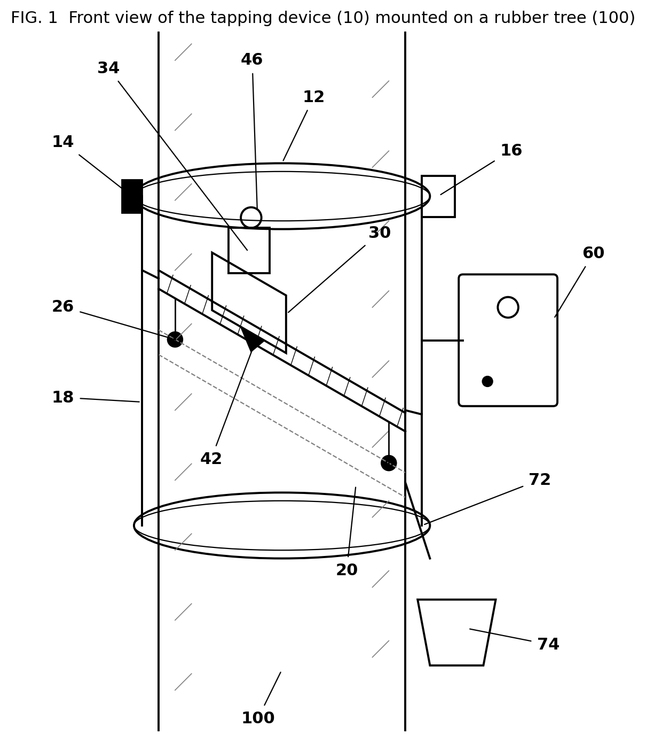
Figure 1: Front view of the device mounted on a tree

4.2 Reference numerals (use the same numbers everywhere, including the patent)
No. | Part | No. | Part
10 | Tapping device (whole machine) | 44 | Blade holder slide
12 | Clamp ring (half rings 12a, 12b) | 46 | Depth stepper motor
14 | Hinge | 48 | Depth lead screw
16 | Over-centre latch | 50 | Probe stepper motor
18 | Vertical posts / frame | 52 | Load cell (force sensor)
20 | Flexible helical guide rail | 54 | Needle probe
22 | Spring-loaded grip rollers | 56 | Skid roller riding on bark
24 | Toothed belt (rack) on rail | 60 | Control unit (microcontroller)
26 | Alignment pins (sit in previous cut) | 62 | Battery pack
30 | Cutter carriage | 64 | Limit switches
34 | Carriage drive motor | 66 | Start / stop button
36 | Drive pulley (pinion) | 68 | LED / buzzer
42 | V-gouge cutting blade | 72 / 74 | Latex spout / collection cup
100 | Rubber tree | 102/104/106/108 | Outer bark / soft bark / cambium / wood

4.3 Sub-system 1: Clamp assembly (12, 14, 16, 18, 22)
- Two half rings of 25 × 5 mm aluminium flat bar, rolled to about 500 mm inner diameter, joined by a hinge (14) on one side and a toggle / over-centre latch (16) on the other.
- Six spring-loaded grip rollers (22) (608 skate bearings with rubber sleeves) on sliding arms. The springs let the same ring grip trunks from 40 to 150 cm girth (about 13 to 48 cm diameter). Add extension arms for the biggest trees.
- Upper and lower rings are joined by two vertical posts (18), 20 mm square aluminium tube, about 350 mm long.
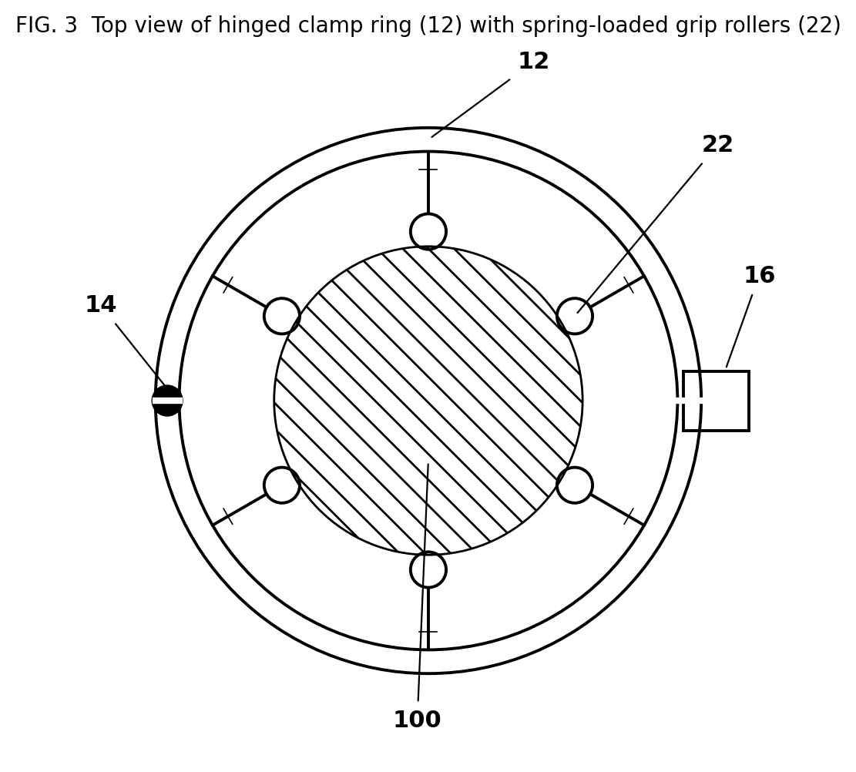
Figure 3: Top view of the clamp ring with grip rollers

4.4 Sub-system 2: Flexible helical rail (20, 24, 26)
- Spring-steel strip 25 mm × 1.5 mm, length about 500 mm (half circumference of the largest tree at 30° slope). Because it is flexible, it wraps around any trunk size.
- A GT2 or T5 toothed belt is glued and riveted along the strip, teeth outward. This works as a cheap flexible rack (24).
- The strip is held by adjustable stand-offs on the posts. An angle bracket with a protractor scale sets the slope from 20° to 35°.
- Alignment pins (26) hang below each end of the rail. For the first tapping, align to the marked panel line. After that, put the pins into yesterday's cut groove. A thumb-screw sets the pin-to-blade distance s (1.0 to 2.0 mm) = bark consumed per tapping.

4.5 Sub-system 3: Cutter carriage (30 to 56)
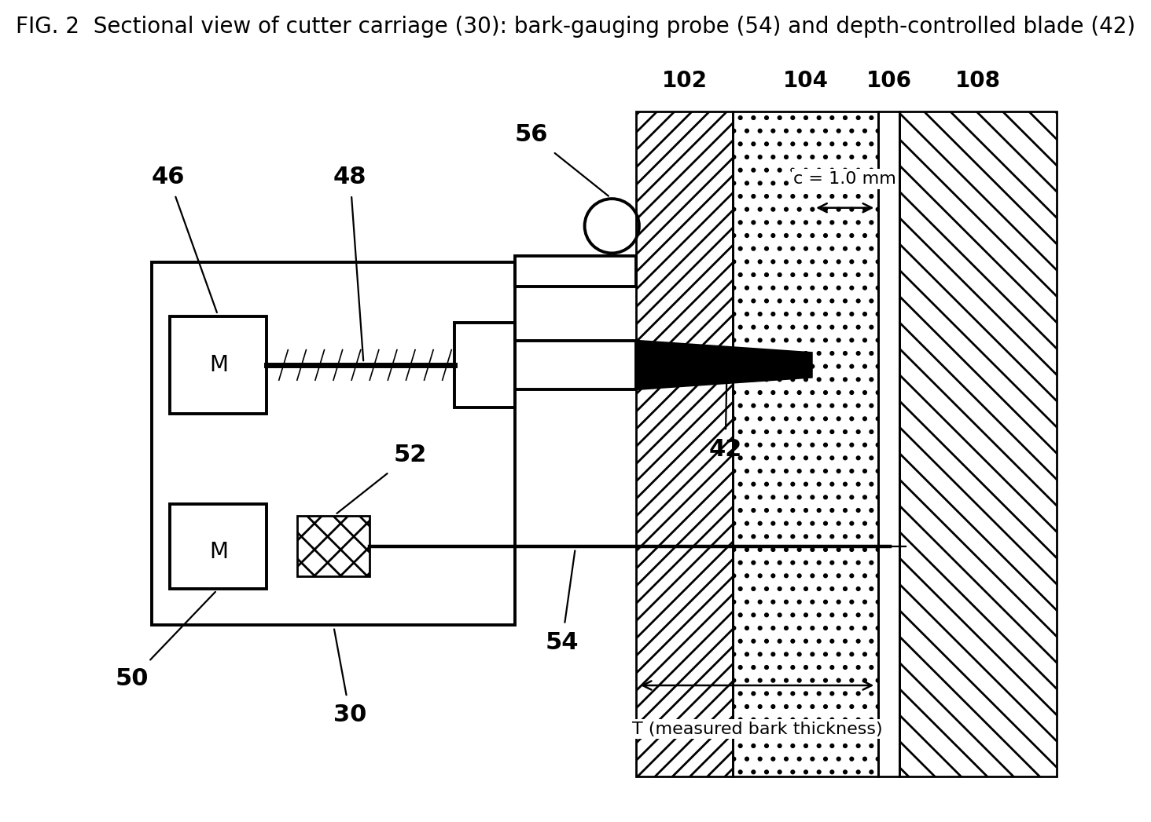
Figure 2: Section through the cutter carriage showing the needle probe and depth-controlled blade
- Drive: 12 V geared DC motor (34), 60 to 100 rpm, 10+ kg·cm torque, with a GT2 pulley (36) meshing the belt rack. Two small guide rollers clamp the carriage onto the strip.
- Blade (42): use a standard V-gouge tapping-knife blade (easy to buy and sharpen), bolted to a slide (44) that moves radially toward the tree.
- Depth control (46, 48): a small lead-screw stepper (2 mm lead, 20 steps per revolution, 1/16 microstepping, so 160 steps per mm and 0.006 mm resolution) pushes the blade slide in and out.
- Skid roller (56): rides on the outer bark surface and gives the zero reference for depth.
- Needle probe (54): 0.8 to 1.0 mm hardened steel needle (a sewing-machine needle with the eye cut off works) driven by a second lead-screw stepper (50) through a 1 kg load cell (52).

4.6 How the bark gauging works (the heart of the invention)
- The needle moves toward the bark in 0.2 mm steps and the load cell reads the force after every step.
- When the force first passes a small value (about 30 g), the needle has touched the bark surface. Save that position as P0.
- The needle passes through bark with moderate force. When it reaches the hard wood (cambium plus wood), the force jumps sharply. Save that position as P1.
- Bark thickness T = P1 - P0. The needle retracts.
- This repeats at 3 points (start, middle, end of the cut). The needle sits just above the blade line, inside the strip that will be shaved off.
- During the cut the blade depth = T - c (c = 1.0 mm), interpolated between the 3 points.
Research part: the exact force values for 'touch' and 'wood' must be found by experiment on real bark (Section 9). This experimental data is valuable. Put it in your report and in the complete patent specification.

4.7 Latex guide (72, 74)
A thin stainless spout is fixed at the lower end of the cut, as in normal tapping, and leads latex into the cup. It stays on the tree. The machine is removed after cutting.

5. Bill of Materials (Prototype)
Prices are approximate (India, 2026). Buy electronics from Robu.in, Robokits, or local electronics markets. Buy metal parts from a local fabrication shop.
# | Item | Qty | Cost (₹)
1 | Arduino Nano (or clone) | 1 | 350
2 | A4988 stepper driver | 2 | 200
3 | BTS7960 43 A motor driver | 1 | 350
4 | Mini lead-screw linear stepper (2 mm lead) | 2 | 700
5 | 12 V geared DC motor, 60-100 rpm, 10 kg·cm | 1 | 700
6 | Load cell 1 kg + HX711 amplifier | 1 | 250
7 | ACS712 current sensor (20 A) | 1 | 150
8 | 3S Li-ion 18650 pack 2600 mAh + BMS | 1 | 1,200
9 | 12.6 V Li-ion charger | 1 | 400
10 | LM2596 buck converter (12 V to 5 V) | 1 | 100
11 | Limit switches, push button, buzzer, LED | set | 160
12 | Aluminium flat 25×5 mm + square tube (clamp, posts) | 2 m | 800
13 | Spring-steel strip 25×1.5 mm (rail) | 0.6 m | 300
14 | GT2 belt 1 m + pulley | 1 | 250
15 | 608 bearings (grip and guide rollers) | 8 | 320
16 | Hinge + toggle latch + springs | set | 350
17 | V-gouge tapping knife (blade) | 1 | 250
18 | Needle for probe | 2 | 50
19 | IP54 enclosure for electronics | 1 | 250
20 | Wires, connectors, perf board, fasteners | set | 600
21 | Machining / welding / cutting charges | - | 1,500
 | Subtotal |  | ≈ 9,230
 | Contingency (≈20%) |  | 1,800
 | Total budget to request |  | ≈ ₹11,000
Save money: take lead-screw steppers from old DVD / CD drives (free) for the probe and depth axes. Also apply for a student project grant, for example the KSCSTE student project scheme, AICTE / MSME idea hackathons, or your college's innovation cell. Ask your guide.

6. Electronics and Wiring
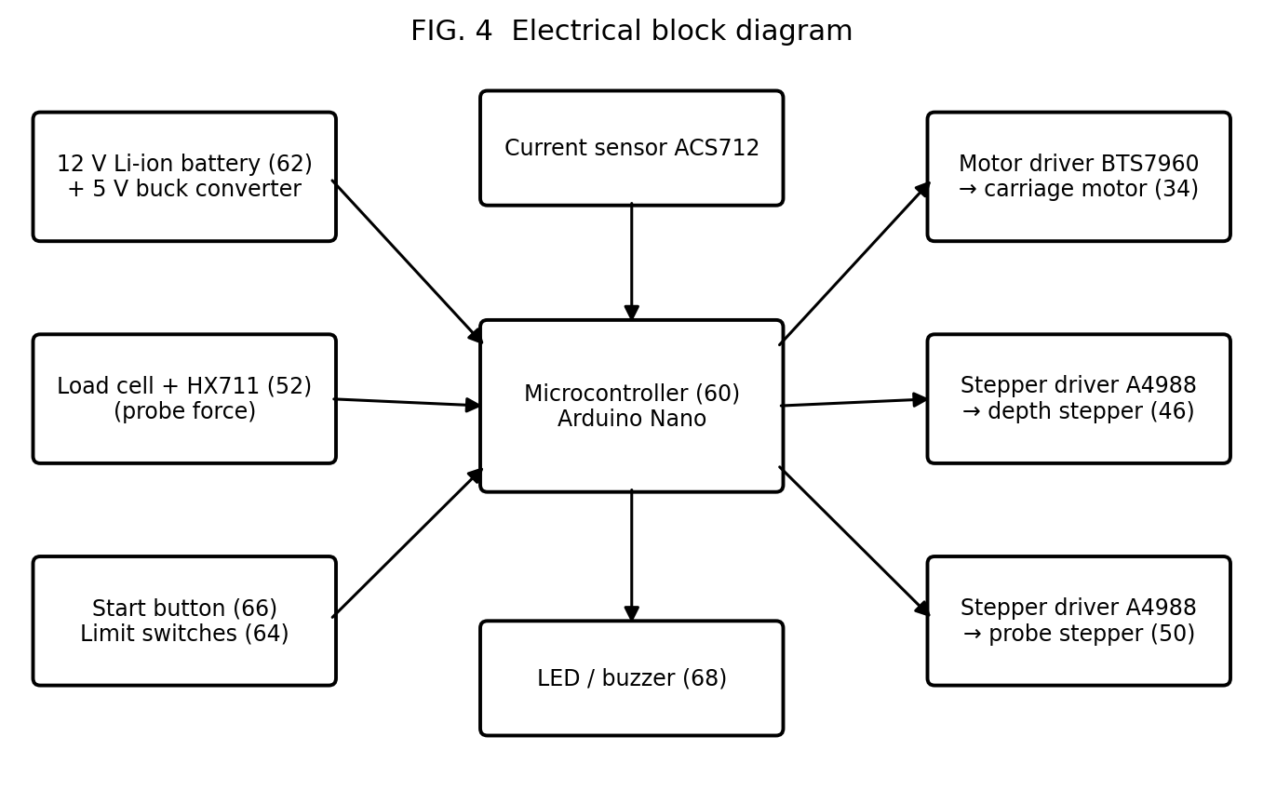
Figure 4: Electrical block diagram
Arduino Nano pin | Connected to | Purpose
D5 / D6 (PWM) | BTS7960 RPWM / LPWM | Carriage motor speed and direction
D2 / D3 | A4988 #1 STEP / DIR | Blade depth stepper
D4 / D7 | A4988 #2 STEP / DIR | Needle probe stepper
D8 | Both A4988 EN | LOW = drivers enabled
D9 / D10 | Top / bottom limit switch (to GND) | End of rail detection
D11 | Push button (to GND) | Start cycle / emergency stop
D12 / D13 | Buzzer / LED | Status signals
A0 | ACS712 OUT | Motor overload detection
A1 / A2 | HX711 DOUT / SCK | Probe force reading
VIN / GND | 5 V from buck converter | Power to logic
Power: the 12 V battery feeds the BTS7960 and both A4988 (VMOT) directly. The LM2596 steps 12 V down to 5 V for the Nano, HX711 and ACS712. Put a 10 A fuse and a main switch right after the battery. Put a 100 µF capacitor across each A4988 VMOT.
Before first power-up: set the A4988 current limit (Vref) for your stepper using the driver's potentiometer.

7. Control Software
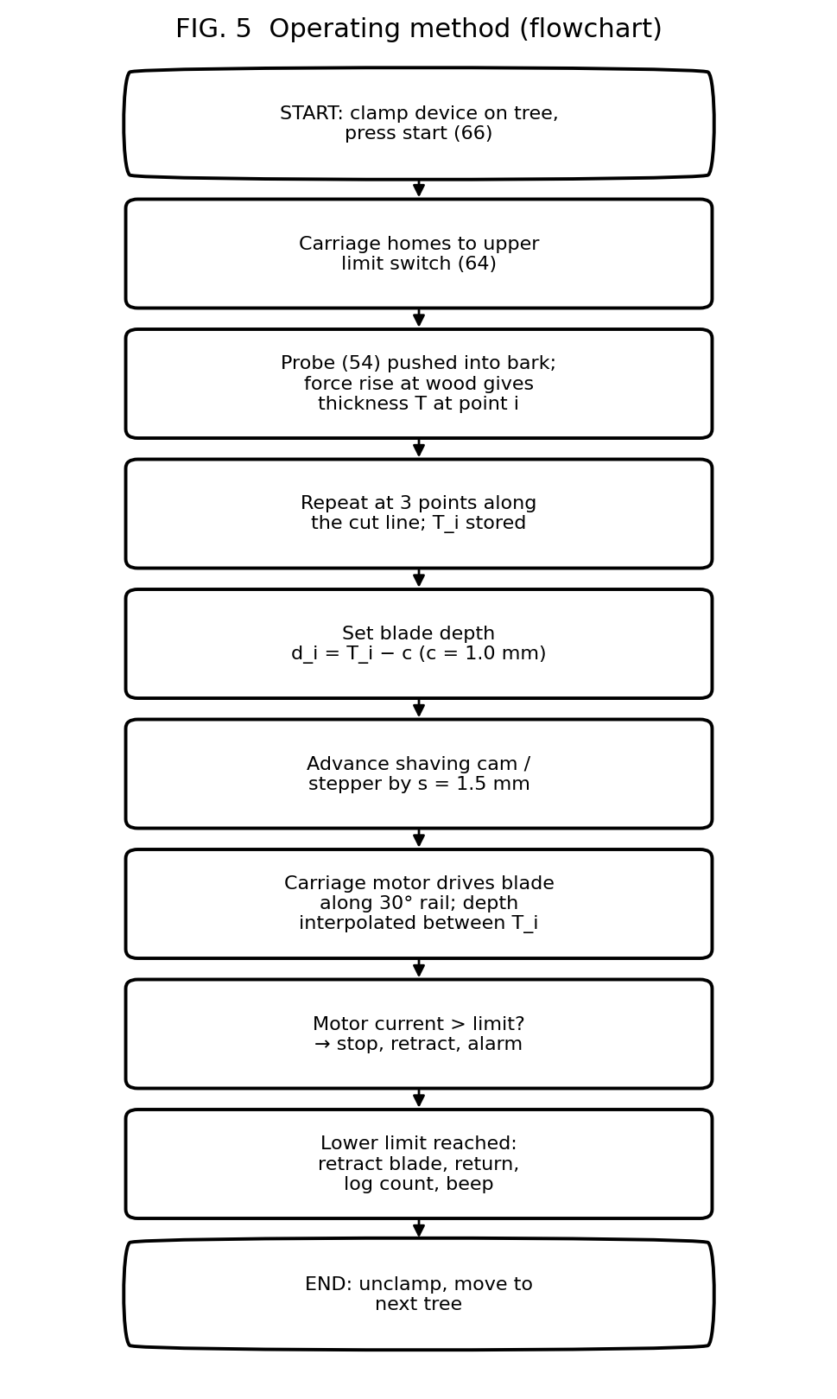
Figure 5: Operating method flowchart
The full Arduino program is in the separate file SmartTapper.ino in this folder. Install the "HX711" library by Bogdan Necula from the Arduino Library Manager. The main logic:
// 1. Gauge bark at 3 points along the cut line
for (int i = 0; i < N_POINTS; i++) {
barkT[i] = gaugeBark(); // needle in, detect surface + wood, retract
moveCarriageToNextPoint();
}
// 2. Cut with depth = T - c, interpolated along the rail
carriage(200);
while (!bottomLimitReached) {
if (motorCurrent > LIMIT) fault("overload");
float T = interpolate(barkT, positionAlongRail);
setBladeDepth(T - RESIDUAL_BARK_MM); // RESIDUAL_BARK_MM = 1.0
}
// 3. Retract blade, return carriage, beep
Calibration constants you must tune: CONTACT_G, WOOD_RISE_G, CURRENT_LIMIT_RAW, RAIL_TIME_MS, and the HX711 scale factor (hang a known weight, for example 500 g, and adjust until it reads 500).

8. Step-by-Step Build Procedure

Phase A: Mechanical (weeks 1 to 5)
- Make a full-size cardboard / PVC-pipe mock-up on a real tree (or a 15 cm PVC pipe) to check all dimensions.
- Cut and roll the two half rings. Drill the hinge and latch holes. Fit the hinge and toggle latch.
- Make the six roller arms with springs. Test the grip on pipes of 15 cm, 30 cm and 45 cm diameter.
- Join the upper and lower rings with the two posts. Fit the angle brackets with a protractor scale.
- Glue and rivet the toothed belt onto the spring-steel strip. Fit the stand-offs so the strip wraps the trunk 25 to 30 mm from the bark.
- Build the carriage: an aluminium plate, 4 guide rollers gripping the strip, the DC motor with GT2 pulley meshing the belt.
- Build the blade slide (drawer-type slide or two 6 mm rods with linear bushes) driven by the depth lead screw. Mount the blade.
- Mount the probe stepper, the load cell and the needle holder just above the blade line.
- Fit the skid roller and the two alignment pins with their thumb-screw adjustment.

Phase B: Electronics (weeks 4 to 7, in parallel)
- Wire everything on a breadboard first, following the table in Section 6.
- Test each part alone: motor forward/back, each stepper, load cell reading, current sensor, limit switches.
- Move to a soldered perf-board and put it in the IP54 box with cable glands.
- Upload SmartTapper.ino and test the full cycle on a PVC pipe covered with a 6 mm layer of cork or soap. Check that the depth moves correctly.

Phase C: Integration (weeks 7 to 9)
- Mount everything on the frame. Balance the weight (keep the battery low and close to the trunk).
- Add a blade guard and an emergency-stop function.
- Take clear photos and short videos of every stage. You need them for your report and for the patent drawings.

9. Testing and Validation Plan

9.1 Test stages
Stage | Where | Goal
1. Bench | PVC pipe with cork/soap layer | Check mechanics, depth accuracy and software
2. Log test | Fresh rubber log sections from a replanting site | Calibrate probe force thresholds on real bark; measure cut depth with vernier
3. Field test | Old trees due for felling (with owner / Rubber Board permission) | Compare with a skilled tapper on the same trees
4. Endurance | 20+ trees in one session | Battery life, heating, blade wear

9.2 What to measure
Metric | How to measure | Target
Bark thickness accuracy | Probe reading vs. vernier on a cut section of the same spot | ±0.3 mm
Residual bark over cambium | Cut a small window after tapping, measure with vernier | 1.0 ± 0.3 mm
Bark consumption per tap | Distance between successive cuts | 1.5 ± 0.2 mm
Cambium wounds | Count visible wounds per 10 trees | 0 (manual: note count)
Latex yield | ml of latex per tree (or g dry rubber), machine vs. manual on alternate trees | ≥ manual
Time per tree | Stopwatch | < 60 s
Trees per charge | Count until low battery | > 200

9.3 Probe calibration data sheet
Sample | Probe force at touch (g) | Force jump at wood (g) | Probe T (mm) | Vernier T (mm) | Error (mm)
1
2
3
…
Plot force against needle depth for about 20 samples. The chart that shows the sharp force rise at the wood is strong evidence for your patent and your viva.

10. Safety
- Blade guard that covers the blade when it is retracted. Never hold the carriage by hand while it runs.
- Push button works as an emergency stop at any time. Over-current trip stops the motor if the blade jams.
- Li-ion pack with BMS and a fuse. Charge only with the correct charger, never unattended.
- Wear gloves and eye protection during tests. Test only on trees you have permission to use.

11. Project Timeline and Team Roles
Week | Work | Deliverable
1 | Prior-art search, visit a rubber estate, fix dimensions | Search table, design sketch
2 | File provisional patent (Section 13) | Application number / priority date
2-5 | Mechanical fabrication | Frame, rail, carriage
4-7 | Electronics and code | Working bench system
7-9 | Integration and log testing | Calibration data
10-12 | Field testing and improvements | Test results
13-14 | Report, presentation, video | Project report
Within 12 months of step 2 | File complete specification + request examination | Complete application
Suggested roles (4-member team): (1) mechanical design and fabrication, (2) electronics and wiring, (3) software and calibration, (4) prior-art search, patent documents, testing records and report. Everyone should keep a dated project logbook. It proves who invented what and when.

12. Draft Provisional Patent Specification (Form 2)
This is a working draft for you and your guide or patent agent to refine. Replace the blanks, adjust the wording after your prior-art search, and keep the reference numerals the same as in the drawings. Attach Figures 1 to 5 as drawing sheets (black and white, A4, sheet number and applicant name on each sheet).
FORM 2
THE PATENTS ACT, 1970 (39 of 1970) & THE PATENTS RULES, 2003
PROVISIONAL SPECIFICATION (See section 10; rule 13)
1. TITLE OF THE INVENTION:
A PORTABLE CLAMP-ON RUBBER TREE TAPPING DEVICE WITH AUTOMATIC BARK-THICKNESS GAUGING AND DEPTH-CONTROLLED CUTTING, AND A METHOD THEREOF
2. APPLICANT(S): Name: ______________ Nationality: Indian Address: ______________
3. PREAMBLE: The following specification describes the invention.

FIELD OF THE INVENTION
[001] The present invention relates to agricultural devices for extracting latex from trees, and more particularly to a portable, motor-driven device for tapping rubber trees (Hevea brasiliensis) that automatically measures the thickness of the bark and controls the depth of the tapping cut so as to protect the cambium.

BACKGROUND OF THE INVENTION
[002] Natural rubber latex is harvested by tapping, in which a thin shaving of bark is removed along an inclined half-spiral line on the trunk so that the latex vessels in the soft bark are opened. For optimum yield, the cut should approach the cambium as closely as possible, typically leaving about 1 mm of bark, and should consume only about 1.5 to 2 mm of bark per tapping.
[003] Conventionally, tapping is performed with manual knives such as the Jebong knife or gouge knife. The depth and bark consumption depend entirely on the skill of the tapper. Deep tapping injures the cambium, causing wounds, bark malformations and loss of yield, while shallow tapping lowers yield. Skilled tappers are increasingly scarce.
[004] Motorised hand-held tapping knives are known in which a motor assists the cutting action and a mechanical guide limits the cut to a fixed depth. However, bark thickness varies from tree to tree and around the circumference of a single tree, so a fixed depth either leaves excess bark or wounds the cambium. Tree-mounted robotic tapping systems have also been proposed, but these are costly and usually require one unit per tree.
[005] There is therefore a need for a low-cost, portable tapping device, usable by unskilled workers, that measures the actual bark thickness at the point of tapping and automatically adjusts the cutting depth, while keeping bark consumption uniform.

OBJECTS OF THE INVENTION
[006] The principal object of the invention is to provide a portable tapping device that measures the bark thickness of each tree along the tapping line and automatically sets the blade depth to leave a predetermined residual thickness of bark over the cambium.
[007] Another object is to measure bark thickness without creating additional wounds on the tree.
[008] Another object is to keep bark consumption per tapping uniform, regardless of operator skill.
[009] Another object is to provide a single device that can be quickly clamped to and removed from trees of different girths, so one unit can serve many trees.
[010] A further object is to provide a method of tapping using such a device.

SUMMARY OF THE INVENTION
[011] According to the invention, a portable tapping device (10) comprises a clamp assembly (12) detachably fixable around the trunk of a tree (100); a guide rail (20) supported by the clamp assembly and inclined at a tapping angle; a cutter carriage (30) driven along the guide rail by a motor (34) and carrying a cutting blade (42) that is radially movable by a depth actuator (46, 48); a bark-thickness gauging means (50, 52, 54) carried by the carriage; and a control unit (60) that sets the radial depth of the blade from the measured bark thickness so that a predetermined residual thickness of bark remains over the cambium (106).
[012] In a preferred embodiment the gauging means is a needle probe (54) advanced by a probe actuator (50) through a force sensor (52). The bark thickness is taken as the probe travel between the first contact with the bark surface and a sharp rise in resisting force when the probe reaches the wood. The probe is positioned so that its puncture lies within the strip of bark removed by the same tapping cut.
[013] Alignment pins (26) engage the groove of the previous tapping cut so that the new cut lies a preset distance above it, giving uniform bark consumption.

BRIEF DESCRIPTION OF THE DRAWINGS
[014] Figure 1 is a front view of the tapping device mounted on a rubber tree.
[015] Figure 2 is a sectional view of the cutter carriage showing the needle probe, the depth-controlled blade and the layers of the bark.
[016] Figure 3 is a top view of the clamp assembly with the grip rollers.
[017] Figure 4 is an electrical block diagram of the control system.
[018] Figure 5 is a flowchart of the tapping method.

DETAILED DESCRIPTION OF THE INVENTION
[019] Referring to Figures 1 and 3, the clamp assembly (12) comprises two half rings (12a, 12b) joined by a hinge (14) and closed by an over-centre latch (16). A plurality of spring-loaded grip rollers (22) on radially sliding arms press against the trunk, allowing the device to be mounted on trunks of girth approximately 40 cm to 150 cm. Upper and lower rings are connected by vertical posts (18).
[020] A guide rail (20) formed of a flexible spring-steel strip is carried on adjustable stand-offs from the posts (18) so that it conforms to the curvature of the trunk and follows an inclined half-spiral path. The angle of inclination is adjustable between about 20° and 35°. A toothed belt (24) fixed along the strip forms a flexible rack.
[021] Alignment pins (26) project below each end of the rail. In use they are placed in the groove of the previous tapping cut, and a screw adjustment sets the vertical distance between the pins and the blade line, which equals the bark consumed per tapping (for example 1.5 mm).
[022] Referring to Figure 2, the cutter carriage (30) is guided on the rail by rollers and driven by a geared DC motor (34) through a pulley (36) engaging the toothed belt (24). A V-shaped gouge blade (42) is fixed on a blade holder slide (44) that is moved radially toward and away from the trunk by a stepper motor (46) and lead screw (48). A skid roller (56) runs on the outer bark (102) and provides the zero reference for the blade depth.
[023] A needle probe (54) of about 0.8 to 1.0 mm diameter is advanced radially by a second stepper motor (50) through a load cell (52). The control unit advances the probe in small increments, for example 0.2 mm, reading the force after each increment. The position at which the force first exceeds a contact threshold is recorded as the bark surface. The probe passes through the outer bark (102) and soft bark (104) at moderate force. On reaching the cambium (106) and wood (108) the resisting force rises sharply; the position at which the increase in force within one increment exceeds a wood threshold is recorded. The difference between the two positions is the bark thickness T. The probe is then withdrawn.
[024] The probe is located on the carriage above the blade line by less than the bark consumption per tapping, so its puncture lies in the strip of bark that is removed by the ensuing cut. No additional wound is left on the tree.
[025] Referring to Figures 4 and 5, the control unit (60) comprises a microcontroller powered by a battery (62). On pressing the start button (66), the carriage moves to the upper limit switch (64). The bark thickness is measured at a plurality of points, for example three, along the tapping line. The carriage then moves down the rail while the control unit sets the blade depth d = T − c, where c is the predetermined residual thickness (for example 1.0 mm, settable between 0.5 and 1.5 mm). T is linearly interpolated between the measuring points. A current sensor monitors the drive motor; if the current exceeds a limit, the carriage stops and the blade retracts. At the lower limit switch the blade is withdrawn, the carriage returns, and an indicator (68) signals completion. The latex flows along the cut to a spout (72) and into a collection cup (74).
[026] The device is then unclamped and mounted on the next tree. Because a single device serves many trees, cost is low. Because depth and bark consumption are set automatically, unskilled workers can tap without injuring the cambium.
[027] In alternative embodiments the bark-thickness gauging means may use an ultrasonic, capacitive or electrical-impedance sensor instead of the needle probe, and the drive may use a rack-and-pinion or screw in place of the toothed belt. Such variations fall within the scope of the invention.
[028] (To add in the complete specification: experimental results, for example force against depth curves, depth accuracy, yield comparison with manual tapping, and photographs of the prototype.)

CLAIMS (to be filed with the Complete Specification)
We claim:
1. A portable tapping device (10) for extracting latex from a tree (100), comprising: a clamp assembly (12) detachably fixable around the trunk of the tree; a guide rail (20) supported by the clamp assembly and inclined at a tapping angle; a cutter carriage (30) movable along the guide rail by a drive motor (34), the carriage carrying a cutting blade (42) that is radially movable relative to the trunk by a depth actuator (46, 48); characterised in that the carriage further carries a bark-thickness gauging means (50, 52, 54) adapted to measure the bark thickness (T) at one or more points along the tapping line before cutting, and a control unit (60) is configured to set the radial depth of the blade from the measured bark thickness so that a predetermined residual thickness (c) of bark remains over the cambium (106).
2. The device as claimed in claim 1, wherein the bark-thickness gauging means comprises a needle probe (54) advanced by a probe actuator (50) through a force sensor (52), and the control unit determines the bark thickness as the probe travel between a first contact force and a rise in force indicative of the wood (108).
3. The device as claimed in claim 2, wherein the needle probe is positioned such that its puncture lies within the strip of bark removed by the subsequent cut of the blade.
4. The device as claimed in claim 1, wherein the control unit measures the bark thickness at a plurality of points along the tapping line and varies the blade depth along the cut by interpolation between the said points.
5. The device as claimed in claim 1, wherein the predetermined residual thickness (c) is settable between 0.5 mm and 1.5 mm.
6. The device as claimed in claim 1, comprising alignment pins (26) adapted to engage the groove of a previous tapping cut, and means for adjusting the distance between the alignment pins and the blade to set the bark consumption per tapping.
7. The device as claimed in claim 1, wherein the guide rail is a flexible strip conforming to the trunk and carrying a toothed belt (24) engaged by a pulley (36) driven by the drive motor.
8. The device as claimed in claim 1, wherein the clamp assembly comprises two half rings (12a, 12b) joined by a hinge (14), an over-centre latch (16), and a plurality of spring-loaded grip rollers (22) adapted to accommodate trunks of different girths.
9. The device as claimed in claim 1, wherein the tapping angle of the guide rail is adjustable between 20° and 35°.
10. The device as claimed in claim 1, comprising a current sensor for the drive motor, wherein the control unit stops the carriage and retracts the blade when the motor current exceeds a limit.
11. The device as claimed in claim 1, comprising a skid roller (56) running on the outer bark surface to provide a reference for the blade depth.
12. A method of tapping a tree using the device as claimed in claim 1, comprising the steps of: (a) clamping the device on the trunk; (b) measuring the bark thickness at one or more points along the tapping line with the gauging means; (c) calculating a blade depth equal to the measured bark thickness minus a predetermined residual thickness; (d) moving the carriage along the guide rail while holding the blade at the calculated depth to remove a strip of bark; and (e) retracting the blade and removing the device from the tree.

ABSTRACT
A PORTABLE CLAMP-ON RUBBER TREE TAPPING DEVICE WITH AUTOMATIC BARK-THICKNESS GAUGING AND DEPTH-CONTROLLED CUTTING, AND A METHOD THEREOF
A portable tapping device (10) for rubber trees comprises a hinged clamp assembly (12) that fits trunks of various girths, an inclined flexible guide rail (20), and a motor-driven cutter carriage (30) carrying a radially adjustable blade (42). A needle probe (54) with a force sensor (52) on the carriage measures the bark thickness at several points along the tapping line by detecting the surface contact and the sharp force rise at the wood. A control unit (60) sets the blade depth to the measured thickness less a predetermined residual thickness, so the cambium is not injured. The probe punctures only the bark strip removed by the same cut. Alignment pins (26) engaging the previous cut give uniform bark consumption. The device allows unskilled workers to tap many trees quickly and consistently. (Figure 2)

13. Patent Filing Procedure (India)

13.1 Who files and who are the inventors
- Inventors: every person who contributed to the inventive idea. This is usually all the students plus your guide. List them honestly. Wrong inventorship can invalidate a patent.
- Applicant (owner): either the inventors themselves, or your college (many colleges' IPR policy says the college owns it and pays the fees). Ask your college IPR cell / guide first.
- Educational institutions and natural persons pay the lowest fees. Check the current fee schedule.

13.2 Step-by-step
- Keep it secret. Do not present at a symposium, submit a paper, post on YouTube/Instagram/LinkedIn, or enter a competition until the provisional application is filed. Public disclosure can destroy novelty.
- Prior-art search (Section 3.3). Adjust claims if needed.
- Register on the e-filing portal: ipindia.gov.in → Patent → Online Filing. You get a digital-signature-based login (a Class 3 DSC is needed; your college or an agent may have one).
- File the provisional application: Form 1 (application), Form 2 (provisional specification, Section 12 of this document), drawings (Figures 1 to 5), Form 3 (foreign filing statement) and Form 5 (inventorship declaration, can also be filed with the complete specification). You get an application number and a priority date. From now on you can present and publish, and write "Patent Pending".
- Build and test the prototype. Collect data (Sections 8 and 9).
- File the complete specification within 12 months of the provisional. Add the experimental results, final claims and any improvements. If you miss this deadline, the application is abandoned.
- Request examination: Form 18 (normal) or Form 18A (expedited, available to startups, small entities, women applicants and some other categories). This must be filed within 48 months of the priority date. File it together with the complete specification to save time.
- Optional: early publication with Form 9. Otherwise publication happens automatically after 18 months.
- Reply to the First Examination Report (FER) within 6 months (extendable by 3 months). Usually you amend the claims and argue against the cited prior art.
- Hearing (if needed) → Grant. After grant, pay renewal fees every year from the 3rd year to keep it in force (up to 20 years).

13.3 Forms and approximate official fees
Form | Purpose | Approx. fee (₹, e-filing, natural person / educational institution / startup / small entity)
Form 1 | Application for grant of patent | 1,600
Form 2 | Provisional or complete specification | Included (extra fee if over 30 pages or 10 claims)
Form 3 | Statement of foreign applications | No fee
Form 5 | Declaration of inventorship | No fee
Form 9 | Request for early publication (optional) | 2,500
Form 18 | Request for examination | 4,000
Form 18A | Expedited examination (eligible applicants only) | 8,000
Form 26 | Power of attorney (only if using a patent agent) | No fee
Form 28 | Proof of startup / small entity status | No fee
Renewal | From 3rd year onward | About 800 per year initially, increasing later
Fees change from time to time. Check the latest First Schedule of the Patents Rules on ipindia.gov.in before paying. A registered patent agent typically charges an extra ₹10,000 to ₹40,000 for drafting and filing. Your college IPR cell or the state council (for example KSCSTE Patent Information Centre in Kerala) may help for free or at low cost.

13.4 Cost and time summary
Stage | Official fee (approx.) | When
Provisional filing (Form 1) | ₹1,600 | Now (week 2)
Complete specification + Form 18 | ₹4,000 (₹8,000 if 18A) | Within 12 months
Early publication (optional) | ₹2,500 | With complete spec
Typical total until grant (without agent) | ≈ ₹6,000 to ₹12,000 | Grant usually 1 to 4 years

14. Checklist: What To Do Next
- Show this document to your guide. Agree on inventors, applicant (college or students) and budget.
- Contact the college IPR cell / Patent Information Centre.
- Do the prior-art search (Section 3.3) and fill in the comparison table.
- Refine the Form 2 draft (Section 12). Replace the blanks with names and addresses.
- Prepare drawing sheets from Figures 1 to 5 (already in the figures folder).
- File the provisional application and note the application number and date.
- Buy parts (Section 5) and start fabrication (Section 8).
- Visit a rubber estate / Rubber Board office for testing permission and expert feedback.
- Run the tests and fill in the data sheets (Section 9).
- File the complete specification with results and final claims within 12 months.

Files in this folder:
- Rubber_Tapping_Machine_Project_and_Patent.docx: this document
- SmartTapper.ino: complete Arduino program
- figures/: patent-style drawings (Figures 1 to 5) as PNG images

