SMART TAPPER
Portable strap-on rubber tapping machine with needle bark gauging, tree-tag memory and automatic depth control
Project file, version 3 (corrected, with Indian patent fixes): design, parts, electronics, code, build, testing, draft Indian patent specification and India launch plan
Final-year team project | Version 3 | September 2026
Team members: ______________________ Guide: ______________________
CONFIDENTIAL. Do not publish, present publicly or upload until the provisional patent application is filed.

Contents
1. Corrections Made in Version 2 3
2. The Idea in One Page 4
3. Background: Tapping Practice the Machine Must Follow 5
4. Existing Solutions, Novelty and Patent Search 6
4.1 What exists 6
4.2 Features we claim 6
4.3 How to do the search (do this before filing) 6
5. Machine Design 7
5.1 Reference numerals (same in drawings, text and patent) 7
5.2 Mounting: straps, pads and rail (12 to 26) 8
5.3 Cutter carriage (30 to 56) 8
5.4 How bark gauging works 9
5.5 Motor sizing (calculation) 10
5.6 Energy per tree (battery sizing) 10
5.7 Latex spout and cup (72, 74) 10
6. Bill of Materials (Prototype) 11
7. Electronics and Wiring 12
8. Control Software 13
9. Step-by-Step Build Procedure 14
Phase A: Mechanical (weeks 2 to 6) 14
Phase B: Electronics (weeks 4 to 7) 14
Phase C: Integration (weeks 7 to 9) 14
10. Testing and Validation Plan 15
11. Working Method and Economics 16
12. Safety 17
13. Timeline and Team Roles 18
14. Draft Provisional Specification (Form 2) 19
15. Patent Filing Procedure (India) 23
15.1 Inventors and applicant 23
15.2 Steps 23
15.3 Approximate official fees (e-filing, natural person / startup / small entity / educational institution) 23
16. Launching the Product in India 24
16.1 Freedom to operate (FTO) 24
16.2 Business setup 24
16.3 Product compliance 24
16.4 Funding options (check current calls) 24
16.5 Manufacturing and sales 24
17. Next-Step Checklist 26

1. Corrections Made in Version 2
Version 1 was reviewed line by line. These mistakes were found and fixed. Keep this list; your guide and the patent examiner will ask about several of these points.
# | Mistake in version 1 | Why it was wrong | Fix in version 2
1 | New cut placed s mm ABOVE the previous cut | In downward tapping the panel is consumed from top to bottom, so each new cut is BELOW the previous one | Alignment pins sit in yesterday's cut and the blade works s mm below it. Figures, text and claims corrected.
2 | Claimed "no extra wound" from the needle | To detect the wood, the needle must pass through the cambium. The deep part of the prick remains even though its outer part is shaved off | Honest wording ("minimal wound"). New tree-tag memory means the needle is used only about once a month per tree, not every day.
3 | One rigid clamp ring for 40 to 150 cm girth | Rollers would need about 190 mm spring travel (impossible), and a 500 mm ring cannot hold a 480 mm trunk plus rollers | Replaced by two ratchet straps with rubber pads. They fit any girth.
4 | Rail length 500 mm | Half spiral at 30° on a 150 cm tree is 75 / cos 30° ≈ 870 mm | Two rail sizes (S/M up to 100 cm girth, L up to 150 cm) and adjustable end stops
5 | Carriage position estimated from time | Speed changes with load, so depth would be applied at the wrong place | Hall-encoder gear motor gives the true position
6 | Motor torque never calculated | Motor could stall in hard bark | Force and torque calculation added (Section 5.5); 15+ kg·cm planetary motor
7 | DVD / mini lead-screw steppers and 1 kg load cell | Too weak to push a needle into wood or hold the blade against cutting force; 1 kg cell overloads | Pancake NEMA 17 + Tr8×2 lead screw + MGN9 guide; 5 kg load cell
8 | 2.6 Ah battery claimed 200+ trees | About 0.3 Wh per tree means only about 70 to 90 trees | 3S3P 7.8 Ah pack (≈ 200 trees, energy estimate shown)
9 | HX711 at 10 samples/s | Probing 15 mm in small steps would take about 30 s per point | HX711 set to 80 samples/s (RATE pin), about 2 to 3 s per point
10 | Start and stop were the same button | Holding the button to start caused an instant stop fault; probe not retracted on fault | Separate hardware E-stop (cuts motor power) plus signal; wait for release; full retraction on any fault
11 | Arduino Nano | No free pins for NFC, RTC, encoder, E-stop | ESP32 (more pins, Bluetooth logging to phone)
12 | Flowchart had a "shaving cam" step | No such part existed in the design | Flowchart redrawn to match the real design
13 | Prototype cost ≈ ₹11,000 | Underestimated once proper actuators were chosen | Realistic BOM ≈ ₹22,000 (Section 6)
14 | Time per tree not compared with a manual tapper | A skilled tapper takes about 15 to 20 s per tree; the machine is slower | Honest comparison and a two-unit working method (Section 11)
15 | Nothing on launching the product | A patent alone does not let you sell | New sections on freedom-to-operate, company, compliance, subsidy and sales (Section 16)
16 | Claims relied on the false "wound-free" benefit | An examiner would object | Claims rewritten; new claims for tree-tag memory, strap mounting and encoder positioning
Honest limit: no design is "perfect" on paper. The needle force values, cutting force and depth accuracy must be proved by the tests in Section 10. Nobody can guarantee in advance that the patent office will grant a patent. What this version does is remove the errors, so the idea, the drawings and the claims are consistent and defensible.

2. The Idea in One Page
Problem. Tapping means shaving a thin strip of bark (about 1.5 mm high) along a 30° half-spiral cut, deep enough to open the latex vessels but stopping about 1 mm short of the cambium. Too deep wounds the tree permanently. Too shallow loses latex. Skilled tappers are scarce, and bark thickness differs from tree to tree, so a fixed-depth tool cannot be right for every tree.
Solution. A battery-powered machine that is strapped to the trunk. A motor drives a blade along a curved rail at the tapping angle. It works like this:
- Reads an NFC tag fixed on the tree. The tag stores that tree's bark thickness and the date it was measured.
- If the record is older than 30 days (or missing), it measures the bark: a thin needle with a force sensor finds the bark surface and the sudden force rise at the wood, at 3 points on the cut line. It writes the new values to the tag.
- Sets blade depth = bark thickness − 1 mm and changes it smoothly along the cut, using the motor encoder to know where the blade is.
- Alignment pins sit in yesterday's cut, so today's cut is always exactly s mm (for example 1.5 mm) below it. Bark consumption stays uniform.
Why it is new: existing hand knives rely on skill. Motorised tapping knives use a fixed depth guide. Tapping robots are fixed on one tree and costly. Our combination is measure bark → store on the tree → cut to a computed depth, with one portable unit. As far as general knowledge of the field goes, this is not on the market in India. It must be confirmed by the patent search (Section 4.3).
Parameter | Target
Tree girth | 40 to 150 cm (two rail sizes)
Tapping angle | 20° to 35° adjustable (30° default)
Cut | Half spiral (S/2), downward, high left to low right
Residual bark over cambium (c) | 1.0 mm, settable 0.5 to 1.5 mm
Depth accuracy | ±0.3 mm (to be proved by tests)
Bark consumption per tapping (s) | 1.0 to 2.0 mm, set by alignment pins
Time per tree (normal day, no gauging) | about 40 to 50 s including strapping
Time per tree (gauging day, once a month) | about 70 to 80 s
Weight | under 3.5 kg
Battery | 12 V, 7.8 Ah Li-ion: about 200 trees per charge (estimate)
Prototype cost | about ₹22,000

3. Background: Tapping Practice the Machine Must Follow
Practice | Typical value | Design consequence
Height of tapping panel opening | About 125 cm (budded trees) | Straps fit anywhere from 50 to 150 cm height
Slope of cut | About 30° (budded), 25° (seedlings) | Rail angle adjustable 20° to 35°
Length of cut | Half spiral (S/2) | Rail covers half the circumference; end stops adjustable
Direction | High left to low right | Carriage cuts downhill; latex flows to spout at low end
Order of cuts | Downward: each new cut is just below the last | Pins in previous cut, blade s mm below
Depth | Stop about 1 mm before cambium | Depth = measured T − c
Bark consumption | About 1.5 to 2 mm per tapping | s set by alignment pins
Tapping time | Early morning | LED light; works in low light
Confirm these values with the Rubber Board or RRII (Kottayam) and ask for permission to test on trees that are due for replanting. A support or test letter from them is also very useful for the patent, funding and sales.

4. Existing Solutions, Novelty and Patent Search

4.1 What exists
Existing type | Depth control | Weakness
Jebong / gouge hand knife | Tapper's skill | Long training; wounds common
Motorised / battery tapping knife | Fixed mechanical guide or hand feel | Same depth for every tree
Tree-mounted tapping robot (research) | Sensors on a fixed per-tree rail | Expensive; one unit per tree
Manual bark gauge (pricking needle) | Used by supervisors to check depth | Not linked to any cutting tool

4.2 Features we claim
- Measure-then-cut (main claim): a force-sensing needle on the carriage measures bark thickness along the tapping line, and the controller sets the blade depth from it.
- Tree-tag memory: the measured thickness and date are written to a tag fixed on the tree and reused until they expire, so the needle is needed only occasionally.
- Depth profile along the cut from several measured points, applied using encoder position.
- Alignment pins in the previous cut that fix bark consumption per tapping.
- Strap mounting with a flexible rail held off the bark by pads, fitting many girths with one unit.

4.3 How to do the search (do this before filing)
- Databases: Google Patents, Espacenet, InPASS (iprsearch.ipindia.gov.in), WIPO Patentscope, Google Scholar, Rubber Board / RRII publications.
- Classification: IPC A01G 23/10 (tapping of tree juices). Also B26B, G01B, G06K 19 (tags).
English keywords | Chinese keywords (Google Patents)
rubber tapping machine / latex tapping device | 割胶机 / 割胶装置
electric tapping knife | 电动割胶刀
tapping robot / automatic tapping | 割胶机器人 / 自动割胶
tapping depth / bark thickness detection | 割胶深度 / 树皮厚度检测
RFID tree tag rubber | 橡胶树 电子标签
Record each close result: number, title, what it has, what it lacks compared with ours. If one document already shows claim 1, the other features (tag memory, pins, strap mounting) or their combination become the main claim.
Patent / paper | Title | Has | Lacks (vs ours)

5. Machine Design
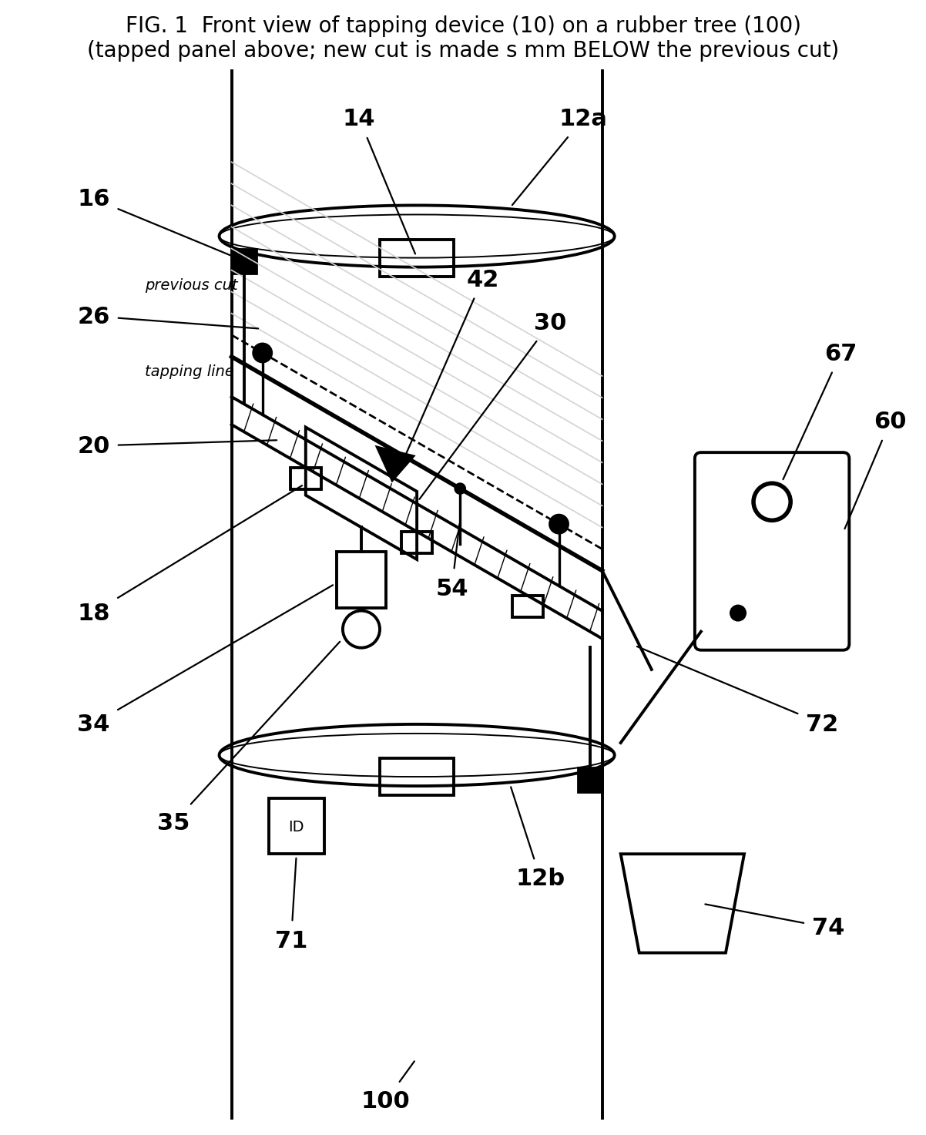
Figure 1: Front view on the tree. The new cut is made s mm below yesterday's cut.

5.1 Reference numerals (same in drawings, text and patent)
No. | Part | No. | Part
10 | Tapping device | 42 | V-gouge blade
12a / 12b | Upper / lower ratchet straps | 44 | Blade slide (MGN9 guide)
14 | Ratchet buckle | 46 / 48 | Depth stepper / Tr8×2 lead screw
16 | Sliding end clips (rail to strap) | 50 | Probe stepper
18 | Rubber-footed support pads | 52 | Load cell 5 kg
20 | Flexible helical rail (spring steel) | 54 | Needle probe
24 | Toothed belt rack on rail | 56 | Skid roller (depth reference)
26 | Alignment pins (in previous cut) | 60 / 62 | Controller (ESP32) / battery
30 | Cutter carriage | 64 | Adjustable end stops (limit switches)
34 / 35 | Gear motor / hall encoder | 66 / 67 | Start button / E-stop
36 | GT2 pulley | 68 | LED / buzzer
70 / 71 | NFC reader / tree tag | 72 / 74 | Latex spout / cup
100 | Rubber tree | 102-108 | Outer bark / soft bark / cambium / wood

5.2 Mounting: straps, pads and rail (12 to 26)
- Two 25 mm polyester ratchet straps (12a, 12b) with rubber backing go around the trunk, one above and one below the tapping line. They fit any girth and do not damage bark when padded.
- The flexible rail (20) is a 25 × 1.5 mm spring-steel strip with a GT2 belt riveted on it (24). It is held about 25 mm off the bark by 3 to 4 rubber-footed pads (18) and fixed at each end to a strap by a sliding clip (16).
- Rail sizes: S/M = 600 mm (trees up to about 100 cm girth; half-spiral length 50 / cos 30° ≈ 580 mm); L = 900 mm (up to 150 cm girth, ≈ 870 mm). Extra length beyond the lower clip simply sticks out straight.
- Adjustable end stops (64): limit switches that clamp on the rail at the two ends of the marked half spiral.
- Slope: set with a 30° bubble level on the carriage (or a phone inclinometer app) when fixing the clips.
- Alignment pins (26): two pins at the rail ends point up into yesterday's cut. A thumb-screw sets the distance from pin to blade top edge = s (1.0 to 2.0 mm). For a new panel, use the marking template.
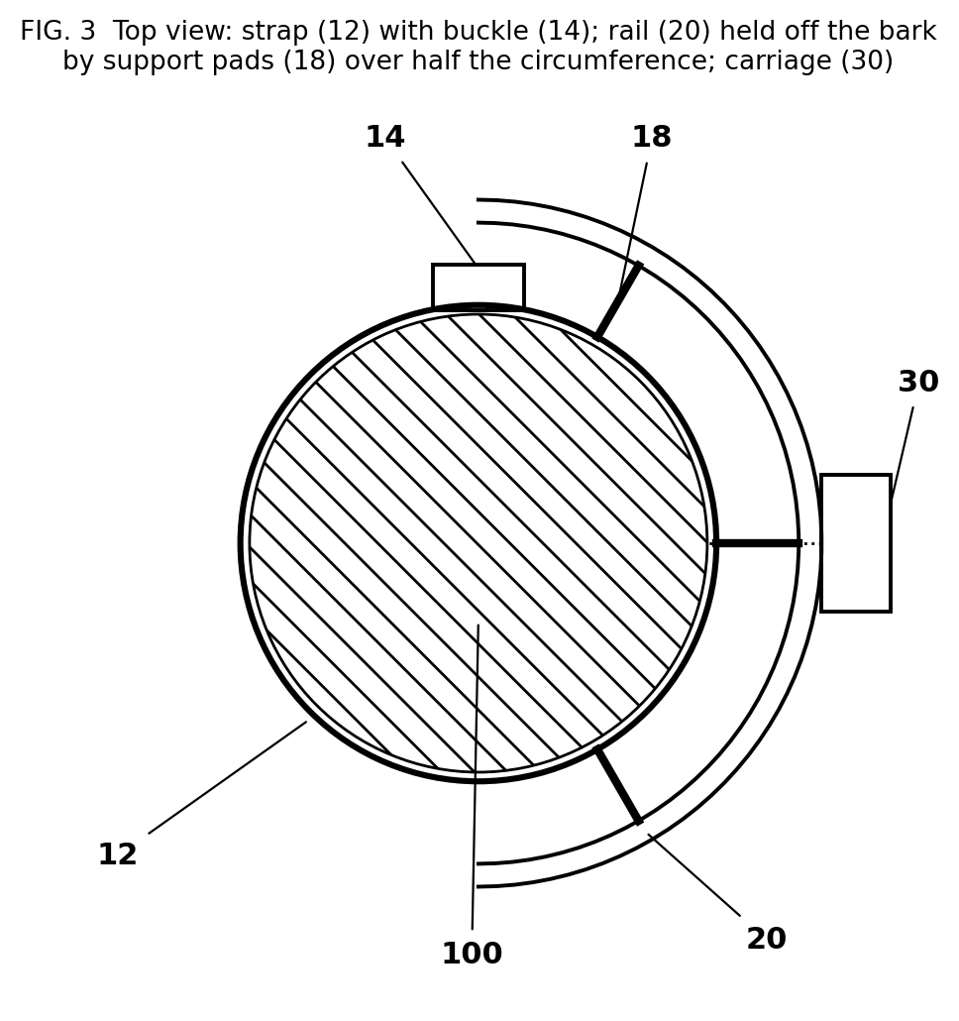
Figure 3: Top view, strap and rail held off the bark by pads

5.3 Cutter carriage (30 to 56)
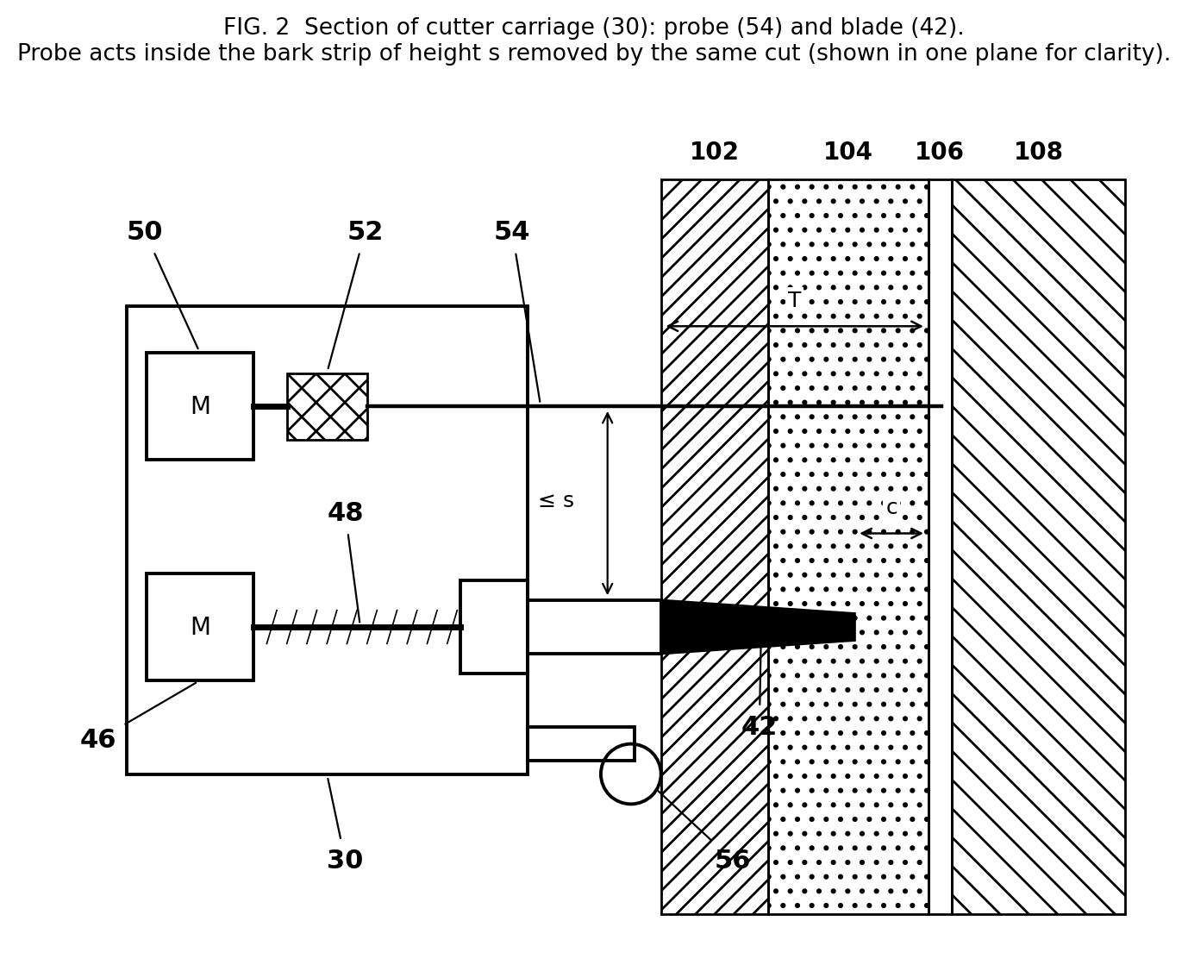
Figure 2: Section of the carriage. The probe works inside the strip removed by the same cut.
- Drive: 12 V planetary gear motor, about 60 rpm, 15+ kg·cm, with hall encoder (34, 35), driving a 20-tooth GT2 pulley (36) on the belt rack. Four V-groove rollers clamp the carriage to the strip.
- Blade (42): a standard V-gouge tapping blade (easy to buy and re-sharpen) on a slide (44) running on an MGN9 miniature linear guide.
- Depth actuator (46, 48): pancake NEMA 17 stepper + Tr8×2 lead screw. With 1/8 microstepping: 800 steps per mm (0.00125 mm per step). The lead screw is self-locking, so cutting force cannot push the blade back.
- Skid roller (56): runs on the outer bark and is the zero reference for depth, so the depth is measured from the real bark surface.
- Needle probe (54): 0.8 mm hardened steel needle, same drive type as the blade, pushing through a 5 kg load cell (52). It is mounted a short distance ahead of the blade along the cut line, so the outer part of each prick is shaved off by the blade.

5.4 How bark gauging works
- The needle advances in 0.1 mm steps; the load cell is read after each step (HX711 at 80 samples/s).
- First force above about 50 g → bark surface (position P0).
- The needle passes the bark at moderate force. When it meets the wood, the force rises sharply. A rise of more than about 600 g within 0.3 mm → wood (position P1). (Both numbers must be calibrated.)
- Bark thickness T = P1 − P0. The needle retracts.
- Measured at 5 %, 50 % and 95 % of the rail length. T values and the date are written to the tree tag.
- While cutting, blade depth d(x) = T(x) − c, interpolated between the 3 points using the encoder position x.
Wound note: the needle does pass through the cambium at 3 small points. This is the same as the standard manual bark gauge that inspectors use, and the 0.8 mm hole is small. Because of tag memory it happens about once a month per tree instead of every tapping. Section 10 includes a check of how these pricks heal.

5.5 Motor sizing (calculation)
Quantity | Value | Note
Estimated cutting force F | 60 to 100 N | ASSUMPTION: measure it (Section 10, test 2)
GT2 20-tooth pulley pitch radius r | 6.37 mm | Pitch diameter 12.73 mm
Torque needed = F × r | 100 × 0.00637 = 0.64 N·m ≈ 6.5 kg·cm | Worst case
Motor chosen | ≥ 15 kg·cm at output | Safety factor about 2.3
Carriage speed | 60 rpm × 40 mm per rev = 40 mm/s | S/M rail cut ≈ 15 s, L rail ≈ 22 s

5.6 Energy per tree (battery sizing)
Load | Estimate
Carriage motor: 12 V × 3 A × 25 s (cut + return) | 0.25 Wh
Steppers and electronics: 12 V × 0.8 A × 20 s | 0.05 Wh
Total, normal tree | ≈ 0.30 Wh
Battery 3S3P 18650: 11.1 V × 7.8 Ah × 80 % usable | ≈ 69 Wh → about 200 trees (fewer on gauging days)

5.7 Latex spout and cup (72, 74)
A normal spout and cup stay on the tree as in manual tapping. The machine is removed after the cut.

6. Bill of Materials (Prototype)
Approximate Indian prices (2026) from online electronics stores (Robu, Robokits, etc.) and local fabricators. Use BIS-registered Li-ion cells or packs.
Item | Qty | Cost (₹)
ESP32 DevKit (WROOM-32) | 1 | 450
TMC2209 stepper driver | 2 | 700
BTS7960 motor driver | 1 | 350
Pancake NEMA 17 stepper | 2 | 1,800
Tr8×2 lead screw 100 mm + nut + coupler | 2 | 800
MGN9 linear guide 100 mm | 2 | 1,400
12 V 60 rpm planetary gear motor with encoder, ≥15 kg·cm | 1 | 1,800
Load cell 5 kg + HX711 | 1 | 250
ACS712-20A current sensor | 1 | 150
PN532 NFC reader | 1 | 450
NTAG213 weatherproof tags (pack of 50) | 1 | 750
DS3231 RTC module | 1 | 200
Li-ion pack 3S3P 7.8 Ah with BMS | 1 | 2,500
12.6 V 2 A charger | 1 | 500
LM2596 buck converter | 1 | 100
E-stop mushroom switch (NC + NO) | 1 | 250
Limit switches, start button, buzzer, LED | set | 200
10 A fuse, holder, main switch | set | 150
Ratchet straps 25 mm + rubber backing | 2 | 700
Spring-steel strip 25×1.5 mm | 1.5 m | 400
GT2 belt 2 m + 20T pulley | 1 | 350
Support pads, end clips (aluminium + rubber) | set | 600
Carriage plate + V-groove rollers | set | 600
V-gouge tapping blade | 1 | 250
0.8 mm steel needles | 5 | 100
IP54 enclosure + cable glands | 1 | 400
Wires, connectors, PCB, fasteners | set | 700
Machining / welding / cutting | - | 2,000
Subtotal |  | ≈ 18,900
Contingency (≈15 %) |  | 2,800
Budget to request |  | ≈ ₹22,000
At production volume (500 to 1,000 units, custom PCB, bulk parts) the parts cost could fall to roughly ₹9,000 to ₹12,000 per unit. This is an estimate to check with suppliers.

7. Electronics and Wiring
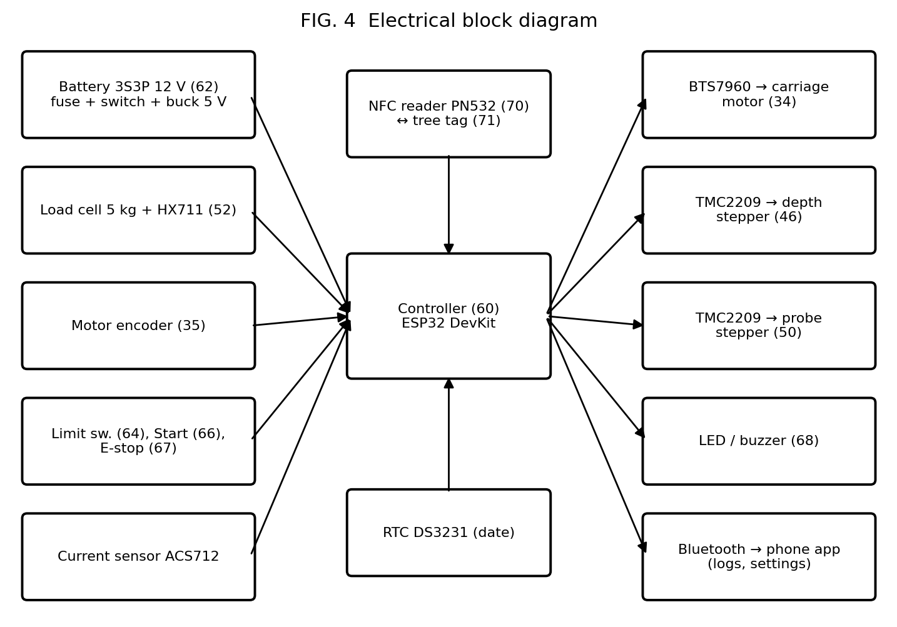
Figure 4: Electrical block diagram
ESP32 pin | Connected to | Purpose
25 / 26 | BTS7960 RPWM / LPWM | Carriage motor
32 / 33 | Encoder A / B | Carriage position
14 / 27 | TMC2209 #1 STEP / DIR | Blade depth
13 / 4 | TMC2209 #2 STEP / DIR | Needle probe
23 | Both TMC2209 EN | LOW = enabled
18 / 19 | Top / bottom end stops (to GND) | Rail ends
16 | Start button (to GND) | Start cycle
35 | E-stop auxiliary contact + 10 kΩ pull-up to 3.3 V | E-stop signal
2 / 17 | LED / buzzer | Status
36 | ACS712 OUT via 10 kΩ / 20 kΩ divider | Motor current
39 / 5 | HX711 DOUT / SCK (RATE pin HIGH) | Probe force
21 / 22 | I2C SDA / SCL | PN532 (I2C mode) and DS3231
34 / 15 | PN532 IRQ / RSTPDN | NFC control
- E-stop: its normally-closed contact is wired in series with the 12 V supply to the motor driver and stepper drivers, so pressing it cuts motor power physically. Its second contact tells the ESP32.
- Power: battery → 10 A fuse → main switch → E-stop → motor drivers; a separate branch goes through the LM2596 (5 V) to the ESP32, HX711, ACS712 and PN532. Put a 100 µF capacitor at each stepper driver.
- Set the TMC2209 current (Vref) to about 70 % of the stepper's rated current before the first run.

8. Control Software
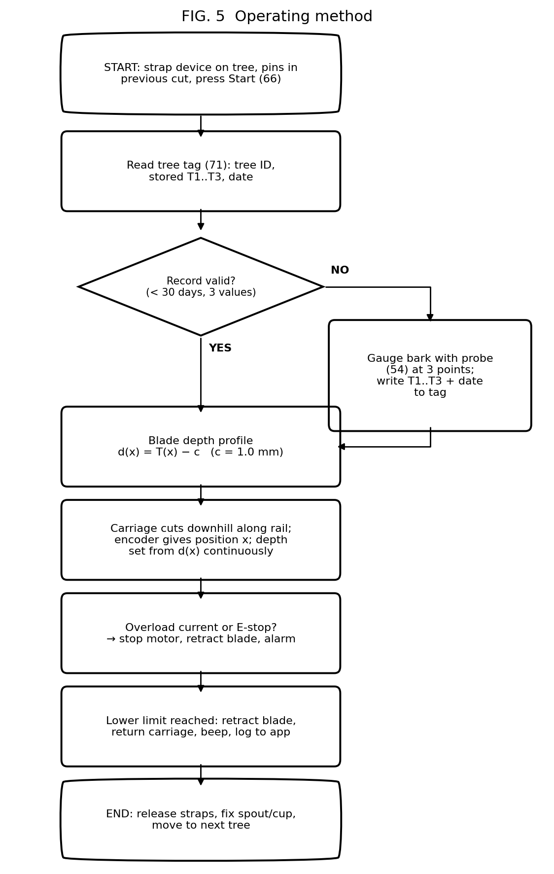
Figure 5: Operating method
The complete program is SmartTapper_v2.ino (ESP32 Arduino core 3.x; libraries: HX711 by Bogdan Necula, Adafruit PN532, RTClib). Main features:
- Reads and writes the tree tag (NTAG213 pages 4 to 6: marker, T1 to T3 in 0.1 mm, date, rail length).
- Gauges bark only when the record is missing, invalid or older than 30 days.
- Encoder-based position, depth profile interpolation, overload and E-stop checks, and full retraction on any fault.
- Sends a log of each tree over Bluetooth ("SmartTapper"): thickness, time and peak current. Any Bluetooth serial app on a phone can display it.
The program has not been compiled or run on hardware yet. Compile it in the Arduino IDE, then test each function on the bench before connecting the blade. Calibrate: HX711 scale factor, CONTACT_G, WOOD_RISE_G, PROBE_OFFSET_COUNTS, CURRENT_LIMIT_A.

9. Step-by-Step Build Procedure

Phase A: Mechanical (weeks 2 to 6)
- Make a mock-up on a 15 cm and a 40 cm PVC pipe (or real trunks) to confirm strap, pad and rail dimensions.
- Rivet the GT2 belt to the spring-steel strip; make pads and end clips; fit the adjustable end stops.
- Build the carriage plate with 4 V-groove rollers and the motor + pulley. Check smooth travel on both pipe sizes.
- Mount the MGN9 guides, the lead screws and the pancake steppers for the blade and the probe; add the skid roller.
- Mount the blade, the load cell and the needle holder. Add the alignment pins with thumb-screw adjustment.
- Add the blade guard.

Phase B: Electronics (weeks 4 to 7)
- Breadboard-test each part: motor + encoder counts, both steppers, load cell, current sensor, NFC read/write, RTC.
- Wire the E-stop in the motor power line. Test that pressing it stops the motors even if the program hangs.
- Solder onto perf-board or a simple PCB; fit in the IP54 box with glands.
- Upload SmartTapper_v2.ino and run the full cycle on a pipe covered with a 6 mm cork layer.

Phase C: Integration (weeks 7 to 9)
- Mount the electronics box on the lower strap; route cables so that they cannot reach the blade.
- Photograph and video every stage (for the report, the complete patent specification and marketing).

10. Testing and Validation Plan
Test | Where |  | Purpose
1. Bench | PVC pipe + cork layer |  | Mechanics, software, E-stop, depth repeatability
2. Cutting force | Fresh rubber log sections; pull a tapping blade with a spring balance / luggage scale |  | Real value of F for motor sizing
3. Probe calibration | Fresh log sections from a replanting site |  | Force-depth curves; set CONTACT_G and WOOD_RISE_G; compare T with vernier on sawn section
4. Field comparison | Trees due for replanting (with owner / Rubber Board permission) |  | Machine vs skilled tapper on alternate trees for 4 to 6 weeks
5. Prick healing | Same trees |  | Inspect probe points after 2 and 4 weeks
6. Endurance | One full field session |  | Trees per charge, heating, blade wear, tag reliability in rain
Metric |  | Method |  | Target
Bark thickness accuracy |  | Probe vs vernier on the sawn section |  | ±0.3 mm
Residual bark over cambium |  | Small inspection window cut after tapping |  | 1.0 ± 0.3 mm
Bark consumption |  | Distance between successive cuts |  | s ± 0.2 mm
Wounds |  | Count per 10 trees, machine vs manual |  | Fewer than manual
Latex yield |  | ml per tree or g dry rubber, alternate trees |  | Equal to or better than manual
Time per tree |  | Stopwatch |  | ≤ 50 s normal day
Trees per charge |  | Count |  | ≥ 150
Probe calibration sheet: for each sample record force at touch, force jump at wood, probe T, vernier T and error. Plot force against depth. This curve is key evidence for the complete specification.

11. Working Method and Economics
A skilled tapper spends about 15 to 20 seconds per tree. The machine needs about 40 to 50 seconds (strap on, cut, strap off). So the machine is not faster for a single worker. Its value is:
- Unskilled workers can tap correctly. This addresses the tapper shortage, and family members can tap their own smallholding.
- Fewer cambium wounds and uniform bark use, so the panel lasts longer and tree life and yield are protected.
- Records: each tree's bark and tapping log, useful for estates.
Two-unit method: one worker uses two machines. While unit A cuts tree 1, the worker straps unit B on tree 2. The effective time falls to about 25 to 30 s per tree. Test this in the field.
Do a simple cost-benefit table with real data from your field test: tapping wage per tree in your area, yield difference, bark saving, machine price. It is the most important slide for any investor or funding body.

12. Safety
- Blade guard; blade always retracted when not cutting; hardware E-stop cutting motor power.
- Over-current stop, time-outs and bark-reading range checks in software.
- BIS-registered Li-ion cells with BMS and fuse; charge with the correct charger only.
- Gloves and eye protection; test only with permission, first on trees due for replanting.

13. Timeline and Team Roles
Week | Work | Output
1 | Patent search; rubber estate / Rubber Board visit | Search table, confirmed dimensions
2 | File provisional patent | Application number, priority date
2-6 | Mechanical build | Frame, rail, carriage
4-7 | Electronics and code | Working bench system
7-9 | Integration, force and probe calibration | Calibration data
10-15 | Field comparison (4 to 6 weeks) | Results
16-17 | Report, video, presentation | Project report
Before month 12 | Complete specification + Form 18/18A | Complete application
Roles: (1) mechanical, (2) electronics, (3) software and calibration, (4) patent search, documents, testing records. Keep a dated, signed logbook; it proves inventorship.

14. Draft Provisional Specification (Form 2)
SUPERSEDED FOR FILING: use Form2_Provisional_Specification.docx and Form2_Complete_Specification_DRAFT.docx. They remove the method claim (Section 3(h)), use a 13-word title and 10 claims, and follow the Indian page format. See Patent_Problems_and_Solutions_India.docx. The draft below is kept for study only.
Draft for your guide or patent agent to refine after the search. Keep the numerals identical to the drawings. Drawing sheets: black and white on A4, with sheet number and applicant name on each sheet.
FORM 2
THE PATENTS ACT, 1970 (39 of 1970) & THE PATENTS RULES, 2003
PROVISIONAL SPECIFICATION (See section 10 and rule 13)
1. TITLE: A PORTABLE TREE TAPPING DEVICE WITH BARK-THICKNESS GAUGING, TREE-MOUNTED DATA TAG AND AUTOMATIC CUT-DEPTH CONTROL, AND A METHOD THEREOF
2. APPLICANT(S): Name: ______________ Nationality: Indian Address: ______________
3. PREAMBLE: The following specification describes the invention.

FIELD OF THE INVENTION
[001] The invention relates to devices for harvesting latex from trees, and in particular to a portable motor-driven device for tapping rubber trees (Hevea brasiliensis) that measures bark thickness, stores it on a tag attached to the tree, and controls the depth of the tapping cut to protect the cambium.

BACKGROUND OF THE INVENTION
[002] Latex is harvested by removing a thin strip of bark along an inclined half-spiral cut. In downward tapping each new cut is made immediately below the previous cut, consuming about 1.5 to 2 mm of bark per tapping. For good yield the cut should approach the cambium closely, leaving about 1 mm of bark.
[003] Manual tapping knives depend wholly on the skill of the tapper. Excess depth wounds the cambium, causing bark malformation and loss of yield, and insufficient depth lowers yield. Skilled tappers are increasingly scarce.
[004] Motorised tapping knives with fixed mechanical depth guides are known, but bark thickness varies between trees and around a single trunk, so a fixed depth is either too shallow or too deep. Tree-mounted robotic tapping systems are costly and generally require one unit per tree. Manual bark gauges measure bark thickness but are not connected to any cutting device.
[005] There is a need for a portable, low-cost tapping device usable by unskilled persons that adapts the cutting depth to the bark thickness of each tree while keeping bark consumption uniform.

OBJECTS OF THE INVENTION
[006] To provide a portable tapping device that measures bark thickness along the tapping line and automatically sets the blade depth to leave a predetermined residual bark thickness over the cambium.
[007] To store the measured bark thickness on a data tag attached to the tree so that measurement, and hence probing of the tree, is required only at intervals.
[008] To keep bark consumption per tapping uniform irrespective of operator skill.
[009] To provide a single device that is quickly mounted on and removed from trees of different girths.
[010] To provide a method of tapping using the device.

SUMMARY OF THE INVENTION
[011] A portable tapping device (10) comprises a mounting assembly (12, 14, 16, 18) detachably fixable to the trunk of a tree (100); a guide rail (20) held by the mounting assembly along an inclined tapping line; a cutter carriage (30) driven along the rail by a motor (34) whose position is sensed by an encoder (35); a blade (42) on the carriage movable radially by a depth actuator (46, 48); bark-thickness gauging means (50, 52, 54) on the carriage; and a control unit (60) that sets the radial depth of the blade from the measured bark thickness so that a predetermined residual thickness of bark remains over the cambium (106).
[012] Preferably the gauging means comprises a needle probe (54) advanced through a force sensor (52), bark thickness being the probe travel between first contact with the bark and a rise in resisting force indicating the wood (108).
[013] Preferably a reader (70) on the device reads and writes a data tag (71) fixed to the tree, storing the measured bark thickness and date. The control unit uses the stored values while they are valid and re-measures when they are missing or older than a set period.
[014] Preferably alignment pins (26) engage the groove of the previous tapping cut so that the new cut is made a preset distance below it.

BRIEF DESCRIPTION OF THE DRAWINGS
[015] Fig. 1: front view of the device on a tree. Fig. 2: section of the cutter carriage with probe, blade and bark layers. Fig. 3: top view of the mounting assembly and rail. Fig. 4: electrical block diagram. Fig. 5: flowchart of the tapping method.

DETAILED DESCRIPTION
[016] Referring to Figs. 1 and 3, upper and lower straps (12a, 12b) with ratchet buckles (14) and resilient backing encircle the trunk. A flexible guide rail (20) of spring-steel strip carrying a toothed belt (24) is held at a distance from the bark by resilient support pads (18) and is fixed at its ends to the straps by sliding clips (16), so that it follows a half-spiral path inclined at 20° to 35° to the horizontal. Adjustable end stops (64) define the ends of the tapping line.
[017] Alignment pins (26) near the ends of the rail engage the groove of the previous tapping cut. A screw adjustment sets the distance between the pins and the upper edge of the blade, which equals the bark consumption per tapping, for example 1.5 mm, the new cut being made below the previous cut.
[018] Referring to Fig. 2, the carriage (30) is guided on the rail by grooved rollers and driven by a geared motor (34) through a pulley (36) meshing with the belt (24). A hall encoder (35) gives the carriage position along the rail. A V-shaped gouge blade (42) on a slide (44) running on a linear guide is moved radially by a stepper motor (46) and self-locking lead screw (48). A skid roller (56) running on the outer bark (102) provides the depth reference.
[019] A needle probe (54) of about 0.8 mm diameter is advanced radially by a stepper motor (50) through a load cell (52). The control unit advances the probe in increments of about 0.1 mm, reading the force after each increment. The position at which force first exceeds a contact threshold is taken as the bark surface. The probe passes through the outer bark (102) and soft bark (104). On reaching the wood (108) the force rises sharply, and the position at which the rise within a short travel exceeds a wood threshold is recorded. The difference is the bark thickness T. The probe is located on the carriage ahead of the blade along the tapping line, within the band of bark removed by the cut, so that the outer portion of each puncture is removed by the blade.
[020] Referring to Figs. 4 and 5, the control unit (60) comprises a microcontroller powered by a battery (62) and connected to an NFC reader (70) and a real-time clock. On start, the control unit reads the tag (71) on the tree. If a valid record not older than a set period (for example 30 days) exists, the stored thicknesses are used. Otherwise the carriage measures the rail length between end stops, gauges the bark at several points (for example at 5 %, 50 % and 95 % of the rail length), and writes the thicknesses and date to the tag.
[021] The carriage then moves along the rail from the upper end to the lower end while the control unit continuously sets the blade depth d(x) = T(x) − c, where T(x) is interpolated between the gauged points from the encoder position x and c is the predetermined residual thickness (for example 1.0 mm, settable from 0.5 to 1.5 mm). A current sensor stops the carriage and retracts the blade on overload. An emergency-stop switch interrupts power to the actuators. At the lower end stop the blade retracts and the carriage returns. Latex flows along the cut to a spout (72) and cup (74).
[022] The device is removed and mounted on the next tree. Because a single device serves many trees and the depth and bark consumption are set automatically, unskilled persons can tap without injuring the cambium, and probing of each tree is needed only at intervals.
[023] In other embodiments the gauging means may be ultrasonic, capacitive or impedance-based; the tag may be RFID, a printed code or a record in a phone linked to a tree identifier; the mounting may use rigid clamps or chains; and the drive may be a rack and pinion or a screw. Such variants are within the scope of the invention.
[024] (Complete specification: add experimental results such as force-depth curves, depth accuracy, yield and wound comparison with manual tapping, and prototype photographs.)

CLAIMS (for the Complete Specification)
We claim:
1. A portable tapping device (10) for extracting latex from a tree (100), comprising: a mounting assembly (12, 14, 16, 18) detachably fixable to the trunk of the tree; a guide rail (20) supported by the mounting assembly along an inclined tapping line; a cutter carriage (30) movable along the guide rail by a drive motor (34), the carriage carrying a cutting blade (42) radially movable relative to the trunk by a depth actuator (46, 48); characterised in that the carriage further carries bark-thickness gauging means (50, 52, 54) adapted to measure the bark thickness (T) at one or more points along the tapping line, and a control unit (60) is configured to set the radial depth of the blade from the measured bark thickness such that a predetermined residual thickness (c) of bark remains over the cambium (106).
2. The device as claimed in claim 1, wherein the gauging means comprises a needle probe (54) advanced by a probe actuator (50) through a force sensor (52), and the control unit determines the bark thickness as the probe travel between a first contact force and a rise in force indicative of the wood (108).
3. The device as claimed in claim 2, wherein the needle probe is located on the carriage ahead of the blade along the tapping line, within the band of bark removed by the blade.
4. The device as claimed in claim 1, comprising a reader (70) adapted to read and write a data tag (71) attached to the tree, wherein the control unit stores the measured bark thickness and a date on the tag and uses the stored bark thickness for subsequent tappings until it is older than a predetermined period.
5. The device as claimed in claim 1, comprising an encoder (35) indicating the position of the carriage along the rail, wherein the control unit measures the bark thickness at a plurality of points and varies the blade depth along the cut by interpolation according to the encoder position.
6. The device as claimed in claim 1, comprising alignment pins (26) adapted to engage the groove of the previous tapping cut and means for adjusting the distance between the pins and the blade, whereby each new cut is made a set distance below the previous cut.
7. The device as claimed in claim 1, wherein the mounting assembly comprises flexible straps (12a, 12b) encircling the trunk, the guide rail is a flexible strip held off the bark by resilient support pads (18) and fixed to the straps by sliding clips (16), and adjustable end stops (64) define the ends of the tapping line.
8. The device as claimed in claim 7, wherein the guide rail carries a toothed belt (24) engaged by a pulley (36) driven by the drive motor.
9. The device as claimed in claim 1, wherein the depth actuator comprises a stepper motor (46) and a self-locking lead screw (48), and a skid roller (56) running on the bark surface provides the depth reference.
10. The device as claimed in claim 1, comprising a current sensor for the drive motor and an emergency-stop switch, wherein the control unit stops the carriage and retracts the blade on overload or emergency stop.
11. The device as claimed in claim 1, wherein the predetermined residual thickness is settable between 0.5 mm and 1.5 mm and the inclination of the tapping line between 20° and 35°.
12. A method of tapping a tree using the device as claimed in claim 1, comprising: (a) mounting the device on the trunk; (b) reading a data tag attached to the tree and, when no valid bark-thickness record exists, measuring the bark thickness at one or more points along the tapping line with the gauging means and writing the result to the tag; (c) calculating a blade depth equal to the bark thickness minus a predetermined residual thickness; (d) moving the carriage along the rail while holding the blade at the calculated depth to remove a strip of bark below the previous cut; and (e) retracting the blade and removing the device.

ABSTRACT
A portable tapping device (10) for rubber trees has straps (12a, 12b) and a flexible inclined rail (20) along which a motor-driven, encoder-tracked carriage (30) moves a radially adjustable blade (42). A force-sensing needle probe (54) on the carriage measures bark thickness at several points on the tapping line by detecting bark contact and the force rise at the wood. The values and date are stored on a tag (71) on the tree and reused until they expire. A control unit (60) sets the blade depth to the bark thickness less a predetermined residual thickness, protecting the cambium, while alignment pins (26) in the previous cut fix the bark consumed per tapping. Unskilled persons can tap many trees consistently. (Fig. 2)

15. Patent Filing Procedure (India)

15.1 Inventors and applicant
- Inventors: everyone who contributed to the inventive idea (students and guide). Be honest; wrong inventorship can invalidate the patent.
- Applicant (owner): the inventors, the college, or later your startup company. Check your college IPR policy first. If you plan to start a company, agree in writing who owns the patent, so it can be assigned to the company later.

15.2 Steps
- Keep it confidential until the provisional is filed (no paper, competition, social media or public demonstration).
- Patentability search (Section 4.3). Adjust claims.
- E-filing account on ipindia.gov.in (needs a Class 3 digital signature; your college, KSCSTE or an agent may help).
- File the provisional: Form 1, Form 2 (Section 14), drawings (Figs. 1 to 5), Form 3 and, if available, Form 5. You get an application number and priority date. Then you may say "Patent Pending".
- Build, test and record results (Sections 9 and 10).
- File the complete specification within 12 months of the provisional date (strict deadline), with results, final claims, Form 5 and Form 3 updates.
- Request examination: Form 18, or Form 18A (expedited) if eligible (for example a DPIIT-recognised startup, small entity or female applicant). The deadline is 31 months from the priority date (Patents (Amendment) Rules, 2024). File it with the complete specification.
- Optional early publication: Form 9 (otherwise publication occurs after 18 months).
- Reply to the First Examination Report within 6 months (extendable by 3), attend any hearing, then grant.
- Pay renewal fees from the 3rd year to keep the patent alive (maximum 20 years from filing).
- Filing abroad (Thailand, Indonesia, Vietnam, Malaysia and Côte d'Ivoire are large rubber producers): file a PCT application within 12 months of the Indian filing. Indian residents need foreign-filing permission (Section 39) unless the Indian application was filed at least 6 weeks earlier and no secrecy direction was issued.

15.3 Approximate official fees (e-filing, natural person / startup / small entity / educational institution)
Form | Purpose | Fee (₹, approx.)
Form 1 | Application | 1,600
Form 2 | Specification | Included (extra if > 30 pages or > 10 claims)
Form 3 / 5 | Foreign filing statement / inventorship | No fee
Form 9 | Early publication (optional) | 2,500
Form 18 | Examination | 4,000
Form 18A | Expedited examination (eligible applicants) | 8,000
Form 28 | Startup / small entity proof | No fee
Renewal | From 3rd year | About 800 per year at first, rising later
This claim set has 12 claims, so 2 claims above 10 attract an extra per-claim fee (small amount for natural persons and startups). You may merge claims to stay at 10. Always check the current fee schedule on ipindia.gov.in. A patent agent typically charges ₹10,000 to ₹40,000 extra. DPIIT-recognised startups can get facilitator (agent) fees largely covered under the government SIPP scheme.

16. Launching the Product in India
A patent protects your idea, but it does not by itself give permission to sell. Launching needs the steps below. Check every regulation with a CA or advisor, because rules change.

16.1 Freedom to operate (FTO)
Even with your own patent, your product might use something covered by someone else's patent (for example a particular motorised tapping knife design). Before selling, get a freedom-to-operate check from a patent attorney, focusing on Indian patents in force in A01G 23/10.

16.2 Business setup
- Form a Private Limited company or LLP (Private Limited is better for investment).
- Get DPIIT Startup India recognition (free, online): lower patent fees, expedited examination, SIPP support, tax benefits.
- Udyam (MSME) registration and GST registration. Ask your CA for the correct HSN code (agricultural / horticultural tools and machinery) and current GST rate.
- Assign the patent application from the inventors or college to the company by a written agreement (with the college's permission if required).
- Trademark your brand name (classes 7 and 8; about ₹4,500 per class for individuals, startups and small entities). Consider design registration for the product's appearance.

16.3 Product compliance
- Batteries: Li-ion cells or packs sold in India must be BIS-registered (Compulsory Registration Scheme, IS 16046). Buy registered cells or packs; chargers may also need BIS registration.
- Battery Waste Management Rules, 2022: a company placing batteries on the market (including inside equipment) may need Extended Producer Responsibility registration with CPCB. Confirm the applicability.
- Safety: user manual in English and Malayalam (and other languages for other states), warning labels, blade guard, warranty terms.
- Subsidy eligibility: to be sold with a government farm-machinery subsidy (for example under the Sub-Mission on Agricultural Mechanization), a machine usually needs a test report from a Farm Machinery Training & Testing Institute or an authorised centre. Plan this test once the design is final.
- Field validation: a trial report from the Rubber Board / RRII or an agricultural university (for example KAU) greatly increases farmers' trust.

16.4 Funding options (check current calls)
- College incubator / Technology Business Incubator (TBI).
- Kerala Startup Mission (KSUM) innovation grants (if in Kerala).
- NIDHI-PRAYAS (DST) prototype grant through host incubators.
- Startup India Seed Fund Scheme through approved incubators.
- Agri-startup programmes (for example NABARD-supported, RKVY-RAFTAAR agribusiness incubators).

16.5 Manufacturing and sales
- Start with a pilot batch of 20 to 50 units by a local fabricator plus a custom PCB, then move to injection-moulded or die-cast carriage parts.
- Customers: rubber estates facing tapper shortage, Rubber Producers' Societies, smallholders through dealers of tapping supplies, Rubber Board demonstration programmes. Kerala has most of the area; Tripura and the North-East are growing regions.
- Business models: outright sale; rental or "tapping-as-a-service" per tree through societies; lease with subsidy.
- After-sales: spare blades, needles, tags, batteries; a service network in rubber districts.
- Price target: set it only after the cost-benefit data from field trials (Section 11). As a rough guide, if production cost is ₹10,000 to ₹12,000, a selling price around ₹20,000 to ₹25,000 would need to be justified by labour saving and bark / yield benefits.

17. Next-Step Checklist
- Review this version with your guide; agree inventors, applicant and budget.
- Contact the college IPR cell or KSCSTE Patent Information Centre.
- Complete the patent search and fill the comparison table.
- Finalise the Form 2 draft and drawings; file the provisional application.
- Visit the Rubber Board / RRII for permission and expert advice.
- Buy parts (Section 6); build (Section 9); calibrate and test (Section 10).
- File the complete specification with results before month 12; request examination.
- If going commercial: company, DPIIT recognition, trademark, FTO check, compliance, subsidy test, pilot batch.
Files in this folder: Rubber_Tapping_Machine_Project_and_Patent_v3.docx / .pdf (this document), Form2_Provisional_Specification.docx, Form2_Complete_Specification_DRAFT.docx, Patent_Drawing_Sheets.pdf, Patent_Problems_and_Solutions_India.docx, SmartTapper_v2.ino (ESP32 program), figures_v2/ (patent drawings). Version 1 files are kept for reference only; do not use them.

