## **Lubricant Oil Manufacturing Process in Singapore**

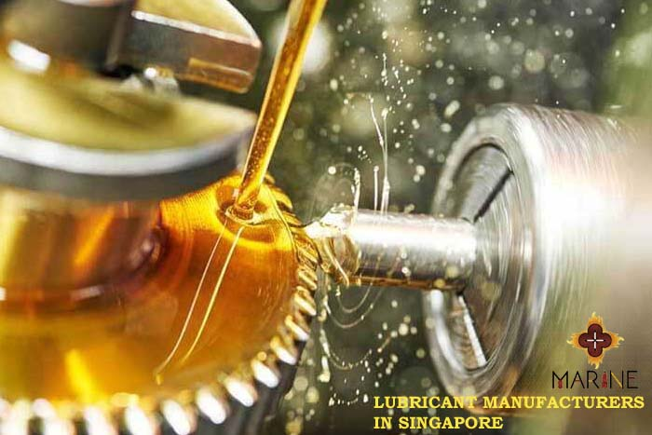

Lube oil is extracted from crude oil in [**Lubricant Oil Company Singapore**](https://marine8.com.sg/), which undergoes a preliminary purification process i.e., sedimentation before it is pumped into fractionating towers. A typical high-efficiency fractionating tower, 25 to 35 feet in diameter and up to 400 feet tall, is formed of high-grade steels to resist the corrosive compounds present in crude oils; inside, it's fitted with an ascending series of condensate collecting trays.

Within a tower, the thousands of hydrocarbons in petroleum are separated from one another by a process called fractionation. As the vapors rise up through the tower, the numerous fractions cool, condense and return to liquid form at different rates determined by their respective boiling points (the lower the boiling point of the fraction, the upper it rises before condensing). Natural gas reaches its boiling point first, followed by gasoline, kerosene, fuel oil, lubricants, and tars.

Sedimentation

1 The petroleum is transported from the oiler to the refinery by pipeline or tanker ship. At the refinery, the oil undergoes sedimentation to get rid of any water and solid contaminants, like sand and rock, which will be suspended in it. During this process from [**Lubricant Manufacturers in Singapore**](https://marine8.com.sg/), the crude is pumped into large holding tanks, where the water and oil are allowed to separate and the contaminants settle out of the oil.

Fractionating

2 Next, the petroleum is heated to about 700 degrees Fahrenheit (371 degrees Celsius). At this temperature, it breaks down into a mix of hot vapor and liquid that's then pumped into rock bottom of the primary of two fractionating towers. Here, the hot hydrocarbon vapors float upward. As they cool, they condense and are collected in several trays installed at different levels within the tower. In this tower, normal air pressure is maintained continuously, and about 80 percent of the petroleum vaporizes.

3 The remaining 20 percent of the oil is then reheated and pumped into a second tower, wherein vacuum pressure lowers the residual oil's boiling point in order that it can be made to vaporize at a lower temperature. The heavier compounds with higher boiling points, like tar and therefore the inorganic compounds, remain behind for further processing.

Filtering and solvent extraction

4 The lube oil that has been collected within the 2 fractionating towers is valued several ultrafine filters, which remove remaining impurities. Solvent extraction is feasible because aromatics are more soluble within the solvent than the lube oil fraction is. When the lube oil is treated with the solvent, the aromatics dissolve; later, after the solvent has been removed, the aromatics are often recovered from it.

Additives, inspection, and packaging

5 Finally, the oil is mixed with additives to offer it the specified physical properties (such because of the ability to face up to low temperatures). At now, the lube oil is subjected to a spread of internal control tests that assess its viscosity, relative density, color, flash, and fire points. The oil that meets quality standards is then packaged for sale and distribution in [**Lubricant oil Company Singapore**](https://marine8.com.sg/oil-and-gas.html).

Quality Control

Most applications of lubricant oils need that they be no resinous, pale-colored, odorless, and oxidation-resistant. Over a dozen physical and chemical tests are wont to classify and determine the grade of lubricating oils. Common physical tests include measurements for viscosity, relative density, and color, while typical chemical tests include those for flash and fire points.

The Future

The future of mineral-based grease is restricted because the natural supplies of petroleum are both finite and non-renewable. **Steel Fabrication Company Singapore** estimates the total recoverable light to medium petroleum reserves at 1.6 trillion barrels, of which a third has been used. This is true not just for grease but also for the opposite products that result from petroleum refining.