# **Steel Fabrication Services for Pharmaceutical Industry**

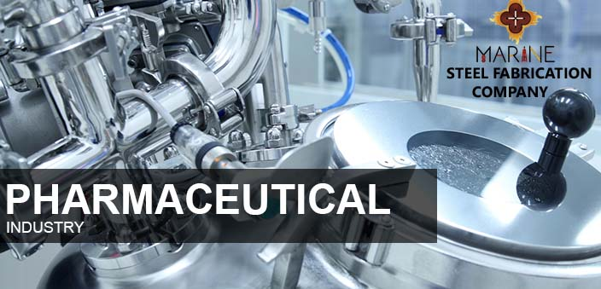

For a number of years now, stainless steel has enjoyed widespread popularity in the pharmaceuticals industry, simply because it matches up very well with the criteria established in the industry for the requirements of industry-specific products. It’s very important in pharmaceutical usage that any metals in [**Structural Steel Supplier in Singapore**](https://marine8.com.sg/) used are highly resistant to corrosion, that they can be easily manufactured, and that they can be quickly and easily cleaned without surface particles coming off in the process.

Some specific examples of how stainless steel is used in the pharmaceutical industry include the areas of pumps, processing and reaction vessels, storage tanks, heat exchangers, tubes and pipelines, and valves and taps. All of these products are easily made, easily cleaned, and are highly resistant to corrosive action, but there are even more uses for the various types and grades of stainless steel in the pharmaceuticals industry.

**Grades of steel and how they’re used**

The most used grouping of stainless steels from steel fabrication company in the pharmaceutical industry is grade 1.4401 and its derivatives. Although other specific grades of stainless steel will still be chosen on the basis of their suitability to a particular service or action being performed.

It’s conjointly potential that the operational mode of a facility can influence stainless-steel grade choice, because some facilities operate continuously while using a clean-in-place method, whereas others will close the power down for a comprehensive all-at-once cleansing.

In mild environments where chloride content does not exceed 200 mg/L, an austenitic stainless steel grade such as 1.4031 might be used, while chloride content up to 500 mg/L might indicate a grade of 1.4401. When chloride content exceeds 500 mg/L, it’s very common to see duplex stainless grades such as 1.4362 and 1.4462 chosen, because they offer high resistance to stress corrosion cracking. For [**Structural Steel Supplier Singapore**](https://marine8.com.sg/) service environments which are even more aggressive, it may be necessary to use the super-austenitic stainless steel grade 1.4547, or the super-duplex grade of 1.4410.

**Types of stainless steel**

Austenitic Steels

The most common types of stainless steel are the austenitic types, whose structure is comprised of nitrogen, nickel, and manganese. This kind of structure is responsible for imparting characteristics such as formability and weldability to the finished product. The resistance to corrosion which stainless steel naturally has can be supplemented by adding more nitrogen, along with chromium and/or molybdenum.

These untainted steels from [**Steel Fabrication Company in Singapore**](https://marine8.com.sg/after-market.html) don't get any tougher with treatment, however, they will be processed to extraordinary levels of strength.

Ferritic Steels

Ferritic steels are largely comprised of chromium, with small amounts of carbon mixed in. They are structurally similar to low-alloy steels and carbon, and since they are not particularly useful for welding, they are mostly used in thin sections where welding is not required.

Martensitic steels are much like for ferritic steels in that their primary ingredient is chromium, although they have a greater carbon content than do the ferritic steels. This being the case, they can be tempered and hardened in the same fashion as carbon or low-alloy steels. Their usage comes in play primarily in settings where moderate resistance to corrosion is necessary, but high-strength is a solid requirement. Martensitic steels are more commonly manufactured in  [**Steel Fabrication Company Singapore**](https://marine8.com.sg/people.html) into long-ish products, rather than in plates or sheets, and have relatively low formability and weldability.

Precipitation-hardening Steels

Precipitation-hardening steels can achieve extraordinary strength when components such as aluminum, niobium, and copper are added in. These types of steels are often machined into shapes that are fairly intricate and delicate because they sustain very minimal distortion during the final treatment process. This is in stark contrast to more conventional martensitic steels, where greater distortion typically occurs during hardening and tempering.