# **Steel and Its usage for various Industry**

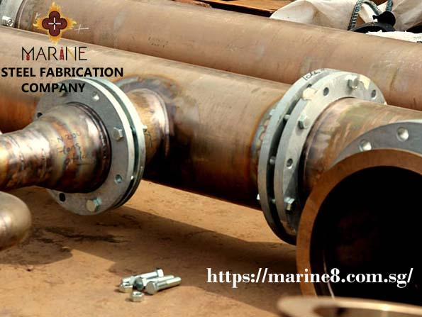

Steel is both the most widely used material and most recycled metal material on earth. From stainless and high-temperature steels to flat carbon products in [**Steel Fabrication Company Singapore**](https://marine8.com.sg/), steel in its various forms and alloys offer different properties to meet a wide range of applications. For these reasons, similarly because the metal's combination of high strength and a comparatively low cost, steel is currently utilized in innumerable merchandise.

Steel applications can be divided into five sectors:

1. Construction
2. Transport
3. Energy
4. Packaging
5. Appliances and Industry

**Construction:**

The majority of steel goes to the development business.

Sustainable steel structures may be engineered quickly at a coffee worth.

Steel, in its various forms and alloys, can be designed to meet the requirements of unique projects of [**Structural Steel Supplier Singapore**](https://marine8.com.sg/after-market.html), which allow it to be incorporated into infrastructure in all environments. Depending on the conditions that the structure is exposed to, steel can be alloyed or surface-treated differently for protection.

The development of efficient steel Fabrication Company Singapore techniques at the end of the 20th century contributed to the growth of railways around the world as well as the advent of the high-rise building.

Steel can also be found in:

Low and high-rise buildings

Education and hospital buildings

Sports stadiums, stations

Reinforced concrete

Bridge deck plates

Piers and suspension cables

Harbors

Cladding and roofing

Office

Tunnels

Security fencing

**Transport:**

Engineering steels are shaped steels that are designed to possess sure specific levels of snap, strength, ductility, and corrosion resistance.

They are used in the general engineering and manufacturing sectors, but the bulk goes to transport vehicles.  
[Steel Fabrication Company in Singapore](https://marine8.com.sg/power-generation.html) accounts for over 50% the weight of an average car. Advanced high-strength steels (AHSS) are used in vehicles. It is a lightweight material that requires less energy to produce and reduces CO2 emissions.

Different types of steel are used for the automotive body, doors, engine, gearbox, steering, suspension, wheel axles, and interior.

Besides the automotive market, steel is found in transport materials such as:

Trucks  
transmissions  
train’s  
rails  
ships  
anchor chains  
aircraft undercarriages  
jet engines components

**Energy:**

All segments of the energy sector, as well as nuclear, wind power, electrical and gas, demand steel for infrastructure.

Steel is additionally used for resource extraction, like in offshore platforms, earth-moving and production instrumentation, cranes, and forklifts.

Due to the demanding environments, carbon, micro-alloyed, high strength and stainless steels are all used in the production of offshore platforms and pipelines.

In addition to those, several different energy comes trust giant amounts of steel:

Oil and gas wells and platforms

Pipelines

Electricity power turbine components

Electricity pylons

Wind turbines

Transmission towers

Electromagnets

Transformer cores

Electromagnetic shields

**Packaging:**

Steel packaging protects the product from water, air, and light-weight exposure, and is absolutely utile.

This technique of storage has been around for over two hundred years. Steel allows for high-speed filling and lightweight, easy to open the packaging.

Packaging steels square measure typically made up of low carbon cold-rolled steel strip and square measure surface finished.

The steel is tin-plated to prevent corrosion and then coated with a polymer, lacquered, and printed.

The majority of steel packaging goes towards food and drink containers, followed by a general line, aerosols, and closures (e.g., bottle caps).

**Appliances and Industry:**

About 75% of the weight of typical household appliances comes from [**Structural Steel Supplier in Singapore.**](https://marine8.com.sg/)

Steel is found in appliances like fridges, laundry machines, ovens, microwaves, sinks, cutlery, etc.

Steel conjointly accounts for several industrial product like farm vehicles and machinery, storage tanks, tools, structures, walkways, and protecting instrumentation.