UNDOABLE COUNTER:
These are the states we have
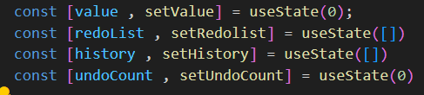
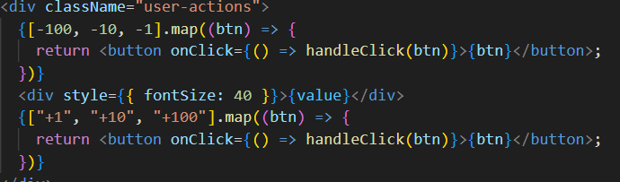
We have the buttons to show when I click on the button.
I will get the value in string I will convert to number. And set value and maintain history.
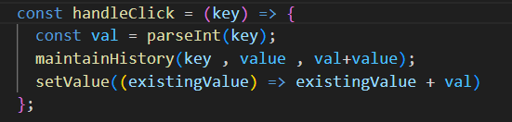
In maintain history I am creating an object and spreading history, history is the array and doing the unshift and set history.
unshift () method adds new elements to the beginning of an array.
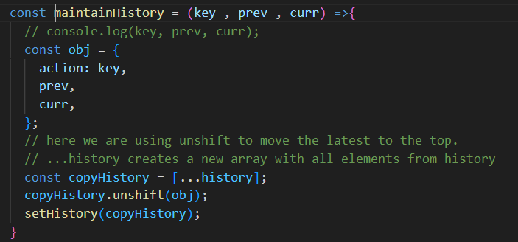
While we are doing the undo it won’t cross the length 5 and we are shift the history first item when we click on the undo then we are set history and set the value of of previous one.
When the undo shift value it will added to the redolist by using the push and we reset redolist.
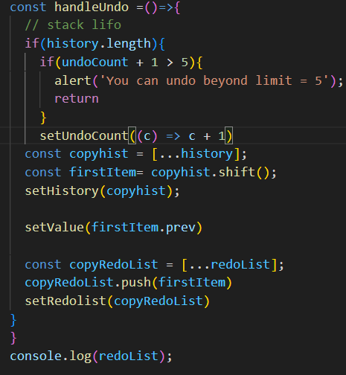
In the handleRedo function we spread the redolist and pop up the value and get that action , Prev and cur value and we set the value and we also maintain history and we set the maintainhistory.
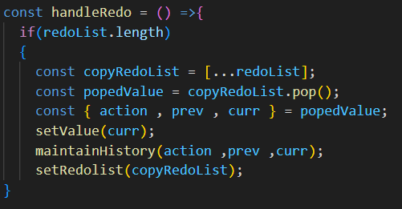
We will display history like this.
