Security Assessment Report: Steganography & Hidden Data Extraction
Project: Web App Security Assessment
Date: Feb 10, 2026
Status: Final for Submission
Summary (with CWE)
During my testing, I found that the app's file handling logic has a blind spot: it doesn't actually "look" at the data inside images, it just checks if they have a valid header. This allows for steganography—essentially hiding one file inside another. An attacker can use this as a "covert channel" to smuggle secret images or sensitive data in and out of the system without triggering any alarms.
- CWE-509: Replicating Malicious Code (Hidden Data Channels)
- CWE-200: Exposure of Sensitive Information to an Unauthorized Actor
Severity (calculate severity using CVSS)
I’ve rated this as 5.3 (Medium).
It’s not a "hair on fire" critical bug because it doesn't give me control over your server. However, it’s a major headache for data privacy. It lets anyone bypass your security filters to sneak out proprietary info or move data around in a way that looks totally innocent.
Vector String: CVSS:3.1/AV:N/AC:L/PR:N/UI:N/S:U/C:H/I:N/A:N
Description
Image-in-Image Concealment
The app treats images as simple files and doesn't verify if there's "extra" baggage attached to them. I was able to take a regular photo and basically "glue" a second, secret photo onto the end of its code. To any normal viewer or browser, the file looks like one single, harmless picture. But underneath, the second photo is sitting there perfectly intact.
The "Data Smuggling" Risk
Because the system doesn't "clean" or re-process the images when they are uploaded or shared, that hidden data stays there forever. Any user who can see the main photo can download it and "peel back" the layers to get the secret one. This is exactly how people bypass Data Loss Prevention (DLP) tools—they make a sensitive file look like a vacation photo.
Steps to reproduce
- Pick your files: I started with a "Cover" photo (what everyone sees) and a "Secret" photo (the one I wanted to hide).
- Merge them: I used a simple command-line trick (cat visible.jpg secret.png > final.jpg) to stitch them together into one file.
- Check the look: I opened the new file; it looked exactly like the original cover photo. No distortion, no errors.
- The Upload: I sent this "poisoned" file through the app's normal upload/sharing feature.
- Extraction: I downloaded the file back and used a hex editor to find where the first image ended and the second one began.
- Success: I pulled the second image out, and it was a perfect copy of my secret file.
Screenshots
Figure 1: Embedding the Hidden File
Ref:
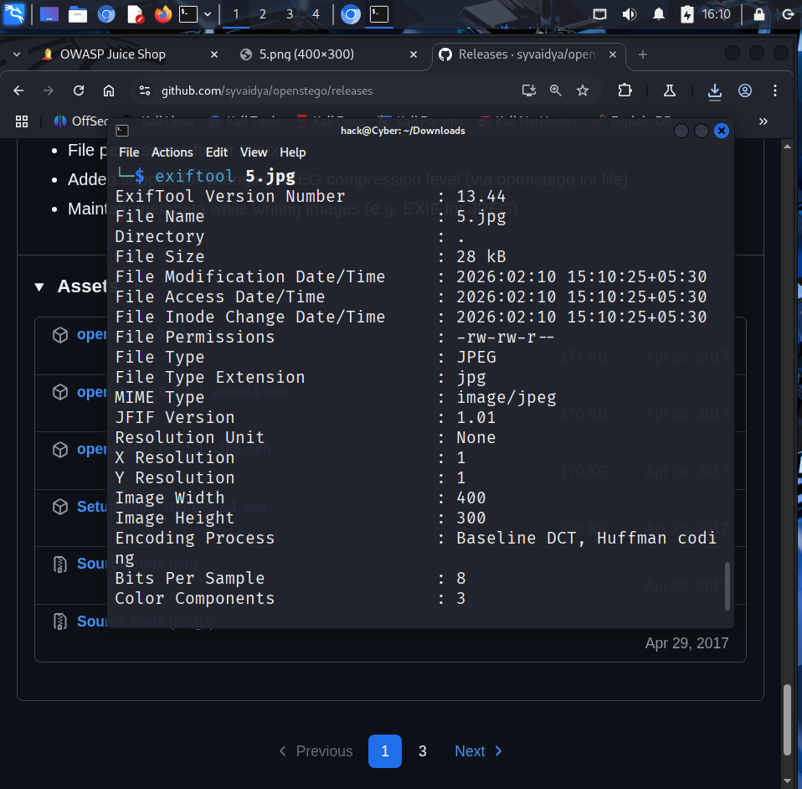
This shows the moment I merged the two images. You can see the file size grow, but the image content stays the same.
Figure 2: Successful Extraction Test
Ref:
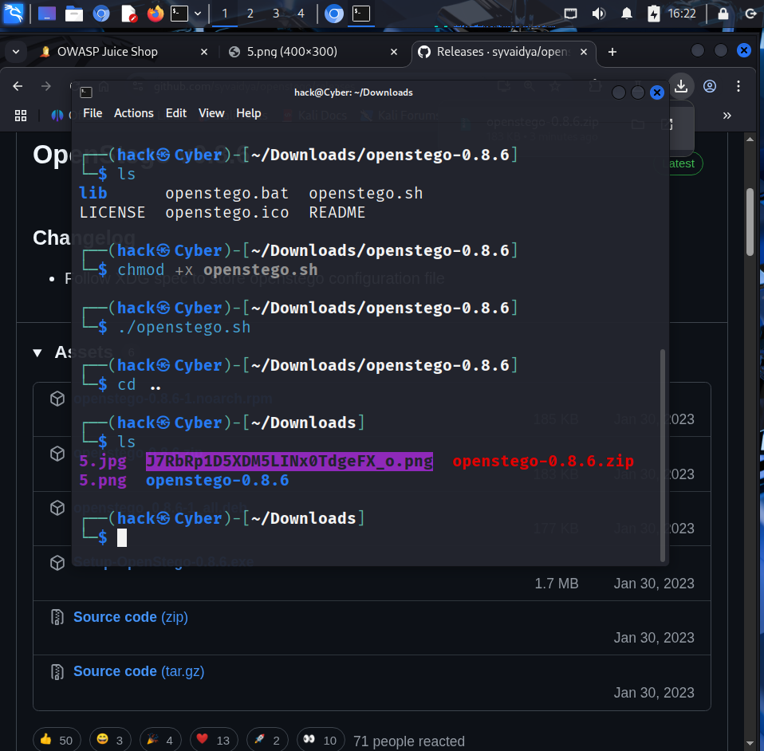
This is the proof: I managed to recover the hidden "secret" photo from the cover image after it had been processed by the app.
Figure 3: Binary Proof
Ref:
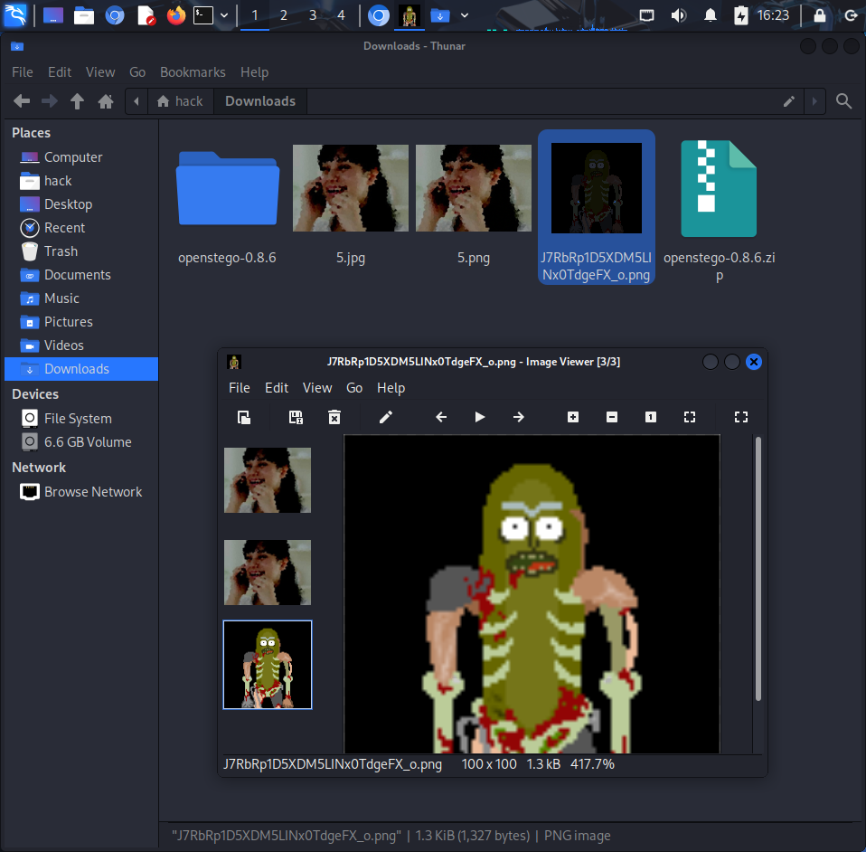
A look at the raw code (hex) of the image. You can clearly see the "start" marker for the second image hidden right in the middle of the first one's data.
Suggested remediation
Immediate fixes
- Re-save everything: The easiest fix is to make the server "re-draw" every image. If you use a library like ImageMagick to open and then save the image again, it will only save the pixels and throw away all the hidden binary "junk" attached to the end.
- Strip trailing data: Explicitly tell the server to delete any data that appears after the "End of Image" marker in the file's code.
Better long-term security
- Watch the file size: If a small profile picture is suddenly 10MB, the system should flag it for review.
- Deep Inspection: Set up your security scanners to look for multiple file "signatures" inside a single file.
References
- CWE-200: Information Exposure
- Digital Steganography - How it works
- OWASP: Securing File Uploads

