[So-care](https://editor.wix.com/html/editor/web/renderer/render/document/cb40bab6-ddcf-41ad-bd80-067da6f6cc2c)

[**Make earth a better place for living**](https://editor.wix.com/html/editor/web/renderer/render/document/cb40bab6-ddcf-41ad-bd80-067da6f6cc2c)

**Inhaling poison day by day is bringing us close to the end. And there wasn’t much that we were able to do about it, but with the following you will be able to breath good.**

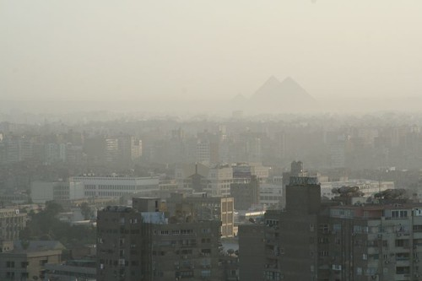

[Grab your reader’s attention with a great quote from the document or use this space to emphasize a key point. To place this text box anywhere on the page, just drag it.]