Executive Summary

-Abstract

-Background

-Methodology

-Results

-Conclusions

Material culture is an important part of the past. It is the only physical representation of a group’s history and tells a story of how they once lived and what they valued. The same can be said of one of the world’s oldest and most beautiful cities, Venice. The city is littered with material culture which can be found in some of the most unexpected places including high above the city in towers.

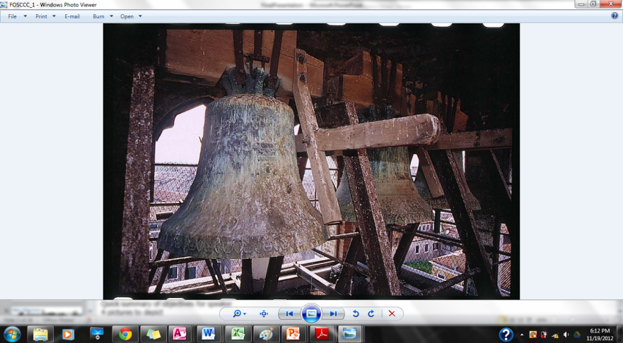Venetian bells are part of the city’s material culture because of their original function as a call to prayer, a signal for celebration, fires, and invading enemies. Considering the age of the bells varies from a few decades to a couple centuries they act as a snapshot of the age when they were caste. Therefore they are an important piece to Venice’s past. However, they remain in a place separated from everyday life. Their separation from humans leaves them forgotten and neglected, as a result the bells and by relation the bell towers, have fallen into a state of disrepair. Without repair the condition of the bells will continue to deteriorate resulting in the loss of precious work by artisans long ago.

Figure 1 Bells covered in Pigeon droppings in Santa Fosca.

Our job going to Venice was to understand what was at risk should the bells deteriorate beyond recognition and which bell or bell tower was in seriously bad condition and in need of repair. The first steps to understanding the condition of the bells was to take a look at the previous work completed from 1992 until 2004 by various groups such as the Venice Project Center, Earthwatch, and historian Adrianno Bocardi. Organizing all of the information they had previously collected into