Cron Jobs on bluehost
ftp.veniceprojectcenter.org/home3/venicep2/public_html/dashboard/scripts/vpc
status and funcionnality April, 12 2015
Initial rel. Tomaso Minelli, 2015.04.11
Update TM 2015.04.12

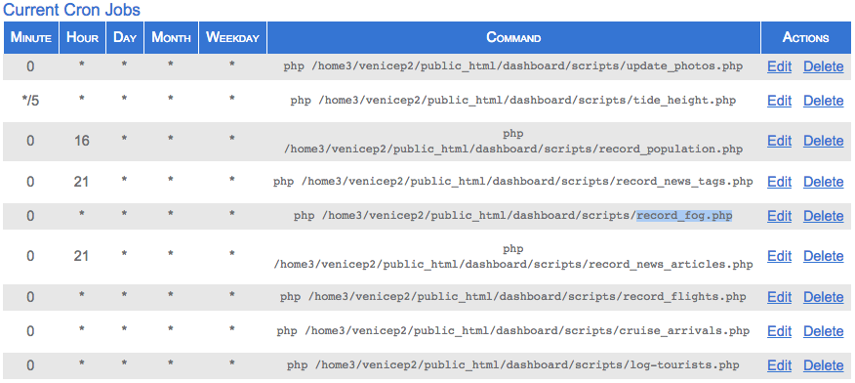
01_update_photo.php
executed: every hour
read from: instagram
write to: dashboard/venice_photos
what they do: log latest 5 photos to lat=45.44&lng=12.33

02_tide_height.php
executed: every 5 minutes
read from: ./tide_functions.php
./lib/simple_html_dom.php
../logs/tide_forecast.json
../logs/tide_forecast.csv
http://www.comune.venezia.it/flex/cm/pages/ServeBLOB.php/L/IT/IDPagina/1748
http://93.62.201.235/maree/ESPORTAZIONI/DATI/Punta_Salute.html
write to: dashboard/t
what they do: set current_tide_level, next_significant_tide
log into ../logs/tide_forecast.csv

03_record_population.php
executed: daily, at 16 o'clock
read from: http://portale.comune.venezia.it/millefoglie/statistiche/scheda/QUARTIERE-POPOLA-2$1$------
write to: dashboard/venicePopulation
dashboard/currentPopulation
../widgets/population.tsv
what they do: log and set current population in Venice

04_record_news_tags.php
executed: daily, at 21 o'clock
read from: http://www.ilgazzettino.it/rss/nordest_venezia.xml
write to: dashboard/newsTags
what they do: get latest news from Gazzettino

05_record_news_articles.php
executed: daily, at 21 o'clock
read from: http://www.ilgazzettino.it/rss/nordest_venezia.xml
write to: dashboard/news_articles
what they do: get latest article from Gazzettino

06_record_fog.php
executed: every hour
read from: http://www.ilmeteo.it/portale/meteo/previsioni1.php?citta=Venezia&c=7729
write to: dashboard/displayFogNotice
what they do: get if any fog news is present

07_record_flights.php
executed: every hour
read from: http://www.flightstats.com/go/FlightSt
write to: dashboard/flights/..
dashboard/flightLogs/venice
what they do: get last hour Venice (*NOT treviso*) arrivals

08_venice_ship.php
executed: every hour
read from: dashboard/venice_ships
write to: dashboard/dashboard/vs
dashboard/ships/tourists
what they do: calculate today venice ships attivals and overnight and store it into fb

09_nmroads_signals.php
executed: every 5 minutes
read from: http://servicev3.nmroads.com/RealMapWAR/GetMessageSigns
write to: dashboard/nmroads/signals
what they do: download only active NM road message signs

99_log-tourists.php
executed: every hour
read from: dashboard/flights/passenger_ref
dashboard/ships/tourists
write to: dashboard/tourists
what they do: log complete tourists-attivals

