CONTENT RESEARCH AND SOURCING

Student Name: Angelique Fernandez
Student Number: ST10504943
Module Name: Web Development (Introduction)
Module Code: WEDE5020

- Organisation’s Website: N/A
- Social Media:
Content ideas are going to be based on research done about other NPOs and outreach groups. Social media will focus heavily on the community, food drives and mental health. This emphasizes the organization's central motto: "Serving with Heart and Purpose.
- Public Domain and Creative Commons Resources:
Fonts- Playfair Display, Times New Roman, Brittant Signature.
Images- Sourced only from Pexels, which are completely free.
IMAGE | IMAGE NAME | REFERENCE + LINK
Image 1 | Supplies.jpg | Supplies. 2026. [Online Image]. Available: image_9dDeYI.png [Accessed 19 August 2026].
Image 2 | Donation.jpg | donation. 2026. [Online Image]. Available: image_b7e7mG.png [Accessed 19 August 2026].
Image 3 | Volunteer.jpg | volunteer. 2026. [Online Image]. Available: image_GTqQjx.png [Accessed 19 August 2026].
Image 4 | Support.jpg | Support. 2026. [Online Image]. Available: image_CyaTAq.png [Accessed 19 August 2026].
Image 5 | Cirlcle.jpg | circle. 2026. [Online Image]. Available: image_-I_I_v.png [Accessed 19 August 2026].
Image 6 | Package.jpg | package. 2026. [Online Image]. Available: https://images.pexels.com/photos/11101542/pexels-photo-11101542.jpeg [Accessed 19 August 2026].
Image 7 | Logo.jpg | Original

- Original Content:
Image number 7 was created by me on Canva. The texts and descriptions were written by me.

WEBSITE STRUCTURE AND PLANNING
- Site map:
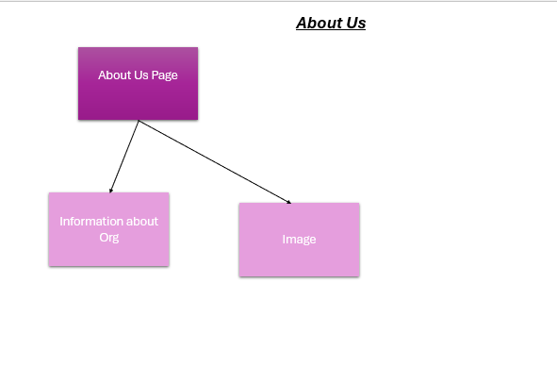
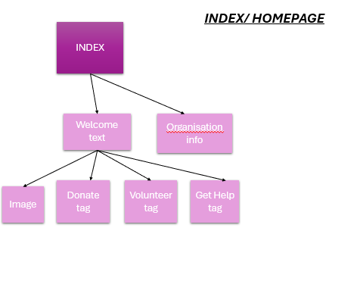

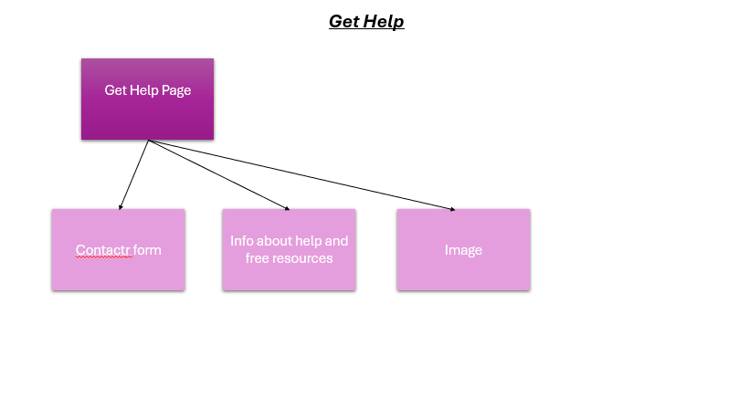
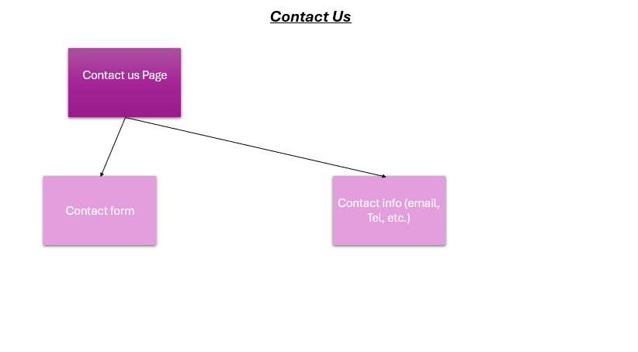
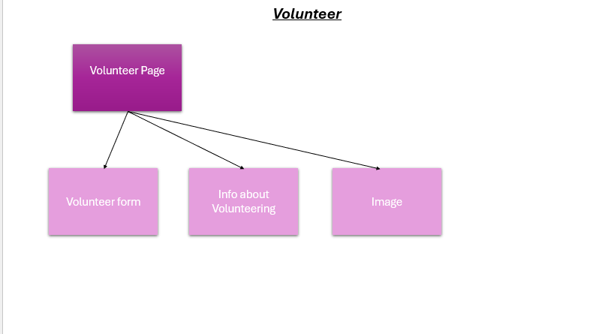
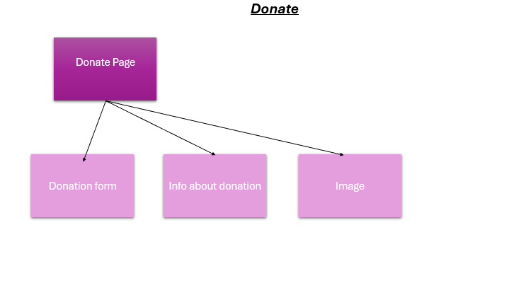

REFERENCES
Aaron Jack, 2024. HTML in 5 minutes. [video online] Available at: https://youtu.be/salY_Sm6mv4?si=SNBGp-xW7o6mGKEd [Accessed 20 August 2026].
Google (2026) Soth african emarganct number search results. Available at: https://www.google.com/search?q=soth+african+emarganct+number&rlz=1C1CHZN_enZA1078ZA1080&sourceid=chrome&ie=UTF-8&amc=1&gs_lcrp=EgZjaHJvbWUyBggAEEUYOdIBDTMxNTQwNDcwajBqMzOoAgCwAgHqBwoIARAAGAAgACgA&oq=soth+african+emarganct+number+&udm=50&aep=109&cud=1&source=chrome.crn.obic&atvm=2&mstk=AUtExfDpmHnyisP5asmlJpP4qWkqVMSAl2bHf8E3MD8GAp2KcWMHASJ5c13pjKW1BtlsItnuRJ52vKzkjIvzpMFqZpguDiBOcQ92k40saoKxcU9u6vBeRShExKBav4ig9xMPKYWuQxaFrvSySMwOPe6AsLC_EFcxUzUqEcL5PAOKgtthOKxz2WiOfgwSRYbK-vUJ3OQZv1bqbo1bUoV1pmuKMoz0WQ297vPCleqE133-OClBGebu-9ZyRTuotPStkCktDh6FNNqVQJCC8Q&csuir=1&mtid=S22IapbXBdaDhbIPnf298QQ [Accessed: 20 August 2026].
W3Schools. 2026. How TO - Alert Buttons. [Online]. Available at: https://www.w3schools.com/howto/howto_css_alert_buttons.asp [Accessed: 21 August 2026].
W3Schools. 2026. HTML <li> Tag. [Online]. Available at: https://www.w3schools.com/tags/tag_li.asp [Accessed: 20 August 2026].
W3Schools. 2026. HTML <li> Tag. [Online]. Available at: https://www.w3schools.com/tags/att_img_width.asp [Accessed: 20 August 2026].
W3Schools. 2026. HTML Tutorial. [Online]. Available at https://www.w3schools.com/html/default.asp [Accessed: 18 August 2026].

REFERENCING (PART 2)
GeeksforGeeks, 2025. CSS3 Media Query for All Devices. [online] Available at: https://www.geeksforgeeks.org/css/css3-media-query-for-all-devices/ [Accessed 24 September 2026].
The Independent Institute of Education, 2026. Mobile App Scripting [WEDE5020w]. nt. [online via internal VLE] The Independent Institute of Education. Available at: Recap: WEDE5020-support session 2 Tuesday, 22 September | Meeting | Microsoft Teams[Accessed 22 September 2026].
W3Schools, 2026. CSS Navigation Bars. [online] Available at: https://www.w3schools.com/css/css_navbar.asp [Accessed 20 September 2026].
W3Schools, 2026. HTML nav Tag. [online] Available at: https://www.w3schools.com/tags/tag_nav.asp [Accessed 18 September 2026].
The Independent Institute of Education, 2026. Mobile App Scripting [WEDE5020w]. nt. [online via internal VLE] The Independent Institute of Education. Available at: Recap: WEDE5020 Part 2 Support Session Monday, 21 September | Meeting | Microsoft Teams [Accessed 23 September 2026].
Rahul, C., 2026. The Correct Way to Center-align Web Layouts. W3Bits. [online] Available at: https://w3bits.com/blog/css-centered-layout/ [Accessed 17 September 2026].
W3Schools, 2026. Responsive Web Design - Media Queries. [online] Available at: https://www.w3schools.com/css/css_rwd_mediaqueries.asp [Accessed 23 September 2026].
W3Schools, 2026. CSS Center Align. [online] Available at: https://www.w3schools.com/css/css_align.asp [Accessed 17 September 2026].
W3Schools, 2026. CSS Forms. [online] Available at: https://www.w3schools.com/css/css_forms.asp [Accessed 15 September 2026].
W3Schools, 2026. CSS Styling Buttons. [online] Available at: https://www.w3schools.com/css/css3_buttons.asp [Accessed 24 September 2026].

