CONTENT RESEARCH AND SOURCING

Student Name: Angelique Fernandez
Student Number: ST10504943
Module Name: Web Development (Introduction)
Module Code: WEDE5020

- Organisation’s Website: N/A
- Social Media:
Content ideas are going to be based on research done about other NPOs and outreach groups. Social media will focus heavily on the community, food drives and mental health. This emphasizes the organization's central motto: "Serving with Heart and Purpose.
- Public Domain and Creative Commons Resources:
Fonts- Playfair Display, Times New Roman, Brittant Signature.
Images- Sourced only from Pexels, which are completely free.
IMAGE | IMAGE NAME | REFERENCE + LINK
Image 1 | Supplies.jpg | Supplies. 2026. [Online Image]. Available: image_9dDeYI.png [Accessed 19 August 2026].
Image 2 | Donation.jpg | donation. 2026. [Online Image]. Available: image_b7e7mG.png [Accessed 19 August 2026].
Image 3 | Volunteer.jpg | volunteer. 2026. [Online Image]. Available: image_GTqQjx.png [Accessed 19 August 2026].
Image 4 | Support.jpg | Support. 2026. [Online Image]. Available: image_CyaTAq.png [Accessed 19 August 2026].
Image 5 | Cirlcle.jpg | circle. 2026. [Online Image]. Available: image_-I_I_v.png [Accessed 19 August 2026].
Image 6 | Package.jpg | package. 2026. [Online Image]. Available: https://images.pexels.com/photos/11101542/pexels-photo-11101542.jpeg [Accessed 19 August 2026].
Image 7 | Logo.jpg | Original

- Original Content:
Image number 7 was created by me on Canva. The texts and descriptions were written by me.

WEBSITE STRUCTURE AND PLANNING
- Site map:
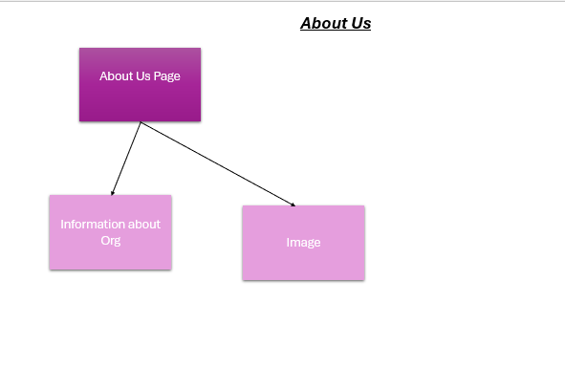
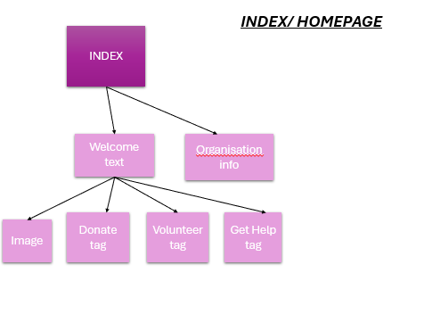

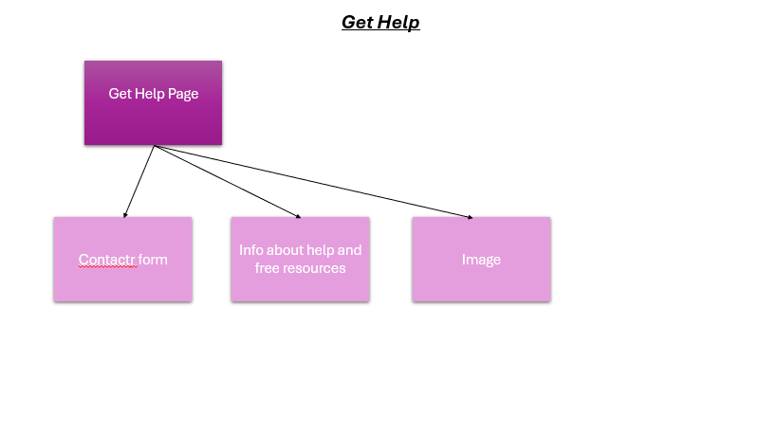
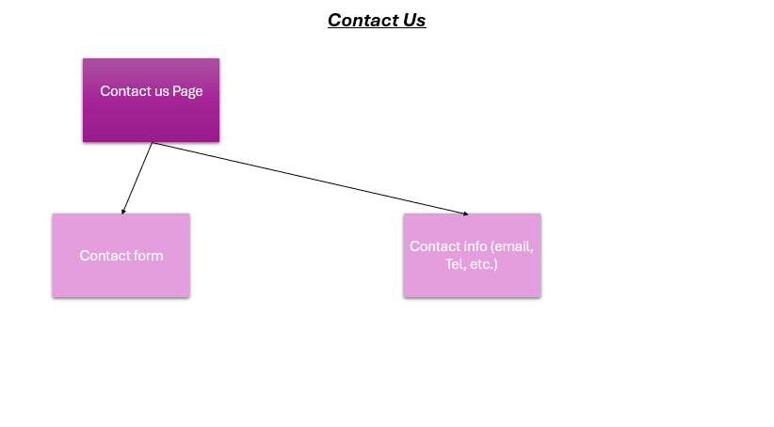
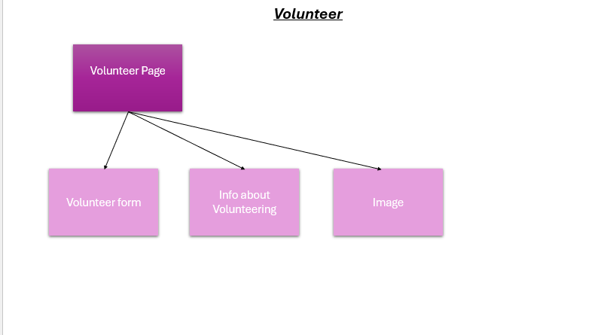
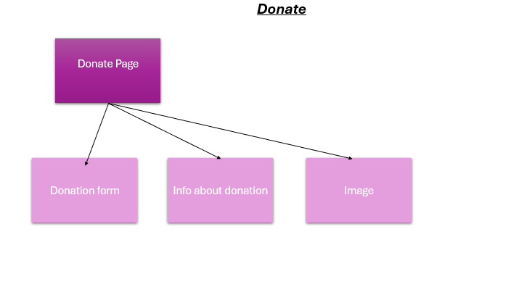

REFERENCES
Aaron Jack, 2024. HTML in 5 minutes. [video online] Available at: https://youtu.be/salY_Sm6mv4?si=SNBGp-xW7o6mGKEd [Accessed 20 August 2026].
Google (2026) Soth african emarganct number search results. Available at: https://www.google.com/search?q=soth+african+emarganct+number&rlz=1C1CHZN_enZA1078ZA1080&sourceid=chrome&ie=UTF-8&amc=1&gs_lcrp=EgZjaHJvbWUyBggAEEUYOdIBDTMxNTQwNDcwajBqMzOoAgCwAgHqBwoIARAAGAAgACgA&oq=soth+african+emarganct+number+&udm=50&aep=109&cud=1&source=chrome.crn.obic&atvm=2&mstk=AUtExfDpmHnyisP5asmlJpP4qWkqVMSAl2bHf8E3MD8GAp2KcWMHASJ5c13pjKW1BtlsItnuRJ52vKzkjIvzpMFqZpguDiBOcQ92k40saoKxcU9u6vBeRShExKBav4ig9xMPKYWuQxaFrvSySMwOPe6AsLC_EFcxUzUqEcL5PAOKgtthOKxz2WiOfgwSRYbK-vUJ3OQZv1bqbo1bUoV1pmuKMoz0WQ297vPCleqE133-OClBGebu-9ZyRTuotPStkCktDh6FNNqVQJCC8Q&csuir=1&mtid=S22IapbXBdaDhbIPnf298QQ [Accessed: 20 August 2026].
W3Schools. 2026. How TO - Alert Buttons. [Online]. Available at: https://www.w3schools.com/howto/howto_css_alert_buttons.asp [Accessed: 21 August 2026].
W3Schools. 2026. HTML <li> Tag. [Online]. Available at: https://www.w3schools.com/tags/tag_li.asp [Accessed: 20 August 2026].
W3Schools. 2026. HTML <li> Tag. [Online]. Available at: https://www.w3schools.com/tags/att_img_width.asp [Accessed: 20 August 2026].
W3Schools. 2026. HTML Tutorial. [Online]. Available at https://www.w3schools.com/html/default.asp [Accessed: 18 August 2026].

