Pray for Israel Live — Growth Initiative

Scaling what's already working — with external funding

Bottom Line: The PFI integration is already delivering results — our long-term reader retention has more than doubled since deployment (GA4-verified). However, the current PFI budget consumes our entire monthly marketing allocation, and the map's impact would multiply dramatically if more intercessors were visible. We propose securing external funding to both free up our marketing budget for its intended purposes and guarantee a dedicated, larger PFI budget from outside sources.

1. The PFI Integration Is Already Working
Since deploying PFI interactive banners across AIN in mid-May 2026, our GA4 cohort data shows a structural improvement in reader behavior. This is not a hypothesis — it is a measured result:
Retention Period | Pre-PFI (Jan 1 – May 15) | Post-PFI (May 16 – Jun 21) | Relative Change
Week 1 | 1.5% | 2.1% | +40%
Week 2 | 0.9% | 1.6% | +78%
Week 3 | 0.7% | 1.4% | +100% (2×)
Week 4 | 0.6% | 1.5% | +150% (2.5×)
PRE-PFI: 1.5% → 0.9% → 0.7% → 0.6% ▼ steady decline — readers leak out
POST-PFI: 2.1% → 1.6% → 1.4% → 1.5% ▲ stabilizes, rebounds — community behavior
The PFI prayer map acts as a "seal of authenticity" for evangelical first-time visitors. Seeing real believers praying in real time from around the world transforms a news visit into a community experience — and community is what brings people back.

2. A Unified Brand: Prayer Points + Global Prayer
The integration of AIN and PFI is not simply a technical feature — it creates a unique, unified brand positioning that no competitor can replicate:

AIN provides the what and why to pray for. PFI provides the where and with whom. Together, they form a brand that is simultaneously informational, spiritual, and communal — a combination no other pro-Israel media or ministry offers. This dual positioning strengthens both products: AIN articles become prayer fuel, and PFI engagement drives readers back to AIN.

3. Two Problems to Solve

Problem A: The marketing budget is maxed out
The current PFI operating cost (~$2,000/month) is being funded from AIN's full monthly marketing budget.
This is not sustainable: marketing needs its budget back for its primary mission

Problem B: The map could be far more impactful
The current results are promising — but they are achieved with approximately 5 simultaneous prayers on the map. Imagine the impact if visitors saw hundreds:
Concurrent Prayers | Visitor Perception | Effect on AIN
~5 (current) | Modest activity — works, but doesn't wow | Retention doubled (current state)
50–100 | "Real community is happening here" | Stronger retention + increased sharing
200–500+ | "The world is praying — I must join!" | Retention multiplier + viral growth
The retention lift we're seeing at 5 concurrent prayers is already remarkable. At 200+, the effect would compound: more prayers → more sharing → more AIN readers → more prayers. The current results prove the concept; proper funding would unlock its full potential.

4. The Solution: External Funding to Free Marketing & Scale PFI
We propose securing dedicated external funding from evangelical donors and foundations. This achieves two goals simultaneously:

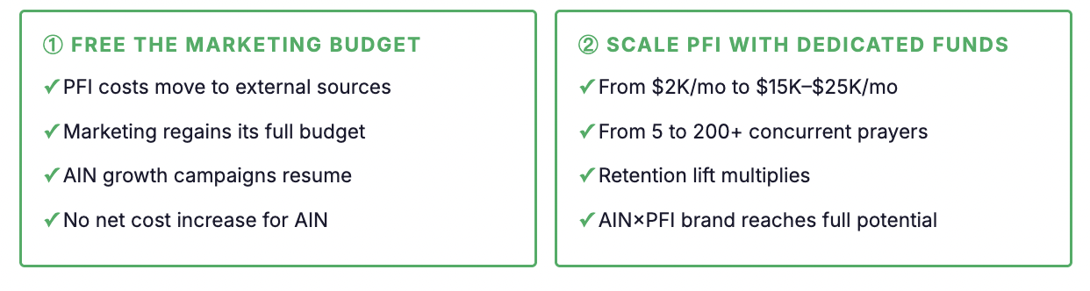5. Fundraising Approach: A Proven Network
I have identified a potential fundraising partner: a retired former director of a well-known Jerusalem-based Messianic school, with decades of personal relationships with major evangelical donors across the US, Europe, and East Asia. She has extensive experience in traveling internationally for faith-based fundraising and has a proven track record of securing significant donations.
She has not yet committed, but based on our initial conversations, I believe she would be open to participating under the right conditions. There are two possible models:
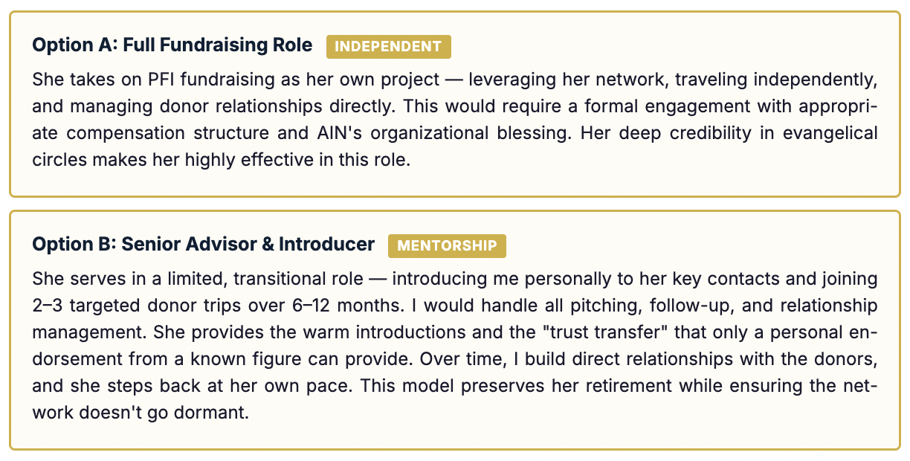
Both options require AIN leadership's authorization and organizational support. The window is time-sensitive: as she disengages further from ministry circles, her personal network access naturally diminishes.

The Ask — What We Need from Leadership

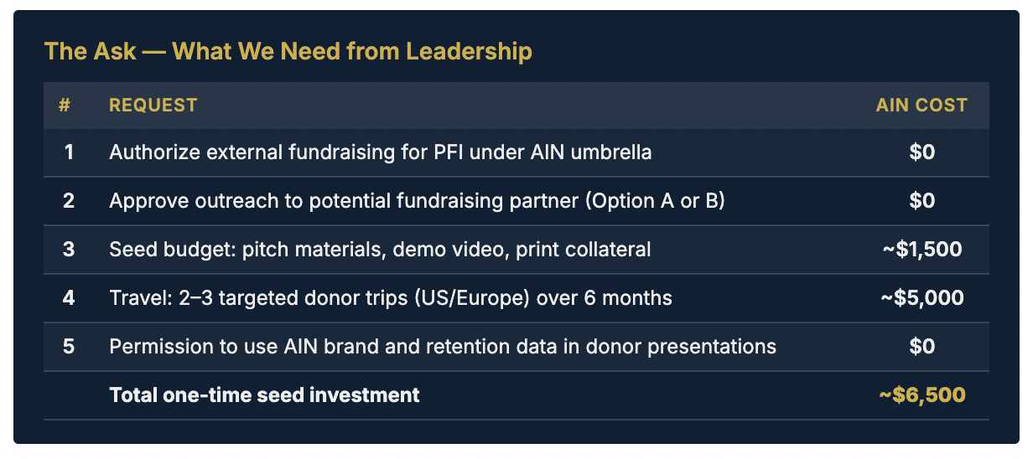

6. Return on Investment
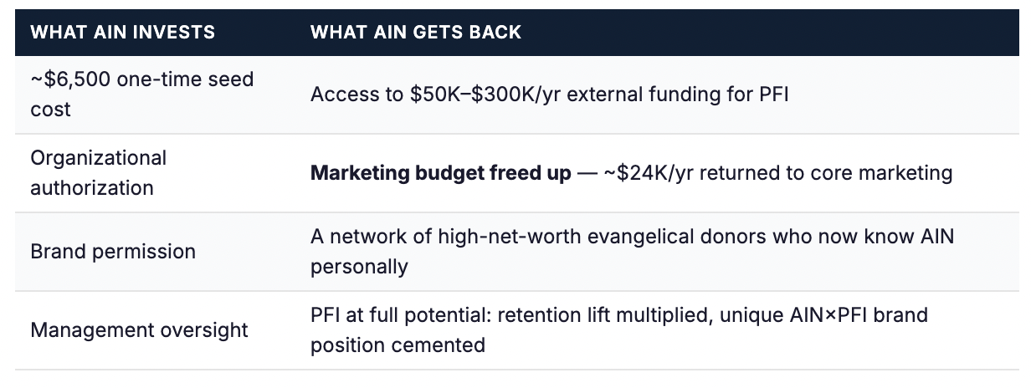
Conservative retention math (est. 400K monthly uniques): the current PFI integration adds approximately 3,600 additional loyal readers per month (Week 4 retention: 0.6% → 1.5%). At even $5/year average lifetime value, that represents ~$216K/year in additional reader value. Scaling PFI would multiply this figure further.

7. Why Now
- The data is in. We have 5 weeks of GA4 proof that PFI integration works. The longer we wait to scale, the more potential we leave unrealized.
- The marketing budget needs relief. Every month PFI runs on marketing's allocation is a month where AIN's other growth levers are unfunded.
- The fundraising partner window is closing. Retirement networks erode — her connections are most accessible now, not in a year.
- The AIN×PFI brand is unique. No one else has this. But "unique" only matters if we scale it before someone imitates it.
The integration works. The data proves it. Now the question is: do we keep it at survival level — or do we fund it to reach its God-given potential, with money that comes from outside our walls?
