Search field

Log inSign Up Get Certified Spaces Plus
❮
HTML CSS JAVASCRIPT SQL PYTHON JAVA PHP HOW TO W3.CSS C C++ C# BOOTSTRAP REACT MYSQL JQUERY EXCEL XML DJANGO NUMPY PANDAS NODEJS R TYPESCRIPT ANGULAR GIT POSTGRESQL MONGODB ASP AI GO KOTLIN SASS VUE DSA GEN AI SCIPY AWS CYBERSECURITY DATA SCIENCE
❯

NumPy Tutorial
NumPy HOMENumPy IntroNumPy Getting StartedNumPy Creating ArraysNumPy Array IndexingNumPy Array SlicingNumPy Data TypesNumPy Copy vs ViewNumPy Array ShapeNumPy Array ReshapeNumPy Array IteratingNumPy Array JoinNumPy Array SplitNumPy Array SearchNumPy Array SortNumPy Array Filter

NumPy Random
Random IntroData DistributionRandom PermutationSeaborn ModuleNormal DistributionBinomial DistributionPoisson DistributionUniform DistributionLogistic DistributionMultinomial DistributionExponential DistributionChi Square DistributionRayleigh DistributionPareto DistributionZipf Distribution

NumPy ufunc
ufunc Introufunc Create Functionufunc Simple Arithmeticufunc Rounding Decimalsufunc Logsufunc Summationsufunc Productsufunc Differencesufunc Finding LCMufunc Finding GCDufunc Trigonometricufunc Hyperbolicufunc Set Operations

Quiz/Exercises
NumPy EditorNumPy QuizNumPy ExercisesNumPy Certificate

NumPy Getting Started
❮ PreviousNext ❯

Installation of NumPy
If you have Python and PIP already installed on a system, then installation of NumPy is very easy.
Install it using this command:
C:\Users\Your Name>pip install numpy
If this command fails, then use a python distribution that already has NumPy installed like, Anaconda, Spyder etc.

Import NumPy
Once NumPy is installed, import it in your applications by adding the import keyword:
import numpy
Now NumPy is imported and ready to use.

ExampleGet your own Python Server
import numpy
arr = numpy.array([1, 2, 3, 4, 5])
print(arr)
Try it Yourself »

NumPy as np
NumPy is usually imported under the np alias.
alias: In Python alias are an alternate name for referring to the same thing.
Create an alias with the as keyword while importing:
import numpy as np
Now the NumPy package can be referred to as np instead of numpy.

Example
import numpy as np
arr = np.array([1, 2, 3, 4, 5])
print(arr)
Try it Yourself »

Checking NumPy Version
The version string is stored under __version__ attribute.

Example
import numpy as np
print(np.__version__)
Try it Yourself »

NumPy Introduction
❮ PreviousNext ❯

What is NumPy?
NumPy is a Python library used for working with arrays.
It also has functions for working in domain of linear algebra, fourier transform, and matrices.
NumPy was created in 2005 by Travis Oliphant. It is an open source project and you can use it freely.
NumPy stands for Numerical Python.

Why Use NumPy?
In Python we have lists that serve the purpose of arrays, but they are slow to process.
NumPy aims to provide an array object that is up to 50x faster than traditional Python lists.
The array object in NumPy is called ndarray, it provides a lot of supporting functions that make working with ndarray very easy.
Arrays are very frequently used in data science, where speed and resources are very important.
Data Science: is a branch of computer science where we study how to store, use and analyze data for deriving information from it.

Why is NumPy Faster Than Lists?
NumPy arrays are stored at one continuous place in memory unlike lists, so processes can access and manipulate them very efficiently.
This behavior is called locality of reference in computer science.
This is the main reason why NumPy is faster than lists. Also it is optimized to work with latest CPU architectures.

Which Language is NumPy written in?
NumPy is a Python library and is written partially in Python, but most of the parts that require fast computation are written in C or C++.

Where is the NumPy Codebase?
The source code for NumPy is located at this github repository https://github.com/numpy/numpy
github: enables many people to work on the same codebase.

❮ PreviousNext ❯

NumPy Getting Started
❮ PreviousNext ❯

Installation of NumPy
If you have Python and PIP already installed on a system, then installation of NumPy is very easy.
Install it using this command:
C:\Users\Your Name>pip install numpy
If this command fails, then use a python distribution that already has NumPy installed like, Anaconda, Spyder etc.

Import NumPy
Once NumPy is installed, import it in your applications by adding the import keyword:
import numpy
Now NumPy is imported and ready to use.

ExampleGet your own Python Server
import numpy
arr = numpy.array([1, 2, 3, 4, 5])
print(arr)
Try it Yourself »

NumPy as np
NumPy is usually imported under the np alias.
alias: In Python alias are an alternate name for referring to the same thing.
Create an alias with the as keyword while importing:
import numpy as np
Now the NumPy package can be referred to as np instead of numpy.

Example
import numpy as np
arr = np.array([1, 2, 3, 4, 5])
print(arr)
Try it Yourself »

Checking NumPy Version
The version string is stored under __version__ attribute.

Example
import numpy as np
print(np.__version__)
Try it Yourself »

NumPy Creating Arrays
❮ PreviousNext ❯

Create a NumPy ndarray Object
NumPy is used to work with arrays. The array object in NumPy is called ndarray.
We can create a NumPy ndarray object by using the array() function.

ExampleGet your own Python Server
import numpy as np
arr = np.array([1, 2, 3, 4, 5])
print(arr)
print(type(arr))
Try it Yourself »
type(): This built-in Python function tells us the type of the object passed to it. Like in above code it shows that arr is numpy.ndarray type.
To create an ndarray, we can pass a list, tuple or any array-like object into the array() method, and it will be converted into an ndarray:

Example
Use a tuple to create a NumPy array:
import numpy as np
arr = np.array((1, 2, 3, 4, 5))
print(arr)
Try it Yourself »

Dimensions in Arrays
A dimension in arrays is one level of array depth (nested arrays).
nested array: are arrays that have arrays as their elements.

NumPy Array Indexing
❮ PreviousNext ❯

Access Array Elements
Array indexing is the same as accessing an array element.
You can access an array element by referring to its index number.
The indexes in NumPy arrays start with 0, meaning that the first element has index 0, and the second has index 1 etc.

ExampleGet your own Python Server
Get the first element from the following array:
import numpy as np
arr = np.array([1, 2, 3, 4])
print(arr[0])
Try it Yourself »

Example
Get the second element from the following array.
import numpy as np
arr = np.array([1, 2, 3, 4])
print(arr[1])
Try it Yourself »

Example
Get third and fourth elements from the following array and add them.
import numpy as np
arr = np.array([1, 2, 3, 4])
print(arr[2] + arr[3])
Try it Yourself »

ADVERTISEMENT

Access 2-D Arrays
To access elements from 2-D arrays we can use comma separated integers representing the dimension and the index of the element.
Think of 2-D arrays like a table with rows and columns, where the dimension represents the row and the index represents the column.

Example
Access the element on the first row, second column:
import numpy as np
arr = np.array([[1,2,3,4,5], [6,7,8,9,10]])
print('2nd element on 1st row: ', arr[0, 1])
Try it Yourself »

Example
Access the element on the 2nd row, 5th column:
import numpy as np
arr = np.array([[1,2,3,4,5], [6,7,8,9,10]])
print('5th element on 2nd row: ', arr[1, 4])
Try it Yourself »

Access 3-D Arrays
To access elements from 3-D arrays we can use comma separated integers representing the dimensions and the index of the element.

Example
Access the third element of the second array of the first array:
import numpy as np
arr = np.array([[[1, 2, 3], [4, 5, 6]], [[7, 8, 9], [10, 11, 12]]])
print(arr[0, 1, 2])
Try it Yourself »

Example Explained
arr[0, 1, 2] prints the value 6.
And this is why:
The first number represents the first dimension, which contains two arrays:
[[1, 2, 3], [4, 5, 6]]
and:
[[7, 8, 9], [10, 11, 12]]
Since we selected 0, we are left with the first array:
[[1, 2, 3], [4, 5, 6]]
The second number represents the second dimension, which also contains two arrays:
[1, 2, 3]
and:
[4, 5, 6]
Since we selected 1, we are left with the second array:
[4, 5, 6]
The third number represents the third dimension, which contains three values:
4
5
6
Since we selected 2, we end up with the third value:
6

Negative Indexing
Use negative indexing to access an array from the end.

Example
Print the last element from the 2nd dim:
import numpy as np
arr = np.array([[1,2,3,4,5], [6,7,8,9,10]])
print('Last element from 2nd dim: ', arr[1, -1])
Try it Yourself »

Test Yourself With Exercises

Exercise:
Insert the correct syntax for printing the first item in the array.
arr = np.array([1, 2, 3, 4, 5])

print(arr)
Submit Answer »
Start the Exercise

❮ PreviousNext ❯

NumPy Array Slicing
❮ PreviousNext ❯

Slicing arrays
Slicing in python means taking elements from one given index to another given index.
We pass slice instead of index like this: [start:end].
We can also define the step, like this: [start:end:step].
If we don't pass start its considered 0
If we don't pass end its considered length of array in that dimension
If we don't pass step its considered 1

ExampleGet your own Python Server
Slice elements from index 1 to index 5 from the following array:
import numpy as np
arr = np.array([1, 2, 3, 4, 5, 6, 7])
print(arr[1:5])
Try it Yourself »
Note: The result includes the start index, but excludes the end index.

Example
Slice elements from index 4 to the end of the array:
import numpy as np
arr = np.array([1, 2, 3, 4, 5, 6, 7])
print(arr[4:])
Try it Yourself »

Example
Slice elements from the beginning to index 4 (not included):
import numpy as np
arr = np.array([1, 2, 3, 4, 5, 6, 7])
print(arr[:4])
Try it Yourself »

ADVERTISEMENT

Negative Slicing
Use the minus operator to refer to an index from the end:

Example
Slice from the index 3 from the end to index 1 from the end:
import numpy as np
arr = np.array([1, 2, 3, 4, 5, 6, 7])
print(arr[-3:-1])
Try it Yourself »

STEP
Use the step value to determine the step of the slicing:

Example
Return every other element from index 1 to index 5:
import numpy as np
arr = np.array([1, 2, 3, 4, 5, 6, 7])
print(arr[1:5:2])
Try it Yourself »

Example
Return every other element from the entire array:
import numpy as np
arr = np.array([1, 2, 3, 4, 5, 6, 7])
print(arr[::2])
Try it Yourself »

Slicing 2-D Arrays

Example
From the second element, slice elements from index 1 to index 4 (not included):
import numpy as np
arr = np.array([[1, 2, 3, 4, 5], [6, 7, 8, 9, 10]])
print(arr[1, 1:4])
Try it Yourself »
Note: Remember that second element has index 1.

Example
From both elements, return index 2:
import numpy as np
arr = np.array([[1, 2, 3, 4, 5], [6, 7, 8, 9, 10]])
print(arr[0:2, 2])
Try it Yourself »

Example
From both elements, slice index 1 to index 4 (not included), this will return a 2-D array:
import numpy as np
arr = np.array([[1, 2, 3, 4, 5], [6, 7, 8, 9, 10]])
print(arr[0:2, 1:4])
Try it Yourself »

Test Yourself With Exercises

Exercise:
Insert the correct slicing syntax to print the following selection of the array:
Everything from (including) the second item to (not including) the fifth item.
arr = np.array([10, 15, 20, 25, 30, 35, 40])

print(arr)
Submit Answer »
Start the Exercise

❮ PreviousNext ❯

NumPy Data Types
❮ PreviousNext ❯

Data Types in Python
By default Python have these data types:
- strings - used to represent text data, the text is given under quote marks. e.g. "ABCD"
- integer - used to represent integer numbers. e.g. -1, -2, -3
- float - used to represent real numbers. e.g. 1.2, 42.42
- boolean - used to represent True or False.
- complex - used to represent complex numbers. e.g. 1.0 + 2.0j, 1.5 + 2.5j

Data Types in NumPy
NumPy has some extra data types, and refer to data types with one character, like i for integers, u for unsigned integers etc.
Below is a list of all data types in NumPy and the characters used to represent them.
- i - integer
- b - boolean
- u - unsigned integer
- f - float
- c - complex float
- m - timedelta
- M - datetime
- O - object
- S - string
- U - unicode string
- V - fixed chunk of memory for other type ( void )

Checking the Data Type of an Array
The NumPy array object has a property called dtype that returns the data type of the array:

ExampleGet your own Python Server
Get the data type of an array object:
import numpy as np
arr = np.array([1, 2, 3, 4])
print(arr.dtype)
Try it Yourself »

Example
Get the data type of an array containing strings:
import numpy as np
arr = np.array(['apple', 'banana', 'cherry'])
print(arr.dtype)
Try it Yourself »

ADVERTISEMENT

Creating Arrays With a Defined Data Type
We use the array() function to create arrays, this function can take an optional argument: dtype that allows us to define the expected data type of the array elements:

Example
Create an array with data type string:
import numpy as np
arr = np.array([1, 2, 3, 4], dtype='S')
print(arr)
print(arr.dtype)
Try it Yourself »
For i, u, f, S and U we can define size as well.

Example
Create an array with data type 4 bytes integer:
import numpy as np
arr = np.array([1, 2, 3, 4], dtype='i4')
print(arr)
print(arr.dtype)
Try it Yourself »

What if a Value Can Not Be Converted?
If a type is given in which elements can't be casted then NumPy will raise a ValueError.
ValueError: In Python ValueError is raised when the type of passed argument to a function is unexpected/incorrect.

Example
A non integer string like 'a' can not be converted to integer (will raise an error):
import numpy as np
arr = np.array(['a', '2', '3'], dtype='i')
Try it Yourself »

Converting Data Type on Existing Arrays
The best way to change the data type of an existing array, is to make a copy of the array with the astype() method.
The astype() function creates a copy of the array, and allows you to specify the data type as a parameter.
The data type can be specified using a string, like 'f' for float, 'i' for integer etc. or you can use the data type directly like float for float and int for integer.

Example
Change data type from float to integer by using 'i' as parameter value:
import numpy as np
arr = np.array([1.1, 2.1, 3.1])
newarr = arr.astype('i')
print(newarr)
print(newarr.dtype)
Try it Yourself »

Example
Change data type from float to integer by using int as parameter value:
import numpy as np
arr = np.array([1.1, 2.1, 3.1])
newarr = arr.astype(int)
print(newarr)
print(newarr.dtype)
Try it Yourself »

Example
Change data type from integer to boolean:
import numpy as np
arr = np.array([1, 0, 3])
newarr = arr.astype(bool)
print(newarr)
print(newarr.dtype)
Try it Yourself »

Test Yourself With Exercises

Exercise:
NumPy uses a character to represent each of the following data types, which one?
i = integer
= boolean
= unsigned integer
= float
= complex float
= timedelta
= datetime
= object
= string
Submit Answer »
Start the Exercise

❮ PreviousNext ❯

NumPy Array Copy vs View
❮ PreviousNext ❯

The Difference Between Copy and View
The main difference between a copy and a view of an array is that the copy is a new array, and the view is just a view of the original array.
The copy owns the data and any changes made to the copy will not affect original array, and any changes made to the original array will not affect the copy.
The view does not own the data and any changes made to the view will affect the original array, and any changes made to the original array will affect the view.

COPY:

ExampleGet your own Python Server
Make a copy, change the original array, and display both arrays:
import numpy as np
arr = np.array([1, 2, 3, 4, 5])
x = arr.copy()
arr[0] = 42
print(arr)
print(x)
Try it Yourself »
The copy SHOULD NOT be affected by the changes made to the original array.

VIEW:

Example
Make a view, change the original array, and display both arrays:
import numpy as np
arr = np.array([1, 2, 3, 4, 5])
x = arr.view()
arr[0] = 42
print(arr)
print(x)
Try it Yourself »
The view SHOULD be affected by the changes made to the original array.

Make Changes in the VIEW:

Example
Make a view, change the view, and display both arrays:
import numpy as np
arr = np.array([1, 2, 3, 4, 5])
x = arr.view()
x[0] = 31
print(arr)
print(x)
Try it Yourself »
The original array SHOULD be affected by the changes made to the view.

ADVERTISEMENT

Check if Array Owns its Data
As mentioned above, copies owns the data, and views does not own the data, but how can we check this?
Every NumPy array has the attribute base that returns None if the array owns the data.
Otherwise, the base attribute refers to the original object.

Example
Print the value of the base attribute to check if an array owns it's data or not:
import numpy as np
arr = np.array([1, 2, 3, 4, 5])
x = arr.copy()
y = arr.view()
print(x.base)
print(y.base)
Try it Yourself »
The copy returns None.
The view returns the original array.

Test Yourself With Exercises

Exercise:
Use the correct method to make a copy of the array.
arr = np.array([1, 2, 3, 4, 5])

x = arr.
Submit Answer »
Start the Exercise

NumPy Array Shape
❮ PreviousNext ❯

Shape of an Array
The shape of an array is the number of elements in each dimension.

Get the Shape of an Array
NumPy arrays have an attribute called shape that returns a tuple with each index having the number of corresponding elements.

ExampleGet your own Python Server
Print the shape of a 2-D array:
import numpy as np
arr = np.array([[1, 2, 3, 4], [5, 6, 7, 8]])
print(arr.shape)
Try it Yourself »
The example above returns (2, 4), which means that the array has 2 dimensions, where the first dimension has 2 elements and the second has 4.

Example
Create an array with 5 dimensions using ndmin using a vector with values 1,2,3,4 and verify that last dimension has value 4:
import numpy as np
arr = np.array([1, 2, 3, 4], ndmin=5)
print(arr)
print('shape of array :', arr.shape)
Try it Yourself »

What does the shape tuple represent?
Integers at every index tells about the number of elements the corresponding dimension has.
In the example above at index-4 we have value 4, so we can say that 5th ( 4 + 1 th) dimension has 4 elements.

Test Yourself With Exercises

Exercise:
Use the correct NumPy syntax to check the shape of an array.
arr = np.array([1, 2, 3, 4, 5])

print(arr.)
Submit Answer »
Start the Exercise

❮ PreviousNext ❯

NumPy Array Reshaping
❮ PreviousNext ❯

Reshaping arrays
Reshaping means changing the shape of an array.
The shape of an array is the number of elements in each dimension.
By reshaping we can add or remove dimensions or change number of elements in each dimension.

Reshape From 1-D to 2-D

ExampleGet your own Python Server
Convert the following 1-D array with 12 elements into a 2-D array.
The outermost dimension will have 4 arrays, each with 3 elements:
import numpy as np
arr = np.array([1, 2, 3, 4, 5, 6, 7, 8, 9, 10, 11, 12])
newarr = arr.reshape(4, 3)
print(newarr)
Try it Yourself »

Reshape From 1-D to 3-D

Example
Convert the following 1-D array with 12 elements into a 3-D array.
The outermost dimension will have 2 arrays that contains 3 arrays, each with 2 elements:
import numpy as np
arr = np.array([1, 2, 3, 4, 5, 6, 7, 8, 9, 10, 11, 12])
newarr = arr.reshape(2, 3, 2)
print(newarr)
Try it Yourself »

ADVERTISEMENT

Can We Reshape Into any Shape?
Yes, as long as the elements required for reshaping are equal in both shapes.
We can reshape an 8 elements 1D array into 4 elements in 2 rows 2D array but we cannot reshape it into a 3 elements 3 rows 2D array as that would require 3x3 = 9 elements.

Example
Try converting 1D array with 8 elements to a 2D array with 3 elements in each dimension (will raise an error):
import numpy as np
arr = np.array([1, 2, 3, 4, 5, 6, 7, 8])
newarr = arr.reshape(3, 3)
print(newarr)
Try it Yourself »

Returns Copy or View?

Example
Check if the returned array is a copy or a view:
import numpy as np
arr = np.array([1, 2, 3, 4, 5, 6, 7, 8])
print(arr.reshape(2, 4).base)
Try it Yourself »
The example above returns the original array, so it is a view.

Unknown Dimension
You are allowed to have one "unknown" dimension.
Meaning that you do not have to specify an exact number for one of the dimensions in the reshape method.
Pass -1 as the value, and NumPy will calculate this number for you.

Example
Convert 1D array with 8 elements to 3D array with 2x2 elements:
import numpy as np
arr = np.array([1, 2, 3, 4, 5, 6, 7, 8])
newarr = arr.reshape(2, 2, -1)
print(newarr)
Try it Yourself »
Note: We can not pass -1 to more than one dimension.

Flattening the arrays
Flattening array means converting a multidimensional array into a 1D array.
We can use reshape(-1) to do this.

Example
Convert the array into a 1D array:
import numpy as np
arr = np.array([[1, 2, 3], [4, 5, 6]])
newarr = arr.reshape(-1)
print(newarr)
Try it Yourself »
Note: There are a lot of functions for changing the shapes of arrays in numpy flatten, ravel and also for rearranging the elements rot90, flip, fliplr, flipud etc. These fall under Intermediate to Advanced section of numpy.

Test Yourself With Exercises

Exercise:
Use the correct NumPy method to change the shape of an array from 1-D to 2-D.
arr = np.array([1, 2, 3, 4, 5, 6, 7, 8, 9, 10, 11, 12])

newarr = arr.(4, 3)
Submit Answer »
Start the Exercise

❮ PreviousNext ❯

NumPy Array Iterating
❮ PreviousNext ❯

Iterating Arrays
Iterating means going through elements one by one.
As we deal with multi-dimensional arrays in numpy, we can do this using basic for loop of python.
If we iterate on a 1-D array it will go through each element one by one.

ExampleGet your own Python Server
Iterate on the elements of the following 1-D array:
import numpy as np
arr = np.array([1, 2, 3])
for x in arr:
print(x)
Try it Yourself »

Iterating 2-D Arrays
In a 2-D array it will go through all the rows.

Example
Iterate on the elements of the following 2-D array:
import numpy as np
arr = np.array([[1, 2, 3], [4, 5, 6]])
for x in arr:
print(x)
Try it Yourself »
If we iterate on a n-D array it will go through n-1th dimension one by one.
To return the actual values, the scalars, we have to iterate the arrays in each dimension.

Example
Iterate on each scalar element of the 2-D array:
import numpy as np
arr = np.array([[1, 2, 3], [4, 5, 6]])
for x in arr:
for y in x:
print(y)
Try it Yourself »

ADVERTISEMENT

Iterating 3-D Arrays
In a 3-D array it will go through all the 2-D arrays.

Example
Iterate on the elements of the following 3-D array:
import numpy as np
arr = np.array([[[1, 2, 3], [4, 5, 6]], [[7, 8, 9], [10, 11, 12]]])
for x in arr:
print(x)
Try it Yourself »
To return the actual values, the scalars, we have to iterate the arrays in each dimension.

Example
Iterate down to the scalars:
import numpy as np
arr = np.array([[[1, 2, 3], [4, 5, 6]], [[7, 8, 9], [10, 11, 12]]])
for x in arr:
for y in x:
for z in y:
print(z)
Try it Yourself »

Iterating Arrays Using nditer()
The function nditer() is a helping function that can be used from very basic to very advanced iterations. It solves some basic issues which we face in iteration, lets go through it with examples.

Iterating on Each Scalar Element
In basic for loops, iterating through each scalar of an array we need to use n for loops which can be difficult to write for arrays with very high dimensionality.

Example
Iterate through the following 3-D array:
import numpy as np
arr = np.array([[[1, 2], [3, 4]], [[5, 6], [7, 8]]])
for x in np.nditer(arr):
print(x)
Try it Yourself »

Iterating Array With Different Data Types
We can use op_dtypes argument and pass it the expected datatype to change the datatype of elements while iterating.
NumPy does not change the data type of the element in-place (where the element is in array) so it needs some other space to perform this action, that extra space is called buffer, and in order to enable it in nditer() we pass flags=['buffered'].

Example
Iterate through the array as a string:
import numpy as np
arr = np.array([1, 2, 3])
for x in np.nditer(arr, flags=['buffered'], op_dtypes=['S']):
print(x)
Try it Yourself »

Iterating With Different Step Size
We can use filtering and followed by iteration.

Example
Iterate through every scalar element of the 2D array skipping 1 element:
import numpy as np
arr = np.array([[1, 2, 3, 4], [5, 6, 7, 8]])
for x in np.nditer(arr[:, ::2]):
print(x)
Try it Yourself »

Enumerated Iteration Using ndenumerate()
Enumeration means mentioning sequence number of somethings one by one.
Sometimes we require corresponding index of the element while iterating, the ndenumerate() method can be used for those usecases.

Example
Enumerate on following 1D arrays elements:
import numpy as np
arr = np.array([1, 2, 3])
for idx, x in np.ndenumerate(arr):
print(idx, x)
Try it Yourself »

Example
Enumerate on following 2D array's elements:
import numpy as np
arr = np.array([[1, 2, 3, 4], [5, 6, 7, 8]])
for idx, x in np.ndenumerate(arr):
print(idx, x)
Try it Yourself »

NumPy Joining Array
❮ PreviousNext ❯

Joining NumPy Arrays
Joining means putting contents of two or more arrays in a single array.
In SQL we join tables based on a key, whereas in NumPy we join arrays by axes.
We pass a sequence of arrays that we want to join to the concatenate() function, along with the axis. If axis is not explicitly passed, it is taken as 0.

ExampleGet your own Python Server
Join two arrays
import numpy as np
arr1 = np.array([1, 2, 3])
arr2 = np.array([4, 5, 6])
arr = np.concatenate((arr1, arr2))
print(arr)
Try it Yourself »

Example
Join two 2-D arrays along rows (axis=1):
import numpy as np
arr1 = np.array([[1, 2], [3, 4]])
arr2 = np.array([[5, 6], [7, 8]])
arr = np.concatenate((arr1, arr2), axis=1)
print(arr)
Try it Yourself »

Joining Arrays Using Stack Functions
Stacking is same as concatenation, the only difference is that stacking is done along a new axis.
We can concatenate two 1-D arrays along the second axis which would result in putting them one over the other, ie. stacking.
We pass a sequence of arrays that we want to join to the stack() method along with the axis. If axis is not explicitly passed it is taken as 0.

Example
import numpy as np
arr1 = np.array([1, 2, 3])
arr2 = np.array([4, 5, 6])
arr = np.stack((arr1, arr2), axis=1)
print(arr)
Try it Yourself »

ADVERTISEMENT

Stacking Along Rows
NumPy provides a helper function: hstack() to stack along rows.

Example
import numpy as np
arr1 = np.array([1, 2, 3])
arr2 = np.array([4, 5, 6])
arr = np.hstack((arr1, arr2))
print(arr)
Try it Yourself »

Stacking Along Columns
NumPy provides a helper function: vstack() to stack along columns.

Example
import numpy as np
arr1 = np.array([1, 2, 3])
arr2 = np.array([4, 5, 6])
arr = np.vstack((arr1, arr2))
print(arr)
Try it Yourself »

Stacking Along Height (depth)
NumPy provides a helper function: dstack() to stack along height, which is the same as depth.

Example
import numpy as np
arr1 = np.array([1, 2, 3])
arr2 = np.array([4, 5, 6])
arr = np.dstack((arr1, arr2))
print(arr)
Try it Yourself »

Test Yourself With Exercises

Exercise:
Use a correct NumPy method to join two arrays into a single array.
arr1 = np.array([1, 2, 3])

arr2 = np.array([4, 5, 6])

arr = np.((arr1, arr2))
Submit Answer »
Start the Exercise

❮ PreviousNext ❯

NumPy Splitting Array
❮ PreviousNext ❯

Splitting NumPy Arrays
Splitting is reverse operation of Joining.
Joining merges multiple arrays into one and Splitting breaks one array into multiple.
We use array_split() for splitting arrays, we pass it the array we want to split and the number of splits.

ExampleGet your own Python Server
Split the array in 3 parts:
import numpy as np
arr = np.array([1, 2, 3, 4, 5, 6])
newarr = np.array_split(arr, 3)
print(newarr)
Try it Yourself »
Note: The return value is a list containing three arrays.
If the array has less elements than required, it will adjust from the end accordingly.

Example
Split the array in 4 parts:
import numpy as np
arr = np.array([1, 2, 3, 4, 5, 6])
newarr = np.array_split(arr, 4)
print(newarr)
Try it Yourself »
Note: We also have the method split() available but it will not adjust the elements when elements are less in source array for splitting like in example above, array_split() worked properly but split() would fail.

ADVERTISEMENT

Split Into Arrays
The return value of the array_split() method is an array containing each of the split as an array.
If you split an array into 3 arrays, you can access them from the result just like any array element:

Example
Access the splitted arrays:
import numpy as np
arr = np.array([1, 2, 3, 4, 5, 6])
newarr = np.array_split(arr, 3)
print(newarr[0])
print(newarr[1])
print(newarr[2])
Try it Yourself »

Splitting 2-D Arrays
Use the same syntax when splitting 2-D arrays.
Use the array_split() method, pass in the array you want to split and the number of splits you want to do.

Example
Split the 2-D array into three 2-D arrays.
import numpy as np
arr = np.array([[1, 2], [3, 4], [5, 6], [7, 8], [9, 10], [11, 12]])
newarr = np.array_split(arr, 3)
print(newarr)
Try it Yourself »
The example above returns three 2-D arrays.
Let's look at another example, this time each element in the 2-D arrays contains 3 elements.

Example
Split the 2-D array into three 2-D arrays.
import numpy as np
arr = np.array([[1, 2, 3], [4, 5, 6], [7, 8, 9], [10, 11, 12], [13, 14, 15], [16, 17, 18]])
newarr = np.array_split(arr, 3)
print(newarr)
Try it Yourself »
The example above returns three 2-D arrays.
In addition, you can specify which axis you want to do the split around.
The example below also returns three 2-D arrays, but they are split along the row (axis=1).

Example
Split the 2-D array into three 2-D arrays along rows.
import numpy as np
arr = np.array([[1, 2, 3], [4, 5, 6], [7, 8, 9], [10, 11, 12], [13, 14, 15], [16, 17, 18]])
newarr = np.array_split(arr, 3, axis=1)
print(newarr)
Try it Yourself »
An alternate solution is using hsplit() opposite of hstack()

Example
Use the hsplit() method to split the 2-D array into three 2-D arrays along rows.
import numpy as np
arr = np.array([[1, 2, 3], [4, 5, 6], [7, 8, 9], [10, 11, 12], [13, 14, 15], [16, 17, 18]])
newarr = np.hsplit(arr, 3)
print(newarr)
Try it Yourself »
Note: Similar alternates to vstack() and dstack() are available as vsplit() and dsplit().

❮ PreviousNext ❯

NumPy Searching Arrays
❮ PreviousNext ❯

Searching Arrays
You can search an array for a certain value, and return the indexes that get a match.
To search an array, use the where() method.

ExampleGet your own Python Server
Find the indexes where the value is 4:
import numpy as np
arr = np.array([1, 2, 3, 4, 5, 4, 4])
x = np.where(arr == 4)
print(x)
Try it Yourself »
The example above will return a tuple: (array([3, 5, 6],)
Which means that the value 4 is present at index 3, 5, and 6.

Example
Find the indexes where the values are even:
import numpy as np
arr = np.array([1, 2, 3, 4, 5, 6, 7, 8])
x = np.where(arr%2 == 0)
print(x)
Try it Yourself »

Example
Find the indexes where the values are odd:
import numpy as np
arr = np.array([1, 2, 3, 4, 5, 6, 7, 8])
x = np.where(arr%2 == 1)
print(x)
Try it Yourself »

ADVERTISEMENT

Search Sorted
There is a method called searchsorted() which performs a binary search in the array, and returns the index where the specified value would be inserted to maintain the search order.
The searchsorted() method is assumed to be used on sorted arrays.

Example
Find the indexes where the value 7 should be inserted:
import numpy as np
arr = np.array([6, 7, 8, 9])
x = np.searchsorted(arr, 7)
print(x)
Try it Yourself »
Example explained: The number 7 should be inserted on index 1 to remain the sort order.
The method starts the search from the left and returns the first index where the number 7 is no longer larger than the next value.

Search From the Right Side
By default the left most index is returned, but we can give side='right' to return the right most index instead.

Example
Find the indexes where the value 7 should be inserted, starting from the right:
import numpy as np
arr = np.array([6, 7, 8, 9])
x = np.searchsorted(arr, 7, side='right')
print(x)
Try it Yourself »
Example explained: The number 7 should be inserted on index 2 to remain the sort order.
The method starts the search from the right and returns the first index where the number 7 is no longer less than the next value.

Multiple Values
To search for more than one value, use an array with the specified values.

Example
Find the indexes where the values 2, 4, and 6 should be inserted:
import numpy as np
arr = np.array([1, 3, 5, 7])
x = np.searchsorted(arr, [2, 4, 6])
print(x)
Try it Yourself »
The return value is an array: [1 2 3] containing the three indexes where 2, 4, 6 would be inserted in the original array to maintain the order.

Test Yourself With Exercises

Exercise:
Use the correct NumPy method to find all items with the value 4.
arr = np.array([1, 2, 3, 4, 5, 4, 4])

x = np.(arr == 4)
Submit Answer »
Start the Exercise

❮ PreviousNext ❯

NumPy Sorting Arrays
❮ PreviousNext ❯

Sorting Arrays
Sorting means putting elements in an ordered sequence.
Ordered sequence is any sequence that has an order corresponding to elements, like numeric or alphabetical, ascending or descending.
The NumPy ndarray object has a function called sort(), that will sort a specified array.

ExampleGet your own Python Server
Sort the array:
import numpy as np
arr = np.array([3, 2, 0, 1])
print(np.sort(arr))
Try it Yourself »
Note: This method returns a copy of the array, leaving the original array unchanged.
You can also sort arrays of strings, or any other data type:

Example
Sort the array alphabetically:
import numpy as np
arr = np.array(['banana', 'cherry', 'apple'])
print(np.sort(arr))
Try it Yourself »

Example
Sort a boolean array:
import numpy as np
arr = np.array([True, False, True])
print(np.sort(arr))
Try it Yourself »

Sorting a 2-D Array
If you use the sort() method on a 2-D array, both arrays will be sorted:

Example
Sort a 2-D array:
import numpy as np
arr = np.array([[3, 2, 4], [5, 0, 1]])
print(np.sort(arr))
Try it Yourself »

Test Yourself With Exercises

Exercise:
Use the correct NumPy method to return a sorted array.
arr = np.array([3, 2, 0, 1])

x = np.(arr)
Submit Answer »
Start the Exercise

❮ PreviousNext ❯

NumPy Filter Array
❮ PreviousNext ❯

Filtering Arrays
Getting some elements out of an existing array and creating a new array out of them is called filtering.
In NumPy, you filter an array using a boolean index list.
A boolean index list is a list of booleans corresponding to indexes in the array.
If the value at an index is True that element is contained in the filtered array, if the value at that index is False that element is excluded from the filtered array.

ExampleGet your own Python Server
Create an array from the elements on index 0 and 2:
import numpy as np
arr = np.array([41, 42, 43, 44])
x = [True, False, True, False]
newarr = arr[x]
print(newarr)
Try it Yourself »
The example above will return [41, 43], why?
Because the new array contains only the values where the filter array had the value True, in this case, index 0 and 2.

Creating the Filter Array
In the example above we hard-coded the True and False values, but the common use is to create a filter array based on conditions.

Example
Create a filter array that will return only values higher than 42:
import numpy as np
arr = np.array([41, 42, 43, 44])
# Create an empty list
filter_arr = []
# go through each element in arr
for element in arr:
# if the element is higher than 42, set the value to True, otherwise False:
if element > 42:
filter_arr.append(True)
else:
filter_arr.append(False)
newarr = arr[filter_arr]
print(filter_arr)
print(newarr)
Try it Yourself »

ADVERTISEMENT

Example
Create a filter array that will return only even elements from the original array:
import numpy as np
arr = np.array([1, 2, 3, 4, 5, 6, 7])
# Create an empty list
filter_arr = []
# go through each element in arr
for element in arr:
# if the element is completely divisble by 2, set the value to True, otherwise False
if element % 2 == 0:
filter_arr.append(True)
else:
filter_arr.append(False)
newarr = arr[filter_arr]
print(filter_arr)
print(newarr)
Try it Yourself »

Creating Filter Directly From Array
The above example is quite a common task in NumPy and NumPy provides a nice way to tackle it.
We can directly substitute the array instead of the iterable variable in our condition and it will work just as we expect it to.

Example
Create a filter array that will return only values higher than 42:
import numpy as np
arr = np.array([41, 42, 43, 44])
filter_arr = arr > 42
newarr = arr[filter_arr]
print(filter_arr)
print(newarr)
Try it Yourself »

Example
Create a filter array that will return only even elements from the original array:
import numpy as np
arr = np.array([1, 2, 3, 4, 5, 6, 7])
filter_arr = arr % 2 == 0
newarr = arr[filter_arr]
print(filter_arr)
print(newarr)
Try it Yourself »

❮ PreviousNext ❯

Random Numbers in NumPy
❮ PreviousNext ❯

What is a Random Number?
Random number does NOT mean a different number every time. Random means something that can not be predicted logically.

Pseudo Random and True Random.
Computers work on programs, and programs are definitive set of instructions. So it means there must be some algorithm to generate a random number as well.
If there is a program to generate random number it can be predicted, thus it is not truly random.
Random numbers generated through a generation algorithm are called pseudo random.
Can we make truly random numbers?
Yes. In order to generate a truly random number on our computers we need to get the random data from some outside source. This outside source is generally our keystrokes, mouse movements, data on network etc.
We do not need truly random numbers, unless it is related to security (e.g. encryption keys) or the basis of application is the randomness (e.g. Digital roulette wheels).
In this tutorial we will be using pseudo random numbers.

Generate Random Number
NumPy offers the random module to work with random numbers.

ExampleGet your own Python Server
Generate a random integer from 0 to 100:
from numpy import random
x = random.randint(100)
print(x)
Try it Yourself »

Generate Random Float
The random module's rand() method returns a random float between 0 and 1.

Example
Generate a random float from 0 to 1:
from numpy import random
x = random.rand()
print(x)
Try it Yourself »

ADVERTISEMENT

Generate Random Array
In NumPy we work with arrays, and you can use the two methods from the above examples to make random arrays.

Integers
The randint() method takes a size parameter where you can specify the shape of an array.

Example
Generate a 1-D array containing 5 random integers from 0 to 100:
from numpy import random
x=random.randint(100, size=(5))
print(x)
Try it Yourself »

Example
Generate a 2-D array with 3 rows, each row containing 5 random integers from 0 to 100:
from numpy import random
x = random.randint(100, size=(3, 5))
print(x)
Try it Yourself »

Floats
The rand() method also allows you to specify the shape of the array.

Example
Generate a 1-D array containing 5 random floats:
from numpy import random
x = random.rand(5)
print(x)
Try it Yourself »

Example
Generate a 2-D array with 3 rows, each row containing 5 random numbers:
from numpy import random
x = random.rand(3, 5)
print(x)
Try it Yourself »

Generate Random Number From Array
The choice() method allows you to generate a random value based on an array of values.
The choice() method takes an array as a parameter and randomly returns one of the values.

Example
Return one of the values in an array:
from numpy import random
x = random.choice([3, 5, 7, 9])
print(x)
Try it Yourself »
The choice() method also allows you to return an array of values.
Add a size parameter to specify the shape of the array.

Example
Generate a 2-D array that consists of the values in the array parameter (3, 5, 7, and 9):
from numpy import random
x = random.choice([3, 5, 7, 9], size=(3, 5))
print(x)
Try it Yourself »

Random Data Distribution
❮ PreviousNext ❯

What is Data Distribution?
Data Distribution is a list of all possible values, and how often each value occurs.
Such lists are important when working with statistics and data science.
The random module offer methods that returns randomly generated data distributions.

Random Distribution
A random distribution is a set of random numbers that follow a certain probability density function.
Probability Density Function: A function that describes a continuous probability. i.e. probability of all values in an array.
We can generate random numbers based on defined probabilities using the choice() method of the random module.
The choice() method allows us to specify the probability for each value.
The probability is set by a number between 0 and 1, where 0 means that the value will never occur and 1 means that the value will always occur.

ExampleGet your own Python Server
Generate a 1-D array containing 100 values, where each value has to be 3, 5, 7 or 9.
The probability for the value to be 3 is set to be 0.1
The probability for the value to be 5 is set to be 0.3
The probability for the value to be 7 is set to be 0.6
The probability for the value to be 9 is set to be 0
from numpy import random
x = random.choice([3, 5, 7, 9], p=[0.1, 0.3, 0.6, 0.0], size=(100))
print(x)
Try it Yourself »
The sum of all probability numbers should be 1.
Even if you run the example above 100 times, the value 9 will never occur.
You can return arrays of any shape and size by specifying the shape in the size parameter.

Example
Same example as above, but return a 2-D array with 3 rows, each containing 5 values.
from numpy import random
x = random.choice([3, 5, 7, 9], p=[0.1, 0.3, 0.6, 0.0], size=(3, 5))
print(x)
Try it Yourself »

Random Permutations
❮ PreviousNext ❯

Random Permutations of Elements
A permutation refers to an arrangement of elements. e.g. [3, 2, 1] is a permutation of [1, 2, 3] and vice-versa.
The NumPy Random module provides two methods for this: shuffle() and permutation().

Shuffling Arrays
Shuffle means changing arrangement of elements in-place. i.e. in the array itself.

ExampleGet your own Python Server
Randomly shuffle elements of following array:
from numpy import random
import numpy as np
arr = np.array([1, 2, 3, 4, 5])
random.shuffle(arr)
print(arr)
Try it Yourself »
The shuffle() method makes changes to the original array.

Generating Permutation of Arrays

Example
Generate a random permutation of elements of following array:
from numpy import random
import numpy as np
arr = np.array([1, 2, 3, 4, 5])
print(random.permutation(arr))
Try it Yourself »
The permutation() method returns a re-arranged array (and leaves the original array un-changed).

❮ PreviousNext ❯

Seaborn
❮ PreviousNext ❯

Visualize Distributions With Seaborn
Seaborn is a library that uses Matplotlib underneath to plot graphs. It will be used to visualize random distributions.
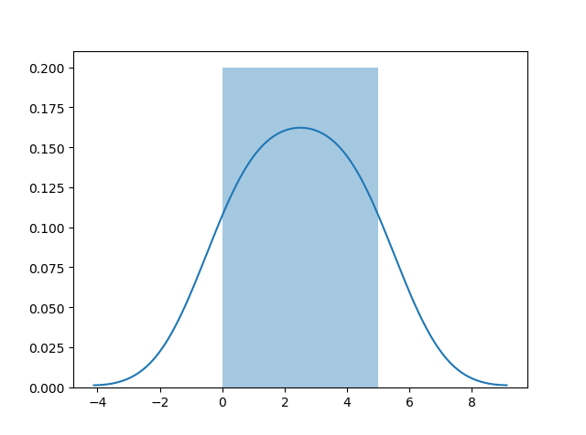

Install Seaborn.
If you have Python and PIP already installed on a system, install it using this command:
C:\Users\Your Name>pip install seaborn
If you use Jupyter, install Seaborn using this command:
C:\Users\Your Name>!pip install seaborn

Distplots
Distplot stands for distribution plot, it takes as input an array and plots a curve corresponding to the distribution of points in the array.

Import Matplotlib
Import the pyplot object of the Matplotlib module in your code using the following statement:
import matplotlib.pyplot as plt
You can learn about the Matplotlib module in our Matplotlib Tutorial.

Import Seaborn
Import the Seaborn module in your code using the following statement:
import seaborn as sns

Plotting a Distplot

ExampleGet your own Python Server
import matplotlib.pyplot as plt
import seaborn as sns
sns.distplot([0, 1, 2, 3, 4, 5])
plt.show()
Try it Yourself »

Plotting a Distplot Without the Histogram

Example
import matplotlib.pyplot as plt
import seaborn as sns
sns.distplot([0, 1, 2, 3, 4, 5], hist=False)
plt.show()
Try it Yourself »
Note: We will be using: sns.distplot(arr, hist=False) to visualize random distributions in this tutorial.

Normal (Gaussian) Distribution
❮ PreviousNext ❯

Normal Distribution
The Normal Distribution is one of the most important distributions.
It is also called the Gaussian Distribution after the German mathematician Carl Friedrich Gauss.
It fits the probability distribution of many events, eg. IQ Scores, Heartbeat etc.
Use the random.normal() method to get a Normal Data Distribution.
It has three parameters:
loc - (Mean) where the peak of the bell exists.
scale - (Standard Deviation) how flat the graph distribution should be.
size - The shape of the returned array.

ExampleGet your own Python Server
Generate a random normal distribution of size 2x3:
from numpy import random
x = random.normal(size=(2, 3))
print(x)
Try it Yourself »

Example
Generate a random normal distribution of size 2x3 with mean at 1 and standard deviation of 2:
from numpy import random
x = random.normal(loc=1, scale=2, size=(2, 3))
print(x)
Try it Yourself »

Visualization of Normal Distribution

Example
from numpy import random
import matplotlib.pyplot as plt
import seaborn as sns
sns.distplot(random.normal(size=1000), hist=False)
plt.show()

Result
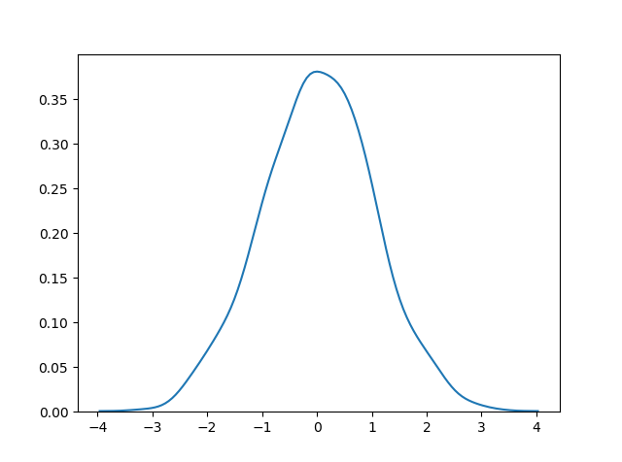
Try it Yourself »
Note: The curve of a Normal Distribution is also known as the Bell Curve because of the bell-shaped curve.

❮ PreviousNext ❯

Binomial Distribution
❮ PreviousNext ❯

Binomial Distribution
Binomial Distribution is a Discrete Distribution.
It describes the outcome of binary scenarios, e.g. toss of a coin, it will either be head or tails.
It has three parameters:
n - number of trials.
p - probability of occurence of each trial (e.g. for toss of a coin 0.5 each).
size - The shape of the returned array.
Discrete Distribution:The distribution is defined at separate set of events, e.g. a coin toss's result is discrete as it can be only head or tails whereas height of people is continuous as it can be 170, 170.1, 170.11 and so on.

ExampleGet your own Python Server
Given 10 trials for coin toss generate 10 data points:
from numpy import random
x = random.binomial(n=10, p=0.5, size=10)
print(x)
Try it Yourself »

Visualization of Binomial Distribution

Example
from numpy import random
import matplotlib.pyplot as plt
import seaborn as sns
sns.distplot(random.binomial(n=10, p=0.5, size=1000), hist=True, kde=False)
plt.show()

Result
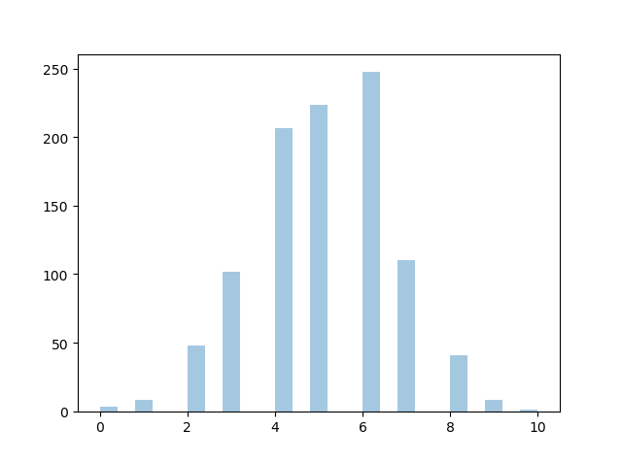
Try it Yourself »

Difference Between Normal and Binomial Distribution
The main difference is that normal distribution is continous whereas binomial is discrete, but if there are enough data points it will be quite similar to normal distribution with certain loc and scale.

Example
from numpy import random
import matplotlib.pyplot as plt
import seaborn as sns
sns.distplot(random.normal(loc=50, scale=5, size=1000), hist=False, label='normal')
sns.distplot(random.binomial(n=100, p=0.5, size=1000), hist=False, label='binomial')
plt.show()

Result
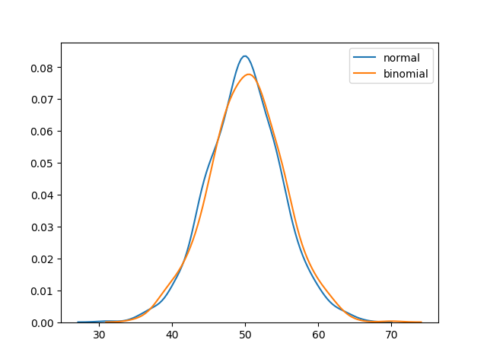
Try it Yourself »

Poisson Distribution
❮ PreviousNext ❯

Poisson Distribution
Poisson Distribution is a Discrete Distribution.
It estimates how many times an event can happen in a specified time. e.g. If someone eats twice a day what is the probability he will eat thrice?
It has two parameters:
lam - rate or known number of occurrences e.g. 2 for above problem.
size - The shape of the returned array.

ExampleGet your own Python Server
Generate a random 1x10 distribution for occurrence 2:
from numpy import random
x = random.poisson(lam=2, size=10)
print(x)
Try it Yourself »

Visualization of Poisson Distribution

Example
from numpy import random
import matplotlib.pyplot as plt
import seaborn as sns
sns.distplot(random.poisson(lam=2, size=1000), kde=False)
plt.show()

Result
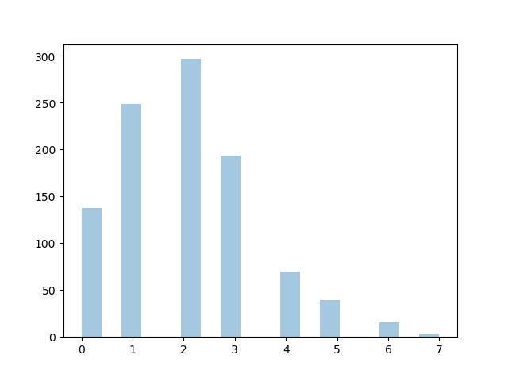
Try it Yourself »

ADVERTISEMENT

Difference Between Normal and Poisson Distribution
Normal distribution is continuous whereas poisson is discrete.
But we can see that similar to binomial for a large enough poisson distribution it will become similar to normal distribution with certain std dev and mean.

Example
from numpy import random
import matplotlib.pyplot as plt
import seaborn as sns
sns.distplot(random.normal(loc=50, scale=7, size=1000), hist=False, label='normal')
sns.distplot(random.poisson(lam=50, size=1000), hist=False, label='poisson')
plt.show()

Result
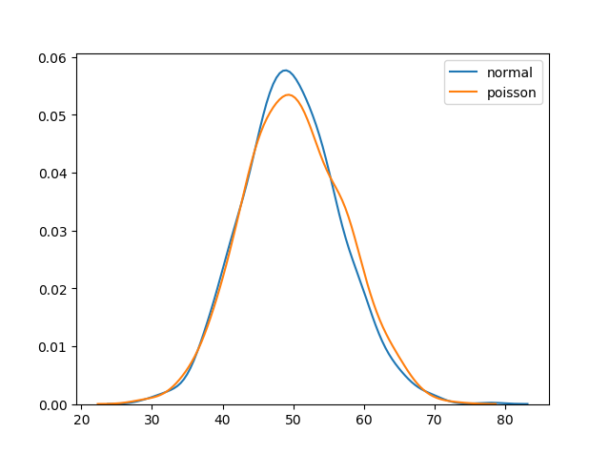
Try it Yourself »

Difference Between Binomial and Poisson Distribution
Binomial distribution only has two possible outcomes, whereas poisson distribution can have unlimited possible outcomes.
But for very large n and near-zero p binomial distribution is near identical to poisson distribution such that n * p is nearly equal to lam.

Example
from numpy import random
import matplotlib.pyplot as plt
import seaborn as sns
sns.distplot(random.binomial(n=1000, p=0.01, size=1000), hist=False, label='binomial')
sns.distplot(random.poisson(lam=10, size=1000), hist=False, label='poisson')
plt.show()

Result
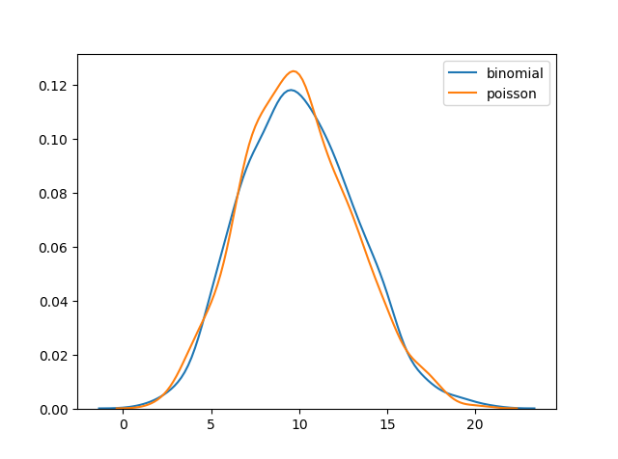
Try it Yourself »

❮ PreviousNext ❯

Uniform Distribution
❮ PreviousNext ❯

Uniform Distribution
Used to describe probability where every event has equal chances of occuring.
E.g. Generation of random numbers.
It has three parameters:
a - lower bound - default 0 .0.
b - upper bound - default 1.0.
size - The shape of the returned array.

ExampleGet your own Python Server
Create a 2x3 uniform distribution sample:
from numpy import random
x = random.uniform(size=(2, 3))
print(x)
Try it Yourself »

Visualization of Uniform Distribution

Example
from numpy import random
import matplotlib.pyplot as plt
import seaborn as sns
sns.distplot(random.uniform(size=1000), hist=False)
plt.show()

Result
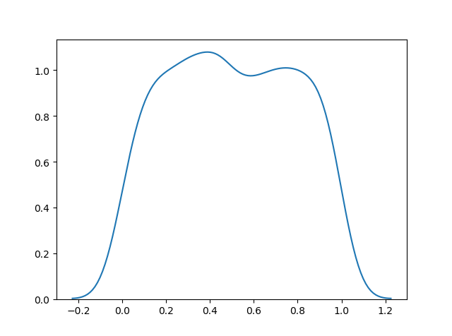
Try it Yourself »

❮ PreviousNext ❯

Logistic Distribution
❮ PreviousNext ❯

Logistic Distribution
Logistic Distribution is used to describe growth.
Used extensively in machine learning in logistic regression, neural networks etc.
It has three parameters:
loc - mean, where the peak is. Default 0.
scale - standard deviation, the flatness of distribution. Default 1.
size - The shape of the returned array.

ExampleGet your own Python Server
Draw 2x3 samples from a logistic distribution with mean at 1 and stddev 2.0:
from numpy import random
x = random.logistic(loc=1, scale=2, size=(2, 3))
print(x)
Try it Yourself »

Visualization of Logistic Distribution

Example
from numpy import random
import matplotlib.pyplot as plt
import seaborn as sns
sns.distplot(random.logistic(size=1000), hist=False)
plt.show()

Result
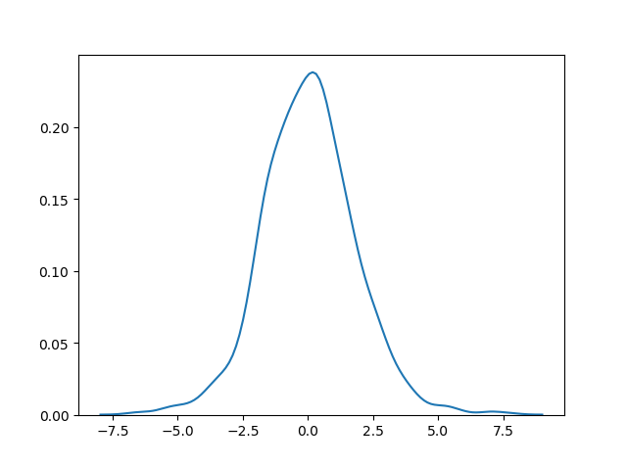
Try it Yourself »

Difference Between Logistic and Normal Distribution
Both distributions are near identical, but logistic distribution has more area under the tails, meaning it represents more possibility of occurrence of an event further away from mean.
For higher value of scale (standard deviation) the normal and logistic distributions are near identical apart from the peak.

Example
from numpy import random
import matplotlib.pyplot as plt
import seaborn as sns
sns.distplot(random.normal(scale=2, size=1000), hist=False, label='normal')
sns.distplot(random.logistic(size=1000), hist=False, label='logistic')
plt.show()

Result
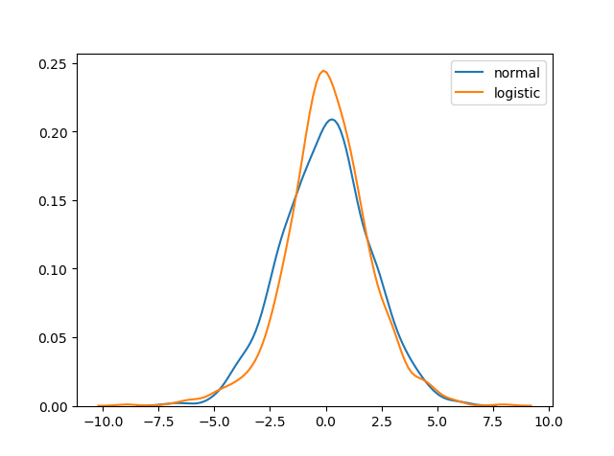

Multinomial Distribution
❮ PreviousNext ❯

Multinomial Distribution
Multinomial distribution is a generalization of binomial distribution.
It describes outcomes of multi-nomial scenarios unlike binomial where scenarios must be only one of two. e.g. Blood type of a population, dice roll outcome.
It has three parameters:
n - number of possible outcomes (e.g. 6 for dice roll).
pvals - list of probabilties of outcomes (e.g. [1/6, 1/6, 1/6, 1/6, 1/6, 1/6] for dice roll).
size - The shape of the returned array.

ExampleGet your own Python Server
Draw out a sample for dice roll:
from numpy import random
x = random.multinomial(n=6, pvals=[1/6, 1/6, 1/6, 1/6, 1/6, 1/6])
print(x)
Try it Yourself »
Note: Multinomial samples will NOT produce a single value! They will produce one value for each pval.
Note: As they are generalization of binomial distribution their visual representation and similarity of normal distribution is same as that of multiple binomial distributions.

Exponential Distribution
❮ PreviousNext ❯

Exponential Distribution
Exponential distribution is used for describing time till next event e.g. failure/success etc.
It has two parameters:
scale - inverse of rate ( see lam in poisson distribution ) defaults to 1.0.
size - The shape of the returned array.

ExampleGet your own Python Server
Draw out a sample for exponential distribution with 2.0 scale with 2x3 size:
from numpy import random
x = random.exponential(scale=2, size=(2, 3))
print(x)
Try it Yourself »

Visualization of Exponential Distribution

Example
from numpy import random
import matplotlib.pyplot as plt
import seaborn as sns
sns.distplot(random.exponential(size=1000), hist=False)
plt.show()

Result
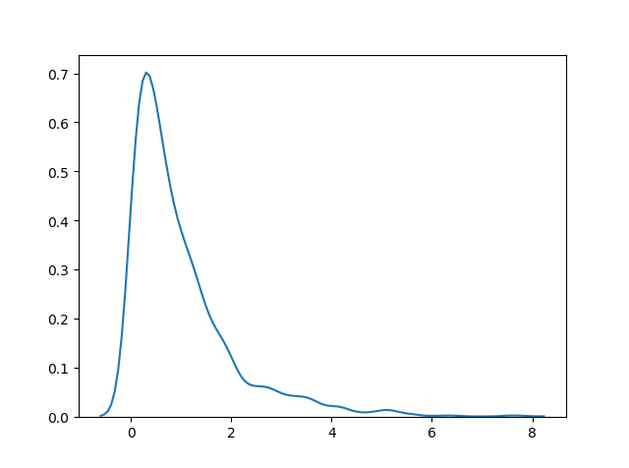
Try it Yourself »

Relation Between Poisson and Exponential Distribution
Poisson distribution deals with number of occurences of an event in a time period whereas exponential distribution deals with the time between these events.

❮ PreviousNext ❯

Chi Square Distribution
❮ PreviousNext ❯

Chi Square Distribution
Chi Square distribution is used as a basis to verify the hypothesis.
It has two parameters:
df - (degree of freedom).
size - The shape of the returned array.

ExampleGet your own Python Server
Draw out a sample for chi squared distribution with degree of freedom 2 with size 2x3:
from numpy import random
x = random.chisquare(df=2, size=(2, 3))
print(x)
Try it Yourself »

Visualization of Chi Square Distribution

Example
from numpy import random
import matplotlib.pyplot as plt
import seaborn as sns
sns.distplot(random.chisquare(df=1, size=1000), hist=False)
plt.show()

Result
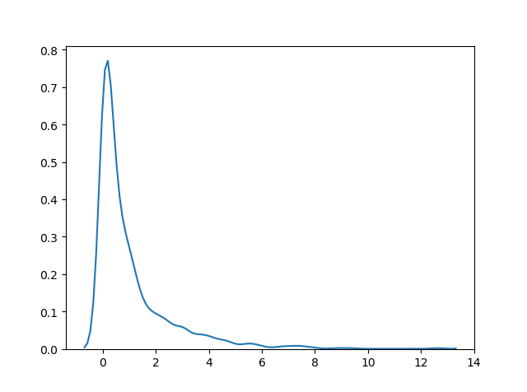

Rayleigh Distribution
❮ PreviousNext ❯

Rayleigh Distribution
Rayleigh distribution is used in signal processing.
It has two parameters:
scale - (standard deviation) decides how flat the distribution will be default 1.0).
size - The shape of the returned array.

ExampleGet your own Python Server
Draw out a sample for rayleigh distribution with scale of 2 with size 2x3:
from numpy import random
x = random.rayleigh(scale=2, size=(2, 3))
print(x)
Try it Yourself »

Visualization of Rayleigh Distribution

Example
from numpy import random
import matplotlib.pyplot as plt
import seaborn as sns
sns.distplot(random.rayleigh(size=1000), hist=False)
plt.show()

Result
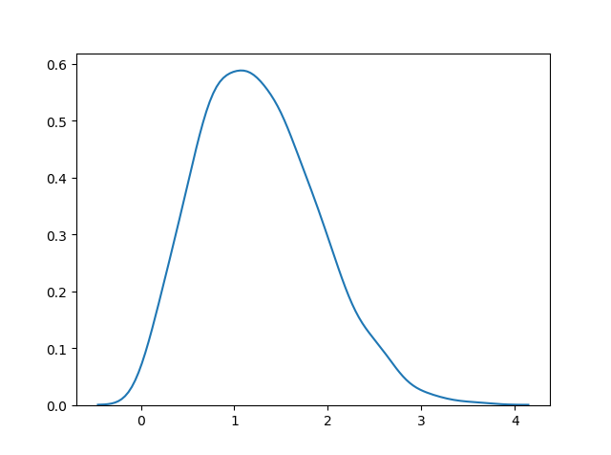
Try it Yourself »

Similarity Between Rayleigh and Chi Square Distribution
At unit stddev and 2 degrees of freedom rayleigh and chi square represent the same distributions.

❮ PreviousNext ❯

Pareto Distribution
❮ PreviousNext ❯

Pareto Distribution
A distribution following Pareto's law i.e. 80-20 distribution (20% factors cause 80% outcome).
It has two parameter:
a - shape parameter.
size - The shape of the returned array.

ExampleGet your own Python Server
Draw out a sample for pareto distribution with shape of 2 with size 2x3:
from numpy import random
x = random.pareto(a=2, size=(2, 3))
print(x)
Try it Yourself »

Visualization of Pareto Distribution

Example
from numpy import random
import matplotlib.pyplot as plt
import seaborn as sns
sns.distplot(random.pareto(a=2, size=1000), kde=False)
plt.show()

Result
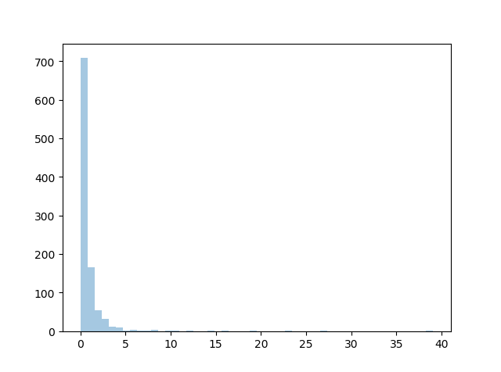
Try it Yourself »

❮ PreviousNext ❯

Zipf Distribution
❮ PreviousNext ❯

Zipf distributions are used to sample data based on zipf's law.
Zipf's Law: In a collection, the nth common term is 1/n times of the most common term. E.g. the 5th most common word in English occurs nearly 1/5 times as often as the most common word.
It has two parameters:
a - distribution parameter.
size - The shape of the returned array.

ExampleGet your own Python Server
Draw out a sample for zipf distribution with distribution parameter 2 with size 2x3:
from numpy import random
x = random.zipf(a=2, size=(2, 3))
print(x)
Try it Yourself »

Visualization of Zipf Distribution
Sample 1000 points but plotting only ones with value < 10 for more meaningful chart.

Example
from numpy import random
import matplotlib.pyplot as plt
import seaborn as sns
x = random.zipf(a=2, size=1000)
sns.distplot(x[x<10], kde=False)
plt.show()

Result
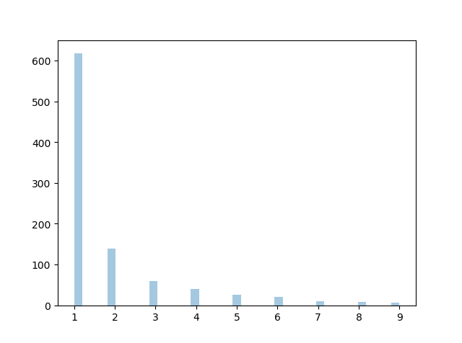
Try it Yourself »

NumPy ufuncs
❮ PreviousNext ❯

What are ufuncs?
ufuncs stands for "Universal Functions" and they are NumPy functions that operate on the ndarray object.

Why use ufuncs?
ufuncs are used to implement vectorization in NumPy which is way faster than iterating over elements.
They also provide broadcasting and additional methods like reduce, accumulate etc. that are very helpful for computation.
ufuncs also take additional arguments, like:
where boolean array or condition defining where the operations should take place.
dtype defining the return type of elements.
out output array where the return value should be copied.

What is Vectorization?
Converting iterative statements into a vector based operation is called vectorization.
It is faster as modern CPUs are optimized for such operations.

Add the Elements of Two Lists
list 1: [1, 2, 3, 4]
list 2: [4, 5, 6, 7]
One way of doing it is to iterate over both of the lists and then sum each elements.

ExampleGet your own Python Server
Without ufunc, we can use Python's built-in zip() method:
x = [1, 2, 3, 4]
y = [4, 5, 6, 7]
z = []
for i, j in zip(x, y):
z.append(i + j)
print(z)
Try it Yourself »
NumPy has a ufunc for this, called add(x, y) that will produce the same result.

Example
With ufunc, we can use the add() function:
import numpy as np
x = [1, 2, 3, 4]
y = [4, 5, 6, 7]
z = np.add(x, y)
print(z)
Try it Yourself »

❮ PreviousNext ❯

Create Your Own ufunc
❮ PreviousNext ❯

How To Create Your Own ufunc
To create your own ufunc, you have to define a function, like you do with normal functions in Python, then you add it to your NumPy ufunc library with the frompyfunc() method.
The frompyfunc() method takes the following arguments:
- function - the name of the function.
- inputs - the number of input arguments (arrays).
- outputs - the number of output arrays.

ExampleGet your own Python Server
Create your own ufunc for addition:
import numpy as np
def myadd(x, y):
return x+y
myadd = np.frompyfunc(myadd, 2, 1)
print(myadd([1, 2, 3, 4], [5, 6, 7, 8]))
Try it Yourself »

Check if a Function is a ufunc
Check the type of a function to check if it is a ufunc or not.
A ufunc should return <class 'numpy.ufunc'>.

Example
Check if a function is a ufunc:
import numpy as np
print(type(np.add))
Try it Yourself »
If it is not a ufunc, it will return another type, like this built-in NumPy function for joining two or more arrays:

Example
Check the type of another function: concatenate():
import numpy as np
print(type(np.concatenate))
Try it Yourself »
If the function is not recognized at all, it will return an error:

Example
Check the type of something that does not exist. This will produce an error:
import numpy as np
print(type(np.blahblah))
Try it Yourself »
To test if the function is a ufunc in an if statement, use the numpy.ufunc value (or np.ufunc if you use np as an alias for numpy):

Example
Use an if statement to check if the function is a ufunc or not:
import numpy as np
if type(np.add) == np.ufunc:
print('add is ufunc')
else:
print('add is not ufunc')
Try it Yourself »

❮ PreviousNext ❯

Simple Arithmetic
❮ PreviousNext ❯

Simple Arithmetic
You could use arithmetic operators + - * / directly between NumPy arrays, but this section discusses an extension of the same where we have functions that can take any array-like objects e.g. lists, tuples etc. and perform arithmetic conditionally.
Arithmetic Conditionally: means that we can define conditions where the arithmetic operation should happen.
All of the discussed arithmetic functions take a where parameter in which we can specify that condition.

Addition
The add() function sums the content of two arrays, and return the results in a new array.

ExampleGet your own Python Server
Add the values in arr1 to the values in arr2:
import numpy as np
arr1 = np.array([10, 11, 12, 13, 14, 15])
arr2 = np.array([20, 21, 22, 23, 24, 25])
newarr = np.add(arr1, arr2)
print(newarr)
Try it Yourself »
The example above will return [30 32 34 36 38 40] which is the sums of 10+20, 11+21, 12+22 etc.

Subtraction
The subtract() function subtracts the values from one array with the values from another array, and return the results in a new array.

Example
Subtract the values in arr2 from the values in arr1:
import numpy as np
arr1 = np.array([10, 20, 30, 40, 50, 60])
arr2 = np.array([20, 21, 22, 23, 24, 25])
newarr = np.subtract(arr1, arr2)
print(newarr)
Try it Yourself »
The example above will return [-10 -1 8 17 26 35] which is the result of 10-20, 20-21, 30-22 etc.

ADVERTISEMENT

Multiplication
The multiply() function multiplies the values from one array with the values from another array, and return the results in a new array.

Example
Multiply the values in arr1 with the values in arr2:
import numpy as np
arr1 = np.array([10, 20, 30, 40, 50, 60])
arr2 = np.array([20, 21, 22, 23, 24, 25])
newarr = np.multiply(arr1, arr2)
print(newarr)
Try it Yourself »
The example above will return [200 420 660 920 1200 1500] which is the result of 10*20, 20*21, 30*22 etc.

Division
The divide() function divides the values from one array with the values from another array, and return the results in a new array.

Example
Divide the values in arr1 with the values in arr2:
import numpy as np
arr1 = np.array([10, 20, 30, 40, 50, 60])
arr2 = np.array([3, 5, 10, 8, 2, 33])
newarr = np.divide(arr1, arr2)
print(newarr)
Try it Yourself »
The example above will return [3.33333333 4. 3. 5. 25. 1.81818182] which is the result of 10/3, 20/5, 30/10 etc.

Power
The power() function rises the values from the first array to the power of the values of the second array, and return the results in a new array.

Example
Raise the valules in arr1 to the power of values in arr2:
import numpy as np
arr1 = np.array([10, 20, 30, 40, 50, 60])
arr2 = np.array([3, 5, 6, 8, 2, 33])
newarr = np.power(arr1, arr2)
print(newarr)
Try it Yourself »
The example above will return [1000 3200000 729000000 6553600000000 2500 0] which is the result of 10*10*10, 20*20*20*20*20, 30*30*30*30*30*30 etc.

Remainder
Both the mod() and the remainder() functions return the remainder of the values in the first array corresponding to the values in the second array, and return the results in a new array.

Example
Return the remainders:
import numpy as np
arr1 = np.array([10, 20, 30, 40, 50, 60])
arr2 = np.array([3, 7, 9, 8, 2, 33])
newarr = np.mod(arr1, arr2)
print(newarr)
Try it Yourself »
The example above will return [1 6 3 0 0 27] which is the remainders when you divide 10 with 3 (10%3), 20 with 7 (20%7) 30 with 9 (30%9) etc.
You get the same result when using the remainder() function:

Example
Return the remainders:
import numpy as np
arr1 = np.array([10, 20, 30, 40, 50, 60])
arr2 = np.array([3, 7, 9, 8, 2, 33])
newarr = np.remainder(arr1, arr2)
print(newarr)
Try it Yourself »

Quotient and Mod
The divmod() function return both the quotient and the the mod. The return value is two arrays, the first array contains the quotient and second array contains the mod.

Example
Return the quotient and mod:
import numpy as np
arr1 = np.array([10, 20, 30, 40, 50, 60])
arr2 = np.array([3, 7, 9, 8, 2, 33])
newarr = np.divmod(arr1, arr2)
print(newarr)
Try it Yourself »
The example above will return:
(array([3, 2, 3, 5, 25, 1]), array([1, 6, 3, 0, 0, 27]))
The first array represents the quotients, (the integer value when you divide 10 with 3, 20 with 7, 30 with 9 etc.
The second array represents the remainders of the same divisions.

Absolute Values
Both the absolute() and the abs() functions do the same absolute operation element-wise but we should use absolute() to avoid confusion with python's inbuilt math.abs()

Example
Return the quotient and mod:
import numpy as np
arr = np.array([-1, -2, 1, 2, 3, -4])
newarr = np.absolute(arr)
print(newarr)
Try it Yourself »
The example above will return [1 2 1 2 3 4].

❮ PreviousNext ❯

Rounding Decimals
❮ PreviousNext ❯

Rounding Decimals
There are primarily five ways of rounding off decimals in NumPy:
- truncation
- fix
- rounding
- floor
- ceil

Truncation
Remove the decimals, and return the float number closest to zero. Use the trunc() and fix() functions.

ExampleGet your own Python Server
Truncate elements of following array:
import numpy as np
arr = np.trunc([-3.1666, 3.6667])
print(arr)
Try it Yourself »

Example
Same example, using fix():
import numpy as np
arr = np.fix([-3.1666, 3.6667])
print(arr)
Try it Yourself »

Rounding
The around() function increments preceding digit or decimal by 1 if >=5 else do nothing.
E.g. round off to 1 decimal point, 3.16666 is 3.2

Example
Round off 3.1666 to 2 decimal places:
import numpy as np
arr = np.around(3.1666, 2)
print(arr)
Try it Yourself »

ADVERTISEMENT

Floor
The floor() function rounds off decimal to nearest lower integer.
E.g. floor of 3.166 is 3.

Example
Floor the elements of following array:
import numpy as np
arr = np.floor([-3.1666, 3.6667])
print(arr)
Try it Yourself »

Ceil
The ceil() function rounds off decimal to nearest upper integer.
E.g. ceil of 3.166 is 4.

Example
Ceil the elements of following array:
import numpy as np
arr = np.ceil([-3.1666, 3.6667])
print(arr)
Try it Yourself »

❮ PreviousNext ❯

NumPy Logs
❮ PreviousNext ❯

Logs
NumPy provides functions to perform log at the base 2, e and 10.
We will also explore how we can take log for any base by creating a custom ufunc.
All of the log functions will place -inf or inf in the elements if the log can not be computed.

Log at Base 2
Use the log2() function to perform log at the base 2.

ExampleGet your own Python Server
Find log at base 2 of all elements of following array:
import numpy as np
arr = np.arange(1, 10)
print(np.log2(arr))
Try it Yourself »
Note: The arange(1, 10) function returns an array with integers starting from 1 (included) to 10 (not included).

Log at Base 10
Use the log10() function to perform log at the base 10.

Example
Find log at base 10 of all elements of following array:
import numpy as np
arr = np.arange(1, 10)
print(np.log10(arr))
Try it Yourself »

Natural Log, or Log at Base e
Use the log() function to perform log at the base e.

Example
Find log at base e of all elements of following array:
import numpy as np
arr = np.arange(1, 10)
print(np.log(arr))
Try it Yourself »

NumPy Summations
❮ PreviousNext ❯

Summations
What is the difference between summation and addition?
Addition is done between two arguments whereas summation happens over n elements.

ExampleGet your own Python Server
Add the values in arr1 to the values in arr2:
import numpy as np
arr1 = np.array([1, 2, 3])
arr2 = np.array([1, 2, 3])
newarr = np.add(arr1, arr2)
print(newarr)
Try it Yourself »
Returns: [2 4 6]

Example
Sum the values in arr1 and the values in arr2:
import numpy as np
arr1 = np.array([1, 2, 3])
arr2 = np.array([1, 2, 3])
newarr = np.sum([arr1, arr2])
print(newarr)
Try it Yourself »
Returns: 12

Summation Over an Axis
If you specify axis=1, NumPy will sum the numbers in each array.

Example
Perform summation in the following array over 1st axis:
import numpy as np
arr1 = np.array([1, 2, 3])
arr2 = np.array([1, 2, 3])
newarr = np.sum([arr1, arr2], axis=1)
print(newarr)
Try it Yourself »
Returns: [6 6]

Cummulative Sum
Cummulative sum means partially adding the elements in array.
E.g. The partial sum of [1, 2, 3, 4] would be [1, 1+2, 1+2+3, 1+2+3+4] = [1, 3, 6, 10].
Perfom partial sum with the cumsum() function.

Example
Perform cummulative summation in the following array:
import numpy as np
arr = np.array([1, 2, 3])
newarr = np.cumsum(arr)
print(newarr)

NumPy Products
❮ PreviousNext ❯

Products
To find the product of the elements in an array, use the prod() function.

ExampleGet your own Python Server
Find the product of the elements of this array:
import numpy as np
arr = np.array([1, 2, 3, 4])
x = np.prod(arr)
print(x)
Try it Yourself »
Returns: 24 because 1*2*3*4 = 24

Example
Find the product of the elements of two arrays:
import numpy as np
arr1 = np.array([1, 2, 3, 4])
arr2 = np.array([5, 6, 7, 8])
x = np.prod([arr1, arr2])
print(x)
Try it Yourself »
Returns: 40320 because 1*2*3*4*5*6*7*8 = 40320

Product Over an Axis
If you specify axis=1, NumPy will return the product of each array.

Example
Perform summation in the following array over 1st axis:
import numpy as np
arr1 = np.array([1, 2, 3, 4])
arr2 = np.array([5, 6, 7, 8])
newarr = np.prod([arr1, arr2], axis=1)
print(newarr)
Try it Yourself »
Returns: [24 1680]

Cummulative Product
Cummulative product means taking the product partially.
E.g. The partial product of [1, 2, 3, 4] is [1, 1*2, 1*2*3, 1*2*3*4] = [1, 2, 6, 24]
Perfom partial sum with the cumprod() function.

Example
Take cummulative product of all elements for following array:
import numpy as np
arr = np.array([5, 6, 7, 8])
newarr = np.cumprod(arr)
print(newarr)
Try it Yourself »
Returns: [5 30 210 1680]

❮ PreviousNext ❯

W3schools Pathfinder

NumPy Differences
❮ PreviousNext ❯

Differences
A discrete difference means subtracting two successive elements.
E.g. for [1, 2, 3, 4], the discrete difference would be [2-1, 3-2, 4-3] = [1, 1, 1]
To find the discrete difference, use the diff() function.

ExampleGet your own Python Server
Compute discrete difference of the following array:
import numpy as np
arr = np.array([10, 15, 25, 5])
newarr = np.diff(arr)
print(newarr)
Try it Yourself »
Returns: [5 10 -20] because 15-10=5, 25-15=10, and 5-25=-20
We can perform this operation repeatedly by giving parameter n.
E.g. for [1, 2, 3, 4], the discrete difference with n = 2 would be [2-1, 3-2, 4-3] = [1, 1, 1] , then, since n=2, we will do it once more, with the new result: [1-1, 1-1] = [0, 0]

Example
Compute discrete difference of the following array twice:
import numpy as np
arr = np.array([10, 15, 25, 5])
newarr = np.diff(arr, n=2)
print(newarr)
Try it Yourself »
Returns: [5 -30] because: 15-10=5, 25-15=10, and 5-25=-20 AND 10-5=5 and -20-10=-30

❮ PreviousNext ❯

NumPy LCM Lowest Common Multiple
❮ PreviousNext ❯

Finding LCM (Lowest Common Multiple)
The Lowest Common Multiple is the smallest number that is a common multiple of two numbers.

ExampleGet your own Python Server
Find the LCM of the following two numbers:
import numpy as np
num1 = 4
num2 = 6
x = np.lcm(num1, num2)
print(x)
Try it Yourself »
Returns: 12 because that is the lowest common multiple of both numbers (4*3=12 and 6*2=12).

Finding LCM in Arrays
To find the Lowest Common Multiple of all values in an array, you can use the reduce() method.
The reduce() method will use the ufunc, in this case the lcm() function, on each element, and reduce the array by one dimension.

Example
Find the LCM of the values of the following array:
import numpy as np
arr = np.array([3, 6, 9])
x = np.lcm.reduce(arr)
print(x)
Try it Yourself »
Returns: 18 because that is the lowest common multiple of all three numbers (3*6=18, 6*3=18 and 9*2=18).

Example
Find the LCM of all values of an array where the array contains all integers from 1 to 10:
import numpy as np
arr = np.arange(1, 11)
x = np.lcm.reduce(arr)
print(x)
Try it Yourself »

❮ PreviousNext ❯

NumPy GCD Greatest Common Denominator
❮ PreviousNext ❯

Finding GCD (Greatest Common Denominator)
The GCD (Greatest Common Denominator), also known as HCF (Highest Common Factor) is the biggest number that is a common factor of both of the numbers.

ExampleGet your own Python Server
Find the HCF of the following two numbers:
import numpy as np
num1 = 6
num2 = 9
x = np.gcd(num1, num2)
print(x)
Try it Yourself »
Returns: 3 because that is the highest number both numbers can be divided by (6/3=2 and 9/3=3).

Finding GCD in Arrays
To find the Highest Common Factor of all values in an array, you can use the reduce() method.
The reduce() method will use the ufunc, in this case the gcd() function, on each element, and reduce the array by one dimension.

Example
Find the GCD for all of the numbers in the following array:
import numpy as np
arr = np.array([20, 8, 32, 36, 16])
x = np.gcd.reduce(arr)
print(x)
Try it Yourself »
Returns: 4 because that is the highest number all values can be divided by.

❮ PreviousNext ❯

NumPy Trigonometric Functions
❮ PreviousNext ❯

Trigonometric Functions
NumPy provides the ufuncs sin(), cos() and tan() that take values in radians and produce the corresponding sin, cos and tan values.

ExampleGet your own Python Server
Find sine value of PI/2:
import numpy as np
x = np.sin(np.pi/2)
print(x)
Try it Yourself »

Example
Find sine values for all of the values in arr:
import numpy as np
arr = np.array([np.pi/2, np.pi/3, np.pi/4, np.pi/5])
x = np.sin(arr)
print(x)
Try it Yourself »

Convert Degrees Into Radians
By default all of the trigonometric functions take radians as parameters but we can convert radians to degrees and vice versa as well in NumPy.
Note: radians values are pi/180 * degree_values.

Example
Convert all of the values in following array arr to radians:
import numpy as np
arr = np.array([90, 180, 270, 360])
x = np.deg2rad(arr)
print(x)
Try it Yourself »

ADVERTISEMENT

Radians to Degrees

Example
Convert all of the values in following array arr to degrees:
import numpy as np
arr = np.array([np.pi/2, np.pi, 1.5*np.pi, 2*np.pi])
x = np.rad2deg(arr)
print(x)
Try it Yourself »

Finding Angles
Finding angles from values of sine, cos, tan. E.g. sin, cos and tan inverse (arcsin, arccos, arctan).
NumPy provides ufuncs arcsin(), arccos() and arctan() that produce radian values for corresponding sin, cos and tan values given.

Example
Find the angle of 1.0:
import numpy as np
x = np.arcsin(1.0)
print(x)
Try it Yourself »

Angles of Each Value in Arrays

Example
Find the angle for all of the sine values in the array
import numpy as np
arr = np.array([1, -1, 0.1])
x = np.arcsin(arr)
print(x)
Try it Yourself »

Hypotenues
Finding hypotenues using pythagoras theorem in NumPy.
NumPy provides the hypot() function that takes the base and perpendicular values and produces hypotenues based on pythagoras theorem.

Example
Find the hypotenues for 4 base and 3 perpendicular:
import numpy as np
base = 3
perp = 4
x = np.hypot(base, perp)
print(x)
Try it Yourself »

❮ PreviousNext ❯

NumPy Hyperbolic Functions
❮ PreviousNext ❯

Hyperbolic Functions
NumPy provides the ufuncs sinh(), cosh() and tanh() that take values in radians and produce the corresponding sinh, cosh and tanh values..

ExampleGet your own Python Server
Find sinh value of PI/2:
import numpy as np
x = np.sinh(np.pi/2)
print(x)
Try it Yourself »

Example
Find cosh values for all of the values in arr:
import numpy as np
arr = np.array([np.pi/2, np.pi/3, np.pi/4, np.pi/5])
x = np.cosh(arr)
print(x)
Try it Yourself »

Finding Angles
Finding angles from values of hyperbolic sine, cos, tan. E.g. sinh, cosh and tanh inverse (arcsinh, arccosh, arctanh).
Numpy provides ufuncs arcsinh(), arccosh() and arctanh() that produce radian values for corresponding sinh, cosh and tanh values given.

Example
Find the angle of 1.0:
import numpy as np
x = np.arcsinh(1.0)
print(x)
Try it Yourself »

Angles of Each Value in Arrays

Example
Find the angle for all of the tanh values in array:
import numpy as np
arr = np.array([0.1, 0.2, 0.5])
x = np.arctanh(arr)
print(x)

NumPy Set Operations
❮ PreviousNext ❯

What is a Set
A set in mathematics is a collection of unique elements.
Sets are used for operations involving frequent intersection, union and difference operations.

Create Sets in NumPy
We can use NumPy's unique() method to find unique elements from any array. E.g. create a set array, but remember that the set arrays should only be 1-D arrays.

ExampleGet your own Python Server
Convert following array with repeated elements to a set:
import numpy as np
arr = np.array([1, 1, 1, 2, 3, 4, 5, 5, 6, 7])
x = np.unique(arr)
print(x)
Try it Yourself »

Finding Union
To find the unique values of two arrays, use the union1d() method.

Example
Find union of the following two set arrays:
import numpy as np
arr1 = np.array([1, 2, 3, 4])
arr2 = np.array([3, 4, 5, 6])
newarr = np.union1d(arr1, arr2)
print(newarr)
Try it Yourself »

Finding Intersection
To find only the values that are present in both arrays, use the intersect1d() method.

Example
Find intersection of the following two set arrays:
import numpy as np
arr1 = np.array([1, 2, 3, 4])
arr2 = np.array([3, 4, 5, 6])
newarr = np.intersect1d(arr1, arr2, assume_unique=True)
print(newarr)
Try it Yourself »
Note: the intersect1d() method takes an optional argument assume_unique, which if set to True can speed up computation. It should always be set to True when dealing with sets.

Finding Difference
To find only the values in the first set that is NOT present in the seconds set, use the setdiff1d() method.

Example
Find the difference of the set1 from set2:
import numpy as np
set1 = np.array([1, 2, 3, 4])
set2 = np.array([3, 4, 5, 6])
newarr = np.setdiff1d(set1, set2, assume_unique=True)
print(newarr)
Try it Yourself »
Note: the setdiff1d() method takes an optional argument assume_unique, which if set to True can speed up computation. It should always be set to True when dealing with sets.

Finding Symmetric Difference
To find only the values that are NOT present in BOTH sets, use the setxor1d() method.

Example
Find the symmetric difference of the set1 and set2:
import numpy as np
set1 = np.array([1, 2, 3, 4])
set2 = np.array([3, 4, 5, 6])
newarr = np.setxor1d(set1, set2, assume_unique=True)
print(newarr)
Try it Yourself »
Note: the setxor1d() method takes an optional argument assume_unique, which if set to True can speed up computation. It should always be set to True when dealing with sets.

❮ PreviousNext ❯

NumPy Online Compiler (Editor)
❮ PreviousNext ❯

NumPy (Python) Editor
With our "Try it Yourself" editor, you can edit Python code and use the NumPy module, and view the result in your browser.
Run »
import numpy as np
arr = np.array([1, 2, 3, 4, 5])
print(arr)
print(type(arr))
[1 2 3 4 5]
<class 'numpy.ndarray'>
Try it Yourself »
Click on the "Try it Yourself" button to see how it works.

Publish Your Code
If you want to create your own website or build Python applications, check out W3Schools Spaces.
W3Schools Spaces is a website-building tool that enables you to create and share your own website. You can also get a Python server, allowing you to develop and host your Python applications with ease.
Note: This includes Python libraries such as: Django, Pandas, NumPy, SciPy and more.
You can change the website's look and how it works by editing the code right in your web browser.
It's easy to use and doesn't require any setup

The code editor is packed with features to help you achieve more:
- Templates: Start from scratch or use a template
- Cloud-based: no installations required. You only need your browser
- Terminal & Log: debug and troubleshoot your code easily
- File Navigator: switch between files inside the code editor
- And much more!
Learn More

Learn Faster
Practice is key to mastering coding, and the best way to put your Python knowledge into practice is by getting practical with code.
Use W3Schools Spaces to build, test and deploy code.
The code editor lets you write and practice different types of computer languages. It includes Python, but you can use it for other languages too.
New languages are added all the time:

Learn More
If you don't know Python, we suggest that you read our Python Tutorial from scratch.

Easy Package Management
Get an overview of your packages and easily add or delete frameworks and libraries. Then, with just one click, you can make changes to your packages without manual installation.
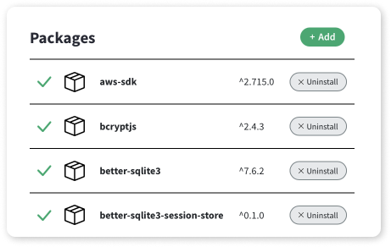
Learn More

Build Powerful Websites
You can also use the code editor in W3School Spaces to build frontend or full-stack websites from scratch.
Or you can use the 60+ templates available and save time:




Create your Spaces account today and explore them all!
Learn More

Share Your Website With The World
Host and publish your websites in no time with W3School Spaces.
W3Schools subdomain and SSL certificate are included for free with W3School Spaces. An SSL certificate makes your website safe and secure. It also helps people trust your website and makes it easier to find it online.
Want a custom domain for your website?
You can buy a domain or transfer an existing one and connect it to your space.
Learn More

How Does It Work?
Get started in a few clicks with W3School Spaces.


❮ PreviousNext ❯

NumPy Quiz
❮ PreviousNext ❯

You can test your NumPy skills with W3Schools' Quiz.

The Test
The test contains 25 questions and there is no time limit.
The test is not official, it's just a nice way to see how much you know, or don't know, about NumPy.

Count Your Score
You will get 1 point for each correct answer. At the end of the Quiz, your total score will be displayed. Maximum score is 25 points.

Start the Quiz
Good luck!
Start the NumPy Quiz ❯
If you don't know NumPy, we suggest that you read our NumPy Tutorial from scratch

NumPy Exercises
❮ PreviousNext ❯

You can test your NumPy skills with W3Schools' Exercises.

Exercises
We have gathered a variety of NumPy exercises (with answers) from the NumPy Chapters.
Try to solve an exercise by filling in the missing parts of a code. If you're stuck, hit the "Show Answer" button to see what you've done wrong.

Count Your Score
You will get 1 point for each correct answer. Your score and total score will always be displayed.

Start NumPy Exercises
Good luck!
Start NumPy Exercises ❯
If you don't know NumPy, we suggest that you read our NumPy Tutorial from scratch.

