Traffic Flow Prediction Using Spatio-Temporal Graph Neural Network
Student Name: somisetti venkaiah swami
Student ID: A00071945

Abstract—The traffic congestion in urban areas is one of the significant issues in modern cities, which leads to higher travel times, fuel use, and pollution of the environment. Transportation planning and intelligent transportation management concern effective traffic planning and should therefore rely on accurate traffic flow forecasting. This study is aimed at examining the deep learning methods in the multi-step forecasting of traffic speed based on METR-LA traffic data. There were four models implemented and evaluated, which are Long Short-Term Memory (LSTM), Gated Recurrent Unit (GRU), Graph Convolutional Network (GCN), and Spatio-Temporal Graph Convolutional Network (STGCN). The historic traffic sensor data were used to train the models and assessed through Mean Absolute Error (MAE), Root Mean Squared Error (RMSE), Mean Absolute Percentage Error (MAPE), and coefficient of determination (R²). Based on experimental results, the GRU model has performed the best when measured by MAE 3.8765, RMSE 10.0342, MAPE 31476518, and R² 0.8877, indicating better performance in capturing temporal patterns in traffic compared to the other models. The results indicate that deep learning models are effective in making traffic predictions and that they can provide intelligent transportation systems.
Keywords—Traffic Flow Prediction, Deep Learning, Graph Neural Networks, Spatio-Temporal Models, Intelligent Transportation Systems.

Introduction
In modern cities, urban traffic congestion has become one of the major challenges, which has increased travel time, fuel consumption, and environmental pollution. Effective transportation planning and intelligent traffic management systems, hence, require accurate prediction of traffic flow [1]. As the smart city technologies increase, it means that huge amounts of real-time traffic sensor data become a reality. These data sources facilitate the adoption of powerful data-driven paradigms, specifically deep learning algorithms that have shown a high ability in comprehending the complicated traffic patterns and refining forecasting outcomes.
Regardless of these developments, road traffic prediction is a difficult task due to the intricate spatial and temporal correlations among the road segments. These dependencies are usually very difficult to model using traditional statistical models or even some machine learning methods. Despite their ability to learn temporal dynamics in the case of traffic data, recurrent neural network models (Long Short-Term Memory (LSTM) and Gated Recurrent Unit (GRU) networks) typically do not identify spatial connections among traffic sensors [2].
To address this challenge, this study explores deep learning architectures that can be used to model both spatial and temporal traffic effects. In particular, LSTM and GRU models are implemented to identify temporal patterns, and graph convolutional networks and spatio-temporal graph convolutional networks are employed to describe both spatial and spatio-temporal relationships through the METR-LA traffic dataset [3].
The remainder of this paper is structured in the following way. It starts by reviewing the literature on current research on traffic forecasting methods, then describes the proposed methodology and model architectures. The findings of the results are given and discussed, and the paper ends with a discussion of the findings and future directions of research.

Related Work
Prediction of traffic flow is an essential activity in intelligent transportation systems since precise predictions can minimise traffic delays, improve route planning, and facilitate traffic management decision-making [4]. But the traffic data are characterised by both spatial and temporal complexity and are therefore difficult to predict. Researchers have, over time, developed several strategies, starting with the classical statistical models and evolving into advanced deep learning techniques, notably the graph neural networks that aim to learn the spatial dependencies within a traffic network.

Traditional and Temporal Deep Learning Methods
The early research on traffic prediction principally used statistical and machine learning approaches, including the Autoregressive Integrated Moving Average (ARIMA), Vector Auto Regression (VAR), and support vector regression (SVR) techniques. Such techniques have the ability to capture temporal behaviour, but in most cases, fail to represent nonlinear traffic behaviour and spatial dependence between road segments. In order to address these limitations, LSTM and GRU networks were proposed as deep learning models. These models performed well in modelling sequential traffic data and temporal correlations [5]. However, they model time series as independent and hence cannot effectively encode spatial relationships in road networks.

Graph Neural Network Approaches
In order to overcome the limitation of the temporal models, they began representing the traffic networks as graphs, with the nodes being the sensors or road segments and the edges depicting the spatial relationships. GNNs are able to learn such non-Euclidean data structures. A study [6] suggested the Bi-GRCN model that uses Graph Convolutional Networks with Bidirectional GRU to learn both spatial and temporal relationships using traffic data. Their findings revealed better prediction with better accuracy as opposed to the traditional models. Similarly, [7] introduced a dynamic spatio-temporal graph neural network that can learn latent spatial-temporal dependencies on traffic flow data. Even though the model enhances prediction performance, it is based on ad hoc graph structures that might not represent dynamic traffic states.
A proposed study [8] suggests a simplified spatio-temporal graph neural network (SST-GNN) that combines data of various graph neighbourhoods and temporal patterns with the weighted aggregation. This method enhances the efficiency of computations, and it records periodic patterns of traffic. Simplified structures can, however, decrease the capacity to model complex spatial relationships in large traffic networks.

Advanced Spatio-Temporal Graph Neural Networks
Recent works focus on more developed spatio-temporal graph neural networks to enhance the accuracy of traffic forecasts. Another study [9] presented an Integrated Spatio-Temporal Graph Convolutional Network (ISTGCN) that combines several layers of graph convolution with temporal sequence learning. They have a complex model of spatially and temporally related elements, and have lower errors on benchmark data. As suggested in [10], a multi-scale spatio-temporal graph neural network was introduced, which breaks down traffic measurements on various time scales to understand both long-term and short-term patterns in traffic. The experimental findings demonstrate better prediction capabilities on a variety of datasets.
They also made further advancements in the field of spatio-temporal modeling by suggesting a dynamic sparse graph convolutional network with a combination of GRU and attention. This methodology describes heterogeneity of traffic patterns and dynamic spatial relations. Similarly, [11] suggested a multi-factor fusion graph convolution network that proposed external factors like weather conditions, as well as spatial and temporal data, to enhance the accuracy of the prediction.

Research Challenges and Gaps
A number of survey studies show the challenges in predicting traffic research. According to [12], it includes an extensive overview of spatio-temporal graph neural networks and underlines their usefulness in time-varying graph data modeling. They further examine some of the recent graph-based traffic forecasting models and point out the problems associated with them, like scalability, dynamic graph modelling, and the absence of standardized benchmarking frameworks, as highlighted in [13]. The study by [14] suggested a Dynamic Graph Convolutional Recurrent Network, which captures dynamic traffic relations using adaptive graph construction, enhancing the prediction performance.
Even with these developments, there are still problems in the accurate representation of dynamic spatial dependencies and tradeoff model complexity versus computational efficiency. This study examines various deep learning architectures, such as LSTM, GRU, GCN, and STGCN, to understand their performance in multi-step traffic prediction on the METR-LA dataset.

Methodology
The section outlines the research methodology employed in developing and evaluating the traffic flow prediction models in this study. It describes the data utilised in the study, the techniques used to preprocess data to present that data, the architecture of the deep learning models implemented, and the training processes employed in the process of developing the model [15]. The section also introduces the evaluation measures that were applied to quantify the predictive performance of the models. The main objective of this methodology is to make sure that the overall experimental procedure is clear and repeatable.

Dataset and Preprocessing
Experiments in this study are based on the METR-LA traffic dataset, which is popular in traffic forecasting literature. The data is a set of measurements of highway traffic speeds that were taken by loop detectors in Los Angeles. The sensors record time-resolved data on the speed of traffic on a five-minute basis, which gives detailed time information on the conditions of the traffic. A smaller sample of 15,000 samples of the training part of the dataset was experimented with in this study. The data set comprises several input features that depict the past traffic conditions, together with the target values that depict the future traffic speeds.
Figure 1 presents the first data loading and column inspection that was done during the preparation stage of the dataset. Dimensions are automatically identified, with the 2 nodes being X shape (15000, 12, 2, 1) and y shape (15000, 12, 2).
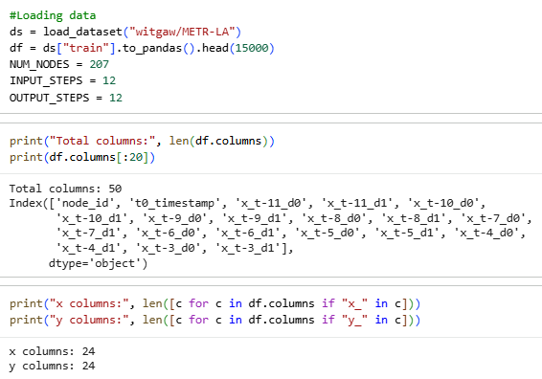
Figure 1 Dataset loading and column inspection
Column name patterns were then used to automatically identify the input and output columns and prepare the dataset to be trained by the model. Historical observation inputs were represented as input features as variables with the prefix x, and the prediction targets were represented as variables with the prefix y. This automatic detection made sure that the data preparation process could be scaled to fit other dataset settings with ease. The StandardScaler normalises the features by transforming arrays to one dimension before fitting and transforming them, so that each feature of the inputs is scaled identically to the desired output value [16].
Figure 2 shows how to identify the number of nodes and transform the data into a spatio-temporal format that can be reshaped into deep learning models. The input data were reshaped into a four-dimensional form that has samples, time steps, sensor nodes, and feature channels.
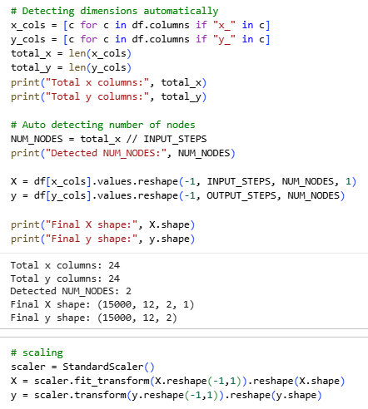
Figure 2 Data reshaping and node detection
The data was reshaped, and feature scaling was performed to normalize the values of traffic speed. The input and output values were standardized using StandardScaler to ensure that the data have a zero mean and unit variance. This is the normalization step, which enhances the stability and convergence rate of deep learning models in training [17].
Exploratory data analysis was done to gain insight into the nature of the traffic data [18]. Figure 3 is a sensor that shows a normalized traffic speed that varies from 0.5 to 1.3 over 200 timesteps. There are occasional sharp dips that go to -1.0 signaling sudden congestion events as indicated. The signal is characterized by average variability, which indicates dynamic traffic conditions where occasional disruptions occur, requiring strong temporal modelling.
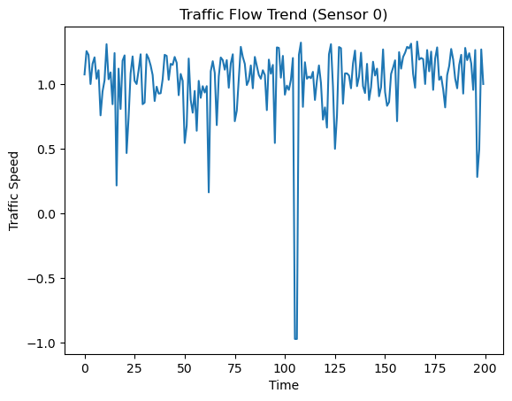
Figure 3 Traffic flow trend for a single sensor
Figure 4 shows that the speed distribution is bimodal, with a pronounced spike at -1.0 that has about 180,000 occurrences, which are sensor malfunctions or zero-speed events. The secondary cluster at 1.0-1.3 indicates normal scaled traffic speed in regular operating conditions.
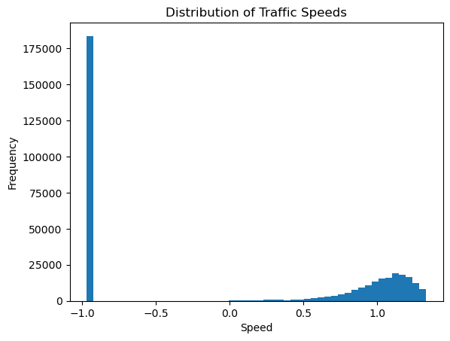
Figure 4 Distribution of traffic speeds
The correlation heatmap in Figure 5 between two sensors indicates that inter-sensor correlation is almost zero (-0.01), and diagonal self-correlations are also perfect (1.00). This means that the two sensors record relatively independent traffic patterns, implying that they represent spatially separate road segments or unrelated road structures.
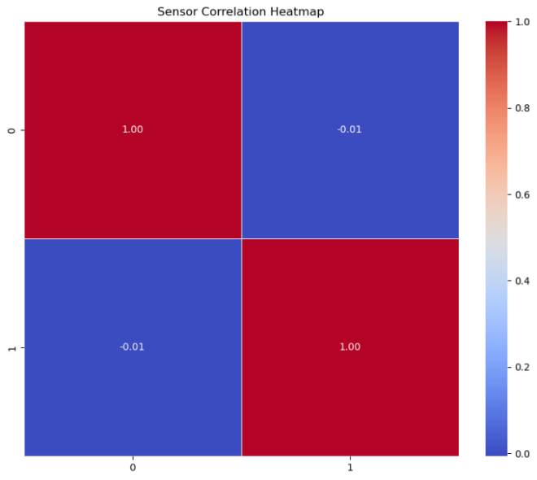
Figure 5 Sensor correlation heatmap
The average vehicle's speed on all sensors in Figure 6 fluctuates around zero, with sharp negative periods repeatedly occurring with values as large as -1.0 over the course of 500 time periods. These periodic drops would suggest periodic synchronized congestion events on more than one sensor, representing real-world disruptions in traffic as captured repeatedly throughout the network.
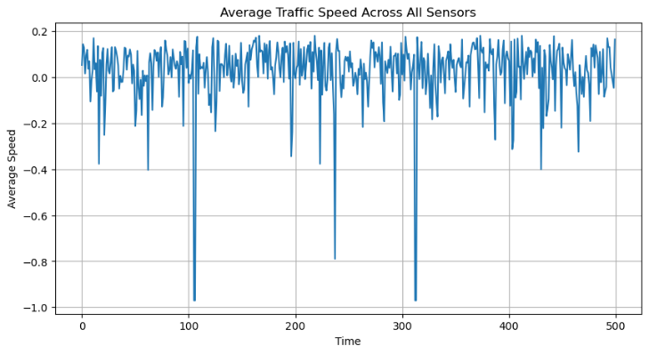
Figure 6 Average traffic speed across sensors
The distribution of the inter-sensor correlation, as shown in Figure 7, indicates that all values are close to 0.0 and support negligible linear associations between sensors. This almost negligible correlation encourages graph-based modeling that is capable of non-linear spatial dependencies instead of the straightforward pairwise statistical relationship.
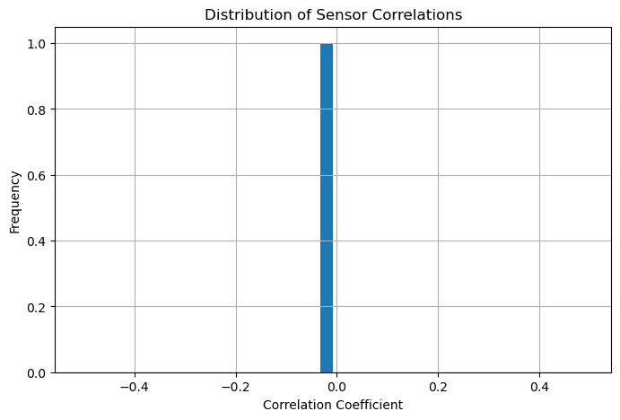
Figure 7 Distribution of sensor correlations
As adjacency estimated through correlation in Figure 8 results in an empty graph, a K-Nearest Neighbor fallback compiles the graph based on the five strongest correlations per node (k=5). The resulting minimal graph has 2 edges, which offers just enough but necessary connectivity to other graph convolution operations.
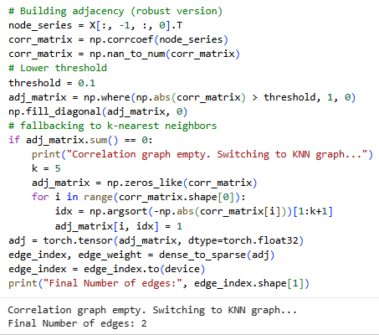
Figure 8 Construction of adjacency matrix and graph edges
The data were split into training and evaluation sets after preprocessing the dataset [19]. The models were trained in 80% of the samples, and the remaining 20% were employed in model evaluation. The PyTorch DataLoader was utilized to load the training batches to the neural networks, and thus, the data loaders were developed [20]. The train-test split and data loading process are described in Figure 9.
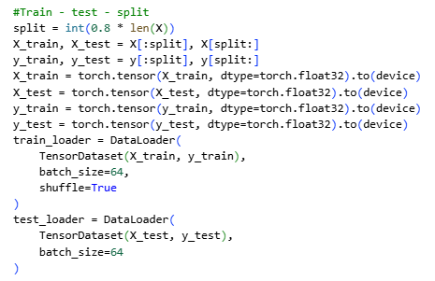
Figure 9 Train–test data split and data loader creation

Model Architectures
The study implemented four deep learning models for traffic prediction performance, including Long Short-Term Memory, Gated Recurrent Unit, Graph Convolutional Network, and Spatio-Temporal Graph Convolutional Network.
Figure 10 shows the LSTM model has two stacked layers with a hidden size of 64, where squeezed input sequences are processed [21]. The output predictive variable is reshaped by means of a fully-connected new layer and the final hidden state to create (batch, OUTPUT_STEPS, NUM_NODES) predictions, which allows the speed prediction of the multi-step-ahead traffic at all sensor nodes.
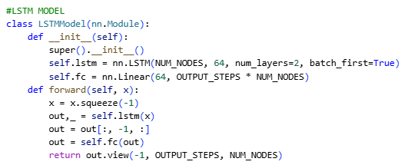
Figure 10 LSTM model architecture implementation
The GRU model in Figure 11 mirrors the LSTM architecture using two recurrent layers with a hidden size of 64 and a batch-first configuration [22]. The final timestep's hidden state feeds a linear layer outputting a prediction reshaped to (batch, OUTPUT_STEPS, NUM_NODES), offering computationally efficient sequential traffic forecasting.
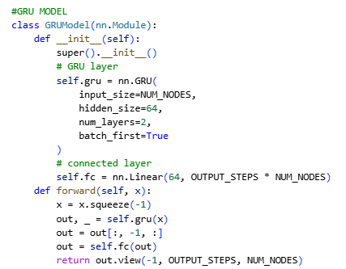
Figure 11 GRU model architecture implementation
The hybrid GCN model shown in Figure 12 is a combination of the GRU-based temporal encoding and two GCNConv spatial layers. GRU is used to extract the temporal characteristics of each node, and spatial dependencies are propagated by graph convolution [23]. The fully connected output layer makes per-node multi-step predictions, with both the temporal dynamics and the spatial topology.
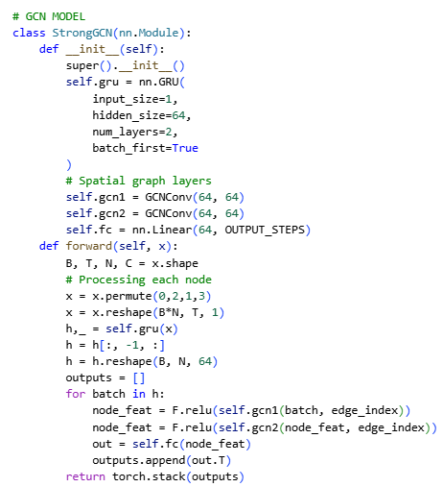Figure 12 Graph Convolutional Network model implementation
The STGCN model in Figure 13, which involves the use of two STGCNBlocks, each having temporal Conv2d and GCNConv spatial processing. Graph convolutions are followed by temporal convolutions, which use a kernel size of (3,1) with padding. The last Conv2d layer is to OUTPUT_STEPS, with mean pooling generating compact spatiotemporal traffic predictions [24].
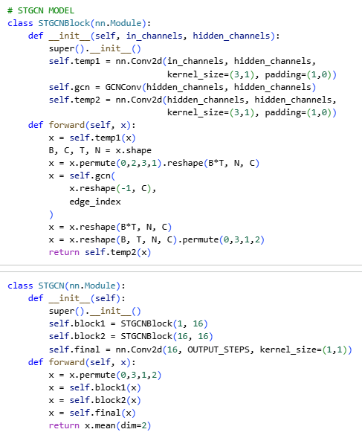
Figure 13 Spatio-Temporal Graph Convolutional Network architecture

Training and Implementation Details
All models were executed using the PyTorch deep learning framework, and the graph neural network functionalities were executed using the PyTorch Geometric library [25]. Python and other libraries, such as NumPy, Pandas, Matplotlib, and Seaborn, were used to conduct the experiments and to process and visualize the data.
The Adam optimizer was used in training the models with a learning rate of 0.001. The loss function was the Mean Squared Error of the difference between the predicted and actual values of the traffic speed. The training batch size was 64, and mini-batch training was effectively performed. The majority of the models used were trained over eight epochs, and the GCN model was also trained over twelve epochs to allow learning of sufficient features in space. A random seed was taken to ensure reproducibility of the experimental results, which was 42.

Evaluation Metrics
The performance of the implemented models was evaluated using four commonly employed regression metrics, such as Mean Absolute Error (MAE), Root Mean Squared Error (RMSE), Mean Absolute Percentage Error (MAPE), and the coefficient of determination (R²). MAE is used to calculate the mean relative error of prediction and actual values, which gives a simple measure of the error in prediction [26]. RMSE is a square root method that factors in the error, resulting in high prediction errors. MAPE is used to compute the mean percentage error between the predicted and actual traffic speeds, and it offers a measure of prediction accuracy that can be interpreted. The R² score has some relation to the extent to which the predicted value can explain the variation in the actual traffic values.
These metrics of evaluation offer a comprehensive, varied assessment of the model's performance in that they measure various aspects of prediction accuracy. These metrics are suitable because traffic flow prediction is a regression problem, which includes continuous numerical values, and thus evaluates the effectiveness and dependability of the forecasting models.
Additionally, the trained model was deployed using Streamlit to demonstrate real-world usability.

Experiments and Results
The section shows the experimental findings of the implemented traffic flow prediction models. The purpose behind the experiments is to evaluate the performance of various deep learning models in predicting the speed of traffic in the future. This study has evaluated four models, including Long Short-Term Memory, Gated Recurrent Unit, Graph Convolutional Network, and Spatio-Temporal Graph Convolutional Network. The datasets that were used to train the models were the METR-LA and the regression measures that evaluated the models. The findings consist of quantitative comparisons of the accuracy of prediction and qualitative analysis in the form of visual prediction plots.

Quantitative Results
Table 1 shows the quantitative comparison of the performance of the four models based on Mean Absolute Error, Root Mean Squared Error, Mean Absolute Percentage Error, and the coefficient of determination (R²). The smaller the values of MAE and RMSE, the higher the degree of predication, and the higher the values of R², the stronger the prediction.
Table 1 Performance comparison of traffic prediction models
Model | MAE | RMSE | MAPE | R²
LSTM | 4.030 | 10.042 | 31050012 | 0.8875
GRU | 3.877 | 10.034 | 31476518 | 0.8877
GCN | 28.608 | 29.631 | 16238712 | 0.0208
STGCN | 4.763 | 10.513 | 29444796 | 0.8767

The findings indicate that the GRU model has performed the best across the performance in terms of MAE, RMSE, and R² score, meaning that it is highly able to model the patterns of traffic over time. The LSTM model also generated the same performance with a slightly higher error value. Conversely, the GCN model performed poorly in comparison with other models. This finding indicates that spatial modelling may be inadequate to precisely predict traffic when there are strong temporal dependencies. The STGCN model, which integrates the spatial and temporal learning, had a competitive performance with a slightly lower accuracy than the GRU and LSTM in this experimental design.
The comparison of the four models of R² scores is shown in Figure 14. GRU and LSTM have the highest values of R², which means that their predictive power is high in terms of identifying traffic flow patterns. The GCN model has a low performance because it fails to adequately capture temporal dependencies.
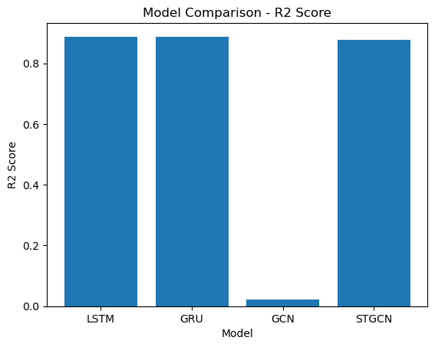
Figure 14 Model comparison based on R² score
The comparison of the RMSE values of the four models is shown in Figure 15. The GRU model had the lowest RMSE value, and the LSTM model came close. The GCN model generated a much larger error value, which implies low predictive power.
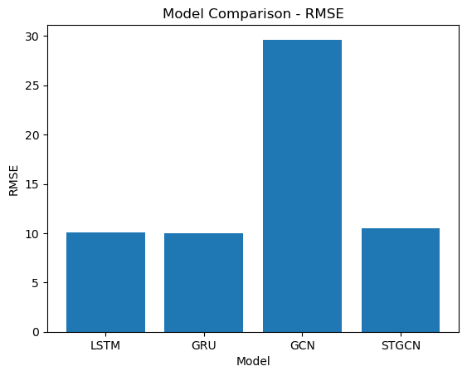
Figure 15 Model comparison based on RMSE
The comparison between the MAE values of the models is shown in Figure 16. Similar to the RMSE performance, the GRU and LSTM models recorded the lowest error of the predictions, with GCN recording the highest error.
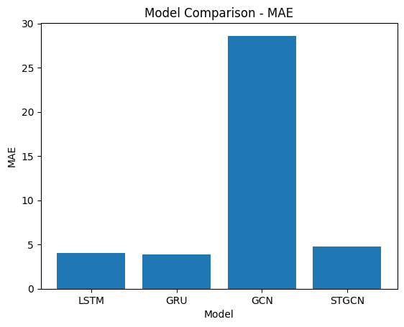
Figure 16 Model comparison based on MAE
The comparison of the values of Mean Absolute Percentage Error (MAPE) of the models is shown in Figure 17. The lowest MAPE value was achieved by the GCN model, but this should be considered carefully, as the general prediction ability was poor as evaluated by other measures like RMSE and R².
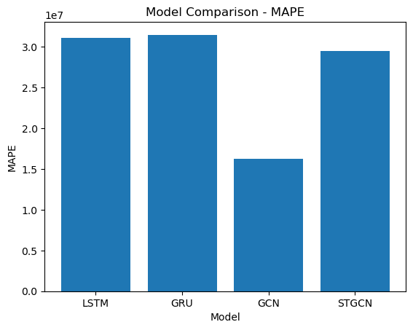
Figure 17 Model comparison based on MAPE

Qualitative Results
To further examine the behaviour of the prediction models, visual plots were created between the predicted and actual traffic speeds. These plots demonstrate the similarity of the predicted traffic values to the ground truth values in the future time steps.
The comparison between the predicted and actual traffic speeds of the GRU model is shown in Figure 18. The predicted values are in the overall direction of the real traffic speeds, though minor variations can be noticed at certain periods of time. The GRU model has a high temporal prediction.
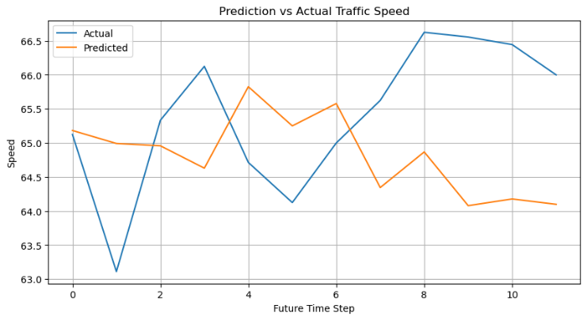
Figure 18 Prediction Vs Actual for GRU
The prediction performance of the STGCN model is shown in Figure 19. The predicted values reflect certain general traffic patterns but show slightly greater deviations than the GRU model. This can be attributed to the fact that it is difficult to model both spatial and temporal dependencies at the same time.
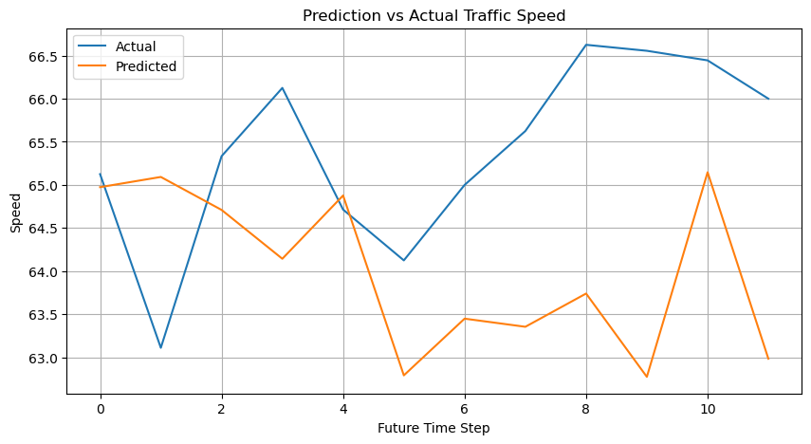
Figure 19 Prediction Vs Actual for STGCN
The results of the prediction of the LSTM model are shown in Figure 20. The predicted values are relatively close to the overall trend of the actual traffic speeds, which may be seen to prove that LSTM can learn temporal changes in the traffic data.
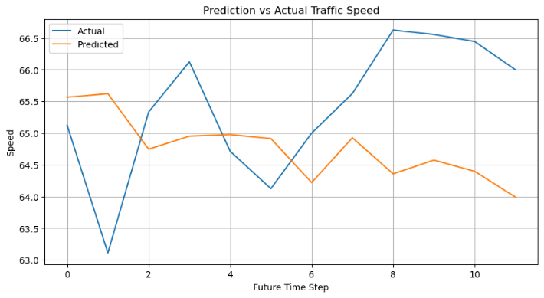
Figure 20 Prediction Vs Actual for LSTM
The prediction results of the GCN model are shown in Figure 21. The predicted values are nearly constant over different time periods and fail to capture the actual speed trends in traffic. This behaviour justifies the low quantitative performance of the GCN model as indicated in the metrics of the evaluation.
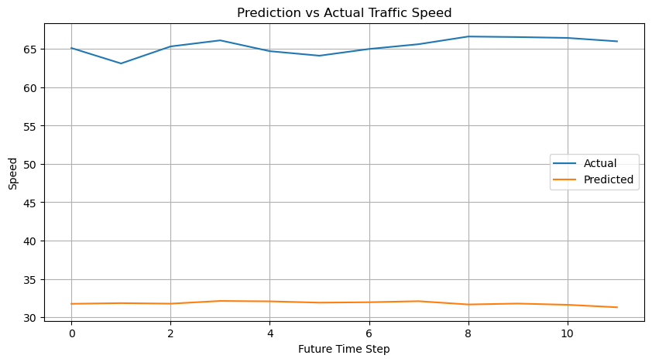
Figure 21 Prediction Vs Actual for GCN

Ablation Analysis
The study does not provide a complete ablation analysis, but the comparison of various models offers an idea of the significance of both temporal and spatial modelling in traffic prediction. The findings indicate that models based on temporal dependencies, i.e., LSTM, GRU, performed better than the GCN model. This demonstrates that temporal trends are imperative in the process of predicting traffic flow. The STGCN model, comprising both spatial and temporal elements, also shows competitive performance, which implies that the added value of spatial data can be better in predicting with bigger sensor networks.
The results of the experiment show that deep learning models are capable of successfully learning patterns of traffic flow based on sensor data. GRU has the highest overall performance in this study because it has an efficient sequential modelling capacity and has been shown to capture temporal dependence in traffic data.
The model was further integrated into a deployment environment for interactive evaluation.

MODEL DEPLOYMENT

Deployment Overview
The trained GRU model was implemented in the Streamlit framework in order to offer an interactive web-based dashboard to predict traffic flow. The deployment allows users to upload traffic datasets and get real-time predictions and performance evaluation metrics.
Streamlit was selected due to its simplicity, ability to integrate Python-based machine learning models, and capability to create visually interactive dashboards with minimal configuration.

User Interface Design
The developed application includes a user-friendly interface with a structured layout consisting of dataset upload functionality, data preview, prediction output, and visual analysis.
Figure 22 shows the main dashboard interface on which the user can upload CSV files with traffic data. The dataset is automatically processed in the system, and a preview is provided for verification.

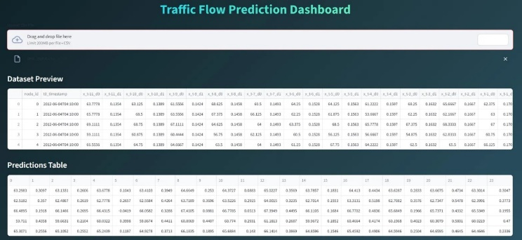
Figure 22 Streamlit Dashboard Interface

Prediction and Evaluation Dashboard
The implemented model provides the forecast of future traffic speeds and metrics of performance measurement through multiple regression.
The results of prediction and evaluation metrics, including MAE, RMSE, MAPE, and R², are shown in Figure 23. Prediction vs actual and error distribution plots are also visualisations that give insight into the performance of the model.
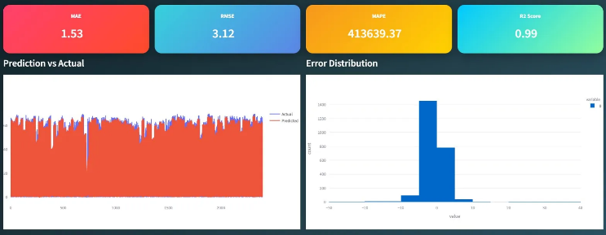
Figure 23 Prediction and Metrics Visualisation

Node-wise Prediction Analysis
Figure 24 presents predictions on a node-by-node basis, allowing for the analysis of the traffic patterns across sensor nodes. The feature is useful in interpreting spatial differences in the behaviour of traffic.
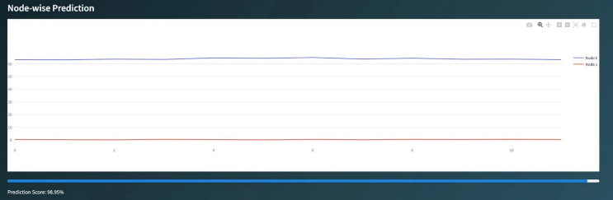
Figure 24 Node-wise Prediction

Functionality and Workflow
The deployment follows the workflow:
- User uploads traffic dataset
- Data preprocessing and scaling are applied
- The trained GRU model generates predictions
- Predictions are visualised through graphs and tables
- Performance metrics are computed and displayed

Practical Significance
The deployed system shows how deep learning models can be used in real-world applications in intelligent transportation systems. It also allows non-technical users to engage with the model and gain insights without knowing how to program.

Discussion
The section gives an interpretation of the experimental results of the traffic flow prediction models and their implications. The discussion aims at explaining the reasons why some of the models performed better than others, the relevance of the findings to existing literature, and what limitations could have affected the findings. Moreover, potential future research directions are recommended. The deployment phase highlights the practical applicability of the proposed model beyond experimental settings

Interpretation of Results
The experimental findings show that temporal deep learning encoder models, especially the GRU and LSTM models, performed the most successfully on average to predict traffic speeds. GRU had the smallest values of error and the greatest R², so it was the most effective model because it can correlate temporal dependencies within the dataset. GRU gating mechanism enables the model to regulate information flowing over time steps and therefore learns long-term sequential patterns efficiently. Traffic conditions are usually periodic in time, like daily commuting patterns and peak hours, so models that are able to capture sequential dependencies effectively can do so and have high prediction accuracy.
The LSTM model also performed well, as the results were quite similar to the GRU model. This result is in line with the existing literature that indicates the effectiveness of recurrent neural networks in the modelling of time series traffic data. Both LSTM and GRU models have been developed with the objective of operating on sequential data and are capable of learning complex time dependencies based on historical traffic measurements.
The Graph Convolutional Network model, on the other hand, achieved much poorer results. The GCN model exhibited a low predictive power with high errors of prediction and low R². A possible reason behind this finding is that the model mainly focuses on the spatial relationship between sensors with little consideration of the temporal dependencies. Traffic flow is very dynamic with time, and a model that does not take into account the time may not produce better predictions. The qualitative prediction plots also revealed that the GCN model generated almost constant results, which is why it does not achieve good quantitative performance.
The Spatio-Temporal Graph Convolutional Network architecture tried to incorporate some spatial and temporal learning in one architecture. Whereas the STGCN model received a better performance, it failed to outscore the GRU and LSTM models in this experiment. One of the reasons could be that the dataset applied to this research had a few active sensor nodes following the preprocessing. Since spatial connectivity is minimal, the spatial aspect of the STGCN architecture might not have had a significant impact on prediction accuracy.

Limitations of the Study
Although the findings achieved in this study are very promising, there are limitations that need to be considered. The experiments were performed on a subset of the METR-LA dataset instead of the entire dataset. This small dataset might cause the models to not be able to learn more intricate spatial relationships of sensors. The spatial size of the dataset was quite small, which minimised the performance of graph-based models like GCN and STGCN. The models did not train for a large number of epochs, and this might not ensure that the neural networks converge completely during training.
The other limitation is that the study admitted only historical traffic speed data without considering other contextual information. Weather conditions, accidents, road closures, and special events are some of the factors that can influence the pattern of traffic flow considerably. The lack of these extrinsic characteristics can trim down the predictive quality of the models.

Future Research Directions
The limitations found in this study can be overcome in the future by undertaking a number of possible improvements. A potential direction is to cover the entire METR-LA data set of all existing traffic sensors, which would cover the space with a richer spatial structure graph-based model. This may enable graph neural networks to develop spatio-temporal models that are able to capture intricate spatial interactions in traffic networks.
The other future potential is to incorporate more contextual details like weather, road events, and holiday plans in the prediction models. The addition of these external factors can enhance the predictive capacity of the model to experience disruptions in traffic due to unexpected events.
Furthermore, more advanced deep learning structures may be investigated. The latest trends, including graph attention networks, transformer-based models, and dynamic graph learning methods, have resulted in promising results in traffic prediction tasks. The exploration of these methods can result in better and more precise traffic forecasting models in future studies.

Conclusion
The study explored the issue of predicting traffic flow in intelligent transportation systems by using deep learning models that can learn patterns using traffic sensor data. Accurate traffic prediction is needed to minimise congestion, enhance route planning, and assist in effective traffic management within the City. To overcome it, four deep learning models were carried out and tested: Long Short-Term Memory (LSTM), Gated Recurrent Unit (GRU), Graph Convolutional Network (GCN), and Spatio-Temporal Graph Convolutional Network (STGCN). These models were developed and evaluated on METR-LA traffic data, and their performance was assessed with several regression parameters such as MAE, RMSE, MAPE, and coefficient of determination (R²). The experimental findings identified that the GRU model had the highest overall performance, and it has high potential in reflecting temporal trends in traffic data. The LSTM model also showed competitive results when compared to the GCN model, and the latter performed poorly because of the failure to model the dependence of time. The performance of the STGCN model by integrating spatial and temporal learning was reasonable, but the benefits were restricted by the small spatial form of the dataset used in this research. The results show that deep-learning-based methods can be effectively utilised in traffic forecasting. The accuracy and reliability of traffic prediction systems can be further refined in the future through bigger sensor networks, the incorporation of extra-contextual features, and more complex graph-based architectures. The deployment of the model as an interactive dashboard demonstrates its potential for real-world intelligent traffic systems.

References
[1]
A. Sharma et al., “A Graph Neural Network (GNN)-Based Approach for Real-Time Estimation of Traffic Speed in Sustainable Smart Cities,” Sustainability, vol. 15, no. 15, pp. 11893–11893, Aug. 2023, doi: https://doi.org/10.3390/su151511893.
[2]
G. Jin et al., “Spatio-Temporal Graph Neural Networks for Predictive Learning in Urban Computing: A Survey,” IEEE Transactions on Knowledge and Data Engineering, pp. 1–20, Jan. 2023, doi: https://doi.org/10.1109/tkde.2023.3333824.
[3]
S. B. Jeon and M.-H. Jeong, “Integrating Spatio-Temporal Graph Convolutional Networks with Convolutional Neural Networks for Predicting Short-Term Traffic Speed in Urban Road Networks,” Applied Sciences, vol. 14, no. 14, p. 6102, Jul. 2024, doi: https://doi.org/10.3390/app14146102.
[4]
S. A. Sayed, Y. Abdel-Hamid, and H. A. Hefny, “Artificial intelligence-based traffic flow prediction: a comprehensive review,” Journal of Electrical Systems and Information Technology, vol. 10, no. 1, Mar. 2023, doi: https://doi.org/10.1186/s43067-023-00081-6.
[5]
J. Chang, J. Yin, Y. Hao, and C. Gao, “STFDSGCN: Spatio-Temporal Fusion Graph Neural Network Based on Dynamic Sparse Graph Convolution GRU for Traffic Flow Forecast,” Sensors, vol. 25, no. 11, p. 3446, May 2025, doi: https://doi.org/10.3390/s25113446.
[6]
W. Jiang, Y. Xiao, Y. Liu, Q. Liu, and Z. Li, “Bi-GRCN: A Spatio-Temporal Traffic Flow Prediction Model Based on Graph Neural Network,” Journal of Advanced Transportation, vol. 2022, pp. 1–12, Feb. 2022, doi: https://doi.org/10.1155/2022/5221362.
[7]
Y. Li, W. Zhao, and H. Fan, “A Spatio-Temporal Graph Neural Network Approach for Traffic Flow Prediction,” Mathematics, vol. 10, no. 10, pp. 1754–1754, May 2022, doi: https://doi.org/10.3390/math10101754.
[8]
A. Roy, K. K. Roy, A. A. Ali, A. M. Ashraful, and Rahman, “SST-GNN: Simplified Spatio-temporal Traffic forecasting model using Graph Neural Network,” arXiv.org, 2021. https://arxiv.org/abs/2104.00055
[9]
V. Singh, S. K. Sahana, and V. Bhattacharjee, “Integrated Spatio-Temporal Graph Neural Network for Traffic Forecasting,” Applied Sciences, vol. 14, no. 24, p. 11477, Dec. 2024, doi: https://doi.org/10.3390/app142411477.
[10]
H. Chen, J. Huang, Y. Lu, and J. Huang, “Multi-scale spatio-temporal graph neural network for urban traffic flow prediction,” Scientific Reports, vol. 15, no. 1, Jul. 2025, doi: https://doi.org/10.1038/s41598-025-11072-0.
[11]
Y.-T. Chen, A. Liu, C. Li, S. Li, and X. Yang, “Traffic flow prediction based on spatial-temporal multi-factor fusion graph convolutional networks,” Scientific Reports, vol. 15, no. 1, Apr. 2025, doi: https://doi.org/10.1038/s41598-025-96801-1.
[12]
S. Z. Al and M. Awad, “Spatio-Temporal Graph Neural Networks: A Survey,” arXiv.org, 2023. https://arxiv.org/abs/2301.10569
[13]
X. Luo, C. Zhu, D. Zhang, and Q. Li, “STG4Traffic: A Survey and Benchmark of Spatial-Temporal Graph Neural Networks for Traffic Prediction,” arXiv.org, 2023. https://arxiv.org/abs/2307.00495
[14]
F. Li, J. Feng, H. Yan, G. Jin, D. Jin, and Y. Li, “Dynamic Graph Convolutional Recurrent Network for Traffic Prediction: Benchmark and Solution,” arXiv.org, May 03, 2021. https://arxiv.org/abs/2104.14917
[15]
R. Liu and S.-Y. Shin, “A Review of Traffic Flow Prediction Methods in Intelligent Transportation System Construction,” Applied Sciences, vol. 15, no. 7, pp. 3866–3866, Apr. 2025, doi: https://doi.org/10.3390/app15073866.
[16]
N. Kazi, “Enhancing Traffic Flow Prediction using Real Time Data with deep learning Techniques,” Ncirl.ie, 2023, doi: https://norma.ncirl.ie/7544/1/nihaddilawarkazi.pdf.
[17]
A. A. Kashyap, S. Raviraj, A. Devarakonda, S. R. Nayak K, S. K V, and S. J. Bhat, “Traffic flow prediction models – A review of deep learning techniques,” Cogent Engineering, vol. 9, no. 1, Dec. 2021, doi: https://doi.org/10.1080/23311916.2021.2010510.
[18]
D. Hungness and R. Bridgelall, “Exploratory Spatial Data Analysis of Traffic Forecasting: A Case Study,” Sustainability, vol. 14, no. 2, p. 964, Jan. 2022, doi: https://doi.org/10.3390/su14020964.
[19]
N. U. Khan, M. A. Shah, C. Maple, E. Ahmed, and N. Asghar, “Traffic Flow Prediction: An Intelligent Scheme for Forecasting Traffic Flow Using Air Pollution Data in Smart Cities with Bagging Ensemble,” Sustainability, vol. 14, no. 7, p. 4164, Mar. 2022, doi: https://doi.org/10.3390/su14074164.
[20]
E. J. Martinez-Noriega, C. Peng, and R. Yokota, “High-Performance Data Loader for Large-Scale Data Processing,” Electronic Imaging, vol. 36, no. 12, pp. 196–6, Jan. 2024, doi: https://doi.org/10.2352/ei.2024.36.12.hpci-196.
[21]
H.-C. Jang and C.-A. Chen, “Urban Traffic Flow Prediction Using LSTM and GRU,” Engineering Proceedings, vol. 55, no. 1, p. 86, 2024, doi: https://doi.org/10.3390/engproc2023055086.
[22]
C. Ma, Y. Hu, and X. Xu, “Hybrid deep learning model with VMD-BiLSTM-GRU networks for short-term traffic flow prediction,” Data Science and Management, Nov. 2024, doi: https://doi.org/10.1016/j.dsm.2024.10.004.
[23]
H. Yang, Z. Li, and Y. Qi, “Predicting traffic propagation flow in urban road network with multi-graph convolutional network,” Complex & intelligent systems, Jun. 2023, doi: https://doi.org/10.1007/s40747-023-01099-z.
[24]
Y. Xu, X. Cai, E. Wang, W. Liu, Y. Yang, and F. Yang, “Dynamic traffic correlations based spatio-temporal graph convolutional network for urban traffic prediction,” Information Sciences, vol. 621, pp. 580–595, Apr. 2023, doi: https://doi.org/10.1016/j.ins.2022.11.086.
[25]
P. Brimos, “Traffic forecasting with graph neural networks,” Lib.uom.gr, 2020, doi: http://dspace.lib.uom.gr/handle/2159/28909.
[26]
A. Navarro-Espinoza et al., “Traffic Flow Prediction for Smart Traffic Lights Using Machine Learning Algorithms,” Technologies, vol. 10, no. 1, p. 5, Jan. 2022, doi: https://doi.org/10.3390/technologies10010005.

