

SHORT TERM INTERNSHIP
(Virtual)

ANDHRA PRADESH
STATE COUNCIL OF HIGHER EDUCATION
(A STATUTORY BODY OF GOVERNMENT OF ANDHRA PRADESH)
















PROGRAM BOOK FOR
SHORT-TERM INTERNSHIP

(Virtual)

Thota Venkata Rao

Lingayas Institute of Management and Technology

22NA1A6103

20/05/25
06/07/25

Sandspace Technologies Private Limited
Address : 2nd Floor, S B I, NCK Plaza, NTR Circle, Vijayawada, Andhra Pradesh 520010
Phone: 096660 78112

University: Jawaharlal Nehru Technological University, Kakinada
2025

Lingayas Institute of Management & Technology

An Internship Report on

Java Full Stack
Submitted in accordance with the requirement for the degree of

Bachelor of Technology
Under the Faculty Guideship of

(Name of the Faculty Guide)

Department of

Artificial Intelligence & Machine learning

Lingayas Institute of Management & Technology

Submitted by:

Thota Venkata Rao

Reg. No: 22NA1A6103

Department of

Artificial Intelligence & Machine learning

Student’s Declaration

I am Thota Venkata Rao a student of Bachelor of Technology Program, Reg. No: 22NA1A6103 of the Department of Artificial Intelligence & Machine learning College do hereby declare that I have completed the mandatory internship from 20/05/2025 to 06/07/2025 in Sandspace Technologies Private Limited under the Faculty Guideship of (Name of the Faculty Guide), Department of Artificial Intelligence & Machine learning, Lingayas Institute of Management and Technology.

(Signature and Date)

Official Certification
This is to certify Thota Venkata Rao that Reg. No.22NA1A6103 has completed his/her Internship in Sandspace Technologies Private Limited on Full Stack Java under my supervision as a part of partial fulfillment of the requirement for the Department of Artificial Intelligence & Machine learning, Lingayas Institute of Management and Technologies.

(Signatory with Date and Seal)

Endorsements

Faculty Guide

Head of the Department

Principal

Certificate from Intern Organization

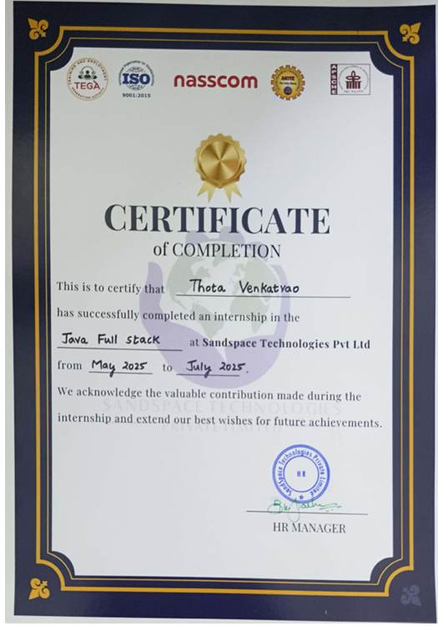

Acknowledgements

I Thank our Honourable chairman sir, mr. Gadde Rajling for his moral support and the excellent facilities provided.

I am grateful to____________, Principal, Lingayas Institute of Management & Technology, Nuzvid, for his support throughout the course and for giving the permission to undergo this internship work.

I wish to place on record our profound gratitude to Prof. Ch. Srinivasa Rao Head of the Department, Department of Computer Science and Engineering for having given me the opportunities to complete this internship successfully.

Firstly, I indebted to my parents, friends and relatives for their physical, psychological and moral extended by them at all time.

A special thanks to ChatGPT, Google, Gemini AI & Youtube for providing awesome facilities.

Thota Venkata Rao
(22NA1A6103)

Contents

S.No | Chapters | Page Numbers
1 | Executive Summary | 13-14
2 | Overview of the Organisation | 15-17
3 | Internship part
 | Internship part | 18
 | Project Explanation | 19-25
 | Implementation and Output | 26-29
 | Conclusion | 30
4 | Activity Log
 | Week-1 | 31-33
 | Week-2 | 34-35
 | Week-3 | 36-37
 | Week-4 | 38-39
 | Week-5 | 40-41
 | Week-6 | 42-43
5 | Outcomes Description | 44-51
6 | Student Self-Evaluation | 52
7 | Evaluation by Supervisor of Intern Organisation | 53
8 | Photos | 54-55
9 | Evaluation by External Examiner | 60

CHAPTER 1: EXECUTIVE SUMMARY

The report epitomizes about internship performed with the time span of two months in Sandspace Technologies Private Limited by Thota Venkata Rao. It is one of the companies approved for providing meaningful industrial exposure as per the guidelines of the All-India Council for Technical Education (AICTE) and Andhra Pradesh State Council of Higher Education (APSCHE). An intern needs to do his/her internship in AICTE or APSCHE recognized companies only.

This internship has paved a way to plan for a few learning objectives that include,

Get exposed to professional tasks and job roles in a reputed software organization and gain hands-on experience.

Develop both technical and communication skills in the chosen field of work.

Apply theoretical knowledge from coursework to real-world projects and scenarios.

Enhance technical, analytical, and soft skills through active involvement in live projects.

Cultivate problem-solving and critical thinking abilities to address challenges encountered during the internship.

The following are the learning outcomes, which include:

The internship provided real-time exposure to software development tasks and enhanced practical knowledge.

Helped in improving effective communication and in preparing concise technical reports.

Successfully applied academic concepts to solve real-world problems in the company environment.

Strengthened technical skills in programming and software tools, while also improving teamwork, time management, and interpersonal skills.

Gained confidence in handling project challenges and identifying efficient solutions.

Overall, the internship at Sandspace Technologies has been a highly enriching experience that contributed to both technical and personal growth. It provided a platform to explore advanced software development practices, real-time project handling, and organizational culture. This internship not only improved problem-solving and teamwork skills but also gave exposure to cutting-edge, real-time projects, which will be valuable in selecting and executing future academic or professional projects.

CHAPTER 2: OVERVIEW OF THE ORGANIZATION
Sandspace Technologies Private Limited is a distinguished and successful software company based in Vijayawada, Andhra Pradesh, with a legacy of over 16 years in the software industry. The company has consistently demonstrated leadership in developing impactful, real-time projects that contribute to national development and technological advancement. With an annual turnover of ₹2.1 crore, Sandspace has established strong financial stability and sustained profitability, reflecting its commitment to innovation, quality, and sustainable growth.
Training / Internship Areas:
Sandspace provides opportunities for learning and professional development through its comprehensive internship and training programs in various domains, including:
- Artificial Intelligence (AI)
- Machine Learning (ML)
- Web Development
- Cloud Computing
- Software Development and Testing
- Data Analytics
- Full Stack Java
- Mobile App Development
Training / Internship Methods:
Sandspace emphasizes hands-on learning by directly involving interns in real-time projects. The internship program follows a practical approach where students gain exposure to live projects under the mentorship of experienced professionals. Along with technical guidance, the company also provides access to tools, learning platforms, and industry-level practices.
Faculty / Mentors:
Interns are assigned dedicated mentors from the professional team who provide:
- Technical guidance and project specifications
- Regular progress reviews and feedback
- Code reviews and constructive suggestions
- Career development insights and skill-building support
Placement / Career Opportunities:
Sandspace uses its internship program as a talent pipeline, encouraging high-performing interns to explore professional roles within the organization. Its strong industry presence and focus on impactful projects help students gain practical skills and improve employability in the competitive job market.
Location:
Sandspace Technologies Private Limited is located in Vijayawada, Andhra Pradesh, India.
Vision:
The vision of Sandspace Technologies is to establish itself as a global leader in real-time software solutions, empowering national progress and transforming productivity in the technological landscape.
Mission:
The mission is centered on designing, developing, and delivering advanced software solutions that address critical national needs. The company is committed to technical excellence, innovation, and impactful contributions to both clients and society.
Core Values:
- Innovation
- Excellence
- Integrity
- National Impact
- Productivity Enhancement
- Collaboration & Teamwork
- Customer-Centric Approach
- Continuous Learning
Services Provided by the Organization:
- Real-time Software Development
- AI and ML-based Applications
- Web and Cloud Solutions
- Data Analytics and Business Intelligence
- Customized Project Development for National and Industrial Needs
Strategy:
- Quality Delivery: Focus on producing reliable and high-quality software solutions.
- Innovation: Encouraging creativity and fresh ideas to solve real-world challenges.
- Hands-on Experience: Emphasizing practical project involvement for interns and employees.
- Collaboration: Building strong teamwork and client partnerships.
- National Development: Aligning projects with the vision of contributing to India’s digital growth.

Structure of the Organization:
Sandspace follows a hybrid organizational model, which includes both functional departments and project-based teams. The leadership structure consists of:
- Chief Executive Officer (CEO)
- Chief Technology Officer (CTO)
- Chief Operating Officer (COO)
- Departments: Software Development, Quality Assurance, Project Management, Business Development, HR & Administration, and IT Infrastructure Support.
Roles and Responsibilities:
- Developing and delivering innovative software solutions
- Conducting real-time project work
- Mentoring and guiding interns
- Providing technical and analytical support to clients
- Fostering teamwork and knowledge sharing
Future Plans of the Organization:
Sandspace Technologies plans to expand its research and development division, explore new service domains, and enter emerging global markets. The company aims to invest in cutting-edge infrastructure, strengthen employee training, and continue developing impactful projects in AI, ML, and other emerging technologies. With its strong vision, Sandspace aspires to maintain its leadership in the software industry while contributing to both national and global technological growth.

CHAPTER 3: INTERNSHIP PART
Description of Activities/Responsibilities
This chapter describes my internship journey at Sandspace Technologies Private Limited, where I worked as a Full Stack Java Intern for two months. My project during this internship was the development of a Library Management System (LMS), which combined frontend, backend, and database technologies to deliver a real-time, role-based web application.
The internship was structured to give exposure to software development practices, project workflows, debugging, testing, and deployment. I worked under the supervision of my mentor, who guided me in applying theoretical knowledge into practical, real-world development.

Working Conditions
- Internship conducted remotely with access to required tools and software.
- Mentor-led guidance through online meetings and code review sessions.
- Collaborative discussions to resolve project challenges.
- Weekly progress reporting and feedback to improve deliverables.

Weekly Work Schedule
- I worked around 49 hours per week.
- This schedule ensured a balance of learning new concepts and practical implementation of project tasks.

Technical Environment
Hardware Requirements
- Processor: Intel i3 or above
- RAM: 4 GB (minimum)
- Hard Disk: 500 GB
- Speed: 2.4 GHz or higher
Software Requirements
- Operating System: Windows 10/11
- Frontend: HTML, CSS, JavaScript
- Backend: Java, Spring Boot, Maven
- Database: MySQL, Spring Data JPA
- Testing Tools: Postman (API testing), MySQL Workbench
- IDE: IntelliJ IDEA / Eclipse
Project Title
“E-Platform to access library resources using java full stack”.

Project Overview
The E-Platform to access library resources is a web-based application designed to streamline library operations, including book management, user management, and borrowing/returning transactions. The system provides role-based access:
- Admin – Manage books, approve borrowing requests, view student/teacher records.
- Student/Teacher – Browse available books, request to borrow, return books.
This project replicates real-time industry development by integrating frontend design, backend logic, and database storage.

Project Objectives
- To develop a scalable and responsive web application.
- To implement role-based access with distinct features for Admin, Student, and Teacher.
- To integrate frontend (HTML, CSS, JS) with backend (Java, Spring Boot APIs).
- To design and manage a MySQL database schema for books and users.
- To test and validate APIs using Postman.
- To gain exposure to real-time project workflow, debugging, and deployment.

Project Approach & Detailed Tasks
1. Frontend Development (Client-Side)
- Designed user-friendly pages (login, dashboard, book listing) using HTML & CSS.
- Implemented JavaScript functions for interactivity (form validation, dynamic updates).
- Created a responsive layout to ensure compatibility across devices.
2. Backend Development (Server-Side)
- Developed RESTful APIs using Java Spring Boot.
- Used Maven for dependency management and build automation.
- Implemented Controller-Service-Repository architecture for clean code structure.
- Added authentication & authorization to differentiate between Admin, Teacher, and Student.
3. Database Integration (Persistence Layer)
- Designed database tables for:
  - Users (Admin, Teacher, Student roles)
  - Books (BookID, Title, Author, Year, Semester, Availability)
  - BorrowRecords (IssuedTo, IssueDate, ReturnDate, Fine)
- Used Spring Data JPA for seamless integration with MySQL.
- Applied constraints (Primary Key, Foreign Key, NOT NULL) to ensure data integrity.
4. Testing & Debugging
- Tested APIs using Postman (GET, POST, PUT, DELETE).
- Verified data consistency between frontend UI and backend database.
- Debugged SQL queries and API response issues.
5. Features Implemented in LMS
- Admin Functions:
  - Add / Delete / Update Books
  - View Borrow Requests
  - Approve or Reject Book Borrowing
  - View all Students & Teachers with borrowing history
- Student Functions:
  - View available books (by year/semester)
  - Request to borrow books
  - Return borrowed books (with fine calculation after 15 days)
- Teacher Functions:
  - View and borrow books (no fines applied)
  - Return borrowed books

Implementation & Output
- Created a book table that displays Title, Author, Year, Semester, and Availability.
- Added "View Book" option that shows book details (cover image, description).
- Integrated fine calculation system:
  - Students fined ₹1/day after 15 days.
  - Teachers exempted from fines.
- Achieved smooth interaction between frontend forms, backend APIs, and database records.

Skills Acquired
Technical Skills
- Strong foundation in Java, Spring Boot, Maven for backend development.
- Hands-on practice with frontend technologies (HTML, CSS, JavaScript).
- Database design and management using MySQL.
- Practical understanding of REST API development and testing.
- Exposure to project deployment and debugging.
Soft Skills
- Improved communication and collaboration through regular updates.
- Developed time management skills by balancing learning and project tasks.
- Enhanced problem-solving by resolving real-world technical challenges.
- Gained professionalism and accountability in meeting deadlines.

Conclusion
The Library Management System internship project at Sandspace Technologies provided me with end-to-end exposure to software development. I learned how different layers—frontend, backend, and database—interact to form a complete web application.
This internship not only improved my technical foundation in Full Stack Java development but also strengthened my soft skills such as communication, teamwork, and time management. The project helped me gain confidence to handle real-time industry projects and prepared me to work effectively in professional software development environments.

CHAPTER - 4

ACTIVITY LOG FOR THE FIRST WEEK - 1
Day & Date | Brief description of the daily activity | Learning Outcome | Person In- Charge Signature
Day – 1  19/05/25 | Aim to know about the 3-2 summer internship and organizations who offering internships, which was conducted meeting by our college. | The learning outcomes from the discussion is gaining the knowledge about values of internship and organizations.
Day – 2  20/05/25 | Aim to select the organization and domain, in this free hand is given to us to select. | The learning outcomes from the Day -2 is to select the organization and domain.
Day – 3  21/05/25 | Aim to enroll to the organization and domain which was selected by us. | The learning outcomes from the Day -3 is to enrollment.
Day – 4  22/05/25 | Aim to onboarding us to the organization and more in detail about the internship and need to upload lecture notes in google form created by our college. | The learning outcomes from the meeting conducted by college is onboarding us and in detail about internship and google form to know our status.
Day – 5  23/05/25 | Aim to know about the organization and facilities offered by it for better internship experience. | The learning outcomes from the discussion is gaining the knowledge about organization and facilities given by them.
Day – 6  24/05/25 | Aim to know about the domain-java and where it is using and why it is trending. | The learning outcomes is to know about java and running applications in it and why it is trending.
Day – 7  25/05/25 | Aim to clear doubts and need to upload lecture notes in google form. | The learning outcomes is to clarification of doubts and upload notes.

WEEKLY REPORT FOR WEEK - 1
WEEK – 1 (From Dt 19/05/2025 to Dt 25/05/2025)
Objective of the Activity Done:
Detailed Report:
Day 1 (19/05/2025):
Understood the purpose of the 3-2 summer internship through an orientation meeting conducted by the college. Learned the importance of internships and the opportunities offered by different organizations.

Day 2 (20/05/2025):
Gained knowledge about selecting the right organization and domain based on personal interest and career goals. Learned how to align choices with professional growth.

Day 3 (21/05/2025):
Successfully enrolled in the chosen organization and domain. Understood the enrollment process and its significance in officially beginning the internship journey.

Day 4 (22/05/2025):
Learned the onboarding process of the organization, including expectations and responsibilities. Also understood the importance of sharing academic progress with the college through Google Forms.

Day 5 (23/05/2025):
Became familiar with the organization’s environment and facilities provided to interns. Understood how these resources support professional learning and skill development.

Day 6 (24/05/2025):
Gained knowledge about Java as a domain, including its applications, trending demand in industry, and importance for software development.

Day 7 (25/05/2025):
Clarified doubts related to internship activities and domain learning. Strengthened understanding of Java and maintained updates by submitting lecture notes to the college.

ACTIVITY LOG FOR THE SECOND WEEK - 2

Day & Date | Brief description of the daily activity | Learning Outcome | Person In- Charge Signature
Day – 1  26/05/25 | Aim to learn about basics of java and what is java full stack & college meeting. | The learning outcomes of the session is to learn basic concepts of and about java full stack & college meeting also held.
Day – 2  27/05/25 | Aim to learn about variables, Data types & Non – primitive data types. | The learning outcomes of the session is to learn about variables, data types & Non – primitive data types.
Day – 3  28/05/25 | Aim to learn about Java tutorial from Geeksforgeeks it was given us task to complete it. | The learning outcomes of the session is assigned a work that is to complete the java tutorial from Geeksforgeeks.
Day – 4  29/05/25 | Aim to learn about java oops concept Abstraction & Encapsulation. | The learning outcomes of the session is to learn about oops concept Abstraction & Encapsulation.
Day – 5  30/05/25 | Aim to attend the online meeting from the college R&C division. | The learning outcomes of the session is track our internship status and clarifying our doubts.
Day – 6  31/05/25 | Aim to learn about remaining oops concept Inheritance & Polymorphism. | The learning outcomes of the session is to learn remaining oops concept.
Day – 7  01/06/25 | Aim to clear doubts and need to upload lecture notes in google form. | The learning outcomes is to clarification of doubts and upload notes.

WEEKLY REPORT FOR WEEK - 2
WEEK – 2 (From Dt 26/05/22025 to Dt 01/06/2025)
Objective of the Activity Done:
Detailed Report:
Day 1 (26/05/2025):
Learned the basics of Java, including its core concepts and applications. Also gained an introduction to Java Full Stack development and attended a college meeting related to internship updates.

Day 2 (27/05/2025):
Understood the concept of variables, primitive data types, and non-primitive data types in Java. Learned how these are used in programming to handle data effectively.

Day 3 (28/05/2025):
Explored Java tutorials from GeeksforGeeks as part of the assigned task. Improved self-learning skills by completing coding exercises and strengthening foundational knowledge.

Day 4 (29/05/2025):
Learned Object-Oriented Programming (OOP) concepts, focusing on Abstraction and Encapsulation. Understood their importance in designing secure and structured Java applications.

Day 5 (30/05/2025):
Attended an online meeting conducted by the college R&C division to track internship progress. Cleared doubts related to tasks and understood expectations better.

Day 6 (31/05/2025):
Studied the remaining OOP principles — Inheritance and Polymorphism. Learned how these concepts support code reusability and flexibility in Java development.

Day 7 (01/06/2025):
Focused on clearing doubts regarding Java concepts and internship activities. Uploaded lecture notes in the Google Form as per the college requirements to maintain updates.

ACTIVITY LOG FOR THE THIRD WEEK - 3

Day & Date | Brief description of the daily activity | Learning Outcome | Person In- Charge Signature
Day – 1  02/06/25 | Aim to learn about HTML from basics to moderate. | The learning outcomes of the session is to learn about html from basics to moderate.
Day –2 03/06/25 | Aim to learn about CSS from basics to moderate. | The learning outcomes of the session is to learn about CSS from basics to moderate.
Day – 3  04/06/25 | Aim to learn about the Bootstrap framework which is used mainly for frontend design. | The leaning outcomes of the session is to learn about bootstrap which is useful for the frontend design.
Day – 4  05/06/25 | Aim to learn about the Java script from basics to moderate. | The learning outcomes of the session is to learn Java script in detail.
Day – 5  06/06/25 | Aim to attend the online meeting from the college R&C division & need to upload lecture notes. | The learning outcomes of the session is tracking our internship status and clarifying our doubts & upload lecture notes.
Day – 6  07/06/25 | Aim to learn about the Node.js & React.js from the basics to moderate. | The learning outcomes of the session is to learn node & react js in detail.
Day – 7  08/06/25 | Aim to learn about the frontend integration with learned from the above technologies. | The learning outcomes of the session is to explain the integration of frontend with learned technologies.

WEEKLY REPORT FOR WEEK - 3
WEEK – 3 (From Dt 02/06/2025 to Dt 08/06/2025)
Objective of the Activity Done:
Detailed Report:
Day 1 (02/06/2025):
Learned the fundamentals of HTML, starting from basic tags to moderate-level structures. Understood how HTML is used to design the skeleton of a webpage.

Day 2 (03/06/2025):
Studied CSS from basics to moderate concepts, including styling elements, layouts, and selectors. Learned how CSS enhances the visual design of web pages.

Day 3 (04/06/2025):
Explored the Bootstrap framework, focusing on its responsive design features and pre-built components. Understood its importance in simplifying frontend development.

Day 4 (05/06/2025):
Learned JavaScript from basics to moderate level, covering syntax, functions, and events. Understood its role in adding interactivity and dynamic features to web pages.

Day 5 (06/06/2025):
Attended an online meeting conducted by the college R&C division to review internship progress. Cleared doubts, tracked activities, and uploaded lecture notes as required.

Day 6 (07/06/2025):
Studied Node.js and React.js from the basics to moderate level. Learned how Node.js is used for backend development and how React.js simplifies frontend user interface creation.

Day 7 (08/06/2025):
Gained knowledge about frontend integration, combining HTML, CSS, JavaScript, Bootstrap, Node.js, and React.js. Understood how these technologies work together for full-stack development.

ACTIVITY LOG FOR THE FORTH WEEK - 4

Day & Date | Brief description of the daily activity | Learning Outcome | Person In- Charge Signature
Day – 1  09/06/25 | Aim to learn about the spring initializr.io. | The learning outcomes of the session is to learn spring initializer, know how to create and install the project structure
Day –2 10/06/25 | Aim to learn about the Spring Boot framework for backend. | The learning outcomes of the session is to learn Spring boot framework for backend.
Day – 3  11/06/25 | Aim to learn about the overall integration of backend. | The learning outcomes of the session is to learn backend integration.
Day – 4 12/06/25 | Aim to learn about the what is data base | The learning outcomes of the session is to learn about the data bases.
Day – 5  13/06/25 | Aim to attend the online meeting from the college R&C division & need to upload lecture notes. | The learning outcomes of the session is tracking our internship status and clarifying our doubts & upload lecture notes.
Day – 6  14/06/25 | Aim to learn about the overall integration of full stack | The learning outcomes of the session is to learn about the integration of full stack.
Day – 7  15/06/25 | Aim to learn about the project structure. | The learning outcomes of the session is to learn in detail about the project structure.

WEEKLY REPORT FOR WEEK - 4
WEEK – 4 (From Dt 09/06/2025 to Dt 15/06/2025)
Objective of the Activity Done:
Detailed Report:
Day 1 (09/06/2025):
Learned about Spring Initializr.io, including how to create and install a project structure. Understood the role of this tool in generating starter Spring Boot projects.

Day 2 (10/06/2025):
Studied the Spring Boot framework for backend development. Gained knowledge on its features, simplicity, and use for building scalable applications.

Day 3 (11/06/2025):
Explored the process of backend integration, learning how different components connect to provide application functionality.

Day 4 (12/06/2025):
Understood the basics of databases, including their importance, types, and how they support backend systems in storing and managing data.

Day 5 (13/06/2025):
Attended an online meeting with the college R&C division to track internship progress. Clarified doubts and uploaded lecture notes as per the requirements.

Day 6 (14/06/2025):
Learned about full-stack integration, combining frontend and backend technologies to work as a unified system.

Day 7 (15/06/2025):
Studied the project structure in detail, gaining clarity on how different modules and layers are organized in a full-stack application.

ACTIVITY LOG FOR THE FIFTH WEEK

Day & Date | Brief description of the daily activity | Learning Outcome | Person In- Charge Signature
Day – 1  16/06/25 | Aim to learn about the in detail about the project. | The learning outcomes of the session is to learn in detail about the project.
Day –2 17/06/25 | Aim to assigned to a project based on the internship & explained how output is required. | The learning outcomes of the session is assigned to a project University login portal & give requirement, how output is required.
Day – 3  18/06/25 | Aim to create a project development overview in a paper for gaining an idea about on the project. | The learning outcomes of the day is creating a paper-based approach to the project building.
Day – 4  19/06/25 | Aim to download the required tools & software’s for the project development. | The learning outcome of the day is to download the required software’s and tools for the assigned project.
Day – 5  20/06/25 | Aim to attend the online meeting conducted by the college R&C division & need to upload lecture notes. | The learning outcomes of the session is tracking our internship status and clarifying our doubts & upload lecture notes.
Day – 6  21/06/25 | Aim to start the work with the frontend based on the requirements and learned content. | The learning outcomes of the day is started the work in frontend with tools& technologies HTML, CSS, JS done work in visual studio.
Day – 7  22/06/25 | Aim to continue the development of frontend by solving the errors and debugging it. | The learning outcomes of the day continues the development of the frontend part of the project by debugging errors.

WEEKLY REPORT FOR WEEK - 5
WEEK – 5 (From Dt 16/06/2025 to Dt 22/06/2025)
Objective of the Activity Done:
Detailed Report:
Day 1 (16/06/2025):
Learned in detail about the assigned project, exploring its objectives, features, and expected outcomes. Understood the scope and importance of the project within the internship.

Day 2 (17/06/2025):
Assigned to develop a University Login Portal as part of the internship project. Understood the requirements, expected features, and how the final output should be delivered.

Day 3 (18/06/2025):
Created a paper-based project development overview to visualize workflow and structure. This helped in building a clear roadmap for the implementation process.

Day 4 (19/06/2025):
Downloaded and set up all necessary tools and software required for project development. Prepared the working environment to ensure smooth execution of tasks.

Day 5 (20/06/2025):
Attended an online meeting with the college R&C division to review progress. Clarified doubts related to the project and uploaded lecture notes as per instructions.

Day 6 (21/06/2025):
Started developing the frontend of the project using HTML, CSS, and JavaScript in Visual Studio Code. Applied previously learned concepts to meet project requirements.

Day 7 (22/06/2025):
Continued frontend development by debugging errors and fixing issues. Improved the interface design and ensured the frontend progressed smoothly.

ACTIVITY LOG FOR THE SIXTH WEEK

Day & Date | Brief description of the daily activity | Learning Outcome | Person In- Charge Signature
Day – 1  23/06/25 | Aim to complete the all dashboards of frontend like index, student, admin, main. | The learning outcomes of the day is to complete the all dashboards in the project.
Day –2 24/06/25 | Aim to start the work of backend for the logic of login & student features. | The learning outcomes of the day is to complete the work of backend logics for login and student features.
Day – 3  25/06/25 | Aim to continue the work of backend in the logic of admin and faculty. | The learning outcomes of the day is to complete the work of backend logics and the debugging the errors.
Day – 4  26/06/25 | Aim to integration of frontend backend with using tools like postman. | The learning outcomes of the day is to complete integration of frontend and backend with tool postman and fixing the errors.
Day – 5  27/06/25 | Aim to attend the online meeting conducted by the college R&C division. | The learning outcomes of the session is concluding our internship and start the work of report and ppt for reviews.
Day – 6  28/06/25 | Aim to integrate the database to the project and debugging the errors. | The learning outcomes of the day is to integrate the MySQL database to the project & debug the errors.
Day – 7  29/06/25 | Aim to start the project in local host. | The learning outcomes of the day is to start the project in the local host and debugging all the issues to working condition.

WEEKLY REPORT FOR WEEK - 6
WEEK – 6 (From Dt 23/06/2025 to Dt 29/06/2025)
Objective of the Activity Done:
Detailed Report:

Day 1 (23/06/2025):
Completed the design and development of all frontend dashboards including index, student, admin, and main pages. Ensured each dashboard aligned with project requirements.

Day 2 (24/06/2025):
Started backend development, focusing on the login functionality and student-related features. Implemented core logic and tested for smooth functionality.

Day 3 (25/06/2025):
Continued backend work by developing admin and faculty modules. Debugged errors in the logic to ensure proper functioning of different roles in the system.

Day 4 (26/06/2025):
Integrated frontend with backend using tools like Postman. Fixed errors during API testing and ensured proper data flow between client and server.

Day 5 (27/06/2025):
Attended an online meeting conducted by the college R&C division. Discussed progress, clarified final doubts, and began preparing the internship report and presentation.

Day 6 (28/06/2025):
Integrated the MySQL database with the project. Worked on debugging errors in queries and database connections to achieve smooth functionality.

Day 7 (29/06/2025):
Successfully deployed and started the project on localhost. Debugged remaining issues and brought the system into a working condition.

ACTIVITY LOG FOR THE SEVENTH WEEK - 7
Day & Date | Brief description of the daily activity | Learning Outcome | Person In- Charge Signature
Day – 1  30/06/25 | Aim to sort out the all issues in the project overall integration part not completed at 29/06/25. | The learning outcomes of the day is to complete overall integration which is not completed.
Day –2 31/06/25 | Aim to start the work of report, what work can be done by us. | The learning outcomes of the day is to start work on report.
Day – 3

01/07/25
Day – 4

02/07/25
Day – 5

03/07/25
Day – 6

04/07/25
Day – 7

05/07/25
WEEKLY REPORT
WEEK – 7 (From Dt 12/07/24 to Dt 18/07/24)
Objective of the Activity Done: Detailed Report:
Day- 1:
Day- 2:
Day- 3:
Day- 4:
Day- 5:
Day- 6:
Day- 7:
Then we use to have doubt sessions for the clarifying the of doubts & we need to upload lecture notes in

ACTIVITY LOG FOR THE EIGHTH WEEK - 8
Day & Date | Brief description of the daily activity | Learning Outcome | Person In- Charge Signature
Day – 1

Day –2
Day – 3

Day – 4

Day – 5

Day – 6

Day – 7

CHAPTER 5: OUTCOMES DESCRIPTION

Describe the work environment you have experienced (in terms of people interactions, facilities available and maintenance, clarity of job roles, protocols, procedures, processes, discipline, time management, harmonious relationships, socialization, mutual support and teamwork, motivation, space and ventilation, etc.
During my internship, I experienced a highly professional and supportive work environment that played a key role in enhancing my learning process. The people interactions were very encouraging, as mentors and coordinators were approachable, willing to clarify doubts, and motivated us to perform well. There was clear communication regarding roles and responsibilities, which helped me understand my tasks without confusion. The organization maintained a healthy balance of guidance and independence, allowing me to explore and learn while still following protocols and procedures.
The facilities provided were adequate and well-maintained, which created a smooth working experience. Access to necessary software tools, resources, and documentation ensured that I could carry out my tasks efficiently. The workspace was clean, well-ventilated, and organized, providing a comfortable environment to stay focused for long hours. Technical support was also available, ensuring that errors or issues during project execution could be resolved without major delays.
Time management and discipline were highly emphasized, as daily and weekly schedules were clearly defined. This taught me the importance of working within deadlines, maintaining consistency, and balancing tasks systematically. The organization followed proper protocols for communication, project documentation, and reporting, which gave me a structured approach to work.
Another important aspect was teamwork and mutual support. Even though individual tasks were assigned, there was a spirit of collaboration among peers, where knowledge-sharing and helping one another were encouraged. This not only strengthened professional relationships but also created a harmonious environment where learning became enjoyable. Socialization and interaction during meetings allowed us to build rapport with mentors and other interns, promoting healthy professional networking.
Overall, the work environment was highly motivating and learner-friendly, combining discipline with mutual support. It provided me with valuable exposure to professional practices, clear role clarity, and efficient processes. The harmonious relationships, team spirit, and structured protocols contributed to a positive and productive experience, ensuring that the internship was both professionally enriching and personally satisfying.
Describe the real time technical skills you have acquired (in terms of the job- related skills and hands on experience)
During the internship, I worked on a University Login Portal, which focused on authentication, user role management, and secure access to university resources. This project helped me gain in-depth experience in both backend and frontend development, along with database integration.
Job-Related Technical Skills
- Frontend Development: Built login and dashboard interfaces using HTML, CSS, and JavaScript, ensuring a user-friendly experience.
- Backend Development: Used Java and Spring Boot to implement secure login logic and role-based features for students, faculty, and admin users.
- Database Skills: Worked with MySQL to handle user records, authentication data, and role-based access storage.
- Project Design and Planning: Created a paper-based development overview to plan workflows and structure before implementation.
- Debugging and Integration: Gained experience in debugging backend logic, frontend issues, and integrating the database with the backend system.
Hands-On Experience
- Configured Spring Initializr.io and project dependencies to set up the development environment.
- Downloaded and used essential tools and software to build and run the project.
- Integrated the project and successfully deployed it on localhost, testing all modules for functionality.
Continuous Learning
- Learned how to analyze requirements and convert them into working features.
- Improved understanding of protocols, project structures, and best practices in software development.
Conclusion:
This project gave me real-time exposure to authentication systems, backend logic, and role-based access control. It not only enhanced my technical knowledge but also improved my problem-solving, debugging, and documentation skills essential for professional software development.
Describe the managerial skills you have acquired (in terms of planning, leadership, team work, behavior, workmanship, productive use of time, weekly improvement in competencies, goal setting, decision making, performance analysis, etc.
During my internship, I not only developed technical expertise but also acquired several important managerial skills that strengthened my overall professional competency. These skills helped me manage tasks effectively, work collaboratively, and deliver results within deadlines.
Planning and Goal Setting:
I learned to plan my weekly tasks systematically by breaking down project requirements into smaller, achievable goals. This approach improved my ability to prioritize activities and track progress, ensuring steady advancement towards project completion.
Leadership and Teamwork:
Through collaborative discussions with peers and mentors, I gained experience in both leading and contributing as a team member. I learned how to share responsibilities, delegate tasks, and support others, which enhanced the overall efficiency of group work.
Behaviour and Workmanship:
The internship emphasized professional behaviour, discipline, and quality of work. I developed a sense of responsibility and accountability, ensuring that my contributions met organizational standards.
Decision Making and Problem-Solving:
I enhanced my decision-making abilities by analysing problems, evaluating different approaches, and implementing the most effective solutions. This was particularly useful in debugging technical issues and selecting tools for integration.
Performance Analysis and Improvement:
Regular feedback sessions and college review meetings allowed me to analyse my performance weekly. This helped me identify strengths, address weaknesses, and improve competencies step by step.

Overall, the internship provided me with strong managerial skills such as planning, leadership, teamwork, time management, decision-making, and continuous performance improvement. These skills are equally valuable as technical knowledge, as they prepare me to take responsibility, work collaboratively, and perform effectively in professional environments.
Describe how you could improve your communication skills (in terms of improvement in oral communication, written communication, conversational abilities, confidence levels while communicating, anxiety management, understanding others, getting understood by others, extempore speech, ability to articulate the key points, closing the conversation, maintaining niceties and protocols, greeting, thanking and appreciating others, etc.,)
During my internship, I realized that communication plays a vital role in both technical and managerial activities. To further improve my communication skills, I plan to focus on several key areas that will strengthen my ability to interact effectively in professional environments.
Oral and Written Communication:
I aim to enhance my oral communication by practicing clear pronunciation, tone, and fluency during meetings and presentations. For written communication, I will improve the way I structure emails, reports, and documentation to make them more precise, professional, and easy to understand.
Conversational Abilities and Confidence:
To become more confident in conversations, I will practice active participation in discussions, express my thoughts clearly, and learn to manage anxiety during public speaking. Improving my extempore speaking skills will help me respond quickly and effectively in unplanned situations.
Listening and Understanding:
Good communication also involves attentive listening. I plan to strengthen my ability to understand others by maintaining eye contact, avoiding interruptions, and asking clarifying questions when needed. This will ensure that I am understood correctly and can also understand others better.
Articulation and Conversation Management:
I will practice summarizing key points in discussions, ensuring that the main ideas are conveyed clearly. Additionally, I will work on closing conversations politely and maintaining professional niceties such as greeting, thanking, and appreciating others.
Overall:
By improving oral and written communication, building confidence, managing anxiety, enhancing listening skills, and practicing professional etiquette, I can develop strong communication skills. These improvements will help me collaborate better, present my ideas effectively, and maintain positive professional relationships in future career opportunities.
Describe how could you could enhance your abilities in group discussions, participation in teams, contribution as a team member, leading a team/activity.
Enhancing Abilities in Group Discussions and Team Participation
Group discussions and teamwork are essential parts of professional growth, and I believe there is always scope for improvement in these areas. To enhance my abilities, I plan to focus on developing active participation, constructive contribution, and effective leadership skills.
Group Discussions:
I aim to strengthen my performance in group discussions by improving my ability to listen carefully, analyse different viewpoints, and respond with relevant, concise points. I will practice maintaining clarity of thought, staying confident, and contributing meaningfully without dominating or being passive. This balance will help me engage productively in discussions.
Participation in Teams:
To become an effective participant, I will actively contribute ideas, share knowledge, and take responsibility for assigned tasks. At the same time, I will remain open to feedback and respect the opinions of others, ensuring that the team functions harmoniously toward common goals.
Contribution as a Team Member:
I plan to focus on collaboration by helping peers when required, encouraging them, and ensuring that my work supports the team’s success. By improving my coordination, adaptability, and willingness to take initiative, I can add greater value to team projects.
Leading a Team/Activity:
To enhance my leadership abilities, I will practice planning activities, setting clear goals, and motivating team members to perform their best. I will also work on decision-making, conflict resolution, and time management skills to ensure smooth execution of tasks. Leading with empathy and fairness will help me earn trust and build strong professional relationships.
Overall:
By improving active participation in discussions, contributing responsibly as a team member, and practicing fair and motivating leadership, I can significantly enhance my abilities in teamwork and group activities. These improvements will make me more confident, collaborative, and effective in both academic and professional environments.

Describe the technological developments you have observed and relevant to the subject area of training (focus on digital technologies relevant to your job role)
While working on the University Login Portal, I observed several technological advancements in the area of secure authentication systems and digital access management. These technologies are widely used to manage academic portals and online services for institutions.
- Spring Boot for Authentication: Modern login systems use Spring Security within Spring Boot to handle authentication, session management, and role-based access, ensuring secure and scalable backends.
- Database Integration: The use of MySQL for storing user credentials and roles highlights how relational databases are vital for maintaining secure and structured login systems.
- Encryption Techniques: I observed how password encryption and hashing are essential developments to protect sensitive login data against cyber threats.
- Frontend Technologies: Interfaces designed using HTML, CSS, and JavaScript with frameworks like Bootstrap provide responsive and accessible login pages across devices.
- API and Middleware: REST APIs enable smooth communication between frontend login forms and backend authentication services, which is a standard practice in digital portals today.
- Deployment Trends: University portals are increasingly being deployed on cloud servers, ensuring high availability, remote access, and scalability for large numbers of users.
- Digital Transformation in Education: The adoption of single sign-on (SSO), integration with student information systems, and OTP/email verification reflect the latest advancements in digital university login systems.
Conclusion:
These technological developments demonstrate how university login portals are evolving with secure authentication frameworks, cloud deployment, and responsive UI designs, ensuring safe, reliable, and user-friendly access to academic resources.

Student Self Evaluation of the Short Term Internship

Organization Name & Address: Sandspace Technologies Private Limited
Address: 2nd Floor, S B I, NCK Plaza, NTR Circle, Vijayawada, Andhra Pradesh 520010
Phone: 096660 78112

Sandspace Technologies Private Limited
Address : 2nd Floor, S B I, NCK Plaza, NTR Circle, Vijayawada, Andhra Pradesh 520010
Phone: 096660 78112

Student Name: | T. Venkata Rao | Registration No: 22NA1A103
Term of Internship: 6 weeks | From: 07/06/24 | To : 10/08/24
Date of Evaluation:

Please rate your performance in the following areas:

Rating Scale: Letter grade of CGPA calculation to be provided

1 | Oral communication | 1 | 2 | 3 | 4 | 5
2 | Written communication | 1 | 2 | 3 | 4 | 5
3 | Proactiveness | 1 | 2 | 3 | 4 | 5
4 | Interaction ability with community | 1 | 2 | 3 | 4 | 5
5 | Positive Attitude | 1 | 2 | 3 | 4 | 5
6 | Self-confidence | 1 | 2 | 3 | 4 | 5
7 | Ability to learn | 1 | 2 | 3 | 4 | 5
8 | Work Plan and organization | 1 | 2 | 3 | 4 | 5
9 | Professionalism | 1 | 2 | 3 | 4 | 5
10 | Creativity | 1 | 2 | 3 | 4 | 5
11 | Quality of work done | 1 | 2 | 3 | 4 | 5
12 | Time Management | 1 | 2 | 3 | 4 | 5
13 | Understanding the Community | 1 | 2 | 3 | 4 | 5
14 | Achievement of Desired Outcomes | 1 | 2 | 3 | 4 | 5
15 | OVERALL PERFORMANCE | 1 | 2 | 3 | 4 | 5

Date: Signature of the Student

Evaluation by the Supervisor of the Intern Organization

Organization Name & Address: Sandspace Technologies Private Limited
Address : 2nd Floor, S B I, NCK Plaza, NTR Circle, Vijayawada, Andhra Pradesh 520010
Name & Address of the Supervisor with Mobile Number:

Student Name: | T. Venkata Rao | Registration No: 22NA1A6103
Term of Internship: 6 weeks | From: 07/06/24 | To : 10/08/24
Date of Evaluation:

Please rate the student’s performance in the following areas:

Please note that your evaluation shall be done independent of the Student’s self- evaluation

Rating Scale: 1 is lowest and 5 is highest rank

1 | Oral communication | 1 | 2 | 3 | 4 | 5
2 | Written communication | 1 | 2 | 3 | 4 | 5
3 | Proactiveness | 1 | 2 | 3 | 4 | 5
4 | Interaction ability with community | 1 | 2 | 3 | 4 | 5
5 | Positive Attitude | 1 | 2 | 3 | 4 | 5
6 | Self-confidence | 1 | 2 | 3 | 4 | 5
7 | Ability to learn | 1 | 2 | 3 | 4 | 5
8 | Work Plan and organization | 1 | 2 | 3 | 4 | 5
9 | Professionalism | 1 | 2 | 3 | 4 | 5
10 | Creativity | 1 | 2 | 3 | 4 | 5
11 | Quality of work done | 1 | 2 | 3 | 4 | 5
12 | Time Management | 1 | 2 | 3 | 4 | 5
13 | Understanding the Community | 1 | 2 | 3 | 4 | 5
14 | Achievement of Desired Outcomes | 1 | 2 | 3 | 4 | 5
15 | OVERALL PERFORMANCE | 1 | 2 | 3 | 4 | 5

Date: Signature of the Supervisor

Photos And Videos

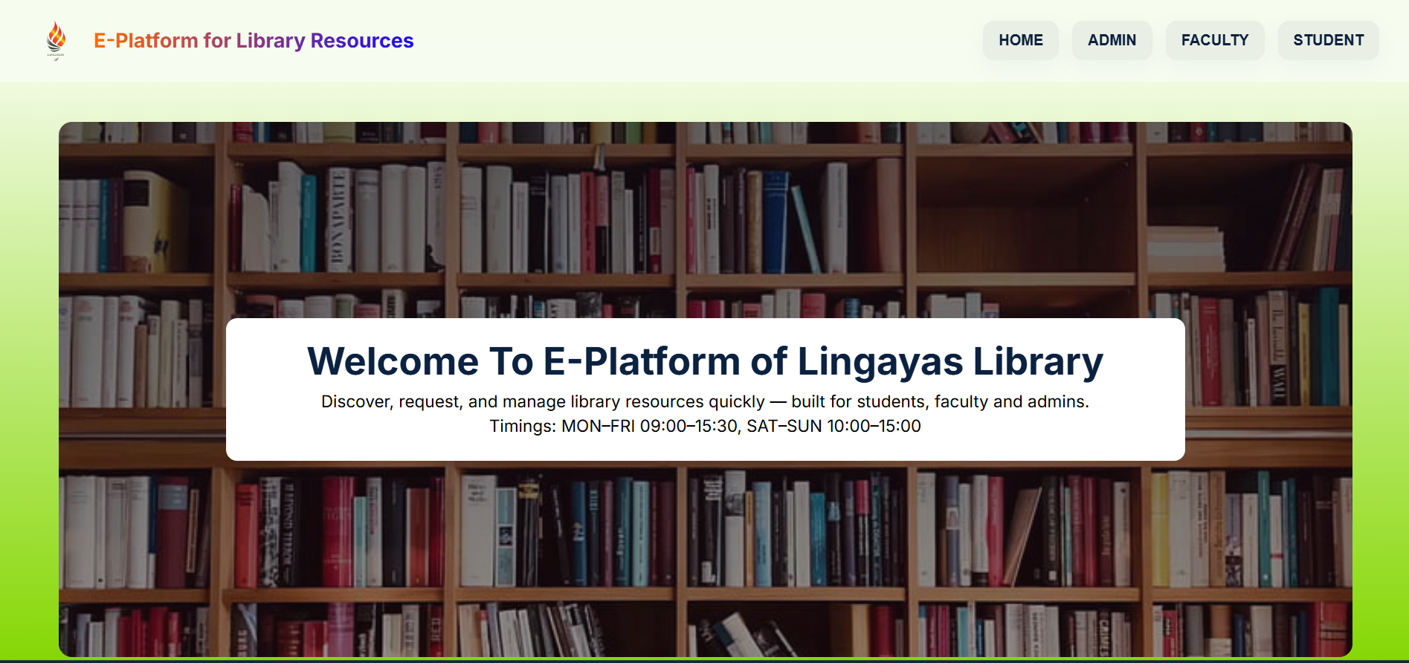

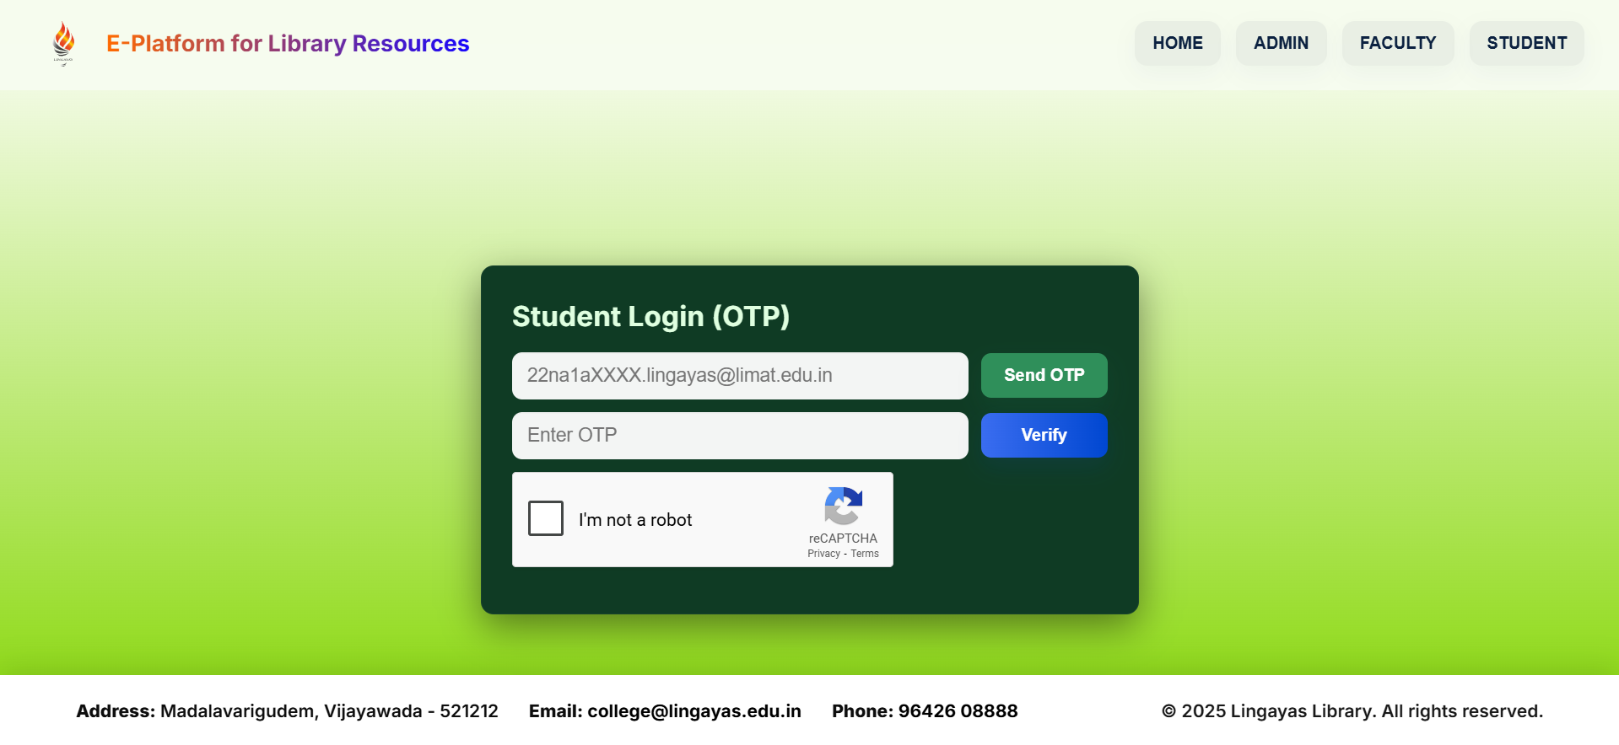

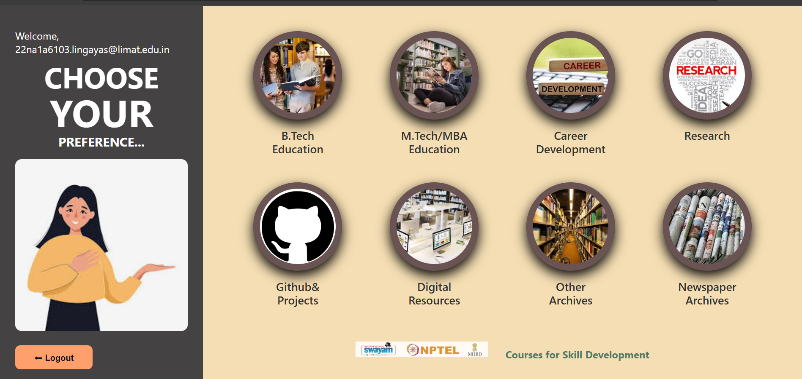

EVALUATION

Internal Evaluation for Short Term Internship (Virtual)

Objectives:
- To integrate theory and practice.
- To learn to appreciate work and its function towards the future.
- To develop work habits and attitudes necessary for job success.
- To develop communication, interpersonal and other critical skills in the future job.
- To acquire additional skills required for the world of work.

Assessment Model:
- There shall only be internal evaluation.
- The Faculty Guide assigned is in-charge of the learning activities of the students and for the comprehensive and continuous assessment of the students.
- The assessment is to be conducted for 100 marks.
- The number of credits assigned is 4. Later the marks shall be converted into grades and grade points to include finally in the SGPA and CGPA.
- The weightings shall be:
  - Activity Log 25 marks
  - Internship Evaluation 50marks
  - Oral Presentation 25 marks
- Activity Log is the record of the day-to-day activities. The Activity Log is assessed on an individual basis, thus allowing for individual members within groups to be assessed this way. The assessment will take into consideration the individual student’s involvement in the assigned work.
- While evaluating the student’s Activity Log, the following shall be considered –
  - The individual student’s effort and commitment.
  - The originality and quality of the work produced by the individual student.
  - The student’s integration and co-operation with the work assigned.
  - The completeness of the Activity Log.
- The Internship Evaluation shall include the following components and based on Weekly Reports and Outcomes Description
- Description of the Work Environment.

- Real Time Technical Skills acquired.
- Managerial Skills acquired.
- Improvement of Communication Skills.
- Team Dynamics
- Technological Developments recorded.

MARKS STATEMENT
(To be used by the Examiners)

INTERNAL ASSESSMENT STATEMENT
Name Of the Student: Thota Venkata Rao
Programme of Study: Bachelor of Technology
Year of Study: 3YEAR

Group: AI&ML
Register No/H.T. No: 22NA1A6103
Name of the College: Lingayas Institute of Management & Technology
University: Jawaharlal Nehru Technological University, Kakinada

Sl.No | Evaluation Criterion | Maximum Marks | Marks Awarded
1. | Activity Log | 25
2. | Internship Evaluation | 50
3. | Oral Presentation | 25
 | GRAND TOTAL | 100

Date: Signature of the Faculty Guide

Certified by

Date: Signature of the Head of the Department/Principal
Seal:



