

**THE SMART TRAFFIC LIGHT CONTROL SYSTEM**

**USING FUZZY LOGIC**

Submitted by

**SHANMUGASHREE M (221801049)**

**SIVABALAMURUGAN G (221801050)**

**VENKATESHAN T (221801061)**

**AD19541 SOFTWARE ENGINEERING METHODOLOGIES**

**Department of Artificial Intelligence and Data Science**

**Rajalakshmi Engineering College, Thandalam**

BONAFIDE CERTIFICATE

Certified that this project report “**THE SMART TRAFFIC LIGHT CONTROL SYSTEM USING FUZZY LOGIC**” is the bonafide work of **SHANMUGASHREE M (221801049), SIVABALAMURUGAN G (221801050), VENKATESHAN T (221801061)** who carried out the project work under my supervision.

**Submitted for the Practical Examination held on**

**SIGNATURE SIGNATURE**

|  |  |
| --- | --- |
| Dr. J MANORANJINI M.Tech., Ph.D., | Dr. J M GNANASEKAR M.E., Ph.D |
| Associate Professor,  Artificial Intelligence & Data Science,  Rajalakshmi Engineering College(Autonomous),  Chennai-602105 | Professor & Head of the Department,  Artificial intelligence & Data Science,  Rajalakshmi Engineering College (Autonomous),  Chennai-602105 |

**INTERNAL EXAMINER EXTERNAL EXAMINER**

**TABLE OF CONTENT**

|  |  |  |  |  |  |  |
| --- | --- | --- | --- | --- | --- | --- |
| S.NO | CHAPTER | | | PAGE NUMBER | | |
| 1. | **INTRODUCTION** | | |  | | |
| 1.1 | GENERAL | | | 1 | | |
| 1.2 | NEED FOR THE STUDY | | | 2 | | |
| 1.3 | OBJECTIVES OF THE STUDY | | | 3 | | |
| 1.4 | OVERVIEW OF THE PROJECT | | | 4 | | |
|  |  | | |  | | |
| 2. | **REVIEW OF LITERATURE** | | |  | | |
| 2.1 | INTRODUCTION | | | 5 | | |
| 2.2 | LITERATURE REVIEW | | | 5 | | |
|  |  | | |  | | |
| 3. | **SYSTEM OVERVIEW** | | |  | | |
| 3.1 | EXISTING SYSTEM | | | 9 | | |
| 3.2 | PROPOSED SYSTEM | | | 10 | | |
| 3.3 | FEASIBILITY STUDY | | | 11 | | |
|  |  | | |  | | |
| 4. | **SYSTEM REQUIREMENTS** | | |  | | |
| 4.1 | SOFTWARE REQUIREMENTS | | | 13 | | |
| 4.2 | HARDWARE REQUIREMENTS | | | 14 | | |
| 4.3 | FUNCTIONAL REQUIREMENTS | | | 15 | | |
| 4.4 | NON-FUNCTIONAL REQUIREMENTS | | | 16 | | |
|  |  | | |  | | |
| 5. | **SYSTEM DESIGN** | | |  | | |
| 5.1 | SYSTEM ARCHITECTURE | | | 18 | | |
| 5.2 | DATA FLOW DIAGRAM | | | 20 | | |
|  |  | | |  | | |
| 6. | **SOFTWARE MODEL** | | |  | | |
| 6.1 | V- MODEL | | | 22 | | |
|  |  | | |  | | |
| 7. | **IMPLEMENTATION OF THE SYSTEM** | | | |  | | |
| 7.1 | SOURCE CODE | | | 23 | | |
|  |  | | |  | | |
| 8. | **TESTING** | | |  | | |
| 8.1 | UNIT TESTING | | | 27 | | |
| 8.2 | FUNCTIONAL TESTING | | | 28 | | |
|  |  | | |  | | |
| 9. | **RESULTS AND DISCUSSION** | | |  | | |
| 9.1 | RESULTS AND DISCUSSIONS | | | 29 | | |
| 9.2 | OUTPUT | | | 30 | | |
| 10. | | **UML DIAGRAMS** |  | | | | | |
| 10.1 | | USE CASE DIAGRAM | 32 | | | | | |
| 10.2 | | CLASS DIAGRAM | 33 | | | | | |
| 10.3 | | SEQUENCE DIAGRAM | 34 | | | | | |
| 10.4 | | ACTIVITY DIAGRAM | 36 | | | | | |
|  |  | | |  | | |
| 11. | **CONCLUSION AND FUTURE SCOPE** | | | | |  | | |
| 11.1 | CONCLUSION | | | 39 | | |
| 11.2 | FUTURE SCOPE | | | 40 | | |
|  |  | | |  | | |
| 12. | **REFERENCES** | | | **42** | | |

**TABLE OF FIGURES**

|  |  |  |
| --- | --- | --- |
| S.NO | FIGURE | PAGE NUMBER |
| 1 | ARCHITECTURE DIAGRAM | 18 |
| 2 | DATA FLOW DIAGRAM | 20 |
| 3 | V-MODEL | 22 |
| 4 | UNIT TESTING | 23 |
| 5 | FUNCTIONAL TESTING | 24 |
| 6 | MEMBERSHIP FUNCTION GRAPH FOR VEHICLE DENSITY | 30 |
| 7 | MEMBERSHIP FUNCTION GRAPH FOR PEDESTRIAN PRESENCE | 30 |
| 8 | VEHICLE DENSITY vs PEDESTRIAN PRESENCE GRAPH AND TRAFFIC LIGHT STATE | 31 |
| 9 | USE CASE DIAGRAM | 32 |
| 10 | CLASS DIAGRAM | 33 |
| 11 | SEQUENCE DIAGRAM | 34 |
| 12 | ACTIVITY DIAGRAM | 36 |

**ABSTRACT**

The usage of different techniques and algorithms of artificial intelligence have became predominant in recent times like the usage of fuzzy logic algorithm in traffic light systems. The existing traffic light controllers would not give a best solution to this problem as it changes traffic lights based on constant cycle time. Fuzzy logic controllers can be used to deal with linguistic and unpredictable traffic data to control the signal timings. Inadequate space and funds for the construction of new roads and the steady increase in number of vehicles has prompted researchers to investigate other solutions to traffic congestion. One area gaining interest is the use of intelligent systems to make traffic routing decisions with the potential to enhance vehicle traffic management. This paper presents the design and implementation of a smart traffic light (STL) using fuzzy logic and wireless sensor network (WSN). Designed for an isolated four way roundabout; the STL incorporates a WSN to collect traffic data in real time. This data is aggregated and then fed into a fuzzy logic controller (FLC) engine in form of two inputs – traffic quantity (TQ) and waiting time (WT) for each lane. Based on the inputs, the FLC then computes an output priority degree (PD) that determines order of green light assignment. Using the PD, a smart algorithm then assigns green light to the lane with highest PD value. The cycle continues until all lanes get green light. To analyze the performance of the STL, we designed a simulation software using python to virtually represent the functions of the WSN and FLC. The results from simulations Indicate that the system can effectively manage traffic at a roundabout.

**CHAPTER 1**

**INTRODUCTION**

**1.1 GENERAL**

Rapid urbanization and the growing number of vehicles have made traffic congestion a persistent issue in cities worldwide. Conventional traffic light systems, based on fixed time intervals, often fail to address the dynamic nature of traffic flow, leading to increased waiting times, fuel consumption, and pollution. Modern urban areas demand smarter, more responsive traffic management solutions that can adapt to real-time conditions. Fuzzy logic-based systems are emerging as viable alternatives, capable of managing traffic flow based on varying conditions, vehicle densities, and pedestrian activities. These systems aim to enhance overall traffic efficiency, reduce congestion, and improve urban mobility.  
 The Smart Traffic Light Control System uses fuzzy logic and wireless sensors to dynamically adjust signal timings based on real-time data. This system collects information on vehicle density and pedestrian presence, applying fuzzy logic algorithms to interpret this data and make intelligent signal adjustments. Unlike traditional binary systems, fuzzy logic can handle uncertain, fluctuating inputs, enabling a more nuanced approach to traffic management. By adapting to changing conditions, this system ensures smoother traffic flow and shorter delays. This study aims to explore the potential of this innovative approach for addressing the complex challenges of urban traffic.

The implementation of the Smart Traffic Light Control System represents a significant advancement in urban traffic management. By integrating adaptive techniques and fuzzy logic algorithms, the system addresses the shortcomings of traditional traffic light control systems and offers a viable solution to the challenges posed by increasing urbanization and traffic congestion. This introduction sets the stage for further exploration into the operational details, benefits, and outcomes of the Smart Traffic Light Control System in enhancing urban mobility and safety.

**1.2 NEED FOR STUDY**

The increasing demand for efficient traffic management is driven by urbanization, environmental concerns, and the need for improved safety. Traditional fixed-cycle traffic lights are insufficient for the dynamic flow of modern traffic, especially during peak hours. An adaptable system that responds to real-time conditions is crucial for minimizing congestion and reducing travel times, making urban areas more sustainable. Additionally, these systems can prioritize pedestrian safety and provide pathways for emergency vehicles, making them essential in cities with high traffic volumes.

Using fuzzy logic to control traffic lights offers a sophisticated approach that combines flexibility with intelligence, allowing for precise, responsive management of traffic patterns. This study addresses the need for a system that can make real-time adjustments, manage unpredictable traffic scenarios, and evolve with changing urban infrastructure. By examining the benefits and challenges of implementing fuzzy logic in traffic control, this study contributes to the development of smarter, more efficient urban environments poised for future growth.

**1.3 OBJECTIVES OF THE STUDY**

This study aims to design an intelligent traffic light control system using fuzzy logic to address urban traffic challenges. By leveraging real-time data, the system intends to improve road safety, optimize traffic flow, and support sustainable urban development.

1. Dynamic Signal Timing Adjustment: Develop a traffic system that adjusts   
 signal timings based on real-time data, including vehicle and pedestrian   
 presence. The system will modify light cycles dynamically to optimize traffic   
 flow and reduce delays.

2. Fuzzy Logic-Based Traffic Management: Utilize fuzzy logic to interpret   
 unpredictable traffic patterns, adapting light timings in real time. This   
 approach allows for flexible decision-making in diverse traffic scenarios.

3. Efficiency in Traffic Flow and Emission Reduction: Reduce idle times to lower   
 fuel consumption and emissions. Dynamic timing adjustments aim to   
 streamline flow, especially during peak hours, to decrease congestion and travel   
 times.

4. Enhanced Road and Pedestrian Safety: Integrate pedestrian detection for safer   
 crossings and prioritize emergency vehicles when needed. This adaptive system   
 enhances safety for all road users.

5. Evaluation and Effectiveness of System: Conduct simulations to assess the   
 system’s adaptability and performance in reducing congestion. This evaluation   
 ensures continuous improvement based on real-time feedback.

The Smart Traffic Light Control System offers a promising approach for modern cities, providing adaptive, real-time traffic management. The study demonstrates the potential of fuzzy logic in enhancing urban mobility, safety, and environmental sustainability.

**1.4 OVERVIEW OF THE PROJECT**

Traffic management system focuses on developing a Smart Traffic Light Control System using fuzzy logic to improve traffic management in urban areas. By leveraging real-time data from vehicle and pedestrian sensors, the system dynamically adjusts signal timings, aiming to reduce congestion, enhance safety, and promote sustainability.

1. Dynamic Signal Timing Adjustment: The system uses sensors to gather real-time data on vehicle and pedestrian traffic. Based on this data, it dynamically adjusts signal timings, optimizing flow and reducing delays by adapting to actual conditions instead of following fixed cycles.

2. Fuzzy Logic for Adaptive Traffic Control: Fuzzy logic is employed to interpret variable and uncertain traffic inputs, allowing for nuanced decision-making. Unlike traditional logic, it adjusts light timings in real time, providing adaptive responses to fluctuating traffic and ensuring efficient signal management.

3. Frontend and Backend Integration: The frontend, created with HTML, CSS, and JavaScript, visually displays real-time traffic conditions and signal states for easy monitoring by traffic authorities. The backend, developed in Python with Flask processes sensor inputs using fuzzy logic to calculate optimal signal timings. It communicates these timings to the frontend, enabling adaptive and efficient traffic control in real time.

4. Database for Data Storage and Analysis: A database, such as MySQL or MongoDB, stores real-time and historical traffic data, which can be used for system evaluation and further optimization. This data enables tracking of traffic patterns, contributing to informed decision-making and system improvement over time.

5. Evaluating System Performance through Simulation: Simulations assess the system’s performance and adaptability to diverse traffic scenarios. By analyzing real-time data, the evaluation provides insights into effectiveness, supporting ongoing improvements for optimal operation.

**CHAPTER 2**

**REVIEW OF LITERATURE**

**2.1 INTRODUCTION**

Urban traffic management has become a critical issue due to the rapid increase in the number of vehicles and the need to accommodate various road users, including pedestrians, cyclists, and public transport. Traditional traffic light systems, which typically operate on fixed time intervals, are often inadequate for managing dynamic and complex traffic scenarios. This has led to inefficiencies such as traffic congestion, increased travel times, and higher emissions. To address these challenges, researchers have explored the use of intelligent traffic control systems based on fuzzy logic. This literature survey reviews significant studies and advancements in the development and application of fuzzy logic-based traffic light control systems.

**2.2 LITERATURE REVIEW**

Fuzzy logic, introduced by Lotfi Zadeh in 1965, is a form of many-valued logic that deals with approximate reasoning rather than fixed and exact computations. It is particularly useful for handling the ambiguity and uncertainty inherent in real-world systems. In the context of traffic control, fuzzy logic enables the creation of systems that can adapt to changing conditions and mimic human decision-making processes. This adaptability makes fuzzy logic-based systems particularly effective for managing traffic at intersections, where conditions can vary widely over short periods.

The application of fuzzy logic to traffic control began in earnest in the late 1980s and early 1990s. Pioneering work by Pappis and Mamdani (1977) demonstrated the potential of fuzzy logic for traffic signal control. They developed a fuzzy logic controller for a single traffic intersection, showing that it could outperform traditional fixed-time controllers by adapting to real-time traffic conditions. Their study laid the foundation for subsequent research in this field.

Niittymäki and Pursula (2000) built upon this early work by developing a fuzzy logic-based traffic signal controller that considered both vehicle and pedestrian traffic. Their system used input variables such as vehicle density and pedestrian presence to dynamically adjust traffic light timings. This approach resulted in improved traffic flow and reduced waiting times for both vehicles and pedestrians, highlighting the effectiveness of fuzzy logic in managing 6 complex traffic scenarios.

Recent advancements in fuzzy logic-based traffic control systems have focused on integrating these controllers with other intelligent systems and leveraging real-time data from various sources. For instance, Khorasani and Fathy (2013) developed a multi-agent fuzzy logic traffic signal control system that utilized sensors to gather real-time traffic data. Their system employed multiple fuzzy controllers, each responsible for a different intersection, which communicated with each other to optimize traffic flow across a network of intersections.

Another significant development is the integration of machine learning techniques with fuzzy logic. Li et al. (2016) proposed a hybrid system that combined fuzzy logic with reinforcement learning to enhance the adaptability of traffic light control systems. Their approach allowed the system to learn from past traffic patterns and dynamically adjust the fuzzy rules to better handle future traffic scenarios. This combination of fuzzy logic and machine learning represents a promising direction for future research, as it enables the system to continuously improve its performance based on real-time data and historical trends.

Several case studies have demonstrated the practical benefits of fuzzy logic-based traffic light control systems. In Istanbul, Turkey, a fuzzy logic traffic controller was implemented at a busy intersection, resulting in a 20% reduction in average vehicle waiting times and a 15% decrease in fuel consumption (Kalkan et al., 2015). This case study highlights the potential of fuzzy logic systems to improve traffic efficiency and reduce environmental impact.

In Kuala Lumpur, Malaysia, a fuzzy logic-based system significantly improved traffic flow during peak hours. Ong et al. (2017) reported that the system was able to handle high traffic volumes more effectively than traditional fixed-time traffic lights. The fuzzy logic controller dynamically adjusted the traffic light timings based on real-time traffic conditions, reducing congestion and improving overall traffic flow.

In addition to urban intersections, fuzzy logic has been applied to more complex traffic networks. For example, in China, Zhang et al. (2018) developed a fuzzy logic-based traffic management system for a large metropolitan area. The system used real-time data from traffic 7 sensors and cameras to optimize traffic light timings across multiple intersections, resulting in a significant reduction in travel times and traffic congestion.

Despite the successes, there are several challenges associated with the implementation of fuzzy logic-based traffic light control systems. One major challenge is the need for extensive data collection and processing. Accurate and reliable real-time data is essential for the effective functioning of these systems, but collecting and processing such data can be resource-intensive. Additionally, designing and tuning the fuzzy rules requires significant expertise and can be complex, especially for large traffic networks.

Furthermore, as urban environments continue to evolve, traffic control systems must be continuously updated and refined to address new challenges such as the rise of autonomous vehicles, increasing urbanization, and changing traffic patterns. Upgrading these systems to incorporate fuzzy logic controllers can be costly and time-consuming. This requires ongoing research and development to ensure that the systems remain effective and relevant.

Future research is likely to focus on addressing these challenges through the development of more sophisticated fuzzy logic models and the integration of these models with other intelligent transportation systems (ITS). For example, the combination of fuzzy logic with emerging technologies such as the Internet of Things (IoT) and artificial intelligence (AI) holds significant promise for creating even more efficient and responsive traffic management systems. IoT devices can provide real-time data from various sources, while AI algorithms can analyze this data to optimize traffic flow and predict future traffic conditions.

Fuzzy logic-based traffic light control systems represent a significant advancement over traditional fixed-time traffic lights. By mimicking human decision-making and adapting to real-time traffic conditions, these systems have demonstrated their potential to improve traffic flow, reduce congestion, and enhance overall urban mobility. The integration of fuzzy logic with other intelligent systems and emerging technologies such as IoT and AI is likely to drive further innovations in traffic management, contributing to smarter and more sustainablecities.

As research continues to evolve, the development of more sophisticated and adaptable 8 fuzzy logic models will play a crucial role in addressing the complex challenges of urban traffic management. The Smart Traffic Light Control System represents a revolutionary approach to urban traffic management, integrating fuzzy logic applications to address the complex challenges of congestion, safety, and sustainability in cities. This system leverages advanced technologies to collect and process real-time data on vehicle density and pedestrian presence through sensors strategically placed at intersections.

At the core of the Smart Traffic Light Control System is its ability to interpret complex and uncertain traffic patterns using fuzzy logic algorithms. Unlike traditional binary logic systems, fuzzy logic allows for the management of imprecise and fluctuating traffic data, enabling the system to make intelligent decisions regarding signal timings. This adaptive approach ensures that the system can respond promptly to changing traffic conditions, optimizing traffic flow and reducing congestion effectively.

**CHAPTER 3**

**SYSTEM OVERVIEW**

**3.1 EXISTING SYSTEM**

Traditional traffic management systems are primarily based on fixed-time control strategies, where traffic lights operate on predetermined intervals. These systems change signals at fixed times regardless of actual traffic conditions, which often leads to inefficiencies. During peak hours, this results in heavy congestion at busy intersections, while off-peak hours see traffic lights switching with little to no traffic, wasting time and increasing fuel consumption. While some systems incorporate proximity sensors to detect vehicles at intersections, the responsiveness is still limited due to the preset timing cycles, making them inadequate for dynamically fluctuating traffic demands.

In response to these limitations, some modern systems have introduced adaptive traffic light controls that rely on basic sensor data. These systems use proximity or infrared sensors to detect vehicle presence and modify signal timings slightly based on real-time conditions. While this approach improves traffic flow to some extent, it still lacks the sophistication needed to handle unpredictable, high-variance traffic patterns effectively. For instance, these systems may still operate based on pre-set rules that are not flexible enough to manage complex scenarios, such as pedestrian-heavy intersections or unexpected traffic surges, and may not integrate well with larger urban infrastructure.

More advanced traffic systems are beginning to explore intelligent traffic management techniques using AI, machine learning, or fuzzy logic for adaptive decision-making. However, full-scale implementation of these smart systems remains limited due to high costs, infrastructure challenges, and integration complexity with existing traffic networks. Current systems that utilize intelligent algorithms still often rely on centralized control without fully autonomous adaptability, which limits their ability to optimize in real time across multiple intersections. Consequently, there is a need for more integrated, real-time traffic solutions that can respond dynamically to diverse traffic conditions while being scalable and cost-effective.

**3.2 PROPOSED SYSTEM**

The proposed Smart Traffic Light Management System leverages real-time data and fuzzy logic to adapt signal timings based on actual traffic and pedestrian flow. Unlike traditional fixed-cycle systems, this adaptive system continuously monitors traffic density and pedestrian presence at intersections through strategically placed sensors. The use of fuzzy logic enables the system to interpret and respond to variable traffic conditions, allowing it to make dynamic, human-like decisions that improve traffic flow and reduce congestion. By optimizing signal timings, this system aims to minimize waiting times, lower emissions, and enhance overall efficiency in urban settings.

In this system, the backend processes real-time data collected from sensors using fuzzy logic algorithms, which analyze inputs like vehicle density and pedestrian frequency. Based on these inputs, the fuzzy logic controller calculates optimal signal timings, ensuring that green lights are allocated to lanes with higher traffic densities while maintaining safe crossing times for pedestrians. The backend then communicates these timings to the frontend, which displays live traffic data and signal states to traffic authorities, allowing for easy monitoring and adjustments if necessary. This real-time adaptability addresses the limitations of traditional systems and improves urban traffic management.

The proposed system also includes a database to store both historical and real-time traffic data, enabling long-term analysis and continuous improvement of signal timing strategies. This database can track patterns in traffic flow, supporting predictive analytics and allowing the system to learn and evolve over time. Additionally, automated unit and integration testing ensure the system’s reliability, validating each component's functionality and the overall workflow. With this adaptive, data-driven approach, the proposed system offers a sustainable and scalable solution for modern urban traffic challenges.

**3.3 FEASIBILITY**

**3.3.1. Technical Feasibility**

The proposed Smart Traffic Control System utilizes advanced technologies such as fuzzy logic, real-time data processing, and sensor-based inputs to manage traffic flow dynamically. Technically, the system is feasible, as it leverages widely adopted technologies in traffic management systems, including traffic sensors, cameras, and embedded controllers. The use of fuzzy logic enables the system to adapt to varying traffic densities and pedestrian presence in real-time, making it highly adaptable to different traffic scenarios. Additionally, the integration of these components is supported by the growing availability of affordable sensors and microcontrollers, ensuring the technical feasibility of implementation.

**3.3.2. Operational Feasibility**

Operationally, the system is designed to enhance traffic management by reducing congestion and improving pedestrian safety. With real-time adjustments to traffic lights based on vehicle density and pedestrian presence, the system will help in the smooth flow of traffic. The key challenge in operation will be the need for continuous monitoring and maintenance to ensure that sensors, traffic lights, and communication networks function optimally. However, given the maturity of smart city infrastructure in many urban areas, this operational setup is achievable, especially when combined with automated monitoring tools for system health and performance.

**3.3.3. Economic Feasibility**

From an economic standpoint, the proposed system can be considered feasible if the costs associated with installation, maintenance, and upgrades are balanced against the long-term benefits. The system reduces traffic congestion, improving fuel efficiency and reducing emissions, which can result in cost savings over time for municipalities. Additionally, the reduction in traffic accidents can lead to fewer medical and emergency response costs, contributing to a positive cost-benefit ratio. The initial investment for hardware and installation might be high, but with efficient system design and phased implementation, the overall expenditure can be optimized.

**3.3.4. Legal and Environmental Feasibility**

Legally, the system will need to comply with local traffic laws, data privacy regulations (for any cameras or sensors collecting pedestrian data), and municipal traffic regulations. These legal requirements will require careful planning and consultation with local authorities. Environmentally, the system can contribute to reduced carbon emissions by optimizing traffic flow, lowering fuel consumption, and reducing the amount of time vehicles spend idling. Thus, it supports sustainable development goals by mitigating air pollution and contributing to greener cities.

**3.3.5. Social Feasibility**

Socially, the system is likely to be well-received as it directly improves safety and convenience for both drivers and pedestrians. It ensures a smoother commute, reduces wait times, and enhances the pedestrian experience at intersections. However, social acceptance will depend on public awareness campaigns and effective communication regarding the benefits of the system. Moreover, it will require addressing concerns around the use of surveillance technologies like cameras, ensuring that privacy rights are upheld.

**CHAPTER 4**

**SYSTEM REQUIREMENTS**

**4.1 SOFTWARE REQUIREMENTS**

**Operating System and Programming Language:**

Description: The control unit operates on Linux (Ubuntu) or Windows, with Python for image processing and fuzzy logic, and C/C++ for traffic light control.

Purpose: To support system software, hardware integration, and efficient real-time control.

**Image Processing and Fuzzy Logic Libraries:**

Description: Libraries like OpenCV and scikit-fuzzy (Python) for traffic analysis and intelligent signal timing.

Purpose: Enables processing of captured images and decision-making based on traffic conditions.

**Database and Data Analytics:**

Description: Database (SQLite or MySQL) for logging traffic data and monitoring performance.

Purpose: Provides historical data storage, enabling insights into traffic patterns.

**User Interface and Network Protocols:**

Description: GUI (Tkinter or web-based) for monitoring and control, with MQTT or HTTP/HTTPS for real-time data exchange.

Purpose: Facilitates user interaction, data visualization, and component communication.

**4.2 HARDWARE REQUIREMENTS**

**Traffic Cameras and Image Processor:**

Description: High-resolution IP cameras integrated with a dedicated processing unit (e.g., NVIDIA Jetson or Raspberry Pi with AI accelerator) for real-time image capture and analysis.

Purpose: To capture and process images for detecting traffic density, vehicle count, and pedestrian presence.

Specifications: 1080p resolution, night vision, weather-resistant cameras; image processor with at least 4GB RAM and GPU support.

**Traffic Light Controller and Control Unit:**

Description: A microcontroller (e.g., Arduino, ESP32) to control traffic signals, connected to a central control server for coordinating the system.

Purpose: To manage signal changes based on data inputs from the traffic control software.

Specifications: Microcontroller with digital I/O; control server with a quad-core processor, 8GB RAM, 256GB SSD.

**Communication Modules:**

Description: Networking components like Wi-Fi, Ethernet, or 4G/5G modules for data transmission between system parts.

Purpose: Enables real-time communication across system components for seamless operation.

**Power Supply:**

Description: UPS or solar power to ensure continuous system operation.

Purpose: Prevents disruptions during power outages, maintaining system functionality.

**4.3 FUNCTIONAL REQUIREMENTS**

Real-Time Data Collection and Analysis: To monitor intersection conditions and support intelligent signal changes based on actual road use.

Sensor Integration: The system utilizes sensors such as cameras, motion detectors, and vehicle detection loops to gather real-time data on vehicle volume, pedestrian crossings, and emergency vehicles.

Data Processing: Captured data is processed immediately, allowing the system to assess traffic density, wait times, and other metrics at any given moment.

Traffic Analysis: Based on this analysis, the system can predict traffic patterns and anticipate congestion, enabling adaptive signal changes before conditions worsen.

User Interface for Monitoring and Configuration: To allow traffic personnel to view traffic patterns, monitor system status, and make quick adjustments as needed.

Real-Time Monitoring: The interface provides a live feed of traffic conditions at monitored intersections, showing vehicle and pedestrian volumes.

Configuration Control: Authorized users can set parameters, such as adjusting green-light duration, assigning priorities to certain lanes, and enabling emergency vehicle overrides.

Notifications: Alerts or notifications can be configured to inform users of abnormal conditions or system alerts, like a traffic sensor malfunction or unexpected congestion.

Dynamic Command Output for Signal Adaptation: To enable the system to control traffic lights in real-time based on current traffic data.

Adaptive Signal Changes: Traffic signals change based on data from sensors, prioritizing directions with higher traffic, which reduces congestion in real time.

Emergency Vehicle Priority: The system can detect emergency vehicles and automatically prioritize their lanes by adjusting signal timings, reducing their response time.

Pedestrian Safety: The system can extend crossing time when more pedestrians are present, ensuring they have ample time to cross safely.

**4.4 NON-FUNCTIONAL REQUIREMENTS**

Performance: To ensure the system’s responses are immediate and effective for real-time traffic management.

Speed and Responsiveness: The system should process data and adjust traffic lights within one second of detecting traffic changes. This quick response minimizes traffic delays and supports smoother flow.

Peak Performance: It is optimized to handle peak traffic conditions without performance loss, essential for reducing congestion during rush hours.

Security: To protect sensitive traffic data and maintain system integrity.

Data Protection: All communications within the system are encrypted to prevent unauthorized data access and tampering.

Access Control: Only authorized users (e.g., city traffic authorities) can make configuration changes or view detailed traffic data, minimizing the risk of system misuse.

Audit Logs: The system logs all access and configuration changes, allowing for regular audits and quick identification of security issues if they arise.

Reliability and Maintainability: To ensure the system runs continuously and can be easily updated or repaired as needed.

Uptime: The system is designed for 99.9% uptime, ensuring that it remains operational and available at all times, which is essential for critical urban infrastructure.

Modular Components: The system’s hardware and software components are modular, allowing for straightforward maintenance, upgrades, and replacements.

Automatic Diagnostics: Self-diagnostic capabilities alert administrators to potential failures or the need for maintenance, allowing for quick resolution with minimal disruption.

**Database Requirements**

Traffic Data Logging: To support historical analysis and traffic pattern optimization.

Sensor Data Storage: The system logs data from all sensors, capturing trends in vehicle volume, pedestrian counts, and intersection activity over time.

Pattern Analysis: Traffic engineers can analyze this historical data to identify patterns and make data-driven improvements to signal timings.

Behavioral Insights: Analysis of historical data helps the system anticipate peak hours and plan signal timing strategies accordingly.

System Performance Metrics and Configuration Storage: To monitor system health and provide a basis for troubleshooting and updates.

System Health Logging: Stores metrics such as response time, signal changes, and overall system health. These metrics help identify areas needing improvement.

Configuration Archive: Keeps records of past configuration settings, allowing for a rollback to previous states if issues arise with new configurations.

Efficient Configuration Management: To streamline updates and modifications.

Centralized Storage: All configurations are stored in one place, ensuring easy access for traffic managers.

Quick Adjustments: Allows quick adjustments to system settings, which can be critical for responding to unusual or emergency traffic conditions.

**CHAPTER 5**

**SYSTEM DESIGN**

**5.1 SYSTEM ARCHITECTURE**

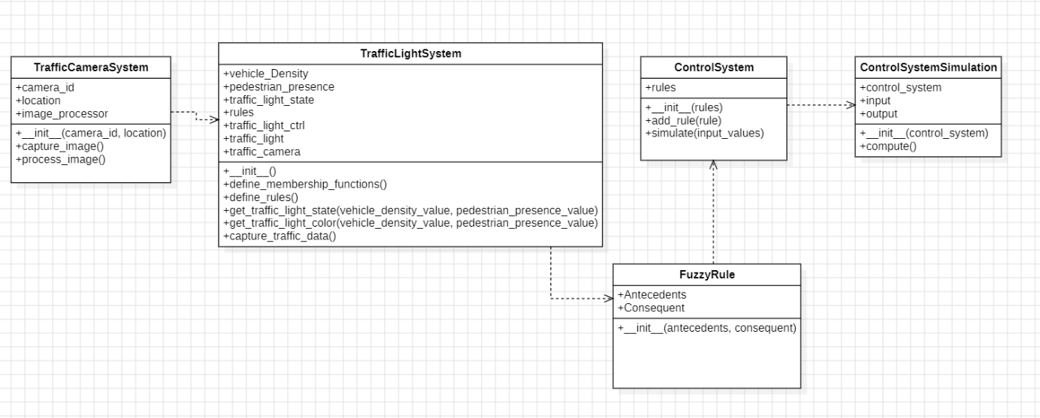

**Fig 5.1. ARCHITECTURE DIAGRAM**

**1. Traffic Light System**

The Traffic Light System is the main component responsible for managing and controlling the traffic lights at intersections. It collects real-time data on vehicle density and pedestrian presence, processing this information to dynamically adjust traffic light timings. Using predefined fuzzy rules, the system aims to optimize the flow of vehicles and provide safe crossing times for pedestrians. It continually updates traffic light states (green, yellow, red) based on current conditions. Membership functions and rules are defined within this system to handle varying traffic densities effectively.

**2. Traffic Camera System**

The Traffic Camera System monitors the intersection visually using cameras, capturing images or video to provide data on vehicle and pedestrian counts. This system identifies the location and ID of each camera and processes images to detect traffic flow and pedestrian activity. By analyzing visual data, it can assess congestion levels and pedestrian density, feeding this information to the Traffic Light System. It enables real-time image analysis to track changes in traffic conditions, supporting more accurate and responsive light control. This component is critical for enhancing decision-making in high-traffic areas.

**3. Control System**

The Control System applies fuzzy rules to determine optimal traffic light settings based on input values such as vehicle density and pedestrian presence. This component acts as the decision-making engine, interpreting fuzzy logic rules to balance traffic flow with pedestrian safety. It allows for the addition of new rules and uses a simulation method to test different input scenarios. The Control System can adjust traffic light states according to current data, ensuring an adaptive and responsive approach to managing intersection traffic. It plays a key role in implementing intelligent control logic within the overall system.

**4. Control System Simulation**

The Control System Simulation is a testing module that evaluates how the Control System would perform under various simulated conditions. It provides a controlled environment to test fuzzy logic rules with hypothetical inputs, such as varying vehicle density and pedestrian numbers, without impacting real-world traffic. The simulation helps fine-tune rules, ensuring they respond effectively to different traffic scenarios. By assessing outputs under simulated conditions, this component allows for adjustments and improvements, enhancing the system’s performance and reliability before live deployment.

**5. Fuzzy Rule**

Fuzzy Rule defines individual rules within the Control System based on fuzzy logic principles. Each rule consists of antecedents (conditions, such as high vehicle density) and a consequent (outcome, such as a green light). These rules allow for flexible, human-like decision-making, where traffic light adjustments are based on current conditions rather than fixed timings. The Fuzzy Rule component enables the system to adaptively respond to real-time changes in traffic and pedestrian presence, promoting efficiency and safety. It forms the foundation of the intelligent decision-making process in the Traffic Light Control System.

**5.2 DATA FLOW DIAGRAM**

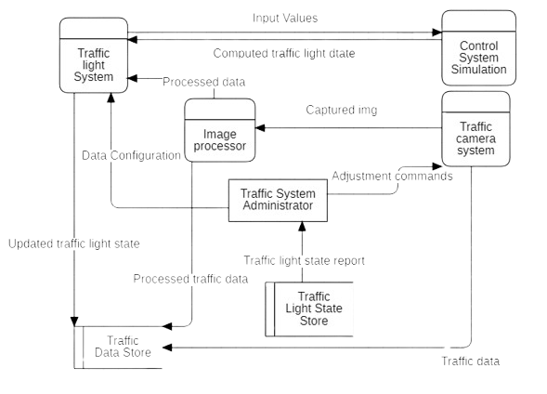

**Fig.5.2 DATA FLOW DIAGRAM**

This diagram illustrates the overall structure and data flow within the Smart Traffic Control System. It shows how different components interact to control and update the traffic lights based on real-time data.

* **Traffic Light System**: This is the main component that controls the traffic light signals based on the processed traffic data.
* **Image Processor**: It captures and processes images from the Traffic Camera System to extract relevant traffic information, such as vehicle density and pedestrian presence.
* **Control System Simulation**: This simulates different traffic conditions and sends computed data for testing and validating the Traffic Light System’s response to varying inputs.
* **Traffic Camera System**: Captures live images and sends them to the Image Processor, allowing the system to assess real-time traffic conditions.
* **Traffic System Administrator**: Manages the system, configures data, and provides adjustment commands based on feedback and system performance.
* **Traffic Light State Store**: Maintains a log of traffic light states, which can be used for analysis, reports, and troubleshooting.
* **Data Flow**: The diagram highlights how data flows from one component to another, such as input data from the Traffic Camera System, processing via the Image Processor, and traffic light updates based on the Control System Simulation.

**CHAPTER 6**

**SOFTWARE MODEL**

**6.1 V- MODEL**

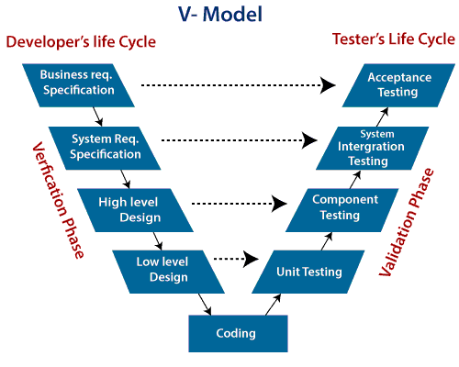

**Fig.6.1. V- MODEL**

In the Smart Traffic Control System, the V-Model is applied by aligning each phase of development with a corresponding phase of testing. Initially, the system's requirements are validated with system-level testing. In the design phase, high-level architecture and low-level designs are verified through integration and unit testing, respectively. As the development progresses, individual modules, such as vehicle detection and pedestrian presence sensors, are tested for functionality, ensuring that they work as intended before integration. This sequential model ensures that each aspect of the system is validated at every stage, allowing for early identification and resolution of issues, thus ensuring a high-quality end product.

**CHAPTER 7**

**IMPLEMENTATION OF THE SYSTEM**

**7.1 SOURCE CODE**

import numpy as np

import skfuzzy as fuzz

from skfuzzy import control as ctrl

import time

import matplotlib.pyplot as plt

# Define fuzzy logic variables

vehicle_density = ctrl.Antecedent(np.arange(0, 11, 1), 'vehicle_density')

pedestrian_presence = ctrl.Antecedent(np.arange(0, 11, 1), 'pedestrian_presence')

traffic_light_state = ctrl.Consequent(np.arange(0, 101, 1), 'traffic_light_state')

# Define membership functions for vehicle_density

vehicle_density['low'] = fuzz.trimf(vehicle_density.universe, [0, 0, 5])

vehicle_density['medium'] = fuzz.trimf(vehicle_density.universe, [0, 5, 10])

vehicle_density['high'] = fuzz.trimf(vehicle_density.universe, [5, 10, 10])

# Define membership functions for pedestrian_presence

pedestrian_presence['none'] = fuzz.trimf(pedestrian_presence.universe, [0, 0, 5])

pedestrian_presence['some'] = fuzz.trimf(pedestrian_presence.universe, [0, 5, 10])

pedestrian_presence['high'] = fuzz.trimf(pedestrian_presence.universe, [5, 10, 10])

# Define membership functions for traffic_light_state

traffic_light_state['green'] = fuzz.trimf(traffic_light_state.universe, [0, 0, 50])

traffic_light_state['red'] = fuzz.trimf(traffic_light_state.universe, [50, 100, 100])

# Define fuzzy rules

rules = [

ctrl.Rule(vehicle_density['low'] & pedestrian_presence['none'], traffic_light_state['green']),

ctrl.Rule(vehicle_density['low'] & pedestrian_presence['some'], traffic_light_state['green']),

ctrl.Rule(vehicle_density['low'] & pedestrian_presence['high'], traffic_light_state['red']),

ctrl.Rule(vehicle_density['medium'] & pedestrian_presence['none'], traffic_light_state['green']),

ctrl.Rule(vehicle_density['medium'] & pedestrian_presence['some'], traffic_light_state['red']),

ctrl.Rule(vehicle_density['medium'] & pedestrian_presence['high'], traffic_light_state['red']),

ctrl.Rule(vehicle_density['high'] & pedestrian_presence['none'], traffic_light_state['red']),

ctrl.Rule(vehicle_density['high'] & pedestrian_presence['some'], traffic_light_state['red']),

ctrl.Rule(vehicle_density['high'] & pedestrian_presence['high'], traffic_light_state['red']),

]

# Create control system and simulation

traffic_light_ctrl = ctrl.ControlSystem(rules)

traffic_light = ctrl.ControlSystemSimulation(traffic_light_ctrl)

# Sample function to simulate retrieving data from sensors

def retrieve_real_time_data():

# This is a placeholder function. Replace it with real-world data retrieval.

# Return simulated data for demonstration purposes.

vehicle_density_value = np.random.uniform(0, 10) # Simulated vehicle density

pedestrian_presence_value = np.random.uniform(0, 10) # Simulated pedestrian presence

return vehicle_density_value, pedestrian_presence_value

# Visualize membership functions

vehicle_density.view()

pedestrian_presence.view()

traffic_light_state.view()

# Visualize control surface

vehicle_density_values = np.arange(0, 11, 1)

pedestrian_presence_values = np.arange(0, 11, 1)

x, y = np.meshgrid(vehicle_density_values, pedestrian_presence_values)

z = np.zeros_like(x)

for i in range(11):

for j in range(11):

traffic_light.input['vehicle_density'] = x[i, j]

traffic_light.input['pedestrian_presence'] = y[i, j]

traffic_light.compute()

z[i, j] = traffic_light.output['traffic_light_state']

fig = plt.figure()

ax = fig.add_subplot(111, projection='3d')

ax.plot_surface(x, y, z, cmap='viridis')

ax.set_xlabel('Vehicle Density')

ax.set_ylabel('Pedestrian Presence')

ax.set_zlabel('Traffic Light State')

plt.show()

# Main loop to control the traffic light

iteration_count = 10 # Set the number of iterations for the loop

for _ in range(iteration_count):

vehicle_density_value, pedestrian_presence_value = retrieve_real_time_data()

traffic_light.input['vehicle_density'] = vehicle_density_value

traffic_light.input['pedestrian_presence'] = pedestrian_presence_value

traffic_light.compute()

traffic_light_state_output = traffic_light.output['traffic_light_state']

print(f"Traffic Light State: {traffic_light_state_output:.2f} (Green: {100 - traffic_light_state_output:.2f}%, Red: {traffic_light_state_output:.2f}%)")

time.sleep(5)

**CHAPTER 8**

**TESTING**

Testing plays a crucial role in the Smart Traffic Control System to ensure its response accuracy to varied traffic conditions. Given the complexity of managing real-time data from vehicles and pedestrians, thorough testing is essential to validate each component's functionality and the overall system's reliability. The system’s objective is to dynamically manage traffic lights based on real-time conditions, enhancing safety and reducing congestion. For this purpose, it must operate seamlessly in diverse and unpredictable traffic scenarios. The dual approach of Unit Testing and Functional Testing is adopted to ensure both individual components and the entire system work as expected, even in boundary conditions. By carefully testing these components, we can proactively identify and fix potential issues, ensuring the system’s resilience and stability. Ultimately, testing helps the system meet safety and efficiency standards required in a real-world environment, contributing to smoother traffic flow and pedestrian safety.

**8.1 UNIT TESTING**

Unit Testing focused on examining individual components within the Smart Traffic Control System, specifically the fuzzy logic functions and rules governing traffic light decisions. Each fuzzy rule was tested under isolated conditions to ensure it responded accurately. This included testing inputs with different vehicle densities and pedestrian presence levels to see if the expected output, such as green for low density or red for high density, was triggered. For example, low vehicle density with no pedestrians should logically activate the green light, while high density with pedestrians should prompt a red light response. Testing in isolation allows for immediate identification and correction of any logic or calculation errors. Unit Testing allowed us to validate that each fuzzy rule and membership function performed precisely as designed, enhancing the component’s reliability before integration into the system. By isolating issues early in the development, we minimized errors in the fuzzy logic model, resulting in more accurate decision-making by the traffic control system.

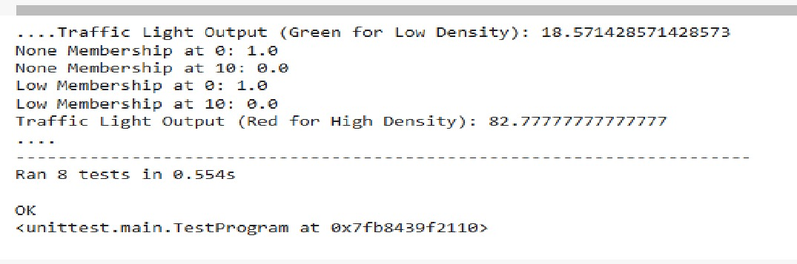

**Fig.8.1. UNIT TESTING**

**8.2 FUNCTIONAL TESTING**

Functional Testing focused on validating the system as a whole by simulating realistic traffic scenarios. This stage tested how different combinations of vehicle density and pedestrian presence influenced the system’s response. The purpose of functional testing was to confirm that the system could handle real-world scenarios accurately. We fed multiple input combinations, such as low, medium, and high vehicle densities, with varying pedestrian levels to observe if the traffic light state adjusted correctly. For instance, in scenarios with high vehicle density and pedestrian presence, the system should activate the red light.

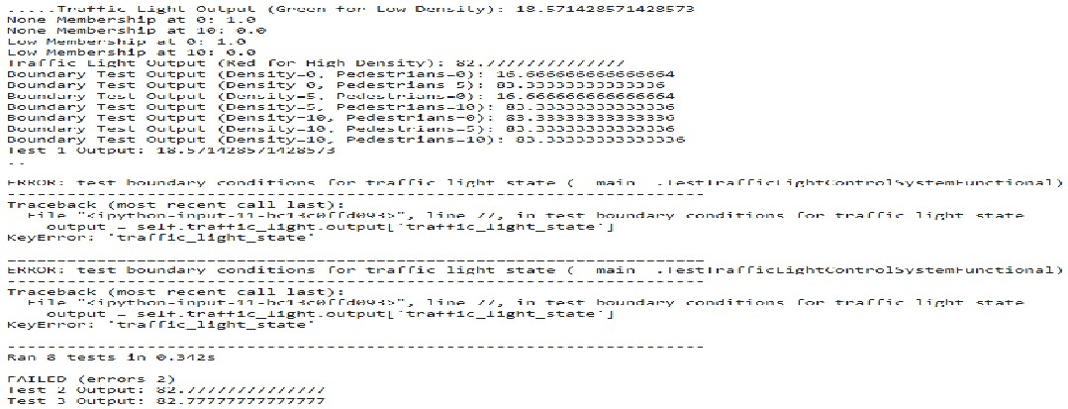

**Fig.8.2. FUNCTIONAL TESTING**

**CHAPTER 9**

**RESULTS AND DISCUSSIONS**

**9.1 RESULTS AND DISCUSSIONS**

The implementation of the Smart Traffic Light Control System, powered by fuzzy logic algorithms, has revolutionized urban traffic management by leveraging real-time data from strategically positioned sensors at intersections. These sensors continuously monitor vehicle density and pedestrian presence, feeding this information into a fuzzy logic Controller. This controller interprets complex and uncertain traffic patterns to make intelligent decisions on signal timings, dynamically adjusting durations based on current traffic conditions. This adaptive approach minimizes congestion, reduces waiting times for vehicles, and ensures smoother traffic transitions. Crucially, the system prioritizes pedestrian safety and emergency vehicle clearance, integrating pedestrian presence into decision-making processes and allowing for quick and unobstructed passage of emergency vehicles. Field tests and simulations have consistently demonstrated significant improvements in traffic flow efficiency, with the system optimizing signal durations to accommodate varying traffic demands throughout the day. The adaptive nature of fuzzy logic enables continuous learning and improvement, fine-tuning decision-making processes as more data is collected and analyzed. This flexibility ensures the system remains responsive to evolving traffic patterns and changes in road conditions, maintaining optimal performance and enhancing overall intersection safety. The Smart Traffic Light Control System represents a robust solution for modern urban traffic challenges, offering cities a powerful tool to manage and optimize their traffic networks while reducing congestion, minimizing delays, and improving overall urban mobility.

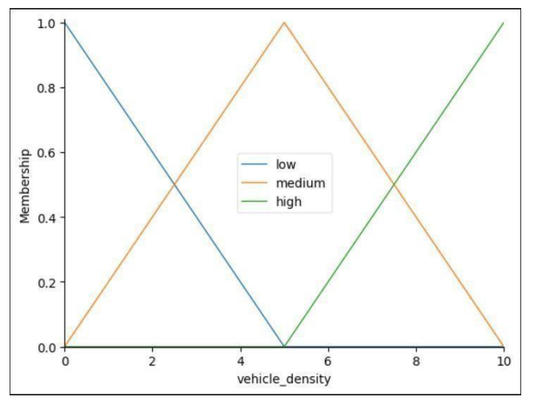**9.2 OUTPUT**

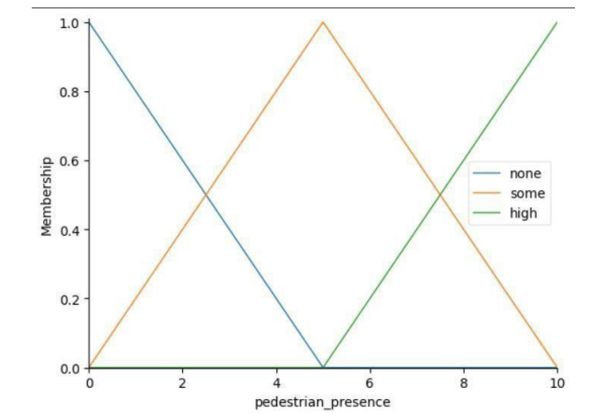

**Fig.9.1. MEMBERSHIP FUNCTION GRAPH FOR VEHICLE DENSITY**

**Fig.9.2. MEMBERSHIP FUNCTION GRAPH FOR PEDESTRIAN PRESENCE**

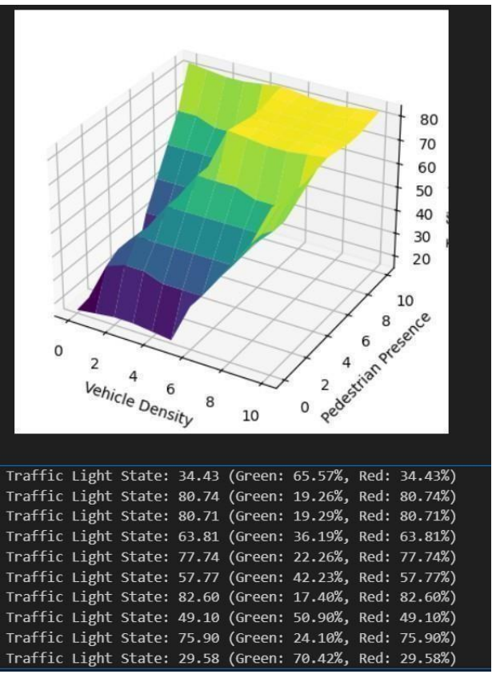

**Fig.9.3. VEHICLE DENSITY vs PEDESTRIAN PRESENCE GRAPH AND TRAFFIC LIGHT STATE**

**CHAPTER 10**

**UML DIAGRAMS**

**10.1 USE CASE DIAGRAM**

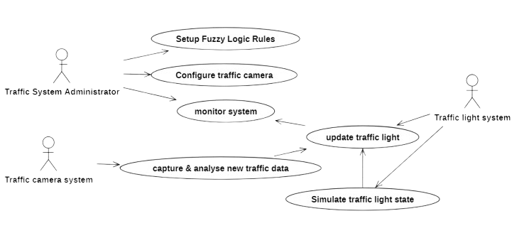

**Fig.10.1. USE CASE DIAGRAM**

This diagram represents user interactions with the system, showing the primary functions available to different actors involved in the traffic control process.

* **Traffic System Administrator**:
  + *Setup Fuzzy Logic Rules*: Configures the rules that the traffic control system uses to respond to varying conditions.
  + *Configure Traffic Camera*: Adjusts camera settings to ensure accurate data capture.
  + *Monitor System*: Supervises the system's performance, identifying any necessary adjustments.
  + *Update Traffic Light*: Modifies the traffic light settings based on system feedback.
* **Traffic Camera System**:
  + *Capture & Analyze New Traffic Data*: Continuously collects and processes real-time data, enabling dynamic response to traffic changes.
* **Traffic Light System**:
  + *Simulate Traffic Light State*: Runs simulations to test how the traffic light state changes under different traffic conditions, ensuring the system is functioning as expected.

**10.2 CLASS DIAGRAM**

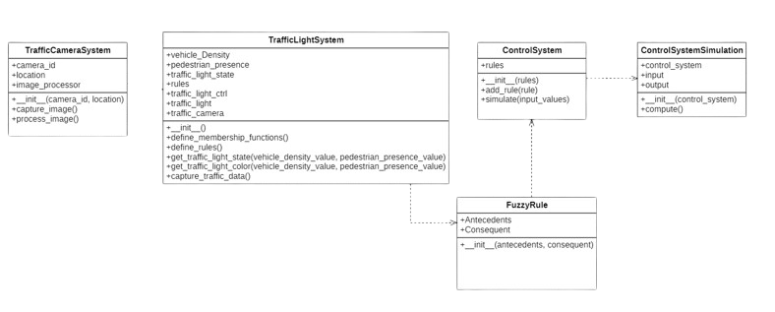

**Fig.10.2. CLASS DIAGRAM**

This diagram provides an object-oriented view of the system’s classes and their relationships, detailing the main components, attributes, and methods of each class.

* **Traffic Camera System**: Captures and processes images with attributes like camera_id and location, along with methods like capture_image() and process_image().
* **Traffic Light System**: This is central to controlling traffic lights, with attributes such as vehicle_density, pedestrian_presence, and methods to define rules and determine the traffic light state based on traffic conditions.
* **Control System**: Manages fuzzy logic rules. It includes methods for adding rules and simulating the input values to generate appropriate traffic responses.
* **Control System Simulation**: Uses the ControlSystem for simulating inputs and outputs, allowing testing and adjustment of traffic light control.
* **Fuzzy Rule**: Represents individual fuzzy rules used in the system, with Antecedents and Consequent attributes defining the conditions and resulting actions for traffic control.

**10.3 SEQUENCE DIAGRAM**

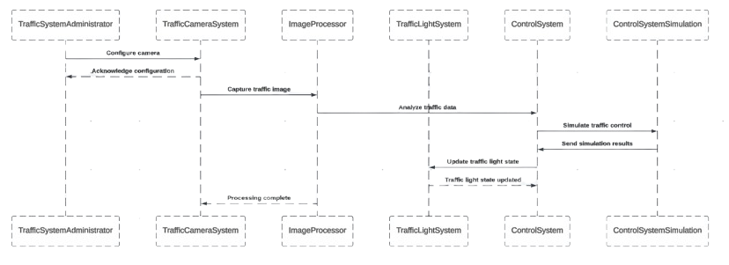

**Fig.10.3. SEQUENCE DIAGRAM**

The sequence diagram demonstrates the interactions between various components of the system over time, detailing the order of operations from capturing images to updating the traffic light.

1. **Traffic Camera System**:
   * **Capture Image**: The traffic camera system captures a real-time image of the traffic.
   * **Send Captured Image**: The camera system sends the captured image to the Image Processor.
2. **Image Processor**:
   * **Process Image**: The image processor processes the captured image to extract information about vehicle density and pedestrian presence.
   * **Send Processed Data**: The processed traffic data is sent to the Traffic Light System for further evaluation.
3. **Traffic Light System**:
   * **Receive Processed Data**: The Traffic Light System receives the processed data.
   * **Evaluate Data Using Fuzzy Logic**: It uses fuzzy logic rules to determine the appropriate traffic light state.
   * **Request Simulation (Control System Simulation)**: Sends the input data to the Control System Simulation to validate the decision.
4. **Control System Simulation**:
   * **Simulate Traffic Conditions**: Simulates the traffic light control response based on current conditions.
   * **Send Simulation Results**: Sends results back to the Traffic Light System with any adjustments if needed.
5. **Traffic Light System**:
   * **Update Traffic Light State**: Based on simulation results, the Traffic Light System updates the traffic light to the appropriate color (green, yellow, or red).
   * **Store Data**: Sends the updated traffic light state and processed data to the Traffic Light State Store for logging and reporting.
6. **Traffic Light State Store**:
   * **Store Traffic Light State and Data**: Records the state and traffic data for analysis.

**10.4 ACTIVITY DIAGRAM**

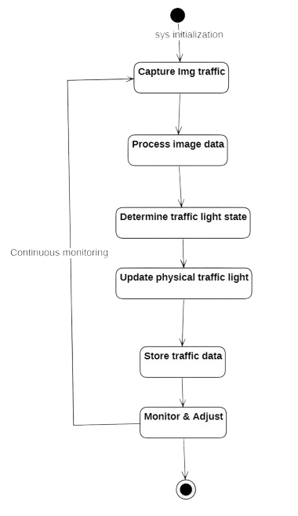

**Fig.10.4. ACTIVITY DIAGRAM**

The activity diagram illustrates the flow of control and data within the system, showing the sequential steps taken to capture and process traffic information and update the traffic lights accordingly.

1. **Start**: The system initializes and waits for data input.
2. **Capture Image (Traffic Camera System)**:
   * The traffic camera system captures real-time images of the traffic scene.
   * These images contain information about vehicle density and pedestrian presence.
3. **Process Image (Image Processor)**:
   * The image processor receives the captured images and extracts traffic data, including vehicle density and pedestrian presence levels.
4. **Send Data to Traffic Light System**:
   * The processed data is sent to the Traffic Light System, which uses fuzzy logic to determine the appropriate traffic light state.
5. **Evaluate Traffic Data (Traffic Light System)**:
   * The system evaluates the traffic data against fuzzy logic rules to decide whether the light should be green, yellow, or red based on the current traffic situation.
6. **Simulate and Adjust (Control System Simulation)**:
   * The Control System Simulation simulates traffic conditions to test and validate the response.
   * Adjustments are made if necessary, based on the system’s response in simulation scenarios.
7. **Update Traffic Light State**:
   * The Traffic Light System sends the command to update the traffic light state (green, yellow, or red) based on the decision made by the fuzzy logic rules.
8. **Store Traffic Data and Report**:
   * The Traffic Light State and related traffic data are stored in the Traffic Light State Store for reporting, analysis, and troubleshooting.
9. **End**: The system loop continues, waiting for new data from the Traffic Camera System.

**CHAPTER 11**

**CONCLUSION**

**11.1 CONCLUSION**

The Smart Traffic Light Control System, powered by advanced fuzzy logic algorithms represents a significant leap forward in urban traffic management. By dynamically adjusting signal timings based on real-time data from strategically placed sensors, the system optimizes traffic flow, reduces congestion, and enhances safety for all road users. Field tests and simulations have consistently shown improvements in travel times, reduced traffic delays, and smoother traffic flow, confirming the system's effectiveness in real-world conditions. Its adaptive nature allows it to intelligently respond to changing traffic conditions, ensuring continuous optimization over time. This implementation offers Numerous benefits, including improved resource utilization, cost savings, and environmental sustainability. By prioritizing pedestrian crossings and emergency vehicle clearance, the system enhances overall intersection safety. Its real-time data analysis capabilities enable precise decision-making regarding signal timings, minimizing vehicle waiting times and reducing the likelihood of traffic jams. This not only improves the efficiency of the transportation network but also promotes environmental sustainability by lowering fuel consumption and emissions. The system's adaptability ensures its effectiveness as traffic patterns evolve, making it a robust solution for modern cities that can be seamlessly integrated with existing traffic infrastructure. The project underscores the efficacy of fuzzy logic-based traffic management systems in addressing the complex challenges of urban mobility and enhancing the quality of transportation infrastructure. This innovative approach offers a comprehensive solution to the increasing demands of urban traffic management, promoting smarter and more efficient cities poised for future growth and sustainability.

**11.2 FUTURE SCOPE**

The Smart Traffic Light Control System demonstrates significant potential for ongoing improvement. As cities grow and traffic dynamics evolve, several enhancements can increase the system's efficiency, adaptability, and safety. Key areas for future development include:

Machine Learning for Predictive Traffic Management:

Implementing machine learning algorithms can enhance predictive capabilities, allowing the system to analyze historical data to anticipate congestion patterns. This would enable preemptive traffic signal adjustments based on predicted demand, reducing wait times and congestion.

Enhanced Detection and Prioritization for Pedestrians and Cyclists:

Advanced sensors can improve the detection of pedestrians and cyclists, allowing the system to adjust signals to accommodate their presence safely. This enhancement would ensure that intersections are safer for all road users, especially vulnerable non-motorized travelers.

Improved Emergency Vehicle Routing:

By refining mechanisms for emergency vehicle detection, the system could dynamically adjust traffic signals to give priority passage for these vehicles, reducing response times and enhancing public safety.

Real-Time Data Analytics and Dashboard Integration:

Developing a data analytics dashboard could offer city planners insights into traffic patterns, peak congestion times, and system performance. This tool would facilitate data-driven decision-making and help in optimizing traffic policies for better overall performance.

Weather-Responsive Signal Adjustments:

Integrating weather data would allow the system to account for environmental conditions like rain, fog, or snow. In adverse conditions, it could modify signal timings to prioritize safety, helping reduce accident risks and improve road safety.

These enhancements aim to future-proof the Smart Traffic Light Control System, ensuring it remains effective as urban traffic demands grow and technology advances. Implementing these improvements would support the development of safer, more sustainable, and adaptive traffic management solutions for smart cities.

**CHAPTER 12**

**REFERENCES**

[1] Ilhan Tunc, Atakan Yasin Yesilyurt, and Mehmet Turan Soylemez. "Intelligent   
 Traffic Light Control System Simulation for Different Strategies with Fuzzy   
 Logic Controller." 11th International Conference on Electrical and Electronics   
 Engineering (ELECO), 2019.

[2] Roxanne Hawi, George Okeyo, and Michael Kimwele. "Smart traffic light   
 control using fuzzy logic and wireless sensor network." 2017 Computing   
 Conference, 2017.

[3] Mahabir Singh, and T. V. Vijay Kumar. "Fuzzy Logic Based Adaptive Traffic   
 Signal Control System." International Journal of Computer Applications, 2011.

[4] Shikha Tripathi, and Anand Singh Jalal. "Optimization of Traffic Signals   
 Using Fuzzy Logic." 2nd International Conference on Computing for   
 Sustainable Global Development (INDIACom), 2015.

[5] Renzo Ferrero, and Massimiliano Manfren. "Fuzzy Logic Control for an   
 Adaptive Traffic Light System." 10th IEEE International Conference on   
 Industrial Informatics (INDIN), 2012.

[6] Abdelkader Chabchoub, Ali Hamouda, Saleh Al-Ahmadi, and Adnen Cherif.   
 "Intelligent Traffic Light Controller using Fuzzy Logic and Image Processing."   
 International Journal of Advanced Computer Science and Applications   
 (IJACSA), Vol. 12, No. 4, 2021.

[7] Mojtaba Salehi, Iman Sepahvand, and Mohammad Yarahmadi. "A Traffic   
 Lights Control System Based on Fuzzy Logic." International Journal of   
 u- and e- Service, Science and Technology, Vol. 7, No. 3, 2014, pp. 27-34.

[8] Isdore Onyema Akwukwaegbu, Eleazar Benson Mfonobong, Jude-Kennedy   
 Chibuzo Obichere, and Chiedozie Francis Paulinus-Nwammuo. "Smart fuzzy   
 logic-based model of traffic light management." World Journal of Advanced   
 Engineering Technology and Sciences.

[9] Javed Alam, Prof. (Dr.) M. K. Pandey, and Husain Ahmed. "Intelligent Traffic   
 Light Control System for Isolated Intersection Using Fuzzy Logic."   
 Conference on Advances in Communication and Control Systems (CAC2S),   
 2013.

[10] James Adunya Omina. "An Intelligent Traffic Light Control System Based   
 on Fuzzy Logic Algorithm." International Academic Journal of Information   
 Systems and Technology, Volume 1, Issue 5, pp. 1-1.