DISEASE PREDICTION SYSTEM USING SYMPTOMS

A Project Report Submitted in partial fulfilment of the requirements for the award of the degree of
BACHELOR OF TECHNOLOGY
in
COMPUTER SCIENCE AND ENGINEERING

Submitted By
B BARATH VINAY 20221A0514
D PAVANI 20221A0531
B LAVANYA 20221A0518
G S R N VENKAT 20221A0551

Under the Esteemed Guidance of

Mr.P RAMESH,
M.Tech
Assistant Professor


DEPARTMENT OF COMPUTERS SCIENCE AND ENGINEERING
BONAM VENKATA CHALAMAYYA ENGINEERING COLLEGE (AUTONOMOUS)
(Approved by A.I.C.T.E, New Delhi & Permanently Affiliated to J. N.T.U.K, Kakinada)
(Accredited by N.B.A & NAAC with ‘A’ Grade)
ODALAREVU–533210
2020-24

BONAM VENKATA CHALAMAYYA ENGINEERING COLLEGE
(AUTONOMOUS)
(Approved by A.I.C.T.E, New Delhi & Permanently Affiliated to J. N.T.U.K, Kakinada)(Accredited by N.B.A&NAAC with ‘A’ Grade)

DEPARTMENT OF COMPUTER SCIENCE AND ENGINEERING

CERTIFICATE

This is to certify tha the project work entitled “DISEASE PREDICTION SYSTEM USING SYMPTOMS” is being submitted for the partial fulfillment of the requirements for the award of the degree of Bachelor of Technology in Computer Science and Engineering, at BVC Engineering College, Odalarevu, is a bonafide work done by B BARATH VINAY (20221A0514), D PAVANI(20221A0531), B LAVANYA(20221A0518), G S R N VENKAT(20221A0551), for the academic year 2023-24 and it has been found suitable for acceptance according to the requirement of University. The results embodied in this thesis have not been submitted to any other University Institute for the award of any degree.

Project Guide
Mr.P RAMESH,
M.Tech
Assistant Professor
Head of the Department
Mr. Dr. B S N MURTHY
M.Tech, Ph.D
Professor

External Examiner

ACKNOWLEDGEMENT

We express our deep sense of gratitude and respect towards our guide Mr. P RAMESH, M.Tech, Associate Professor, BVC Engineering College, Odalarevu for his excellent guidance right from selection of the Project work. His constant encouragement and support have been the cause of our success in completing this thesis in the college.
We are thankful To Mr. Dr. B S N MURTHY, Professor and Head of the Department of CSE for facilitating, training, counselling and support to carry out the project work.
We are also thankful to Dr.ChandramouliVSA, Principal ,BVC Engineering College, Odalarevu, for his support during and till the completion of the project.
We are thankful to all the teaching and non-teaching staff of Computer Science & Engineering Department, Management, BVC Engineering College, Odalarevu, and our friends for their direct and indirect help provided to us in completing the project.

PROJECT ASSOCIATES
B BARATH VINAY ( 20221A0514)
D PAVANI ( 20221A0531)
B LAVANYA ( 20221A0518)
G VENKAT ( 20221A0551)

ABSTRACT

The "Disease Prediction based on Symptoms with Machine Learning" system represents a significant advancement in healthcare technology, offering users the ability to predict diseases based on their reported symptoms. This system is designed to provide reliable conclusions derived from clinical manifestations, ensuring informed decision-making in medical practice. In light of the challenges faced by healthcare professionals in diagnosing illnesses, particularly with limited patient information, this method offers a valuable tool for gaining insight into common ailments without compromising patient safety. By empowering users with basic knowledge of their illness and offering guidance on potential treatment strategies, the system serves as a valuable resource for both individuals seeking medical advice and healthcare providers seeking to streamline the diagnostic process. Utilizing machine learning techniques and Python programming with the Tkinter interface, the system leverages a dataset sourced from hospitals to train predictive models. Through the input of symptoms and other relevant information, users can gain valuable insights into their health condition, while healthcare professionals can benefit from a streamlined diagnostic process that relies on accurate symptom-based predictions. Overall, this system represents a promising approach to disease prediction and has the potential to significantly impact the healthcare industry by facilitating timely and accurate diagnoses along with hospital names without the need for extensive medical intervention.

TABLEOFCONTENTS

CHAPTERNO  1 | TITLE  INTRODUCTION | PAGENO | 6
2 | LITERATURE SURVEY |  | 7
3 | SYSTEM ANALYSIS AND DESCRIPTION |  | 8
 | 3.1ExistingSystem |  | 8
 | 3.1.1 Drawbacks |  | 8
 | 3.2ProposedSystem |  | 10
 | 3.2.1 Advantages |  | 11
 | 3.3Modules Description |  | 11
 | 3.4FeasibilityStudy |  | 14
4 | REQUIREMENT ANALYSIS |  | 15
 | 4.1Software Requirements |  | 15
 | 4.2Hardware Requirements |  | 14
 | 4.3Functional Requirements |  | 14
5 | SOFTWARE DESIGN |  | 15
 | 5.1 System Architecture |  | 15
 | 5.2 Dataflow diagram |  | 16
 | 5.3 Methodology |  | 17
6 | ALGORITHM
7 | IMPLEMENTATION |  | 18
 | 7.1 Python |  | 18
 | 7.2 OpenCV |  | 28
 | 7.3 NumPY |  | 28
8 | TESTING |  | 30
9 | SAMPLE SCREENS |  | 34
10 | CONCLUSION |  | 39
11 | FUTURE ENHANCEMENTS |  | 40
12 | BIBLIOGRAPHY |  | 41

CHAPTER-1

INTRODUCTION

The advent of the Android app users in the mobile technology era. The economy and the welfare of humanity depend on a functional healthcare system. There has been a significant amount of change between the world we live in today and the one we did a few decades ago. Everything has become more disorganized and ugly. In this case, medical professionals are risking their own lives in order to save as many lives as they possibly can. Board-certified physicians who prefer to practice online via phone and video consultations over in-person consultations are known as "virtual doctors, "albeitth is not always feasible in an emergency. Machines are considered to be superior to humans in the absence of human error because they can do tasks more quickly while keeping a constant degree of precision. Without involving a person, a disease predictor, also referred to as a virtual doctor, can correctly forecast a patient's illness. In severe cases, like COVID-19 and EBOLA, a disease predictor can save a person's life by identifying their health without the need for physical contact. There are virtual doctors available now, but they cannot deliver the necessary level of precision. Machines are considered to be superior to humans in the absence of human error because they can do tasks more quickly while keeping a constant degree of precision. Without involving a person, a disease predictor, also referred to as a virtual doctor, can correctly forecast a patient's illness. In severe cases, like COVID-19 and EBOLA, a disease predictor can save a person's life by identifying their health without the need for physical contact. There are virtual doctors available now, but they cannot deliver the necessary level of precision. The technology compares the symptoms to the data that was previously saved. By fusing these data sets with the patient's symptoms, we can predict the patient's disease % with accuracy. Before the user selects the characteristics and enters the symptoms, the dataset and symptoms are uploaded to the system's prediction model, where the data is pre-processed for future references. Following that, the data is categorized using a range of algorithms and techniques, including Decision Tree, KNN, and Naive Bayes, to name a few.

CHAPTER-2
LITERATURE SURVEY

Prediction of Heart Disease using Machine Learning
(Nagaraj M. Lutimath, Chethan C, Basavaraj S Pol )

The literature explores the application of machine learning, specifically Naïve Bayes Classification and Support Vector Machines (SVM), for heart disease detection. Previous studies have investigated various algorithms for this purpose. The research employs a dataset from the UCI repository, prepares it through feature engineering, and evaluates model performance using metrics like MAE, SSE, and RMSE. The findings indicate that radial kernel SVM outperforms Naïve Bayes in accuracy, with suggestions that female patients may be more susceptible to heart disease. Attribute choice,such as chest pain (f_cp), significantly affects prediction accuracy. In conclusion, the study highlights the effectiveness of radial kernel SVM for heart disease prediction and suggests further research avenues for improved accuracy.

Effective Heart Disease Prediction Using Machine Learning Techniques
(Chintan M. Bhatt, Parth Patel, Tarang Ghetia and Pier Luigi )

The above article addresses the critical need to predict and prevent heart disease through machine learning, emphasizing its global impact on health and economics. It highlights the challenge of early detection due to the cost and practicality of traditional diagnostic tools. Machine learning, a cornerstone in modern healthcare, is instrumental in revealing hidden patterns in medical data. While previous studies have applied data mining to predict diseases, the quest for more accurate results persists. The research's primary goal is to predict heart disease accurately, using a range of machine learning algorithms like Random Forest, Decision Tree, Multilayer Perceptron, and XGBoost. Data preprocessing, including k-modes clustering, is employed to enhance model performance. Results indicate that the Multilayer Perceptron model performed exceptionally well with an 87.23% accuracy rate. Acknowledging limitations, the study suggests further research to compare clustering algorithms, address missing data, and evaluate model performance on unseen data, ultimately
aiming for robust and generalizable results.

Enhancing Heart Disease Prediction Accuracy through Machine Learning Techniques and Optimization
(Chandrasekhar N ; Peddakrishna S)

This research focuses on enhancing the accuracy of heart disease prediction using machine learning techniques and optimization methods. It highlights the global significance of heart disease and its
risk factors while emphasizing the need for accurate prediction models to improve diagnosis. The
study employs six machine learning algorithms, including random forest, K-nearest neighbor, logistic regression, Naïve Bayes, gradient boosting, and AdaBoost classifier, using datasets from Cleveland and IEEE Data port .

CHAPTER-3
SYSTEM ANALYSIS AND DESCRIPTION

  - Existing System
The existing system of the "Disease Prediction System Using Symptoms in Python" project typically involves traditional diagnostic methods conducted by healthcare professionals. In the absence of automated prediction systems, patients typically visit healthcare facilities such as hospitals or clinics, where they undergo physical examinations, provide medical history, and describe their symptoms to a doctor or medical practitioner. The healthcare provider then uses their expertise and medical knowledge to assess the patient's condition, potentially ordering additional tests or examinations to confirm a diagnosis. This process relies heavily on the experience and judgment of the healthcare professional, and the accuracy of the diagnosis may vary depending on factors such as the complexity of the condition and the quality of information provided by the patient.
However, this traditional approach to disease diagnosis has limitations, including potential delays in obtaining appointments, reliance on subjective assessments, and the possibility of human error. Additionally, patients may face challenges in accessing healthcare services, particularly in remote or underserved areas.

    - Drawbacks:

      - Subjectivity: Diagnosis often relies on the subjective interpretation of symptoms by healthcare professionals, which can lead to variability in diagnoses between different practitioners.
      - Time-consuming: The process of diagnosis typically requires patients to schedule appointments, wait for availability, and undergo physical examinations, which can result in delays in receiving treatment.

      - Limited access: Patients in remote or underserved areas may face challenges in accessing healthcare services, leading to delays in diagnosis and treatment.

      - Potential for misdiagnosis: Human error and the complexity of certain medical conditions can lead to misdiagnosis or incorrect treatment recommendations.

      - Cost: Traditional diagnostic methods can be costly, particularly if multiple tests or consultations are required to confirm a diagnosis.

      - Dependency on healthcare professionals: The reliance on healthcare professionals for diagnosis may result in inefficiencies, particularly in busy healthcare settings where resources are limited.

      - Inability to handle large volumes: Traditional methods may struggle to handle large volumes of patients efficiently, leading to longer wait times and potential delays in diagnosis and treatment.

  - Proposed System
The proposed system for the "Disease Prediction System Using Symptoms in Python" project aims to address the limitations of traditional diagnostic methods by leveraging machine learning techniques to automate disease prediction based on reported symptoms. This system will provide users with a user-friendly interface where they can input their symptoms, medical history, and other relevant information. Utilizing a dataset collected from hospitals, the system will employ machine learning algorithms to analyze the input data and predict potential diseases or health conditions. By harnessing the power of Python programming language and machine learning libraries, such as scikit-learn, the system will offer accurate and efficient disease predictions, enabling users to receive timely insights into their health status. Additionally, the system will serve as a valuable tool for healthcare professionals, facilitating faster and more accurate diagnoses, and potentially reducing the burden on healthcare resources. Overall, the proposed system aims to revolutionize disease prediction by providing accessible, efficient, and accurate diagnostic capabilities to users and healthcare providers alike.

Fig 3.2.1 Proposed System

Disease Prediction Model
Machine Learning Algorithms

Predicted Result

User Input(symptoms)

User Details

Training Data
Data

Transformation

    - Advantages:

1. Efficiency: The system automates the disease prediction process, enabling faster and more efficient diagnoses compared to traditional manual methods.

2. Accessibility: Users can access the system from anywhere with an internet connection, eliminating the need for physical appointments and reducing barriers to healthcare access.

3. Accuracy: By leveraging machine learning algorithms and a comprehensive dataset, the system can provide accurate predictions based on reported symptoms, potentially reducing the risk of misdiagnosis.

4. Timeliness: Users receive immediate feedback on potential diseases or health conditions, allowing for timely intervention and treatment.

5. Cost-effectiveness: The system may help reduce healthcare costs by streamlining the diagnostic process and minimizing the need for unnecessary tests or consultations.

6. Scalability: The system can handle large volumes of users simultaneously, making it scalable to accommodate growing demand for healthcare services.

7. User-friendly interface: The system offers a simple and intuitive interface for users to input their symptoms, ensuring ease of use and accessibility for individuals with varying levels of technological proficiency.

MODULES: -
- Data Preprocessing
- Machine Learning Model Training
- User Interface
- Prediction
- Integration

Data Preprocessing Module:
The Data Pre-processing Module is an essential component of the disease prediction system, responsible for preparing the raw dataset for training the machine learning model. This module performs several crucial tasks to ensure that the dataset is clean, structured, and suitable for analysis.
Firstly, the module handles data cleaning by identifying and removing any inconsistencies, errors, or missing values present in the dataset. This process ensures the integrity and reliability of the data, preventing potential biases or inaccuracies in the predictive model.

Next, the module performs data normalization or standardization to scale the features within the dataset to a consistent range. This step is important for ensuring that all features contribute equally to the model and preventing any features from dominating the training process due to differences in their scales.
Additionally, the module may involve feature extraction, where relevant features are selected or engineered from the raw dataset to improve the predictive performance of the model. This may include transforming categorical variables into numerical representations or creating new features based on domain knowledge.

Machine Learning Model Training Module:
The Machine Learning Model Training module is a key component of the disease prediction system, responsible for building and training the predictive model using the pre-processed dataset. This module employs various machine learning algorithms to learn patterns and relationships within the data, ultimately enabling the model to make accurate predictions based on input symptoms.
Firstly, the module involves selecting an appropriate machine learning algorithm based on the nature of the problem, the size and complexity of the dataset, and the desired output. Common algorithms used for disease prediction include decision trees, random forests, support vector machines, and neural networks.
Once the algorithm is chosen, the module proceeds to train the model using the pre-processed dataset. During the training process, the model learns from the input data and adjusts its internal parameters to minimize prediction errors. This is achieved through iterative optimization algorithms such as gradient descent or stochastic gradient descent.
The performance of the model is evaluated using metrics such as accuracy, precision, recall, and F1 score, which measure the model's ability to correctly classify instances and make predictions. The training process may involve techniques such as cross-validation to ensure the robustness and generalization of the model.
Additionally, hyper parameter tuning may be performed to optimize the performance of the model by selecting the best combination of hyper parameters. This process involves experimenting with different parameter values and evaluating their impact on the model's performance.
User Interface Module:

The User Interface Module is responsible for creating a user-friendly interface that allows users to interact with the disease prediction system. This module serves as the bridge between the user and the underlying functionalities of the system, providing a seamless and intuitive experience for inputting symptoms and receiving predictions.

Firstly, the module designs the layout and appearance of the user interface, taking into consideration factors such as readability, accessibility, and ease of use. This involves creating graphical elements such as buttons, input fields, dropdown menus, and result displays, as well as arranging them in a logical and intuitive manner.

Next, the module implements the functionality for user input, allowing users to enter their symptoms, medical history, and other relevant information into the system. This may involve implementing input validation to ensure that the entered data is accurate and in the correct format.

Once the user has inputted their information, the module facilitates the transmission of this data to the backend of the system for processing. This involves establishing communication channels between the user interface and other modules, such as the Data Preprocessing Module and the Machine Learning Model Training Module.

After the data has been processed and the prediction has been generated, the User Interface Module displays the results to the user in a clear and understandable format. This may include presenting the predicted disease or health condition, along with any relevant information or recommendations.
Prediction Module:
The Prediction Module functions by harnessing a trained machine learning model to analyze input symptoms and deliver predictions regarding potential diseases or health conditions. Initially, it receives symptom data from the user interface and preprocesses it to ensure compatibility with the model. This includes tasks like data cleaning and feature scaling. Following preprocessing, the module applies the trained model to the prepared data, utilizing learned patterns to make predictions about possible ailments based on the provided symptoms. Subsequently, it interprets the model's predictions, often calculating probabilities to gauge confidence levels associated with each prediction. Finally, the module returns the predictions to the user interface for presentation to the user, along with any supplementary information or recommendations. Through this process, the Prediction Module plays a vital role in facilitating informed healthcare decisions by leveraging machine learning to analyze symptoms and predict potential diseases.
Integration Module:

The Integration Module acts as the coordinator of the disease prediction system, ensuring smooth communication between its various parts. It receives input from the user interface, sends it to be processed, then guides the machine learning model to generate predictions. Once predictions are ready, it brings them back to the user interface for display. Essentially, it makes sure all parts of the system work together seamlessly to provide accurate predictions to the user.

3.4 FEASIBILITY STUDY:

The feasibility study of the "Disease Prediction System Using Symptoms in Python" project involves assessing its technical, economic, and operational viability.
1.Technical Feasibility:
This aspect evaluates whether the project can be implemented from a technical perspective. It involves assessing factors such as the availability of necessary technology, expertise in machine learning and Python programming, and compatibility with existing systems and infrastructure. The project's technical feasibility may be determined by conducting prototype development, testing, and validation to ensure that the proposed system functions as intended.
2. Economic Feasibility:
Economic feasibility examines whether the project is financially viable and cost-effective. It involves estimating the project's budget, including expenses related to software development, hardware acquisition, training, and ongoing maintenance. Additionally, economic feasibility considers the potential return on investment (ROI) and benefits derived from the project, such as improved healthcare outcomes, cost savings from early disease detection, and increased efficiency in healthcare delivery.
3. Operational Feasibility:
Operational feasibility assesses whether the project aligns with the operational requirements and objectives of stakeholders. It involves evaluating factors such as user acceptance, ease of use, scalability, and integration with existing workflows. Operational feasibility may be determined through user feedback, usability testing, and stakeholder consultations to ensure that the proposed system meets the needs and expectations of end-users and healthcare professionals.

CHAPTER-4
REQUIREMENT ANALYSIS

  - Software Requirements
For developing the application, the following are the Software Requirements:
    - Python

Operating Systems supported

- Windows10 and above
- macOS, or Linux.

Debugger and Emulator
  - Any Browser (Particularly Chrome)

  - Functional Requirements

The functional requirement includes;

Community:
- Any Individual can educate himself with respect to various pathology especially how they are transmitted and how they can have been prevented.
- They Can Subscribe Hospital News-letters in other to received information weekly.
- They could leave a message to the Hospital office by using the contact form.

Medical Doctor (Specialist):
- Doctors can log in to the system or create an account, which has to be activated by IT personnel at each hospital.
- Once the Doctor has logged in, the System will be directed to the Multiple Disease Prediction App for a possible prediction by the doctor, where a form will be presented and a form should be filled out.

CHAPTER-5

SOFTWARE DESIGN

DATAFLOWDIAGRAM:

The system design process normally partitions the requirements into either hardware or software systems. It builds the overall system architecture. Software Design involves identifying and describing the fundamental abstractions of software systems and their relationships. Based on the detailed requirements that were obtained from the first phase of this project, the software architectural design task is performed, which includes identifying the data flow, the class diagram of this application, and also a text plan. The data flow diagram shows the flow of information and the transformation applied when data moves in and out of a system.
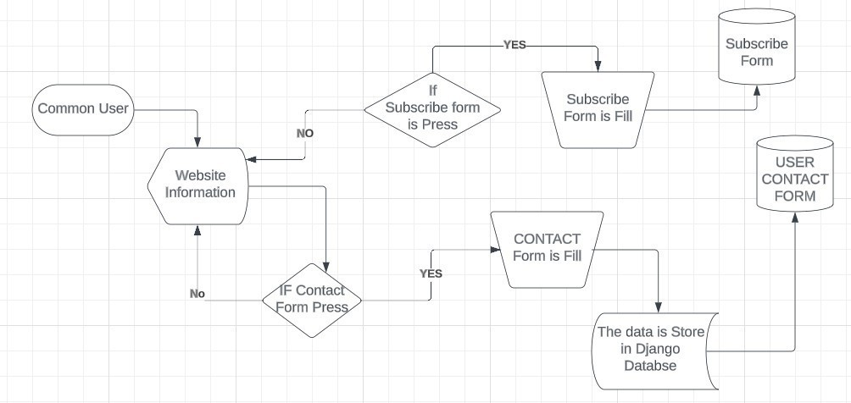
Fig 5.1.1 Dataflow of a Common User interaction with the system

The diagram above shows the data flow of the user (Common User )interacts with the system.
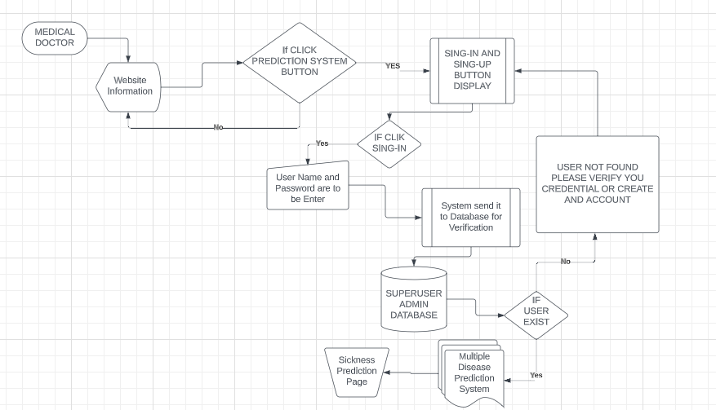

Fig 5.1.2 Data flow of a Medical Doctor interaction with the system

The diagram above shows the data flow of the doctor's interaction with the system.

The diagram above shows the data flow of the Medical doctor's (approved) interaction with the system. The Class diagram and E-R diagram are used to illustrate the objects, their properties and methods, and the relationships between objects once the User has authenticated and been redirected to the Prediction Application.
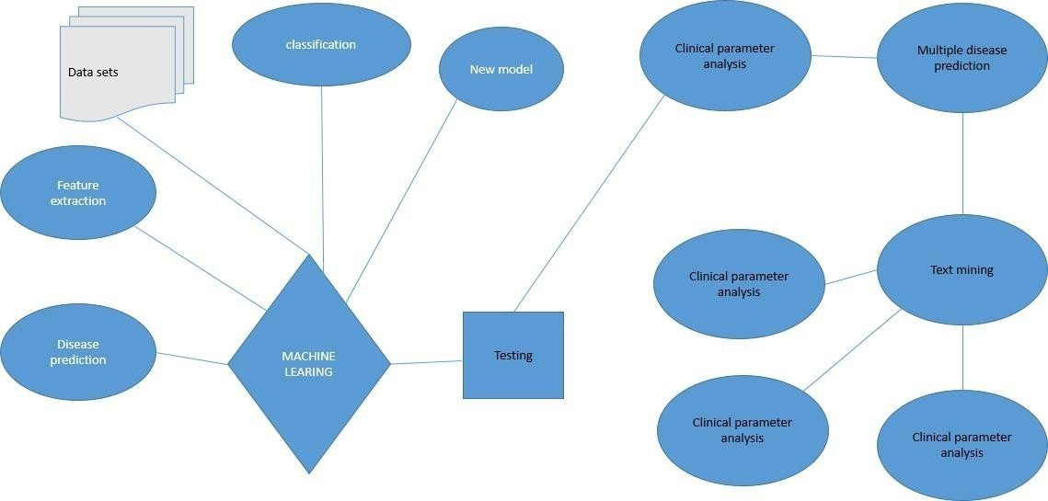

Fig 5.1.3 ER-Diagram of the Prediction System Once the Doctor has Login

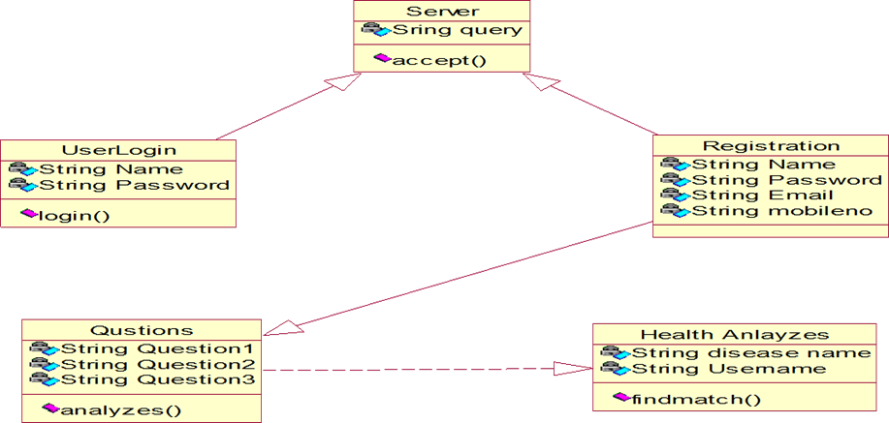
Fig 5.1.4 Class Diagram of the multiple prediction system

METHODOLOGY

1)Naive Bayes Classifier: The Naive Bayes algorithm is a supervised machine learning classification method that calculates the probabilities of outcomes based on input features. It is particularly useful for analytical and predictive tasks, as it can handle noisy input data. By assuming independence between features, Naive Bayes simplifies the modeling process and is commonly applied in text classification, spam filtering, and medical diagnosis.

2) Decision Tree: The decision tree learning algorithm constructs a tree-like structure to represent the relationship between input features and output classes. Classification trees partition the input space into regions corresponding to different classes, while regression trees predict continuous output values. Decision trees are intuitive and interpretable models that can be used for both classification and regression tasks, making them popular in data mining and decision-making scenarios.

Test Data
Subjecting Data to algorithms
Start
Input Symptoms
(Data)
Data
Pre-processing
Training
Data
Decision tree
Random Forest
Naïve Bayes

Compare Output of
Algorithms
Predicted Disease
Predicted Disease
Predicted Disease

End
Display Predicted Disease
(Output)

Fig 5.2.1 Methodology of Flow Chart

3) Random Forest Algorithm: The Random Forest algorithm is an ensemble learning method that combines the power of multiple decision trees to improve classification accuracy. It works by building a collection of decision trees, each trained on a random subset of the data and features. The final prediction is made by aggregating the predictions of individual trees through voting or averaging. Random Forests are known for their robustness, scalability, and ability to handle high-dimensional data with many input factors. They are widely used in various domains, including healthcare, finance, and bioinformatics, for tasks such as disease prediction, fraud detection, and gene expression analysis. In the proposed approach, machine learning techniques are utilized to accurately predict illnesses based on patient symptoms, leveraging historical healthcare records as a dataset for training the model. This enables more precise disease forecasts, empowering healthcare professionals to make informed decisions and provide timely interventions for patients.

CHAPTER-6
ALGORITHM

Random Forest Algorithm:
Random Forest is a popular machine learning algorithm that belongs to the supervised learning technique. It can be used for both Classification and Regression problems in ML. It is based on the concept of ensemble learning, which is a process of combining multiple classifiers to solve a complex problem and to improve the performance of the model.

The below diagram explains the working of the Random Forest algorithm:

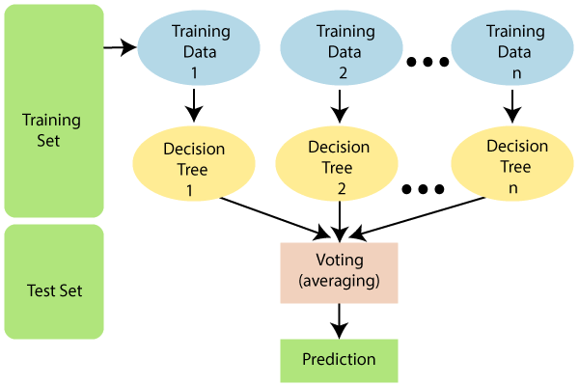

How does Random Forest Algorithm work?

Random Forest works in two-phase first is to create the random forest by combining N decision tree, and second is to make predictions for each tree created in the first phase.

Step-1: Select random K data points from the training set.

Step-2: Build the decision trees associated with the selected data points (Subsets).

Step-3: Choose the number N for decision trees that you want to build.

Step-4: Repeat Step 1 & 2.

Step-5: For new data points, find the predictions of each decision tree, and assign the new data points to the category that wins the majority votes.

Applications of Random Forest Algorithm:
There are mainly four sectors where Random forest mostly used:
- Banking: Banking sector mostly uses this algorithm for the identification of loan risk.
- Medicine: With the help of this algorithm, disease trends and risks of the disease can be identified.
- Land Use: We can identify the areas of similar land use by this algorithm.
- Marketing: Marketing trends can be identified using this algorithm.
Advantages of Randon Forest Algorithm
- Random Forest is capable of performing both Classification and Regression tasks.
- It is capable of handling large datasets with high dimensionality.
- It enhances the accuracy of the model and prevents the overfitting issue.
Disadvantages Of Random Forest Algorithm
- Although random forest can be used for both classification and regression tasks, it is not more suitable for Regression tasks.

CHAPTER-7 IMPLEMENTATION

  - Python:-
What is Python:
These are some facts about Python. Python is present most widely used multi-purpose and high-level programming language .it allows programming in Object-Oriented and Procedural paradigms. Python programs commonly are smaller than other programming languages like Java. Programmers have to write relatively less and indentation requirement of the language, makes them readable all the time. Python language is being used by the almost all tech-giant companies like – Google, Amazon, Facebook, Instagram, Dropbox, Uber… etc. The biggest strength of Python language is huge collection of standard library it can be used for the following –Machine Learning
    - GUI applications(such as Kivy, Tkinter, PyQt, etc.)
    - Web frameworks such as Django (used byYouTube, Instagram, Dropbox)
    - Image processing(such as Opencv and Pillow)
    - Web scraping(such as Scrapy ,Beautiful Soupand Selenium)
    - Test Framework
    - Multimedia

Advantages of Python: -
Let's see how Python outperforms other languages.
Advantages of Python Over Other Languages
- Less Coding
When performing the same task in other languages, all tasks performed in Python require less coding. Python is also excellent standard library support, so there is no need to search for third-party libraries to get the job done. This is the main reason why many people recommend that beginners learn Python.

- Affordable
Python is a free resource, so individuals, small businesses, or large organizations can use available free resources to build applications, and Python is a popular and widely used community support.

- Python is for Everyone
Python can run in any environment, be it Linux, Macro Windows. Programmers need to learn different languages for different jobs, but with Python, you can professionally use Python to create web applications, perform data analysis and machine learning, automate things, perform web scraping, and create powerful games and visualization in itallaterra in programming language

Disadvantages of Python
We have seen why Python is the best choice for our project. But if you allocate it ,you should also be aware of its consequences. Let us now look at the disadvantages of choosing

Python over another language.
  - Speed Limitations
We have seen that Python code executes line by line. But because Python is interpreted, its execution speed is very slow. This is not a problem, unless speed is the focus of the project work. In other words, the speed is necessary, and the benefits Python provides are enough to dis structure from its speed limitations.

  - Weak in Mobile Computing and Browsers
Although Python is a good server-side language, Python is rarely seen on the client side. Most importantly, is rarely used to implement smart phone-based applications. One of these applications is called Carbonell. Although Brighton exists, it is not so famous because it is not so safe.

  - Design Restrictions
Python is a dynamically typed language. This means that you do not need to declare variable types when writing code content. It uses to duck typing. what is that? Well, it just means that if it looks like a duck, then it must be a duck. This is easy for programmers in the coding process, and it will generate runtime errors.

  - Under developed database access layer
Compared to the most widely used technologies such as JDBC (Java Database Connectivity) and ODBC (Open Database Connectivity), Python's database access layer is a bit under developed and it is used less in large companies.

  - Simple
We are not kidding. Python's simplicity is indeed a problem. I don't do Java, I'm more of a Python person. To me, its syntax is so simple that Java code seems unnecessary.

Install Python on Windows and Mac Step by Step:
Step1: Goto the official site and use Google Chrome or any other web browser to download and install Python. Or click on the following link:
https://www.pytho

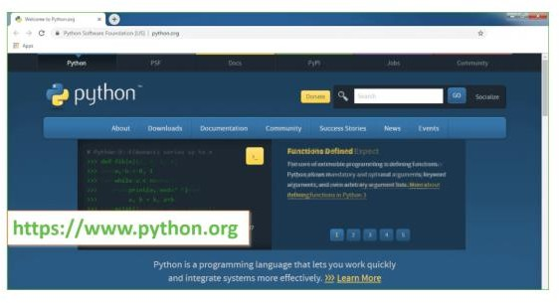
Fig 7.1.1 Open Python website to download the python latest version

Now check the latest and correct version of your operating system.

Step2: Click on the Download Tab.
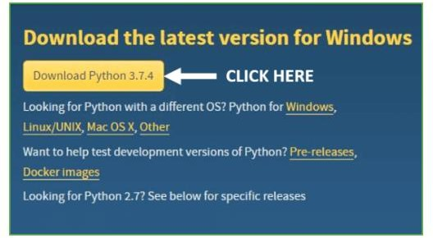
Fig 7.1.2 Click on Download Python

Step3: You can select the yellow Download Python for Windows3.7.4 button ,or you can scroll down and click the download of the corresponding version. Here, we are downloading the latest version of Python for Windows3.7.4.
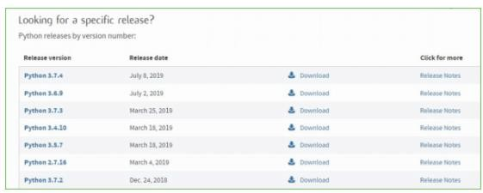
Fig 7.1.3 Select the version what you want
Step4: Scroll down the page until you find the "File" option.
Step5: Here you will see different versions of Python and operating systems.
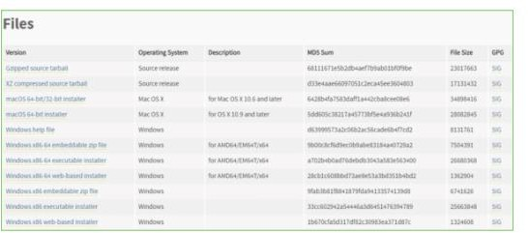
Fig 7.1.4 Python Versions

  - To download Windows 32bit Python, you can select the built-in Windows X86 Zip file,
Windows X86 executable installer orWindowsX86 installer on the Web.
  - To download Windows 64bit Python, you can select any option of the here options. Zip File Embeddable Windows X866, Windows X8664 executable installer or Windows X8664 installer based on the web.
Here you will install the installer based on the Windows X8664 website. Here, the first part of the Python version was completed. Now we will go in advance the second part when installing Python I. Note: You can click on the option of the release of the version to know the changes or updates made in the version.
Installation of Python
Step 1: Go to Download and Open the downloaded python version to carry out the installation process.

Step2: Before you click on Install Now, make sure to put a tick on Add Python3.7 to path

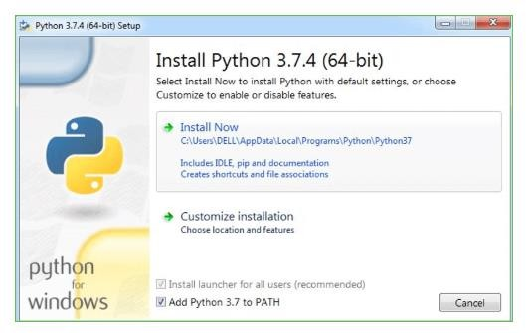
Fig 7.1.5 Click on install Now to install

Step3: Click on Install NOW After the installation is successful. Click on Close.

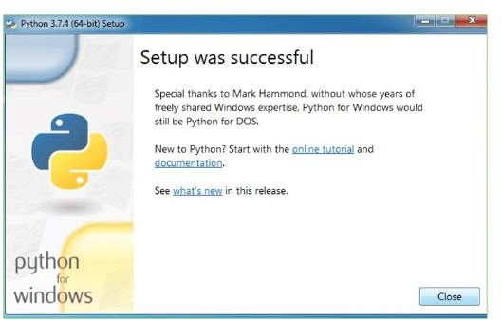

Fig 7.1.6 After installation successful. Click on Close

With these above three steps on python installation, you have successfully and correctly installed Python .Now is the time to verify the installation.
Note: The installation process might take a couple of minutes.

7.2 Verify the Python Installation
Step1: Click on Start
Step2: In the Windows Run Command, type “ cmd ” .

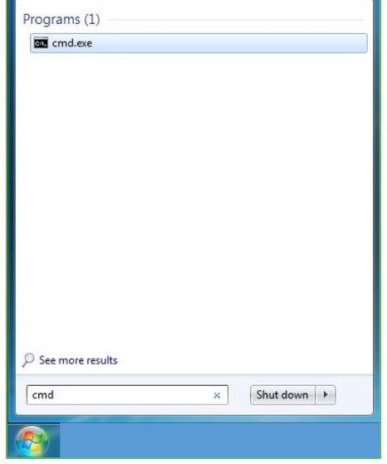
Fig 7.2.1 Open Command Prompt

Step3: Open the Command prompt option.

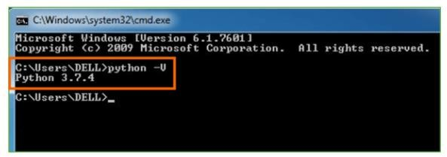
Step4: Let us test whether the python is correctly installed. Type python– V and press Enter.
Fig 7.2.2 Type Python -V to check the python is correctly installed or not

Step5: You will get the answer as3.7.4

Note: If you have any of the earlier versions of Python already installed You must first uninstall the earlier version and then install the new one.

7.3 Check how the Python IDLE works
Step 1: Click on Start
Step2: In the Windows Run command , type “python idle”.
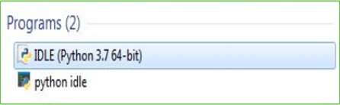

Fig 7.3.1 click on IDLE(python3.7 64-bit) and launch the program

Step3: Click on IDLE (Python3.764-bit) and launch the program

Step4: To go ahead with working in IDLE you must first save the file. Click on File Click on Save

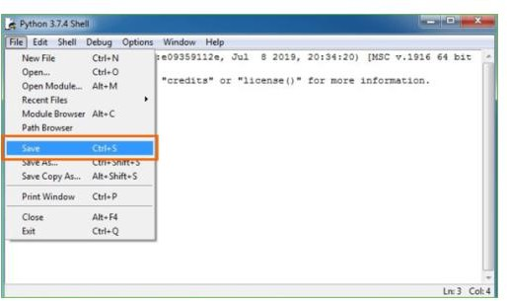

Fig 7.3.2 Click on File and save the file

Step5: Name the file and save as type should be Python files. Click on SAVE .Here I have named the files as Hey World.

Step6: Nowfore.g.enterprint
The Scikit-learn tool has been used to import machine learning algorithms. The data set is divided into training set and test set in the proportions of 50:50, 70:30 and 90:10 respectively. Each classifier uses the training set for training, and the test set is used to evaluate the performance of the classifier. The performance of the classifier is evaluated by calculating the precision, false negative rate, and false positive rate of the classifier

DJANGO
Django is an open-source python web framework used for rapid development, pragmatic, maintainable, clean design, and secures websites.
Django is based on MVT (Model-View-Template) architecture. MVT is a software design pattern for developing a web application.

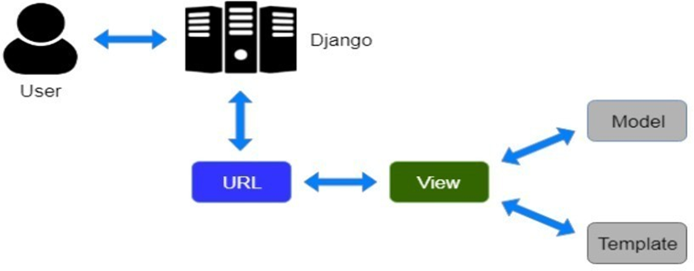
Fig 7.4 Django MVT Architecture

It is a collection of three important components Model View and Template .The Model helps to handle the database. It is a data access layer that handles the data. The Template is a presentation layer that handles the User Interface part completely. The View is used to execute the business logic and interact with a model to carry data and renders a template. Django follows the MVC pattern but maintains its conventions.

Streamlit (Spyder):
Even though the Project will have an educational part, whereby sickness will be explained to the user, especially their way of transmitting it and how it can be avoided, the principal objective of the research work is to ensure that Doctors are able to determine at the end of having tofill out a form if a Patient is sick or not.
Spyder was built specifically to be used for data science. Its interface allows the user to scroll through various data variables and also offers an online help option. The output of the code can be viewed in the Python console (for this research, streamlit is used) on the same screen. Where I will work on different scripts at a moment and then try them out one by one in the same console or different as per your choice, all the variables used will be stored in the variable explorer tab. It also provides an option to view graphs and visualizations in the plot window. So the data will be trained and tested on Kaggle and then downloaded with extension of be of (.sav) and connected to Spyder apps, and then a form is created from the Spyder app to enable the data to be parsed from the form to the train model after the user has been given access by the Django web app.

CHAPTER-8
TESTING

SYSTEM TEST

The purpose of testing is to discover errors. Testing is the process of trying to discover every conceivable fault or weakness in a work product. It provides a way to check the functionality of components, sub-assemblies, assemblies and/or a finished product It is the process of exercising software with the intent of ensuring that the Software system meets its requirements and user expectations and does not fail in an unacceptable manner. There are various types of test. Each test type addresses a specific testing requirement.

TYPES OF TESTS

Unit testing
Unit testing involves the design of test cases that validate that the internal program logic is functioning properly, and that program inputs produce valid outputs. All decision branches and internal code flow should be validated. It is the testing of individual software units of the application .it is done after the completion of an individual unit before integration. This is a structural testing, that relies on knowledge of its construction and is invasive. Unit tests perform basic tests at component level and test a specific business process, application, and/or system configuration. Unit tests ensure that each unique path of a business process performs accurately to the documented specifications and contains clearly defined inputs and expected results.

Integrated Testing
Integration tests are designed to test integrated software components to determine if they actually run as one program. Testing is event driven and is more concerned with the basic outcome of screens or fields. Integration tests demonstrate that although the components were individually satisfaction, as shown by successfully unit testing, the combination of components is correct and consistent. Integration testing is specifically aimed at exposing the problems that arise from the combination of components.

Functional Testing

Functional tests provide systematic demonstrations that functions tested are available as specified by the business and technical requirements, system documentation, and user manuals.

Functional testing is centered on the following items

Valid Input : identified classes of valid input must be accepted.
Invalid Input : identified classes of invalid input must be rejected.
Functions : identified functions must be exercised.
Output : identified classes of application outputs must be exercised.
Systems/Procedures :interfacing systems or procedures must be invoked.

Organization and preparation of functional tests is focused on requirements, key functions, or special test cases. In addition, systematic coverage pertaining to identify Business process flows; data fields, predefined processes, and successive processes must be considered for testing. Before functional testing is complete, additional tests are identified and the effective value of current tests is determined.

System Testing
System testing ensures that the entire integrated software system meets requirements. It tests a configuration to ensure known and predictable results. An example of system testing is the configuration oriented system integration test. System testing is based on process descriptions and flows, emphasizing pre-driven process links and integration points.

White Box Testing

White Box Testing is a testing in which in which the software tester has knowledge of the inner workings, structure and language of the software, or at least its purpose. It is purpose. It is used to test areas that cannot be reached from a black box level.

Black Box Testing
Black Box Testing is testing the software without any knowledge of the inner workings, structure or language of the module being tested. Black box tests, as most other kinds of tests, must be written from a definitive source document, such as specification or requirements document, such as specification or requirements document. It is a testing in which the software under test is treated, as a black box. you cannot “see” into it. The test provides inputs and responds to outputs without considering how the software works.

Unit Testing
Unit testing is usually conducted as part of a combined code and unit test phase of the software lifecycle, although it is not uncommon for coding and unit testing to be conducted as two distinct phases.

Test strategy and approach
Field testing will be performed manually and functional tests will be
Written in detail.

Test objectives

- All field entries must work properly.
- Pages must be activated from the identified link.
- The entry screen, messages and responses must not be delayed.

Features to be tested

- Verify that the entries are of the correct format
- No duplicate entries should be allowed
- All links should take the user to the correct page.

Acceptance Testing
User Acceptance Testing is a critical phase of any project and requires significant participation by the end user. It also ensures that the system meets the functional requirements.

Test Results:
All the test cases mentioned above passed successfully. No defects encountered.

CHAPTER-9

SAMPLE SCREENS

STEP 1

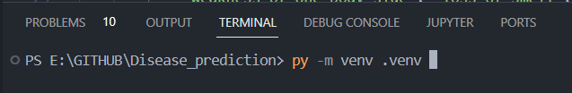

Fig 9.1 Create an virtual environment

STEP 2

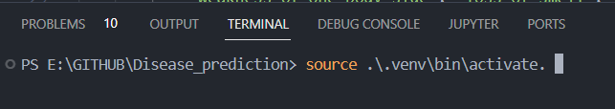

Fig 9.2 open command prompt to active venv

STEP 3

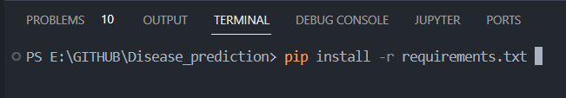

Fig 9.3 To pip install requirements
STEP 4

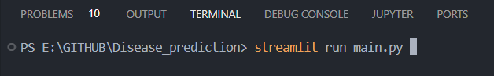

Fig 9.4 Run the main file streamlit run main.py
STEP 5

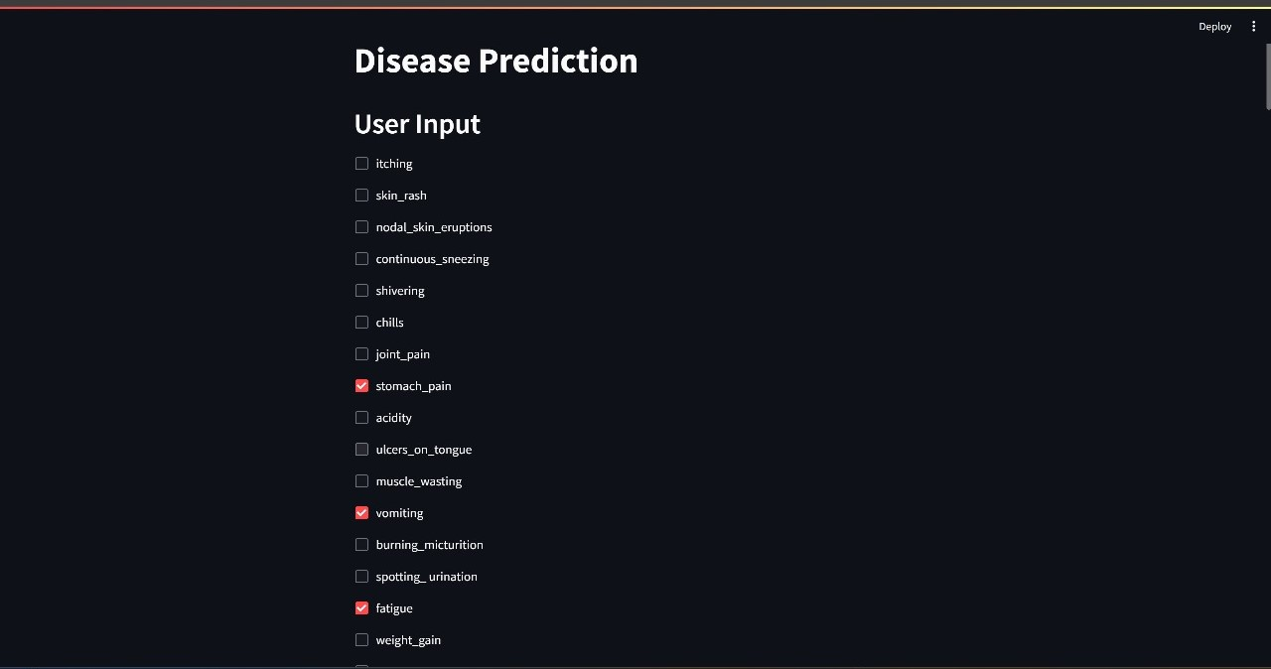

Fig 9.5 Select symptoms

STEP 6

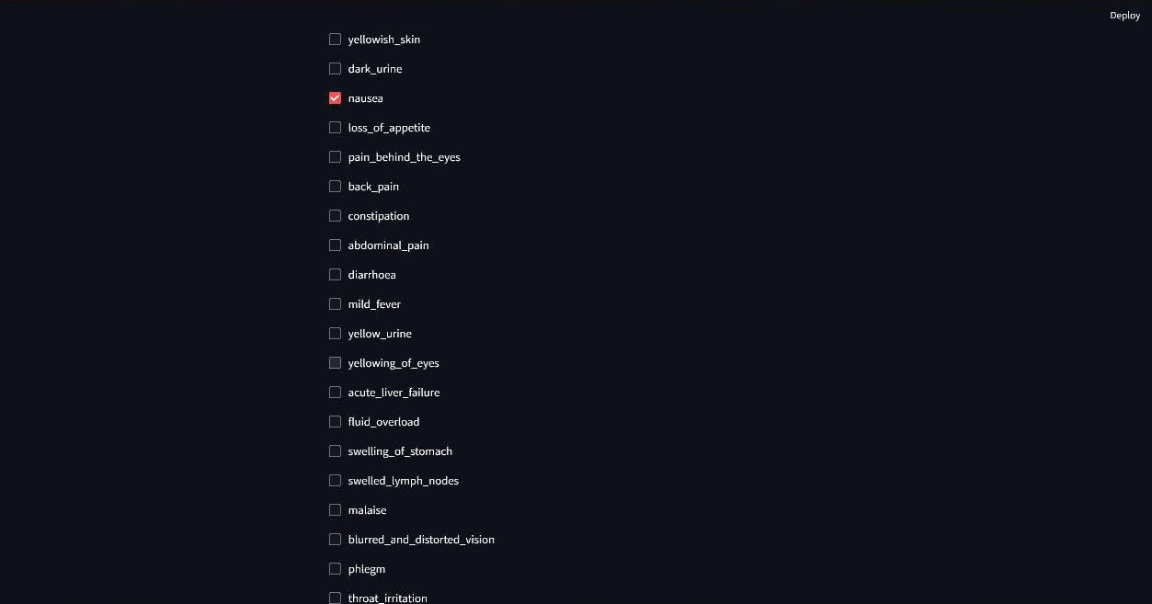

Fig 9.6 select symptoms

STEP 7

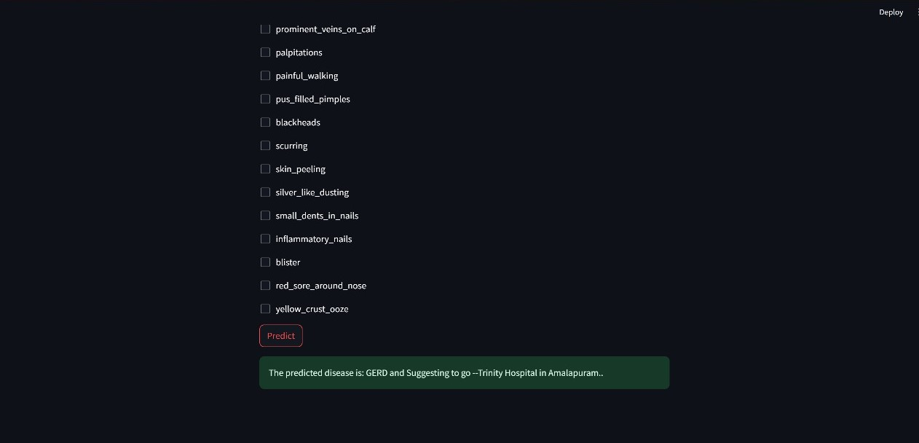

Fig 9.7 Then obtained the final output web page

GERD (Gastroesophageal Reflux Disease)and Suggesting to go-Trinity Hospital in Amlapuram

What is GERD?
GERD is a chronic condition where stomach acid flows back into the esophagus, causing symptoms like heartburn, chest pain, and discomfort
.
Possible Causes of GERD:

1. Faulty Lower Esophageal Sphincter (LES): The LES is a ring of muscle that acts as a valve between the esophagus and stomach. If it doesn't close properly, stomach acid can leak back into the esophagus.
2. Hiatal Hernia: When the upper part of the stomach moves up into the chest through a small opening in the diaphragm (hiatus), it can lead to GERD symptoms
3.Obesity: Excess weight can put pressure on the abdomen, pushing up stomach acid into the esophagus, leading to acid reflux and heartburn.

CHAPTER-10

CONCLUSION

The significance of the project on disease prediction using machine learning cannot be overstated, particularly within the healthcare sector where such systems are indispensable tools for forecasting patients' illnesses based on their symptoms and general characteristics. By enabling users to input their symptoms and relevant information, the system empowers individuals to gain insights into their health conditions without the need for extensive medical consultations. Moreover, the healthcare industry stands to benefit significantly from the adoption of such predictive technologies, as they play an increasingly pivotal role in diagnosing and treating patients' ailments. This approach not only serves as a valuable informational resource for healthcare professionals but also offers convenience and accessibility to users who may prefer to avoid hospital visits or clinic appointments. By integrating disease prediction systems into routine medical practices, doctors' workloads can be alleviated, allowing them to focus on more complex cases and provide timely interventions where necessary. Ultimately, disease prediction serves as a proactive measure to identify common illnesses before they escalate, potentially preventing mortality and alleviating burdens for patients and their families.

CHAPTER-11

FUTURE ENHANCEMENT

In future iterations, several enhancements could be incorporated into the "Disease Prediction System Using Symptoms in Python" project to further augment its capabilities. Potential enhancements may include the integration of additional data sources, such as genetic information or lifestyle factors, to enhance the accuracy and specificity of disease predictions. Furthermore, the incorporation of advanced machine learning techniques, such as deep learning or ensemble learning, could potentially improve prediction performance and enable the system to handle a wider range of diseases and health conditions. Additionally, the development of a mobile application version of the system could enhance accessibility and usability for users, allowing them to input symptoms and receive predictions conveniently from their smartphones or tablets. Moreover, the inclusion of features for personalized health recommendations or treatment suggestions based on predicted diseases could further empower users to take proactive steps towards managing their health. Overall, these future enhancements have the potential to elevate the effectiveness and utility of the disease prediction system, contributing to improved healthcare outcomes and patient well-being.

CHAPTER-12

BIBLIOGRAPHY

REFERENCES

[1] M. Jiang, Y. Chen, M. Liu, S. T. Rosenbloom, S. Mani, J. C. Denny, and H. Xu, “A study of machine-learning-based approaches to extract clinical entities and their assertions from discharge summaries,”
J. Am Med Inform Assoc, vol. 18, no. 5, pp. 601–606, 2011.
[2] M. Chen, Y. Hao, K. Hwang, L. Wang, and L. Wang, “Disease prediction by machine learning over big data from healthcare communities” IEEE Access, vol. 5, no.1, pp.8869–8879, 2017.
[3] SayaliAmbekar, RashmiPhalnikar, “Disease RiskPrediction by Using Convolutional Neural Network” IEEE, 978-1-5386-5257-2/18, 2018.
[4] NagannaChetty, Kunwar Singh Vaisla and NagammaPatil, “An Improved Method for Disease Predictionusing Fuzzy Approach” IEEE, DOI 10.1109/ICACCE.2015.67, pp. 569-572, 2015.
[5] DhirajDahiwade, GajananPatle and EktaaMeshram, “Designing Disease Prediction Model Using Machine Learning Approach” IEEE Xplore Part Number: CFP19K25-ART; ISBN: 978-1-5386-7808-4, pp. 1211-1215, 2019.
[6] Lambodar Jena and Ramakrushna Swain, “ChronicDisease Risk Prediction using Distributed Machine Learning Classifiers” IEEE, 978- 1-5386-2924-6/17, pp. 170-173, 2017.
[7] DhomseKanchan B. and MahaleKishor M., “Study of Machine Learning Algorithms for Special Disease Prediction using Principal of Component Analysis” IEEE, 978-1-5090-0467-6/16, pp. 5-10, 2016.
[8] AnkitaDewan and Meghna Sharma, “Prediction of Heart Disease Using a Hybrid Technique in Data Mining Classification” IEEE, 978-9- 3805-4416-8/15, pp. 704-706, 2015.

[9] Pahulpreet Singh Kohli and Shriya Arora, “Application of Machine Learning in Disease Prediction” IEEE, 978-1-5386-6947-1/18, pp. 1-4, 2018.
[10] Deeraj Shetty, KishorRit, Sohail Shaikh and Nikita Patil, ” Diabetes DiseasePrediction Using Data Mining” IEEE, 978-1-5090- 3294-5/17, 2017.
[11] Rashmi G Saboji and Prem Kumar Ramesh,“A Scalable Solution for Heart Disease Prediction using Classification Mining Technique” IEEE, 978-1-5386-1887-5/17, pp. 1780-1785, 2017.
[12] Rati Shukla, Vikash Yadav, Parashu Ram Pal and Pankaj Pathak, "Machine Learning Techniques for Detecting and Predicting Breast Cancer" IJITEE, ISSN: 2278-3075, Volume-8, pp. 2658-2662, 2019.
[13] Servant Leadership from a Christian Perspective Essay | Bartleby. (n.d.). Retrieved May22, 2022, from https://www.bartleby.com/essay/Servant-Leadership-From-a-Christian- Perspective-F3CVTBFZTC.

