Visualising the Impact of Distance Metrics on k-Nearest Neighbours (k-NN)
Student Id: 24098263
Module name: 7PAM2021-0901-2025 - Machine Learning and Neural Networks

1. Introduction
k-Nearest Neighbours (k-NN) is one of the simplest yet most intuitive algorithms in machine learning. Despite its conceptual simplicity, k-NN is powerful for classification tasks, especially when the decision boundaries are complex or nonlinear. Unlike parametric models that learn explicit functions, k-NN is an instance-based technique; it makes predictions by examining the k closest examples in the training dataset. Because the algorithm relies entirely on distance calculations, the choice of distance metric has a significant impact on classification performance and decision boundary shapes.
This project focuses on a visual and comparative study of three commonly used distance metrics in k-NN:
- Euclidean distance (p=2)
- Manhattan distance (p=1)
- Minkowski distance (p=3)
To make the differences clear and visually intuitive, the code has been modified to generate unique colour-coded plots for each metric. This visual enhancement allows for clearer interpretation of how each metric shapes the decision regions.
The following sections describe the dataset, outline the methodology, present the resulting plots, and provide detailed analysis of how distance metrics influence k-NN classification behaviour.

2. Dataset Description
The dataset used in this analysis consists of two numerical features and one categorical class label. It is provided as a manually uploaded CSV file and processed through scaling and splitting steps to prepare it for training and testing.
Before training k-NN, both features are scaled using StandardScaler, which standardises the values so that each feature contributes equally to distance calculations. This step is essential because k-NN relies on geometric distances; without scaling, a single feature with a large numerical range could dominate the distance measurement and bias the classification.
The scatter plot below shows the distribution of the two classes using a neutral colour scheme, providing an unbiased view of the data:

📷 Image 1 — Dataset Scatter Plot (Neutral Colours)
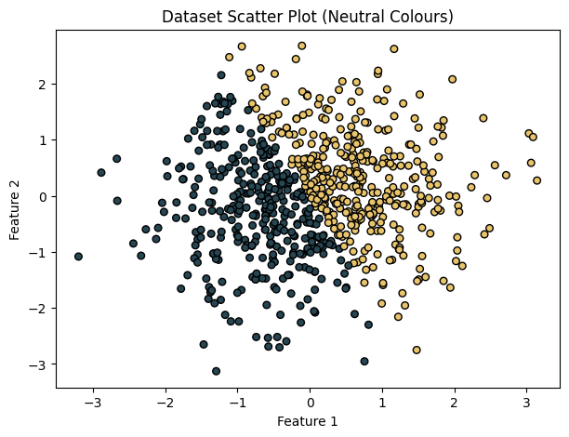

This scatter plot uses deep navy and golden-yellow as the two class colours. The points appear moderately intermingled, especially in the central region. This overlap makes classification more challenging and provides an excellent test case to examine how distance metrics behave in ambiguous areas. The feature values range roughly between -3 and +3, forming a relatively dense cluster with no extreme outliers.
This neutral plot serves as a baseline to visually compare how each distance metric generates and reshapes the classification regions.

3. Methodology
The methodology centres on training three k-NN models using the same dataset but different distance metrics. To ensure a fair comparison, each model is trained with k=5 neighbours and evaluated on identical train-test splits.
3.1 Feature Scaling
Feature scaling ensures fair distance calculations across both dimensions. Without scaling, k-NN would incorrectly give more weight to the feature with the largest measurement scale.
3.2 Train-Test Split
We perform a 75–25 split:
- 75% for training
- 25% for evaluation
3.3 Distance Metrics
Each model uses one of the following metrics:
- Euclidean distance (p=2): Straight-line distance between points
- Manhattan distance (p=1): Sum of absolute differences
- Minkowski distance (p=3): A higher-order generalisation that exaggerates large differences
3.4 Unique Colour Schemes for Each Plot
To enhance visual distinction, each distance metric is assigned a unique colour palette:
Metric | Boundary Colours | Point Colours
Euclidean | Teal & Blue | Navy & Green
Manhattan | Orange & Red | Burgundy & Red
Minkowski | Pink & Sky Blue | Violet & Magenta

This ensures that each decision plot is easily identifiable and visually distinct.

4. Results and Visualisations
📷 Image 2 — Euclidean (p=2) Decision Boundary
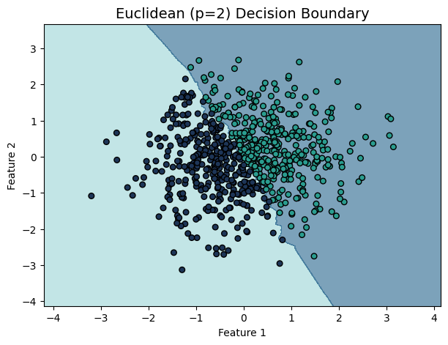
The Euclidean-distance plot shows smooth, continuous decision boundaries. The regions are shaded using teal and blue tones, and the data points are coloured in deep navy and green. The boundary is diagonally oriented, separating the two classes with rounded transitions.
Explanation:
Euclidean distance forms circular neighbourhoods around each data point. This gives the classifier the ability to follow naturally curved patterns within the data. As a result, the decision boundary appears smooth and balanced. This metric is highly suited for datasets where both features contribute continuously and symmetrically to classification.

📷 Image 3 — Manhattan (p=1) Decision Boundary
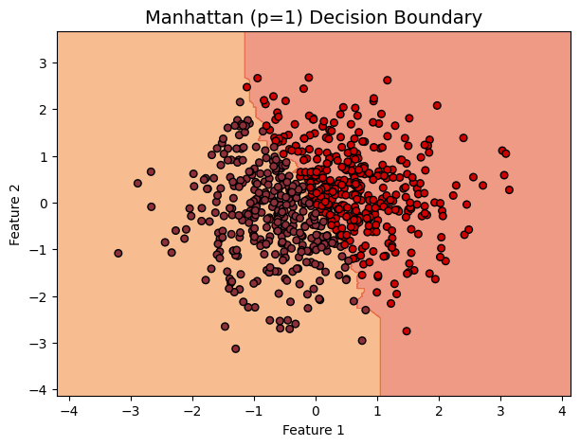
This plot features a dramatic shift in appearance. Using warm orange and red tones for the background, and deep burgundy and red for points, the Manhattan plot reveals a far more angular boundary. The decision regions include vertical and horizontal segmentation.
Explanation:
Manhattan distance calculates the sum of absolute differences, resulting in diamond- or square-shaped neighbourhoods. This produces sharper, more geometric decision boundaries that are aligned with the x and y axes. This behaviour makes Manhattan distance particularly sensitive to directional differences and can produce more abrupt class transitions.

📷 Image 4 — Minkowski (p=3) Decision Boundary
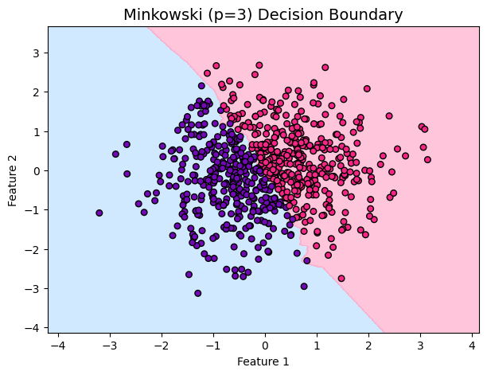
The Minkowski (p=3) decision boundary appears as a hybrid between Euclidean and Manhattan. The classification regions use hues of pink and sky blue, while the scatter points have magenta and violet shades. The boundary curves naturally but includes sharper bends that are absent in the Euclidean version.
Explanation:
For p>2, Minkowski distance exaggerates larger coordinate differences. This means neighbourhood boundaries stretch and adapt based on which dimension contributes more strongly to distance. As a result, the decision boundary captures subtle variations that fall between the smooth curves of Euclidean and the sharp edges of Manhattan.

5. Discussion
The coloured plots clearly highlight how dramatically distance metrics can alter neighbourhood shapes and classification boundaries. Even though the dataset remains unchanged, each metric interprets distance differently, resulting in distinct decision structures.

5.1 Analysis of Each Metric
- Euclidean: Smooth, rounded, and robust against small variations. Ideal for most continuous-data scenarios.
- Manhattan: Angular and axis-aligned. More sensitive to coordinate-wise differences and beneficial when features naturally differ along separate axes.
- Minkowski: A flexible metric that blends curvature with sensitivity. Useful when relationships are irregular or when some dimensions contribute more strongly.
5.2 Visual Clarity Through Colour Coding
The unique colour schemes substantially enhance comparability across plots. Each image becomes immediately recognisable, ensuring clarity when presenting or evaluating the impacts of distance metrics. This is particularly beneficial in educational contexts or technical reports where intuitive visual interpretation is essential.
5.3 Importance of Scaling
All metrics benefited greatly from scaling. Without standardisation, one feature could distort the geometry of neighbourhoods, leading to misleading results.
6. Conclusion
This study demonstrates the power and flexibility of k-NN while emphasising the importance of distance metric selection. By applying three distinct metrics and visualising their effects using unique colour palettes, we observed significant differences in boundary shapes and classification behaviour.
Euclidean produced smooth and balanced boundaries, Manhattan introduced sharp angular separations, and Minkowski offered a hybrid boundary combining both curvature and sensitivity. These visualisations provide a clear, intuitive understanding of how metric choice affects k-NN performance, reinforcing the value of careful selection based on dataset characteristics.
7. References
- Cover, T., & Hart, P. (1967). Nearest neighbor pattern classification. IEEE Transactions on Information Theory.
- Scikit-learn documentation: https://scikit-learn.org/stable/modules/neighbors.html
- Géron, A. (2019). Hands-On Machine Learning with Scikit-Learn and TensorFlow. O'Reilly.
GIT HUB Repository
https://github.com/venkat-chowdary12/Machine-Learning-Tutorial/tree/main

