Project- Deploying an web application with RDS in AWS

Deployed Web Application using Java Platform through Elastic Beanstalk AWS Service

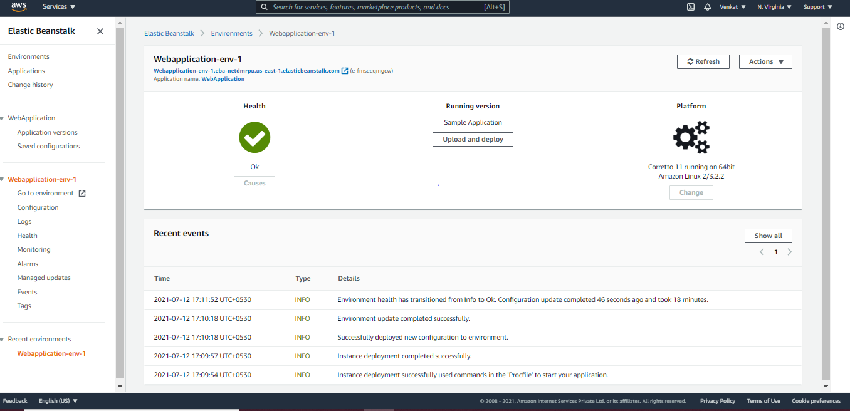

Configured RDS to connect to Instances.

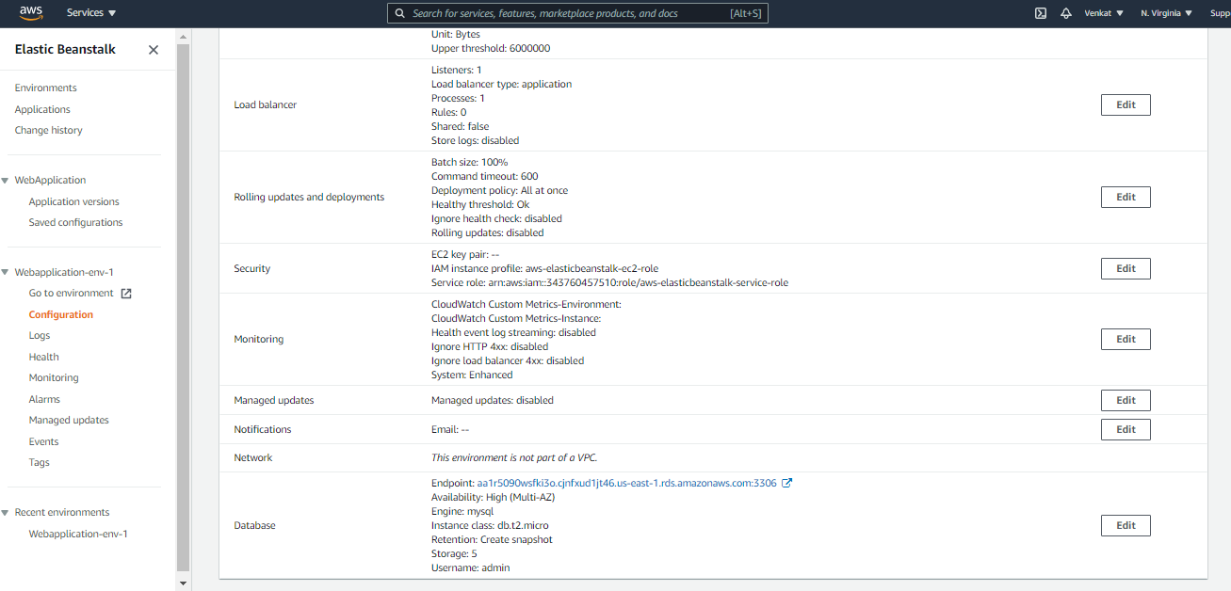

Health Monitoring using Beanstalk

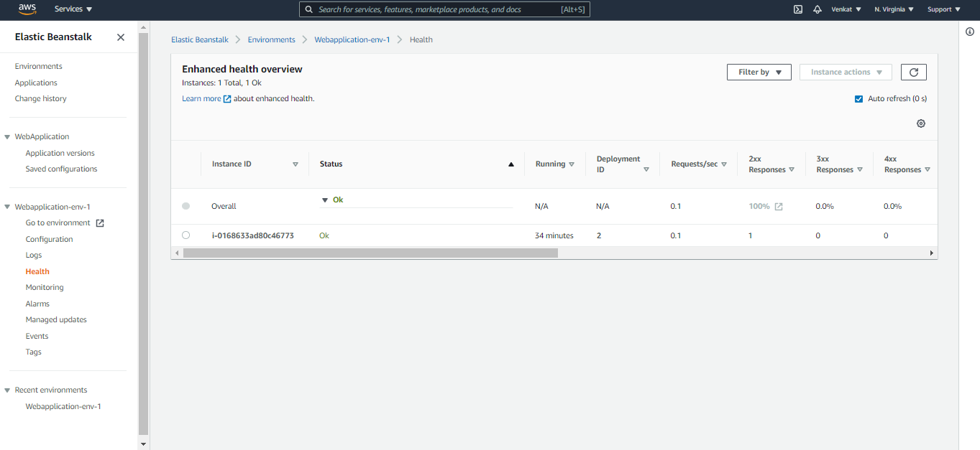

Events logged in Elastic Beanstalk

