AWS Cloud HandsOn

Activate Multi Factor Authentication for that account

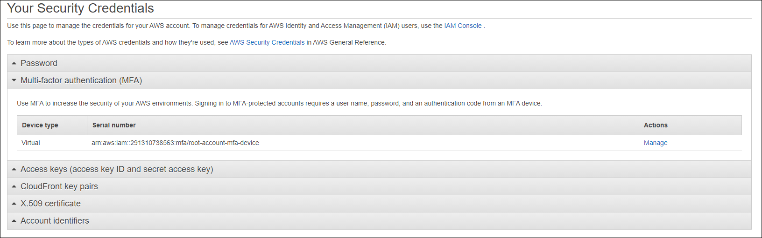

Create an IAM user called awsadm1, log-in to AWS console using awsadm1 credential

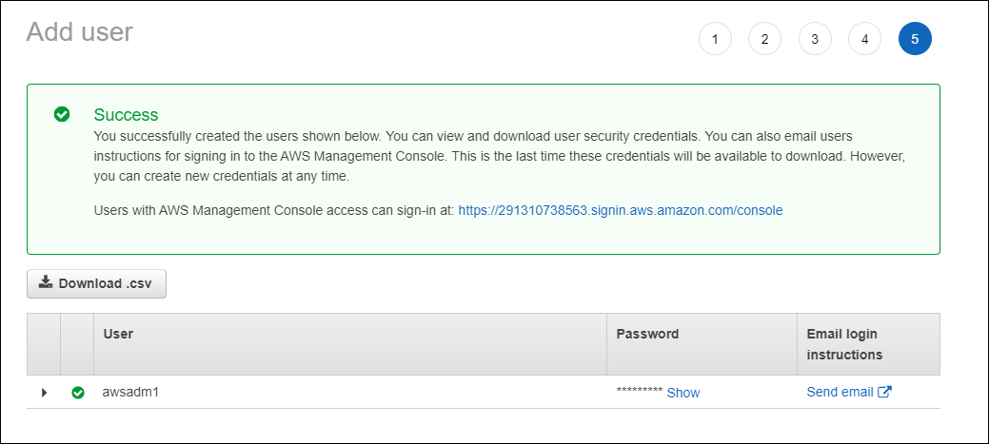



Create a Group called “s3-group”

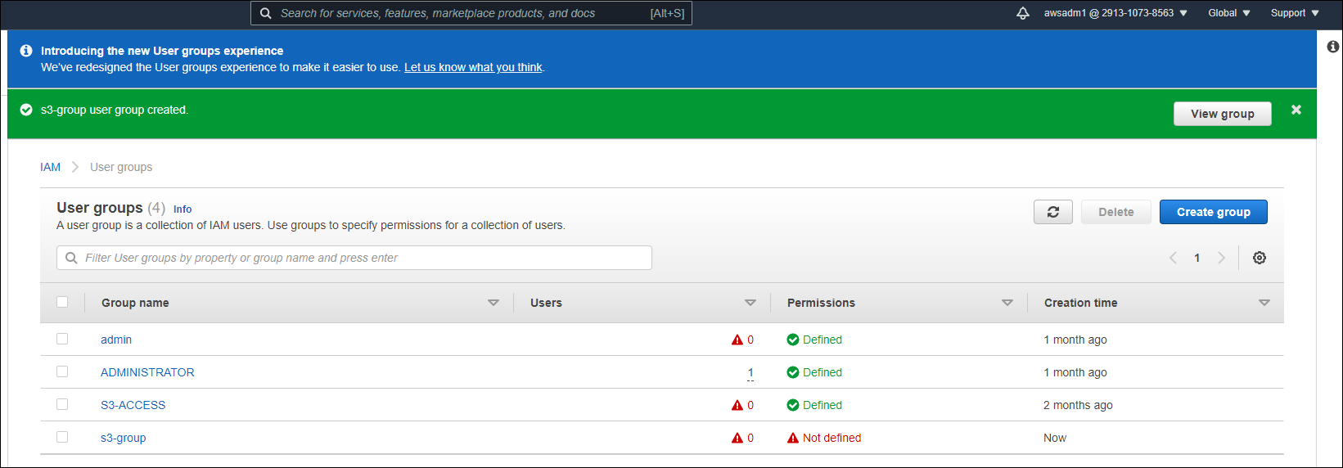

Create 3 users called s3-user1, s3-user2 and s3-user3.

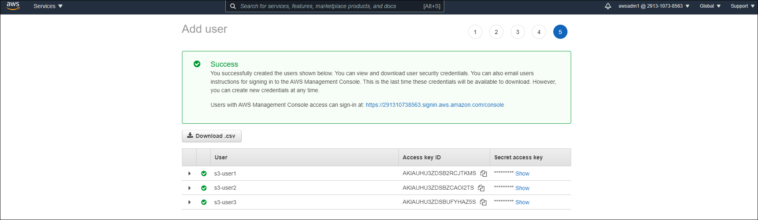

Provide S3 view privilege to s3-group.

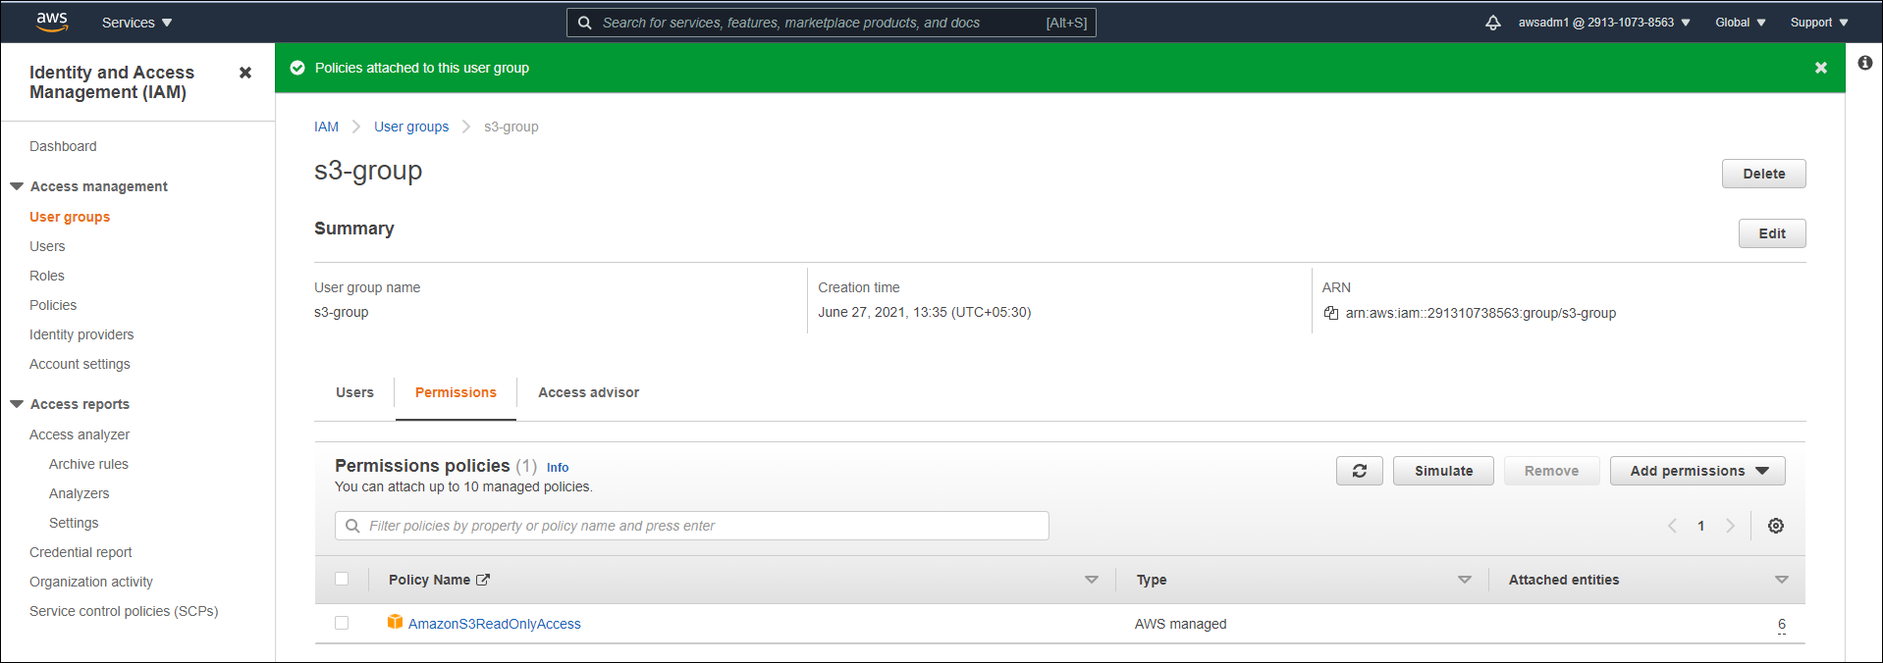

Provide S3 all privileges to s3-user1

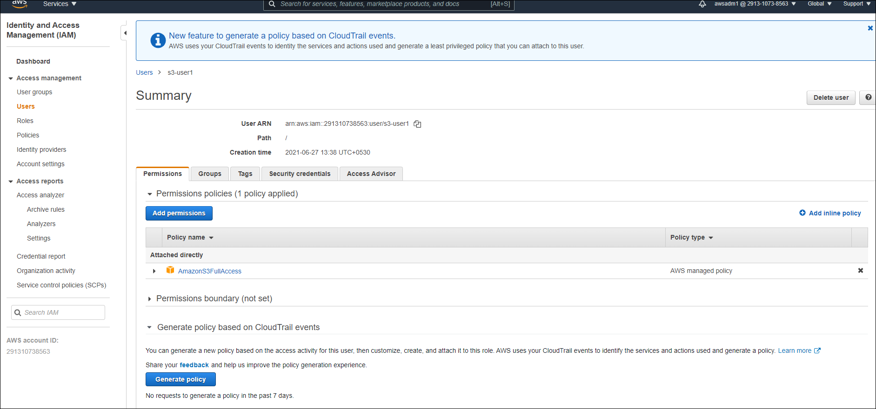

**EC2 and VPC**

* Create two Linux instances on a custom vpc and in the same custom subnet.

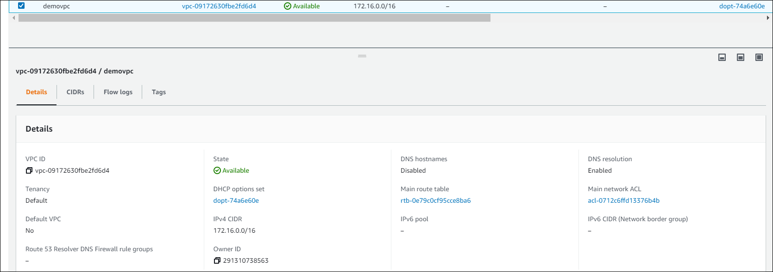

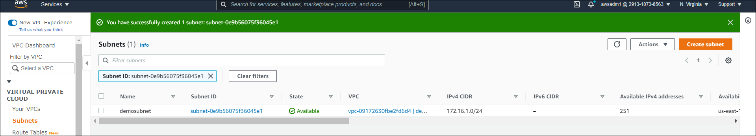

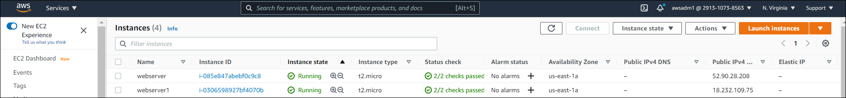

Enable adequate security to interconnect two instances, and connect those from Putty client

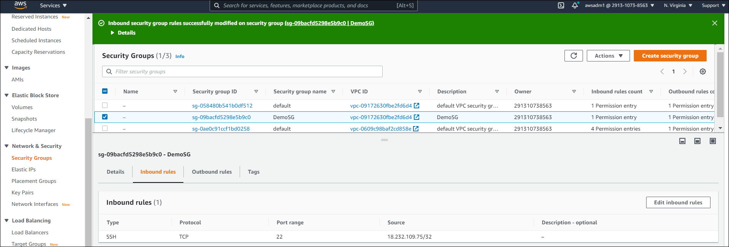

Create one EC2 instance of Windows, opt any AMI available on Free-Tier. Use default vpc and subnets for that Instance.

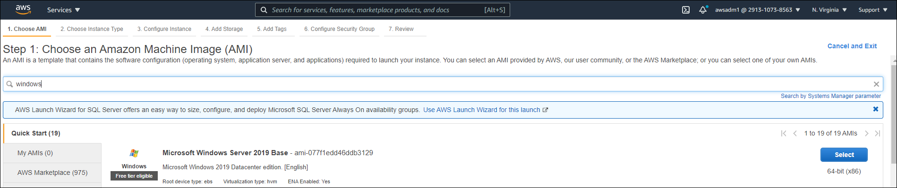

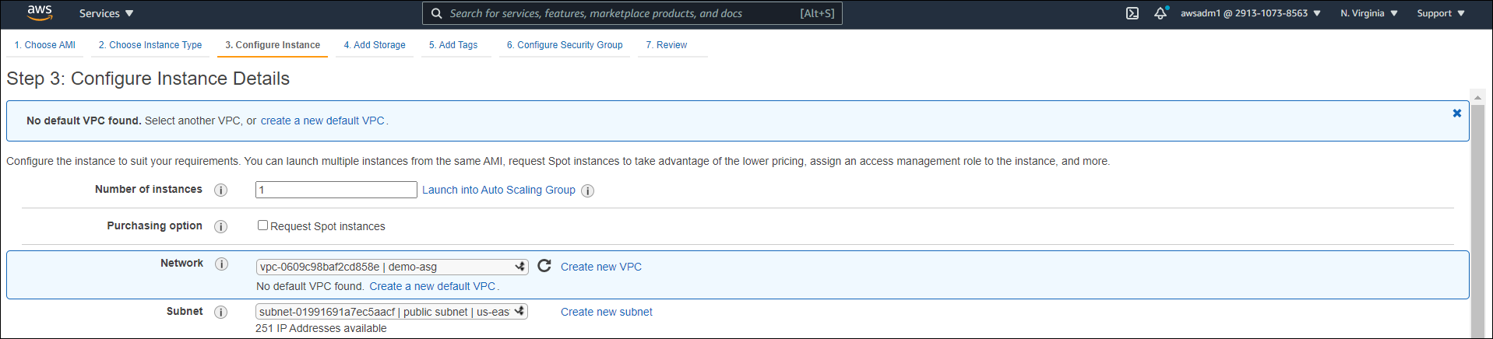

Connect the Windows instance using remote desktop.

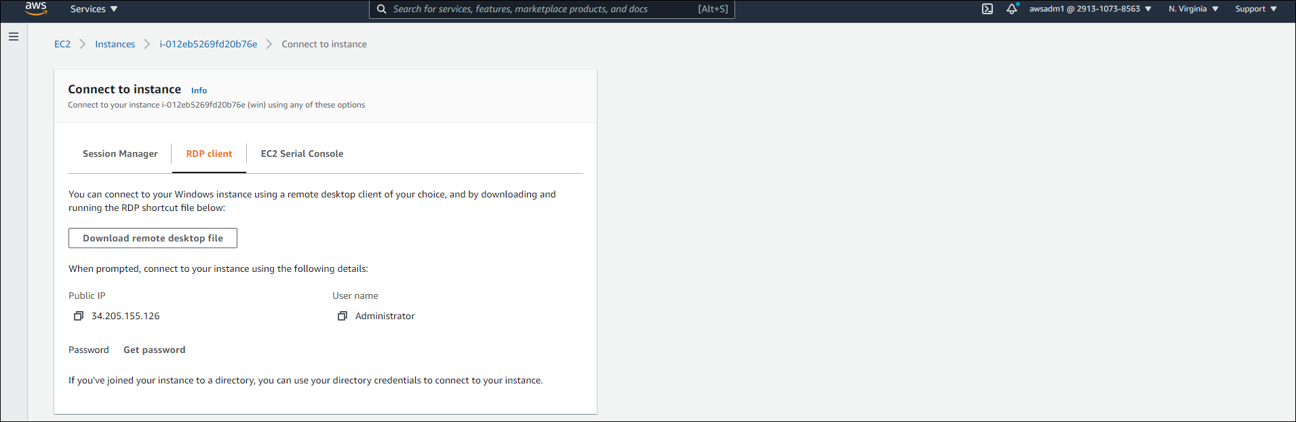

**Object Storage**

Create a bucket, where the bucket name will be your first name and employee-id combination, Example: shalini123456.

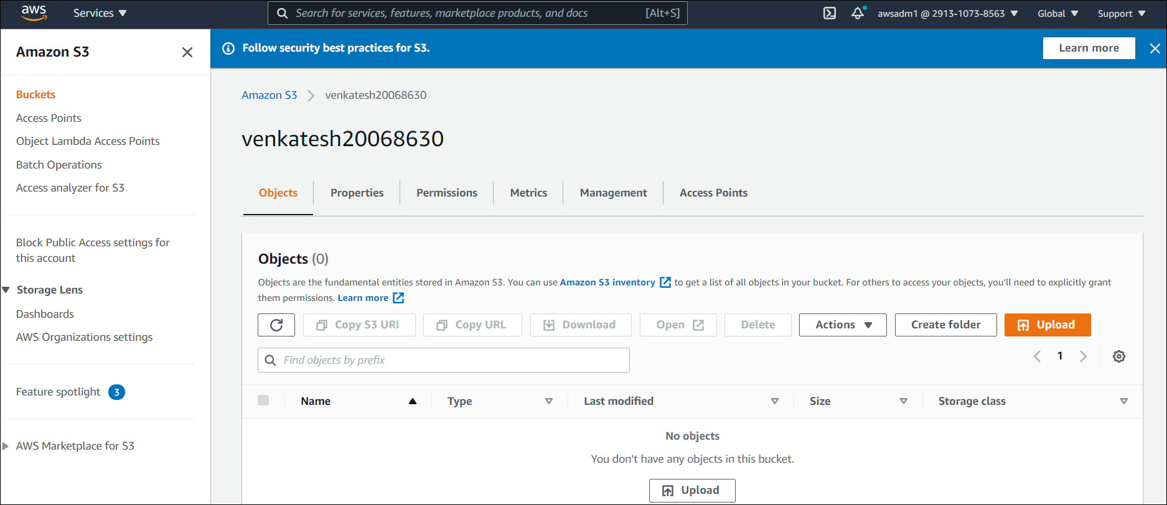

In that bucket upload 2 .png files and 1 .txt file of your choice

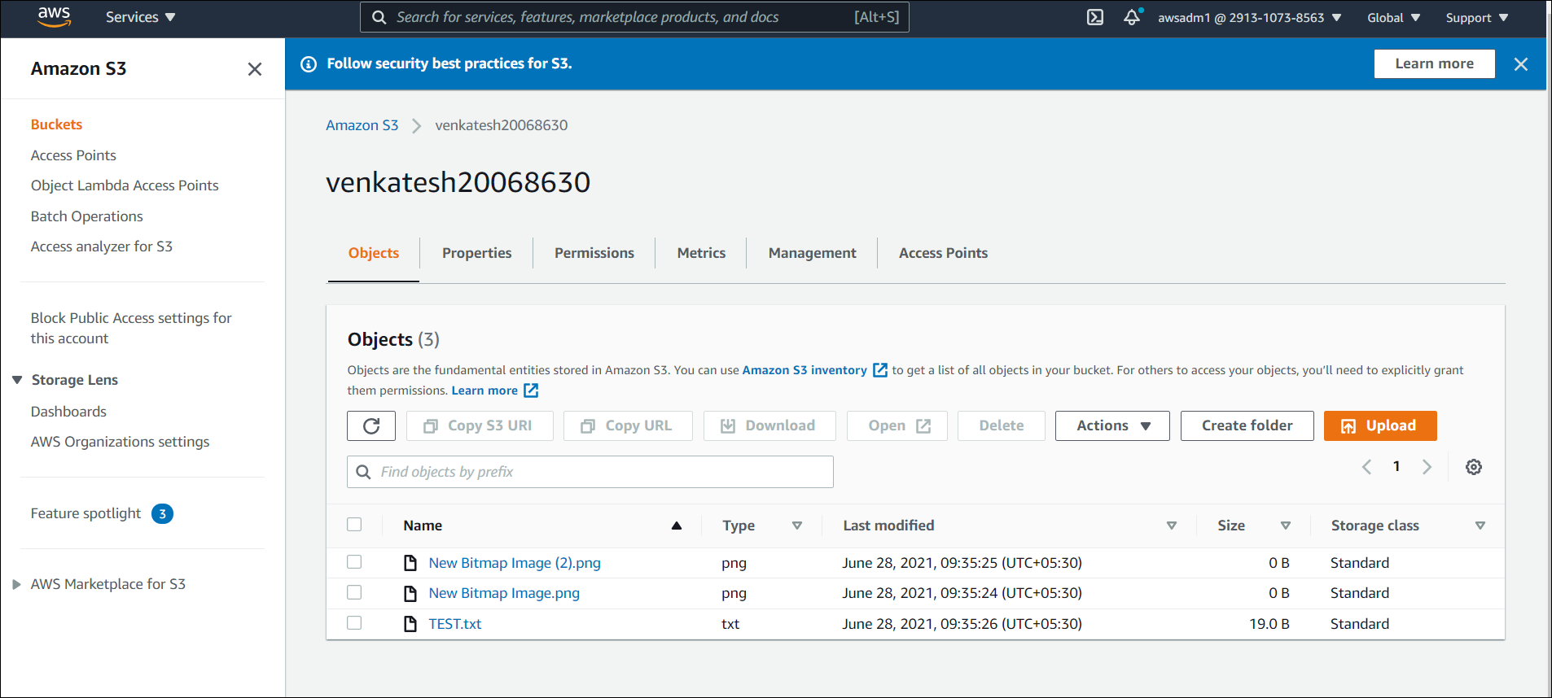

Provide adequate access to the .png files so that anybody can see the content using web browser but can’t see the .txt file.

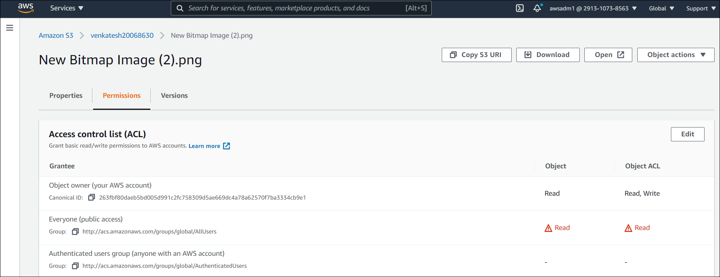

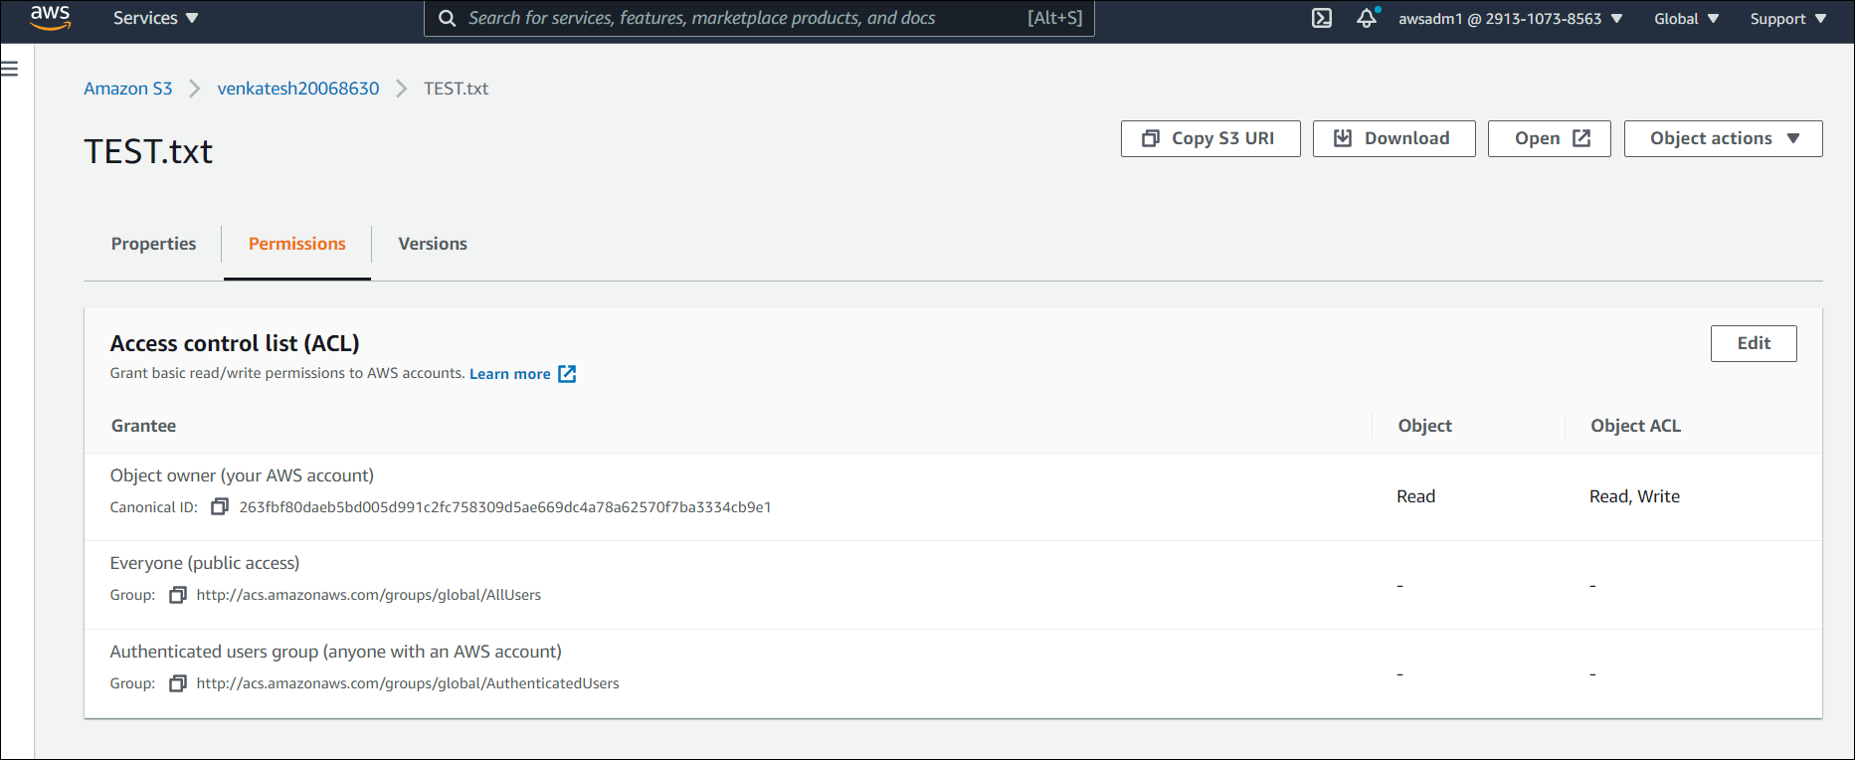

Make sure that after 30 days of creating the current version of all the files are transferred to Glacier and after 400 days those are permanently deleted.

