**ABSTRACT**

In a sprawling university campus, students often encounter difficulties in navigating through the finding precise departments, faculty offices, and crucial facilities including the library, cafeteria, and administration workplace. The lack of a centralized, person-friendly navigation gadget results in wasted time and frustration among college students trying to find their locations correctly. This user-friendly and secure campus navigation website ensures seamless access for both students and faculty members, facilitating effortless location finding within the college premises. Parents benefit from guest logins, offering access to essential areas like the principal’s office and HOD cabins, while providing detailed routes to campus hostels and pertinent information about hostel facilities and staff. With streamlined access and comprehensive features, the app prioritizes convenience and efficiency for all users navigating the college environment.

**Index Terms**: Web-based application, Navigation, HTML CSS, Flask.

**TABLE OF CONTENTS**

1. **INRODUCTION PAGE NO**

1.1 Cabin Management 1

1.2 Class Management 1

**2.BACKGROUND STUDY**

2.1 Literature Survey 2-3

2.2 Existing Project 3

**3.METHODOLOGY**

3.1 Proposed Project 4

3.2 System Architecture 4-5

**4.RESULT ANALYSIS**

4.1 Project Overview 6

4.2 User Authentication 6

4.3 Faculty Home page 7

4.4 Student Home page 7

4.5 Frontend Design 8

4.6 Debugging and Transparency 8

4.7 Security Considerations 8

4.8 Conclusion 8

**5.FUTURE SCOPE** 8

**6.CONCLUSION** 10

**REFERENCES** 11

**LIST OF FIGURES**

**S.no Title Page No**

1 Working architecture 4

2 Index page 6

3 User Login 6

4 Faculty Profile page 7

5 Student profile page 7

**CHAPTER 1**

**INTRODUCTION**

Over the decades, the evolution of technology has significantly increased, with rapid advancements in processing, data management, and the facilitation of daily life. The use of Google Maps is escalating each day for navigation between cities or even countries. Utilizing Global Positioning System (GPS) technology in Android applications can greatly aid in tracking the current location of users, providing precise location details. The demand for navigation has surged, particularly in smaller areas like campuses, in comparison to larger cities or regions. During events at specific colleges, it proves immensely beneficial for students attending from other institutions, aiding them in navigating within the campus seamlessly. Additionally, it assists parents visiting the college to accompany or visit their children, helping them locate administrative offices or other destinations without external assistance. Presently, Google Maps offers top-notch navigation services. However, its effectiveness within college campuses is limited, as it may not provide detailed location information for all facilities within the campus, such as libraries, seminar halls, or bakeries.

.

* 1. **CABIN MANAGEMENT**

An integrated online platform can streamline communication between students and faculty, allowing easy access to cabin locations. It includes features like messaging systems and appointment scheduling for academic queries. Faculty details, class, department, and cabin locations are readily available to students. Role-based access control ensures privacy and security. By using their roll numbers as login credentials, students can access relevant information. This system reduces the burden on class representatives significantly. Efficient communication fosters a conducive learning environment. It promotes transparency and strengthens relationships within the academic community. The platform enhances administrative processes and academic interactions. Overall, it improves the efficiency of student-faculty communication and information access.

**1.2 CLASS MANAGEMENT**

To further streamline the process of finding substitute teachers, the online platform could feature a section where faculty members can post requests for substitutes. This allows any available faculty within the institution to accept the request and step in for the absent teacher. This system enhances class management and ensures that work proceeds efficiently in the absence of regular instructors. With this solution in place, the hassle of finding substitutes is significantly reduced, leading to smoother operations within the institution.

**1**

**CHAPTER 2**

**BACKGROUND STUDY**

**2.1 LITERATURE SURVEY**

Campus management is a crucial part of running educational institutions smoothly. It involves various administrative, operational, and academic tasks that create a conducive environment for teaching, learning, and research. Research shows that efficient campus management is key to making the most of resources, enhancing student experiences, and achieving institutional success. To tackle the complex challenges faced by modern educational institutions, it is important to understand the key components and issues of campus management.

**Administration and Governance:**

Administrative processes and governance structures have a big impact on how educational institutions function. Scholars study topics like strategic planning, organizational structures, leadership styles, and decision-making frameworks in the context of campus management. By looking at different administrative models and best practices, institutions can improve their governance mechanisms to promote accountability, transparency, and effective decision-making at all levels.

**Facilities Management:**

Facilities management is crucial for keeping campuses safe, functional, and sustainable. Research in this area explores maintenance strategies, space planning, energy efficiency initiatives, safety protocols, and technology integration for facilities management. By adopting innovative approaches and leveraging technology, institutions can allocate resources efficiently, reduce operational costs, and create eco-friendly campuses that support teaching, learning, and research.

**Student Services:**

Student services play a vital role in supporting the overall development and well-being of students within the campus community. Literature on student services covers a wide range of topics including counselling, career guidance, health and wellness programs, student engagement initiatives, and diversity support services. By offering comprehensive and accessible student services, institutions can help students succeed, stay enrolled, and have a positive experience on campus.

**Academic Affairs:**

Academic affairs management involves planning, implementing, and evaluating academic programs and services offered by educational institutions. Studies in this area focus on curriculum development, course scheduling, faculty-student interactions, assessment practices, and academic support services. By aligning academic affairs with institutional goals and student needs, institutions can improve teaching quality, academic outcomes, and overall effectiveness.

**Technology Integration:**

The integration of technology has revolutionized campus management practices, providing opportunities to streamline operations, improve communication, and enhance decision-making. Research on technology

integration in campus management covers areas such as student information systems, learning management platforms, data analytics tools, and emerging technologies like artificial intelligence and IoT.

**2**

**Stakeholder Engagement:**

Engaging stakeholders is crucial for promoting collaboration, communication, and shared governance within the campus community. Literature on stakeholder engagement explores strategies for involving students, faculty, staff, alumni, and external partners in decision-making processes and institutional initiatives. By encouraging open dialogue, transparency, and inclusivity, institutions can foster a sense of ownership and collective responsibility, driving positive change and innovation on campus.

**Best Practices and Case Studies:**

Analysing best practices and case studies from educational institutions worldwide provides valuable insights into successful campus management initiatives. By studying real-life examples and comparing them to industry standards, institutions can identify effective strategies, learn from past experiences, and find areas for improvement. Sharing best practices and success stories also encourages,knowledge sharing and collaboration among institutions contributing to continuous improvement and excellence in campus management.

**2.2 EXISTING SYSTEM**

**A) COLLEGE CAMPUS NAVIGATION SYSTEM:**

An Android application has been developed specifically for college campus navigation, operable even in offline mode. While Google navigation is widely used for general travel, it often lacks precision in pinpointing specific locations within college campuses. To address this issue, an application has been created for Nitte Meenakshi Institute of Technology, aiding newcomers and existing students, faculty, etc., in navigating the campus. The app displays markers for source and destination points and utilizes predefined paths and GPS for navigation. This solution can be extended to other colleges, with potential future implementations including virtual reality integration.

**B) A WEB BASED CAMPUS NAVIGATION using QR CODE:**

Indoor navigation within complex campus environments presents significant challenges due to various factors such as multiple buildings, numerous entrances, diverse numbering systems, limited signage, ongoing construction, and intricate connection routes. Existing indoor navigation systems, as highlighted by research from LORENZ et al. (2013), often rely on building blueprints but struggle to meet cartographic standards and visualization techniques. Moreover, according to WINTER et al. (2017), floorplan maps are notorious for their complexity, requiring advanced mental rotation and orientation skills to decipher effectively. These findings underscore the complexity of managing indoor navigation within large campuses and emphasize the need for innovative solutions to enhance user experience and accessibility.

**C)** **CAMPUS CONNECT:**

Campus Connect is a comprehensive campus management system designed to streamline administrative processes, enhance communication, and foster collaboration within the campus community. It integrates various modules to address key aspects of campus management, including student services, academic affairs, facilities management, and stakeholder engagement.

**3**

**CHAPTER 3**

**METHODOLOGY**

**3.1 PROPOSED SYSTEM**

A central navigation system will go a long way toward directing visitors and new students around the campus. It will provide real-time interactive maps and directions to navigate from one building to another, classroom to another, and administrative office, and many more of the institution. It can also include virtual tours, step-by-step navigation, accessibility options, and those features that would cater to individuals with disabilities. The system would be coupled with an advanced class management system that helps locate the subordinate faculty members easily. It will enable faculty to easily and effectively locate and secure a substitute to ensure that classes continue to move ahead. It can include features like automated notifications, a database of available substitutes, and scheduling tools to facilitate quick and effective coordination. The system also provides students with information about their faculty members, including their cabins. This will help a student easily locate where the professor's office is located, which will further enhance student–professor communication. With these integrated systems, the institution can go ahead, keeping in view improved operational efficiency, improvisation in the student–visitor experience, and further connectivity in an organized academic place.

Moreover, the integrated system would provide students with invaluable information about their faculty members, including the locations of their offices. By effortlessly locating professors' offices, students can enhance communication and foster meaningful interactions with their instructors, ultimately enriching their academic experience. This feature not only promotes accessibility but also strengthens the student-faculty relationship, fostering a supportive and collaborative learning environment.

**3.2 SYSTEM ARCHITECTURE:**

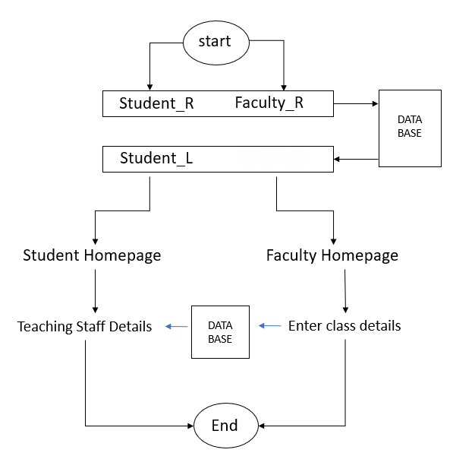

Faculty_L

**Fig 1: Working architecture**

**4**

* **START**: The process begins here.
* **STUDENT_R** and **FACULTY_R**: These seem to be the registration options for students and faculty, respectively.
* **DATA BASE**: This is likely the central database where the information from the registration is stored.
* **STUDENT_L** and **FACULTY_L**: These could be the login options for students and faculty after registration.
* **STUDENT HOME PAGE** and **FACULTY HOMEPAGE**: After logging in, students and faculty are directed to their respective homepages.
* **TEACHING STAFF DETAILS**: This might be a section where details of the teaching staff can be viewed.
* **ENTER CLASS DETAILS**: This could be an option for entering details about different classes.
* **End**: This marks the end of the process.

**Sequence of Implementation:**

The following are the processes of creating the system to deliver the route maps to the requested user:

**Developing interfaces**: Development of a user-friendly interface for users to input destinations and get the shortest route for users' destinations. Interface development is frontend work for web applications that involve the usage of technologies and the core languages that machines understand which are HTML, CSS, JS. HTML provides the structure and content of a webpage, allowing you to define elements like headings, paragraphs, links, images, forms, and many more. CSS is used to describe the presentation and styling of HTML documents. With the help of CSS, we can control the appearance of elements on a webpage, such as colors, fonts, spacing, layouts, backgrounds, and more. JS is used for adding interactivity, dynamic behavior, and functionality to web pages. It allows users to manipulate the content and structure of HTML and CSS.

**Development of a webpage:** Deploying a webpage involves making of website accessible to users on the internet. This process includes uploading your web files to a web server.

V**isual Studio Code (Vs code):** Visual Studio Code (VS Code) is a popular source code editor which is known for its lightweight design, versatility and making it a popular choice among developers for a wide range of programming languages and web development.

**Flask:** Flask is a micro web framework written in python. It is classified as micro web framework because it does not require particular tools or libraries. Flask supports extensions that can add application features as if they were implemented in Flask itself.

**Deploying website:** Deploying a website involves making your web application visible and accessible to users over the internet server. Deploying of websites can be done by online websites for deploying webpages or websites.

**5**

**CHAPTER 4**

**RESULT ANALYSIS**

**4.1 Project Overview**

This is a web application that demonstrates good examples of authenticating users and providing faculty and student-specific home pages. It uses Flask in the backend to read the data for user authentication from a CSV file. Simple but also very extensible in managing its users.

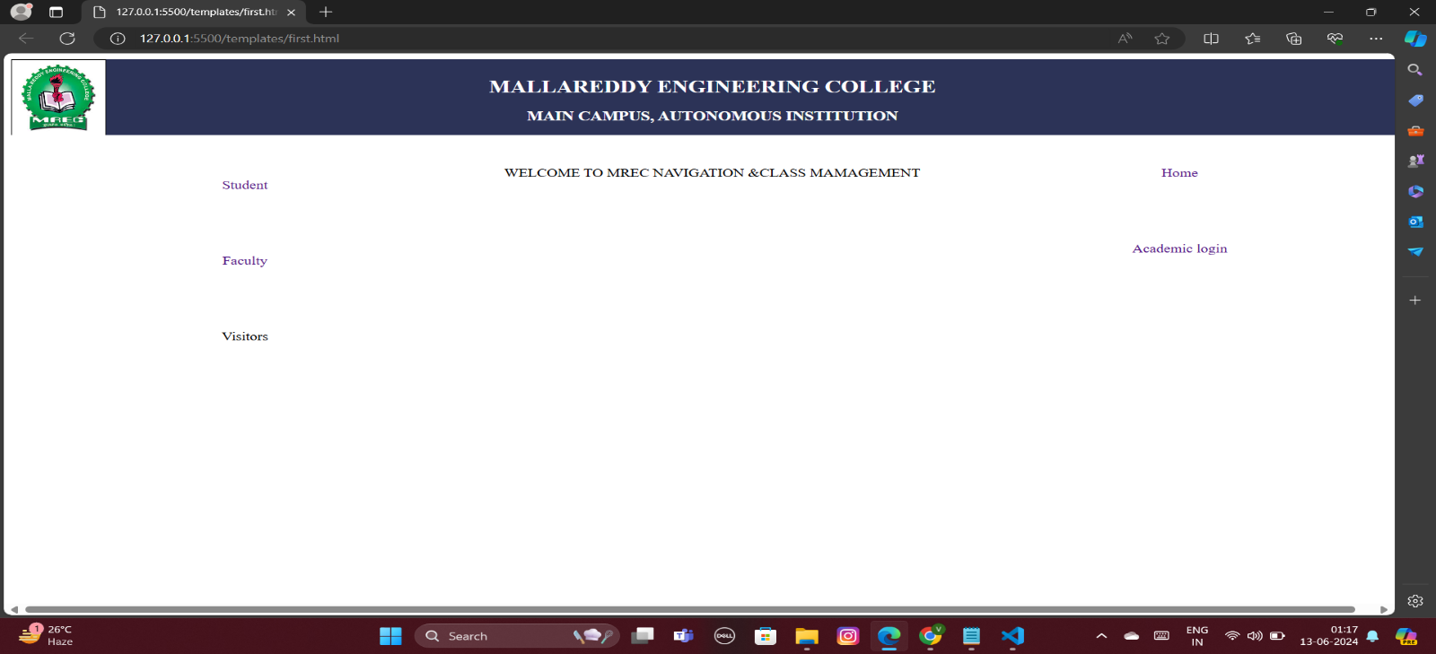

Fig 2: Index page

**4.2 User Authentication**

Login is pretty solid as it verifies the username and password and redirects according to their roles. It makes certain applications of relevant parts accessible only by the authorized user.

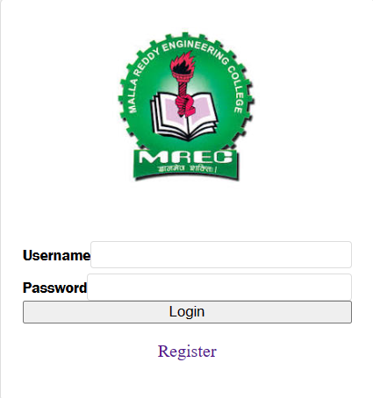

Fig 3: User Login

**6**

**4.3 Faculty Home Page**

The faculty home pages show the cabin and classes, which are fetched dynamically from the CSV file and are shown pretty fashionably for the faculty member to just go and see his details.

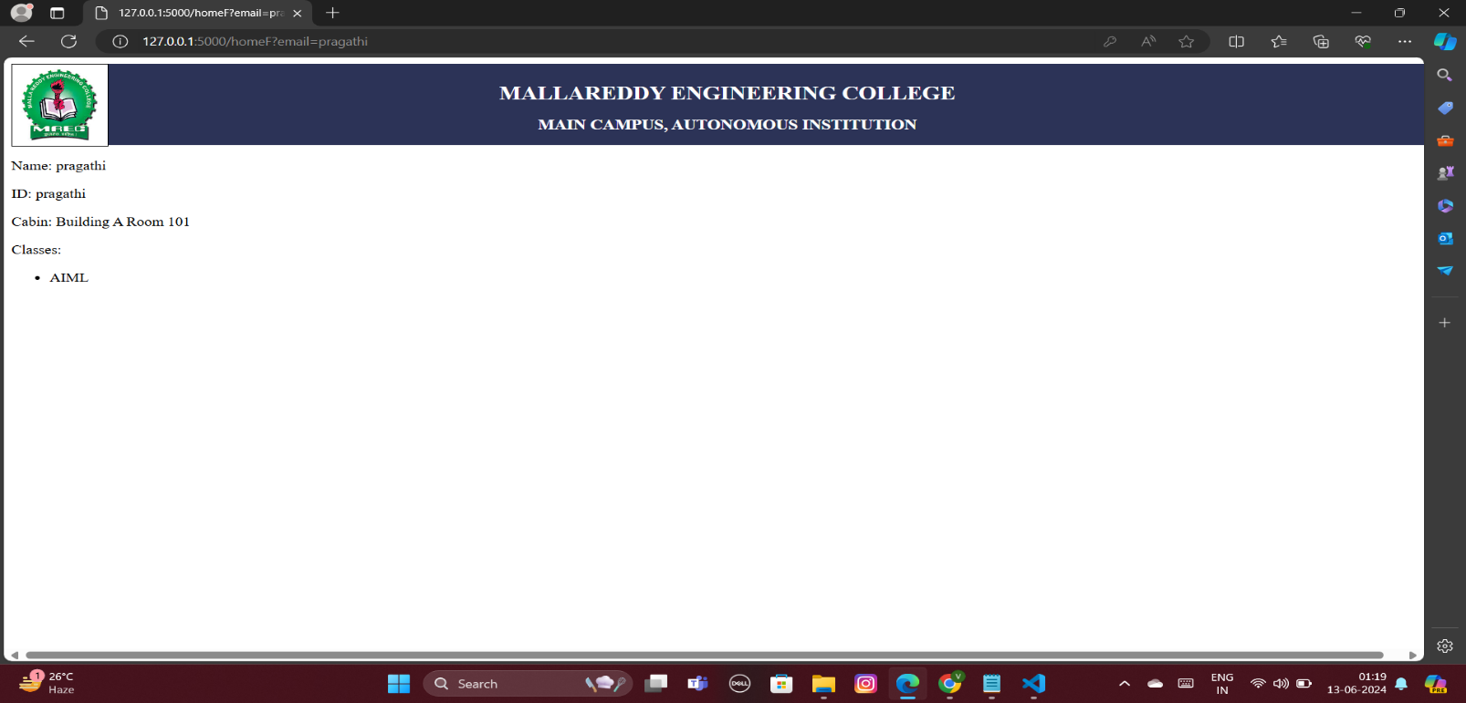

Fig 4: Faculty Profile page

**4.4 Student Home Page**

Student home pages cross-reference classes to give relevant faculty details._WEB, on comparing the student classes with classes of faculties finds out which faculties are relevant for the student and thereby displays their names and cabin locations.

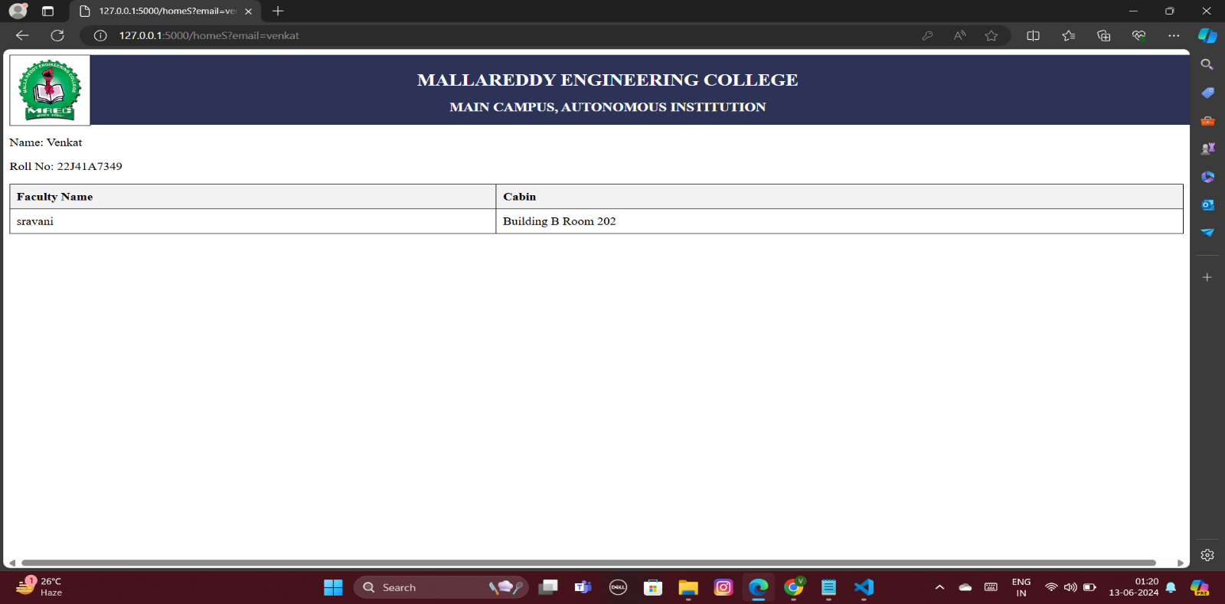

Fig5: Student profile page

**7**

**4.5 Frontend Design**

The frontend is a web interface created in HTML/CSS. The way HTML templates have been designed ensures maximum clarity and thus accessibility. The CSS has been used to make the templates visually appealing. This provides an excellent feel when the user navigates through it. The render_template _ string function makes dynamic content rendering possible, which creates a wonderful experience during navigation.

**4.6 Debugging and Transparency**

These debugging print statements serve to track login attempts and also provide transparency while developing the application. Of course, all these statements will be kept during the development phase so that the application works as it should.

**4.7 Security Considerations**

Secure password handling and user session management can be developed further. Much security and good user experience would be brought in this way. It would go a long way in introducing things like hashed passwords and secure cookies, making the application much more secure.

**4.8 Conclusion**

In any case, it is a valuable starting point for further development and enhances the capability to build an application securely and with ease for the management of faculty and student information.

**8**

**CHAPTER 5**

**FUTURE SCOPE**

**Advanced Navigation Features**

Further development and refinement of this project involves integrating the newest available options of navigation for better user experience. It may also have a dynamic menu system based on the roles of the user, such as faculty, student, visitor, or any other roles of users, and based on the preference, so it has to be more intuitive. Integration of Google Maps API can also be done for guiding the user through directions around the campus to reach any place, so a new student or visitor would be able to navigate around the campus with an easy method

**Class Management**

The entire project can. receive a giant boost in utility by having the feature of faculty substitution. It will greatly help in managing unforeseen absences and continuity in teaching. The faculty members by availing this feature, would be able to forward substitution requests to their colleagues who perhaps according to availability can either accept or reject it.

**Advantages:**

1. The project is extended to include a facility for substituting faculties in the case of absence, this feature will enable the management to conduct classes without interruption.
2. This project can facilitate interaction between the students and the faculty through an integrated online platform about the location of cabins.
3. Users can save time and effort by using this project to find their way around campus quickly and accurately.

**9**

**CHAPTER 6**

**CONCLUSION**

In conclusion, the campus management project has revealed significant insights into enhancing the efficiency and effectiveness of campus operations. Through comprehensive research and implementation efforts, several key findings have emerged:

1. **Improved Communication**: The integration of advanced communication technologies has facilitated better communication among students, faculty, and administrative staff. This has streamlined information dissemination and enhanced collaboration across campus.
2. **Enhanced Resource Allocation**: By leveraging data analytics and resource optimization techniques, the project has enabled more efficient allocation of resources such as classrooms, equipment, and personnel. This has resulted in cost savings and improved utilization of available resources.
3. **Streamlined Processes**: The implementation of automated workflows and digital platforms has led to the streamlining of various administrative processes, including enrollment, registration, and student services. This has reduced manual errors and administrative overhead, leading to a more seamless experience for all stakeholders.
4. **Data-Driven Decision Making**: The project has underscored the importance of data-driven decision-making in campus management. By collecting and analyzing data on student performance, campus activities, and resource usage, administrators can make informed decisions to optimize campus operations and enhance student success.
5. **Future Directions**: Looking ahead, there are several opportunities for further improvement and innovation in campus management. Embracing emerging technologies such as artificial intelligence and machine learning can unlock new possibilities for personalized learning experiences and predictive analytics. Additionally, fostering a culture of continuous improvement and collaboration will be essential for sustaining the momentum of positive change.

In essence, the campus management project has not only addressed current challenges but also paved the way for a more efficient, data-driven, and student centered approach to campus administration.

Students, especially the new ones will not be briefed about the school thereby having a hard time at first in locating the various places they need to be in while faculty will not have problems handling with with substitutions. It will lead students to have a smooth relationship with their professors in support of their coursework. Inline, the integrated systems will only add more order and ease to the campus, and therefore, highlight more efficiency and management to the part of the institution in the education process.

**10**

**REFERENCES**

**Flask Documentation**

* **Official Flask Documentation**: Comprehensive resource for understanding Flask, its components, and its functionalities.
  + URL: Flask Documentation

**CSV Handling in Python**

* **Python's CSV Module**: Detailed information on how to use Python's built-in CSV module to read and write CSV files.
  + URL: [Python CSV Documentation](https://docs.python.org/3/library/csv.html)

**HTML and CSS**

* **MDN Web Docs**: Extensive resource for learning about HTML, CSS, and modern web development practices.
  + URL: [MDN HTML](https://developer.mozilla.org/en-US/docs/Web/HTML)
  + URL: [MDN CSS](https://developer.mozilla.org/en-US/docs/Web/CSS)

**Web Application Security**

* **OWASP Top Ten**: A list of the top ten web application security risks, essential for understanding how to secure your application.
  + URL: OWASP Top Ten

**Flask Security Practices**

* **Flask Security Guide**: Tips and best practices for securing Flask applications.
  + URL: Flask Security

**User Authentication**

* **Implementing User Authentication in Flask**: A tutorial on how to implement user authentication in Flask.
  + URL: User Authentication in Flask

**Debugging Flask Applications**

* **Flask Debugging Tips**: Guide on how to effectively debug Flask applications.
  + URL: Flask Debugging

**Python's Dictionary Handling**

* **Python Dictionary Documentation**: Official documentation on Python dictionaries, which are used to store user data in this project.
  + URL: [Python Dictionary](https://docs.python.org/3/tutorial/datastructures.html#dictionaries)

11