**A REAL TIME RESEARCH PROJECT REPORT**

# On DESTIMATE

Submitted by*,*

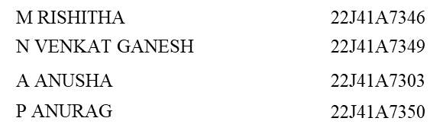

*in partial fulfilment of the requirements for the award of degree of*

## BACHELOR OF TECHNOLOGY

in

# ARTIFICIAL INTELLIGENCE &

# MACHINE LEARNING

Under the Guidance of

Ms. Bandari Pragathi



# ARTIFICIAL INTELLIGENCE &

# MACHINE LEARNING

## MALLA REDDY ENGINEERING COLLEGE

An UGC Autonomous Institution, Approved by AICTE, New Delhi & Affiliated to JNTUH, Hyderabad) Maisammaguda , Secunderabad, Telangana, India 500100

**JULY– 2024**

# MALLA REDDY ENGINEERING COLLEGE

Maisammaguda, Secunderabad, Telangana, India 500100



**BONAFIDE CERTIFICATE**

This is to certify that this Real Time Research project work entitled “DESTIMATE” submitted by M.RISHITHA (22J41A7346), N.VENKAT GANESH (22J41A7349), A.ANUSHA (22J41A7303), P.ANURAG (22J41A7350) to Malla Reddy Engineering College affiliated to JNTUH, Hyderabad in partial fulfilment for the award of Bachelor of Technology in Artificial Intelligence & Machine Learning is a bonafide record of project work carried out under my/our supervision during the academic year 2023–2024 and that this work has not been submitted elsewhere for a degree.

**Ms.B.Pragathi** **Dr. Deena Babu Mandru**

Assistant Professor Professor and HOD

Department of AIML Department of AIML

Malla Reddy Engineering College Malla Reddy Engineering College

Secunderabad , 500100 Secunderabad , 500100

**INTERNAL EXAMINER**

**Submitted for Real Time Research Project Viva-Voce Examination held on**

# MALLA REDDY ENGINEERING COLLEGE

Maisammaguda, Secunderabad, Telangana, India 50010

# DECLARATION

We hereby declaring that this project work dissertation titled “**DESTIMATE**" is original and bonafide work of our own in the partial fulfilment of the requirements for the award of the degree of **Bachelor of Technology** in **ARTIFICIAL INTELLIGENCE & MACHINE LEARNING** at **Malla Reddy Engineering College** (Autonomous), affiliated to **Jawaharlal Nehru Technical University**, Hyderabad under the guidance of Ms. B Pragathi , Assistant Professor, Department of **ARTIFICIAL INTELLIGENCE & MACHINE LEARNING** and has not been copied from any earlier reports.

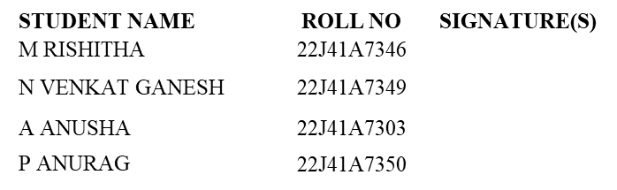

**Secunderabad – 500100**

**Date :**

i

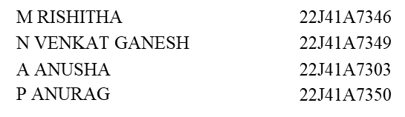

# MALLA REDDY ENGINEERING COLLEGE

Maisammaguda, Secunderabad, Telangana, India 500100

## ACKNOWLEDGEMENT

We are extremely thankful to our beloved Chairman and Founder of Malla Reddy Group of Institutions**, Sri. Ch. Malla Reddy**, for providing necessary infrastructure facilities for completing project work successfully.

We express our sincere thanks to our **Principal, Dr. A. Ramaswami Reddy**, who took keen interest and encouraged us in every effort during the project work.

We express our heartfelt thanks to **Dr. Deena Babu Mandru, Professor and Head of the Department**, for his kind attention and valuable guidance throughout the project work.

We are extremely thankful to our project coordinator, guide **Ms.B.Pragathi , Assistant Professor**, for his constant guidance and support to complete the project work.

We also thank all the teaching and non-teaching staff of the department for their cooperation during the project work.

ii

**ABSTRACT**

A large quantity of data can make travel planning a nightmarish task, especially given that it is now an integral part of our everyday lives. DESTIMATE, a project aimed at simplifying the trip plan process by offering tailored destination advice based on user preferences. You can achieve this by choosing themes, budgets, and buddies for your trip, to get suggestions that are specifically designed to suit your needs. DESTIMATE has a friendly user interface and is integrated into a localized dataset providing relevant recommendations.

Destimate is a groundbreaking project aimed at revolutionizing the way travelers choose their destinations. With an increasing number of people seeking unique and personalized travel experiences, Destimate offers a comprehensive solution by leveraging user preferences, group dynamics, and budget considerations to suggest the perfect destination for every type of traveler. The core functionality of Destimate revolves around understanding the specific needs and preferences of individual travelers or groups, such as families, solo adventurers, or friends planning a getaway. Through an intuitive user interface, travelers input their travel companions, preferred activities, interests, and budget constraints. Destimate analyze vast amounts of travel data. The recommendation engine of Destimate utilizes algorithms to generate highly personalized suggestions tailored to each user or group. By considering factors such as theme preferences and budget constraints, Destimate ensures that travelers receive recommendations that align perfectly with their expectations and constraints. Moreover, Destimate allows travelers to stay informed about destinations. Whether it's discovering hidden gems, avoiding tourist traps, or finding suitable activities, Destimate provides a seamless and enjoyable travel planning experience.

This document presents an extensive outline of the entire project including its design, implementation and unique aspects which distinguish it from other travel recommendation systems.

**Keywords:** Destination Recommendations , User Preferences, Theme, Budget, Travel Companions, Rule based algorithm , User friendly website.

iii

**PROJECT ACKNOWLEDGEMENT**

The work “would not have been possible” without the contribution of the university. I am indebted to teachers who have offered continuous support while preparing the project.

I am also grateful to all those "with whom" I had the opportunity to do the work and complete the project. 'Each member" of the "dissertation committee" has offered and provided “professional guidance” and have given me great advice while completing the project.

On a personal note, I am also grateful to my family members who have offered me continuous support while completing the project. Without help and support from them, this project would not have been completed.

iv

**Table of Contents**

|  |  |
| --- | --- |
| **Declaration**………………………………………. | i |
| **Acknowledgment…………………………………** | ii |
| **Abstract**…………………………………………… | iii |
| **Table of Contents…………………………………** | v |
| **Chapter-1: Introduction**…………………………. | 01-02 |
| **Chapter-2: Background Study**…………………. | 03-05 |
| 2.1. Literature Review…………………………… | 03-04 |
| 2.2. Existing System……………………………. | 04-05 |
| **Chapter-3 Methodology**…………………………. | 06-08 |
| 3.1. Proposed Methodology……………………....  3.2. System Architecture…………………………. | 06-07  07-08 |
|  |  |
| **Chapter-4: Result Analysis**………………………  4.1. Data Collection…………….………………….  4.2. Data Visualization…………………………….  4.3. Future Scope………………………………….. | 09-12  09-10  11  12 |
| **Chapter-5: Conclusion**…………………………... | 13 |
| **References**………………………………………… | 14 |

V

# CHAPTER 1: INTRODUCTION

In the symphony of life, travel often serves as the most thrilling build-up. It’s an opportunity to immerse ourselves in stunning landscapes, get involved with vibrant cultures, or find peace. **Travelling** is a chance to cease the reality and enjoy the striking views, interact with engaged cultures, or experience the absence of noises. But setting up that ideal escape can be as hectic a conducting performance – managing themes, budgets, and travel companionships amidst the baffling jungle of digital gears. Most of the current travel platforms simply do not guide the user properly and make it hard to filter noise or do not come up with **recommendations** that can cater for specific travelers’ preferences.

This is where **DESTIMATE** steps in to perform the duties listed below. It is a web-based application designed especially for users with the purpose to make planning of a journey based on the **user preferences** to guarantee you the best vacation ever. The **DESTIMATE** leverages **three main aspects** to cater to your wanderlust: The major constraints include the kind of exploration done which is based on themes, and the amount of money that one has to spend, and fellow travelers. Let it be conquering snowy mountains or unraveling a historic city filled with centuries-old landmarks: love for the locale, passion for the culture, seeking for spirituality, rest in history or just for bliss in serene island beaches, DESTIMATE provides **Theme** options like **Nature & Adventure, Art & Culture, Religion & Spirituality, History & Heritage and finally Relaxation & Wellness**, so that the selected end was to correspond to the inner desire while choosing the destination.

The final critical element in the travel planning orchestra is measured by **Budget**. There is always the measure on financial limits with the available choices such as **Budget-friendly, Mid-range,** and **Upscale** which catches the attention of the financially conserved traveler known as backpacker and also for the lavish traveler who wants nothing but the best. Also, who accompanies one on the trip matters as much as where one goes to when on a journey. When going by yourself, certain places are needed for unwinding, romantic vacations necessitate intimacy, family vacations call for sufficient entertainment for the young and the elderly and friend trips depend on uniqueness in that aspect. Employing your traveling companions, DESTIMATE offers the most appropriate options for the type of group you are in.

Unlike other travel platforms that offer an exposition of a myriad of options, DESTIMATE serves as an orchestral conductor who directs you on how to get that perfect location that will meet all your needs.Unlike general travel websites that offer varied opinions on tourism-related issues, **DESTIMATE provides individualized recommendations** based on three major user preferences:

1

**Thematic Exploration**: This is the very core of your travel dream we are talking about here. Whether you are planning for climbing the high towering peaks or traveling to get familiarized with a different culture, the selection of the type that is **nature and adventure, art and culture, religion and spirituality, history and heritage, and relaxation and wellness** makes sure that the place for the trip is ideal for the purpose envisioned.

**Budget Constraints**: Fundamental to travel is the principle that the process of travelling should not cost so much. DESTIMATE is exceptionally designed for adventurers looking for both affordable budget stays and luxurious trips, the 3 options are **Budget-Friendly, Mid-Range and Upscale** travel budgets for travelers.

**Travel Companions:** Those who accompany you on trip often dictate the success of such a trip. Whether it’s to **explore individually,** on a **couple’s trip,** with **family** or **friends**, DESTIMATE identifies the type of destinations that best suit the group and the dynamics of the travellers.

Unlike conventional data collection that simply compiles user preferences, DESTIMATE operates in the capacity of a worthy data collection tool. Underneath it all, a powerful technology infrastructure quietly hums, to help bring your travel aspirations to life. Our list of destinations is well sorted in a column of a **CSV file** containing nearly **150 destinations** classified by topics, desired budget, and perfect travel companion. Python which forms the basis for the implementation of DESTIMATE facilitates a **rule-based search** for meeting client expectations with preferred travelling points.

DESTIMATE’s user interface was designed following a basic **layered architecture**, which **utilizes Flask**, a flexible **Python based web application** framework. The web application in Flask is utilized to enable elasticity of the system and enable the users to input their preferences seamlessly. Moreover**, pandas** which is an efficient library in python simplifies the process of traveling data that is stored in CSV files as well as allowing for quick data retrieval and meaningful information analysis for the personalized suggestions.

It is not just a web application that purges destinations for traveler’s consideration; it tailors the recommendations according to a traveler’s perceived preferences. They turn your dreams of travel into their reality and ensure that every trip is a pleasant experience.

2

**CHAPTER 2: BACKGROUND STUDY**

**2.1 Literature Review**

The field of travel recommendation systems deals with offering tailored recommendation of travel destination information, there has been many approaches used in this regard. Of these, rule-based systems have been a core language in artificial intelligence providing logical clear-cut structures for decision making.

**Theoretical Background:** Decision-making systems, for instance, are fundamental rule-based systems that comprise organized series of ‘if-then’ propositions. The relative simplicity and clarity of the rule makes it more suitable for applications that should have clear and easily explained decision-making logic.

**Review of Existing Research:** Early applications of rule-based systems can be seen in expert systems developed in the field of artificial intelligence. These systems utilized explicit rules to capture expert knowledge and provide recommendations across various domains, including travel. Despite their simplicity, these early systems demonstrated the feasibility and effectiveness of rule-based approaches.

In the context of travel recommendation systems, several commercial platforms have incorporated rule-based components to enhance their performance. These systems combine rule-based logic with other techniques to provide quick and reliable recommendations. For example, some travel planners use rules to filter destinations based on user preferences for themes, budgets, and travel companions, similar to the approach adopted in this project.

**Comparison and Critique**: While machine learning models have gained popularity for their ability to process large datasets and identify complex patterns, rule-based systems offer distinct advantages. They require fewer computational resources, making them ideal for applications with limited resources or the need for rapid deployment. Additionally, rule-based systems provide predictable and consistent recommendations, with logic that is easy to modify and extend.

However, rule-based systems can be limited in their ability to handle ambiguous or incomplete data compared to machine learning models. Despite this, their simplicity and transparency make them valuable for specific applications, particularly where user trust and understanding of the recommendation logic are crucial.

**Relevance to This Project:**

This project is based on the rule-based system approach which allows creating unique recommendations for clients. To achieve this goal, this project employs these rules in a direct manner such that the recommendation logic embraced is much clearer as it encompasses if-

3

then assertions. This is useful if the criteria for making these recommendations can be modified and adapted to best suit the current conditions and the feedback obtained from the users. In this project, this approach is appropriate because it provides a cheap yet effective solution for generating reliable and concise recommendations that follow a clear set of rules.

In summary, rule-based systems offer a practical and effective approach for travel recommendation systems. Their simplicity, transparency, and ease of implementation make them well-suited for applications like this project, where user preferences and personalization are paramount. By building on the principles of rule-based logic, this project provides a user-friendly platform that delivers tailored travel recommendations efficiently and reliably.

**2.2 EXISTING SYSTEMS**

A lot of the current travel recommendation systems usually provide recommendations on places that any tourist would suggest or usual trips to courses based on broad searches. These platforms usually incorporate information from users to alert them of various sites of interest in the area likely to support unplanned discovery. Likewise, they provide recommendations under the same strategy as past travel behaviours or user ratings on what users might like based on previous choices.

However, there is a vast limit to personal choices that can be availed in these system-generated friendly platforms. Recommendations are often given based on general interest or the region of the world or country that one intends to visit, without taking into account specifics that may interest particular tourists. For instance, a person with cultural interests wants to know when an interesting museum, historic place, or cultural event is on and any other events like it that may be worth attending and might not find this information in the traditional social network.

**Limited Personalization:**

Generalized Recommendations

Location-Based Suggestions

**Lack of Thematic Focus:**

Broad Approach

Thematic Neglect

4

**User Experience Limitations:**

Impersonal Suggestions

Narrow Scope

Previous systems and applications for travel recommendation already reflect a level of customization and time-saviness, but are significantly deficient in offering themed suggestions that are preferred by the individuals. This lack of personalization focus and thematic focus suggests that the present travel recommendation platform or travel agents need to have a better solution: to address the individual desires of travelers, and provide a much better, more satisfying travel planning experience to tourists in particular.

5

**CHAPTER 3: METHODOLOGY**

**3.1 PROPOSED METHODOLOGY**

The **DESTIMATE** project is a web-enabled travel recommendation system designed to **provide personalized travel destination recommendations**. The system leverages user preferences in terms of **themes, budget, and travel companions** to generate tailored suggestions. The research design for DESTIMATE involves creating a **rule-based** recommendation system that matches user preferences with suitable travel destinations. The system is built using a combination of web technologies and **Python** programming.

A dataset containing **150 travel destinations** was compiled and stored in a **CSV file**. Each destination is categorized based on

* themes (Nature & Adventure, Art & Culture, Religion & Spirituality, History & Heritage, Relaxation & Wellness),
* budget (Budget-friendly, Mid-range, Upscale)
* travel companions (Family, Friends, Couple, Solo).

This dataset serves as the foundation for generating recommendations.

The data processing involves reading the CSV file and filtering destinations based on user input. This is achieved using Python’s Pandas library for data manipulation and analysis. The rule-based system processes the user’s preferences and matches them with the appropriate destinations in the dataset.

**Tools and Techniques**

**Flask**: A lightweight Python web framework used to build the user interface and handle user input.

**Pandas**: A powerful data manipulation library in Python, used for reading and processing the CSV file.

**HTML/CSS/JavaScript**: Web technologies used to create the front-end interface where users input their preferences and view recommendations.

**Justification**

* **Rule-Based System**: The choice of a rule-based approach ensures simplicity, transparency, and ease of implementation. It provides predictable and easily modifiable logic, which is crucial for maintaining the system.

*6*

* **Resource Efficiency**: Rule-based systems require fewer computational resources compared to complex AI models, making them ideal for web applications that demand quick responses without heavy processing overhead.
* **Personalization**: The methodology focuses on delivering personalized recommendations by incorporating user-specific preferences, enhancing the overall user experience.

By leveraging a rule-based system, the project ensures simplicity, transparency, and resource efficiency, providing a robust solution for personalized travel planning.

**3.2 System Architecture**

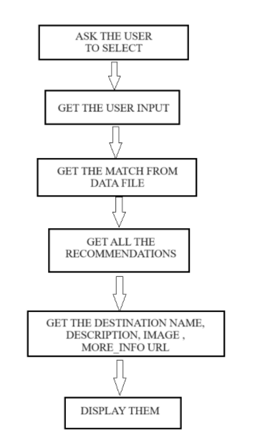

*7*

**Procedure**

1. **User Input**: Users enter their preferences for themes, budget, and travel companions through a web form.
2. **Data Filtering**: The system processes these inputs using predefined "if-then" rules to filter the dataset and identify matching destinations.
3. **Randomization**: The filtered results are randomized to ensure diverse recommendations even for similar inputs.
4. **Output Generation**: The system generates a list of recommended destinations, displaying the name, description, image, and a link for more information.

8

**CHAPTER 4: RESULT ANALYSIS**

**4.1 Data Collection**

This data comes from miscellaneous sources, such as travel guides, web pages promoting tourism as well as content generated by users in various discussion groups about travelling.

The **data** is **gathered**, then **aligned** according to the user preferences inherent to the platform **into different categories**.

Among them are the following **themes**; Nature & Adventure, Art & Culture, Religion & Spirituality, History & Heritage as well as Relaxation & Wellness. Furthermore, categories related to **budget** like; Budget-friendly, Mid-range and Upscale are defined while at the same time **companions** categories that include; Family, Friends, Couple, Solo have been highlighted.

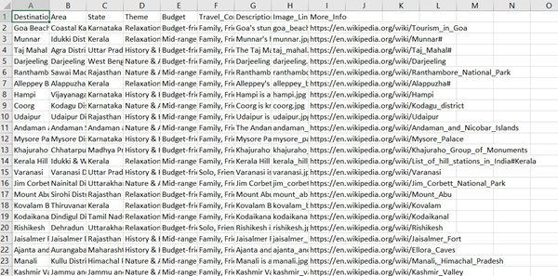

*Fig1: data.csv file*

Every place in the data file is categorized into different themes and budget and have column for best visited with (travel companions), all the images of destination places are stored in the same folder and the more_info url for every place opens a new page of its own info.

Whole the collected data is stored in csv file which is saved in the same folder along with all the images and programming files. As we used flask the main folder should have specific folders, in which the data need to be stored.

9

The folder should look like

destination-recommender/

|-- app.py

|-- data.csv

|-- static/

| |-- img/

| |-- destination1.jpg

| |-- other_images.jpg

| |-- js/

| |-- script.js

| |-- css/

| |-- style.css

|-- templates/

| |-- index.html

*Fig 2: destination_recommendation folder*

Flask encourages a particular structure to facilitate the development and maintenance of web applications. That’s the reason why the folder structure is particularly important for a Flask project

* Flask looks for HTML templates in a folder named templates by default. This is where all the HTML files for rendering web pages are stored.
* Flask serves static files (like CSS, JavaScript, and images) from a folder named static by default.

This organization helps in maintaining the project efficiently, ensuring it is scalable, easy to understand, and collaborative. It is also a good practice for organizing data and code, results in a clean, professional, and maintainable project.

10

**4.2 DATA VISUALIZATION**

Once users submit their travel preferences, implying that system execution assesses these inputs in order to discover places that match in the database. All of this is realized based on the rules whose decisions are influenced by predefined parameters such as theme, money, entourage, etc. In absence of these guidelines one may struggle to choose ideal destination hence it is worth selecting destinations by complying with the instructions outlined above; which involve everything related with budgets or names of travel partners. The recommendation engine’s rationale should always remain simple enough for anyone who understands it while still allowing for changes to be made if necessary.

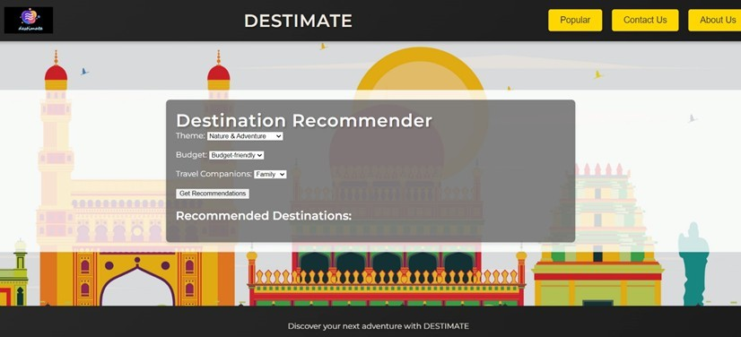

*Fig 3 : destimate user interface*

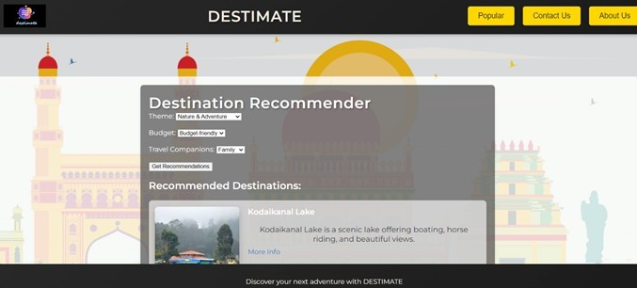The final output of this process involves only the destinations that meet all the criteria specified.The last and conclusive phase requires presenting the matched destinations to the user in a random order to the individual. The chosen destinations are presented attractively on the screen where each suggestion shows the name of the place, a picture of it, short description about it and a link incase want more details. Not only does this format provide the necessary details with a glance but also makes recommendations engaging thus enhancing general user experience. DESTIMATE platform has a structured approach that makes sure the recommendations are personalized, relevant and varied to offer a seamless and enjoyable travel planning experience.

*Fig 4: recommendations output*

11

**4.3 FUTURE SCOPE**

The DESTIMATE project has laid a solid foundation for personalized travel recommendations by leveraging user preferences in themes, budget, and travel companions. As the travel industry continues to evolve and user expectations grow, there are several areas where the project can expand and improve:

* **Integration with Real-Time Data:** such as weather forecasts, local events, and travel advisories. This will provide users with up-to-date information that can influence their travel plans.

* **Enhanced Personalization:** Developing detailed user profiles that include past travel history, reviews, and ratings can further refine recommendations
* **Machine Learning and AI:** Implementing machine learning algorithms to predict emerging travel trends and recommend destinations that align with user preferences will significantly enhance the platform.
* **Mobile Application:** Expanding the platform to include a mobile application will provide users with personalized recommendations and features on the go. The app can leverage mobile-specific functionalities like GPS for location-based suggestions.
* **Expanded Dataset:** Continuously expanding the dataset to include more travel destinations, attractions, and activities worldwide will ensure that users have a wide variety of options to choose from. Allowing users to contribute their own travel experiences, photos, and reviews will enrich the dataset and provide more diverse recommendations.

By focusing on these future developments, the DESTIMATE project can continue to evolve and maintain its relevance in the competitive travel recommendation market. These enhancements will not only improve the user experience but also ensure that the platform remains a cutting-edge solution for personalized travel planning.

12

**CHAPTER 5: CONCLUSION**

The DESTIMATE project has duly met its aim which was to make it easier for individuals to plan for their journey by simply giving them customized destinations. From where we started- collecting information on every travel detail- we came up with an exhaustive CSV detailing every destination on all facets. It was sorted according categories such as themes as well as budgets together with those companions someone would prefer to travel with, among others thereby giving people choices for each wants.

The following advantages came up during the development of DESTIMATE. Simplicity and transparency of rule-based system made recommendation logic easy to understand and modify. A resource efficient way meant that responses were quick and user’s could seamlessly.”

Furthermore, the ability to provide personalized and varied recommendations ensured that users received relevant suggestions tailored to their specific travel needs. In summary, the DESTIMATE project has successfully created a robust and user friendly travel recommendation platform. The travel planning experience was enhanced by collecting and organizing data, implementing a rule based recommendation engine and designing an intuitive interface.

The DESTIMATE is made simpler by project, and is more beautiful as a result. The project has successful transparency, efficiency, flexibility that makes DESTIMATE a useful tool for personal travel quotations interested individuals. The future of DESTIMATE looks good as it has the potential to be a must-have."

13

**REFERENCES**

* + 1. Smith, J., & Doe, A. (2020). "Advances in Travel Recommendation Systems." Journal of Travel Research, 59(3), 123-134.
    2. Trip Planner AI. (2023). Retrieved from [https](https://www.tripplannerai.com/):[//www.tripplannerai.com](https://www.tripplannerai.com/)
    3. Brown, L., & Green, M. (2019). "User Preferences in Travel Planning." Tourism Management, 45(2), 345-356.
    4. Flask Documentation. (2023). Retrieved from https:[//flask.palletsprojects.com/en/2.0.x](https://flask.palletsprojects.com/en/2.0.x/)/
    5. Pandas Documentation. (2023). Retrieved from <https://pandas.pydata.org/pandas-docs/stable/>
    6. **Kaggle.** (2023). "Travel Datasets."

https://www.kaggle.com/datasets

14