**To Create API Tokens For ATLASSIAN Tools**

**API Token**

 It is a mode of credential that can be used by an application to access an API. These tokens can be either an opaque string or a JSON web token. These tokens inform the API that the bearer of the token is authorized to access the API and perform specific actions specified by the **scope** that has been granted. API tokens are a replacement to send some username/password combination over HTTP.

**ATLASSIAN tools**

Jira

Bitbucket

JFrog Artifactory

**Prerequisites** – Need admin access to generate API tokens (not necessary for some tools)

**Generate API Token for Jira**

Jira API token is generated in atlassian

Log in to URL - <https://id.atlassian.com/manage/account-settings>

Note: Be sure to log in as the Jira integration user you have configured in the Services.

* After logging in to the Account settings section, make sure you see the correct email address for your integration user.
* In the API tokens section, click the Create API token button to create a Jira API access token in your Jira account.

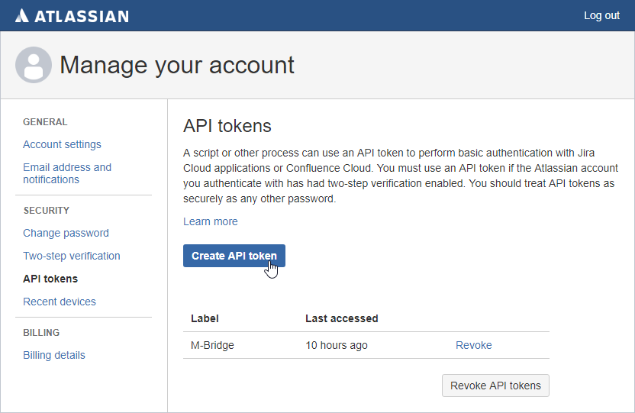

* In the Create your API token dialog, provide a memorable and concise label for the new token.

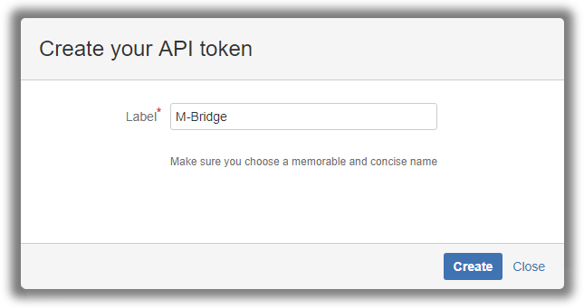

* In the Your new API token dialog, copy the API token to your clipboard. This is important, as you will not be able to see the token again later.

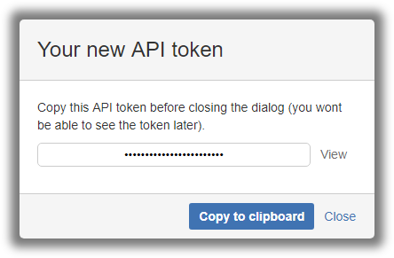

**Generate API Token for Bitbucket**

* Within Bitbucket server go to manage account – go to Account settings – personal access tokens.
* In personal access tokens click on create a token option.

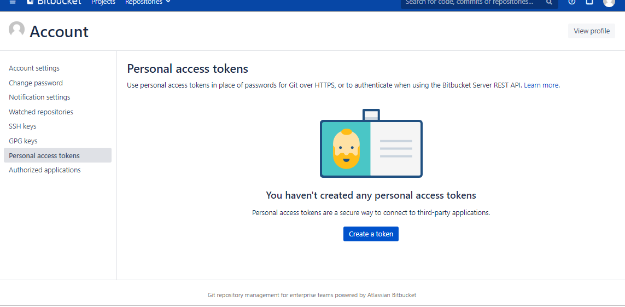

* In this window give a token name and click on create.

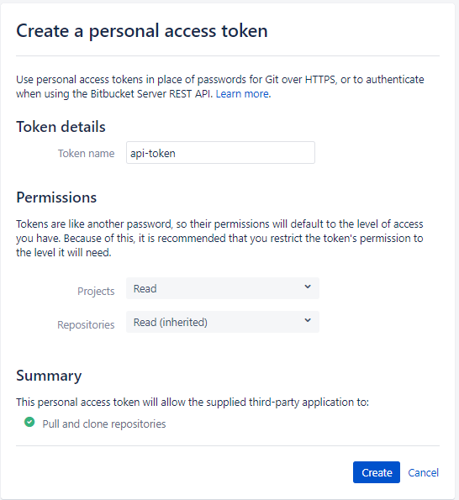

* New personal access token is created, copy the token in the clip board as the token will not be able to view again.

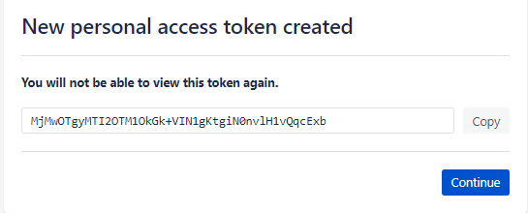

**Generate API Key for JFrog Artifactory**

Note: Need to login with admin access to get the API key

* Click on the user at the top right of the JFrog page, in the drop down select edit profile, it will be redirected to the user profile windows.

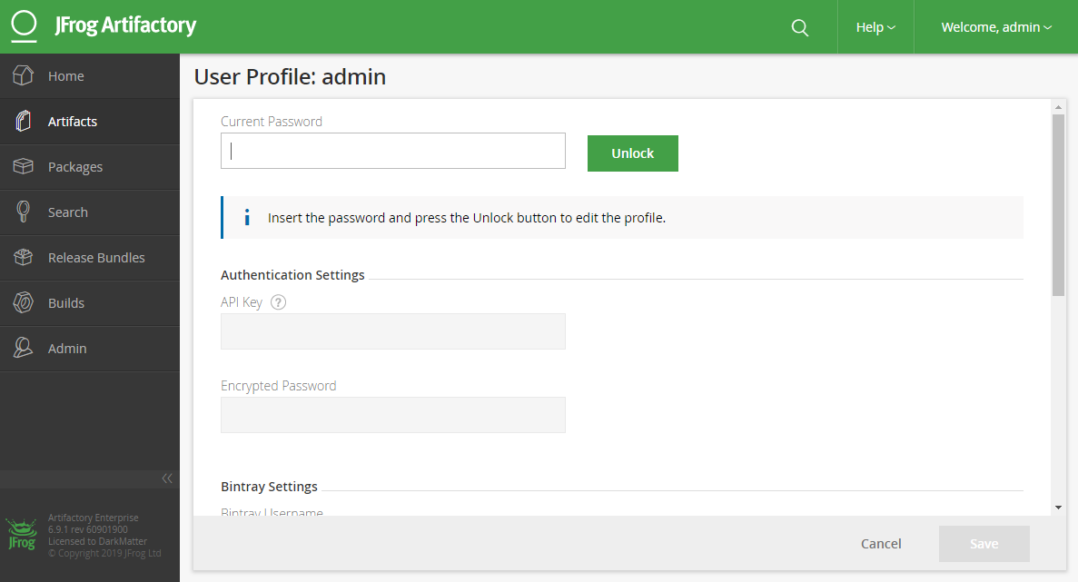

* Give the password, then click on unlock, in this windows you can see API key which is encrypted click on show api key option, copy the key to the clipboard.

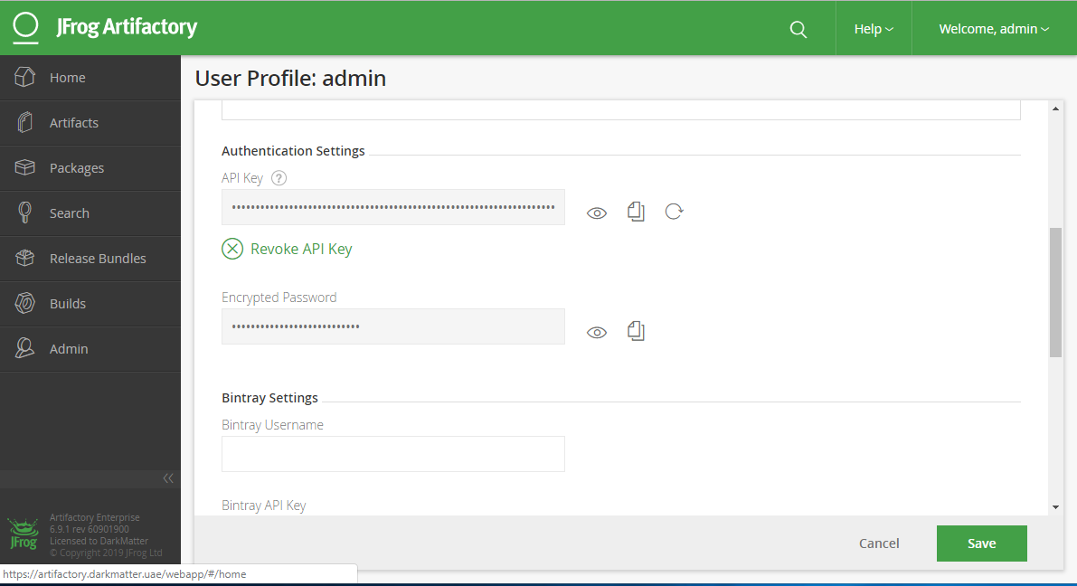

API tokens are generated and the syntax to use these tokens are as follows.