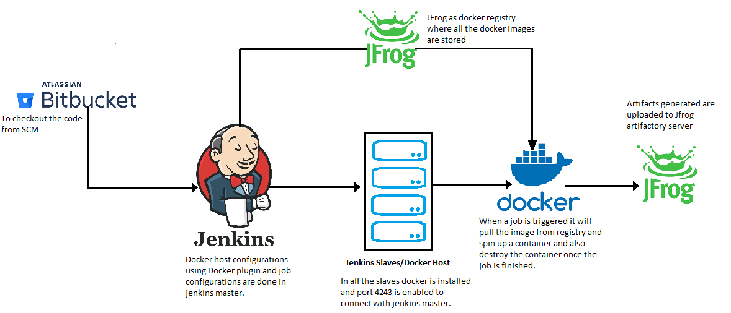
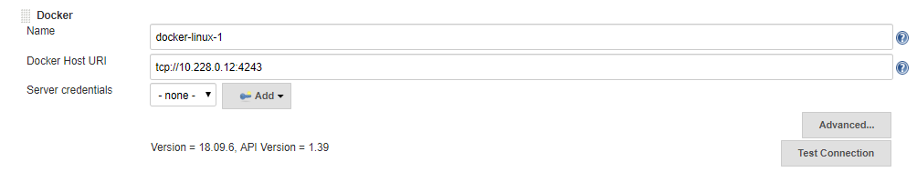
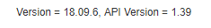
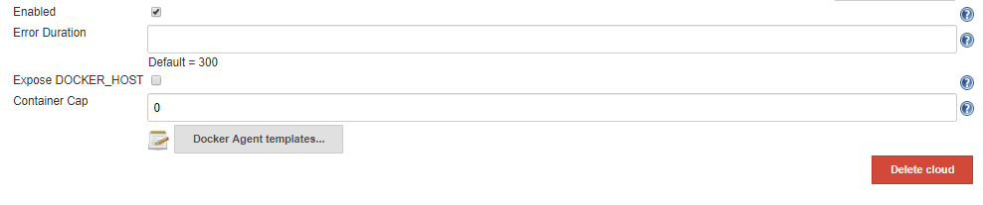
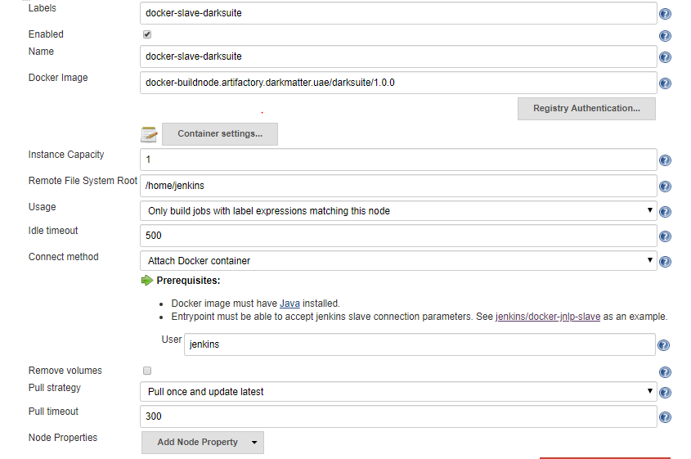
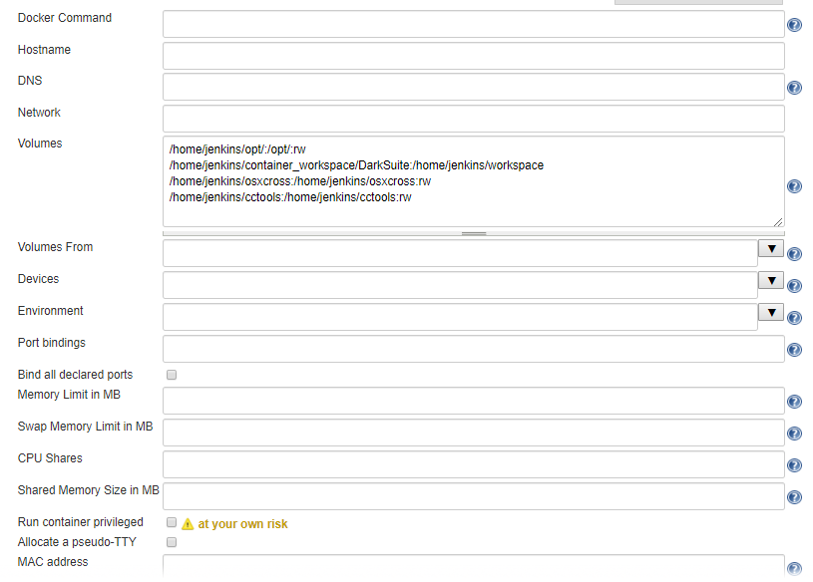
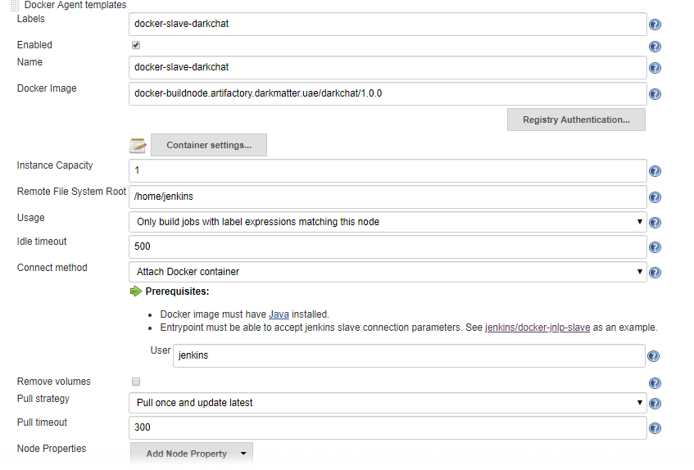
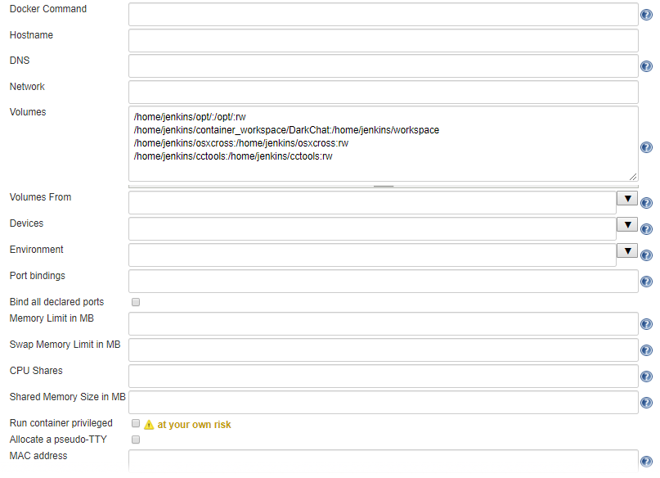
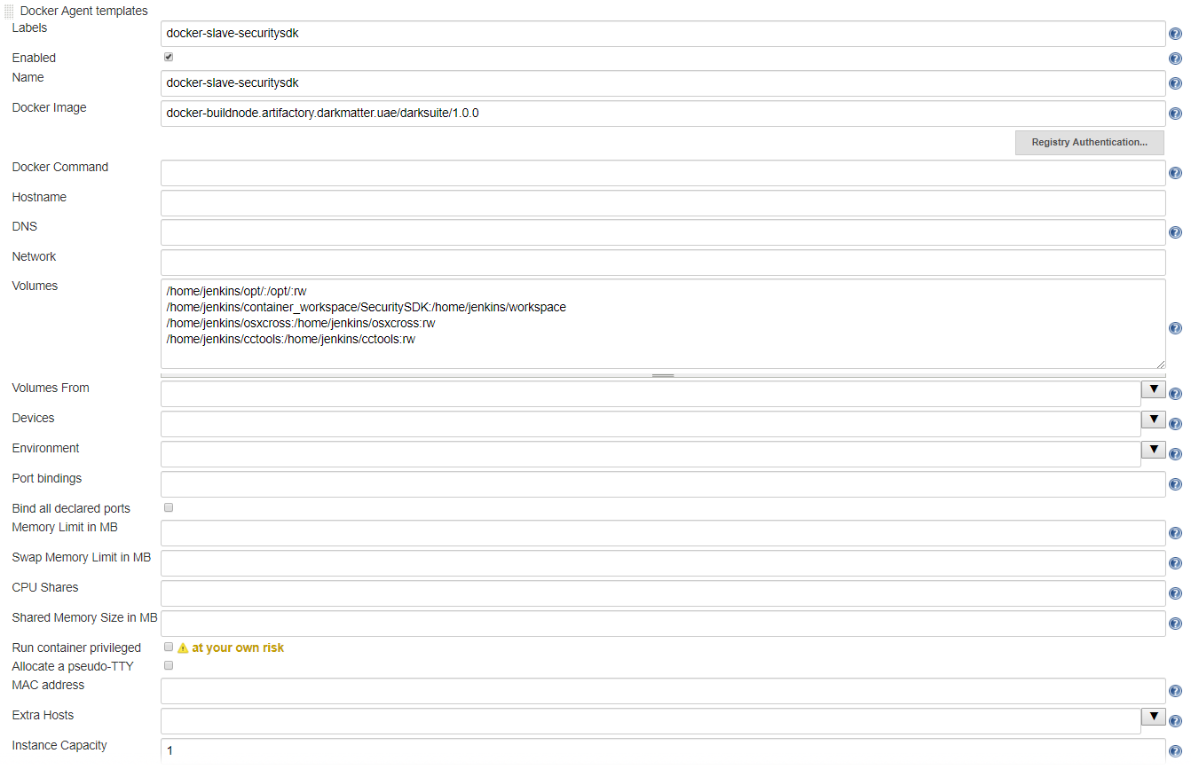
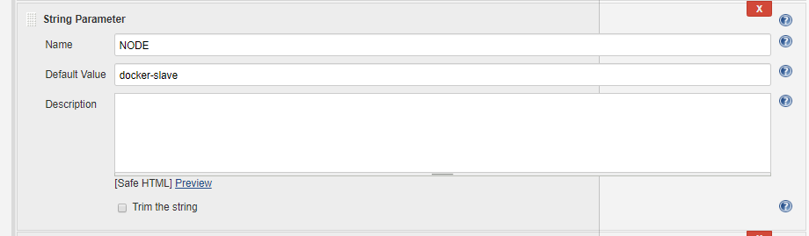
Docker as build slaves in Jenkins.
Architecture Diagram of Docker build slaves in Jenkins.
Components involved in above architecture.
* Bitbucket
* Jenkins master
* Jenkins slave/ Docker host
* Docker Container
* Docker Registry/Artifactorty (JFrog)
Architecture
To build a job in Docker as slaves using Docker plugin. As per our environment Bitbucket as a source code management, where the code is to be checkout. Docker Plugin which is installed in Jenkins Master and all the configurations are made as described below, and also the Docker slaves has the port 4243 enabled and the configurations need to be updated in docker.service file.
The pipeline job is configured for the build, as the per our requirement the Docker images are made and pushed to JFrog Artifactory which is our Docker registry, whenever the build is triggered it will pull the image from Registry and spin up a container, all the artifacts generated through the build are pushed to the JFrog artifactory server and terminates the container once the build is finished, as our workspace inside the container terminates, we have mounted the workspace with the host server with the directory “/home/jenkins/container_workspace” for troubleshooting of any build failures.

Configuring JFrog as Docker Registry
JFrog as Docker registry where all the Docker images as per our requirement as stored. To push the Docker images

Configure Docker Slave in Jenkins Master
In Jenkins master dashboard go to manage jenkins and configure systems at the end of the page add the cloud details as below.

Name - Provide a name for this Docker Cloud
URI - URI to the Docker Host you are using.
Once the settings are done and port 4243 is enables at the host end click on test connection. If the connection is successful it will show the below message if not it will throw an error.
Enabled - If not ticked then this functionality will be disable (Make sure to check the box mandatorily)
Click on the Docker Agent Templates for container settings and image details.
Add a new Docker Agent Template it is used to parameterize your image. Here is a list of the crucial parameters needed.
* Labels: How you will identify this image in your pipelines.
* Docker image: The name of the image related to this template.
* Registry Authentication: The credentials used to log in to your registry account.
* Remote Filing System Root: The home folder for the user we’ve created in the image, in this case, jenkins.
* Connect Method: Select “Connect with SSH” which our images were built to be accessed with.
* User: Name of the user used to connect, so, jenkins.

For DarkSuite jobs – configurations are as follows and Dockerfile can be found in
URl - https://bitbucket.darkmatter.uae/projects/DEV/repos/pipeline/browse/DarkSuite?at=refs%2Fheads%2FDocker_images
Name of the image - docker-buildnode.artifactory.darkmatter.uae/darksuite/1.0.0

Click on the container settings as per our requirement Volumes to be mounted are
* Volumes : As per jobs volumes mount from the server are
/home/jenkins/opt/:/opt/:rw
/home/jenkins/container_workspace:/home/jenkins/workspace
/home/jenkins/osxcross:/home/jenkins/osxcross:rw
/home/jenkins/cctools:/home/jenkins/cctools:rw

Click on apply and save after all the changes are made.
To build the job in Docker slave in job configuration select the node as per our requirement.

