**Case Study #1: User Management using React-Redux**

**Three Modules:**

* + - **Register & Login Admin User**
    - **Add Customers**
    - **Search and Update User**

1. **Register & Login Module for Admin**

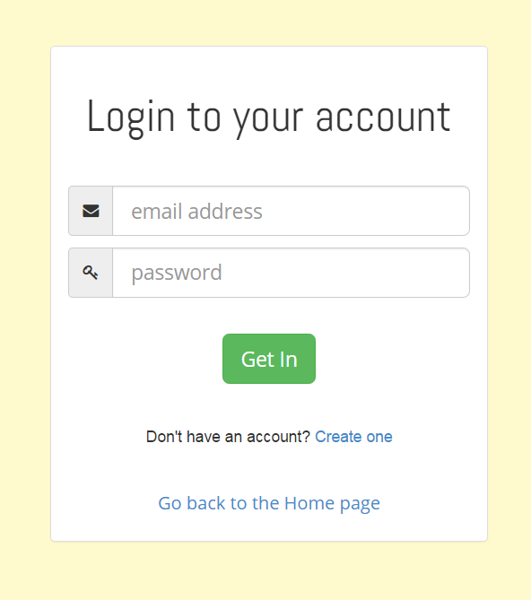

**2. Add Customers**

Logged in Admin can add customers.

**Add Customer**

**First Name:**

**Last Name**

**State:**

**City:**

**Email:**



**Evaluation Criteria:**

* For State and City dropdown, Use Custom Tag lib
* Props validation

**3. Search and Update User:**

This module facilitate user like search and update user data.

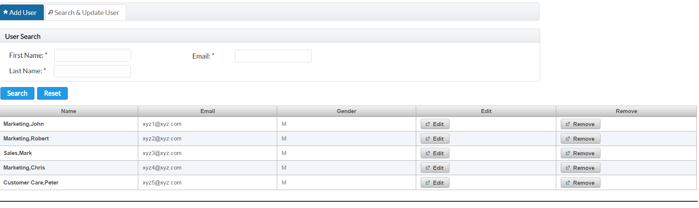

1. a: On click of Remove button, User should be removed

1. b: On click of Edit button, Dialog window should open and allow client to update the user data.

