Student Name : Venkat Subramanian

Group : A34

Date : 07/02/2023

**LAB 1: UNDERSTANDING NETWORKING WITH INTERNET TECHNOLOGIES**

**Exercise 1A: communication architectures**

Classify the following installed communication modules into their appropriate layers in the TCP/IP architecture(ie protocol stack in figure 1.1):

Internet Protocol (IP) : Network

Network controller card

(eg. Realtek PCIe GBE Family Controller) : Physical Layer

**Exercise 1B: ADDRESSING**

Classify the use of the following addresses into their appropriate layers in the TCP/IP architecture(protocol stack in figure figure 1.1):

Port number : Transport

IP address : Network

MAC address : Data Link

**Exercise 1C: PHYSICAL/MAC/ETHERNET ADDRESSES**

Determine the MAC address of your laboratory PC:

MAC Address : A4-BB-6D-5F-9A-ED

Manufacturer : DELL Inc

**Exercise 1D: IP ADDRESSES**

NTU IP address range(**NOT** your PC IP address): 155.69.0.0 – 155.69.255.255

Determine the special uses of the following IP addresses:

{ 127, <any> } : Loopback address

{ 172.21, <any> } : Private Address Space

**Exercise 1E: DYNAMIC HOST CONFIGURATION PROTOCOL (DHCP)**

Determine the following for your laboratory PC:

DHCP Enabled : Yes

DHCP Server : 155.69.3.8

Network/Subnet Mask : 255.255.248.0

What is your IP address(from Ipconfig) : 172.21.151.130

What is the reported IP address from website (try https://whatismyipaddress.com/ ):

155.69.179.9

Who is the owner of the IP address reported by the website?

NTU

**Exercise 1F: PORT NUMBERS**

Determine the well-known ports for the following services:

TELNET : 23

Simple Mail Transfer Protocol (SMTP) : 25

Quote of the Day Protocol : 17

Domain Name Service (DNS) : 53

Hyper-Text Transfer Protocol (HTTP) : 80

**Exercise 1G: DOMAIN NAMES**

How do you register/buy a domain name under .sg, e.g. myweb.per.sg?

One can register their domain name ( ‘.sg’, ’.com.sg’, ’.org.sg’) with any of the registars accredited by SGNIC for example Adicio Pte Ltd, CSC Corportate Domain Inc

**Exercise 1H: DOMAIN NAMES/IP ADDRESSES TRANSLATION**

**- DOMAIN NAME SYSTEM (DNS)**

Determine the followings:

Local DNS servers for your laboratory PC: 155.69.3.8, 155.69.3.9

Authoritative DNS servers for ntu.edu.sg :

DNSTEX.NTU.EDU.SG(155.69.254.5)  
DNSTEX1.NTU.EDU.SG (155.69.254.230)

IP address of domain name www.ntu.edu.sg : 155.69.3.8, 155.69.7.173

What is the command to show the entries in the DNS cache? ipconfig/displaydns

What is the command to clear the entries in the DNS cache? ipconfig /flushdns

**Exercise 1J: PROPRIETARY MICROSOFT WINS**

Determine the followings for your laboratory PC:

NetBIOS/Host name : hwl1-vb28

Primary WINS server : 155.69.5.154

Secondary WINS server : 155.69.5.54

**Exercise 1K: DEFAULT GATeWAY**

IP address of default gateway : 172.21.151.254

**Exercise 1L: IP ADDRESS/PHYSICAL ADDRESS TRANSLATION**

**- ADDRESS RESOLUTION PROTOCOL (ARP)**

Physical MAC address of default gateway : 00-08-e3-ff-fc-a0

**Exercise 1M: NETWORK REACHABILITY - *PING* COMMAND**

***ping*** your neighbour's PC and run ***arp*** command again. Do you see your neighbour's PC listed? Why?

Physical address of neighbour's PC : A4-BB-6D-5F-C2-D9

The ping was successful in connecting to the neighbor's PC, resulting in a mapping being created in the ARP cache for quicker ARP lookups in the near future. This is possible as both PCs are on the same private network.

**Exercise 1N: TRACE ROUTE - *TRACERT* COMMAND**

How many routers are separating your laboratory PC and the local DNS servers?

There are 2 Routers inbetween the local PC to the local DNS server

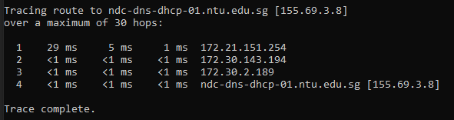

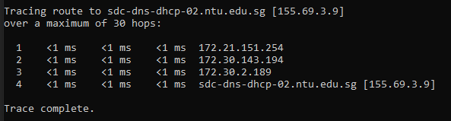

Run ***arp*** command again. Can you find the MAC address of the DNS servers? Why?

No. ARP maps IP addresses to MAC addresses of devices within a local network, but the mapping in the ARP cache is not established since the PC is on a private network. Instead, the PC must first go through a default gateway before it can establish a connection.