1.GAN Architecture

What Is the Adversarial Process in GAN Training?
At the heart of a GAN (Generative Adversarial Network) is a game between two neural networks:
- Generator (G) – the "artist"
- Discriminator (D) – the "art critic"
They are in constant competition:
- The Generator tries to create fake images that look real.
- The Discriminator tries to spot the fakes and distinguish them from real images.
This competition drives both networks to improve over time.

🧠 Goals of Each Component
Component | Goal (What It Wants)
Generator | Fool the discriminator by generating realistic images
Discriminator | Correctly identify which images are real and which are fake

🔁 How They Improve Through Competition
- At first, the generator makes very bad (obviously fake) images.
- The discriminator easily spots the fakes and gives low scores.
- The generator learns from this feedback and improves its image generation.
- As the generator gets better, the discriminator has a harder time spotting fakes, so it also improves.
- This back-and-forth continues until (ideally) the generator produces images so good the discriminator can't tell they're fake.
🎮 It's like a video game where both players keep leveling up to beat each other.

📊 Diagram: GAN Architecture and Data Flow
Let's visualize this:

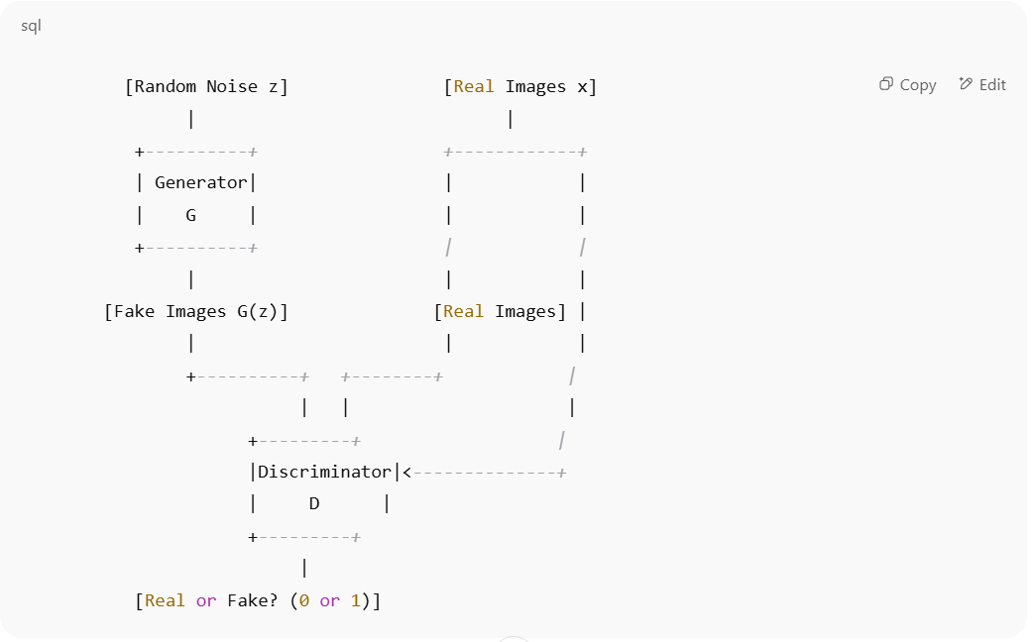
[Real or Fake? (0 or 1)]
🔄 Training Objectives
- Generator wants: D(G(z)) → 1 (fool D into thinking fake is real)
- Discriminator wants:
  - D(x) → 1 (real images look real)
  - D(G(z)) → 0 (fake images look fake)

🏁 Summary
- The Generator learns to create images from noise that look real.
- The Discriminator learns to tell real from fake.
- They compete in a zero-sum game where one improves by outsmarting the other.
- Over time, this adversarial training leads to realistic image generation.

Ethics and AI Harm

Representational Harm (Human-Friendly Explanation)
Let’s say you’re using an AI image generator to create pictures of different professions—like “doctor,” “teacher,” or “CEO.” You type in:
- “CEO” → The AI mostly shows white men in suits.
- “Nurse” → Mostly women, often with a stereotypical look.
- “Criminal” → Often shows people of color.
This is called representational harm—when an AI system repeats and reinforces stereotypes. It doesn’t directly hurt someone’s chances (like hiring), but it shapes how people are seen.
Over time, this kind of bias can affect how we think:
- Kids might not see people like them in roles they dream of.
- It can normalize unfair ideas, like certain people “belong” in some jobs and not in others.

🛠 How Can We Reduce This Harm?
1. Fix the Training Data
Many AI models learn from large image collections scraped from the internet—which already contains tons of bias.
We can:
- Clean and balance the data to make sure it shows a diverse mix of people.
- For example, if you’re training on images of “doctors,” include women, people of color, and people with disabilities—not just old stock photos of white men in lab coats.
2. Add Diversity Controls at Generation Time
Even after training, we can build in options that give users control.
- Let users ask for diverse results: “Show me a female CEO,” or “a Black software engineer.”
- Or better yet, make the model automatically mix things up instead of showing the same type of person every time.

🧠 In a Nutshell
- Representational harm is when AI reinforces stereotypes—not by denying people opportunities, but by distorting how they’re shown.
- It matters because people internalize what they see—especially kids and in media.
- We can help fix it by training on more inclusive data and giving users tools to generate diverse, fairer results.
Let me know if you'd like to turn this into a quick slide or short essay version!

Absolutely! Here's a more natural, conversational version of the response:

⚖️ Legal & Ethical Concerns of AI-Generated Content
Generative AI is super impressive—it can write essays, create art, even mimic famous writing styles. But with that power come some big ethical and legal concerns. Let’s talk about two of the biggest ones:

🔐 1. When AI “Remembers” Private Info
Some early AI models (like GPT-2) were caught doing something pretty creepy: they could sometimes spit out things like people’s names, phone numbers, or private messages that were buried somewhere in the training data.
Even though it wasn't intentional, this is a serious issue.
It’s kind of like:
You told a secret in a crowded room, and now the room won’t shut up about it.
🧠 Why it’s a problem:
- The people whose info was memorized never gave permission.
- That info could be used for identity theft, doxxing, or worse.
- It breaks the basic rule of AI: don't do harm.

📚 2. Copying Copyrighted Work
Another big issue is when AI generates content that looks a lot like existing creative work—say, a paragraph that sounds exactly like a line from Harry Potter.
That raises questions like:
- Is this still “AI creativity,” or is it just copying?
- Who owns the result—the AI company, the user, or the original creator (like J.K. Rowling)?
🧠 Why it matters:
- Artists and authors deserve credit—and compensation—for their work.
- If AI can just remix and reprint their work, that’s unfair and possibly illegal.

💭 Should We Restrict What Data AI Trains On?
Yes—within reason.
Not everything on the internet should be fair game for AI training. Here’s why:
✅ 1. People Deserve Privacy
AI shouldn’t be trained on private things like emails, medical records, or leaked data.
That’s just basic respect. If you didn’t agree to share it, it shouldn’t be used—end of story.
✅ 2. Artists Deserve Protection
If a musician, author, or artist creates something original, they should be able to control how it’s used.
AI should learn styles, sure—but it shouldn’t memorize and repeat someone else’s work word-for-word.

🧠 Final Thought
Generative AI is exciting, but we can’t ignore the risks.
To keep it safe, fair, and respectful:
- We need clear rules about what AI can learn from.
- Companies should be upfront about their training data.
- And AI should be built with respect for people’s privacy and creativity.
So yes—giving AI models some boundaries on what they can learn from isn’t limiting. It’s just being responsible.

Let me know if you want this turned into a slide, summary, or something shorter for a discussion!

🧪 Bias & Fairness Metric: False Negative Rate Parity
Let’s say you're building a model to decide who gets into a job training program. The goal is to pick people who are likely to succeed. Sounds fair, right?
But what if the model keeps missing qualified candidates from certain groups—like women, or people from minority backgrounds?
That’s where False Negative Rate Parity comes in.

🧭 What Does It Actually Measure?
This metric looks at how often the model says “no” to people who should’ve gotten a “yes.”
In other words, how often it misses people who are actually qualified.
If the model misses more people from one group than another, that’s a problem. This metric checks whether the rate of those misses (false negatives) is fair across all groups.

💡 Why Does It Matter?
Let’s say the model wrongly denies:
- 1 in 10 qualified candidates from Group A
- but 3 in 10 from Group B
That means people in Group B are getting left out more often—even if they’re just as qualified.
🧠 Real-world impact:
- Someone doesn’t get a job opportunity
- A student isn’t offered a scholarship
- A patient is denied care
These mistakes aren’t just technical—they can change someone’s life.

⚠️ How Can a Model Fail This?
Imagine the training data mostly includes success stories from men in urban areas. Now you try to use that model to evaluate women from rural communities.
Because the model hasn’t seen many examples like them, it may wrongly assume:
“They probably won’t succeed.”
Even if they’re totally qualified.
And so it fails the false negative rate parity—because it’s making more mistakes for one group than others.

✅ In a Nutshell
Question | Answer
What is it? | A fairness check: “Are we missing people unfairly across groups?”
Why it matters | Because being overlooked (a false negative) can deny someone a life-changing opportunity
What can go wrong? | If a model sees fewer examples from a group, it may judge them unfairly

Want help running this in Aequitas or seeing a real dataset example? Happy to walk you through it!

