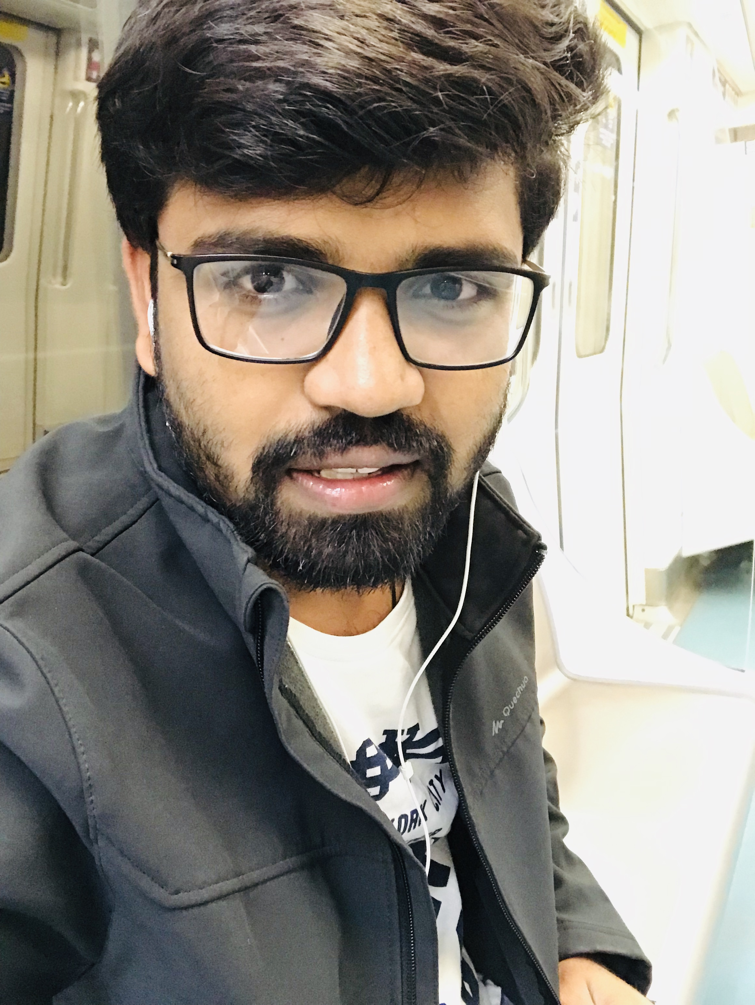

Venkata koti reddy chinnapareddy

I chose Computer Science Engineering as my major during my undergraduate degree, as it gave me countless options for Software Engineering specialization.During the four years of my under-graduation, I was introduced to subjects like operating systems such as UNIX, Linux, Programming languages like C, C++, Java, HTML, Python, Scripting languages like JavaScript, DBMS and SQL server. The subjects I was most enthusiastic about were C, Java and JavaScript because these subjects enabled me to think as a programmer.

I have worked on an expense manager project, particularly on the

front-end with React technology. This project has helped me gain experience in React technology and also I have worked on a DELOS project, where I shoulder the responsibility of converting XML files into a single document in PDF format using XSL-formatting objects as well as working on some of the rest of the APIs, such as uploading a file, unzipping a file and XML parser.

In this course, i will be learning full stack development with a concentration on Vue.

Before joining my masters, I did a full stack developer internship. During my internship, I've learned a lot like react, node js spring boot, api's, and much more, this course seems like expanding my internship so that I can learn more technologies like Vue.