Ref:

Jquery

<https://andersdjohnson.com/magnificent.js/examples/demo/> product detail carousel related

<http://www.bestjquery.com/?UkwZ1JOo> product detail carousel related

<https://www.jqueryscript.net/demo/Product-Carousel-Magnifying-Effect-exzoom/> product detail carousel related(http://ivanovdmitry.com/blog/post/product-carousel-with-magnifying-glass-effect-jquery-exzoom)

------------------------------------------------------------------------------------------------------------------------------------------

<https://1stwebdesigner.com/free-web-design-resources/>

<http://css3transition.com/>

<http://sbtechnosoft.com/eduworld/> ref for underline hover css rotate 180deg

<http://html.berserk.nikadevs.com/demo_freelance_portfolio.html> ref for timeline or history range slider

<https://creativegigs.net/html/gullu/> different **font** makeover whole site and different shape images

<http://html.themedemo.co/awa/index.html> fonts

<http://html.themedemo.co/awa/creative-agency.html> fonts and images

<http://t.commonsupport.com/rexal/> fonts and heading style

<http://thememascot.net/demo/personal/j/learnpro/v4.0/demo/index-mp-layout3.html> many shortcodes , elements

<http://themeht.com/loptus/html/intro.html> v multi pupose ref

<http://codelayers.net/templates/consep/index3.html> v multi-pupose ref]

<http://templates.seekviral.com/newdana/index7.html>, <http://themazine.com/html/mogh/> image shape ref

<http://qbix.c-kav.com/demos/index-corporate-01.html> multi-pupose ref

<https://www.templatemonster.com/demo/57796.html> ref

<http://quadra.goldeyestheme.com/elements-carousels.html> carousel

<http://melankolia.space/tf/creativora/> ref for div and sections good template

<https://www.bootdey.com/bootstrap-snippets> for all code same as freefont end

<http://makeoverkit.appspot.com/confettiKit> on click button particles on screen glow

<http://atixscripts.info/demo/html/majestic/> hover icons effect

<https://bootsnipp.com/snippets/featured/responsive-invoice-template> responsive invoice template

color: #fafaaf yellow color trendy

color: #f3f9fe gray-light blue trendy

**timthumb link**:- <?= base_url('timthumb.php?src=') ?><?php echo base_url();?>aasets/img/next.jpg&w=300&h=300

**1. Jquery focus input field – trioptus ref**

<a onclick="$('#frmRegisterName').focus()" class="btn " href="javascript:void(0)">APPLY FOR THIS JOB</a>



**Images free**

<https://www.everypixel.com/>

[https://isorepublic.com/](https://www.google.com/url?q=https://isorepublic.com/&sa=D&source=hangouts&ust=1549089422737000&usg=AFQjCNH5juD1F2YA_R21ALrdjGeNqRHPdg)

<https://allthefreestock.com/>

<https://picjumbo.com/>

textures

<https://www.toptal.com/designers/subtlepatterns/>

<https://www.transparenttextures.com/>

<https://www.texturepalace.com/>

<https://www.textureking.com/>

colors

<http://bootflat.github.io/color-picker.html>

#f94673 **pik red** , #fecdd2 –**baby pink,**

#1f8ded – **blue**, #bdecea –**lite blue**, #0ebdca – **aqua**,

#9571f9 –**bringal,**

#fff582 –**yellow,** #c6b069- **dark yellow**

Fonts

1.'Gotham-Medium', Oswald, 2."Kaushan Script", cursive, 3. dancing script

Cooper Black™

carousels

<http://visuallightbox.com/content/30-best-image-sliders-173.html>

<https://www.jqueryscript.net/demo/Slideshow-Carousel-slideWiz/>

<https://www.jqueryscript.net/demo/Circular-Carousel-circleCarousel/> circular motion big circles rounded icons tabs like slider vvimp

go farms g clip path

-webkit-clip-path: polygon(91% 21%, 100% 1%, 1% 1%, 0 100%, 100% 100%, 100% 41%, 90% 41%, 42% 41%, 43% 61%, 43% 61%, 81% 61%, 81% 81%, 21% 80%, 21% 21%);clip-path: polygon(91% 21%, 100% 1%, 1% 1%, 0 100%, 100% 100%, 100% 41%, 90% 41%, 42% 41%, 43% 61%, 43% 61%, 81% 61%, 81% 81%, 21% 80%, 21% 21%);

Stastics

<http://bankhar.mn/Baako/index-apps.html> refer a friend

**irregular shape background for icons**



.single-service-area .service-icon {}



.testimonials_image_overlay {position: absolute; top: 0; left: 0; width: 100%; height: 100%;background-color: transparent; background-image: linear-gradient(to right, transparent 50%, #f1f6fc); background: transparent; background: linear-gradient(to right, transparent 50%, #f1f6fc);}

**Vertical text**

.service-title { font-size: 50px; color: #e7e8eb;position: relative; transform: rotate(180deg); -webkit-transform: rotate(180deg);-webkit-writing-mode: vertical-lr;writing-mode: vertical-lr;}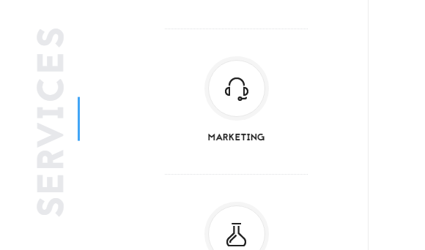

1. <http://themezinho.net/financer/>



1. <http://themescare.com/demos/jobguru/>



1. <https://www.freepik.com/free-vector/black-watercolor-brushes-with-text-template_1194984.htm>

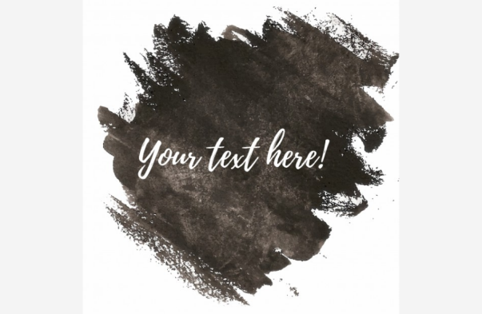

1. <https://preview.oklerthemes.com/ezy/1.1.0/multi-purpose-3.html>

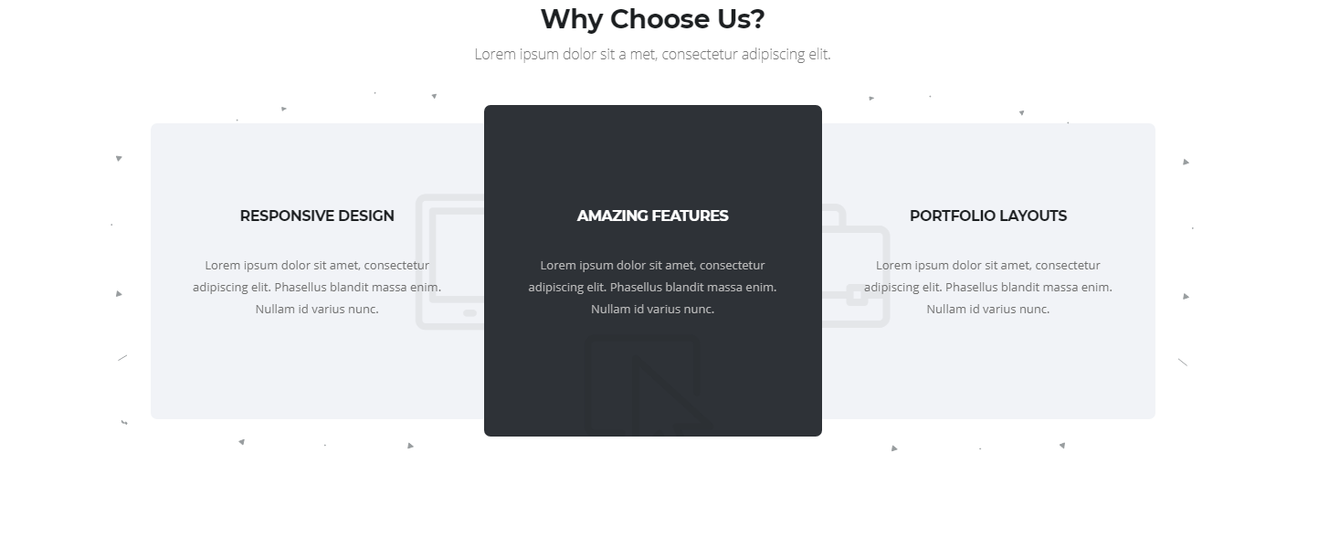

1. <http://www.themesindustry.com/html/xeone/element-counter.html> 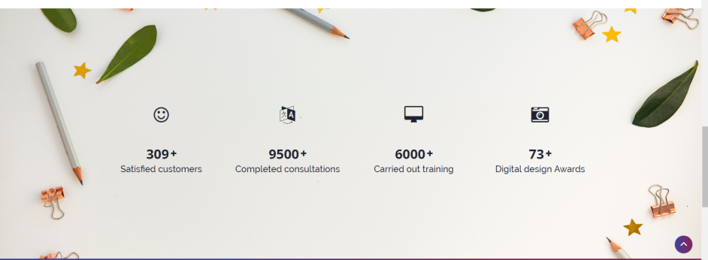
2. Mission - <https://www.freepik.com/free-vector/leadership-background-flat-style_3198037.htm>

