LOAN APPROVAL PREDICTION
A Machine Learning Approach to Automated Credit Risk Assessment

Project Documentation
Dataset: loan_approval_dataset.csv | 4,269 Applicant Records | 13 Features
Best Performing Model: Random Forest (Tuned) — 98.0% Test Accuracy
Prepared August 2026

1. Business Understanding

Problem Statement
A bank wants to predict whether a loan application should be approved based on the applicant's personal and financial information. Automating this decision reduces manual effort and speeds up the loan approval process.

Business Objectives
- Reduce manual verification effort in loan processing.
- Minimize the risk of approving high-risk applicants.
- Improve the overall customer experience through faster decisions.

Machine Learning Problem Framing
Attribute | Description
Type | Supervised Learning
Category | Binary Classification
Target Variable | loan_status (Approved / Rejected)

2. Dataset Understanding
The dataset contains 4,269 loan applications across 13 attributes covering applicant demographics, income, requested loan terms, credit history, and asset holdings.
Feature | Description
no_of_dependents | Number of dependents the applicant has
education | Graduate / Not Graduate
self_employed | Whether the applicant is self-employed
income_annum | Annual income of the applicant
loan_amount | Loan amount requested
loan_term_years | Loan repayment term, in years
cibil_score | Applicant's credit (CIBIL) score
residential / commercial / luxury assets | Value of applicant's asset holdings
bank_asset_value | Value of the applicant's bank assets
loan_status (Target) | Approved or Rejected

3. Data Preparation

Data Quality Assessment
- Dataset shape: 4,269 rows × 13 columns; duplicate records: 0; missing values: 0 across all columns.
- Column names were stripped of whitespace, and loan_term / bank_assets_value were renamed to loan_term_years / bank_balance for clarity.
The dataset was clean and required no imputation or duplicate removal — a strong foundation for reliable model training.

Feature Engineering
- Label Encoding — education, self_employed, and loan_status were converted from text to numeric codes.
- Feature Scaling — StandardScaler applied to income, loan amount, CIBIL score, and asset-value columns so distance-based models (KNN, SVM) are not biased by feature magnitude.
- Train / Test Split — 80% training, 20% held-out testing (random_state = 42) for unbiased evaluation.

4. Exploratory Data Analysis
Univariate, bivariate, and multivariate analysis were used to understand feature distributions and their relationship with loan approval outcomes.

Feature Distributions
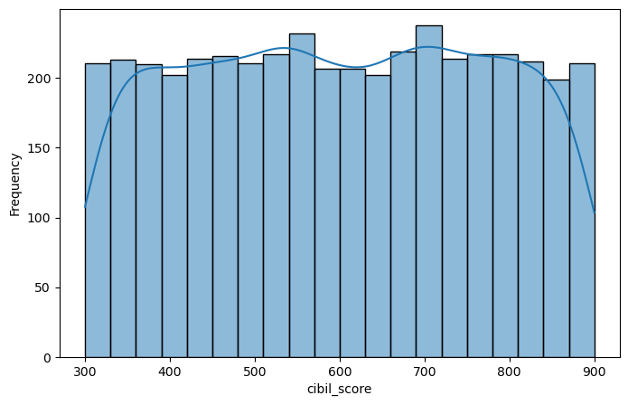  CIBIL score distribution | 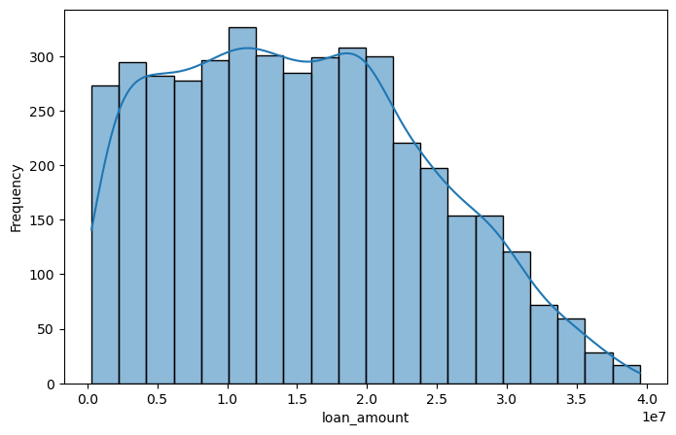  Loan amount distribution
Most applicants cluster above a 700 CIBIL score, with a secondary group between 500-600. Requested loan amounts are concentrated between ₹1-2 crore, with very few applicants requesting more than ₹2.5 crore.

CIBIL Score vs. Loan Status
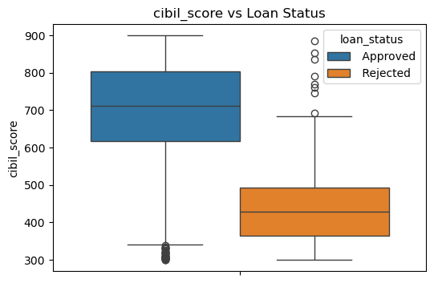
Approved applications consistently show a higher median CIBIL score than rejected ones.

Correlation Heatmap
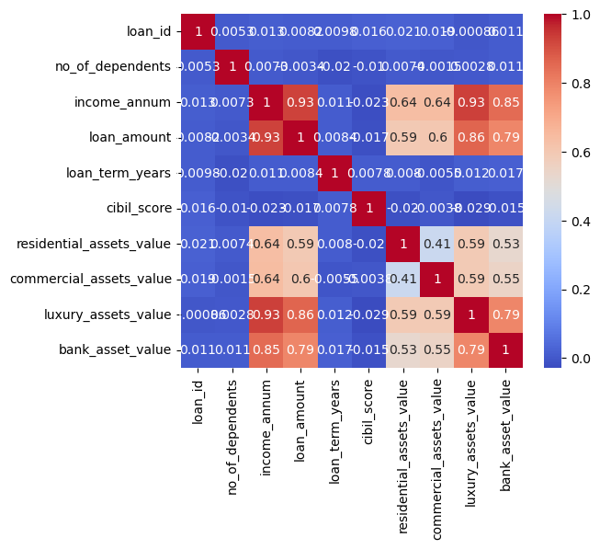
Income, loan amount, and asset values are strongly positively correlated with one another.

Key Insights from Exploratory Analysis
- Applicants with a higher CIBIL score are markedly more likely to have their loan approved; CIBIL is the single strongest driver of approval.
- Education and self-employment status show minimal impact on approval outcomes.
- Loan amount scales strongly with annual income and asset values, but average income is similar between approved and rejected groups.
- no_of_dependents, education, and self_employed contribute little independent signal and are largely redundant for prediction.

5. Model Building & Evaluation
Seven classification algorithms were trained on the prepared dataset and evaluated on the held-out 20% test set using accuracy as the primary metric.
Model | Test Accuracy
XGBoost | 97.89%
Random Forest | 97.78%
Decision Tree | 97.42%
AdaBoost | 96.49%
Logistic Regression | 90.05%
Support Vector Machine (SVM) | 62.76%
K-Nearest Neighbors (KNN) | 57.38%
Tree-based ensemble methods (XGBoost, Random Forest, Decision Tree, AdaBoost) substantially outperform distance- and margin-based models, which struggle with the scale and feature mix of this dataset.

6. Hyperparameter Tuning
Random Forest was tuned using both Grid Search and Randomized Search cross-validation (cv = 5) to identify the optimal configuration and further improve generalization.
Method | Best Parameters | Test Accuracy
GridSearchCV | n_estimators=50, max_depth=15, min_samples_split=2 | 97.42%
RandomizedSearchCV | n_estimators=150, max_depth=15, min_samples_split=5, min_samples_leaf=1 | 98.01%
RandomizedSearchCV produced the best-performing model overall, reaching 98.01% test accuracy — the final selected configuration.

7. Feature Importance
Feature importance rankings from both Random Forest and XGBoost confirm that credit history dominates the approval decision.
Feature | Random Forest | XGBoost
cibil_score | 79.96% | 66.21%
loan_term_years | 6.43% | 22.02%
loan_amount | 2.58% | 2.50%
income_annum | 1.65% | 2.80%
Asset values (combined) | ~4.9% | ~2.5%
no_of_dependents / education / self_employed | < 1% each | < 1% each

8. Final Insights & Recommendations
- Give the highest priority to applicants' CIBIL score — it is by far the strongest predictor of loan approval across all models.
- Ensure the requested loan amount is proportionate to the applicant's income to reduce default risk.
- Factor in loan term, as longer terms materially affect approval likelihood per the XGBoost importance ranking.
- Use asset values (residential, commercial, luxury, and bank assets) as secondary indicators of repayment capacity.
- Education and self-employment status can be deprioritized in scoring, as they show negligible predictive value.

Conclusion
The tuned Random Forest model (98.0% test accuracy) is recommended for deployment as a first-pass automated screening tool, with CIBIL score, loan term, and loan-to-income ratio as the primary decision drivers. The model and its preprocessing pipeline were serialized (Loan_model.pkl) for integration into the bank's loan origination workflow.

