Enhancing Endpoint Security Through AI Powered Anomaly Detection in Endpoint Logs Using Local Outlier Factor(LOF)

Akbar Badhusha Mohideen
Department of computer Science and Engineering
Kalasalingam Academy of Research and Education
Virudhunagar,Tamil Nadu, India
akbar_sha@yahoo.com
S. Sohel
Department of computer Science and Engineering
Kalasalingam Academy of Research and Education
Virudhunagar,Tamil Nadu, India
shaiksohel4868@gmail.com
P. Krishna Sai
Department of computer Science and Engineering
Kalasalingam Academy of Research and Education
Virudhunagar,Tamil Nadu, India
ponugantikrishna@gmail.com
Y. Venkateswara Reddy
Department of computer Science and Engineering
Kalasalingam Academy of Research and Education
Virudhunagar,Tamil Nadu, India
venkyyeduru7gmail.com
Y. Subhan Basha
Department of computer Science and Engineering
Kalasalingam Academy of Research and Education
Virudhunagar,Tamil Nadu, India
yerrasubhan005@gmail.com

Abstract— In today’s digital era cybersecurity landscape, endpoint security remains a critical concern due to the increasing sophistication of cyber threats. This study explores anomaly detection using AI-powered techniques to enhance endpoint security by identifying malicious login attempts. The publicly available BETH dataset, which includes authentication logs and security event data, was utilized to conduct a comprehensive analysis of user behavior and potential threats. Three machine learning classifiers that is One-Class SVM, Isolation Forest, and Local Outlier Factor (LOF) were employed for anomaly detection. Among these, LOF, a density-based algorithm, demonstrated the highest accuracy (95%), outperforming Isolation Forest (90%) and One-Class SVM (68.84%).Additionally, outlier detection techniques, such as box plots, were applied to visualize and analyze data anomalies. The results indicate that density-based anomaly detection methods outperform traditional approaches in identifying security threats. This research proposed the efficiency of AI-based anomaly detection in cybersecurity and underscores the potential of machine learning for real-time Anomaly detection.
Keywords—Anomaly Detection, Machine Learning, Ensemble learning, One-Class SVM, Isolation Forest, Local Outlier Factor (LOF ).
SUSTAINBLE DEVELOPMENT GOALS—SDG 4(QUALITY EDUCATION), SDG 3(HEALTH CARE ACCESS), SDG 13(CLIMATE ACTION), SDG 10(REDUCING INEQUITIES).

Introduction
In the rapidly evolving cybersecurity threats have become increasingly sophisticated, targeting endpoints as critical access points to sensitive information. Endpoint security is a crucial aspect for any organizations that handles sensitive data as protects from individual devices like computers, mobile devices, and servers, often serve as gateways for cyberattacks. Among the most pressing challenges in endpoint security is the detection of abnormal activities in event logs, which indicate potential security breaches, unauthorized access, or malicious attacks. Abnormal detection in endpoint logs involves identifying deviations from normal user behaviour, which may suggest cyber threats such as unauthorized login, insider attacks, privilege escalation, or credential stuffing. Traditional security mechanisms, such as rule-based intrusion detection systems (IDS) and signature-based methods, struggle to keep up with novel attack patterns and zero-day exploits. These traditional approaches rely on predefined signatures and rules, making them ineffective in identifying unknown threats or subtle anomalies in log data.
A central aspect shared among existing log anomaly detection methodologies is log parsing, a technique that translates each log message into its specific static event template with associated variable parameters. This is followed by the construction of log sequences and the transformation of these sequences into vector representations, which are subsequently fed into downstream anomaly detection models. Previous studies predominantly utilized static embedding techniques, such as word2vec and FastText for constructing vector representations [1]. For example, an abnormal login pattern(such as multiple login attempts from different geographic locations within a short timeframe) can indicate potential credential misuse or account compromise. Traditional security systems, which rely heavily on predefined rules or known threat signatures, often fail to detect such anomalies, especially when the attack pattern is new or evolving, such as in the case of a zero-day login anomaly. These systems lack the adaptability to recognize subtle, behavior-based deviations, underscoring the need for AI-driven anomaly detection that can learn and adapt to new threats in real time.
Machine learning (ML)-based approaches have emerged as powerful alternatives for cybersecurity, enabling anomaly detection through pattern recognition and data-driven insights. Unlike conventional security tools, ML models can learn from historical data, detect irregularities, and adapt to evolving threat. Machine learning techniques, particularly ensemble methods, have emerged as powerful solutions for analysing large-scale log data to identify unusual patterns and activities. An ensemble approach combines the strengths of multiple models, offering improved accuracy, robustness, and adaptability. By leveraging different learning algorithms, it can effectively capture both simple and complex data patterns, ensuring comprehensive detection. Anomaly detection techniques focus on identifying deviations from normal behaviour in endpoint security logs by analysing vast amounts of authentication data, system events, and user activity logs.
Machine learning (ML)-based approaches have revolutionized cybersecurity by enabling the detection of anomalous activities in endpoint logs. In contrast, ML-based anomaly detection methods can learn from historical data, recognize patterns, and classify deviations as potential threats. Anomaly detection models in cybersecurity primarily use unsupervised learning, which allows models to identify irregularities without prior labelled data. Unlike supervised learning, which depends on labelled attack samples, unsupervised methods analyse log data distributions and detect rare, abnormal behaviours. However, machine learning methods themselves face challenges, such as requiring large volumes of labelled data for training and the computational cost associated with maintaining complex models. Despite these hurdles, ensemble learning mitigates false positives by aggregating predictions and offers better resilience against noisy data. Their ability to adapt to evolving patterns in real-time makes them suitable for dynamic environments with diverse endpoint activities. Ultimately, the deployment of ensemble machine learning for anomaly detection provides organizations with a scalable and effective solution to safeguard their digital infrastructure, even in the face of inherent challenges and data complexities.
This study explores three key ML techniques for anomaly detection in endpoint security logs: One-Class SVM, a boundary-based approach that defines a hyperplane separating normal and abnormal data; Isolation Forest, a tree-based ensemble method that isolates anomalies through recursive partitioning; and Local Outlier Factor (LOF), a density-based technique that detects outliers by comparing local density deviations. The performance of these models is assessed using the BETH dataset, which includes authentication logs and security event logs, making it a valuable resource for identifying abnormal behaviours.
This paper is structured as follows. Section II reviews prior studies on common approaches in log anomaly detection, review of the existing techniques describing their strengths, major weaknesses, and relevance to the proposed work. In Section III ,the proposed methodology is introduced by describing the data collection, including preprocessing, data analysis use machine Learning techniques. Section IV focuses on the evaluation of the proposed methodology, comparison with existing techniques result and discussion. In Section V, conclude by summarizing the key findings and discussing the potential future research avenues.

Literature Review
Several existing log-based anomaly detection approaches rely on effective log parsing methods, to extract structured event templates from raw log data [1].
The researchers in [1] introduces SaRLog, a log anomaly detection method that leverages BERT for semantic understanding and contrastive learning to improve robustness. The research paper proposes a new approach for detecting anomalies in system logs by using a pre-trained language model and a Siamese network. The pre-trained language model is used to generate embeddings from the log messages, and the Siamese network is used to compare the embeddings of two log messages to see if they are similar or different. The authors evaluate their approach on two publicly available datasets, and show that it outperforms several state-of-the-art methods.
The study [2] evaluates the performance of machine learning-based malware detectors at real-world endpoints. The authors highlight a significant performance gap when detectors trained on sandbox data are applied to endpoint detection, achieving below 20% accuracy. They identify challenges such as label noise and behavior variability and propose methods that improve performance by 5-30%.
The authors [3] presents a three-stage deep learning framework integrating unsupervised (K-means clustering), semi-supervised (GANomaly), and supervised learning (Convolutional Neural Networks) algorithms for intrusion detection. The framework is evaluated on benchmark datasets, demonstrating its effectiveness in detecting network intrusions.
The research work [4] explores the use of federated learning for anomaly detection in network security. The authors propose an autoencoder with a classifier within a federated learning framework to identify malicious network activity. Their experiments demonstrate that federated learning enables global models to learn from client data, enhancing intrusion detection systems' defense against cyber-attacks.
Another recent research paper [5] investigates the application of Quantum Boltzmann Machines (QBMs) for unsupervised anomaly detection in fraud detection. The authors evaluate the performance of QBMs on a synthetic dataset inspired by Endpoint Detection and Response (EDR) scenarios, indicating that QBMs can outperform classical models like Restricted Boltzmann Machines in specific cases.
The research paper [6] proposes a novel approach, named OneLog, for detecting anomalies in software logs. This approach uses a single deep neural network, specifically a character-level convolutional neural network (CNN), to process log data and identify anomalies. This is a departure from traditional methods that typically use a multi-stage process involving preprocessors, parsers, vectorizers, and classifiers.
OneLog is evaluated on six datasets, demonstrating state-of-the-art performance. The model is shown to generalize well across different datasets and can effectively utilize multi-project datasets, which is particularly useful when training data is limited. The paper also explores the interpretability of the model, showing that it learns to parse log messages and detect anomalies in a manner similar to traditional methods.
This paper [7] discusses the application of AI based techniques in microgrids from a cybersecurity perspective, focusing on vulnerabilities and proposing explainable AI methods for detection and mitigation. Highlights the importance of explainable AI in enhancing trust in microgrid cybersecurity solutions. The specific implementation details and experimental results are not provided.
The study in [8] explores untrained neural networks (UNNs) for anomaly detection (AD), using random projections and Mahalanobis distance for anomaly scoring. Experiments on 14 datasets show that UNNs can perform competitively with established models without training, offering benefits in time, cost, and accessibility. However, training remains essential for higher performance beyond the untrained baseline The lack of training might limit UNNs' ability to achieve optimal performance compared to trained models and Results may not generalize across all types of datasets or applications.
This paper [9] introduces MTGFlow, an unsupervised anomaly detection method for multivariate time series that works without requiring a clean training dataset. It leverages dynamic graph learning to capture complex dependencies and entity-aware normalizing flow to model unique entity characteristics. With a clustering strategy for improved density estimation, MTGFlow achieves superior performance on six benchmark datasets. However, MTGFlow has some limitations, including high computational complexity from its dynamic graph learning and normalizing flow components, which may impact efficiency. Scalability could be an issue for very large or complex datasets, and the method requires careful parameter tuning for optimal performance. Additionally, its clustering strategy may need customization for datasets with highly diverse entity characteristics, limiting general applicability.
The research paper [10] proposes a new approach for detecting anomalies in system logs by using a pre-trained language model and a Siamese network. The pre-trained language model is used to generate embeddings from the log messages, and the Siamese network is used to compare the embeddings of two log messages to see if they are similar or different. The authors evaluate their approach on two publicly available datasets, and show that it outperforms several state-of-the-art methods and the research paper is a promising contribution to the field of anomaly detection in system logs. The approach is novel and has the potential to improve the accuracy of anomaly detection. However, the approach is complex and may be computationally expensive to train. More research is needed to evaluate the effectiveness of the approach on real-world datasets.
The paper [11] presents a hybrid anomaly detection model for Cyber–Physical Systems (CPS) that integrates signature-based, threshold-based, and machine learning (ML)-based behaviour detection. High False Positives, practically one class models, Lack of real-world anomalous data affects training accuracy. Using traditional methods like Signature-based systems require periodic updates, and ML models.
This work [12] uses a centralized approach using a Long Short-Term Memory (LSTM) model for log-event sequences, to detect anomalous patterns and discussing the challenges and proposing a federated learning approach to enhance detection capabilities. The proposed approach may face challenges in communication overhead and convergence in federated settings.
The performance comparison between the proposed methodology and existing approaches highlights the effectiveness of AI-based anomaly detection in endpoint security. Among the models tested using the BETH dataset, the Local Outlier Factor (LOF) achieved the highest accuracy (0.95), followed by Isolation Forest (0.90) and One-Class SVM (0.69), demonstrating that density-based models are more suited for identifying anomalies in log data. In contrast, prior works such as those employing Federated Learning with LSTM [12] reported even higher accuracy (0.99) on the HDFS dataset, indicating strong potential for collaborative learning methods. Deep learning approaches like CNN [16] also yielded high performance metrics (0.98 accuracy, precision, and F1-score), whereas traditional models such as the Elliptic Envelope [14] showed relatively poor results (F1-score of 0.4). Additionally, BERT and Bi-LSTM models [18] achieved an F1-score of 0.94, underscoring the capability of language models in handling log data. While several models in literature reported strong results on various datasets (e.g., Random Forest [15], COPOD [17], and NB [7]), the proposed LOF-based method remains competitive, especially in unsupervised settings, proving its robustness and practical applicability in endpoint anomaly detection.

Despite in recent advancements in anomaly detection have introduced a diverse range of techniques, including deep learning, federated learning, and quantum-inspired models, each offering unique strengths across various domains such as log analysis, network intrusion, and cybersecurity. While AI-based models like SaRLog, OneLog, and MTGFlow demonstrate high accuracy and adaptability, challenges such as computational complexity, data diversity, and scalability remain. Traditional models such as rule-based systems, heuristics, and signature-based methods often struggle with evolving threats, emphasizing the need for robust, explainable, and efficient AI-driven approaches to effectively detect and respond to anomalies in real-world scenarios.

Proposed methodology
The proposed anomaly detection framework follows a systematic five-step process. First, real-world log data is collected from the BETH dataset, rich in authentication and security event records. Next, data preprocessing is performed to clean, normalize, and encode the dataset for model training. Data Analysis (DA) is then conducted using visual tools like box plots and bar charts to identify outliers and understand data distributions. The core anomaly detection phase involves applying three machine learning models(One-Class SVM, Isolation Forest, and Local Outlier Factor (LOF))to independently detect abnormal behaviors. Finally, model performance is evaluated using Precision, Recall, and F1-score, ensuring a balanced and fair assessment of each technique under real-world conditions.
The proposed algorithm employs the Local Outlier Factor (LOF) technique within a structured anomaly detection framework to identify suspicious behavior in endpoint logs. The algorithm’s adaptability to varying patterns makes it suitable for real-world, unsupervised environments. Performance is validated using Precision, Recall, and F1-score, demonstrating its superiority over other models like One-Class SVM and Isolation Forest three machine learning-based anomaly detection classifiers are used to identify anomaly detection in endpoint security logs. These classifiers operate in an unsupervised learning setting, meaning they do not require labelled attack data and can detect anomalies based on deviations from normal behavior patterns.

Log Data Collection

The proposed system is evaluated using the BETH (BPF-extended tracking honeypot ) dataset, as shown in Fig.1, a real-world dataset designed for malicious login detection in cybersecurity. It contains a comprehensive collection of authentication logs and security event logs, making it highly suitable for analyzing user behavior and detecting malicious activities.
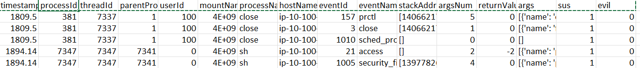
- BETH log dataset.

Preprocessing

In this preprocessing ,the BETH dataset was utilised for Correcting errors, removing redundancies, and handling missing data. Data preprocessing involves techniques such as cleaning the data to handle missing values, as shown in Fig.2, removing outliers, scaling features, encoding categorical variables, and splitting the data into training and testing sets.
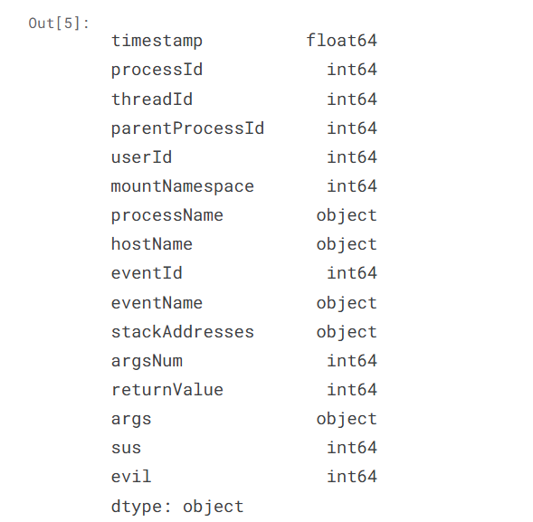
- Preprocessing of BETH dataset.

Data Analysis

Data Analysis is an important part of our project involving data. It is important to investigate and understand the data better before building a model with it. Thorough analysis of the data ,the visualization is valuable for understanding data distribution and detecting anomalies that could affect data analysis or modelling. The visualization of BETH dataset through outliers ,as shown in Fig.3,Fig.4,Fig.5.
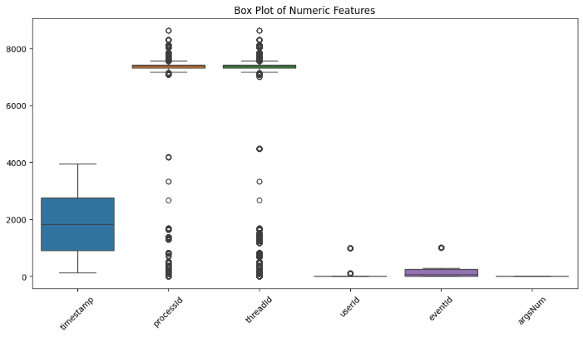
- Box plots to check outliers of BETH dataset

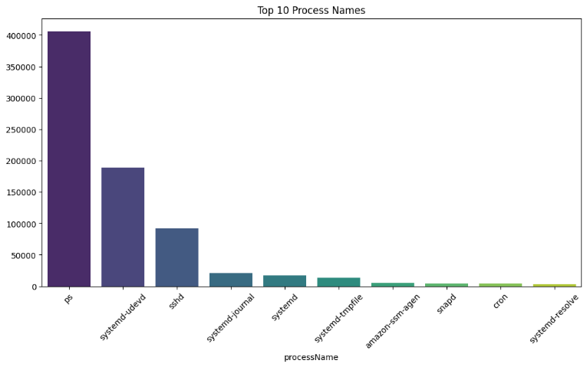
- Top Process Names (Bar Plot) of BETH dataset.
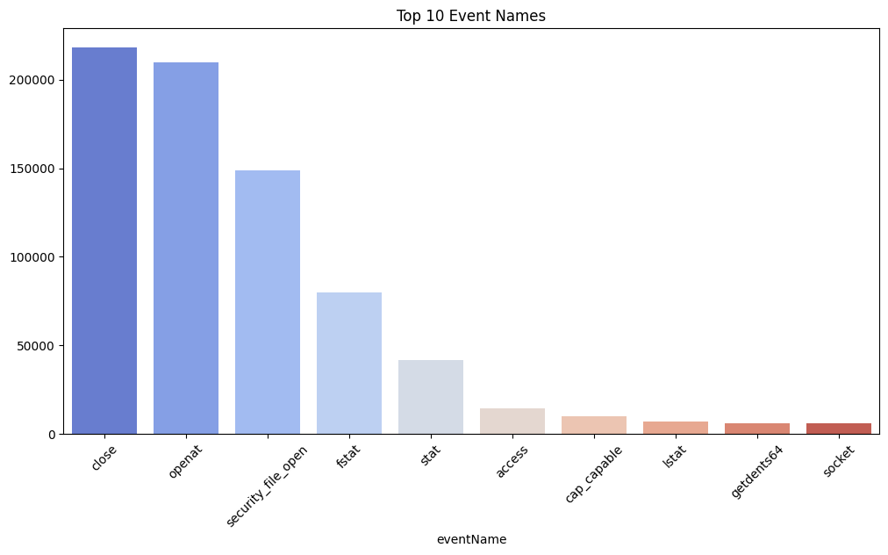

- Top 10 Process Names(Bar Plot) of BETH dataset.

Machine Learning techniques

In the field of Artificial Intelligence (AI), various machine learning techniques such as One-Class Support Vector Machine (OC-SVM), Isolation Forest, and Local Outlier Factor (LOF) are employed for anomaly detection.

1. One-Class SVM (Support Vector Machine)
One Class SVM operates by constructing a decision boundary (or hypersphere) that encloses the majority of normal data points while keeping outliers outside this boundary. It maps the input data into a higher-dimensional space using a kernel function, such as the Radial Basis Function (RBF). kernel, allowing the algorithm to better separate normal data from anomalies by creating a more flexible decision boundary. The algorithm then finds the optimal hyperplane that best encloses the majority of the normal data points, ensuring that most normal instances lie on one side while anomalies remain on the other.
Any data point that falls inside the boundary is considered normal, whereas points outside are classified as anomalies or outliers. One-Class SVM is a powerful boundary-based anomaly detection algorithm that learns the normal behavior of data and identifies anomalies as deviations from this norm. By mapping data into a higher- dimensional space and constructing an optimal hyperplane, it effectively distinguishes normal instances from outliers. However, its performance heavily depends on the choice of kernel function and parameters, making hyperparameter tuning crucial for achieving accurate results.
2.Isolation Forest
Isolation Forest is a tree-based ensemble method designed for anomaly detection by isolating anomalies through recursive partitioning of the data space. It works by building multiple decision trees, with each split randomly choosing a feature and a value within its range. The core principle of Isolation Forest is that anomalies, being rare and distinct, are isolated with fewer splits compared to normal data points, which are more densely grouped and need more partitions to be separated. As a result, anomalies are easier to detect since they appear in fewer tree partitions.
Unlike traditional density-based or distance-based anomaly detection methods, Isolation Forest focuses on the number of splits required to isolate a data point, making it highly efficient and scalable, even for high-dimensional datasets. It has a low computational cost and works well with large datasets by leveraging its tree-based structure. However, its performance depends on factors such as the number of trees used and the sample size, making hyperparameter tuning crucial for achieving optimal results. Due to its efficiency and effectiveness, Isolation Forest is widely used in cybersecurity, fraud detection, and system monitoring to identify unusual patterns and potential threats in large datasets.
3. Local Outlier Factor
Local Outlier Factor (LOF) is a density-based technique for detecting anomalies that works by evaluating the local density of a data point relative to its neighboring points. The method computes the local reachability density (LRD) for each point, which reflects how densely packed it is in comparison to its k-nearest neighbors. Outliers are identified when a point exhibits a notably lower density than its neighbors, indicating that it is more isolated compared to typical data points. The LOF score measures the degree of deviation from the local density, with higher scores signifying more pronounced anomalies.
Unlike global anomaly detection methods, LOF focuses on local density variations, making it particularly effective for datasets where anomalies are context-dependent. This method is advantageous in detecting subtle outliers that might not be globally distinct but stand out within their local neighborhood. However, its performance is sensitive to choice of number of neighbors (k) and can be computationally expensive for large datasets. LOF is widely used in cybersecurity, fraud detection, and network intrusion detection, where anomalies may appear in different density regions, making it a valuable approach for identifying localized deviations in data behavior.

E. Experiments
1. One-Class SVM (Support Vector Machine)

The anomaly distribution for the One-Class SVM model is illustrated in Fig. 6, highlighting the model's capability to separate normal and anomalous data points effectively. A breakdown of how anomalies are distributed across different features is shown in Fig. 7, providing insights into which attributes most contribute to the detection of anomalies. The performance evaluation of the One-Class SVM on both training and testing datasets is presented in Fig. 8, detailing accuracy, precision, recall, and F1-score metrics.

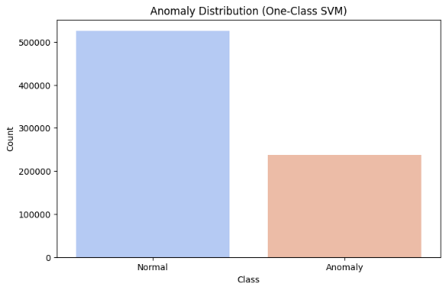
- Anomaly distribution graph of One Class-SVM
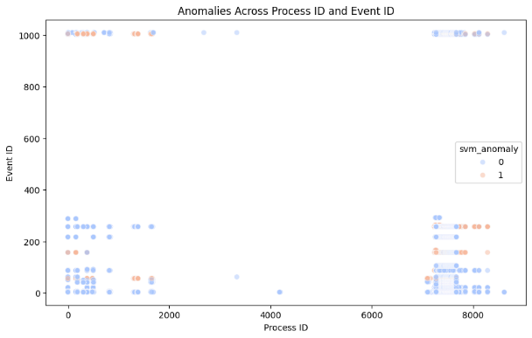
- Anomalies across features of One class-SVM.

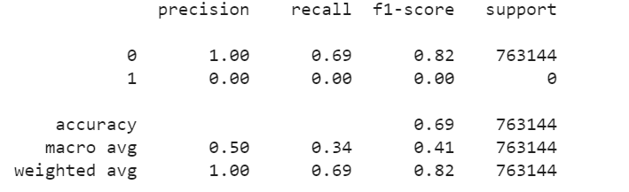
- Performance metrics for the training and testing datasets of one class SVM
2. Isolation Forest
For the Isolation Forest approach, the distribution of anomaly scores generated by the decision function is visualized in Fig. 9. This graph aids in understanding the separation between inliers and outliers. Fig. 10 displays how anomalies are distributed across key features, which helps identify influential attributes in anomaly detection. The performance metrics for the model on both the training and testing sets are summarized in Fig. 11.

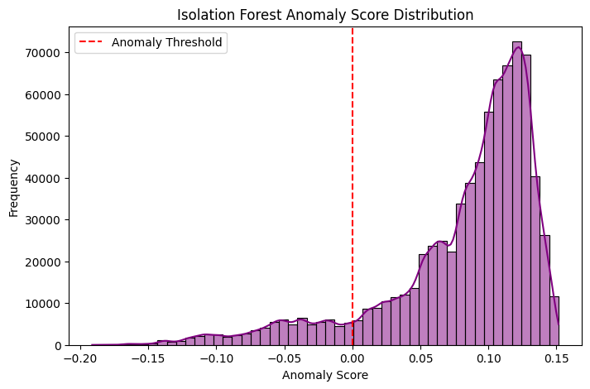
- Anomaly Score Distribution (Decision Function).
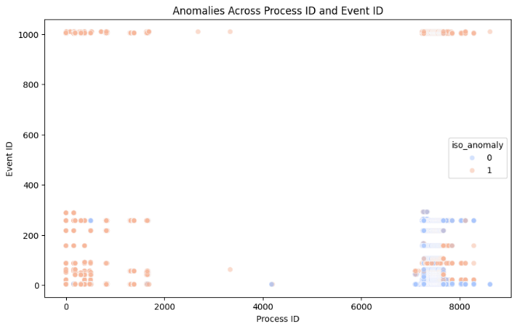
- Anomalies across key features.
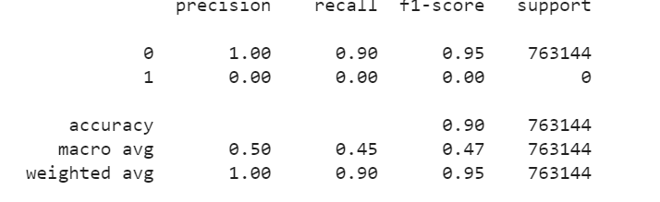
- Performance metrics for the training and testing datasets of Isolation Forest.
3. Local Outlier Factor (LOF)
The LOF algorithm's effectiveness in identifying anomalies across significant features is illustrated in Fig. 12, while the associated performance metrics for training and testing datasets are shown in Fig. 13.
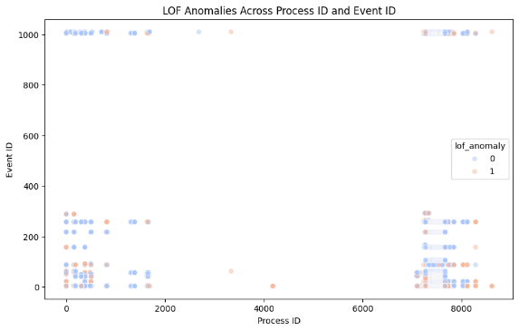
- LOF Anomalies across key features.
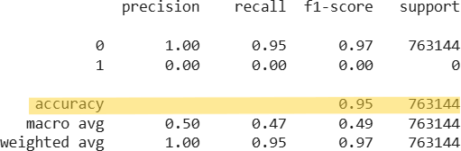
- Performance metrics for the training and testing datasets of LOF

F. Work Flow

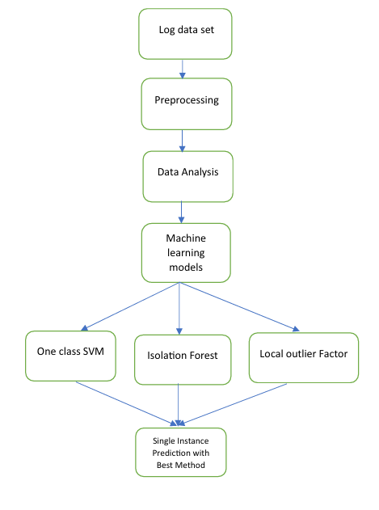
- Work Flow for proposed methodology
In this proposed methodology section work flow, as shown in Fig.14, each anomaly detection model(One-Class SVM (OC-SVM), Isolation Forest (IF), and Local Outlier Factor (LOF))is examined in detail, with dedicated outlining their respective strengths and limitations. The OC-SVM model is effective in identifying outliers when the training data is predominantly normal; however, it struggles with high-dimensional data and is sensitive to parameter tuning. The Isolation Forest demonstrates high efficiency and scalability, making it well-suited for large datasets, but it may underperform when anomalies are not clearly distinguishable or when feature relevance is uneven. On the other hand, the LOF model excels at detecting local density deviations and provides high accuracy in complex datasets, though it is computationally intensive and less effective in sparse data environments. The models were selected based on their unsupervised nature, ability to scale to high-dimensional data, and proven effectiveness in cybersecurity literature. LOF, in particular, was chosen for its strength in identifying context-sensitive outliers in log data.This structured analysis allows for a comprehensive understanding of each model's practical applicability in different anomaly detection scenarios.

Result and Analysis

A. Evaluation Metrics
To evaluate the effectiveness of the , the experiments use the following metrics:
• Precision (P) measures the proportion of correctly identified anomaly samples (TP), out of all the anomalies detected by the model, and is calculated as
P = TP/(TP + FP). (1)
• Recall (R) measures the proportion of correctly identified anomaly samples (TP) out of all real anomalies and i calculated as
R = TP / (TP+ FN). (2)
• F1 Score (F1) is the harmonic mean of the Precision and Recall and is calculated as
F1 = 2 * (P*R)/(P + R). (3)

Result and Discussion

In the project "Enhancing Endpoint Security with Anomaly Detection Using AI using LOF ," Three different anomaly detection classifiers were evaluated: One-Class SVM, Isolation Forest, and Local Outlier Factor (LOF). Results indicate that LOF achieved the highest accuracy (95%) as shown in Fig.13, followed by Isolation Forest (90%) as shown in Fig.11, while One-Class SVM performed the lowest (68.84%) as shown in Fig.8.

The effectiveness of these models was utilized with up to 7 lakh data entries for evaluation, with LOF consistently outperforming when compared with other different datasets using less than 2 lakh data entries in terms of accuracy throughout the analysis.
The proposed model demonstrates significant advancements over existing anomaly detection techniques, highlighting the improvements achieved by the AI-based approach compared to traditional algorithms. This comparison with existing model's, the proposed methodology shows superior performance in terms of accuracy and robustness across diverse datasets. The works of Jilcha et al. [1] and Aziz et al. [10], who emphasized the role of context-aware anomaly detection. This study builds on that direction by validating LOF on a larger real-world dataset.

Further details regarding the datasets used and performance differences are comprehensively presented in TABLE I demonstrating the scalability and adaptability of the proposed method of anomaly detection.

. 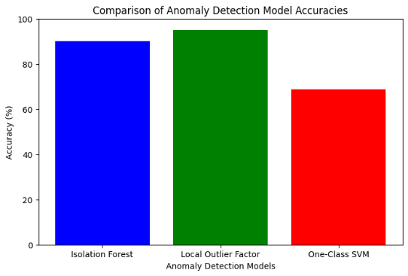
- Comparison of Anomaly Detection Model Accuracies through Graph.
- comparison with existing techniques
Paper Ref. | Algorithms | Performance metrics |  |  | Datasets Used
Paper Ref. | Algorithms | Acc. | Prec. | F1-Score | Other
PROPOSED Methodology | One Class-SVM | 0.69 | 1.00 | 0.69 | BETH
PROPOSED Methodology | Isolation Forest | 0.90 | 1.00 | 0.90 | BETH
PROPOSED Methodology | Local outlier Factor | 0.95 | 1.00 | 0.95 | BETH
[12] | Federated learning, LSTM | 0.99 | 0.87 | 0.92 | HDFS
[13] | Ensemble Autoencoder | ˟ | ˟ | ˟ | CERTr4.2
[14] | Elliptic Envelope | ˟ | ˟ | 0.4 | CERTr6.2
[15] | Random Forest | ˟ | ˟ | 0.87 | TWOS& Enron
[16] | CNN | 0.98 | 0.98 | 0.98 | TWOS
[17] | COPOD (Copula Based Outlier Detection ) | ˟ | 0.98 | 0.98 | ˟
[18] | BERT & Bi-LSTM | ˟ | ˟ | 0.94 | ˟
[7] | TST | 0.92 | ˟ | ˟ | microgrid
[7] | NB | 0.93 | 0.94 | 0.93 | microgrid
[7] | SVM | 0.89 | 0.92 | 0.89 | microgrid

- comparison between the proposed model and Traditional models
Features | Traditional Methods | Proposed LOF-Based Model
Detection Technique | Signature/Rule-Based Detection | Density-Based Anomaly Detection
Adaptability | Low | High (Adapts to unseen threats)
Supervision Requirement | Requires labelled data | Unsupervised (unlabelled data)
Real-Time Capability | Limited | High
Computational Efficiency | Medium | Moderate to High
- comparison of anomaly detection model
S.no | classifier | Accuracy
1. | One-Class SVM | 68.84 %
2. | Isolation Forest | 90.0 %
3. | Local Outlier Factor | 95.0 %

A comparative visualization of model accuracies is shown in TABLE II which highlights the superior performance of LOF. Additionally, a comparative analysis between the proposed AI-based models and traditional anomaly detection methods is provided in Table III . This comparison emphasizes the robustness and efficiency of the proposed methodology in real-world anomaly detection scenarios with over conventional approaches in terms of accuracy, adaptability, and overall performance
The superior performance of LOF suggests that local density-based anomaly detection is highly effective in identifying abnormal behaviors in endpoint security data. Isolation Forest also performed well, benefiting from its ability to efficiently isolate anomalies through recursive partitioning. In contrast, One-Class SVM struggled, likely due to its dependency on decision boundaries that may not be well-suited for complex anomaly distributions.
Overall, LOF is the most suitable approach for this task, but further improvements can be explored through feature engineering, hyperparameter tuning, and ensemble techniques to enhance anomaly detection in endpoint security systems.

CONCLUSION
The machine learning-based approach significantly outperforms traditional models by combining multiple learning algorithms, leading to more precise anomaly detection in endpoint logs. This improvement is particularly evident when dealing with diverse types of abnormal behaviors that may go unnoticed by single models. By integrating multiple algorithms, the machine learning method offers scalability and flexibility in adapting to large and complex datasets. It can handle a variety of log formats, making it applicable across different industries and use cases, from cybersecurity to system performance monitoring.
Among the three classifiers evaluated in this study, the Local Outlier Factor (LOF) emerged as the most effective, achieving an accuracy of 95% in detecting anomalies within endpoint security logs. Isolation Forest also performed well with 90% accuracy, effectively identifying unusual patterns. In contrast, One-Class SVM showed lower performance, with an accuracy of 68.84%, indicating limitations in handling complex log data. The evaluation was conducted on a large-scale dataset with up to 7 lakh entries, where LOF consistently outperformed the other models—even when compared to different datasets containing fewer than 2 lakh entries.
This research highlights the strong potential of AI-based techniques in advancing cybersecurity through reliable anomaly detection. LOF, in particular, proves to be a robust solution for real-time analysis of endpoint logs. Future enhancements could involve hybrid approaches that integrate supervised, unsupervised, and deep learning methods, including large and small language models (LLMs and SLMs). These combinations would increase adaptability, detection accuracy, and responsiveness. Additionally, incorporating domain-specific knowledge and expert insights can further improve the model’s contextual understanding. The proposed system offers a scalable and intelligent framework for proactive cybersecurity monitoring, capable of detecting and mitigating threats such as malicious login attempts and unauthorized access.

References

- L. A. Jilcha, D. -H. Kim and J. Kwak, "SaRLog: Semantic-Aware Robust Log Anomaly Detection via BERT-Augmented Contrastive Learning," in IEEE Internet of Things Journal, vol. 11, no. 13, pp. 23727-23736, 1 July1, 2024, doi: 10.1109/JIOT.2024.3386183.
- Kaya, Yigitcan, et al. "Demystifying behavior-based malware detection at endpoints." arXiv preprint arXiv:2405.06124 (2024).
- Kale, Rahul, et al. "A hybrid deep learning anomaly detection framework for intrusion detection." 2022 IEEE 8th Intl Conference on Big Data Security on Cloud (BigDataSecurity), IEEE Intl Conference on High Performance and Smart Computing,(HPSC) and IEEE Intl Conference on Intelligent Data and Security (IDS). IEEE, 2022.
- Mehrnoosh Navidimehr, Ali Mojahed Khalilabad, Haleh Amintoosi, Mohammad Allahbakhsh, "An LPWAN-Based Framework for Food Supply Chain Management Using Blockchain and Federated Multi-Task Learning", 2024 8th International Conference on Smart Cities, Internet of Things and Applications (SCIoT), pp.207-212, 2024.
- Stein, Jonas, et al. "Exploring unsupervised anomaly detection with quantum boltzmann machines in fraud detection." arXiv preprint arXiv:2306.04998 (2023).
- Hashemi, Shayan, and Mika Mäntylä. "OneLog: towards end-to-end software log anomaly detection." Automated Software Engineering 31.2 (2024): 37.
- Trivedi, Rohit, Sandipan Patra, and Shafi Khadem. "Data-centric explainable artificial intelligence techniques for cyber-attack detection in microgrid networks." Energy Reports 13 (2025): 217-229.orks
- Ryu, Seunghyoung, Yonggyun Yu, and Hogeon Seo. "Can untrained neural networks detect anomalies?." IEEE Transactions on Industrial Informatics 20.4 (2024): 6477-6488.
- Zhou, Qihang, et al. "Label-free multivariate time series anomaly detection." IEEE Transactions on Knowledge and Data Engineering 36.7 (2024): 3166-3179.
- Aziz, Ayesha, and Kashif Munir. "Anomaly Detection in Logs using Deep Learning." IEEE Access (2024).
- Jeffrey, Nicholas, Qing Tan, and José R. Villar. "A hybrid methodology for anomaly detection in Cyber–Physical Systems." Neurocomputing 568 (2024): 127068.
- Himler, Patrick, et al. "Anomaly detection in log-event sequences: A federated deep learning approach and open challenges." Machine Learning with Applications 16 (2024): 100554.
- Li, Dongyang, et al. "Image‐Based Insider Threat Detection via Geometric Transformation." Security and Communication Networks 2021.1 (2021): 1777536.
- Bin Sarhan, Bushra, and Najwa Altwaijry. "Insider threat detection using machine learning approach." Applied Sciences 13.1 (2022): 259.
- Huang, Weiqing, et al. "Itdbert: Temporal-semantic representation for insider threat detection." 2021 IEEE Symposium on Computers and Communications (ISCC). IEEE, 2021.
- Shu, Xiaokui, et al. "Breaking the target: An analysis of target data breach and lessons learned." arXiv preprint arXiv:1701.04940 (2017).
- Zhang, Fangtao, Xiu Ma, and Weiqing Huang. "SeqA-ITD: User behavior sequence augmentation for insider threat detection at multiple time granularities." 2022 International Joint Conference on Neural Networks (IJCNN). IEEE, 2022.
- Fei, Kexiong, et al. "A graph convolution neural network based method for insider threat detection." 2022 IEEE Intl Conf on Parallel & Distributed Processing with Applications, Big Data & Cloud Computing, Sustainable Computing & Communications, Social Computing & Networking (ISPA/BDCloud/SocialCom/SustainCom). IEEE, 2022.
.

