**IE 643**

Deep Learning – Theory and Practice

Challenge Dataset for Image Segmentation

**Name:** Venkatakrishnan V K

**Roll number:** 19D180032

**INTRODUCTION**

The dataset is a camouflage dataset, and the objective is to design an architecture for achieving the best possible results. The current state-of-the-art network is the **U-Net architecture**.

**DATA PREPROCESSING –**

1. **Resizing**(torchvision.transforms.Resize((128,128)):

Resized all the images to 128 x 128 images. Reason: All the images in the dataset were of different sizes.

1. **Tensor conversion**(torchvision.transforms.ToTensor():

All the images were converted to PyTorch Tensors, for using the GPU

1. **Grayscaling Masks**(torchvision.transforms.Grayscale():

There was 1 mask which was an RGB image, hance applied grayscaling on all masks

1. **Normalization**(torchvision.transforms.Normalize()):

Normalized the data to mean of 0 and variance of 1 assuming the mean and variance to be 0.5 for both

1. **Horizontal Flipping**(torchvision.transforms.RandomHorizontalFlip()):

Appended horizontally flipped images of the train dataset to itself, to increase data. Set probability **p** parameter to **1** for the same

LOSS FUNCTION – **Binary Cross Entropy** (torch.nn.BCELoss())

(Did not use Dice loss, since it wasn’t converging for the given camouflage dataset)

Learning Rate scheduler (LR scheduler) – **Step LR** with **gamma** = 0.5, and **step** **size** = 1

**HISTORY OF TRIALS**

1. **Pure U-Net** (Without Extra Horizontally Flipped Data)
   1. **Image Size:** 200 x 200
   2. **Batch Size:** 64
   3. **Epochs:** 25
   4. **Optimizer:** Adam
   5. **Trainable Parameters:** 21,315,347
   6. **Train Time:** 43m 20s
   7. Validation set
      1. **Jaccard Index** =
      2. **Dice Score** =
2. **Longer U-Net** (Without Extra Horizontally Flipped Data)
   1. **Image Size:** 200 x 200
   2. **Batch Size:** 64
   3. **Epochs:** 30
   4. **Optimizer:** Adam
   5. **Trainable Parameters:** 26,037,011
   6. **Train Time:** 66m 58s
   7. Validation set
      1. **Jaccard Index** =
      2. **Dice Score** =
3. **U-Net** (**With** Extra Horizontally Flipped Data)
   1. **Image Size:** 128 x 128 (To increase speed of training)
   2. **Batch Size:** 64
   3. **Epochs:** 25
   4. **Optimizer:** Adam
   5. **Trainable Parameters:** 26,037,011
   6. **Train Time:** 38m 6s
   7. Validation set
      1. **Jaccard Index** = 0.2078
      2. **Dice Score** = 0.3441
4. **Dense Inception U-Net** (**With** Extra Horizontally Flipped Data)
   1. **Image Size:** 128 x 128
   2. **Batch Size:** 64
   3. **Epochs:** 20
   4. **Optimizer:** Adam
   5. **Trainable Parameters:** 39,507,523
   6. **Train Time:** 51m 32s
   7. Validation set
      1. **Jaccard Index** = 0.3248
      2. **Dice Score** = 0.4903
5. **Increased Dense Inception U-Net** (**With** Extra Horizontally Flipped Data)
   1. **Image Size:** 128 x 128
   2. **Batch Size:** 16
   3. **Epochs:** 10
   4. **Optimizer:** Adam
   5. **Trainable Parameters:** 90,260,995
   6. **Train Time:** 73m 28s
   7. Validation set
      1. **Jaccard Index** = 0.3108
      2. **Dice Score** = 0.4742
6. **Increased Dense Inception U-Net** (**With** Extra Horizontally Flipped Data)
   1. **Image Size:** 128 x 128
   2. **Batch Size:** 16
   3. **Epochs:** 10
   4. **Optimizer:** SGD (Changed)
   5. **Trainable Parameters:** 363,437,059
   6. **Train Time:** 110m 22s
   7. **Threshold:** 0.39
   8. Train set
      1. **Jaccard Index** = 0.6416
      2. **Dice Score** = 0.7817
   9. Validation set
      1. **Jaccard Index** = 0.3661
      2. **Dice Score** = 0.5360
7. **DeepLab V3** (**With** Extra Horizontally Flipped Data)
   1. **Image Size:** 128 x 128
   2. **Batch Size:** 16
   3. **Epochs:** 5
   4. **Optimizer:** SGD
   5. **Trainable Parameters:** 60,991,062
   6. **Train Time:** 3m 22s
   7. **Threshold:** 0.5
   8. Train set
      1. **Jaccard Index** = 0.7383
      2. **Dice Score** = 0.8494
   9. Validation set
      1. **Jaccard Index** = 0.5232
      2. **Dice Score** = 0.6870
8. DeepLab V3
   1. Changes –
      1. **With** Extra Horizontally Flipped Data
      2. **Added** Sharpness to Flipped Data
   2. **Batch Size:** 16
   3. **Epochs:** 5
   4. **Optimizer:** SGD
   5. **Trainable Parameters:** 60,991,062
   6. **Train Time:** 3m 4s
   7. **Threshold:** 0.5
   8. Comments: Did not perform as well
9. DeepLab V3
   1. Changes –
      1. **Loss** changed to **IoU Loss** from **BCE Loss**
   2. **Batch Size:** 16
   3. **Epochs:** 10
   4. **Optimizer:** SGD
   5. **Trainable Parameters:** 60,991,062
   6. **Train Time:** 7m 49s
   7. **Threshold:** 0.5
   8. Train set
      1. **Jaccard Index** = 0.7422
      2. **Dice Score** = 0.8520
   9. Validation set
      1. **Jaccard Index** = 0.5451
      2. **Dice Score** = 0.7056
10. DeepLab V3
    1. Changes –
       1. Added **IoU Loss** and **BCE Loss**
    2. **Batch Size:** 16
    3. **Epochs:** 10
    4. **Optimizer:** SGD
    5. **Trainable Parameters:** 60,991,062
    6. **Train Time:** 7m 49s
    7. **Threshold:** 0.5
    8. Train set
       1. **Jaccard Index** = 0.7791
       2. **Dice Score** = 0.8758
    9. Validation set
       1. **Jaccard Index** = 0.5504
       2. **Dice Score** = 0.7099
11. DeepLab V3
    1. Changes –
       1. Added Vertically Flipped images to train dataset
    2. **Batch Size:** 16
    3. **Epochs:** 10
    4. **Optimizer:** SGD
    5. **Trainable Parameters:** 60,991,062
    6. **Train Time:** 11m 43s
    7. **Threshold:** 0.49
    8. Train set
       1. **Jaccard Index** = 0.7415
       2. **Dice Score** = 0.8515
    9. Validation set
       1. **Jaccard Index** = 0.5643
       2. **Dice Score** = 0.7215

FINAL MODEL – **DEEP LAB V3 Transfer Learnt Model**

1. **Dataset:** Added horizontally and vertically flipped images to the dataset
2. **Image Size:** 128 x 128
3. **Batch Size:** 16
4. **GPU:** MPS (Metal Performance Shaders)
5. **Epochs:** 10
6. **Optimizer:** SGD
7. **Learning Rate =** 0.1
8. **LR Scheduler:** **Step LR** with gamma = 0.5 with step size = 1
9. **Trainable Parameters:** 60,991,062
10. **Train Time:** 11m 43s
11. Train dataset

**Jaccard Index** = 0.7415

**Dice Score** = 0.8515

1. Validation dataset

**Jaccard Index** = 0.5643

**Dice Score** = 0.7215

**LOSS Function**

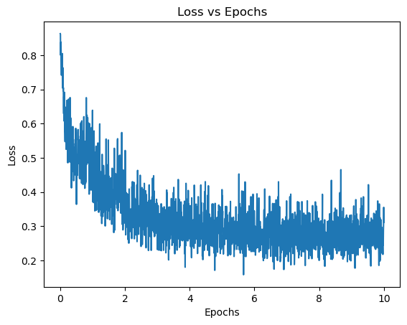

RESULTS

1. **Train Data example image**

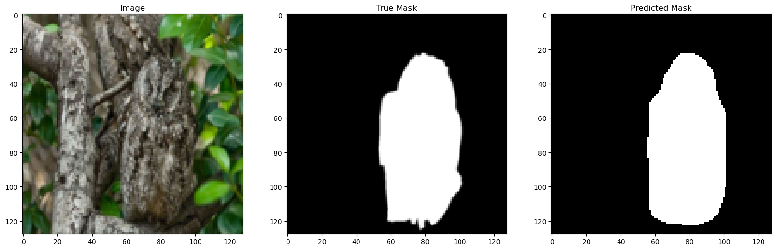

1. **Validation Data example image**

