**Ansible**

> It is a configuration management tool.

> Configuration: Ram, Storage, OS, Software and IP address of device.

> Management: Update, Delete, Add.

> Ansible is simple open-source IT engine which automates application deployment.

> Orchestration, security and compliance.

> Uses YAML scripting language which works on KEY-VALUE PAIR.

>Ansible GUI is called Ansible tower. It was just drag and drop.

> used PYTHON for back end.s

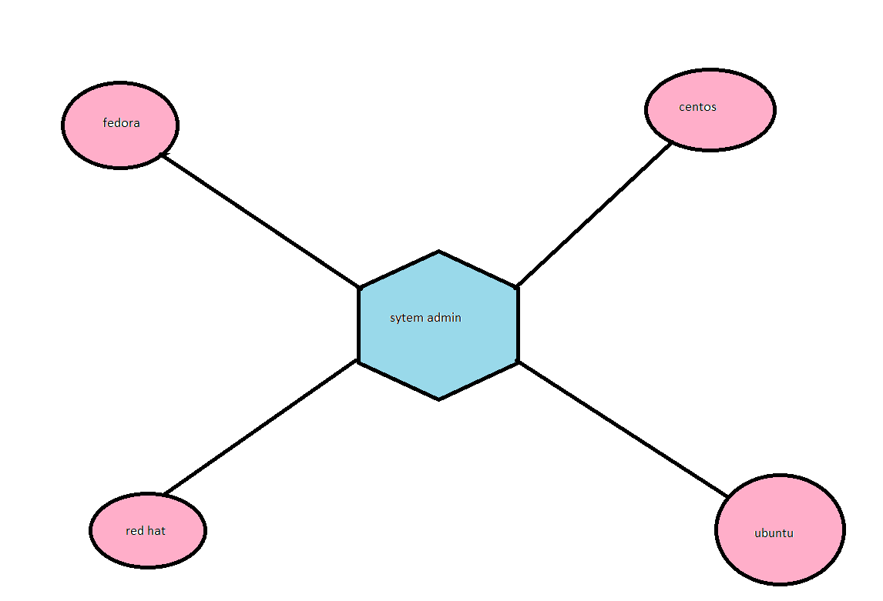

Manual-----🡪 automation

If a system admin has to install those Linux flavours across all the systems on his company, then he has do it manually. In manual work there might be some errors so we use here automated tools like

Ansible, chef, puppet etc.

Ansible : PUSH CHEF : PULL

PUSH: if we have many servers then it will push the notification for updates in all devices.

PULL: it will go to client server and ask for the notifications for update.

**Advantages**

. Very consistent and light weight and no constraints regarding the OS or underlying H,W.

. Secure less due to agent less capability and open SSH security features.

. Doesn’t require any special system admin skills to install and use it (YAML).

. Push mechanism.

**Disadvantages**

. Ansible does not have any notion of state like other automation tools such as puppet.

. Ansible does not track dependencies and simply executes sequential tasks and stops when tasks finish, fail, or any error comes.

. Ansible has external dependencies to python modules.

. Windows interaction requires some scheming.



Ansible installation:-

I am launching 3 servers

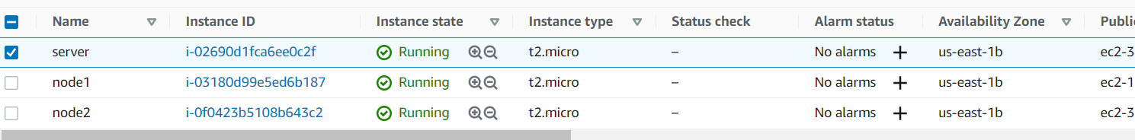

. log in with server

. amazon-linux-extras install ansible2 –y

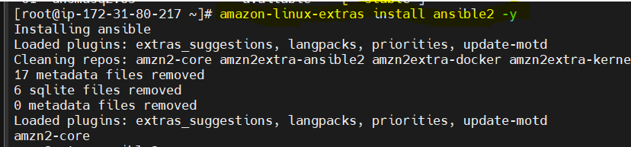

. install all dependencies

. yum install git python python-pip python-level openssl –y

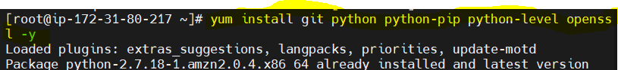

. every configuration file in etc

. vi /etc/Ansible/hosts

. add nodes private ip

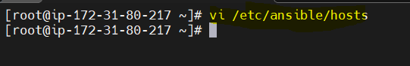

. ex( if my company give one task to install git in all developers machine, so I am adding developers nodes private ip)

[dev]

Nodes private ip

. :wq

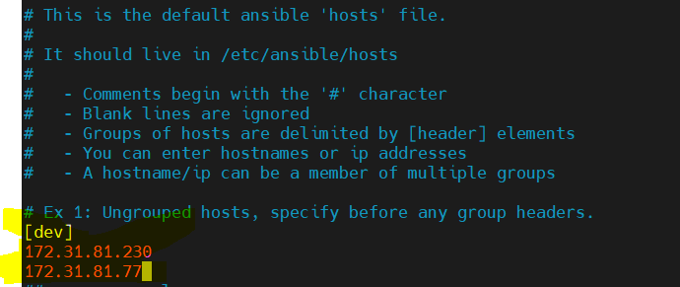

. to edit Ansible configuration

. vi /etc/ansible/ansible.cfg

. untag (# remove)

:wq

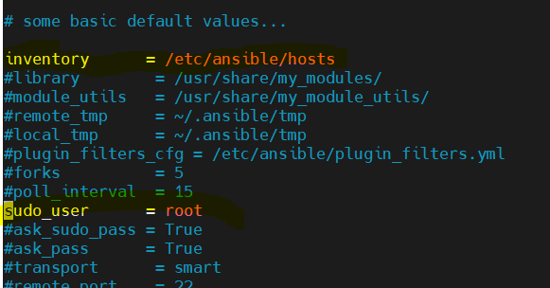

. add user and password

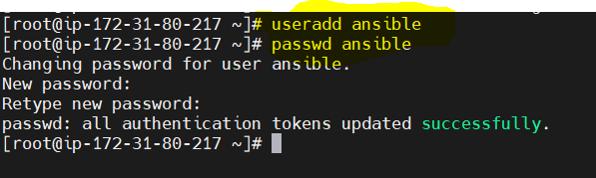

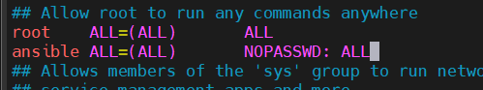

. again we need to change sshd conf file

. vi /etc/ssh/sshd_config

. bydefault it is no, so we create yes

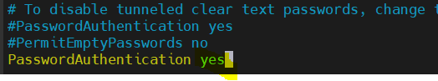

Login with node server

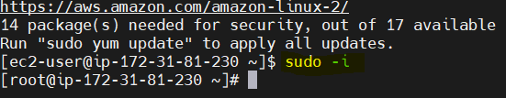

. add user and password

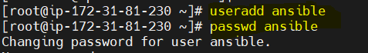

. edit sudo . visudo



. edit sshd_config file (remove no- put yes)



How to connect Ansible server and node server

. restart sshd (in both servers(Ansible server and node server))

. now do those commands in both the nodes

. systemctl restart sshd

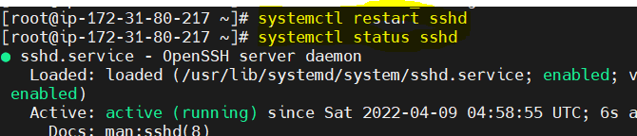

. login as Ansible in all servers by using

. su – ansible



. generate ssh key in Ansible server

. your public key has been stored in ls /home/Ansible/.ssh/id_rsa.pub.

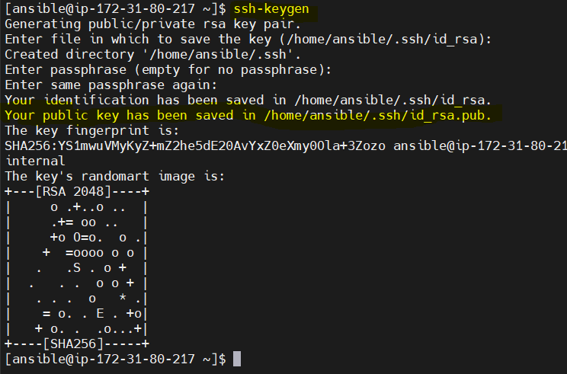

. how to move the ansible ssh key to node 1 server.

. ssh-copy-id ansible@<nodeprivateip>

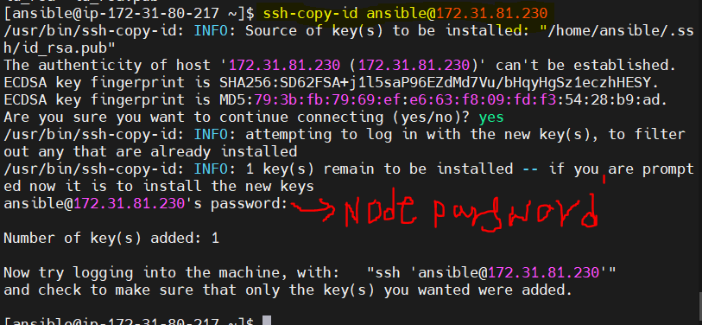

. how to change Ansible server though node server 1

. ssh ansible@<nodeprivateip>

