**Jenkins**

**What is Jenkins:-**

Jenkins is a continuous integration (CI) and continuous deployment (CD) tool.

**What is ci and cd means:-**

CI means integrate the developer’s code. CD means delivery or deploy the code into the different environment (QA, pre-production, production).

- It is java based application.

- It will help to automate the process of code integration, code build, code delivery.

- it is a open source tool like Hudson/bamboo/teamcity.

- Jenkins original name is Hudson.

- Jenkins is the core part of the DevOps.

- Jenkins will connect to the scm, qa, tomcat, production, etc.

- it is interacted with those systems with plugins.

- it is plugin based tool.

Note:- in Jenkins server git must install.

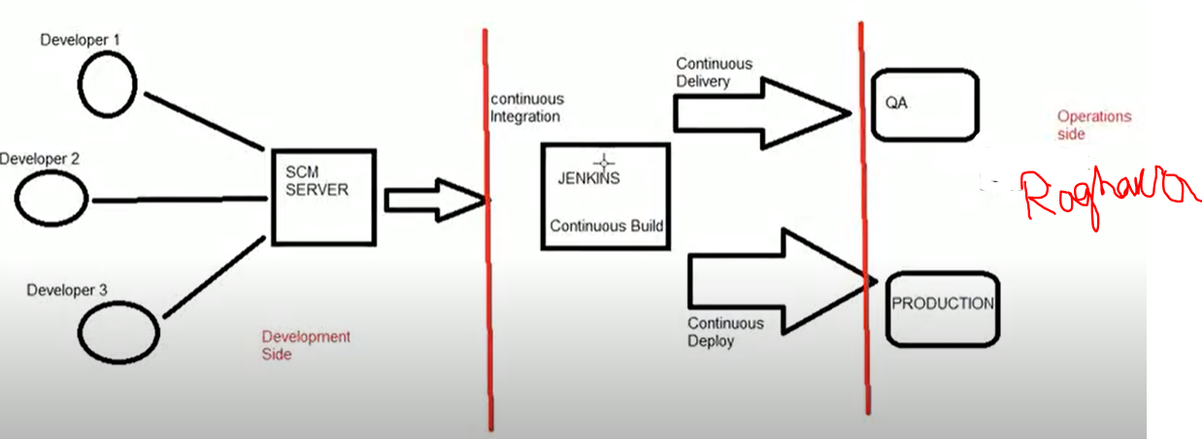

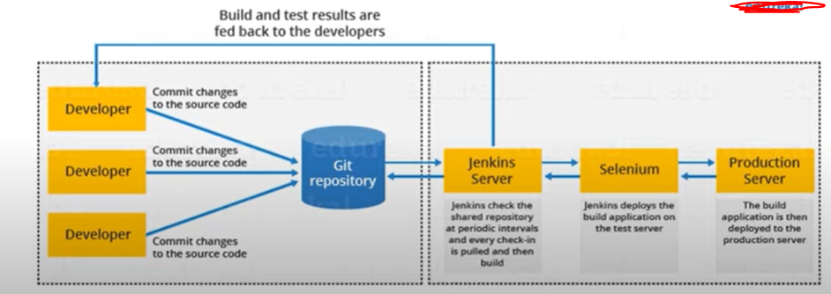

Jenkins installation command:-

> sudo yum update

> sudo yum upgrade

> sudo yum install git

> sudo yum install java (or) yum install java-1.8.0-openjdk / sudo amazon-linux-extras install java-openjdk11

> sudo wget -O /etc/yum.repos.d/jenkins.repo http://pkg.jenkins-ci.org/redhat/jenkins.repo

> sudo rpm --import https://pkg.jenkins.io/redhat/jenkins.io.key

> sudo yum install jenkins –y

> systemctl start jenkins

> systemctl status Jenkins

>

Install suggest plugins

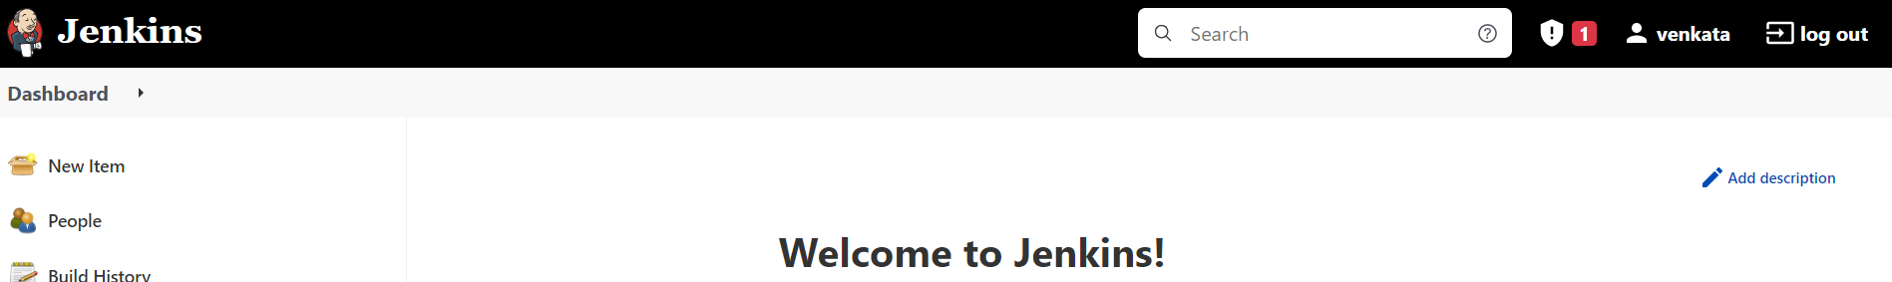

Create new job

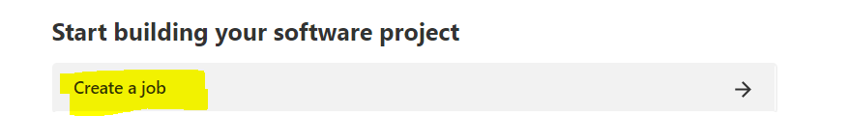

. for example I am creating free style project

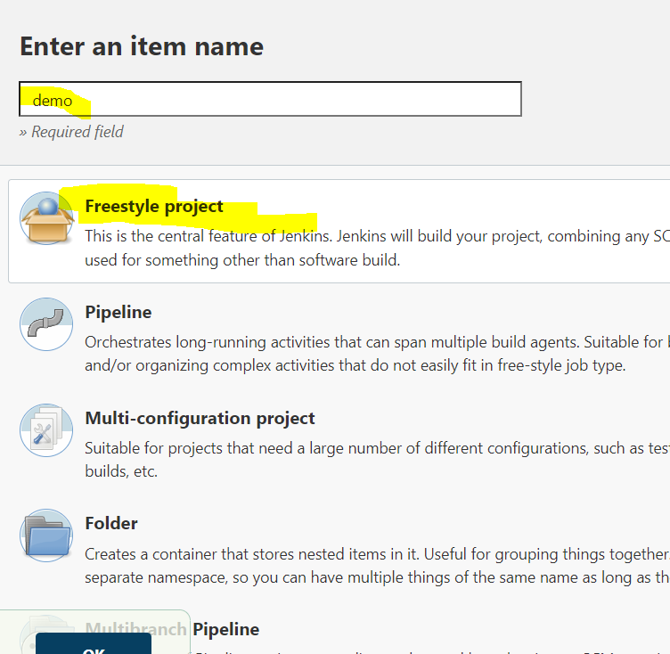

. give job description

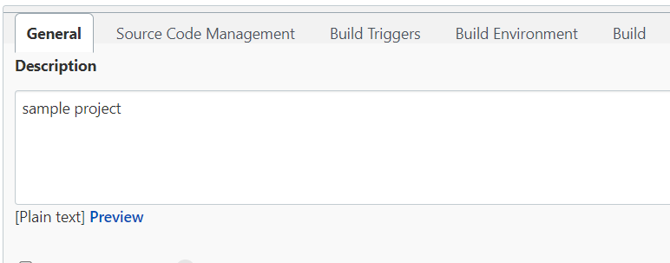

For ex I am executing shell command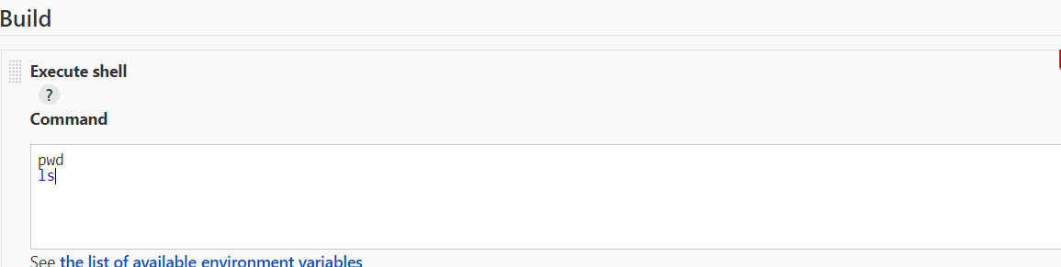

. Apply&save

. build now

. when the build success or failure to check console output.

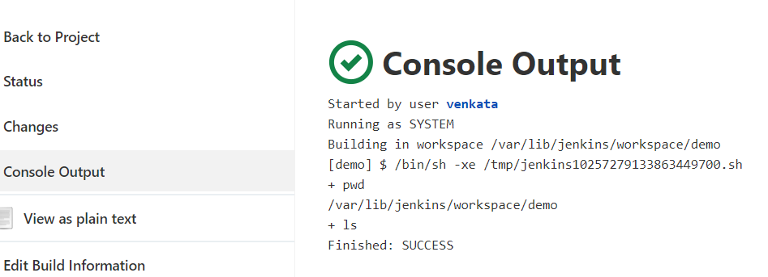

. open mobaxterm

. Jenkins history store in

. cd /var/lib/Jenkins

.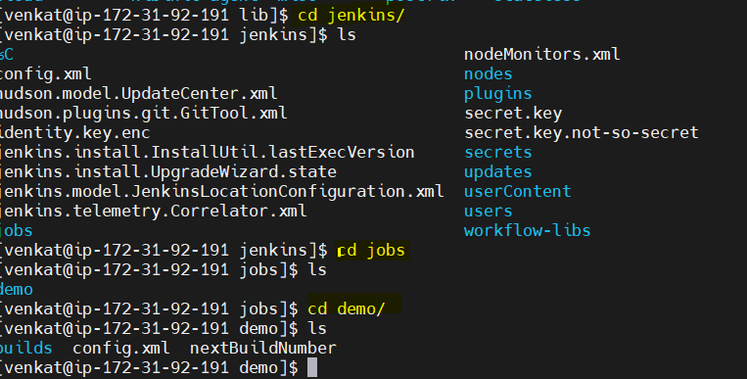

How to integrate git with Jenkins

. go to Jenkins dashboard🡺select new item🡺select free style🡺

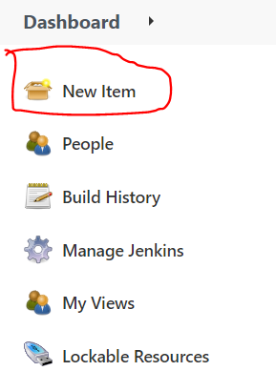 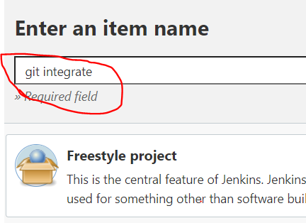

. go to git hub account🡺select repo url🡺copy repo url

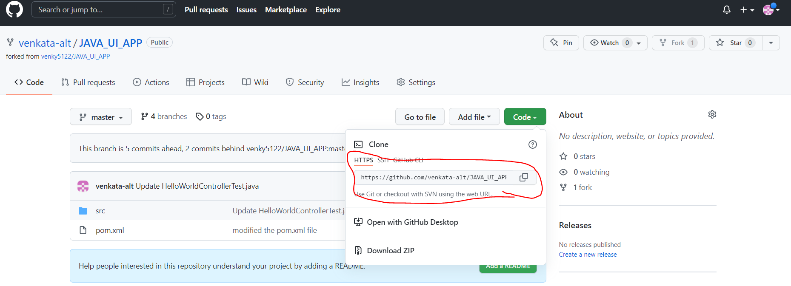

. go to Jenkins homepage paste selected url in github project

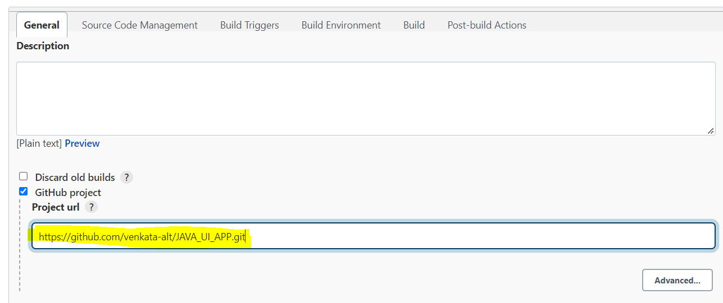

. go to source code management copy selected repo url

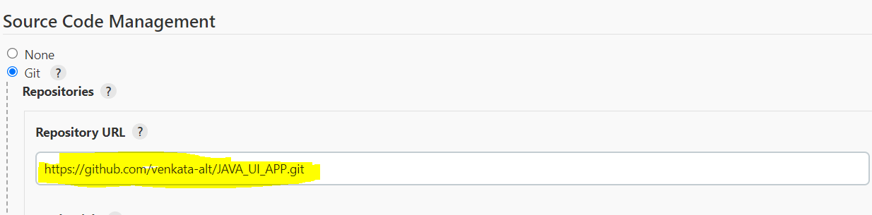

. What is credentials:-

. Credentials is nothing but repository access is public or private, in case it is private to give credentials to url,

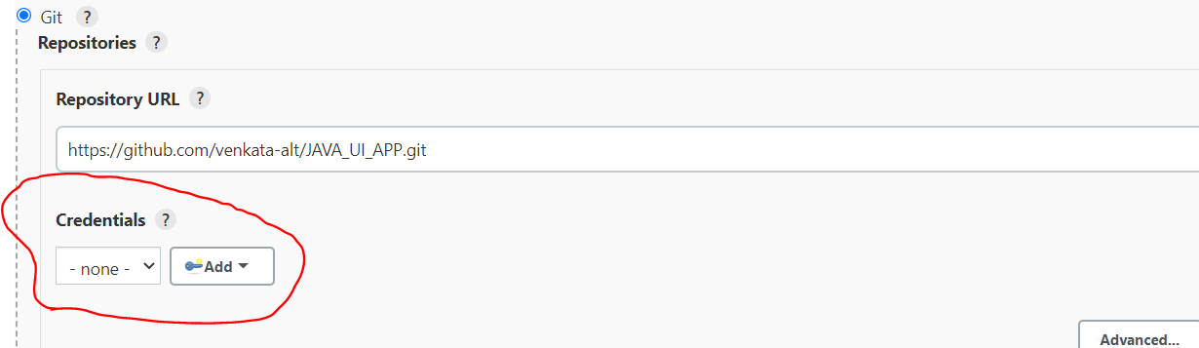

. apply& save🡺 go to dash board🡺go to latest creation job🡺click on build now

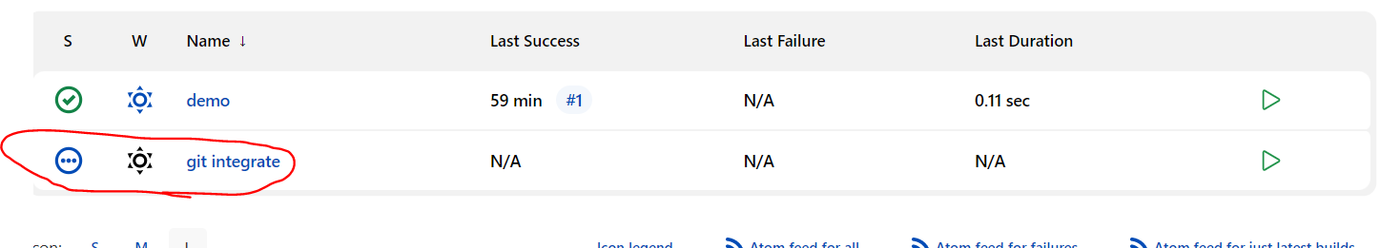

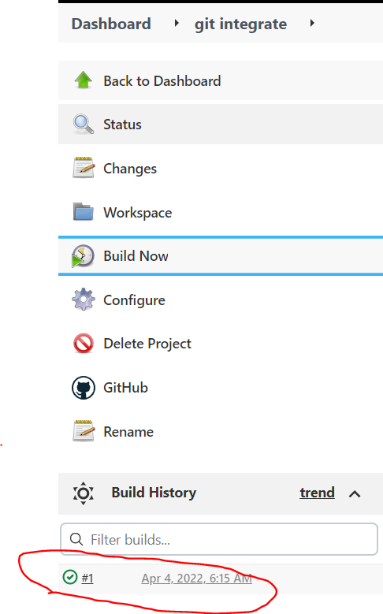

. go to console out put

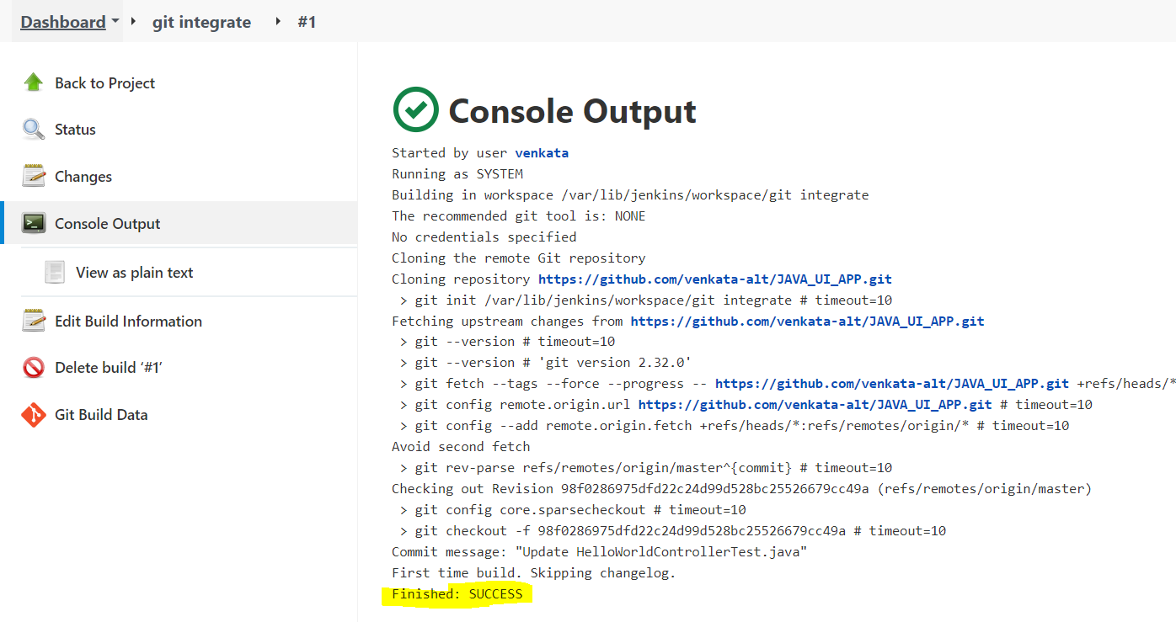

. click on job🡺 workspace🡺🡺to show the files in repository

