The AI Business Brief
Where Artificial Intelligence Is Actually Moving the Needle, August 2026 Edition

Welcome Back, Readers
If you have felt like AI headlines are all hype and no substance lately, this issue is here to push back on that. Over the past month, three industries in particular have moved past pilot programs and into real, measurable business impact: finance, healthcare, and software development. In this issue, we will walk through what changed, who is behind it, and what it actually means for the people running these businesses day to day.
This Issue at a Glance
- Finance: AI agents are now handling fraud detection, compliance, and even customer facing financial advice at a scale that was science fiction two years ago.
- Healthcare: New AI powered diagnostic tools and billing systems are cutting both clinical delays and administrative overhead.
- Software Development: The tools engineers use to write code had two major upgrades in six weeks, changing both cost and capability.
Industry Spotlight: Finance
Banks spent the last few years experimenting with AI. This month, several of them graduated to running it in production, at serious scale.
JPMorgan Chase: AI at Trillion Dollar Scale
JPMorgan Chase now runs more than 400 production AI use cases on its enterprise machine learning platform, processing roughly $10 trillion in daily transactions. This is no longer a pilot program bolted onto the side of the business, it is core infrastructure.
Commonwealth Bank: Fraud Losses Down 20%
Using a homegrown AI agent, Commonwealth Bank reduced fraud losses by 20% in the first half of fiscal year 2026, showing that AI's biggest financial win right now may be defensive rather than flashy.
Lloyds Banking Group: The UK's First Agentic Banking Assistant
Lloyds announced an AI powered financial assistant that does not just answer questions, it takes action. Customers can ask it to process a payment, and the agent plans the steps and executes the transaction directly, referring to a human specialist only when needed. This is what industry insiders call "agentic AI": systems that do not just chat, they act.
Industry Spotlight: Healthcare
Healthcare AI news this month split cleanly into two categories: better diagnostics and less paperwork.
GE HealthCare: Faster, Smarter Breast Cancer Screening
GE HealthCare launched Invenia ABUS Prime and ABUS StreamVue, an automated breast ultrasound system that recently received FDA clearance. Automated ultrasound tools like this help radiologists screen more patients without sacrificing accuracy, which matters enormously in areas with specialist shortages.
Caris Life Sciences: One Blood Test, Many Cancers
Caris Detect, a new blood test that can catch many types of cancer early, was announced this month. It aims to catch multiple cancer types from a single, less invasive blood draw rather than separate specialized screenings.
ModMed: AI Handles the Paperwork So Doctors Do Not Have To
ModMed's new RCM (Revenue Cycle Management) AI Platform sends AI agents directly into medical billing workflows to reduce claim denials and speed up reimbursements, a quiet but very real source of relief for specialty medical practices drowning in administrative work.
Industry Spotlight: Software Development
For engineers, the last six weeks brought two major changes to the tools used to actually build software.
Claude Opus 5: Frontier Performance, Half the Price
Anthropic released Claude Opus 5 on July 24, delivering top level coding performance at half the price of the previous top level model. Claude Code, the terminal coding agent, immediately adopted it as the default, and added the ability to assign cheaper models to routine tasks while reserving the strongest model for hard problems.
GPT-5.6: Aggressive Price Cuts Across the Board
OpenAI's GPT-5.6 went generally available on July 9 with price cuts of up to 80% compared to prior models, This raises competition and makes advanced coding tools much cheaper for smaller teams and individual developers.
Cursor 3: From Editor to Multi Agent Platform
Cursor 3 marks a big change in how the tool works: instead of an AI enhanced code editor, it is now a platform for running multiple AI agents in parallel across different environments, with background agents that work independently on their own Git branches and open pull requests when finished.
Deep Dive: Stripe's Fraud Detection Foundation Model
Of everything covered this month, one example best illustrates AI's real commercial impact: Stripe's new payments foundation model, trained on tens of billions of real transactions. For one common type of payment fraud affecting large businesses, this model raised detection rates from 59% to 97%, a difference that translates directly into fewer chargebacks, less fraud loss, and safer transactions for millions of customers.
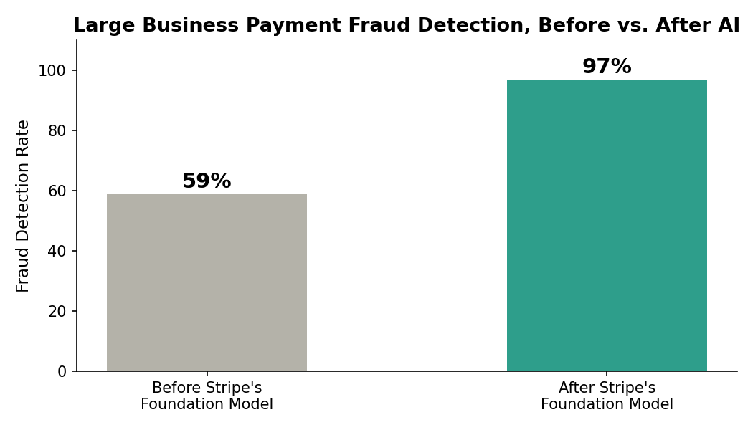
Why it matters: What makes this significant is the shift in approach it represents. Instead of building a new, narrow AI model every time a new type of fraud emerges, Stripe trained one large model on the full breadth of its transaction data and applies it across many fraud types at once, the same way large language models handle many tasks at once. NVIDIA's 2026 State of AI in Financial Services report found that 65% of financial institutions already use AI, but having too many separate, narrow AI systems is now the industry's biggest obstacle. Foundation models like Stripe's point toward where the industry is likely headed next: fewer, more broadly capable systems instead of a patchwork of narrow ones.
Looking ahead: As these foundation models mature, expect fraud detection to keep improving while shrinking the work needed to maintain dozens of separate AI tools, a trend likely to spread well beyond payments into fraud detection for insurance, lending, and other financial services.
The Bottom Line
Across finance, healthcare, and software development, the same story is repeating: AI is moving from experimentation to infrastructure. The organizations seeing real results, JPMorgan Chase, Commonwealth Bank, GE HealthCare, and the developer tooling ecosystem, are not chasing novelty. They are embedding AI into the workflows that already run their business, and measuring the results in real numbers: fraud losses down 20%, detection rates up to 97%, prices for top AI tools cut by up to 80%. That is the throughline for this month, and likely for the months ahead: less hype, more infrastructure.

Thanks for reading this edition of The AI Business Brief. See you next month.
Sources
- PLANADVISER: AI Product and Service Launches, 8/10/2026
- PYMNTS: Banks and FinTechs Are Sitting on the Most Powerful AI Dataset in Finance
- Yahoo Finance and Retail Banker International: Lloyds Banking to launch AI powered financial assistant
- Healthcare IT Today: Bonus Features, August 9, 2026
- Health IT Answers: Health IT Product News Report, August 2026
- Build Fast with AI: 7 AI Tools That Changed Developer Workflow, August 2026
- morphllm.com: Best AI Coding Agents, August 2026 Scored Leaderboard

