**Assignment-2**

Loading the raw data to the google colab:

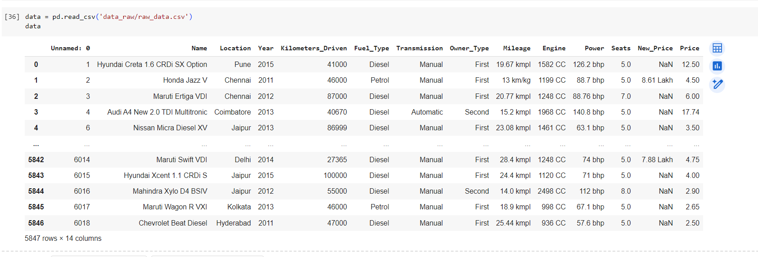

**Task-(a):**

Checking for the columns where there are missing values.

Dropping the New_Price column and handling the missing values in the other columns by filling out their mean.

* The dataset contains 5,847 rows.
* The New_Price column has a significant number of missing values (5,032 out of 5,847), which is around 86% of the dataset. Given the high number of missing values, it might be best to drop this column.
* Other columns have a smaller number of missing values, and we can fill the missing values with the mean.

**Task-b:**

**Task-c:**

Saving the above encoded results to a separate .csv in the results folder.

**Task-d:**

**Task-e:**

