**Question-2:**

**a.**

The sample mean glucose level is slightly above the population mean, while the sample's maximum glucose level is lower than that of the population, which suggests a broader range of glucose values in the overall population compared to the sample.

**b.**

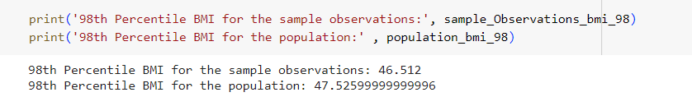

The 98th percentile BMI for the sample observations is slightly lower than that of the population, which suggests that the sample may have slightly lower extreme BMI values compared to the overall population.

**c.**

The population mean blood pressure is relatively low, while the standard deviation indicates moderate variability within the population. The 98th percentile blood pressure value suggests that a small proportion of the population has significantly higher blood pressure values, potentially indicating the presence of outliers or a subgroup with elevated blood pressure levels.