Software Requirement Specification Document

For

BeeBuzz
Keep Trucks Moving. Keep India Growing.

Table of Contents

- Introduction
  - Purpose
  - Intended Customers/Users
  - Product Scope
  - Outline of the document
- Overall Description
  - Product Perspective
  - Product Functions
  - User Classes
  - Design and Implementation Constraints
- Diagrams
  - UML Diagrams
  - ER Diagrams
  - DFD Diagrams
- External Interface Requirements
  - User Interfaces
  - Hardware Interfaces
  - Software Interfaces
  - Communication Interfaces
- Other Non-Functional Requirements
  - Performance Requirements
  - Safety Requirements
  - Security Requirements
  - Software Quality Attributes
  - Business Policies/Rules (if any)
- Testing
  - White-Box Testing
  - Black-Box Testing
- Conclusion
- References
- Acknowledgements

Introduction
- Purpose
The purpose of this document is to explain the requirements of BeeBuzz logistics app, that directly connects shippers with truck drivers. This SRS document helps us understand what this app will do, whothe users are, how the app works, how it looks, process of developmentof Beebuzz app.
- Intended Customers / Users

BeeBuzz app is mainly meant for:
  - Shippers: People or businesses who want to transport goods from a place to other.
  - Truck Drivers: Drivers who want to find loads easily without relying on middlemen and avoid empty return trips.
  - Admin: The system manager who verifies the tasks and manages app activities.
- Product Scope
BeeBuzz is a mobile and web logistics app that links shippers directly with truck drivers. The aim of the app is to reduce empty return trips, conserve fuel and increase driver income. The app allows shippers toupload load data, drivers to accept them and track the shipment in real time usingGPS. Digital payments for fast and easy access makes the system much more efficient.
- Outline of the document
This document includes all the software requirement specification for the BeeBuzz app. It includes system overview, user types, and major features. It also includes ER diagrams, UML diagrams, interface details, non-functionalrequirements and finally testing approaches. It provides a complete understanding the behavior the system design.

Overall Description
- Product Perspective
BeeBuzz is an application that works as a bridge between shippers and truck drivers. It uses map services for location tracking and payment gateway for online payments. The system can be accessed from any phone or desktop without any external hardware requirement.

- Product Functions
Some of the main functions of BeeBuzzapp:
- User registration and login.
- Different access for Drivers and shippers.
- Shippers can post load details.
- Shippers can see nearby available truck drivers.
- Accepting and completing trip by Drivers.
- Live location tracking for both the users.
- Online payment support.
- Rating and feedback system after the trip.

- User Classes
BeeBuzz system has three types of users
- Shippers: Create transport requests and track deliveries.
- Truck Drivers: Accept the load and ships it to the destination.
- Admin: Manages users, verifies details, and handle issues.
Each user has their own features and permissions.

- Design and Implementation Constraints
While developing this app, somethings need to be considered:
- This app need internet access.
- GPS accuracy depends on the user’s device.
- Digital payment uses third party services.
- System must protect user data and privacy.

Diagram
- UML Diagrams
Shipper Use Case Diagram:
This Use case diagram shows how a shipper uses BeeBuzz app to book a vehicle, make payments, and track the delivery of goods.
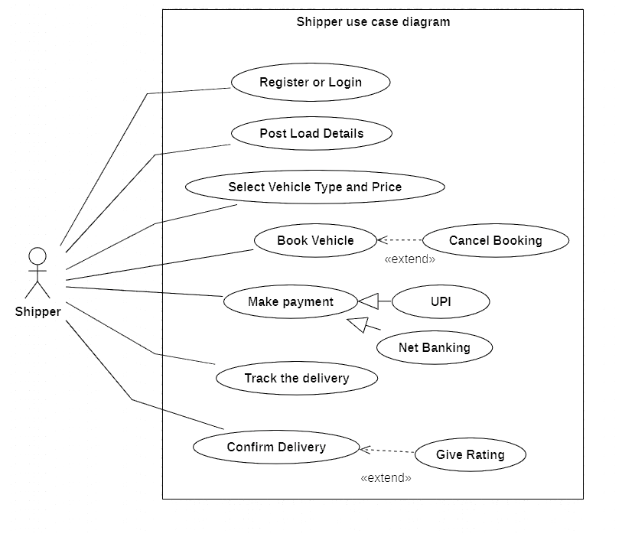

Transporter Use Case Diagram:
This use case diagram shows how a truck driver uses BeeBuzz app to view available loads, accept orders, deliver goods, and receive payments.
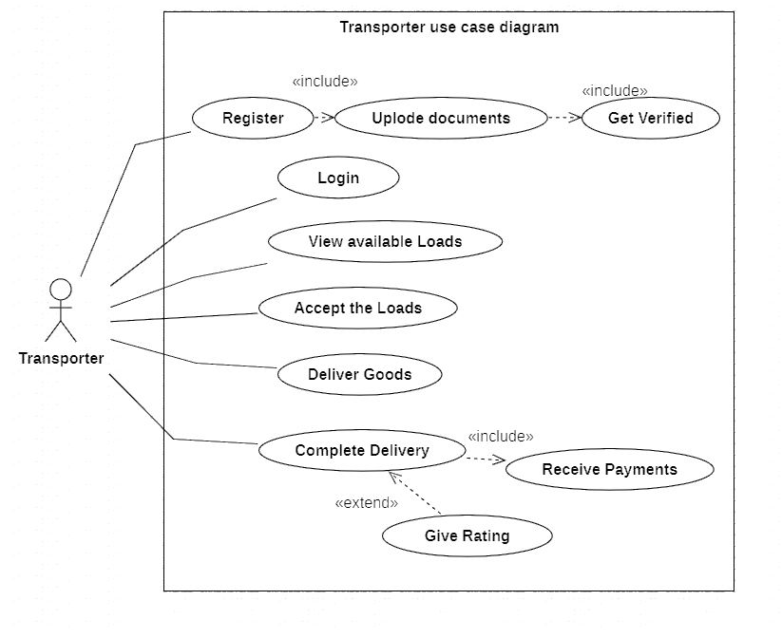

Admin Use Case Diagram:
This use case diagram shows how admin manages users, verifies transporter documents, monitors trips, handles payments, and resolves complaints.
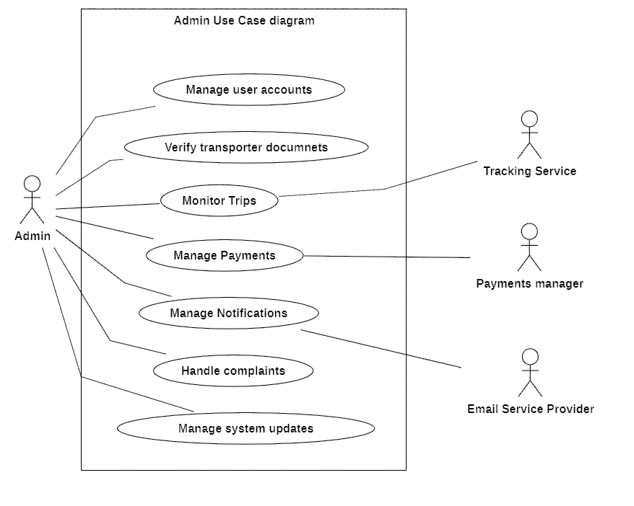
Shipper Class Diagram:
This class diagram shows the attributes and operations of the shipper, including posting load details, booking vehicles, making payments, and tracking shipments.
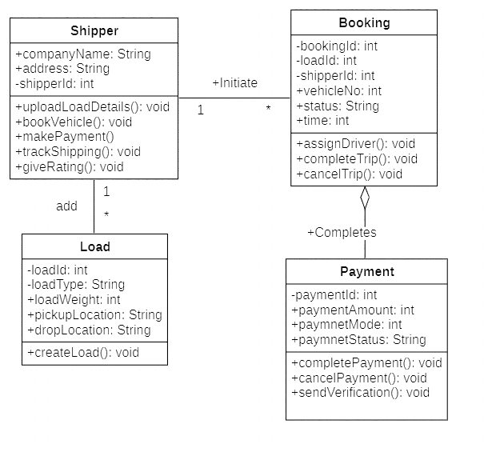
Transporter Class Diagram:
This class diagram represents the transporter’s role in the system, including accepting loads, delivering goods, completing trips, and receiving payments.
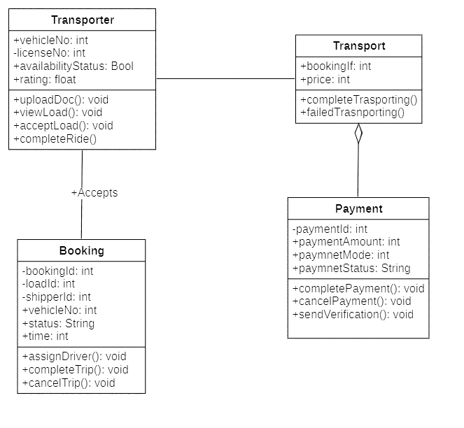
Login Class Diagram:
This class diagram represents the login functionality of the BeeBuzz system, including user Login, registration, and logout operations.
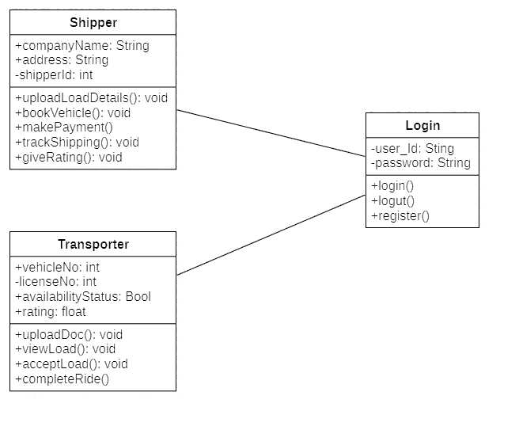

Admin Class Diagram:
This class diagram shows how the admin manages users, verifies transporters, monitors trips, and handles payment-related operations.
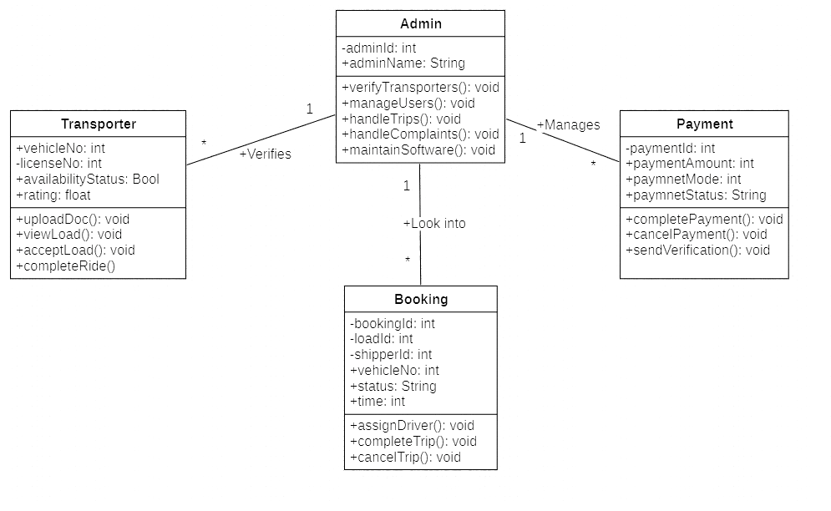
Core Class Diagram:
This class diagram represents the core structure of the BeeBuzz system, showing the relationship between users, bookings, loads, payments, and admin functionalities.
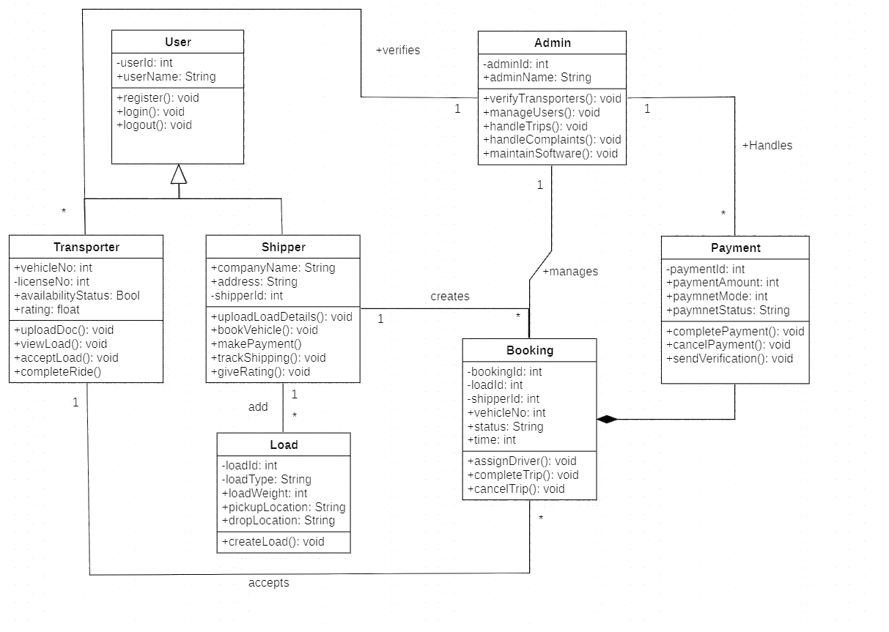

- UML Diagrams
State Chart Diagram:
This state chart diagram shows the different states of the login, shipper, and transporter processes from login to booking, delivery, and completion.
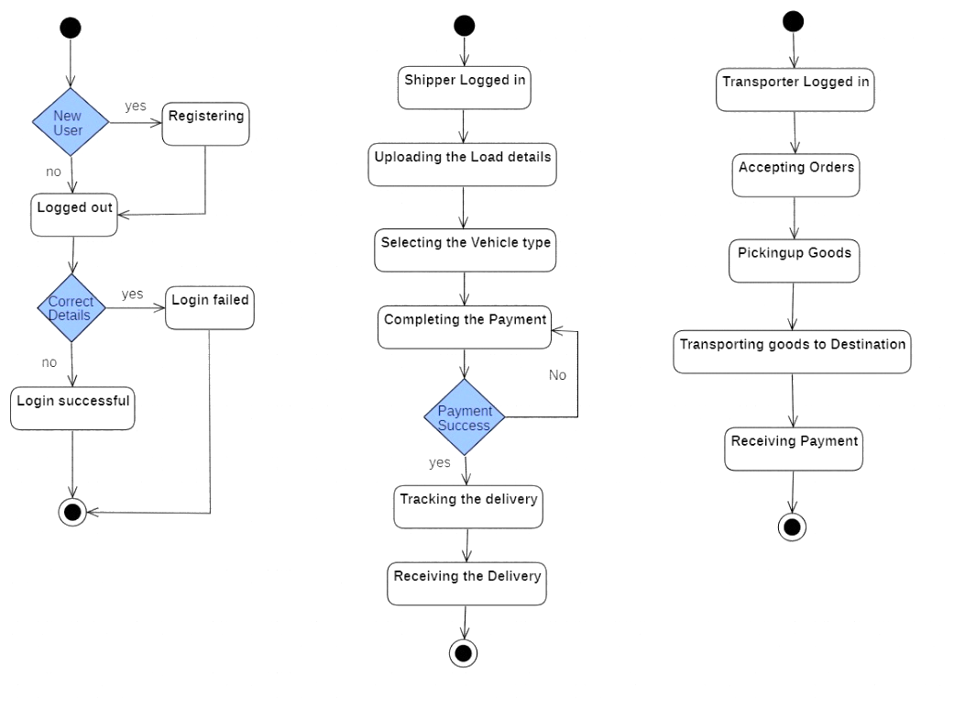

- UML Diagrams
Activity Diagram:
This activity diagram shows the complete workflow of the BeeBuzz system from user login to booking, delivery, and payment.
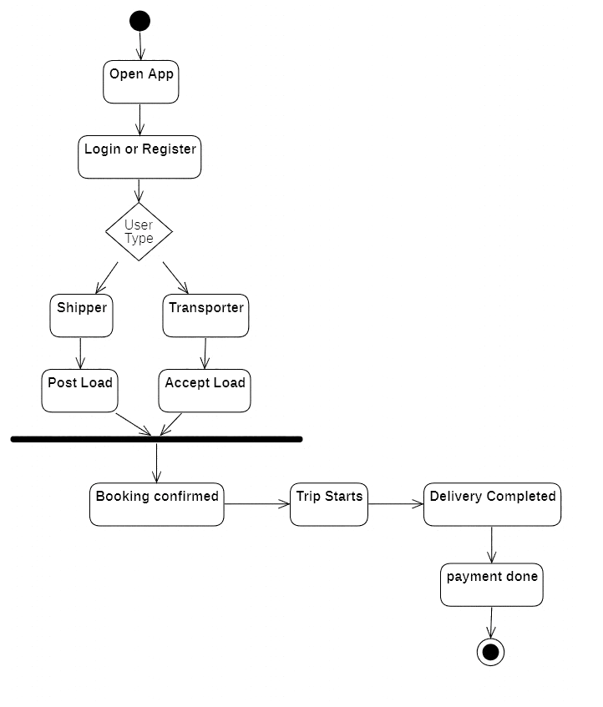

- UML Diagrams
Login Sequence Diagram:
This shows the interaction between user, application, server, and database during login by the customer.
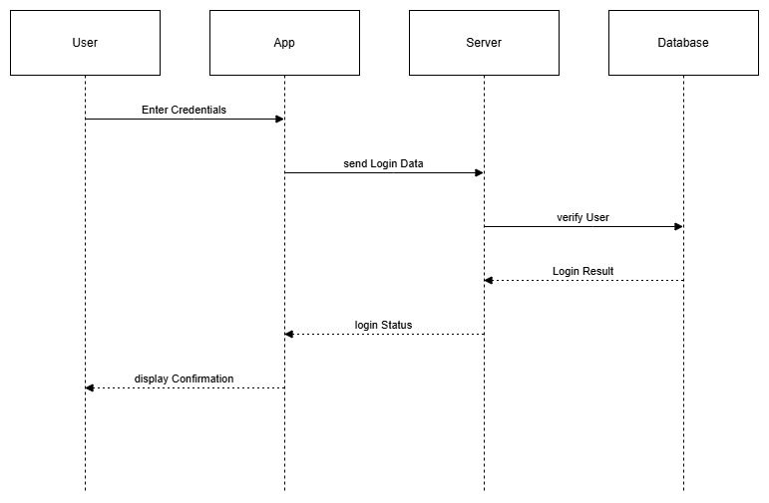

Shipper Sequence Diagram:
This shows the interaction between shipper, system, database, and payment gateway during load uploading, booking, and payment.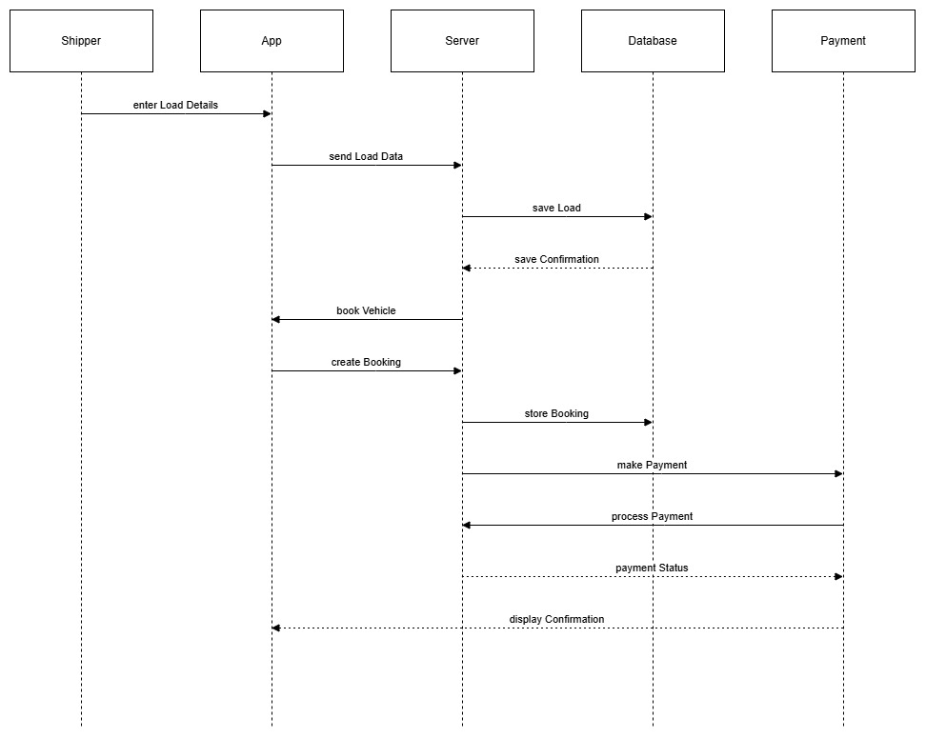

Transporter Sequence Diagram:
This shows the interaction between the transporter and app during load acceptance, tracking, and delivery.
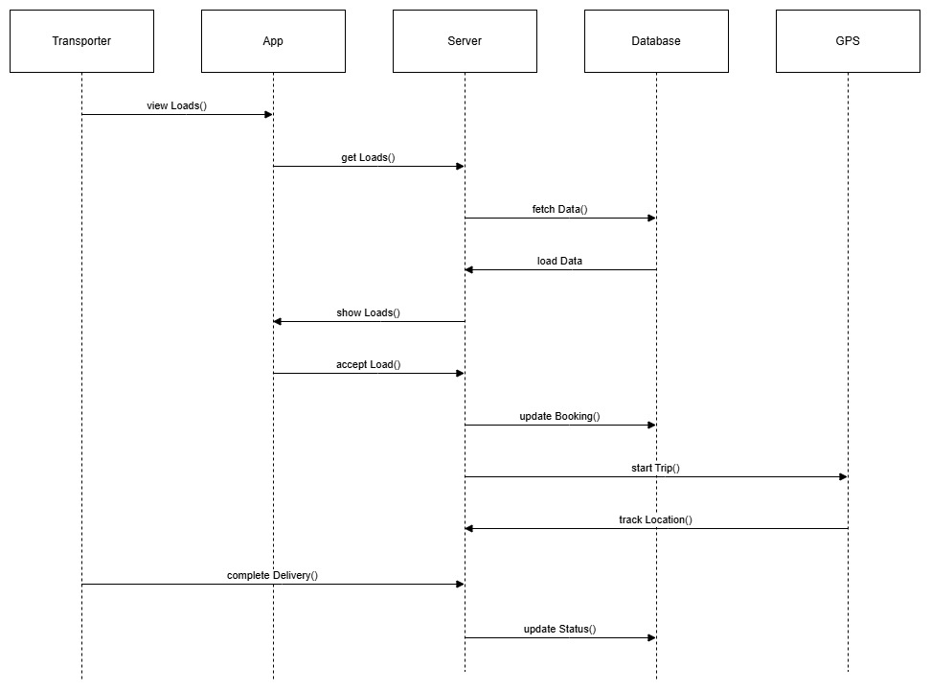

Admin Sequence Diagram:
This shows the interaction between admin and system for verification, monitoring tasks, and handling the situations.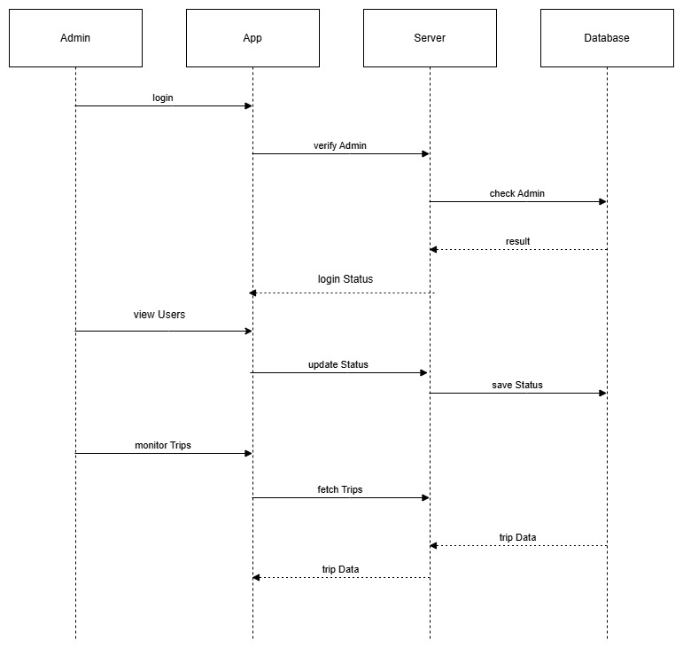
Core Sequence Diagram:
This shows the interaction between shipper, transporter, system, and payment service during a complete booking process.
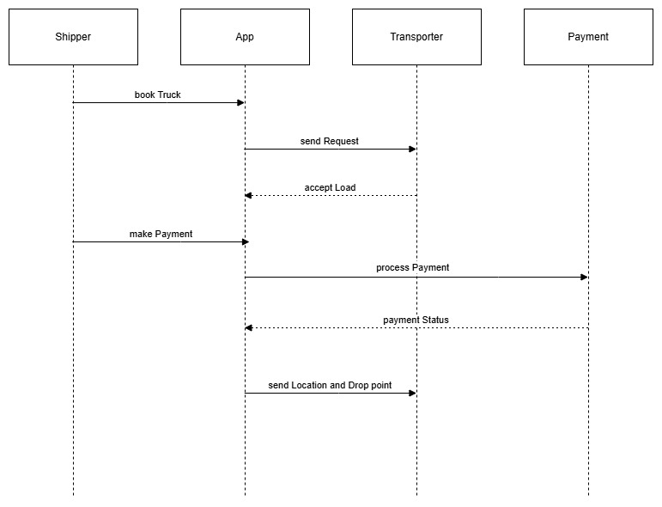

- UML Diagrams
Login Collaboration Diagram:
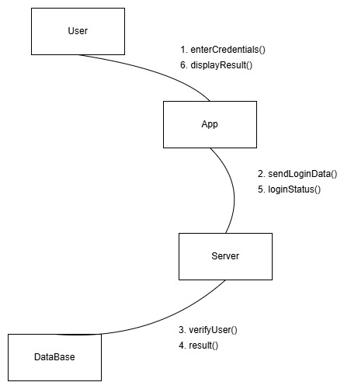

Shipper Collaboration Diagram:
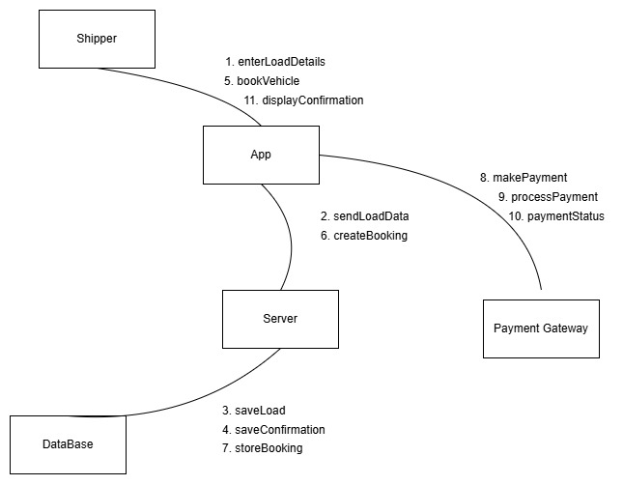

Transporter Collaboration Diagram:
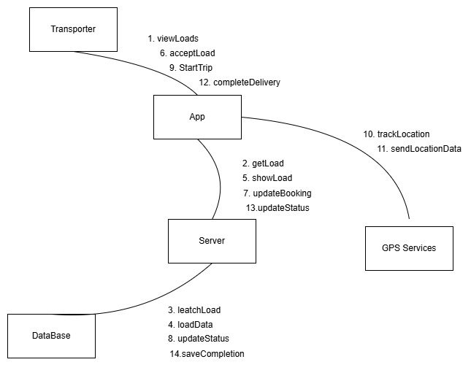

Admin Collaboration Diagram:
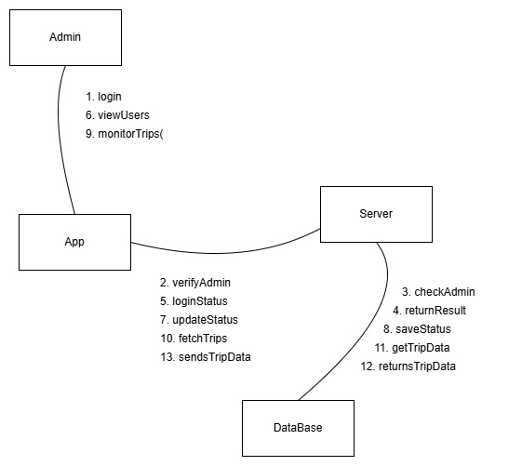

Core Collaboration Diagram:
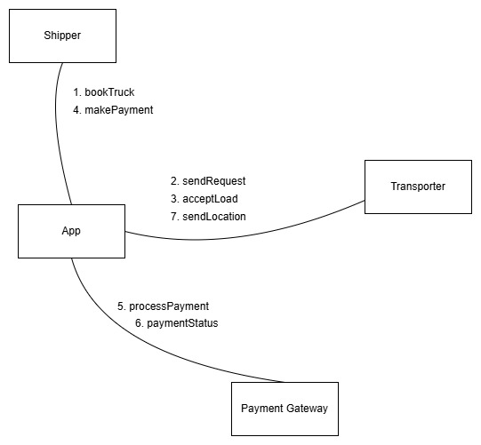

- ER Diagram
The ER diagram models the relationships between users, shippers, transporters, loads, bookings, and payments with proper cardinality
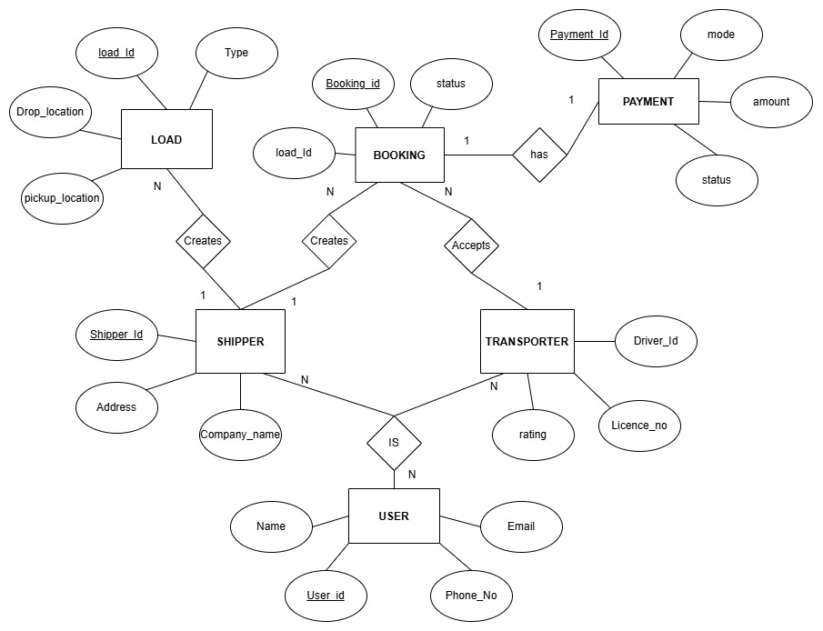

- DFD
This Level-1 DFD shows how login, booking, payment, and database processes interact through the user interface.
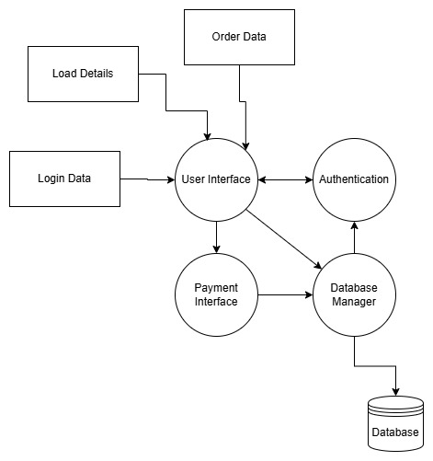

External Interface Requirements
- User Interfaces
Beebuzz system will be available for both smartphone as well as desktop pc.
- Mobile Application: Build using React Native
- Web Application: Developed using React.js
- Backend: integration using Python
Features in UI:
- User Registration and Login
- Load Posting Interface
- Booking Dashboard
- Payment Page
- Real-Time Tracking Screen
- Admin Control Panel

- Hardware Interfaces
To run BeeBuzz standard Hardware requirements are:
- Smartphone.
- Desktop or Laptop computers.
- Cloud-services (Microsoft Azure).

Additional Hardware components required
- GPS Module (Mobile Built in GPS / Manual location entry for PCs)
- Internet-enabled network (Wifi / 4G / 5G)

- Software Interfaces
To run BeeBuzz standard software requirements are:
- Operating System
  - Mobile Application (Android 8.0+ / IOS 12+)
  - Web Application (Windows / Mac / Linux with any suitable browser)
- Database Management
  - Mysql Database Management system.
- Payment Gateway
  - UPI Integration (Razorpay / Paytm API)
  - Net Banking
  - Credit/Debit Card Processing APIs
- Maps and location services
  - Mapple Maps API
- Authentication
  - CloudFlare
- Communication Interfaces
Beebuzz system will use internet-based communication protocols.
  - Protocol: HTTPS (Secure HTTP)
  - API Communication: Hugging Face APIs
  - Data Format: JSON
  - Real-Time Tracking: Mapple’s API
  - Encryption: CloudFlare encryption for secure data transmission

Other Non-Functional Requirements
- Performance Requirements
  - The System should respond in 2-3 seconds.
  - Login and booking should not fail.
  - The app should support many users at the same time.
  - Live tracking should update quickly.
- Safety Requirements
  - User data should not be lost.
  - Regular backup of Database to ensure safety.
  - Payment data should safely be stored.
  - Some errors should not crash the system.
- Security Requirements
  - User password should be encrypted.
  - Data transfer should use HTTPS.
  - Only authorized users can access the system.
  - Protection from hacking and attack.
- Software Quality Attributes
  - Reliability: System should work properly.
  - Usability: App should be easy to use.
  - Scalability: System should grow in future.
  - Maintainability: Easy to update and fix.
  - Availability: System should work 24/7.
- Business Requirements
  - Only Verified transporters can accept bookings.
  - Cancellation rules must be followed.
  - Admin can block fake users.

Testing
- White-Box testing
Program (Login) :
import re
def login(user,password):
p="^(?=.*[A-Z])(?=.*\d)(?=.*[@$!%*?&]).{8,}$"
if(len(user)>=5 and type(user)==type("S")):
if(re.match(p,password)):
return "Login Successful"
else:
return "Invalid Password"
else:
return "Invalid User"

print(login("admin","12345"))
print(login("Admin","Doraemon@3"))
print(login("df","12345"))

Flow Graph:
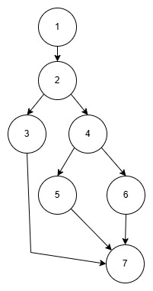
Cyclometric Complexity:
V(G) = E – N + 2
N = 7
E = 8
V(G) = 3

Independent Paths:
Path 1 (Successful Login)
1 → 2 → 3 → 4 → 7

Path 2 (Invalid Password)
1 → 2 → 3 → 5 → 7

Path 3 (Invalid User)
1 → 2 → 6 → 7

Path No | Independent Path (Node Sequence) | Test Input (marks_list) | Expected Output
P1 | 1 → 2 → 3 → 4 → 7 | ("Admin","Password@3") | Login Success
P2 | 1 → 2 → 3 → 5 → 7 | ("admin","12345") | Invalid Password
P3 | 1 → 2 → 6 → 7 | (“df” , “Password@3”) | Invalid User

UnitTesting:
class TestLogin(unittest.TestCase):
def test_Success(self):
self.assertEqual(login("Admin","Password@3"), "Login Successful")
def test_inv_pass(self):
self.assertEqual(login("admin","12345"), "Invalid Password")
def test_inv_user(self):
self.assertEqual(login("df","Password@3"), "Invalid User")

unittest.main()

Output:
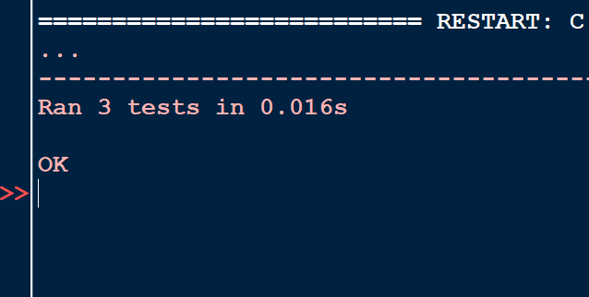
- Black-Box testing
Functional Requirements:
- User Name length should be greater than 5
- Password Must contain
  - uppercase letter
  - number
  - special character
  - length ≥ 8
- Else Invalid
Equivalence Partitioning:
- User Name
Length <5 Invalid
Length >=5 Valid

- Password
Condition | Outcome
Length < 8 | Invalid
Length >=8 | Valid
Contains a Number | Valid
Does not contain Number | Invalid
Contains anUppercase | Valid
Does not contain Uppercase | Invalid
Contains a Special Char | Valid
Does not contain Special Char | Invalid

Boundary Value Analysis:
Username minimum length = 5

Test | Username | Result
Boundary -1 | abcd | Invalid User
Boundary | abcde | Valid User

Password
Test Case | Password | Length | Expected Result
B1 (Below boundary) | Pass@1 | 6 | Invalid
B2 (Just below boundary) | Pass@12 | 7 | Invalid
B3 (Boundary) | Pass@123 | 8 | Valid
B4 (Above boundary) | Password@3 | 10 | Valid

Test Cases Output:
print(login("admin","12345"))
print(login("Admin","Password@3"))
print(login("df","12345"))

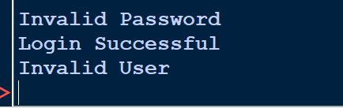

Testing (Program 2)
- White-Box testing
Program (Shipper load post):
loads = []
def post_load(shipper, pickup, drop, weight, vehicle):
vehicles = ["Truck", "MiniTruck", "Trailer"]
if len(shipper) < 3:
return "Invalid Shipper Name"
if pickup == drop:
return "Pickup and Drop cannot be same"
if weight <= 0:
return "Invalid Load Weight"
if vehicle not in vehicles:
return "Invalid Vehicle Type"
loads.append((shipper, pickup, drop, weight, vehicle))
return "Load Posted Successfully"

print(post_load("Admin", "Vijayawada", "Hyderabad", 2000, "Truck"))
print(post_load("AB", "Delhi", "Mumbai", 1000, "Truck"))
print(post_load("Shipper1", "Chennai", "Chennai", 500, "Truck"))
print(post_load("Shipper2", "Pune", "Nagpur", -10, "Truck"))

print("\nCurrent Loads:", loads)

Flow Graph:
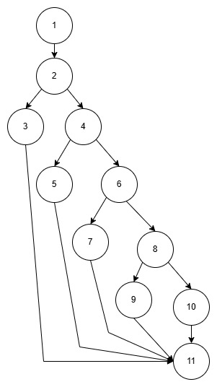
Cyclometric Complexity:
V(G) = E – N + 2
N = 11
E = 14
V(G) = 5

Independent Paths:
Path 1 (Invalid Shipper)
1 → 2 → 3→ 11
Path 2 (Invalid Pickup or drop)
1 → 2 → 4 → 5→ 11
Path 3 (Invalid Load Weight)
1 → 2 → 4 → 6 → 7 → 11
Path 4 (Invalid Vehicle Type)
1 → 2 → 4 → 6 → 8 → 9 → 11
Path 5 (Successful load)
1 → 2 → 4 → 6 → 8 → 10 → 11

Path No | Independent Path (Node Sequence) | Test Input (marks_list) | Expected Output
P1 | 1 → 2 → 3→ 11 | ("An", "Vijayawada", "Hyderabad", 2000, "Truck") | Invalid Shipper
P2 | 1 → 2 → 4 → 5→ 11 | ("Shipper1", "Chennai", "Chennai", 500, "Truck") | Invalid Pickup or drop
P3 | 1 → 2 → 4 → 6 → 7 → 11 | ("Admin", "Delhi", "Mumbai", -10, "Truck") | Invalid Load Weight
P4 | 1 → 2 → 4 → 6 → 8 → 9 → 11 | ("Shipper2", "Pune", "Nagpur", 100, "bike") | Invalid Vehicle Type
P5 | 1 → 2 → 4 → 6 → 8 → 10 → 11 | ("Admin", "Vijayawada", "Hyderabad", 2000, "Truck") | Load post successful

UnitTesting:
import unittest
class TestPostLoad(unittest.TestCase):
def test_invalid_vehicle(self):
self.assertEqual(
post_load("Admin", "Vijayawada", "Hyderabad", 2000, "Auto"),
"Invalid Vehicle Type")
def test_success(self):
self.assertEqual(
post_load("Admin", "Vijayawada", "Hyderabad", 2000, "Truck"),
"Load Posted Successfully" )
def test_invalid_shipper(self):
self.assertEqual(
post_load("AB", "Delhi", "Mumbai", 1000, "Truck"),
"Invalid Shipper Name")
def test_same_location(self):
self.assertEqual(
post_load("Shipper1", "Chennai", "Chennai", 500, "Truck"),
"Pickup and Drop cannot be same")
def test_invalid_weight(self):
self.assertEqual(
post_load("Shipper2", "Pune", "Nagpur", -10, "Truck"),
"Invalid Load Weight")

unittest.main()

Output:
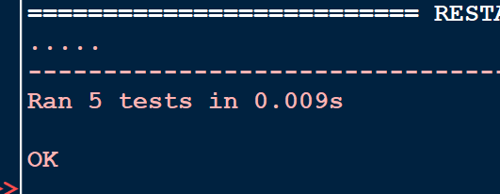

- Black-Box testing
Functional Requirements:
- Shipper Name
- Pickup and Drop
- Weight
- Vehicle Type
Equivalence Partitioning:
- Shipper Name
Length <3 Invalid
Length >=3 Valid
- Pickup and Drop
Pickup = Drop Invalid
Pickup != Drop Valid
- Weight
Weight <=0 Invalid
Weight >0 Valid
- Vehicle Type
Truck or MiniTruck or Trailer Invalid
Else Valid
Boundary Value Analysis:
Shipper Name minimum length = 5
Test | Username | Result
Boundary -1 | ab | Invalid User
Boundary | abc | Valid User

Minimum valid weight >0
Test | Weight | Result
Boundary -1 | -1 | Invalid
Boundary | 0 | Invalid
Boundary +1 | 1 | Valid
Vehicle Type
Test | Vehicle | Result
TC1 | Truck | Valid
TC2 | MiniTruck | Valid
TC3 | Trailer | Valid
TC4 | Any other vehicle | Invalid

Pickup and Drop location
Test | Pickup | Drop | Result
TC1 | Delhi | Munbai | Valid
TC2 | Chennai | Chennai | Invalid
Test Cases Output:
print(post_load("Admin", "Vijayawada", "Hyderabad", 2000, "Truck"))
print(post_load("AB", "Delhi", "Mumbai", 1000, "Truck"))
print(post_load("Shipper1", "Chennai", "Chennai", 500, "Truck"))
print(post_load("Shipper2", "Pune", "Nagpur", -10, "Truck"))

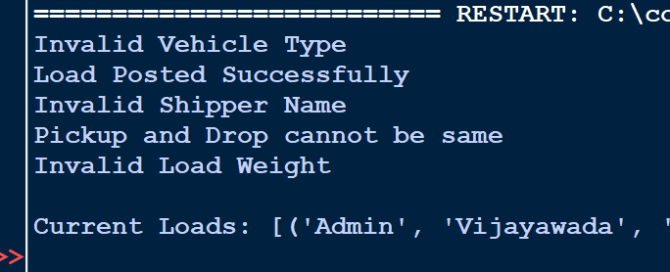

Conclusion
The software requirement specification (SRS) describes the complete architectural functionality of BeeBuzz software. It explains how the software connects truck drivers and many other members related to the field. This document describes the systems functionalities, interfaces, schematics and testing techniques required for the development of the BeeBuzz software. It serves as a guide for the BeeBuzz system’s design and execution and ensures everything works as planned. It also ensures all the stakeholders are aware of the system requirement and its behaviour.

References
- Software Engineering laboratory notes provided by the faculty
- StarUMLgeneral guidelines for UML diagrams
- Software Requirement Specification (SRS) format guidelines.

Acknowledgement
I would like to express my sincere gratitude to our lab faculty for providing the lecture notes and guidance that helped in preparing this Software Requirement Specification document. Their explanations and support helped in understanding concepts such as UML diagrams, systemrequirement, and software testing. I also thank my classmates and friends for their discussions and support during the development of the BeeBuzz project.

Design Architecture

Component Design
Login
The Login component has user authentication and access to the BeeBuzz system.
It validates user’s password and user name and verifies them with the database before granting system access.
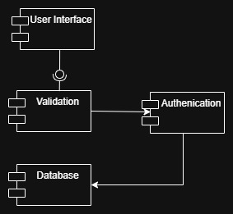

Shipper
The Shipper componentshows process of users post load details and create transport bookings.
It also enables shippers to make payments and track the delivery of their goods.
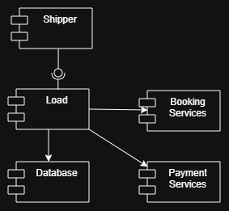
Transporter
The Transporter module allows drivers to view available loads and accept transport requests.
It also enables drivers to update delivery status and share location information during shipment.
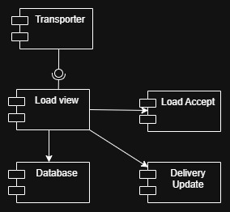

Admin
The admincomponent shows how admin manages users and monitors the overall system activities.
It verifies transporter details, handles complaints, and maintains the smooth operation of the BeeBuzz software.
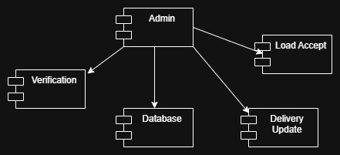

Deployment Diagram
The deployment diagram represents the physical architecture of the BeeBuzz software. Mobile devices communicate with the application server over the internet, showing which hardware processes requests and interacts with the database server and application services such as payment gateways,booking services and notification services.

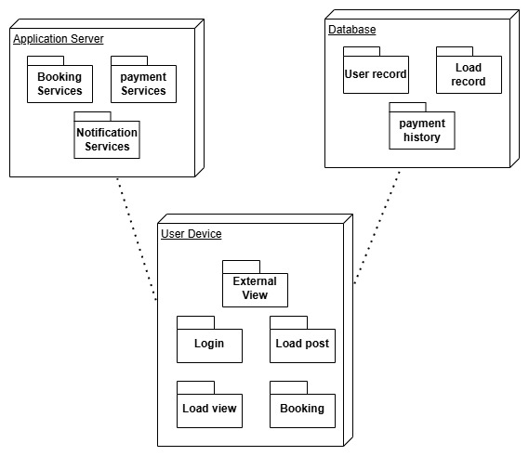

Product Matrices

Function Point Analysis
The Information Domain Values have also been categorized into 2 types.
Transactional Functional type
- External inputs (EIs).
- External outputs (Eos).
- External inquiries (EQs).

Data functional type
- Internal logical files (ILFs).
- External interface files (EIFs).

Function Point:
FP = count total * (0.65 + 0.01 * ∑ Fi)

- Step 1: Calculate count total or UFP

Information Domain value | count | Weightage Factor  simple Average complex |  |  | Total
External inputs (EIs). | 7 | 3 | 4 | 6 | 21
External outputs (Eos). | 5 | 4 | 5 | 7 | 20
External inquiries (EQs). | 3 | 3 | 4 | 6 | 9
Internal logical files (ILFs). | 1 | 7 | 10 | 15 | 7
External interface files (EIFs). | 3 | 5 | 7 | 10 | 15
Count Total |  |  |  |  | 72

The final value of Count Total is 72.

- Step 2: Calculate Complexity Adjustment Factor CAF or VAF

Value Adjustment Factor:
- Does the system require reliable backup and recovery?
- Are specialized data communications required to transfer information to or from the application?
- Are there distributed processing functions?
- Is performance critical?
- Will the system run in an existing, heavily utilized operational environment?
- Does the system require online data entry?
- Does the online data entry require the input transaction to be built over multiple screens or operations?
- Are the ILFs updated online?
- Are the inputs, outputs, files, or inquiries complex?
- Is the internal processing complex?
- Is the code designed to be reusable?
- Are conversion and installation included in the design?
- Is the system designed for multiple installations in different organizations?
- Is the application designed to facilitate change and ease of use by the user?

∑(Fi ) – the sum of value adjustment factors

Weightage:
  - No Influence - 0
  - Incidental - 1
  - Moderate - 2
  - Average - 3
  - Significant - 4
  - Essential - 5

Since BeeBuzz involves moderate complexity such as online transactions, database usage, and real-time tracking, all factors are considered moderate.

All the factors are rated Moderate ie 2
∑ Fi = 14 * 2
CAF = (0.65 + 0.01 * 28)
CAF = 1.07

- Step 3: Calculate Function Point (FP)
The Function Point comes out to be:
FP = Count Total * CAF
FP = 72 * 1.07
FP = 77.04

  - The Function Point value of 77.04 indicates that BeeBuzz is a medium-sized project.
  - It shows that the system has moderate complexity with balanced functionalities.
  - The project can be developed efficiently with a small team in a reasonable time.

Empirical
Estimation Model:
COCOMO Model

- Basic COCOMO model

The Basic COCOMO can be used for quick and slightly rough calculations of Software Costs.
The following formulas are used to calculate effort and time estimates.

Effort (E) = A*(KLOC)^{B}
Time (T) = C*(Effort)^{D}
Persons required = Effort / Time

The constant values A, B, C and D for the Basic Model for the different categories of software
projects.
Software Project | A | B | C | D
Organic | 2.4 | 1.05 | 2.5 | 0.38
Semi Detached | 3.0 | 1.12 | 2.5 | 0.35
Embedded | 3.6 | 1.20 | 2.5 | 0.32

On rough estimation out project beebuzz has around 3500 lines of code
So, KLOC = 3.5
For 3.5 KLOC it comes under Organic (Software Project)
A = 2.4 , B = 1.05 , C = 2.5 , D = 0.38
Effort (E) = A*(KLOC)^{B}
= 2.4*(3.5 ^{1.05})
= 8.94

Time (T) = C*(E)^{D}
= 2.5*(8.94 ^{0.38})
= 5.74 months

Persons required = Effort / Time
= 8.94/5.74
= 1.55 approx. (2 members)

- Intermediate COCOMO Model

In the intermediate COCOMO model, various other factors such as reliability, experience, and
Capability is considered along with LOC to estimate effort and time schedule.
These factors are known as Cost Drivers and the Intermediate Model utilizes 15 such drivers for
cost estimation.

  - Product attributes:
    - Required software reliability extent
    - Size of the application database
    - The complexity of the product
  - Hardware attributes:
- Run-time performance constraints
- Memory constraints
- The volatility of the virtual machine environment
- Required turnabout time
  - Personnel attributes:
- Analyst capability
- Software engineering capability
- Applications experience
- Virtual machine experience
- Programming language experience
  - Project attributes:
- Use of software tools
- Application of software engineering methods
- Required development schedule

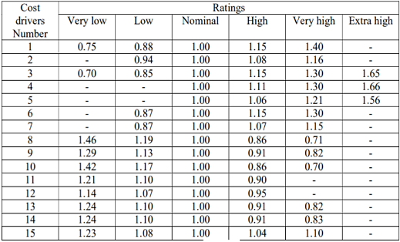

The Intermediate COCOMO model formulas are

Effort (E) = A*(KLOC)^{B}*EAF.
Time (T) = C*(Effort)^{D}
Persons required = Effort / Time

The constant values A, B, C and D for the Basic Model for the different categories of software
projects.
Software Project | A | B | C | D
Organic | 3.2 | 1.05 | 2.5 | 0.38
Semi Detached | 3.0 | 1.12 | 2.5 | 0.35
Embedded | 2.8 | 1.20 | 2.5 | 0.32

Let use assume these values for our BeeBuzz EAF (Product of cost estimation)

No | Cost Driver | Rating | Multiplier
1 | Reliability | Nominal | 1.00
2 | Database Size | High | 1.08
3 | Product Complexity | Nominal | 1.00
4 | Run-time Constraints | Nominal | 1.00
5 | Memory Constraints | Nominal | 1.00
6 | VM Volatility | Nominal | 1.00
7 | Turnaround Time | Nominal | 1.00
8 | Analyst Capability | High | 0.86
9 | Software Engg Capability | High | 0.91
10 | Application Experience | Nominal | 1.00
11 | VM Experience | Nominal | 1.00
12 | Language Experience | Nominal | 1.00
13 | Software Tools | High | 0.91
14 | Engineering Methods | Nominal | 1.00
15 | Schedule | Nominal | 1.00

EAF = 1.00 * 1.08 * 1.00 * 1.00 * 1.00 * 1.00 * 1.00
* 0.86 * 0.91 * 1.00 * 1.00 * 1.00 * 0.91 * 1.00 * 1.00
EAF = 0.77

On rough estimation out project Beebuzz has around 3500 lines of code
So, KLOC = 3.5
For 3.5 KLOC it comes under Organic (Software Project)
A = 3.2 , B = 1.05 , C = 2.5 , D = 0.38
Effort (E) = A*(KLOC)^{B}*EAF
= 3.2*(3.5 ^{1.05})* 0.77
= 9.19

Time (T) = C*(E)^{D}
= 2.5*(9.19^{0.38})
= 5.8 months

Persons required = Effort / Time
= 9.19/5.8
= 1.58 approx. (2 members)

