**Assignment**

**Step 1:**

**Created SSM Parameter with standard tier of type string.**

**Details:**

Name: UserName

Value: JohnDoe

**Output**:

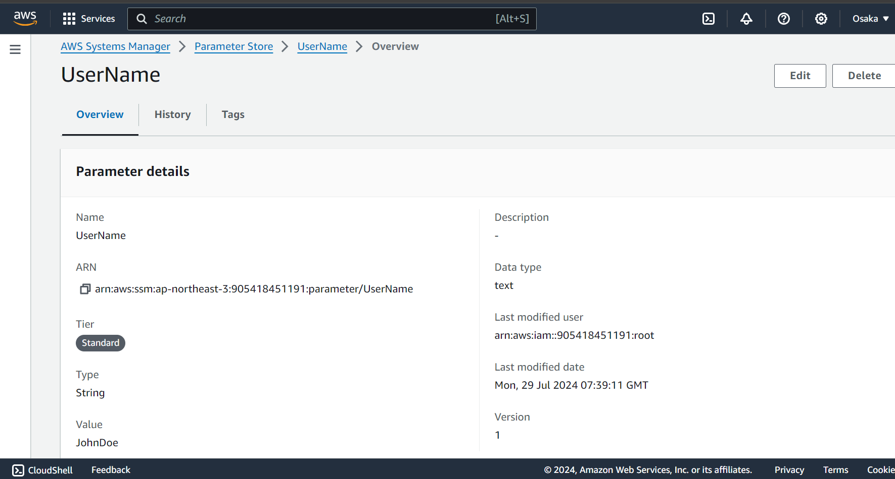

**Step 2:**

Created s3 bucket to store python source code and SSM output files.

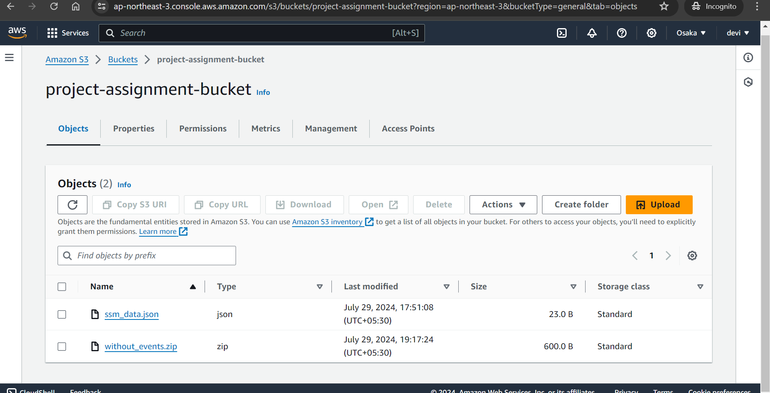

**Step 4:**

**Deploy CFT:**

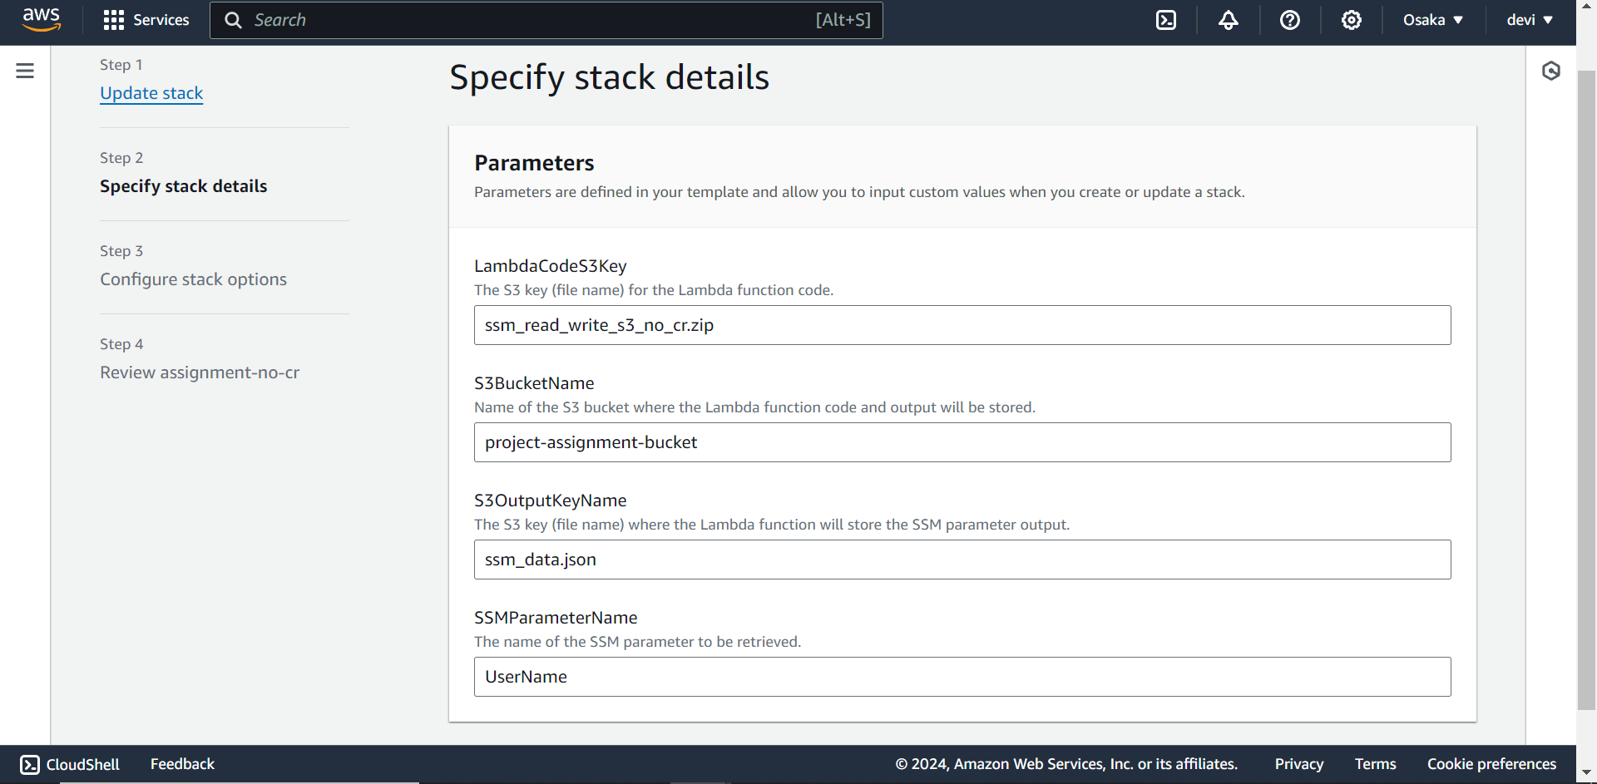

**Step 5:**

**Trigger lambda**

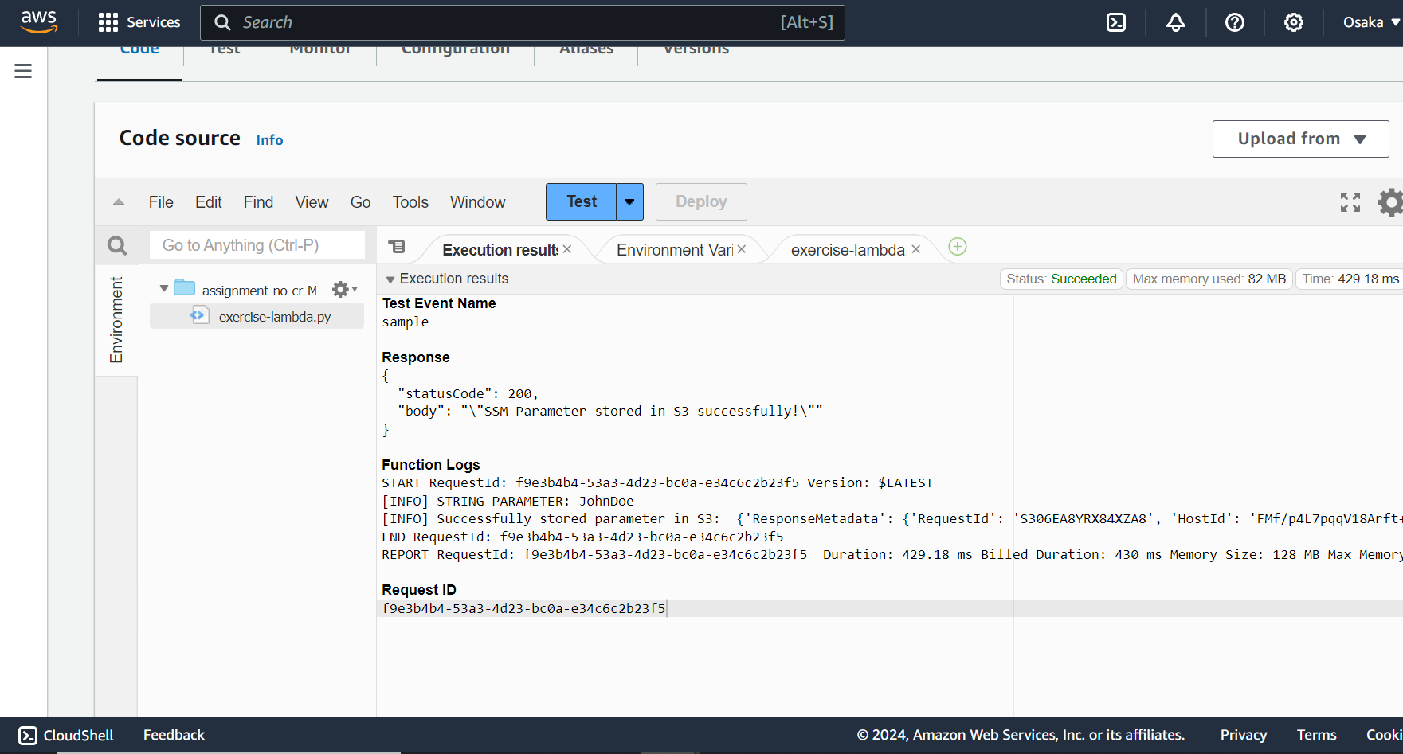

**Step 6:**

**Check the “json” file output.**

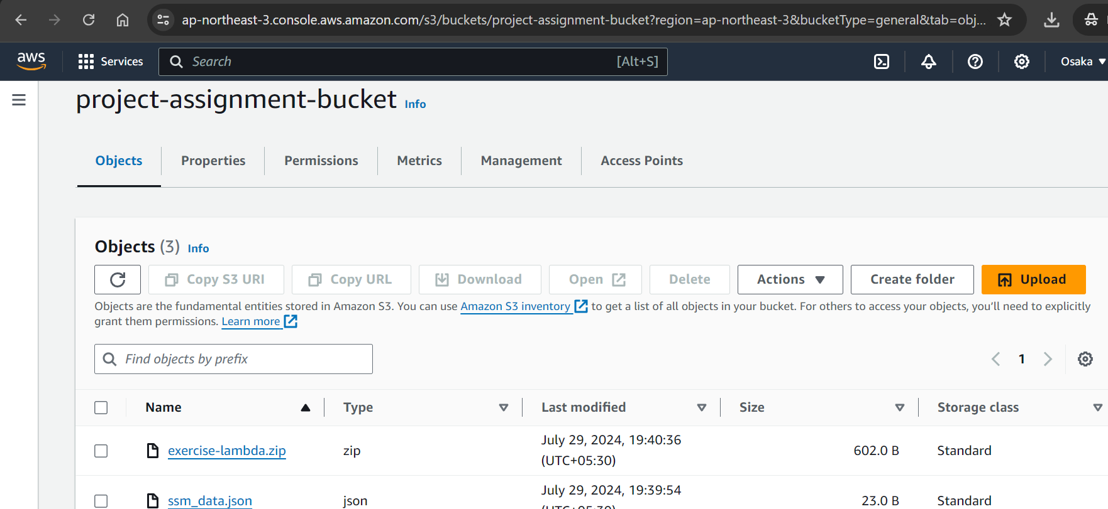

**Json Output:**

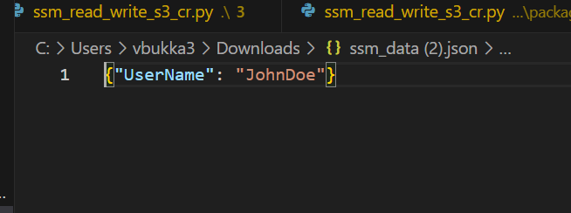

**Note:**

**Roles for lambda:**

