**ASSET NAME**:- Clean instances in a zone

**Problem :-** Forgetting to delete the instances after practice.

**Design :**

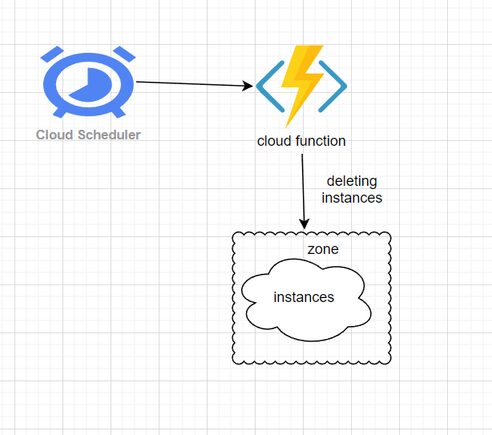

**Flow:-**

From cloud scheduler a job will trigger a cloud function through http url and executes python script to delete all the instance in a particular zone.

**Steps involved:**

Infrastructure creation using terraform.

**Resources: -**

1. Cloud scheduler
2. Cloud function

**Folder structure:-**

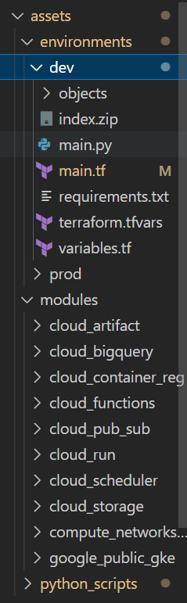

**Infra code for cloud scheduler:**

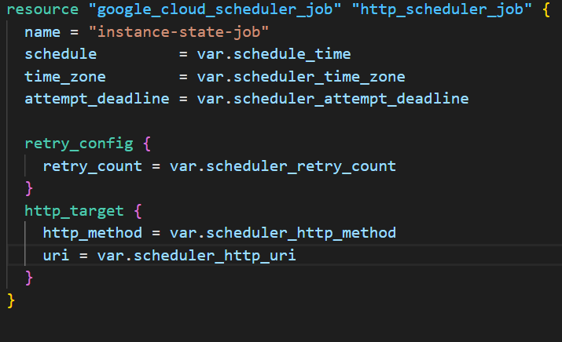

**Infra code for cloud function:**

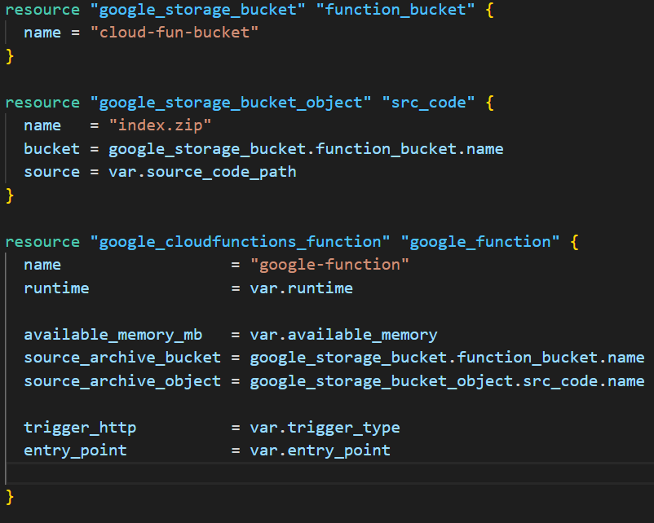

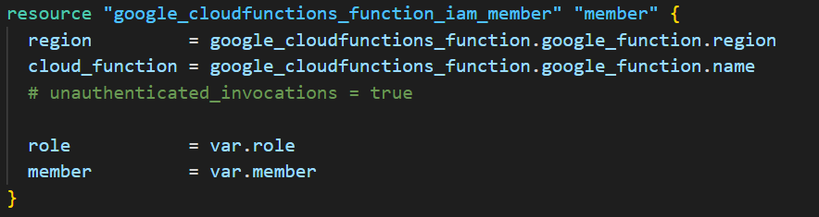

This below code is from modules from here we will have to pass the values to the main.tf file.

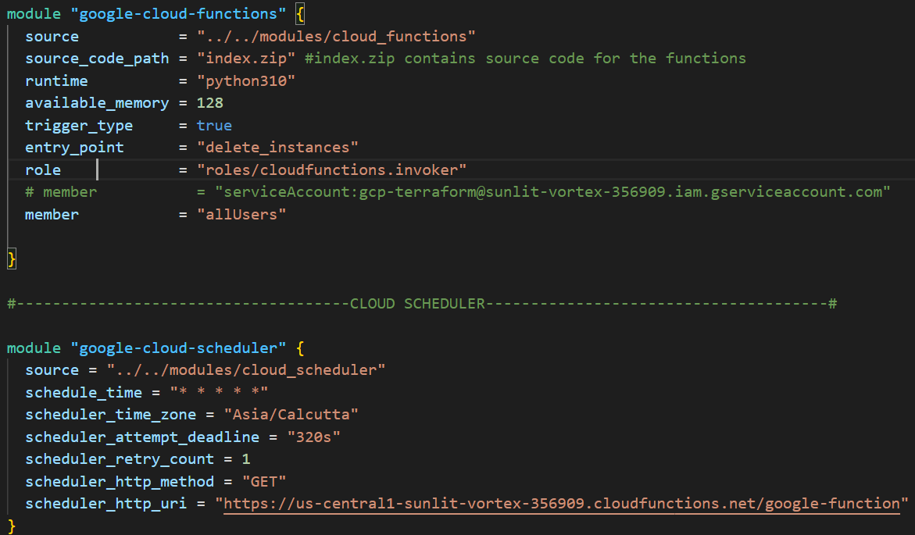



**Python script for deleting instances in the zone--**

