🡺create table cls2(id int primary key,stu_name varchar(20),assignment_no int,score int);

insert into cls2 values(3,'aman',1,45);

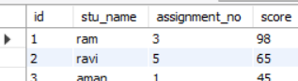

1. select max(score) from cls2;



select stu_name,score

from cls2

where score>(select max(score) from cls2);

1. select stu_name,count(assignment_no)

from cls2

group by stu_name

having count(assignment_no)>1;

1. recently joined employee

select name

from cls2

where hire_date=(select min(hire_date) from cls2);

