**Dictionary :**

Dictionary is a built-in type which is used to store the data in a key-value pair format.

(or)

Dictionary is an unordered ,changeable collection of data values which holds the key value pairs. The keys and values are separated by the collon.keys are immutable. This dictionary will be indicated by calling “dict ( )” function or by calling the “ { } “

**Methods in dictionary :**

**Ex1 :**

y={ } #by using curly braces

print(y)

print(type(y))

print(len(y))

**EX2:**

z= { “python”:90, “java”:95, “django”:100 }

print(z)

print(type(z))

print(len(z))

**EX3:**

x=dict ( ) #by using dict funct

print(x)

print(type(x))

print(len(x))

**EX4:**

y={ } #using of curly braces

print(y)

print(type(y))

print(len(y))

**EX5:**

z= {"python":90, "java":95, "django":100 }

print(z)

print(type(z))

print(len(z))

z["hadoop"]=85 #inserting the data

print(z)

**EX6:**

i={1000:True, "gopichand":123.123,False:3+4j}

print(i)

for p in i:

print(p)

**EX7:**

a={"python":90, "java":95, "django":100 }

b=a.keys() #getting keys

print(b)

c=a.values() #getting values

print(c)

d=a.items() #getting items one by one

print(d)

for i in d:

for j in i:

print(j)

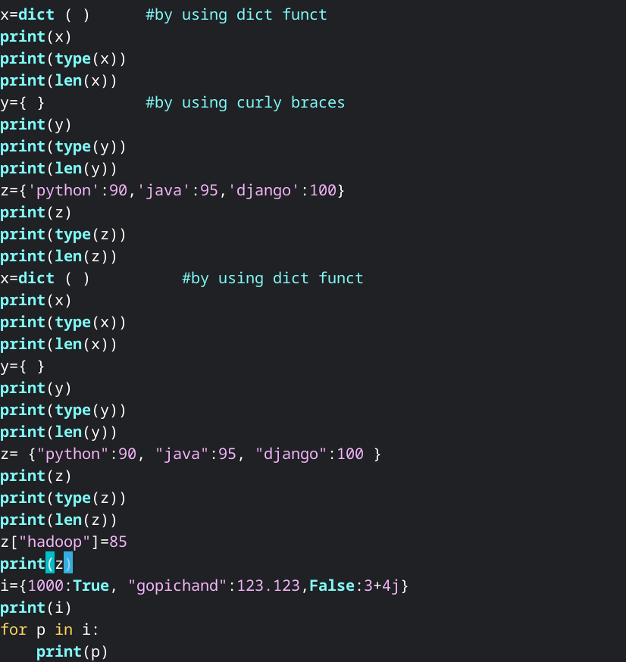

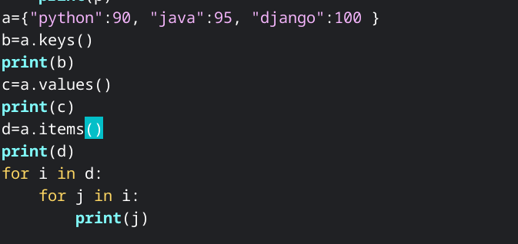

**Output :**

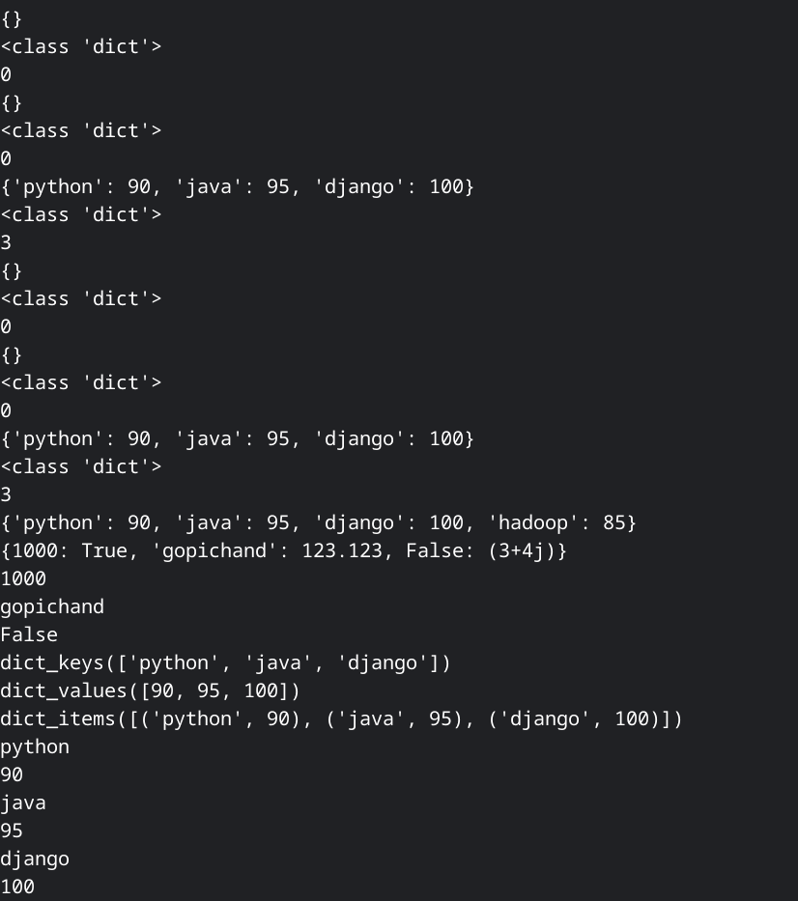

**Sets:**

set objects are created by using { } or by calling the set functions.

A Set in Python programming is an unordered collection data type that is iterable, mutable and has no duplicate elements.

EX1:

x=set( ) #using of set function

print(x)

print(type(x))

print(len(x))

y={100,200,300,200,100} #assigning of some values

print(y)

print(type(y))

print(len(y))

i={10,20,30,40}

print(i)

print(type(i))

print(len(i))

j={30,40,50,60}

print(j)

print(i/j) #using of union

print(i.union(j))

print(i&j) #using of intersection

print(i.intersection(j))

print(i-j) #using of difference

print(i.difference(j))

print(i^j) #using of symmetric difference

print(i.symmertic_difference(j))

i.update(j)

print(i)

print(i.issuperset(j))

print(i.issubset(j))

print(i)

print(j)

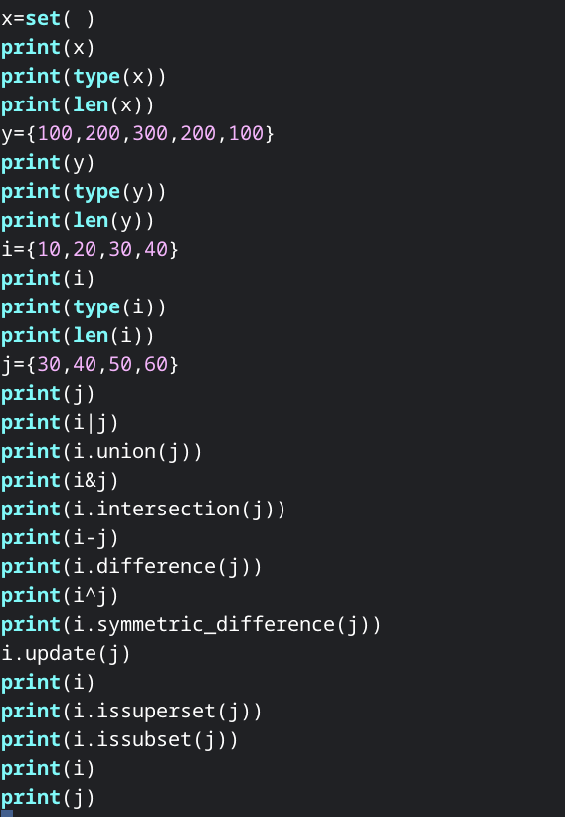

Output :

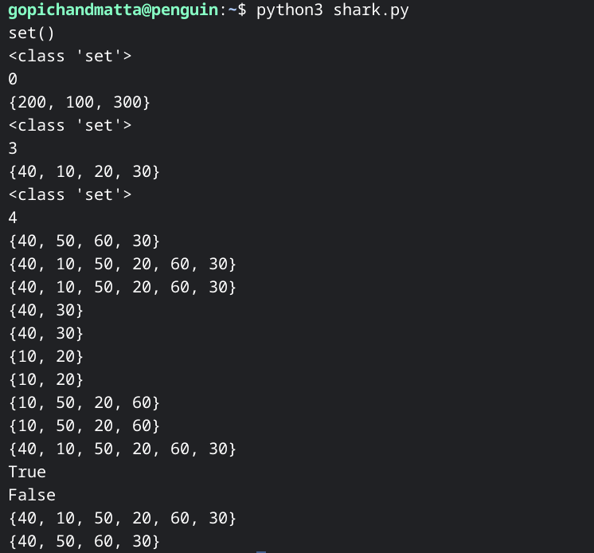

**String :**

String is a sequence of Unicode characters that is enclosed in quotation marks.

**EX1 :**

x="Hello_World"

print(x.lower()) #convert into lower

print(x.upper()) #convert into upper

print(x.title()) #starting letters will become upper

print(x.swapcase()) #capitals become small | small become upper

print(x.capitalize()) #first letter only upper

print(x.isalnum()) # print True if it is alphanumeric

print(x.isalpha()) # print True if it is all alpha

print(x.isdecimal()) # print True if it is all decimal

print(x.isdigit()) # print True if it is all digits

print(x.isidentifier())

print(x.istitle())

y="Ant"

print(x.join(y)) #joins at the end of the each letter of Ant here

print(x.startswith(y))

print(x.splitlines()) #splitlines are denoted in the [ ].

print(x.format())

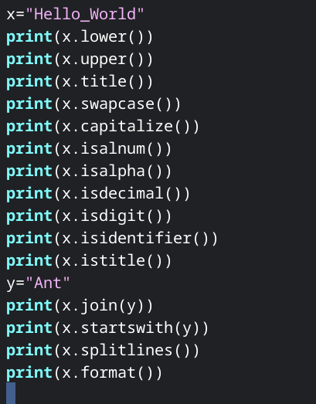

output:

