**Dictionary methods**

# 1.clear():

The clear() method in python dictionary is a built in method, this is used to clear the entire elements of a dictionary(key:values).

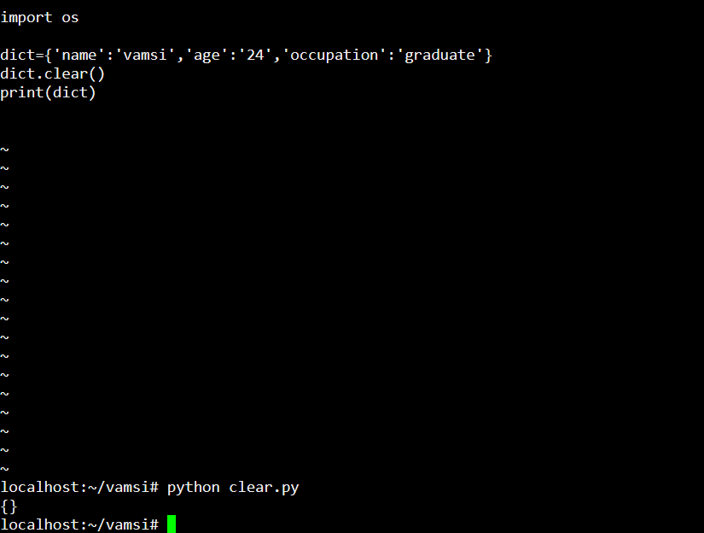

# 2.get():

the get() method in python is a pre built dictionary function it is used to obtain the dictionary value linked to a particular key.in this method we can not get keyerror if there is no key.

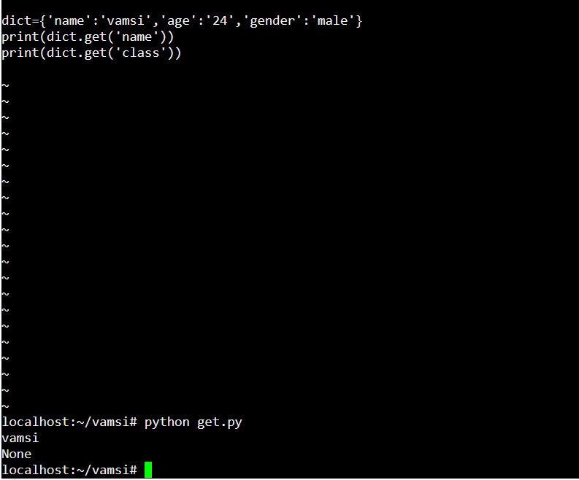

# 3.items():

The items() method in python is a inbuilt dictionary function that is retrieves a viewing objects of list of tuple. Each tuple represent a key value from the dictionary and it’s a easy way to access the key values from a dictionary.

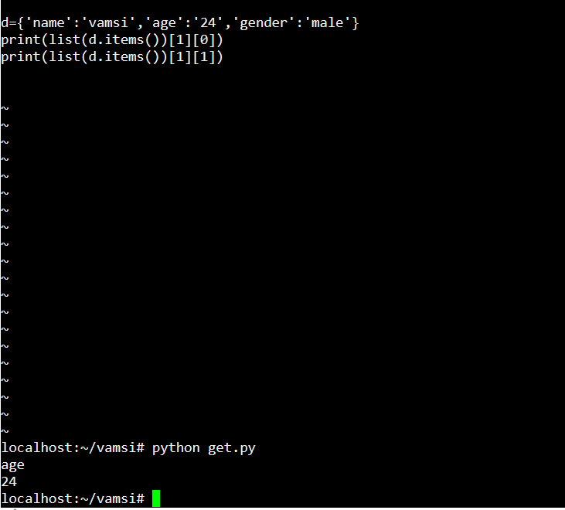

# 4.keys():

the keys() method in python is used to display the viewing objects with dictionary keys its allowing to access.

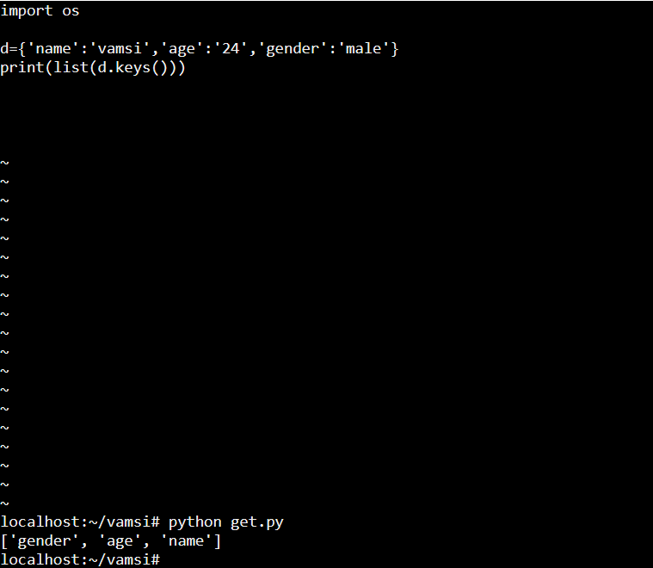

# 5.values():

The values() method in python returns the viewing objects of all the values of a dictionary.it is very easy to access.

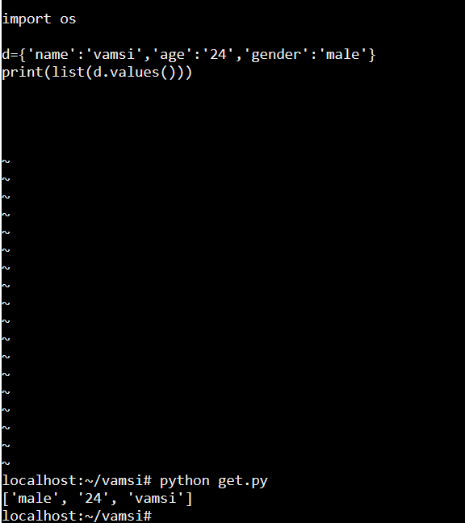

# 6.update():

Python update() method is a built in dictionary function it is used to update the key value pairs by using update() method, it will add the new key values into a new dictionary or existing dictionary.

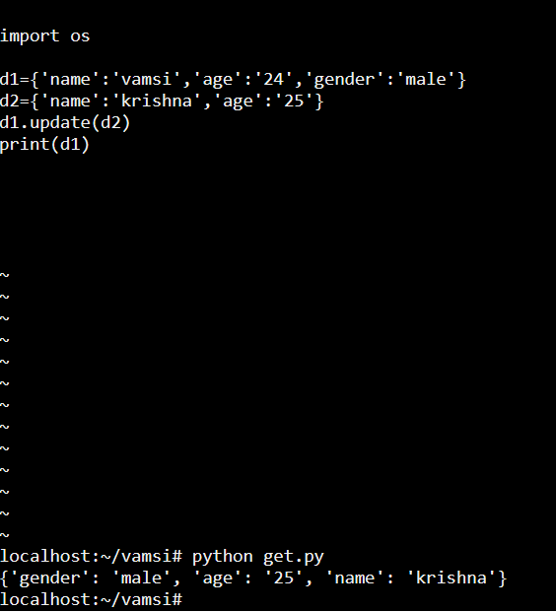

# 7.pop():

The pop() method in python dictionary is used to remove or retrieve the value of given key in the dictionary, If the key value is not presented then it will raise the error.

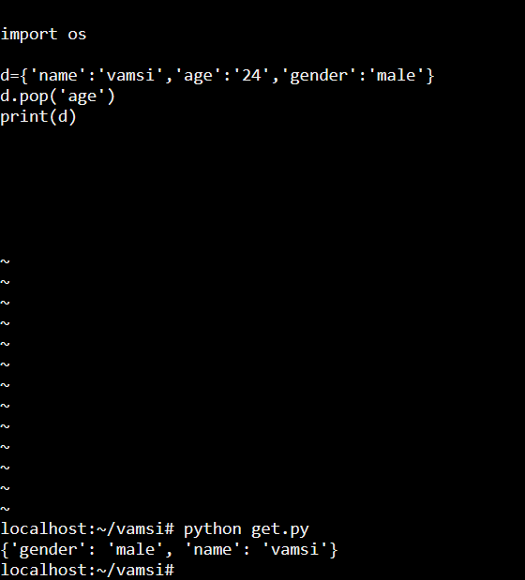

# 8.popitem():

In python the popitem() method is a dictionary function it is used to remove or retrieve the key pair from a dictionary it will take the random key value pair with out mention the key value. It is opposite to the pop() method.

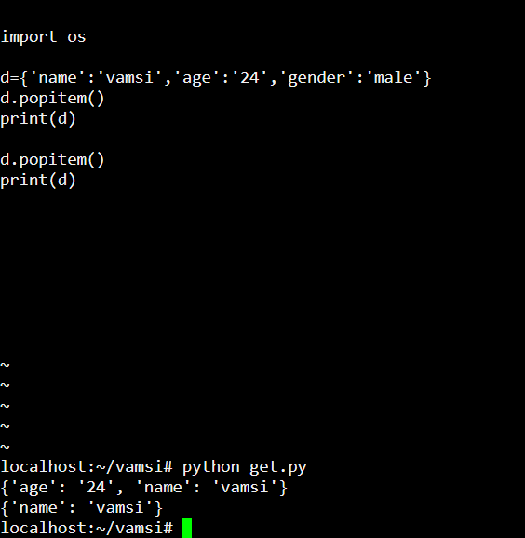

# 9.copy():

in python dictionary copy() method is used to create a copy of a original dictionary in this copy the key values of dictionary will not change.

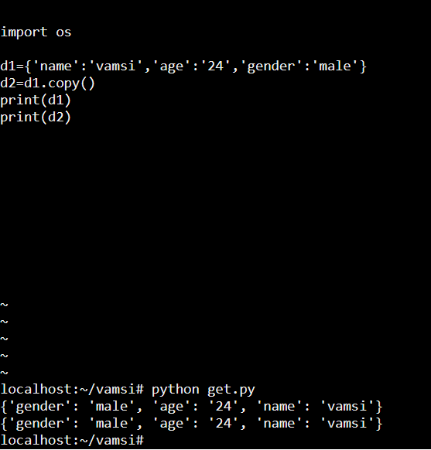

# 10.fromkeys():

In python dictionary fromkeys() method is used to return a dictionary by mapping the keys values, then it will create a new dictionary.in this we take sequence as a dictionary and values as none.

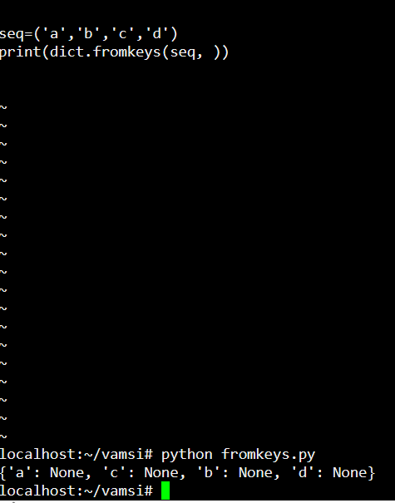

# 11.setdefault():

In python dictionary setdefault() method is used to print the value of key if the key is existing in the dictionary, other wise it returns the key as a default value if mention.

