**Set methods**

# 1.add():

The python set add() method is used to add an elements to a set.

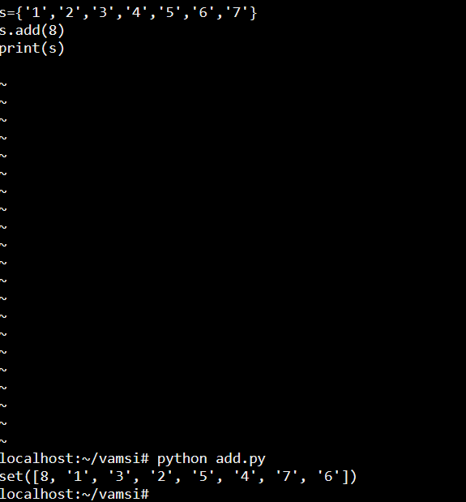

# 2.clear():

The clear() method is used to remove all the elements from the set.

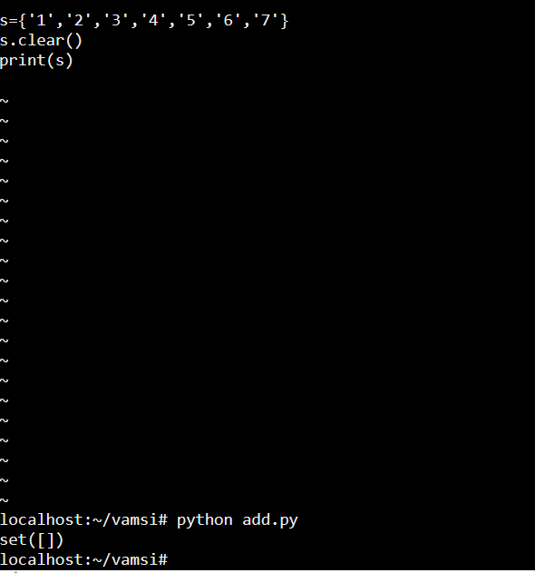

# 3.copy():

The set copy() method is used to create a copy of a original set into a new set. When copying a set in that time we use ‘=’ symbol to copy set if we change of modify the elements in new set the changes will auto matically applied on the new set also.

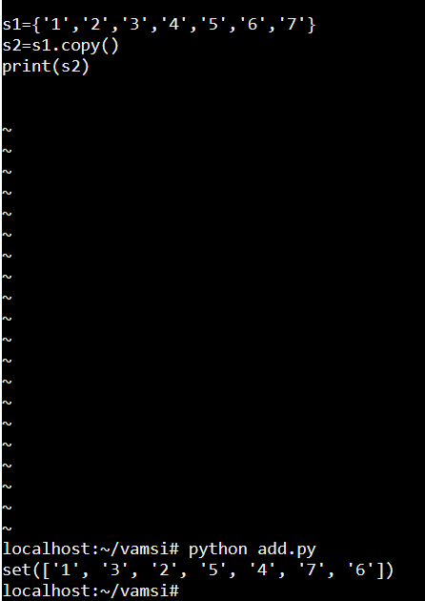

# 4.difference():

the difference() method is used to return the difference between the two set, it will check wether the elements of a set1 in set2 or not and also it will return the difference values as output.

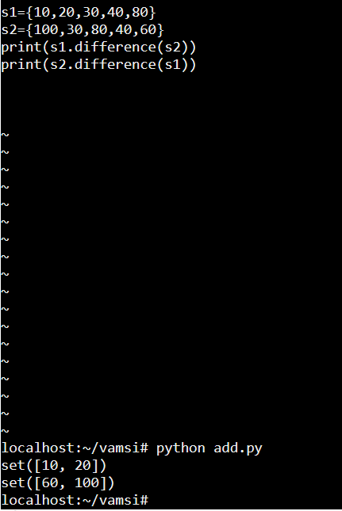

# 5.difference_update():

in set methods previously we see set difference() to in that method it will return the different elements between the two sets and make it as a new set but now in difference_update() method the difference elements will be updated as a new set.

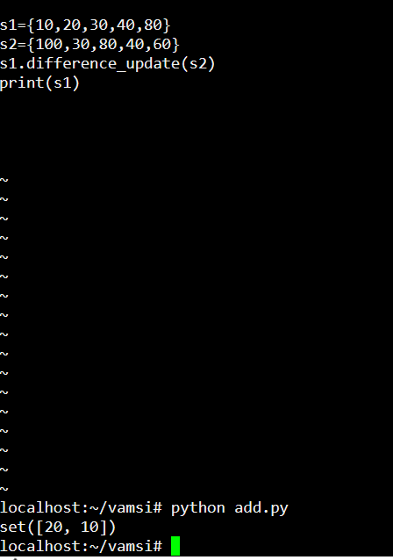

# 6.frozenset():

In python method creates an immutable set objects from an iterable, by using the frozenset() method we can not insert a duplicate values to the frozenset.

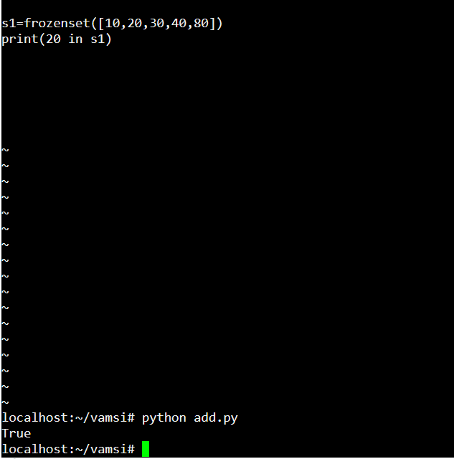

# 7.intersection():

The intersection() method in python sets is used to create a new set with the common elements of all the existing sets.

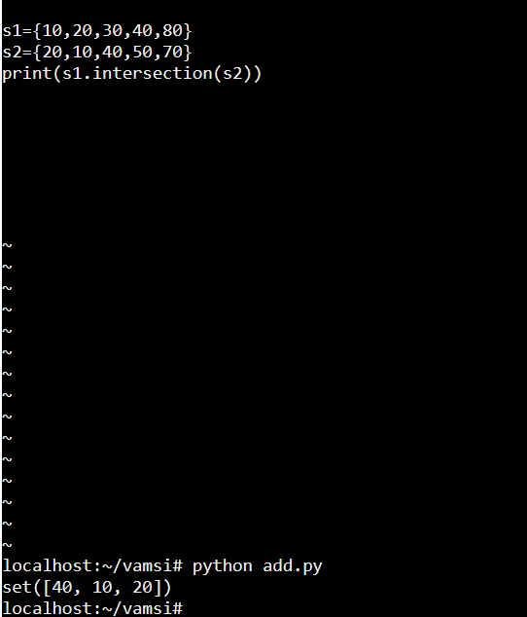

# 8.isdisjoint():

In python the set isdisjoint() method is used to check wether the two sets are disjoint or not, if they are disjoint it will return TRUE other wise it will return FALSE.

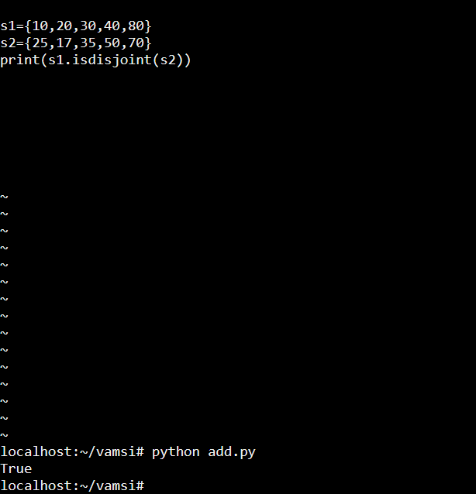

# 9.issubset():

In python issubset() method is used to check wether the elements of setA in setB or not if the elements will same it will return TRUE then it will say as subset, other wise it will return FALSE.

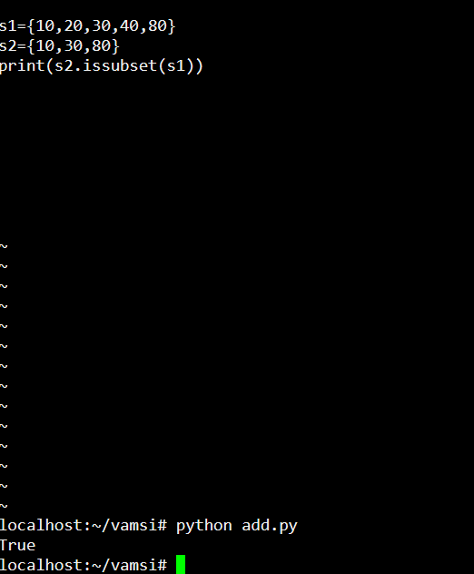

# 10.issuperset():

In python issuperset() method is used to return TRUE if all the values of setB in setA then setA will be a superset of setB.

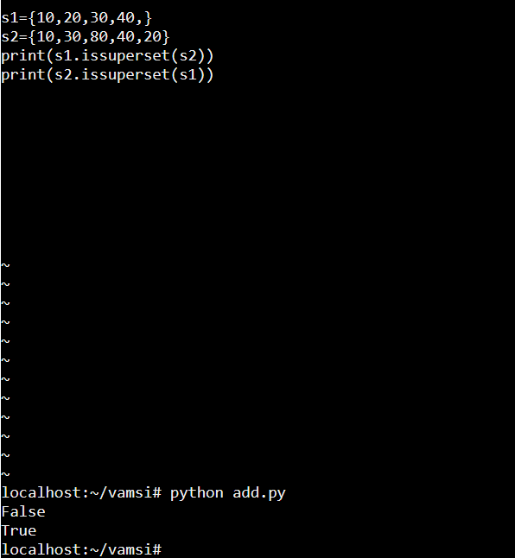

# 11.pop():

In python set pop() method is used to remove and return a random element from the set return the remaining elements of a set.

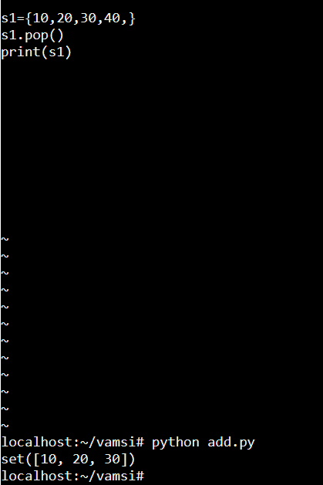

# 12.remove():

it is used to remove the element from the set.

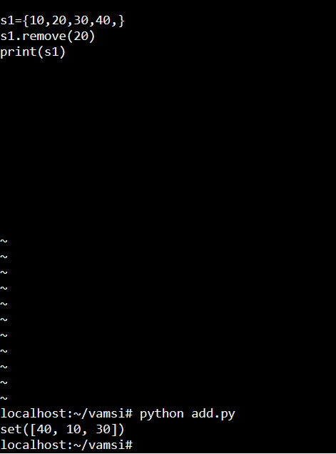

# 13.symmetric_difference():

The symmetric_difference() method is used to check the difference of two sets, the elements of set1 and set2 if the elements will either of two sets then it will said to be a symmetric_difference.

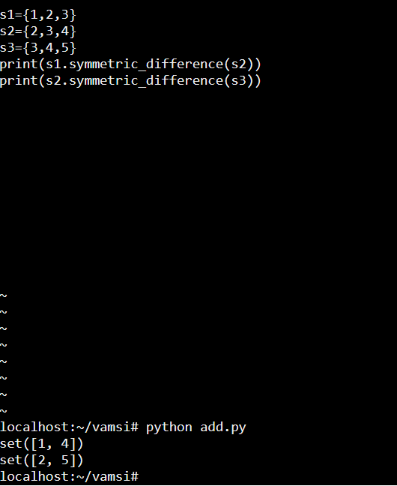

# 14.symmetric_difference_update():

in this method we call the previous symmetric_difference elements and update it and create a one new set.

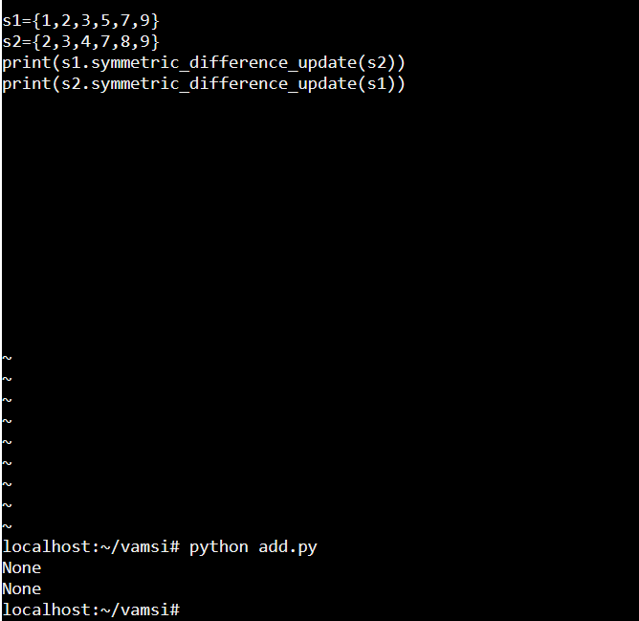

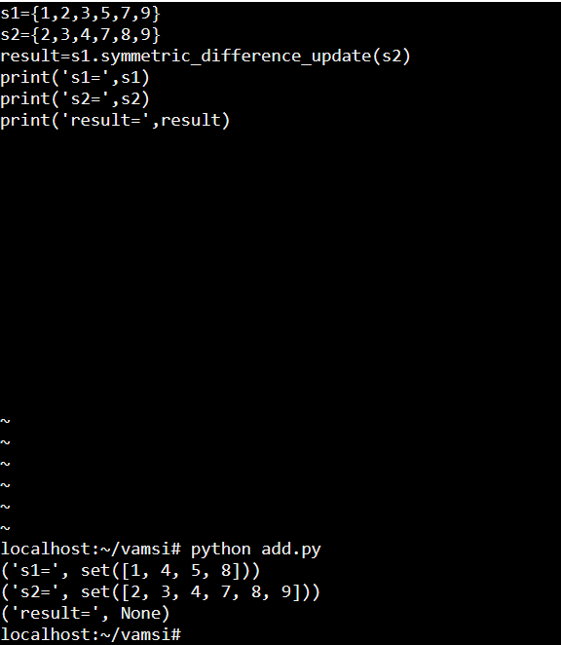

# 15.union():

It is used to return the new set that is contains the all the elements of the original sets of both the sets.

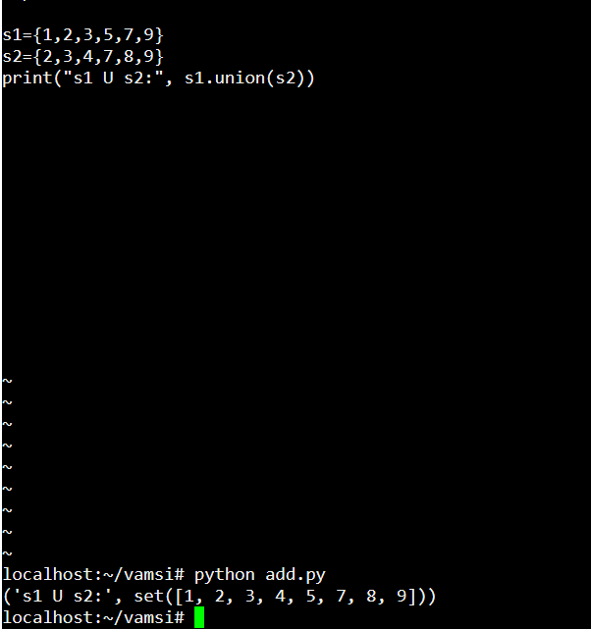

# 16.update():

In python set update() method is used to add the elements from a set to the set.

