1)mkdir Foldername/Directory_name



# creating a folder

2) cd Folde_name/ Directory_name



# to change the directory

3)vi \file_name.(with some extension ex:.py/.txt and etc...)



# to create a file inside the folder

# to edit the file / or insert the data

4):wq!

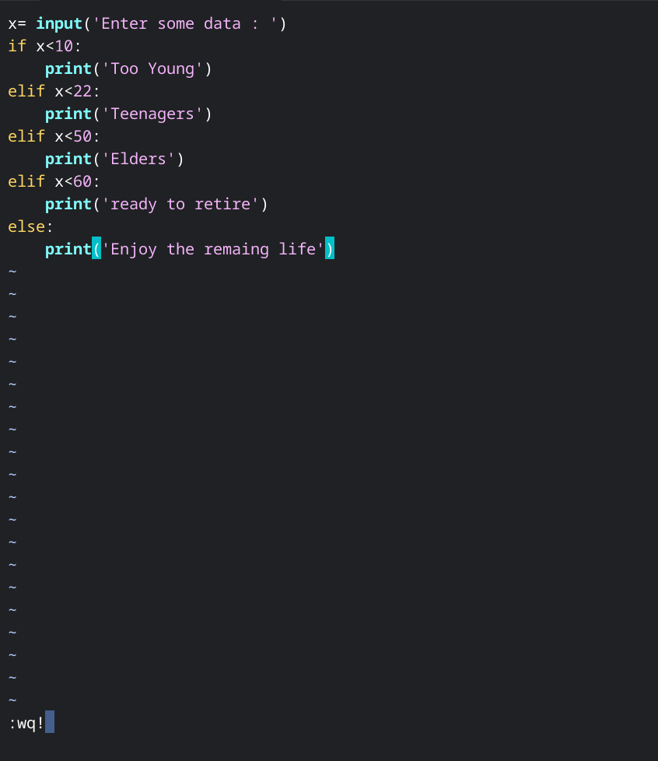

# to save the code

# to save and quit the file

# to save the recent changes

5) :q!

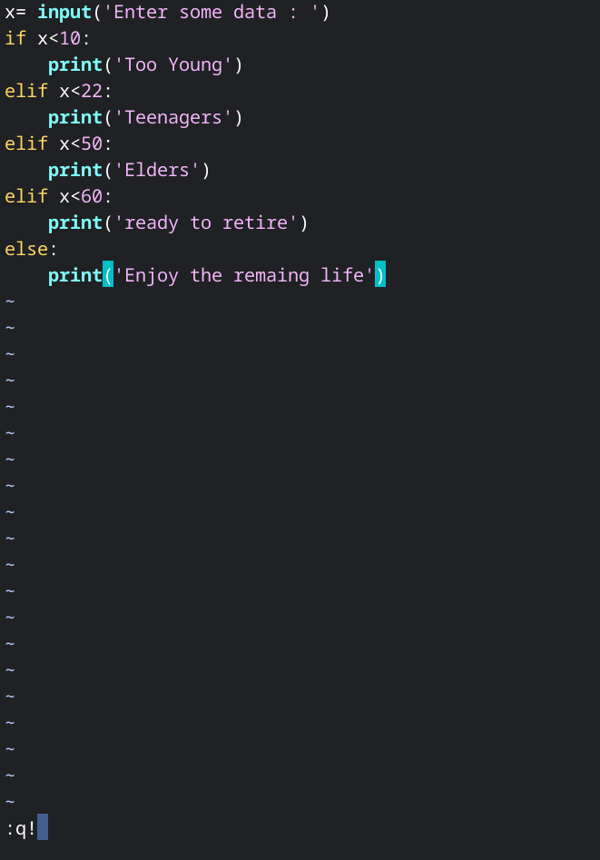

# quit without saving

6):wq

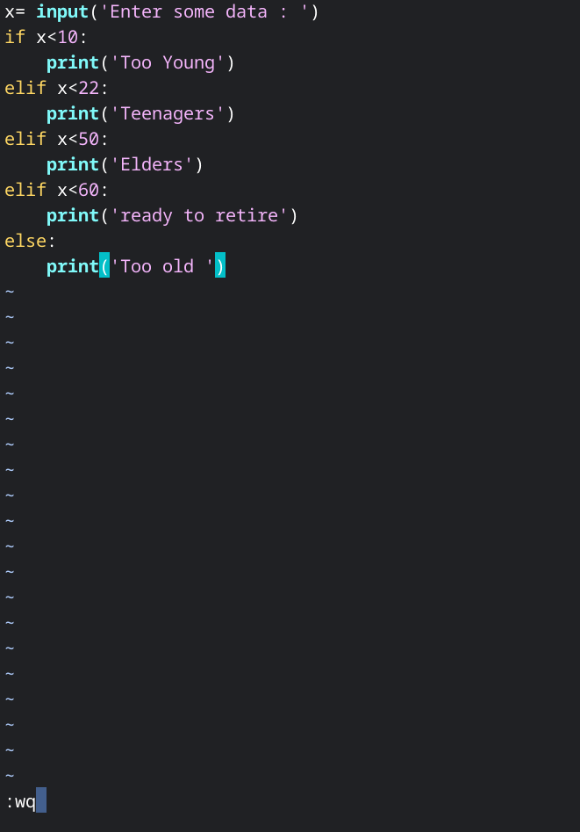

# save and quit

7) whoami



#print the user name currently logged into the terminal session

8)sudo su

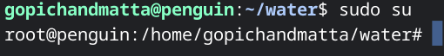

# to use as a super user

9)clear



#to clear all the previous commands what we ran in this terminal

10) cd ..



#to come out from the folder(here we are in the water folder to come out from the water folder we use this command.)

11) rmdir (folder_name)



#to delete the specific folder

12) rm (file_name)



#to delete the file

13) ls



# to display the list of files in the current folder

14) dir



# to display the folders

15) open (filename)with extension



# to open the file

16) cat (file_name)with extension



# to display the content on the file,to cross_check the data

17) man



# to run manually

18) pwd



# to know the current path

20) cp (original_file) (new_file)



# to copy the original file data into the new file

21) mv (original_file) (new_file)



# to move the original file data into a new file and make the original file empty.

22) mkdir (new_folder) (new_folder)



# to create multiple folders at a time

23) mkdir -p (newfolder)/(newfolder)



# to create multiple nested folders

24) rm -rf filename filename



# to delete multiple files or multiple folders

25) touch (newfile_name)with extension



# to create empty file

# if the file already exists,it open in write mode

26) less (Originalfile_name)



# to display the content on the file

# we can quit by pressing ‘q’

27) sort (filename)with extension



# to get the data in the file in proper order use it

28) sort -r (filename)with extension



# to get the data in the reverse order (or)Descending order

29) echo “Writhe Text Here”



# to displays the text directly on the terminal

30) df



# to know the disk usage information

31) vim (filename)with extension



# to open the file or to insert the data into the file

32) more (filename)with extension

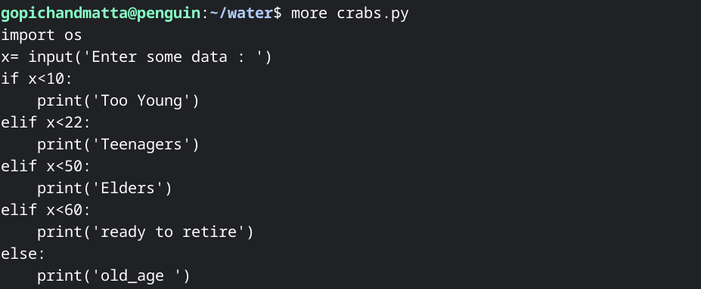

# view a file on the screen

33) less (filename)with extension



# view a file on the screen

34) vim (filename)with extension



# open text editor to edit the file

35) ps

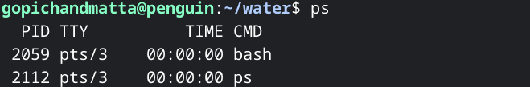

# show running processes

36)free

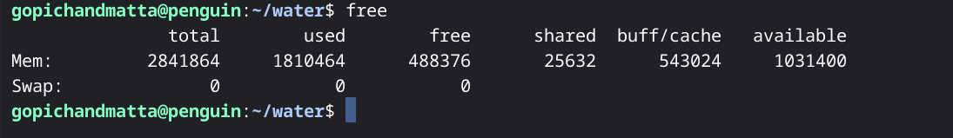

# display memory usage

37)head (filename)with extension

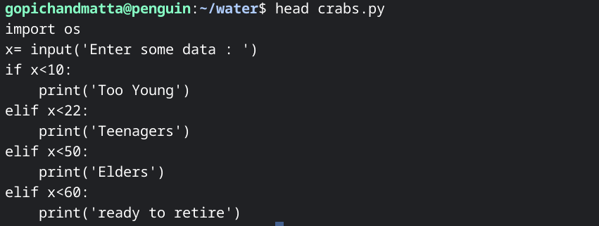

# to display the beginning of the file

38) wc (filename)with extension



# used to count lines ,words and characters of a file

39) gzip (filename)with extension



# compress a file with zip

40) gunzip (filename)with extension



# decompress a zip file