GIT COMMANDS

Repository : it is a folder/package for a project like used to store date & manage

1. git clone : When we create a repository on GitHub.com, it exists as a remote repository. we can clone our repository to create a local copy on our system and sync between the two locations

Process : On github in the main page of the repository. we find the code from there we must copy the remote repository URL and go to command prompt and clone it with copied URL in the cloned location.

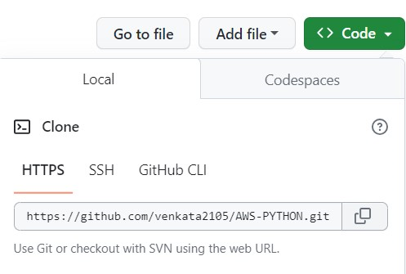

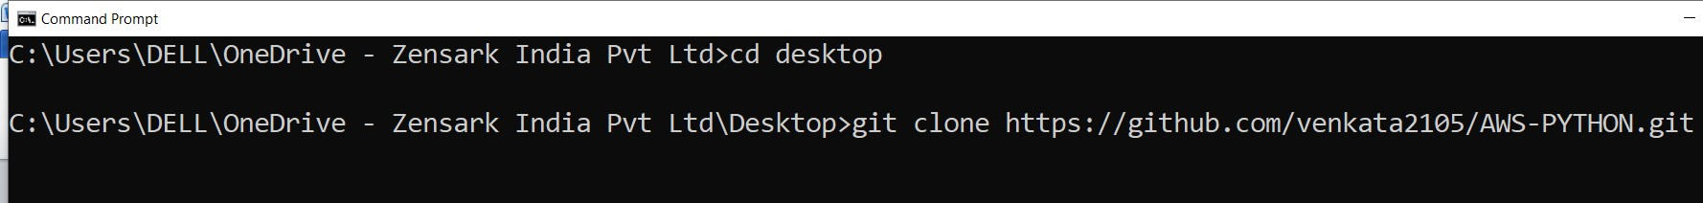

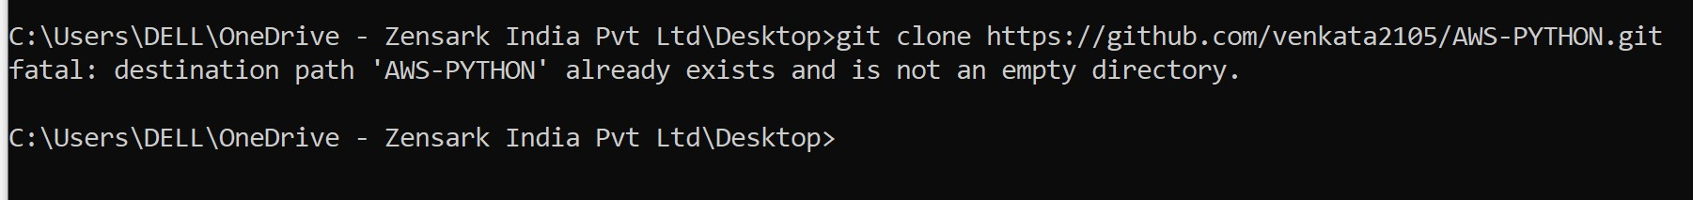

2. git pull : this command is used to fetch the changes from remote repository to local repository.it automatically downloads/save the changed remote repository to local repository.

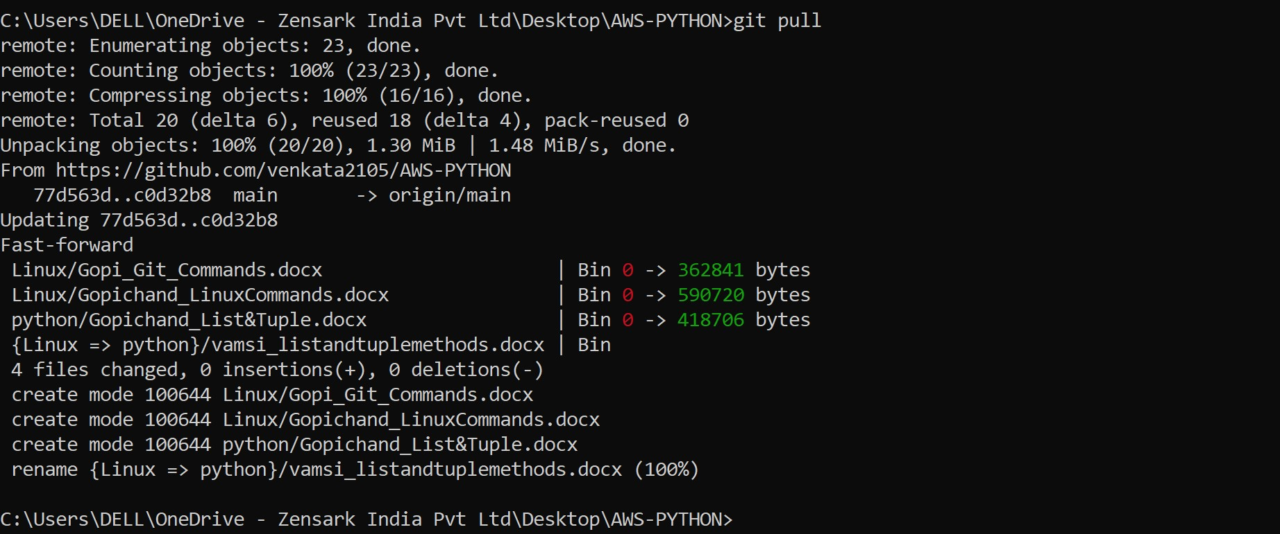

3. git add . : it is used to add file from local repository to remote repository.if you want to add entire changes then we use “git add . “ or you want to change the only specific file them you mention “ git add <filename>.

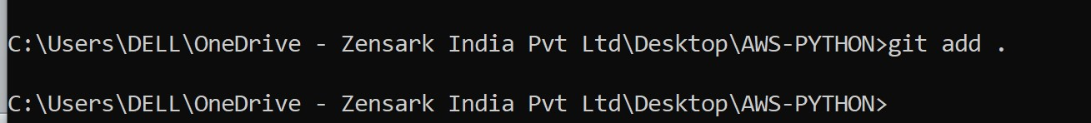

4. git commit –m : it is used to save the changes in a repository.

-m is used to show the comments of the changes. In this it identify the changes in the file and it takes snapchat.

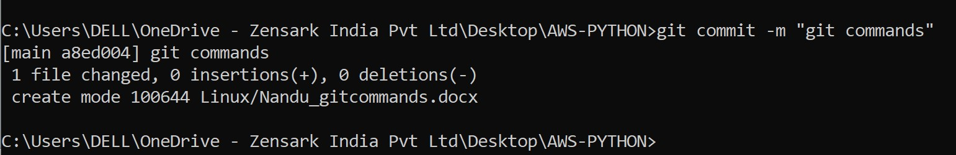

5. git push : it is used to upload the local repository changes to the remote repository, by this everyone will get access to the file when they click git pull.

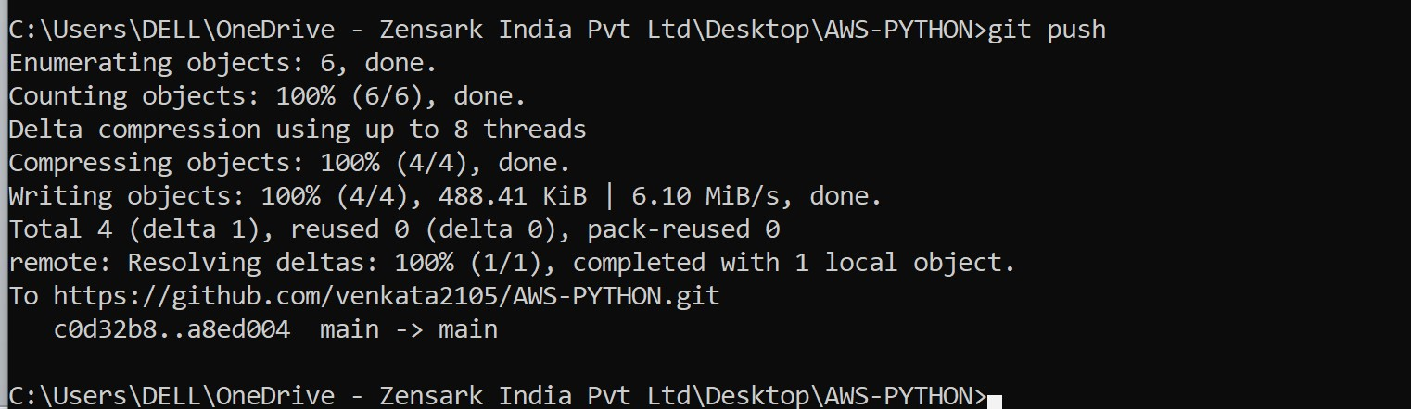

6. git fetch : it is used to show the changes in the remote repository but it will not download the changes into local repository until if you want those changes you typically use git merge to download those changes into our local repository.

